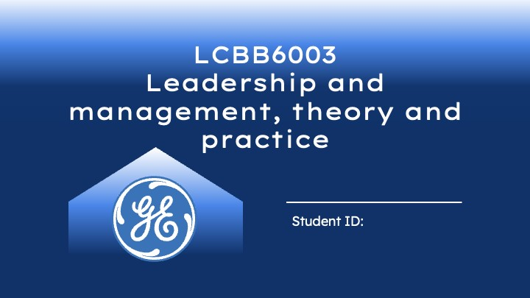
Student: MIHAELA DODOC ID: 2022006
Student: PATRICIA CONSTANDACHE ID: 2020640
Student: KAMIL CHODNICKI ID: 2020641
Student: VIRGINIA ANDREEA SIRBU ID:2021007
Student: ADELINA CAMELIA PERVA ID: 2020310

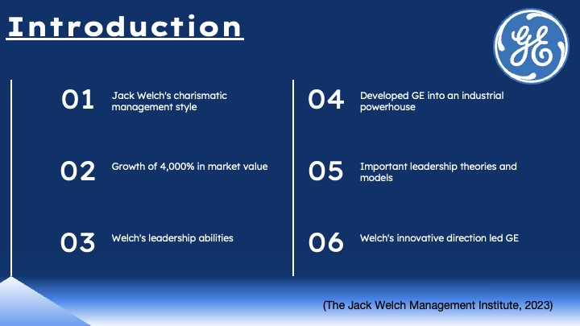
In this presentation, we examine Jack Welch's charismatic management style as the venerable CEO of General Electric (GE). Welch developed GE into an industrial powerhouse between 1981 and 2001, resulting in a startling growth of 4,000% in market value. With help from important leadership theories and models, we critically assess Welch's leadership abilities in this presentation. Welch's innovative direction led GE to new heights by putting the concepts of leadership into practice. The eternal truths we learn from the path of this legendary leader will inspire you (The Jack Welch Management Institute, 2023).
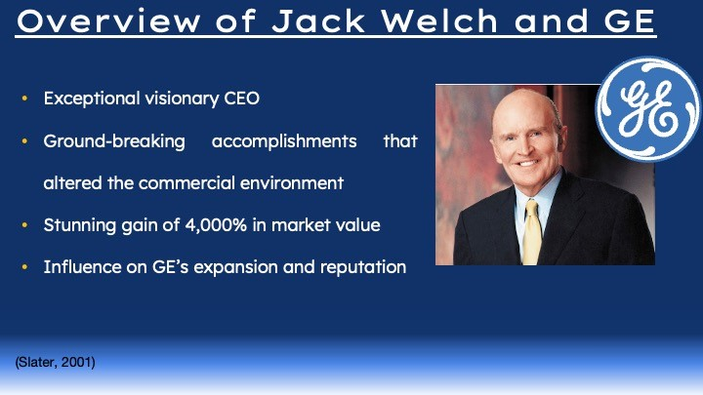
Introducing the exceptional visionary CEO who had a lasting impression on the history of GE was Jack Welch. Welch oversaw several ground-breaking accomplishments that altered the commercial environment throughout his two decades as the company's leader. He guided GE to unmatched success via creative thinking and a never-ending quest for perfection, resulting in a stunning gain of 4,000% in market value. This slide offers a view into Welch's incredible career, highlighting the significant turning points and his deep influence on GE's expansion and reputation in the market (Slater, 2001). Prepare to be impressed by the dynamic leadership that helped Jack Welch rewrite GE's future.
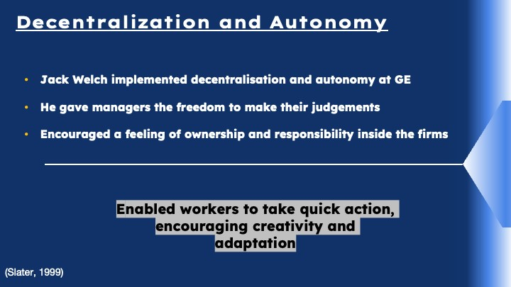
Examine how Jack Welch implemented decentralisation and autonomy at GE, which was a key component of his leadership style. Consider how he gave managers the freedom to make their judgements, encouraging a feeling of ownership and responsibility inside the firms they worked for. Determine how this strategy will affect the agility, organisational structure, and decision-making procedures of GE. Describe how decentralisation enabled workers to take quick action, encouraging creativity and adaptation. Discover how Welch's conviction in giving leaders at all levels the freedom to make decisions created the tone for GE's amazing development and success. Find the link between this leadership style and GE's overall effectiveness.
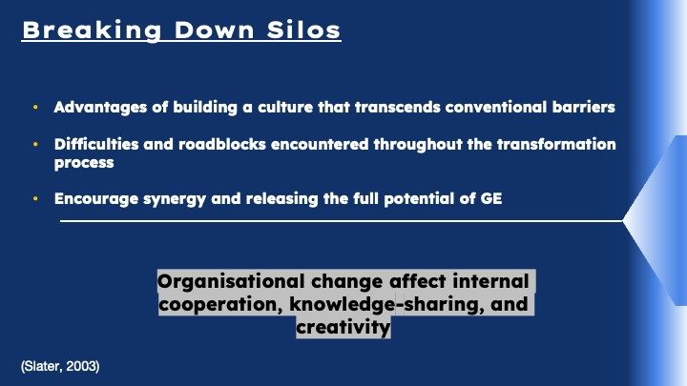
Discover Jack Welch's innovative methods for GE's business divisions to overcome silos. Examine how this organisational change will affect internal cooperation, knowledge-sharing, and creativity. He has advantages of building a culture that transcends conventional barriers so that cross-functional teams may cooperate to achieve shared objectives (Slater, 2003). Learn about the difficulties and roadblocks encountered throughout the transformation process, such as possible change resistance and communication impediments. By encouraging synergy and releasing the full potential of GE's broad talent pool, Welch's drive to break down walls made the company a case study in establishing a boundaryless and collaborative organisation.




