
Skills for the Workplace
Module Assignment Submission
Student Name: | Emma Louise Stevens
Student Number: | 20075270
Module No: | BMSK4004
Module Title: | Problem Solving and Decision Making

Statement of Confirmation of Authenticity
By the act of making this submission, the student declares that this is the work of the student named above. The work has not, in whole or in part, been knowingly presented elsewhere for assessment, or where assessment has been built on a previous assessment, this has been identified. Where materials have been used from other sources it has been properly acknowledged. If this statement is untrue, the student acknowledges that an assessment offence has been committed.
Attention is drawn to the plagiarism and unfair practice policies of UWTSD.

Table of Contents
Define a complex problem in the workplace, including its scope and impact 3
Analyse information on the identified problem, to help inform the decision making process 3
Using a decision making technique, evaluate a range of solutions to identify the most appropriate option 6
Develop a detailed plan for implementing the solution 7
Communicate the plan to relevant stakeholders 9
Assess appropriate monitoring and review techniques to ensure successful implementation of solution 11
References 12
Appendix 1 13

Define a complex problem in the workplace, including its scope and impact
According to Rittel & Webber (1973), ‘complex problems are typically defined as those that include the ability to approach them from multiple, sometimes competing, perspectives and which may have multiple possible solutions.’ Within the writer’s current place of work, they are experiencing problems with customer dissatisfaction, especially in the lack of telephone calls being answered. This is not only a disservice to the customers but is also reflected in the branch’s performance data. The bank thrives on building relationships with their customers and with the number of missed calls the customers are losing trust in the staff and company, not only this but the bank also takes and books a lot of business through inbound calls and when these calls are missed, they are missing out on valuable business.
The scope of the problem is that between the hours of 9AM to 5PM the high street branch see’s approximately one hundred to one hundred and fifty customers each day requiring a face-to-face interaction. Since the onset of Covid 19, these number have decreased to approximately fifty to eighty face to face interactions per day; however, the telephony channel direct into the branch line has significantly increased from an average of thirty calls per day to seventy or some days even more. The impact of this is the customers are left feeling they are at a disservice and the company are left with low performance data – which has a knock-on effect of the company’s profits. This problem does not lie with any individual staff member, this is a problem belonging to the whole team and a solution needs to be found to increase branch productivity and customer satisfaction.

Analyse information on the identified problem, to help inform the decision-making process
To help inform the decision-making process the manager has analysed and collected information to help solve the problem of missed calls within branch setting. The manager has used techniques such as brainstorming with the team, creating a mind map (referenced in appendix one), five whys and root cause analysis. The information and data that was proven are as shown below.
Brainstorming with the team meant that all voices, opinions, ideas, and collaboration were brought to the table, and gave relevant and up to date data to create a meaningful and useful mind map. (Referenced in appendix one).
Mind map – the manager and the team find using a mind map shows clearly all the possible solutions to underpin the successful implementations and how the change will be received and/or managed.
The manager has categorized the mind map into seven sections, which are as follows: Physical barriers, Mindset, Job role, Communication, Benefits of answering the phone, Disadvantages of missing calls and what the team needs to stop doing, start doing and continue doing. The team have demonstrated a wide range of ideas and thoughts. The second mind map shows ways in which we can solve the problem. These include solutions such as – invest in new, reliable phones and place them strategically through the branch, next to computers and on every workstation, create a role for a dedicated phone answerer (this could be a different member of staff from day to day / hour to hour), if the dedicated phone answerer is unable to answer the phone due to being on another line with a customer, toilet break or for any other reason another member of staff needs to answer the phone (back up phone answer, when phone is not answered within three rings), acknowledge the phone answering role as just as important as all other roles in the branch and schedule this onto the daily planner and increase the ring volume on all phones though out the branch so everyone can hear and members of staff can answer phone quickly and efficiently.
The manager has done some research themselves on the disadvantages of missing calls and the lasting side effects and felt this would be useful to share with the team. When discussing with the team they show the picture as shown below to the staff members and leaves to conversation open to allow the staff to voice their opinions freely. The team are quick to agree with the findings although admit they are shocked on the consequences and lasting effects of what missing a phone call could be. They also share the missed call data with the branch for that week and it is the highest it has ever been with one day the branch missing a total of seventy-nine phone calls direct to the branch. The manager has made it clear to the team that a solution needs to be found quickly but must be a sustainable solution to ensure the branch do not fall this low on performance again. If the branch where to miss this amount of direct phone calls to the branch the branch will be put on a risk report and the area director will need to keep a record of all calls answered and missed daily.
Devin Bailey (2019).

The manager has had an open and insightful conversation with the team to gather an understanding into the team’s thoughts on why the volume of missed calls has been high over the past six months. When asking the first ‘why’ – why are there a high volume of missed calls? The team reach out and voice their opinions on the problem at hand. The main point being the branch are receiving a far higher volume of calls than previous months and even years as they were and still are in a global pandemic fighting COVID-19. With a lot of customers still unable to leave the comfort of their homes due to isolation, medical issues and/or working from home the as explained above the footfall may have dropped however the telephony service has almost doubled in figures both in branch and within the telephone banking department.
Another ‘why’ the team discussed was – why is there not a phone based on every station? This is something that has been captured on the mind map and that the manager has taken into consideration. The team have discussed and established that there did used to be a phone on every station however the previous manager moved these telephones as they felt they were in the way and made the branch look “messy”.
Whist using the techniques above to collect and analysis the data the manager has also had to take into consideration the cost to the company, timeline, availability, feasibility, and relevance.
The company use an online store named Ariba which stocks all essential stationary, leaflets/brochures, equipment, including office equipment such as telephones. The phones retail at twenty pounds a phone and the manager has made a not that to have a phone at every station within the branch setting five phones will need to be ordered. This is a total of one hundred pounds– however the bank will need to pay separate for delivery from a well know courier DPD. This retails at an extra cost of twenty pounds. Meaning the total cost to have a phone at every station will be one hundred and twenty pounds. The branch is given an annual spending limit on Ariba of two thousand two hundred which on average the branch spends between one hundred and fifty to two hundred pounds monthly. By purchasing five new phones the branch is sacrificing money that would normally be needed for everyday essentials, like office stationery and keeping all merchandising up to date. This would mean possible approvement from the area manager or even reginal manager if the branch where to go over the average monthly budget.
There would be no need for the company to employ more staff to take on the role of answering the phone or manning the phone throughout the day. This is part of the job role and expected from every team member. The daily planner would be updated from day to day to show what each member of staff’s roles are for that day from hour to hour. The planner will be updated frequently throughout the day as and when plans change or when staff need to adapt to situations/customer needs.
Another possible solution the team discussed was adjusting the ring volume so that members or staff can hear the phone ring clearly and answer quickly and efficiently. This would not cost the company any money and the managers have the authority to adjust the ring volume and ‘lock it in’ which means no other member of staff would be able to adjust the volume up or down. The problem this raises is whether the staff members would be able to hear their customer talking at the till, in an appointment, in a private room or even in the banking hall (an open space) over all the telephones ringing loudly.
The time it would take from ordering the phones on Ariba to the phones being delivered to the branch and set up on each station ready to take inbound calls would be a total of four days. As the courier service provide next day delivery this means the branch can be efficient. However, the software company used, can take up to three days to install and connect the phone lines. This means the branch would be sacrificing another four days with possible high missed call volumes.
The time it would take to implement the role of a dedicated phone answer would be immediate. This would be added to the daily planner and the manager would delegate the role and explain the role in full during a morning meeting. The manager would need to explain the importance of this job and that communication is key. The dedicated phone answer will need to let all team members know when leaving their post to ensure a minim or even no calls are missed while they are absent.
Increasing the ring volume of the phone is also something that the manager would be able to implement immediately and would also need to let all team members know that this has happened. This is something that staff members will need to be conscious of when conduction an appointment with a customer or dealing with a more sensitive subject.

Using a decision-making technique, evaluate a range of solutions to identify the most appropriate option
The first step the manager took was to eliminate unviable solutions with the team. At this stage they examined each solution in turn and rejected those which do not meet all the constraints they have. The second step the manger took was to evaluate the remaining solutions with the team. Each of the remaining solutions was then examined to see how well it provides the results required. They then assessed the risks – if any at all. Although the solutions chosen to show what offers the best balance of benefits versus disadvantages, they then examine the possible risks associated with this solution to ensure that they are acceptable and to identify areas where risks could be minimised. The manager then needs to take lead in the decision-making process. The team then commit themselves to increasing the ring volume and buying two new telephones. They commit to this solution and will each play a role in making it happen.
Through the manager using different techniques with the team, they found the mind map to be most useful to gather all the information needed, hear all the staff’s thoughts and opinions and to start a plan on how to implement the ideas into every day working life.
All the solutions to the problem above are relevant and will all have a significant impact on how the branch manage to answer the telephone during their working hours. However, the manager through using the techniques and looking at cost management has decided to increase the ring volume on telephones in an open space (banking hall), however not in in closed rooms used for appointments. This is something that can be implemented immediately and no planning or authorisation from the area manager is needed.
The manager has also decided to order two additional phones to be bought and the correct software to be downloaded onto them. As discussed, the cost of the phone is twenty pound per phone and twenty pounds for next day delivery, this totals sixty pound which the branch will need to take out their monthly spending budget for Aribia (stationary). This means the branch will need to create a list of stationary to order and prioritise things they are short on or need for legal/risk reasons such as up to date brochures and information/posters placed around the branch.
Below the manager has created a detailed plan using a Gantt chart to help everyone know exactly what the plan is and when each step needs to be executed.

Develop a detailed plan for implementing the solution

The manager has used a Gantt chart to set a clear timeline of what needs to be implemented straight away and what needs to be prioritised. As shown in the chart below the manager has indicated that red highlighted cells are of high importance and must be completed on time as per chart shows, the orange columns are labelled important and yellow cells labelled as can be delayed or rescheduled if must or schedule changes.
The manager has stressed the importance to the team that this chart is followed as shown below and made all full time and part time staff aware of changes and software engineers coming into the branch. The manager has recapped with all staff members the policy and procedure that must be followed when allowing external companies into the branch and the importance of taking identification.
The manager will increase the volume of telephone placed in the banking hall, counter space and office within the first two weeks on the plan being actioned. The volume will not be on max however loud enough to hear from throughout the banking hall. The volume will be ‘locked in’ which means only the manager has authorisation to increase or decrease volume as and when needed.
The manager has appointed a senior member of staff to use Ariba to order the telephones and organize the next day delivery, these actions must be requested before 12pm to ensure next day delivery. If they are ordered after 12pm this means the plan will be a day behind schedule and could mean another day of the branch missing several calls.
The manager will need to contact the software engineers and request them to come out to the branch to set up new telephones and discuss how they are programmed, how to use and any software differences.
All staff members have already been made aware of delivery this means any member of staff will be able to sign and take telephones from the courier. These telephones must be kept in a secure location within the branch – preferably in a locked safe that only senior members of staff have access to. If this is not possible the manager has asked for them to be in a locked room or cupboard in readiness for the software engineers attending the branch – this may take up to three working days.
Any member of staff within the branch can allow the software engineers into the branch, they must follow the most recent and relevant policy and procedures and ensure that the correct and valid identification is taken. This is to ensure that the software engineers entering the bank premises are genuine.
If telephones have been stored in a locked safe a senior member of staff must retrieve these and give to the software engineers. If a senior member is staff is unavailable a manger must retrieve the telephones.
The manager must then test all the new telephones to ensure they are working as they should, with no errors or differences from other phones throughout the branch. This step will be carried out by the branch manager throughout the week again to ensure there are no issues. If there is an issue this must be reported and logged straight away to the external software company. The software company then have twenty-four hours to respond, if this issue is unable to be resolved via telephone, email or externally a software engineer must attend the branch as soon as possible. However, is unable to attend out with the working hours of 9am to 5pm.

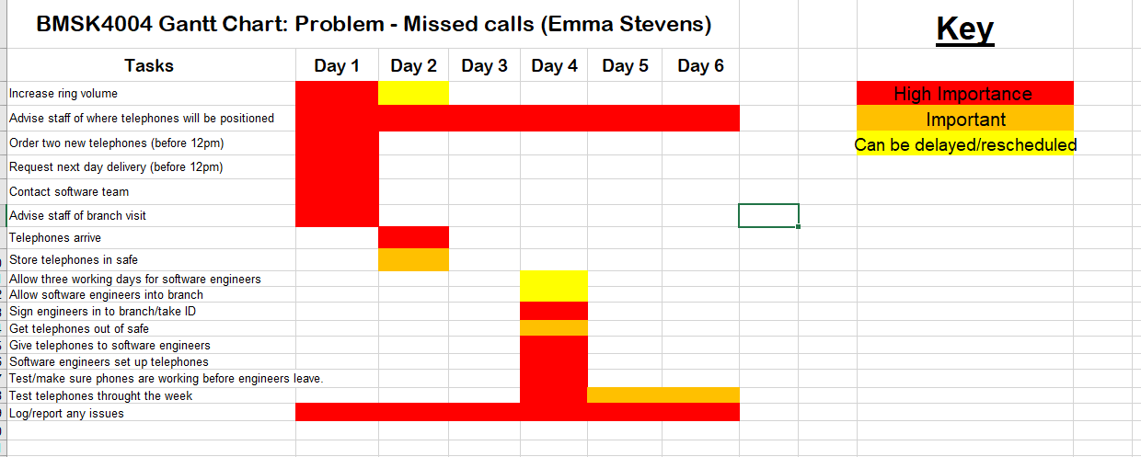

Communicate the plan to relevant stakeholders
According to Fernando (2021) a stakeholder is a “party that has an interest in a company and can either affect or be affected by the business. The primary stakeholders in a typical corporation are its investors, employees, customers, and suppliers.
However, with the increasing attention on corporate social responsibility, the concept has been extended to include communities, governments, and trade associations.”
TSB Bank’s stakeholders consist of the owners, investors, and suppliers. This means for a purchase on new telephones they will all be informed, and the purchase will be recorded on the database under branch expenses.
The manager will need to make the area director aware of the branch plans before implementing any of the solutions. This is because there is a cost included and must be authorised by someone who has clearings to authorise the branch spending over one hundred pounds. The purchase of the two telephones will need to be communicated to the area director before ordering and the manager must keep and inform the area director of any changes to the plan discussed. During the execution the manager must give not only the staff members but also the area director status updates, resource allocation, and if there are any unexpected developments. These are all appropriate for staff members, the area director and stakeholder communication. As the solution/fix to the problem approaches, it’s another opportunity to check back in with everyone including stakeholders to be sure they’re ‘in the loop’, know their role in making things successful, and have the resources available to support or assist if needed.
As this does not impact or exceed the monthly expenditure of the branch allowance there is no need to inform the reginal director. As the branch are within their monthly budget this means there is no loss or impact to the stakeholders such as the owners, investors, or suppliers. This simply means the branch need to be strategic and priories what needs to be ordered for stationary over small/less important items or stationery.
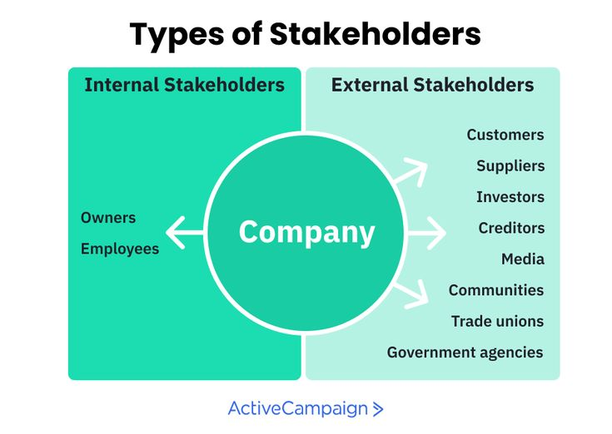
(Minning, 2021)
The team have acknowledged that the problem of the missed calls is an improvement problem – this means it will not only improve the weekly data on calls answered/missed calls, but it will also improve the data for appointments booked, improve customer satisfaction, improve net promoter scores, and improve staff morale. By rectifying the problem of missed calls within the branch is known as a strategic plan as it will have long term benefits for the company, such as more business for the company meaning an overall profit for the companies’ annual profits, customer satisfaction will improve therefore the staff members will be building long term relationship with the customer. The team will collaborate and come together more often to share ideas and thoughts on how to improve or change things though the daily routine or working day and it will also help individual staff members to become confident at their every day jobs and/or roles.

Assess appropriate monitoring and review techniques to ensure successful implementation of solution

The manager will need to review the information immediately with the software engineers to ensure they know how to use the telephones properly. They will need to spend a few minutes reviewing the new information as soon as they have learned it and look through the material again. They may need to add notes that they have made. The manager has said this will help them to explain any key points out loud to the team. The manager has said the first review is a good way of checking that they have got everything they need, and that they have understood it. It will also avoid them having to "relearn" it completely when they review it again later or with a new staff member.

The manager has said the next step is to schedule further reviews as it takes repeated effort to move information into your long-term memory and that it is vital to review material frequently. Otherwise, key details can be forgotten, and issues may not be picked up or reported.

The manager has openly said to the team to test themselves and they will also be testing themselves when reviewing the telephone software. (Ireland, 2021) The manager said “Every time you review something, include an element of testing. This will uncover any gaps in your knowledge, highlight key areas that you need to focus on, and reinforce your learning”.

The manager will teach all members off staff over several morning meetings. One of the most powerful ways to embed learning is to teach it to someone else. This will quickly reveal any aspects that you they staff members do not understand or cannot remember, pinpointing where their knowledge is weakest. This will also boost the team’s confidence to use and apply their knowledge. The team may ask you questions, which will test the mangers knowledge even more deeply – and, in the process, strengthen the teams grasp of the software.

The manager will receive weekly data informing them of the number of calls answered via the amount off calls missed this is something that will need to be reviewed using the strategy above. This is the manager’s job to gather the correct information and data and share with the team their successes or indeed of things have not improved after making the changes to improve the amount of missed calls. If the number of missed calls does not improve after the ring volume and new telephones have been bought the team will need to revaluate their previous solutions to the problem and begin the process again.

References
BBC (2019). Stakeholders - Revision 1 - GCSE Business - BBC Bitesize. [online] BBC Bitesize. Available at: https://www.bbc.co.uk/bitesize/guides/z4gcd2p/revision/1.
Department of Agricultural Economics, Sociology, and Education (2014). Complex or “Wicked Issues” (Center for Economic and Community Development). [online] Center for Economic and Community Development (Penn State University). Available at: https://aese.psu.edu/research/centers/cecd/engagement-toolbox/problems/complex-or-wicked-issues.
Fernando, J. (2021). Stakeholder. [online] Investopedia. Available at: https://www.investopedia.com/terms/s/stakeholder.asp.
Hicks, T. (n.d.). Seven Steps for Effective Problem Solving in the Workplace. [online] Mediate.com. Available at: https://www.mediate.com/articles/thicks.cfm.
Indeed Editorial Team (2021). Effective Problem Solving Steps in the Workplace. [online] Indeed Career Guide. Available at: https://www.indeed.com/career-advice/career-development/effective-problem-solving-steps.
Ireland, T. (2021). Reviewing.
Mbalerio (29AD). 13 Steps for Effective Problem Solving in the Workplace | PA Prive. [online] pa-prive.com. Available at: http://pa-prive.com/13steps-for-effective-problem-solving-in-the-workplace/ [Accessed 8 Aug. 2021].
McLeod, S. (2019). Qualitative vs. quantitative research. [online] Simply Psychology. Available at: https://www.simplypsychology.org/qualitative-quantitative.html.
Minning, L. (2021). The 10 Types of Stakeholders That You Meet in Business. [online] Active Campaign. Available at: https://www.activecampaign.com/blog/types-of-stakeholders [Accessed 2 Sep. 2021].
Nowak, S. (2018). A Holistic Approach to Problem-Solving. [online] . Available at: https://content.ebscohost.com/ContentServer.asp?T=P&P=AN&K=129312355&S=R&D=aph&EbscoContent=dGJyMNLe80SeprA40dvuOLCmsEmep7dSsqu4TbGWxWXS&ContentCustomer=dGJyMPGqtVGxp7FRuePfgeyx44Dt6fIA [Accessed 2 Sep. 2021].
Rittel, H.W.J. and Webber, M.M. (1973). Dilemmas in a general theory of planning. Policy Sciences, 4(2), pp.155–169.
Sullivan, J. (2010). Management Theory of Henry Gantt. [online] business.com. Available at: https://www.business.com/articles/management-theory-of-henry-gantt/.
Toll, C.A. (2016). A Problem-Solving Model for Literacy Coaching Practice. The Reading Teacher, 70(4), pp.413–421.
Unicom Teleservices (2019). The Impact of Missed Calls for Your Business. [online] Unicom Teleservices. Available at: https://www.unicomcorp.com/blog/the-impact-of-missed-calls-for-your-business/#:~:text=%20Steps%20to%20Fix%20the%20Unanswered%20Call%20Problem [Accessed 2 Sep. 2021].

Appendix 1
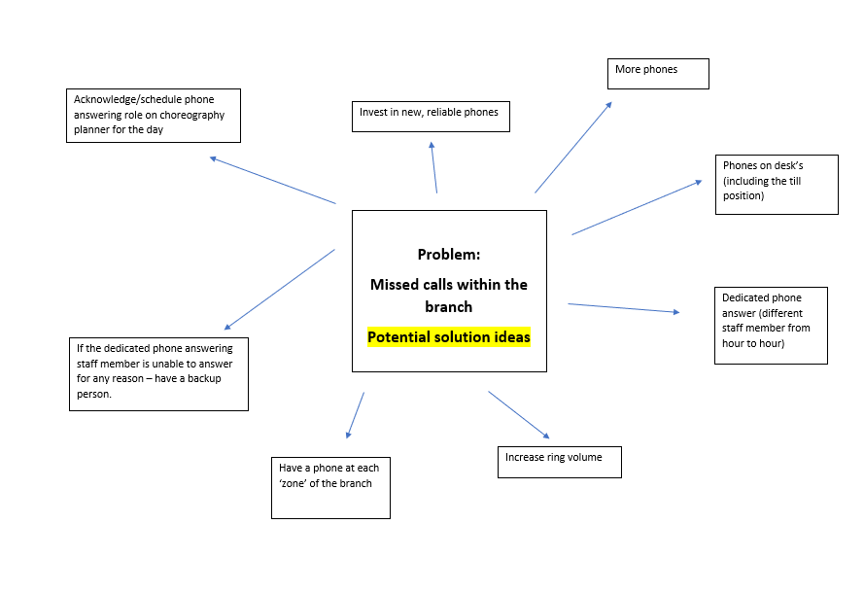
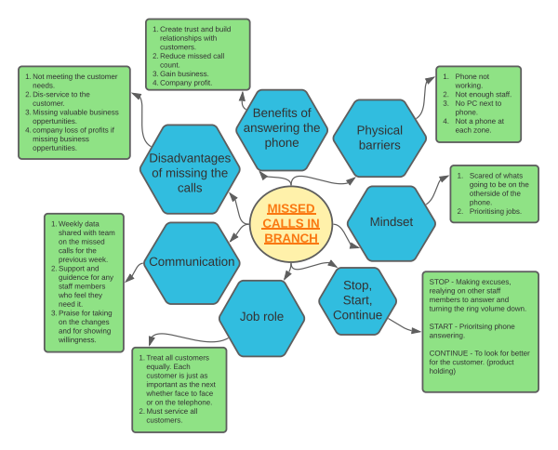

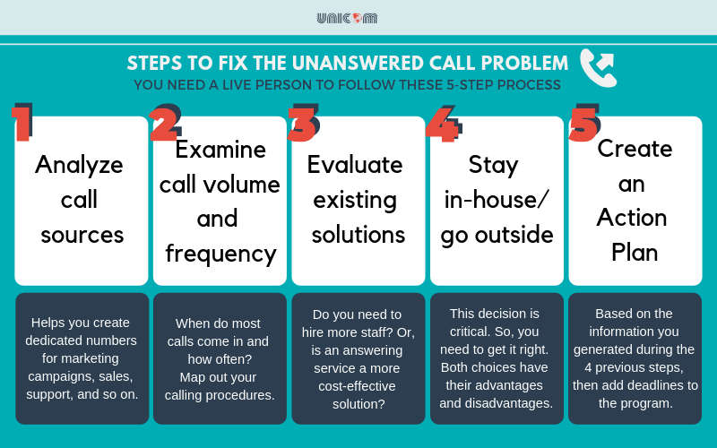Devin Bailey (2019)

Devin Bailey (2019)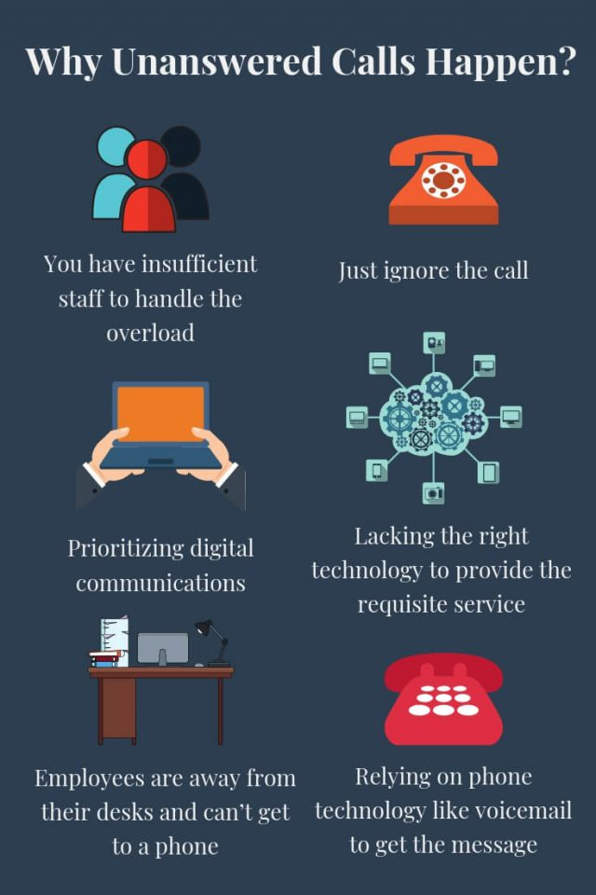 Devin Bailey (2019)

