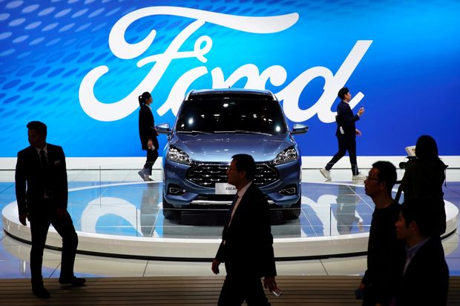

THE DECLINE OF FORD
  - PROBLEM SOLVING AND DECISIONS MAKING
NATALIA MICHALAK | PROBLEM SOLVING AND DECISION MAKING | 06.03.2020

EXECUTIVE SUMMARY

CONTENS PAGE

INTRODUCTION
Report present the Ford Motor company’s actual status on the market by introducing all the problems which companies facing actually. The nature of report is find all existing problems going forward identifying that problems deeper through analytical skills. Also report present the number of ways of resolved that problems More analyzing one of them using relevant tools in decision-making process.
Report represent all skills known to me through Problem Solving and Decision Making module. My lecturer and supporter is Laura James.
Report must be submitted to Turnitin by March 6, 2020. All research methods in the report findings are added on last pages in references.

FORD MOTORS

2.1 the HISTORY OF FORD MOTORS COMPANY
Company has them begins in America. 12 investors run that company in 1903. One of associated investors was Henry Ford. In 1919 the corporation changed investors for Ford’s family- his wife, Clara, and his son, Edsel. Finally, family last name had changed previous company’s name for Ford Foundation in 1936. Stockholders sole until January 1956 at the time when common stock has started been public sale. Actually they do products in offer like: passenger cars, tractors, trucks, automotive part and accessories.

2.1.2 The history of ford
Born in Detroit, behind his home there he builds his first car in workshop in 1896. In July 1903 his first car was assembled and 5 years after, 1998, one of most successful model has introduced. Success of production develop company to organize a mass production in order of manufactured. In 1911 another two companies run in Kansas City as two first industry assembly plant, then opened second overseas manufacture in Manchester, England. At the same in 1913 big step was run first moving assembly line for cars.
Of the great success as company, Ford introduced to further improve labor productivity new wages 5$ for eight-hour shift instead of 2,34$ for nine-hour shift.

2.1.3 productus and marques
Ford Motors sells a numbers of vehicles worldwide using different marques. Marque Ford and Lincoln originally come from United States but Ford is selling global since 1903, but Lincoln, is selling since 1922, in North America, Middle East, China, South Korea. Ford Motors has originally since 2007 only on Brazil market marque Troller.
As a global company Ford selling different products on market:
- AUTOMOBILES- Through all the years since begging started from America to present selling cars global.
- TRUCKS- Ford has produced trucks since 1903
- BUSES- Were complete manufactured since early begging but roles in companies has changed and now there are second stage manufacturing.
- TRACTORS- Ford company starts making that mobiles from 1908, in meantime changing a places of production.
- FINANCIAL SERVICES- Company offers automotive finance through Ford Motor Credit Company.
- AUTOMOTIVE COMPONENTS-Ford’s FoMoCo sells part under other name of brand the Motorcraft aftermarket parts

2.2 MAJOR PROBLEMS

2.2.1 high copmetition
Products on the market are specific. Amongst them, 6 categories can be distinguished. In section 2.1.3 are divided into: automobiles, trucks, tractors, buses, financial services and automotive components.
USA as origin market making a trends which are opportunity for Ford Motor Company.
It happening like this of the fact big other competitors like Tesla using technology for reducing exhaust for economical drive in the fact of bad impact on natures environment. That is why trucks are more stable on the selling market. For small cars crude oil prices demand making at the same more popular UV’s vehicles Important information is crude oil prices growth 70% since 2014. Cheaper gasoline encourages potential customers to buy UV’s instead of small cars burning more fuel.

2.2.2 increased prices of raw materials
The rising prices of steel and steel coil can effect on all finances problems. From last breaking news that prices can rapidly grow of the big companies’ problem on Asia’ market. China is one if the biggest exporter has big problem of coronavirus known as 2019-nCoV. Because of the epidemic many companies stop working.

2.2.3 ReGULATION AND COMPLIANCE
One of the biggest threats for companies are constantly changing regulations. That most important are big impact for environment improvements increased in the past automobile sell going around the word. At the same people making new standards for high quality design and public safety.

2.2.4 Failure on Asia market

2.3 DESCRIPTION OF:

2.3.1 NATURE
USA is origin country for Ford, company is highly sticks to the trends on the American’s market. All that trends depends from potential customers. Customers is amount of trust making the biggest profit for Ford Motors’ company on US market indeed.
Sales picked in 2015 at 2.58 million vehicles and fallen down in 2019 to 2.41 million vehicles
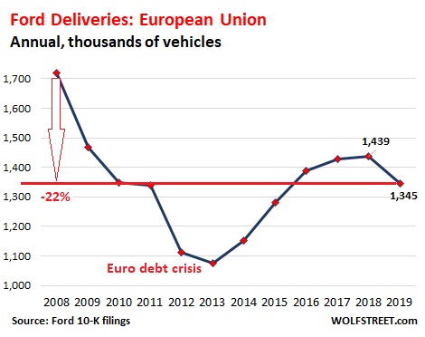
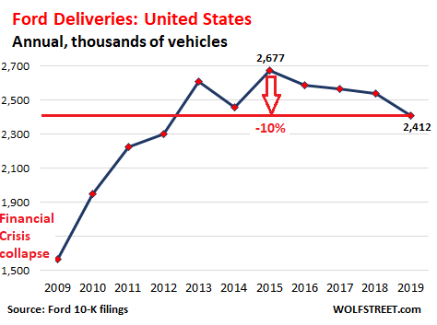
Europe- Ford’s second largest market. Because of the different needs customers Ford Europe launch special own models in own manufacturers plants. In 2008 Ford sale 1.72 million vehicles but in 2019 sales fallen to 1.34 million vehicles, down 22% from 2008.
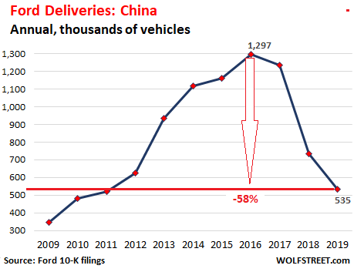
China- Sales after booming collapsed down 58% from 2016. In 2016 Ford picked 1.3 million vehicle fallen to 0.5 million vehicles.
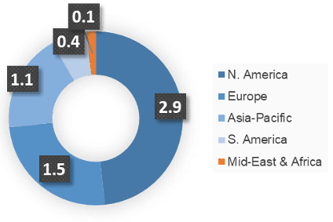

2.3.1.1 three main purposes
The purpose of identify a nature of problems is most significant problems faced Ford Motors challenging corporation every day on every single type of markets distinguish three picking top profits but divided by same three problems:
- Ford’s current business plan is not as financially and environmentally sustainable as it could be.
- Global economic markets are performing far worse than Ford had expected in prior planning.
- Ford’s market shares in developing foreign markets is lower than desired.

2.3.2 SCOPE
To looks deeper in problems nature it must investigate scope contributing that problems in smaller parts:
- Failing demand – After the many years building strong brand 2018 drop a bomb of failures on global market. One of the biggest player China destroy expectation of carmakers Chines slummed companies making bigger own companies in country at the same showing new trends on the market left behind other global brands from Europe or US.
Chinese market trade built strong structure of companies which citizens understanding better than other countries. Specially in the situation when economic slowed down amid waning consumer confidence.
Dave Leggett, editor of the car industry website just-auto, says:
"Trade tensions between Washington and Beijing have hit confidence in China generally. The economy was slowing down anyway, but that accentuated it.”.

- Emission woes- Because of European new regulations cars brands has difficulties with finding solution and change completely eco-political distribution of their cars. Challenge follow new regulations is some though new CO2 emission standards forcing Ford to design new model rebuilding brand of new ideas for making a place for hybrids on market. From 2021, manufacturers will face big fines in the EU if their fleets break agreed emissions limits, and these targets will get progressively tougher.
"Carmakers have to add on average €1,000 of content to cars to make them comply with the new rules," says Arndt Ellinghorst, an automotive industry analyst at Evercore.

- Electric challenge- One of the biggest obstacles for cars sellers is sells more electric cars of the all emissions reductions. One side of the problem is market is not really ready for electrical cars. The fact is in more modern countries is not a lot electric stations which could be very difficult to people who using cars to travels in long distance across countries. Situation become more complicated in countries with not good economic situation.
Global sales of battery electric cars surged 73% in 2018 to 1.3 million units, but that was still just a fraction of the 86 million cars sold overall.

- A shift away from ownership- New technologies makes worries on carmakers’ minds. Big brands showing possibilities of none drivers cars in approximate time up to next 15 years. That constantly changing trends and technologies is not at the same quotes with Fords traditional doctrine.

- Brexit- In the UK, car firms have been warning repeatedly of the dangers of a no-deal Brexit since the EU referendum in 2016.And investment in the UK car industry has fallen in the last two years, slumping 46.5% in 2017 alone. The problem, analysts say, is that British car plants rely heavily on components imported from the EU, while most of the finished cars they produce are exported to the European mainland. “If we are going to have uncertainty in the form of tariffs, then that will cause bottlenecks and delays which will make UK plants less economic," says Dr Owens.

2.3.3 IMPACT
Obstacles arise around Fords’ company are consequences of changing world and daily problems reach not top heads of company like managers or team leaders but normal people. Natural consequences of all political and governmental decisions making new regulations are average consumers having a problem to buy cars and at the same make profits for company.
Other serious problem is all the problems with designing new models, steel industry or failure on Chinese market equals in financial problems. Financial problems is less money in the pockets which is straight ahead decline way down.

2.4 SWOT
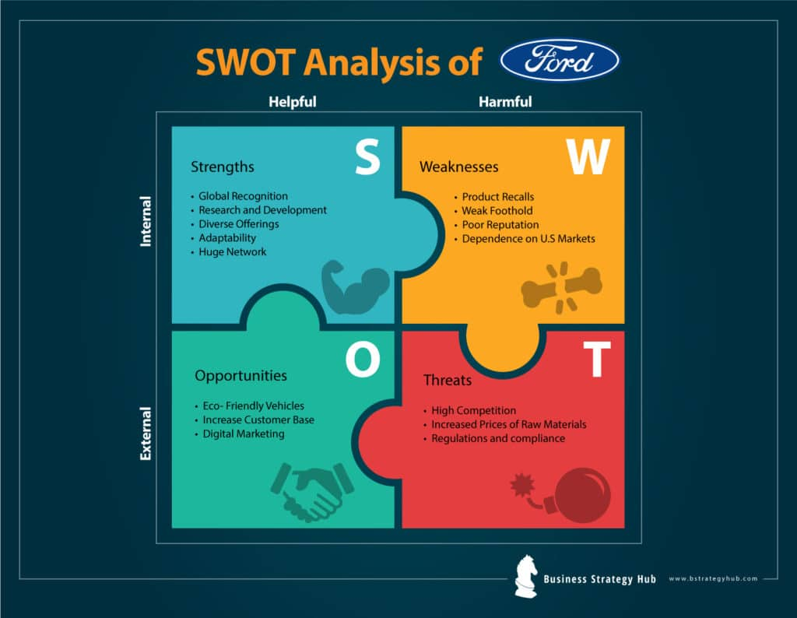

REFERANCES
https://www.britannica.com/topic/Ford-Motor-Company hist

# Hyde, Charles K. (June 2005). "National Historic Landmark Nomination – Ford Piquette Avenue Plant" (PDF). National Park Service. p. 11. Archived from the original (PDF) on February 22, 2017. Retrieved August 18, 2017

https://www.ford.co.uk/experience-ford/about-ford

https://marketrealist.com/2016/03/ford-can-benefit-recent-trend-us-auto-market/

https://bstrategyhub.com/swot-analysis-of-ford-2019-ford-swot-analysis/ swot threats

https://www.fastmarkets.com/commodities/steel-raw-materials/news/1 steel situation

https://www.just-auto.com/companies/ford-group_cid155 pic

https://wolfstreet.com/2020/02/06/ford-better-figure-out-how-to-sell-vehicles-and-i-mean-globally-pronto-before-its-too-late/ europe usa sells

https://www.fool.com/investing/2020/01/30/china-not-buying-fords-but-does-it-matter.aspx

https://www.ukessays.com/essays/marketing/sustaining-the-ford-motor-company-marketing-essay.php nature

