Manage and maintain Network resources, and its services applying suitable policies and drafting security and redundancy practices.
Author: Dylan Thomas
Network Operating Systems and Services (ACCA5023)
School of Applied Computing
Wales Institute of Science and Art
05/05/23 Date of Submission

Abstract
This assignment is a continuation of the work undertaken in the first assignment that was undertaken. Building on that work, this document encompasses various tasks associated to the Managing and maintaining of Network Resources, specifically security and policies. Continuing the policies, group policies are implemented to the case study for improving network object management. Finally Packet filtering and routing is investigated.

Table of Contents
Contents
1. Task 1 4
1.1 Introduction 4
1.2 Mandatory Team Submission Details 4
1.3 Managing and maintaining Network Resources using Policy and Security (Screenshots) 5
NTFS 5
Share Permissions 8
Accessing the File share/server over the Network 9
1.4 Utilise Group Policy management Console to better facilitate network object Management (Screenshots) 10
Moderating Access to the Control Panel (GPO 1) 11
Removing Access to the Command Prompt. (GPO 2) 13
Restricting Access to Removable Media Drives (GPO 3) 13
Restricting Software Installs (GPO 4) 14
Enforcing Password Policy in the ‘accatask.msft’ domain (GPO 5) 15
1.5 Routing and Packet Filtering within core TCP/IP Services and Failover/Redundancy 17
Utilising ARP and Routing Tables 17
Deploy Core Services 17
Installing and Configuring the Routing and Remote Access Services 19
IP Packet Filtering – Filter 1 20
IP Packet Filtering – Filter 2 21
IP Packet Filtering – Filter 3 22
2. Task 2 25
2.1. Question i 25
2.2 Question ii 26
2.3 Question iii 26
2.4 Question iv 29
2.5 Reflection on Collaborative Work 29
3. References 31

Task 1

Introduction
The Purpose of this Task is to work as a team on the practical aspect of adding to the work completed within the first assignment of building, configuring, managing, and deploying a virtual network. The additional work undertaken in this assignment showcases the managing and maintaining of network resources using policies and other security practices. As a team we will collaborate on working through the requirements of the worksheet, this also includes routing and packet sniffing filtering, critical failover, and redundancy practices.

Mandatory Team Submission Details
Name of the Team: DMTJ
Team Members:
Student Name | Student ID
Dave Cornelius | 2023506
David Corner | 1809784
Dylan Thomas | 2014801
Morgan Combstock | 2014028
Team Evaluation (Self Evaluate your Team)
 | Student 1 | Student 2 |  | Student 3 |  | Student 4 |  | Student 5
Student 1 | X |  | 5 |  | 5 |  | 5 |  | X
Student 2 | 5 |  | X |  | 5 |  | 5 |  | X
Student 3 | 5 |  | 5 |  | X |  | 5 |  | X
Student 4 | 5 |  | 5 |  | 5 |  | X |  | X
Rate your Teams Contribution with a scale of 1 to 5 (1 No Contribution and 5 Excellent Contribution)
Add your comments on Team Evaluation: (Justify your evaluation)
Student 2: David is also very knowledgeable in this area, he was also great at assisting with queries/concerns as they arose. Was always in attendance, again on the occasions he wasn’t he was available online to assist on queries.
Student 1: Dave was again very knowledgeable in this area, was kind enough to share is expertise with the rest of the group when we worked through the worksheet. Always available to discuss, was available virtually when he wasn’t able to get on site
Student 4: Morgan undertook most of the tasks on his VM and was the source of most of the screenshots. Following an issue with the document was adding the screenshots to the teams channel so that I could update the document and add annotations.

Managing and maintaining Network Resources using Policy and Security (Screenshots)

NTFS
Prior to making changes to the policy and security of a Network, we firstly as a group had to build the virtual network using a Type2 Hypervisor and apply the active directory services. This was completed within assignment 1 and provides the platform to showcase how to Manage and maintain Network resources.
Figure – Create a Folder Share_ACCA5023 and File name Confidential File
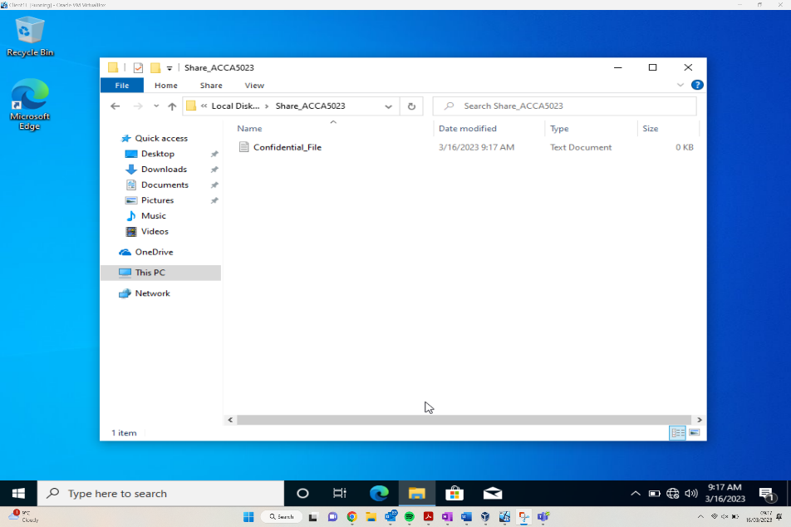
As can be seen from the above screenshot, the user is within the homepage of the Vitrual Network within the “Morgan Combstock” account, this account belongs to the Administrators group within the specified accatask.msft domain.
The folder has been renamed to Share_ACCA5023 as requested, and within this folder the file Confidential_File has been created.
Figure – Configure permissions for the file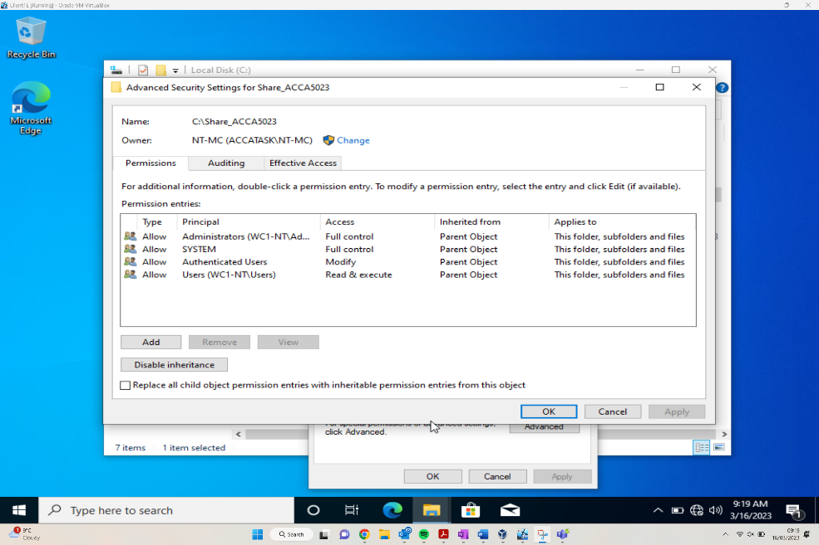
Following the creation of the folder and file, the file Confidential File requires the permissions to be amended. As can be seen from the above screenshot Principal column showing specific user groups, and the access column then shows what level of access they have for the file. This varies from Full Control, to Modify and Read + Execute. This is allowing certain groups certain CRUD access levels.
Following this, Inheritance needs to be disabled because of the following error message presented to the user:
“You can’t remover authenticated users because this object is inheriting permissions from its parent. To remove authenticated users, you must prevent this object from inheriting permissions.”
Figure – Morgan Combstock given full permissions to folder.
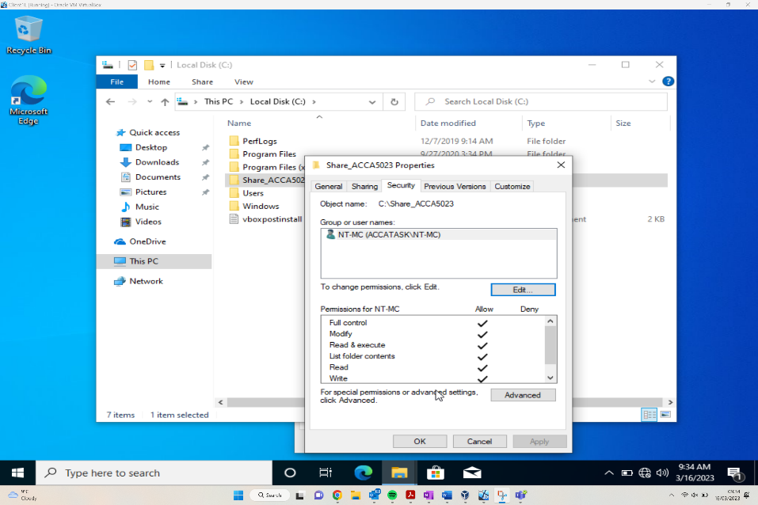
As can be seen from the above screenshot, the user has been added to the group NT-MC (ACCATASK\NT-MC), and within the share Properites window the Permissions for NT-MC section shows the CRUD functionality the user has. The Allow all shows the user has full functionality for this file.
Figure – Confidential file inheriting permissions from folder.
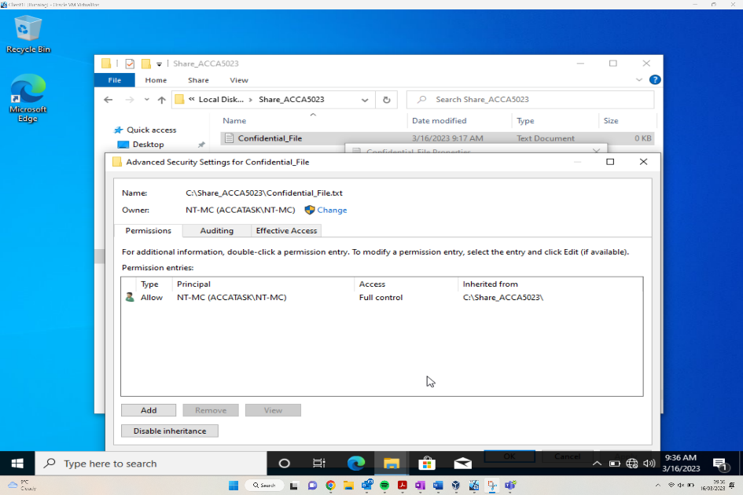
Following on from an earlier screenshot of the Advanced Security Settings for Confidential_File, this updated screenshot now shows that it’s only the NT-MC group that is allows access to the Confidential_File. Some of the original groups which had full access has now been removed from any levels of access.
Figure – Add another User to the folder “Security Group”.
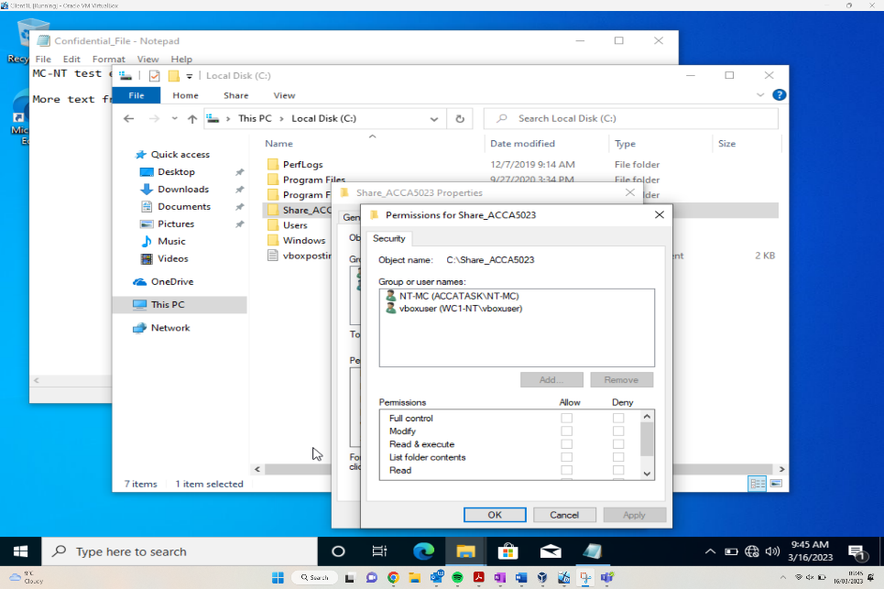
The above screenshot shows the addition of another user to the folder, the user has been labelled vboxuser. Following this screenshot the user was allowed full access credentials to the file, with the exception of the Delete functionality.
Following this functionality update the user “vboxuser” then accessed the file and added ‘more text from vboxuser’ to the document.

Share Permissions
After the NTFS work has been implemented, the share permissions can be implemented to have greater security of the resources. The share permissions can be accessed by entering ‘Server Manager’ in the search bar and then loading the Server Manager itself.
Figure – Checking other share options.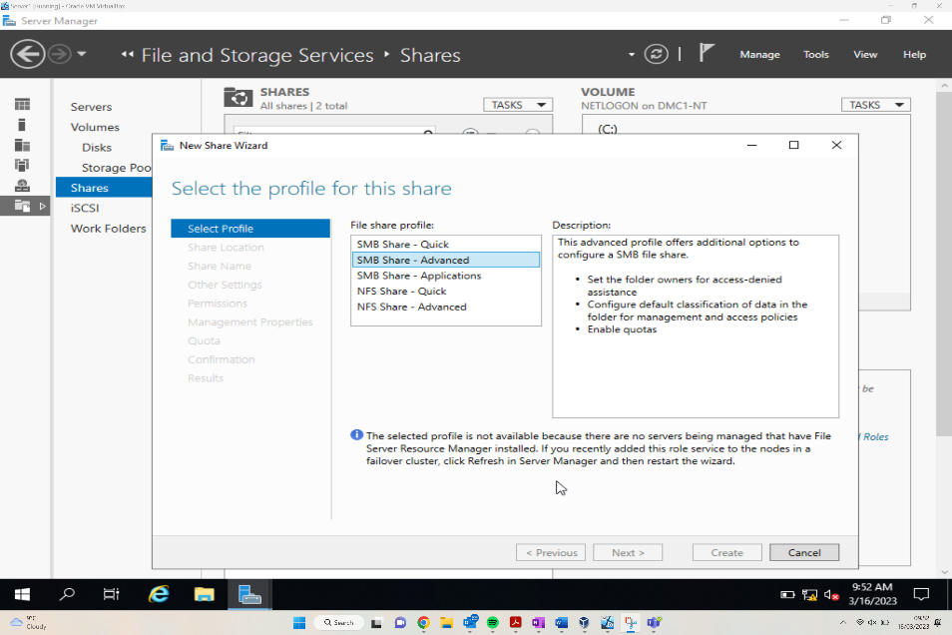
Once within the Server Manager, by selecting the file and storage services the user can then navigate to the new share wizard. There are various file share profile options to choose from, each providing differing levels of access.
Figure - Setting share name and noting path
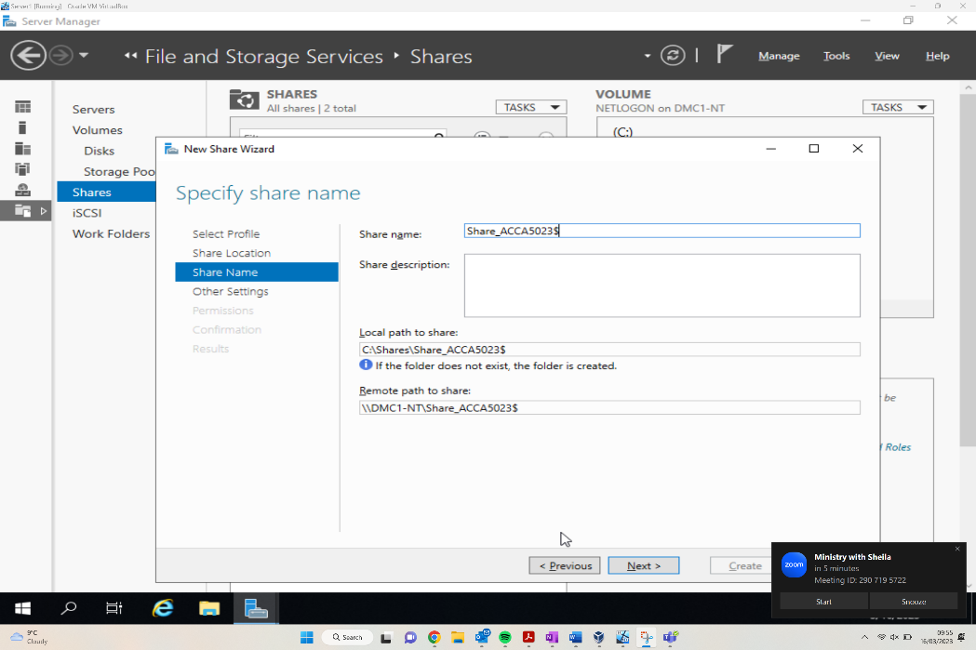
Once the share options are selected, the share name and path needs to be specified. As can be seen the name is set to “Share_ACCA5023$”, local path and remote paths have also been set.

Figure - Two users set up with read & execute permissions.
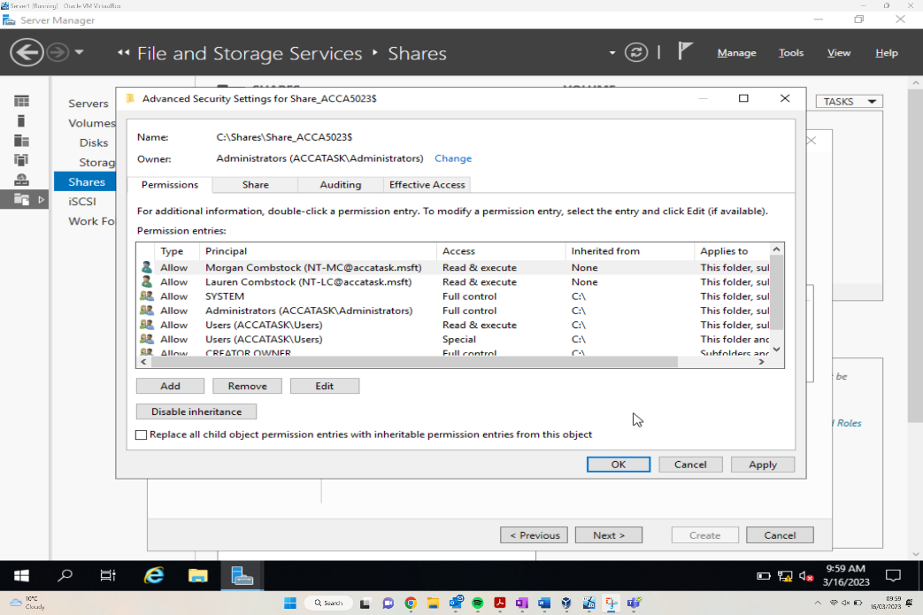
Following the setting of the file name, local and remote file share paths are set, two further users have been set up on the Advanced Security settings of “ACCA_5023$”. The users added to the permissions are “Morgan Combstock” and “Lauren Combstock”, these users have been granted Read + Execute access permissions.

Accessing the File share/server over the Network
Following the amendments to sharing permissions, the file then needs to be accessed by those users who need to access it. The file share paths have been set in the previous section, both local and remote, however the file should also be accessible via the File Explorer.
Figure - File is viewable from Client 1 when created in Server 1
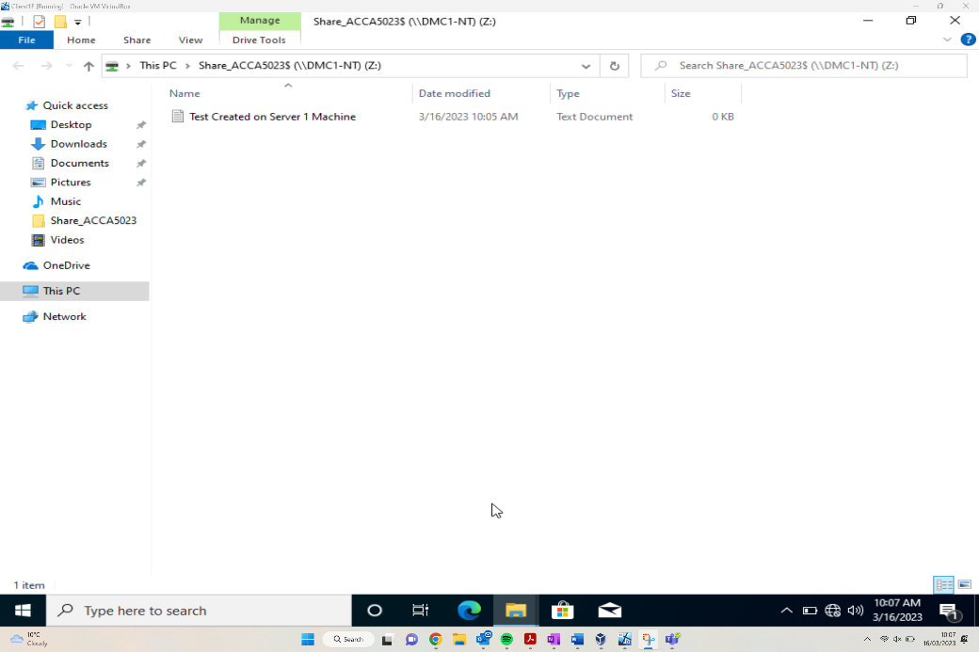
The above figure shows the user accessing the test created on Server1 document. This was accessed by searching the PC. As can be seen from the dollar sign at the end of the file, this shows the share feature of the file has been hidden or prevented due to security purposes.
Figure – Mapping the Network Drive
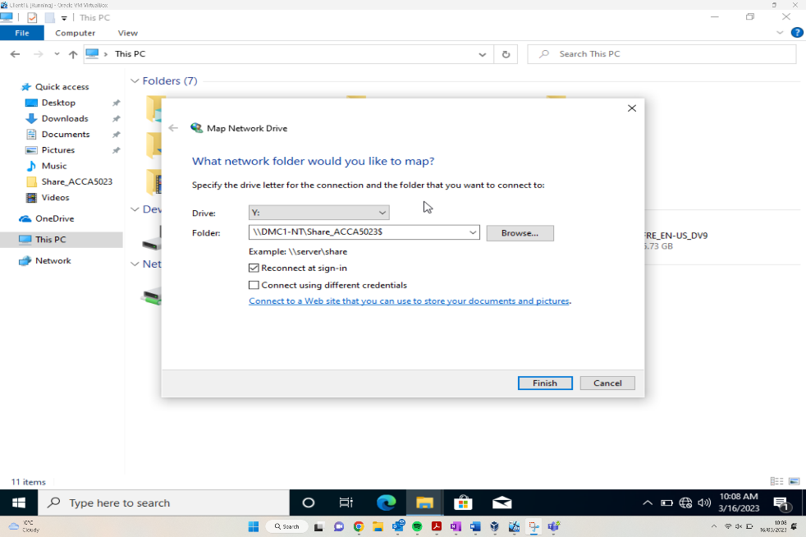
The above shows the mapping of a Network device. This helps specify which drive the folder should reside, along with the option to browse all files to select a location to store the file. There are other sign in options which the user can choose to fit their own use case.

Utilise Group Policy management Console to better facilitate network object Management (Screenshots)
According to Microsoft [1], Group Policy is “an infrastructure that allows you to specify managed configurations for users and computers through Group Policy settings and Preferences”. The purpose of GP is to implement organisation wide settings, whether that’s Local policies that are manual configurations to a singular device, Site Policies that implements an Active directory which is applicable across multiple sites or Domain Policies that will be deployed across the organisation.
For this demonstration, Group Policy Objects will be created at an Organisational Unit level.

Moderating Access to the Control Panel (GPO 1)
Figure – New Organizational Unit
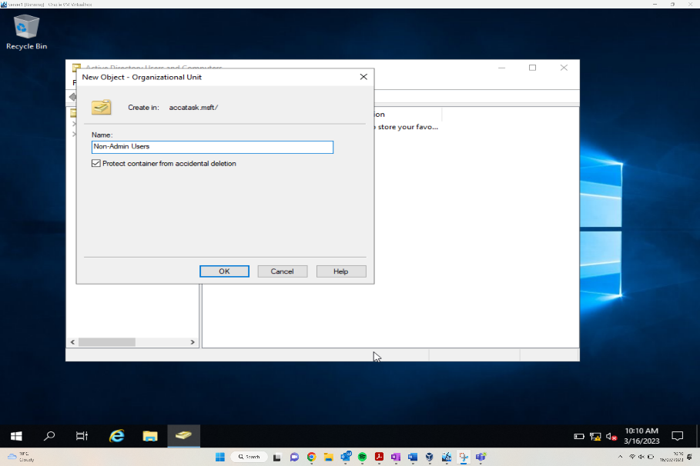

Before being able to apply group policy that can be deployed across the network first, we need to create a structure. The first part of a structure is an organization unit which the creation of has been demonstrated above,

Figure – Adding new user.
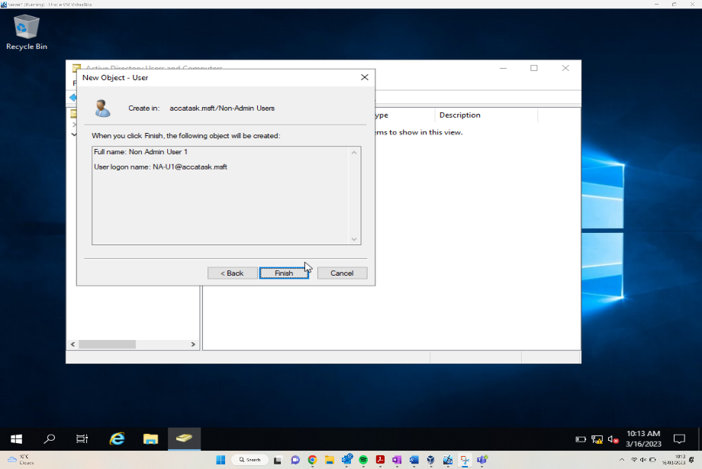
User added
username: NA-U1
password: P@ssword123

Figure – Adding a new GPO
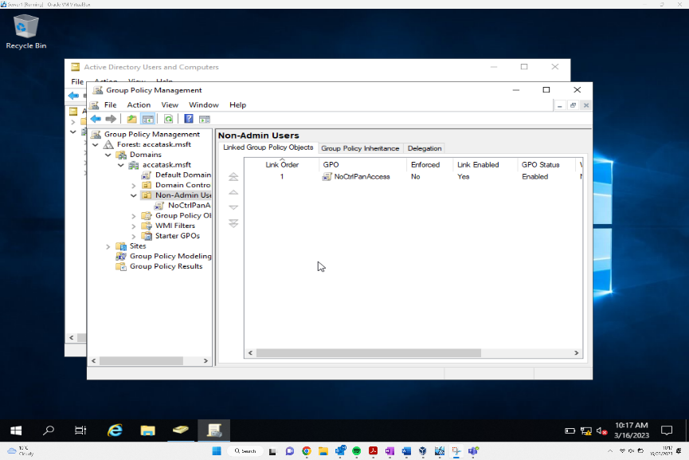
Figure – Enabled Control Panel Access Restriction

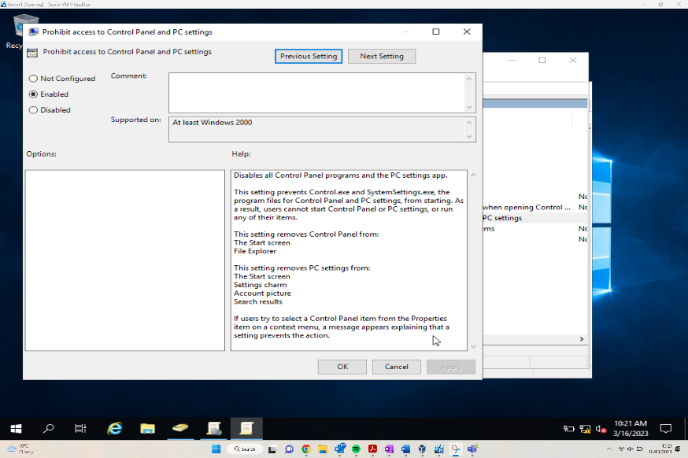

The above figures demonstrating the application and enabling of the first group policy which in this scenario is the denial of the control panel to non admin users. This is achieved utilising the inbuilt GPO GUI which allows for easy configuration of settings using the UI.

Figure – Command Prompt and Client 1 Machine signed in as NA-U1 can’t access control Panel

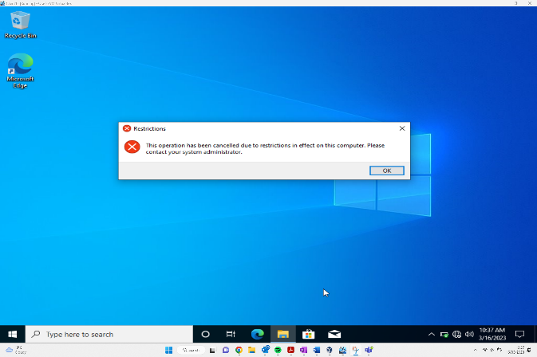
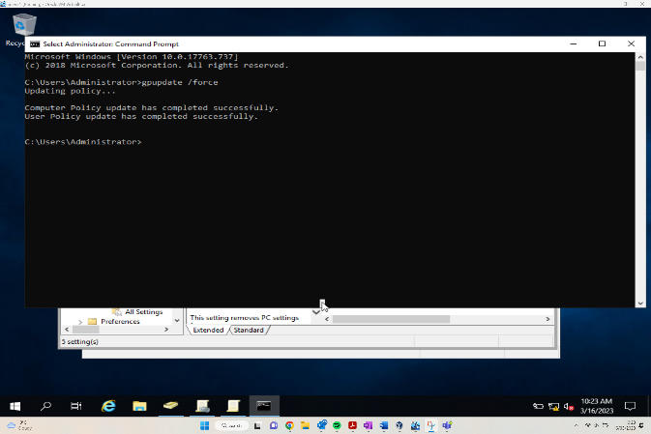

Demonstrating of the succesful denial of the control panel to a non admin user as stipulated by the Group policy previously show being enabled.

Removing Access to the Command Prompt. (GPO 2)
Most general users on the network wouldn’t know how to access the command prompt, let alone use it. However, for those with the knowledge, disabling the command prompt prevents those users the ability to run commands to override settings, especially those with hacking abilities.
The figure below shows a user within the network attempting to utilise the control panel, however the ‘Prevent access to command prompt’ GPO has been implemented meaning the user is unable to utilise as they will be greeted with a ‘The command prompt has been disabled by the admin’ message.
Figure – User unable to use command prompt.
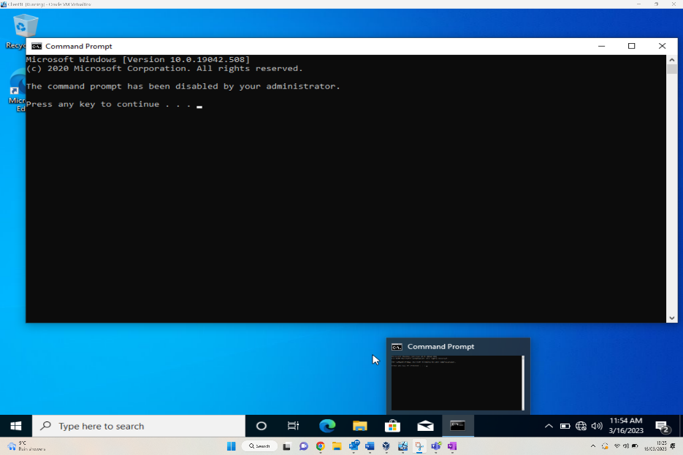

Restricting Access to Removable Media Drives (GPO 3)
Removable Media drives can be used by those with bad intentions towards the network to inject malware/malicious software into the network. By disabling the acceptance of removable drives to the network it prevents another access route to the network.
As can be seen from the figure below, the user has attempted to access a floppy disk and is greeted by an error message “Location is not available”.

Figure – User unable to access floppy disk Drive.
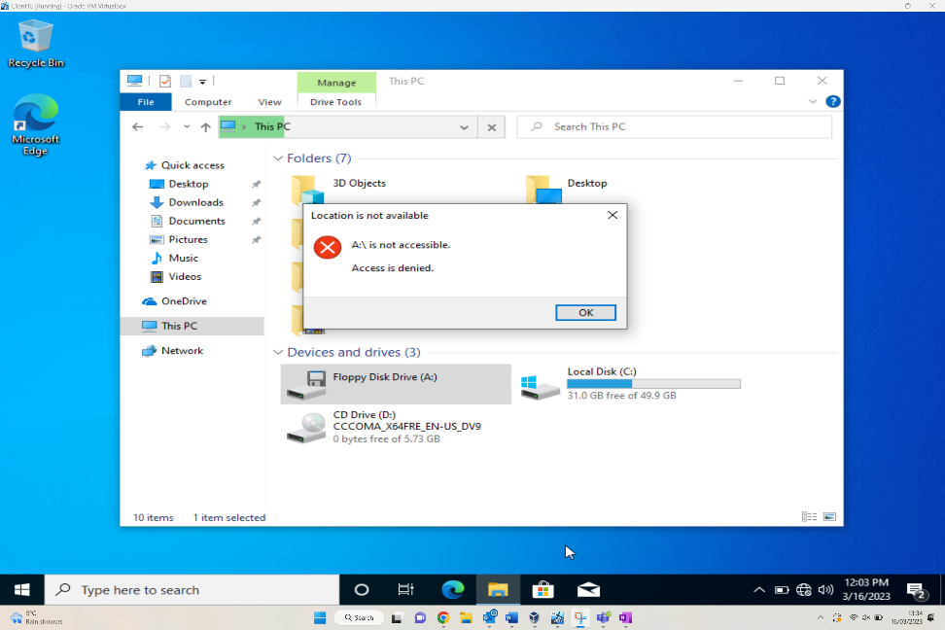

Restricting Software Installs (GPO 4)
Restricting users of installing software inside the network is a major security boost to the network. This prevents unauthorised software installations, which could be malicious software used by threats to infiltrate the network. By implementing a group policy restricting installation, only safe approved/acceptable software can be installed on the network.
Figure – Configuring Group Policy in Manager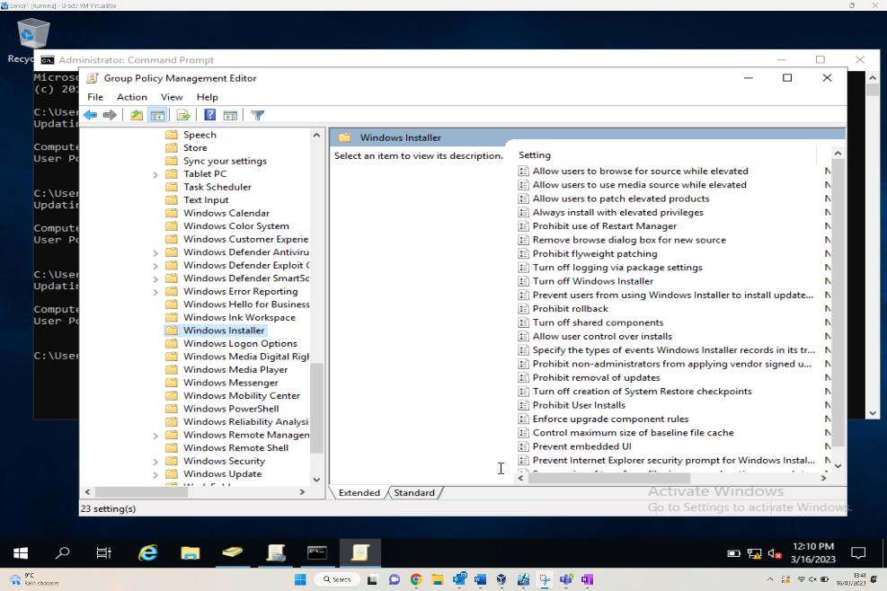
Once navigated to accatask.msft domain, the user must select new organisational unit and label it “NWClient Computers”. Within the Group Policy Management Editor, the Windows Installer screen allows the administrator to implement the security rules. As can be seen there are many security settings that can be turned on and off, one of which being turn off ability to install software.
Figure – Client1 user unable to install software.
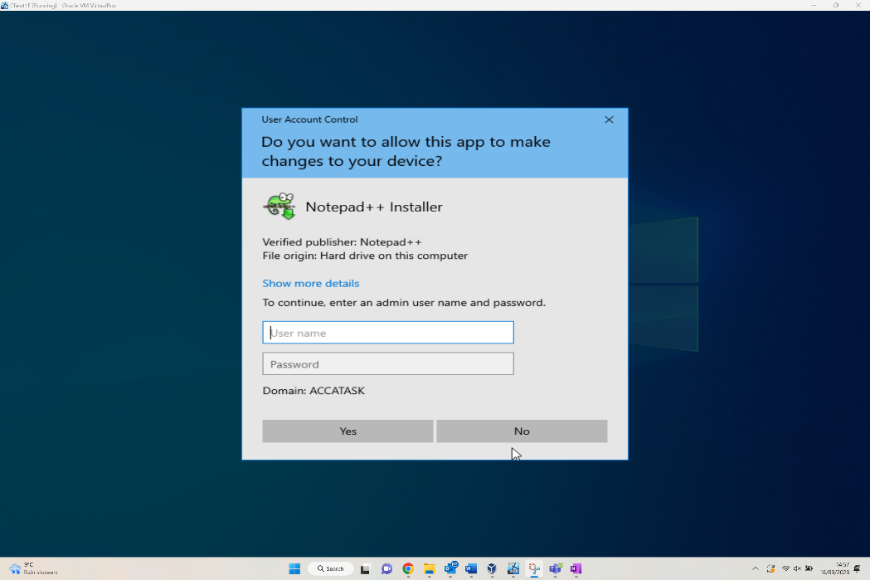
The above shows a user attempting to install Notepad++ to the ACCATASK domain. Unfortunately, the install ability for the domain has been restricted, so the user will not be able to download the software.

Enforcing Password Policy in the ‘accatask.msft’ domain (GPO 5)
Enforcing a password policy within a domain is an important aspect of securing the network. Like this scenario, adding requirements of the password set makes it harder to crack for any threats to the network. Even by having a simple password, this is still an additional barrier to slow down threats from accessing the data within the accatask.msft domain.

Figure – Unable to create a user with password failing Requirements.
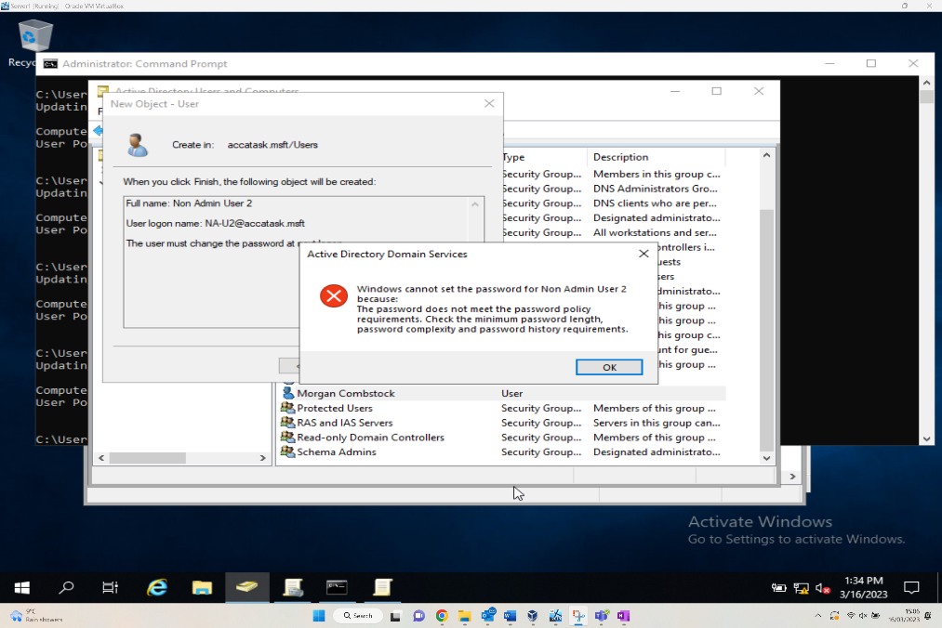
The above shows a user attempting and failing to create a user. The error screen is due to the user not meeting the required security standard. The predefined settings were changed as requested, so without meeting the following stipulations a user can’t be created,
Enforce Password History: | 3 Passwords
Maximum Password Age: | 2 Days
Minimum Password Age: | 1 Day
Minimum Password Length: | 7 Characters
Passwords must meet complexity Requirements: | Enabled
Store Password using reversible encryption: | Disabled

Routing and Packet Filtering within core TCP/IP Services and Failover/Redundancy

Utilising ARP and Routing Tables
Figure – ARP Table
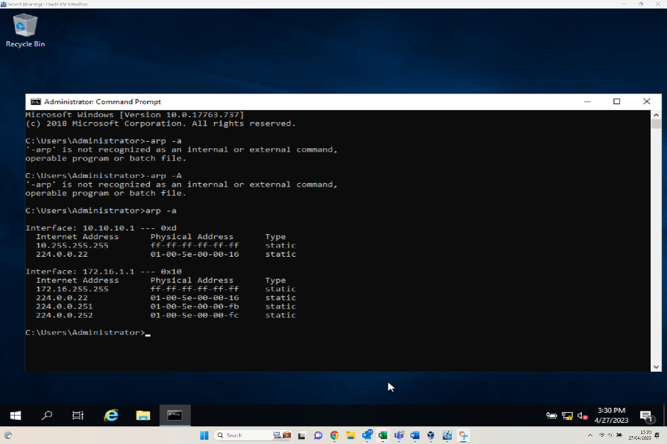
The above figure demonstrates the ARP Table on host x – ARP tables are utilised when trying to understand the Network topology and routing principles employed. The ARP table lists MAC Address bindings and their relational IP Address. ARP Tables are generally utilised when checking configurations or troubleshooting network connectivity issues.

Deploy Core Services
Figure – Added new user ftpuser in server Manager
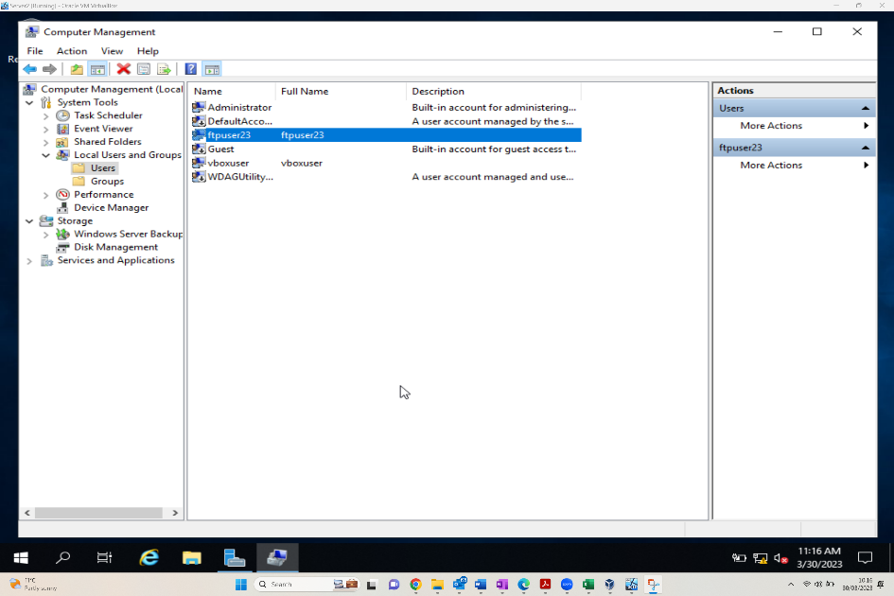
Creating a user which can be used to access the previously created FTP Site. Before access can be achieved however, authentication access will be required to be configured via IIS

Figure – Added FTP Site
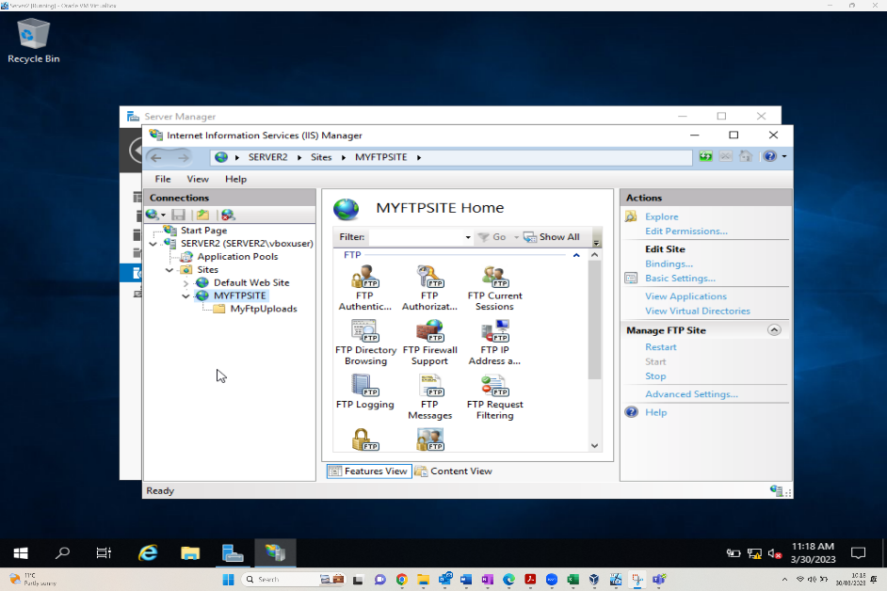
The above demonstrates the successful configuration of the FTP server within IIS. Now the site has been added further configurations can be considered such as transfer protocols, access ports and authentication.
Figure – Root site Folder (xvii) and ftp Folder Security
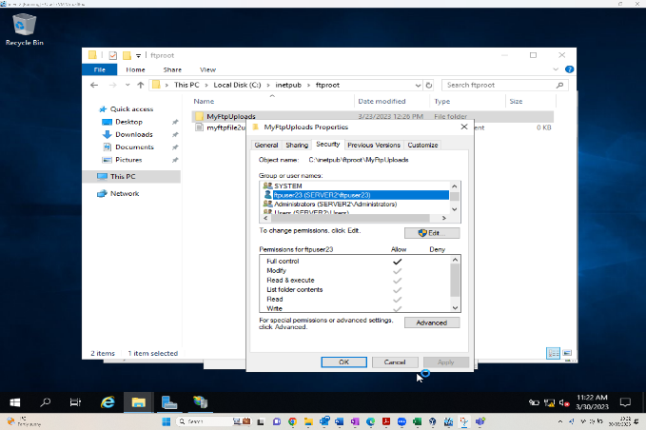
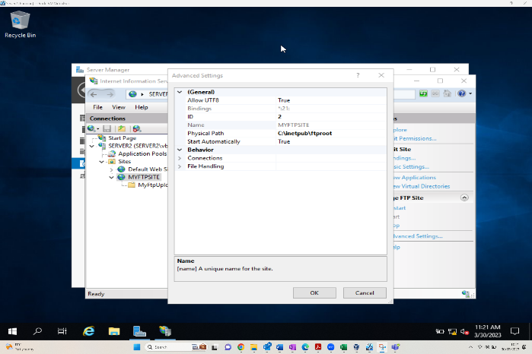
Advanced configuration demonstrates the correct configuration of the SSL protocol. Followed by an authentication configuration utilising the in-built windows permissions manager. By setting the permissions as outlined in the screenshot we are granting our ftp user access to the newly configured ftp site.

Figure – Connecting to ftp via command prompt in client 2 (xliv)
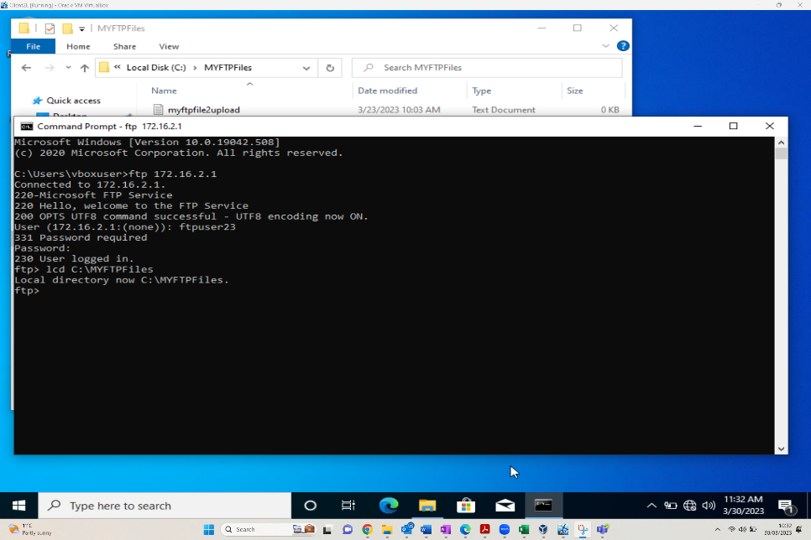
Now the FTP configurations have been completed and the user has been assigned the relevant permissions. We can attempt connection. The above screenshot demonstrates clearly a succesful attempt indicating all configurations including authentication have been configured succesfully

Installing and Configuring the Routing and Remote Access Services

Now the initial network design can be expanded, with the aim of connecting the two remote local area networks. Through deployment of software within the Windows server routing service, the two disconnected networks of PrivateNet1 and PrivateNet2 should be able to communicate.
Figure – Wizard to set up and start service.
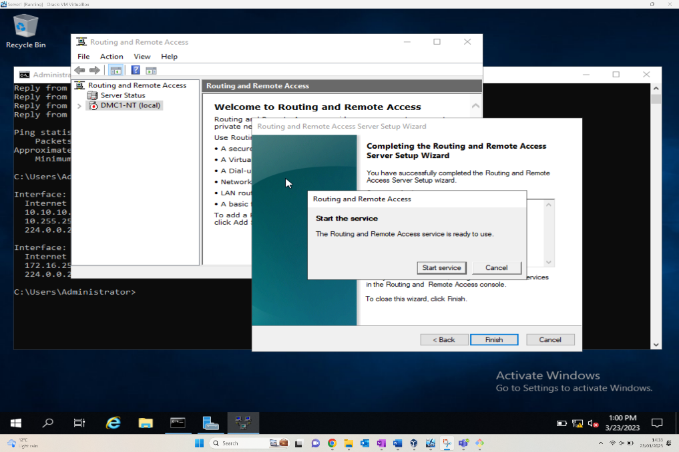
The figure above shows the Routing and Remote access screen on the specific server DMC1-NT, pre-requisite work of installation of the wizard and Deploy VPN only must be done. This wizard will allow the routing to be completed, and the two separate networks to finally communicate. For this task, a custom configuration of the LAN routing is required.

Figure – RIP 2
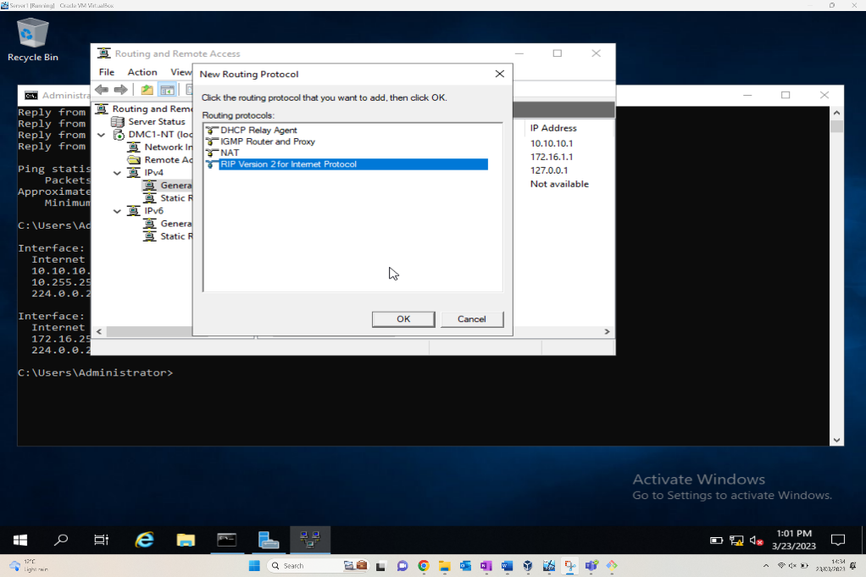
Following on from the Installation Wizard, Routing and networking protocols should be implemented, so that “learn about new networks” can be utilised via the WAN. Having selected the specific server, RIP v2 can now be selected as a new routing protocol option. This is then a repeatable action that needs to be implemented for Server 2VM. This can then be verified by attempting a ping on the PublicNet.

IP Packet Filtering – Filter 1
Packet Filtering is a service configuration of the firewall which can implement protocols to manage the inbound and outbound packets/messages of a network. It can filter the incoming messages for malicious software, as can the outbound filters look at any software or below par security. This function can restrict the flow, depending on if the traffic meets the set protocols or not.
Filter 1 is specific to anyone in PrivateNet1 pinging the firewall service.
Figure – ICMP Filter
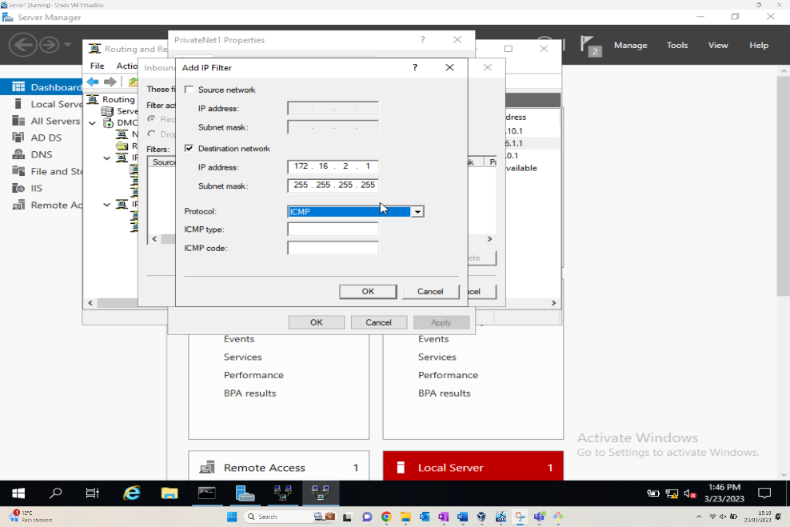
The above figure shows the IP filter configuration window. This is accessed via the server manager tools, routing and remote access. Within the PrivateNet1 connection interface properties the inbound filter requires amending. By adding the IP Filter the specific configurations of IP Address, Subnet Mask and protocols can be set as requested.
Figure – Successful Google ping, unsuccessful ping to 172.16.1.1
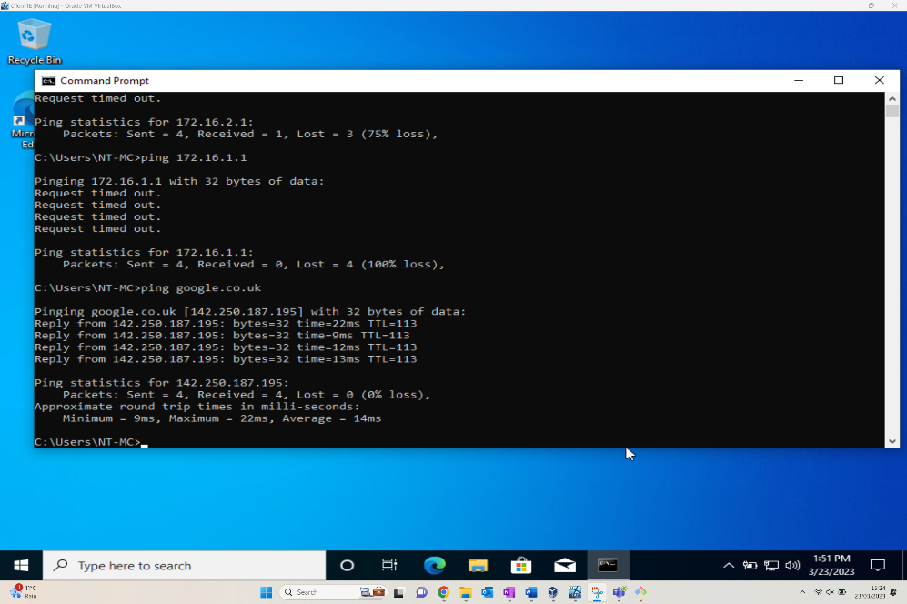

IP Packet Filtering – Filter 2

The second filter is to restrict access to the FTP Service on Server2, limiting it hosts in PrivateNet2 only. This is slightly less common, but the purpose of this filter is to restrict hosts on one network from accessing the FTP of another.

Figure – TCP Filter
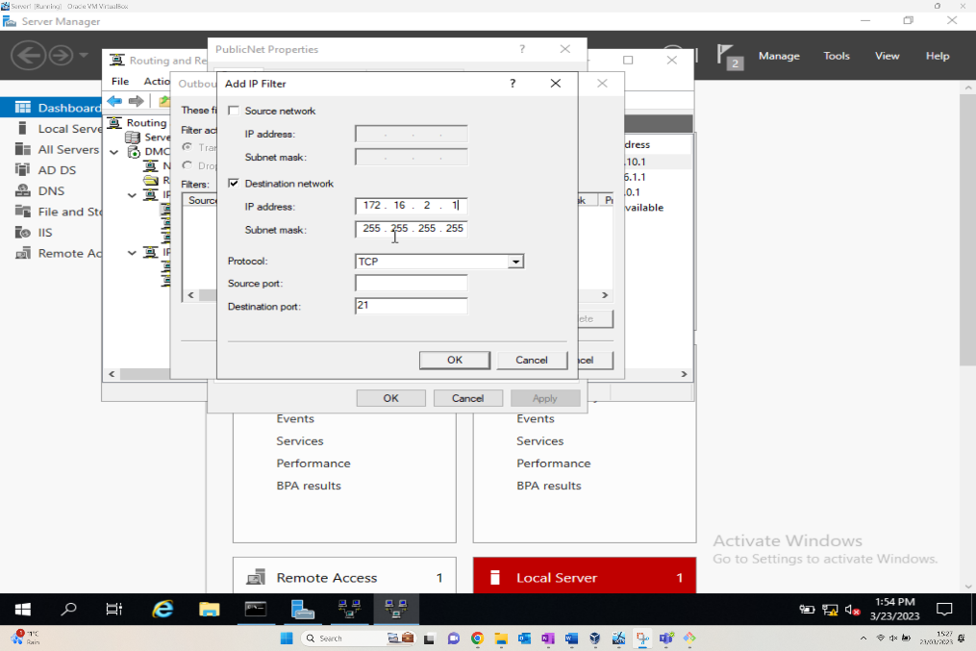
Similar to the first filter applied, the Filter window is accessed by the server manager tools, routing and remote access, via the IP Routing. This time an outbound filter is selected, and the required IP Address, subnet mask, and Protocol of TCP can be set.
Figure – Unable to connect to FTP
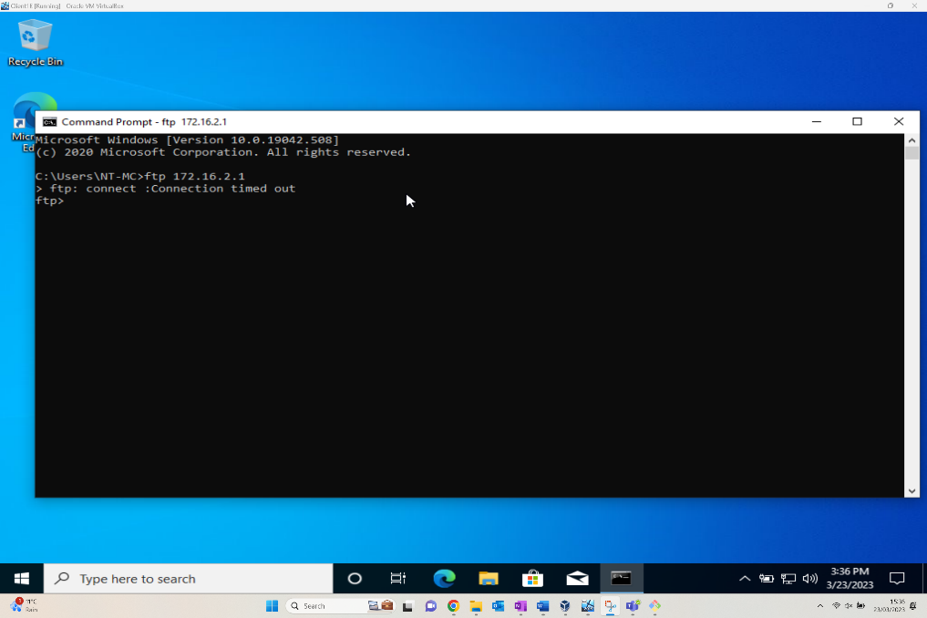

IP Packet Filtering – Filter 3

The third filter involves creating a rule as a group to restrict FTP access to everyone except Client1.

Figure – Adding new filter (Receive packets from 172.16.1.2 on PublicNet)
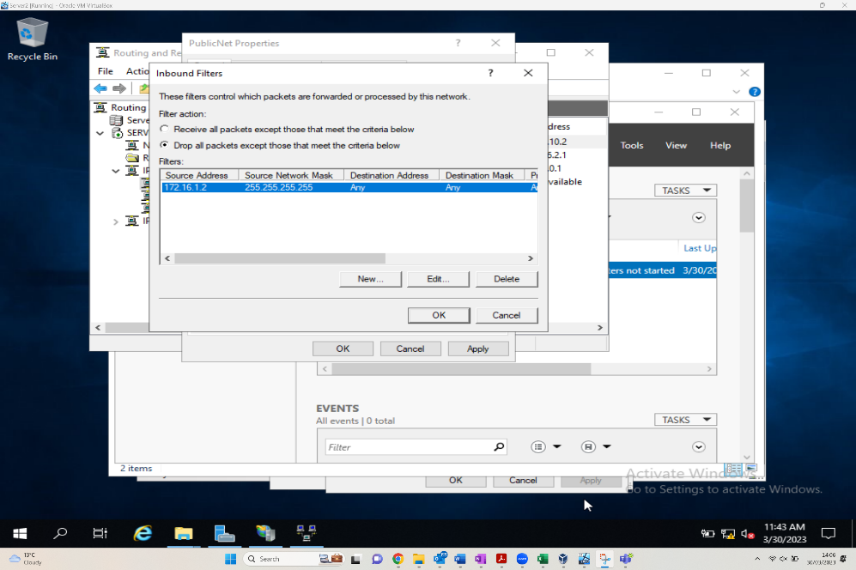
Like the other filters applied, the Filter window is accessed by the server manager tools, routing and remote access, via the IP Routing. This time an inbound filter is selected and provides the administrator with a couple of criteria options along with the Create, Edit and Delete functions of CRUD.
Figure – Inbound filter to drop packets from 172.16.1.2 on PrivateNet2
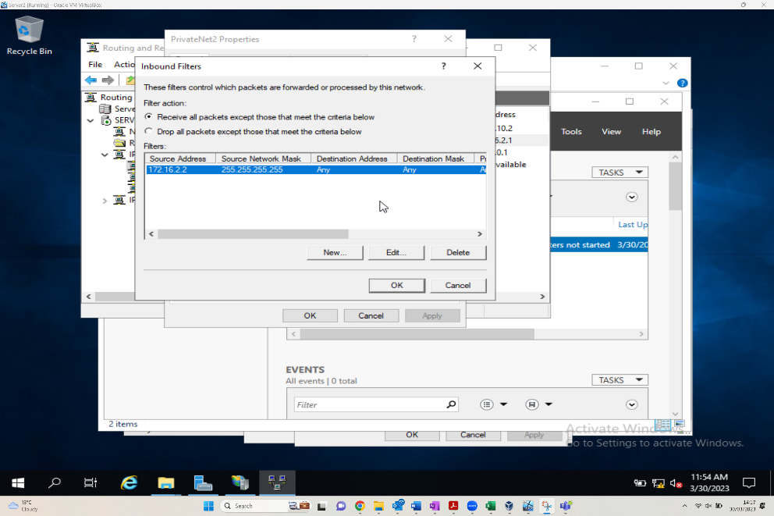
The above shows the administrator changing the selection of the Drop all packets except from those that meet the criteria below radio button to the Receive all packets except those the meet the criteria below. Having inputted the source IP protocols details, this can now be implemented.

Figure – Unsuccessful attempt to access FTP from 172.16.2.2
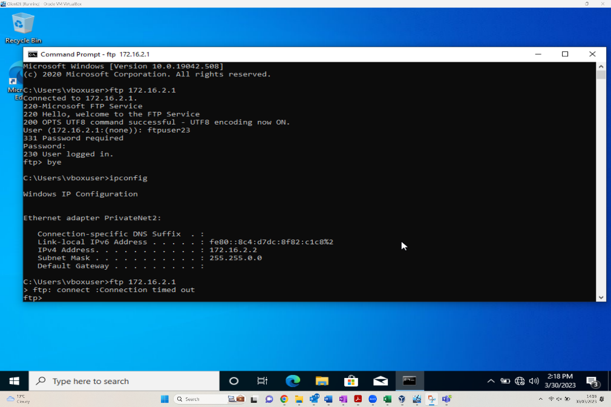

Task 2

2.1. Question i
In general, relating to a SOHO network there are a few potential security enhancements I would implement.
-Increasing the security of wireless network, whether it’s simply renaming the password, changing the service set identifier (SSID), disabling the SSID Broadcast, making the wireless network difficult to infiltrate will prevent many threats from entering the network. When renaming the password, using a wifi protected setup (WPS) allows configuration via a personal identification pin or even the push of a button.
-Amending the firewalls settings. This can be as simple as ensuring the WAP or wireless router have the Network address Translation (NAT) feature enabled.
-Physical security. Usually associated with large organisations, but still relevant for a SOHO. I work for a government agency, given the data accessible via my device I take my work bag upstairs and store it in a locked cupboard every night in case of intruders and general hazards. Making sure windows + doors are locked again prevent potential network threats, as does ensuring the network cabling is safely/neatly installed to prevent trips to users and the network.
Relating to the worksheet itself, there are some Microsoft group security policies that can be put in place to enhance the security of the network and all its hosts.
-Control Panel Access moderation. By limiting the access within the control panel, it allows for greater control on security, and prevents those tech savvy employees from circumventing the security rules set in place by using SystemSettings.exe and Control.exe commands.
-Idle computer screen Auto lock. It’s easy to walk away from a device and forget to lock the screen, implementing a group policy ensures added safety as the screen could lock after 2 minutes of idle time, shutting off access to potential black hatters.
-Passwords. Group Policies can be applied to passwords, having a benchmark of complexity and rationale to passwords can slow down threats from accessing the network. Trading Password1 for something with at least 8 characters, lower and upper case and special characters makes it far more difficult to guess a password.

2.2 Question ii
According to Techtarget, a failover cluster is defined as “a group of independent servers that work together to maintain high availability of services”. [5]
The purpose of the failover cluster is to maintain service availability in the event the main server fails. Failover clustering forms a part of disaster recovery as is mentioned in section 2.3, where an organisation has a plan when an incident which prevents the business functioning as it should. And that’s what a failover cluster does, keeps the applications running via a different server to prevent an outage to its customers even in the event of a server failure.
When implementing Failover clusters there are some factors that must be considered.
-Usage of additional servers to allow failover to secondary servers. To implement failover clustering, by nature further servers are required. Rather than running off a single server another server is required as a failover option if primary server fails. However, it’s advisory that there’s an additional two servers added to the original, for further peace of mind and an additional option just in case a scenario arises where the primary and secondary servers fail. The solution also needs to be scalable to cater for a growing organisation network.
-Usage of a VPN to create a remote failover cluster. As can be seen via Microsoft [6] there is readily available guidance for VPN remote access usage of a load balanced cluster. It gives step by step instructions on deploying load-balancer clusters. As always by utilising a VPN it enhances the security of the private data and lessens the effects to bandwidth and data usage.
-Costs. When considering implementing a failover cluster solution, costing is a large factor. The organisation must be aware of the upfront costs of setting up the additional servers, but alongside this is the continual maintenance of the servers and employment of further staff specialised in maintaining the way of working adds ongoing costs to the significant initial costs.
Further advice on setting up of Failover clustering via Microsoft servers can be found via the Microsoft whitepaper [7]

2.3 Question iii
The security team itself would usually sit as part of the IT directorate within an organisation alongside HR and others. The Security Team would be reportable to the Chief Technology Officer (CTO), and would sit alongside other teams like Architecture, Networks, Engineering etc. The make up of the IT Security team would look like the below.
Figure – IT Security Team
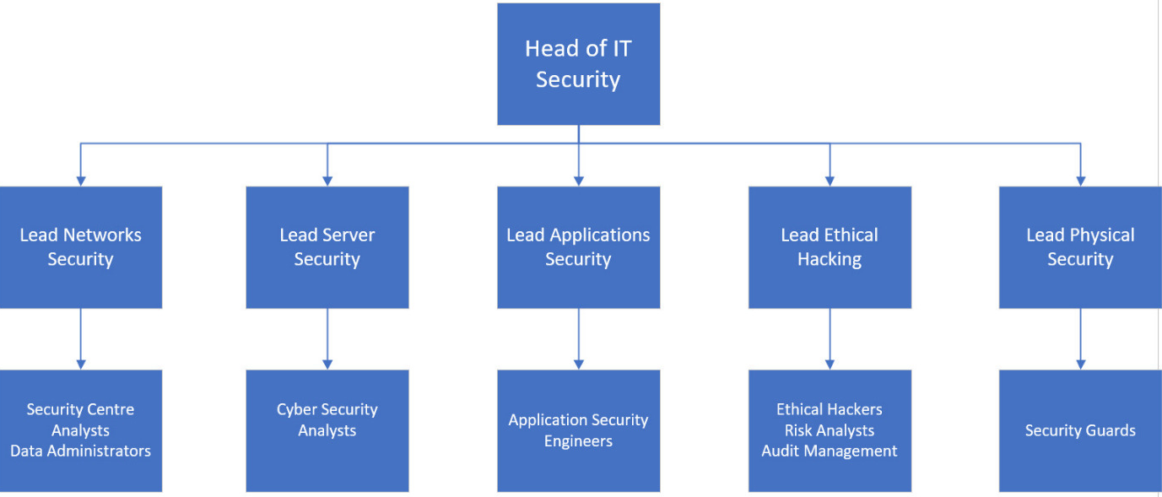
There are various aspects of security, and as such the team is split so that there are specialists for certain security methods. The split ensures accountability and responsibility for certain aspects of security that are assigned.
Following security standards can ensure the organisation is complaint with security best practices and avoid large financial and reputational penalties for poor practice. GDPR legislation has been a recent development within the security space, and Gov.uk provide a framework meeting the GDPR guidelines [8].
A well-known security standard for cyber security is the ISO 2700’s series. According to itGovernance, the ISO family of standards is “a series of mutually supporting information security standards that can be combined to provide a globally recognised framework for best-practice information security management”.[9]
There are many segments to the series focussing on different aspects of security. For example, ISO 27014 focusses on Governance of Information security, while 27002 focusses on Information security controls. A recommendation for this organisation would be to look at sections 27000 – 27799, pick out the specific sections most relevant to the organisation and summarise into standards which can be documented and utilised moving forward.
Another useful framework which is focussed on cyber security is NIST. The framework is comprised of the five core functions, Identify, Protect, Detect, Respond and Recovery. These functions are like those steps taken in risk management. When it comes to risk management, a Data Protection Impact Assessment (DPIA) is a useful tool/document in assessing risks to security. By continually reviewing the risks to personal data, sensitivity, value, and other factors it allows the organisation to consider the most relevant remedial steps. By assessing risks, it allows the organisation to prioritise those causing the most risk and potential harm to be resolved first, and those with lesser impact and frequency can be put on the risk register. It is important to continually review the risks, as those with lesser impact/frequency could one day pose a far greater risk to the organisation.
Security policies can be split into two areas, Technology, and people. Policies covering both are essential, as threats can infiltrate the network not only via the technology route but through people’s actions.
Technological policies could include access control, within Microsoft networks an Active directory could be utilised to group users into access groups and provide a blanket level of access for each role. This feeds into System Security policy which also includes system backups, firewall configuration and security of all devices within the estate. Further security measures could include encryption policy, where PII is in motion that a layer of encryption is applied, especially for a large organisation in multiple locations. Other policies can include vulnerability scanning to keep firewall software strengthened and secure from threats, and Disaster recovery policy for when issues do arise that the correct measures and protocols are in place.
As mentioned in section 2.1, policies around acceptable password criteria can prevent data loss and network infiltration if devices are lost. Along with enforcing password strengths using differing characters and complexity, the addition of a bit locker password as an initial password before getting to the log in page adds a further layer of security. Also mentioned in the previous section was screen locking. Adding a group policy to implement an auto lock after certain time on idle screen can prevent access to the network and potential PII. Alongside this a policy of screen locking and potential consequences for leaving a screen open can cause behaviour change.
Acceptable Use is a general policy that most large organisations implement. Ensuring all staff read the document, it should cover the acceptable use of the organisation’s resources, its data, and how certain software’s/applications should be used. This could cover the use of social media, possibly allowed on the organisation’s device but outside of work time.
Finally, contingency planning is another important facet to keeping the organisation secure. As defined by the Oxford Dictionary a contingency plan is “a plan designed to take account of a possible future event or circumstance.” [10]
In the event where a disaster has occurred, by having a solid well documented contingency plan it should allow the organisation to return to operating as usual sooner than those without a plan. A good plan will cover multiple potential scenarios and have a specific plan of action for each. Disaster recovery should be a plan to cover very rare events, like covid for example which brought a lot of the world to a standstill, especially those organisations with inability to work in a hybrid manner. Incident response should also be considered for frequent events that could cause an outage, what’s the plan when this occurs as the organisation needs to continue to function.

2.4 Question iv
Personally, I found the tasks undertaken in this worksheet great for improving my knowledge of implementing security and group policies. This knowledge was then implemented on a VM which gave me the confidence to experiment, knowing that it wouldn’t compromise the security of my device which is supplied by the government. Having the expertise of my teammates also gave me the confidence to experiment, knowing that they could assist with any struggles as Dave + David undertakes most of these tasks daily.
I found the instructions excellent; they are detailed and give a true step by step instruction of how to implement what was being asked of us. There were some “misprints”, however I did find they were easy to spot, and was about re-affirming learning rather than genuine mistakes.
The most enjoyable aspect of the tasks for me were implementing the IP Packet filters, more than likely because as soon as the settings were amended, I could go into the control panel and see the connection timeouts knowing what I’d implemented has instantly affected accessibility.

2.5 Reflection on Collaborative Work
Continuing from the first assignment, nothing much changed in the team dynamic. Given I had big life events around the easter period (wedding and honeymoon), we all worked together brilliantly to get the teamworking sections of the assignment done prior to Easter. This not only gave us plenty of time complete the work whilst balancing other submissions, but it took a lot of pressure off me and I’m grateful to my teammates for their understanding and getting onboard with grafting hard early in the semester.
Again, the team worked well, working through the assignment, adding too many screenshots, and giving plenty of selection for when adding in content. In this semester, there was a lot of leave and disruptions, but the teams channel allowed us all to stay in contact, and to continue working on the assignment even when we didn’t have the full complement on site. I think the mentality from the first assignment more than carried through, we all knew our strengths and where we can add value, and we did so perfectly working in harmony.
I do feel that having 4 full time IT professionals on the team lead to us working so well. Understand the constraints of full timers and DDA’s on differing timetables, but I feel a full-time student would’ve benefitted greatly from being part of our team. Learning about agile working and watching how people collaborate to this standard would’ve been beneficial to their professional development.

3. References
Citations Group Work
[1] Anonymous, Microsoft “Group Policy Overview”, 2016. [Online]. Available: https://learn.microsoft.com/en-us/previous-versions/windows/it-pro/windows-server-2012-r2-and-2012/hh831791(v=ws.11) [Accessed: 02-May-2023]
[2] Anonymous, Microsoft “Group Policy Management Console”, 2016. [Online]. Available: https://learn.microsoft.com/en-us/previous-versions/windows/it-pro/windows-server-2012-r2-and-2012/dn265969(v=ws.11) [Accessed: 02-May-2023]
[3] Anonymous, Microsoft “Accessing FTP”, 2022. [Online]. Available: https://learn.microsoft.com/en-us/troubleshoot/developer/webapps/iis/ftp-authentication-authorization/how-to-use-ftp-utility [Accessed: 02-May-2023]
[4] Microsoft – “What is group policy?”, 2016. [Online]. Available: https://learn.microsoft.com/en-us/previous-versions/windows/it-pro/windows-server-2012-r2-and-2012/hh831791(v=ws.11) [Accessed: 01-May-2023]
Citations Individual Section
[5] R. Awati, “What is a failover cluster?,” 2023. [Online]. Available: https://www.techtarget.com/searchwindowsserver/definition/failover-cluster. [Accessed: 03-May-2023]
[6] “Configure a Remote Access Cluster,” 2021. [Online]. Available: https://learn.microsoft.com/en-us/windows-server/remote/remote-access/ras/cluster/configure/configure-a-remote-access-cluster . [Accessed: 04-May-2023]
[7] J. Martin, “Whitepaper: Failover Clustering with AD Certificate Services in Server 2008,” 2019. [Online]. Available: https://techcommunity.microsoft.com/t5/failover-clustering/new-whitepaper-failover-clustering-with-ad-certificate-services/ba-p/371272 . [Accessed: 02-May-2023]
[8] “GDPR Security policy framework,” 2022. [Online]. Available: https://www.gov.uk/government/publications/security-policy-framework/hmg-security-policy-framework . [Accessed: 03-May-2023]
[9] Anonymous, “ISO 27000 Series of Standards | IT Governance UK,” 2023. [Online]. Available: https://itgovernance.co.uk/iso27000-family . [Accessed: 02-May-2023]
[10] Anonymous, “Definition of Contingency,” 2023. [Online]. Available: https://www.collinsdictionary.com/dictionary/english/contingency . [Accessed: 02-May-2023]

