
Name: Rana Fatima
Student ID: 2407474
Module code: BMHP5014
Assignment Title: Component 1 : Online Portfolio of Set Exercises
Date: 25.03.2026

Task 1 – Concept Map:
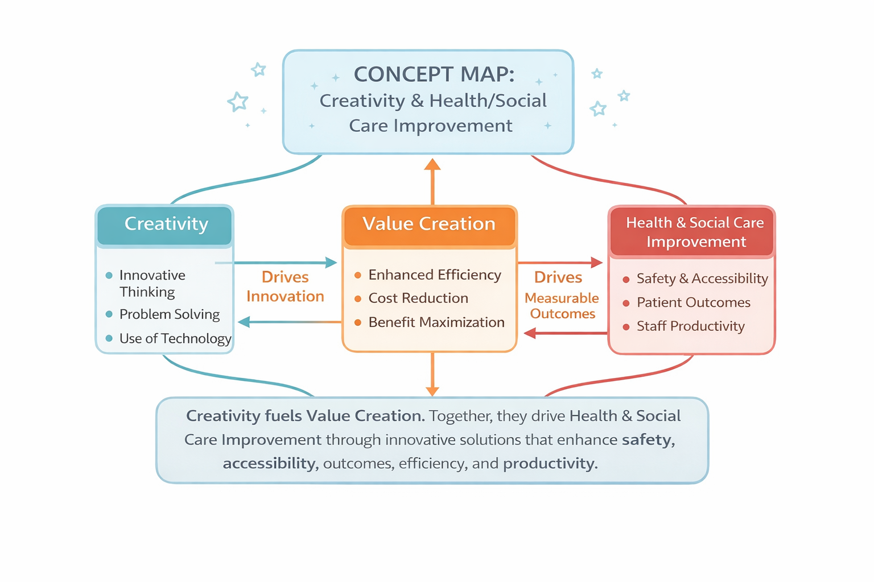
This concept map illustrates the relationship between
1: Creativity
2: Value creation
3: Health and social care improvement
Creativity: Such as the ability to generate new ideas and solve problems, drives innovation in health care by designing new services and improving processes. These creative ideas are translated.
value creation: Which turns them into practical benefits such as cost reduction, increased efficiency, and improved patient outcomes. Ultimately, these two elements together drive health and social care improvement by enhancing safety. Accessibility. (Greenhalgh et al.,2020)
Health and social care Improvement: Quality of care, in this way, creativity sparks new possibilities, value creation ensures those possibilities are effective and sustainable, and together they lead to continuous improvement in health and social care systems

Task 2 - Self-Reflection of Group A
Self-Reflection on the Convergent/Divergent paperclip thinking class activity using a reflective model:
During the Convergent/Divergent paperclip thinking class activity, I participated first by individually generating as many uses for a paperclip as possible (divergent thinking). Afterward, in my group, we collaboratively narrowed these ideas down to the most practical (convergent thinking). Using Gibbs’ Reflective Cycle, Gibbs, 1988) I analyzed this experience.
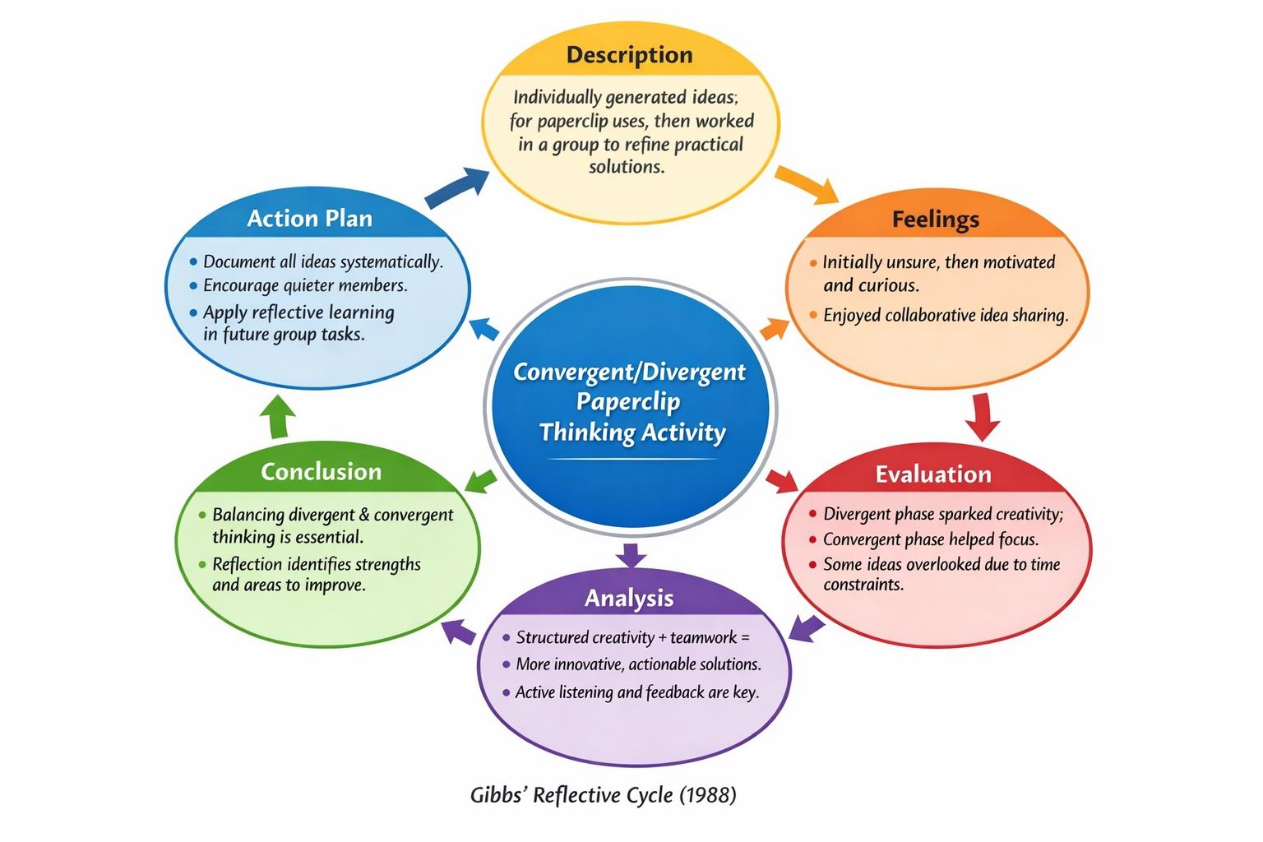
- At first, I felt a bit unsure because the task was open-ended, but I quickly grew excited as I saw how diverse ideas emerged from the group. Evaluating the process, I realized that the divergent phase was extremely effective in sparking creativity, while the convergent phase ensured we stayed grounded in practicality. In analysis, I recognized how critical it was to balance free-flowing ideas with purposeful selection. I also saw that my role in the group was to listen actively and build on others’ suggestions. As a conclusion, I learned that structured reflection allows me to see both my strengths and areas for improvement. In the future, I will document all ideas more systematically and ensure all group members have an equal chance to contribute. (Gibbs, 1988)

Task 3 - Case Study of a UK innovation (NHS Digital First)
The NHS “Digital First access to primary care services through initiative, launched in 2019, sought to transform Case Study: NHS “Digital First” Primary Care Initiative digital technology, including video consultations, online triage, and remote monitoring. The project responded to challenges such as long patient waiting times, uneven access to services, and the need to improve operational efficiency. Creativity played a central role, as the initiative required rethinking traditional GP services and designing digital solutions tailored to diverse patient needs.
Creativity in Action
The initiative demonstrated creativity through co-design with clinicians and patients. Digital platforms were iteratively prototyped and refined based on feedback, ensuring usability and addressing potential barriers like digital literacy and data security. The team also creatively integrated remote monitoring devices for chronic conditions, enabling personalized care plans. This innovation required adapting existing workflows and leveraging technology to enhance patient-centered care.
Value Creation
The “Digital First” approach generated tangible benefits for both patients and the NHS. Patients gained faster, more convenient access to GP services, especially those in rural areas or with mobility limitations. Video consultations and online travel reduced unnecessary travel and waiting times, increasing satisfaction and engagement. For the NHS, the system streamlined appointment management, reduced low-complexity in-person consultations, and allowed clinicians to focus on complex cases. Early evaluations suggested digital consultations reduced GP workload by 20% while improving care continuity (Greenhalgh et al., 2020).
Impact and Lessons
The project illustrates how creative problem-solving and innovative thinking can drive systemic change in UK healthcare. Co-design, iterative testing, and collaborative innovation ensured solutions were both practical and effective. The initiative demonstrates the importance of combining creativity with evaluation to create real value for patients and service users (NHS England, 2021). Key lessons include involving end users in design, embracing flexible technology adoption, and maintaining a continuous feedback loop to maximize impact

Task 4 - Research Task
A major current issue in health and social care is mental health stigma, which continues to prevent many individuals from accessing appropriate support and treatment. Stigma refers to negative beliefs, attitudes, and discrimination towards people experiencing mental health conditions. This issue is particularly significant among young people and vulnerable populations, where fear of judgement can delay or completely stop individuals from seeking help.
According to research by Corrigan, P. W. et al. (2014), stigma is largely caused by a lack of understanding and widespread misconceptions about mental illness. The study explains that society often associates mental health conditions with danger or weakness, which leads to discrimination. A key finding from this research is the concept of self-stigma, where individuals internalise negative stereotypes and begin to feel ashamed of their condition. This can lower self-esteem and confidence, making individuals less likely to seek professional help. As a result, untreated mental health conditions can worsen, leading to long-term negative outcomes for individuals.
Similarly, a study by identifies stigma as one of the most significant barriers to help-seeking behaviour. Their research, which reviewed multiple studies, found that many individuals avoid accessing services due to fear of being judged, labelled, or treated unfairly. The study also highlights that stigma is more common in certain cultural or social groups where mental health is not openly discussed. This creates inequalities in healthcare access, particularly for minority and disadvantaged communities, who may already face additional barriers such as poverty or limited-service availability.

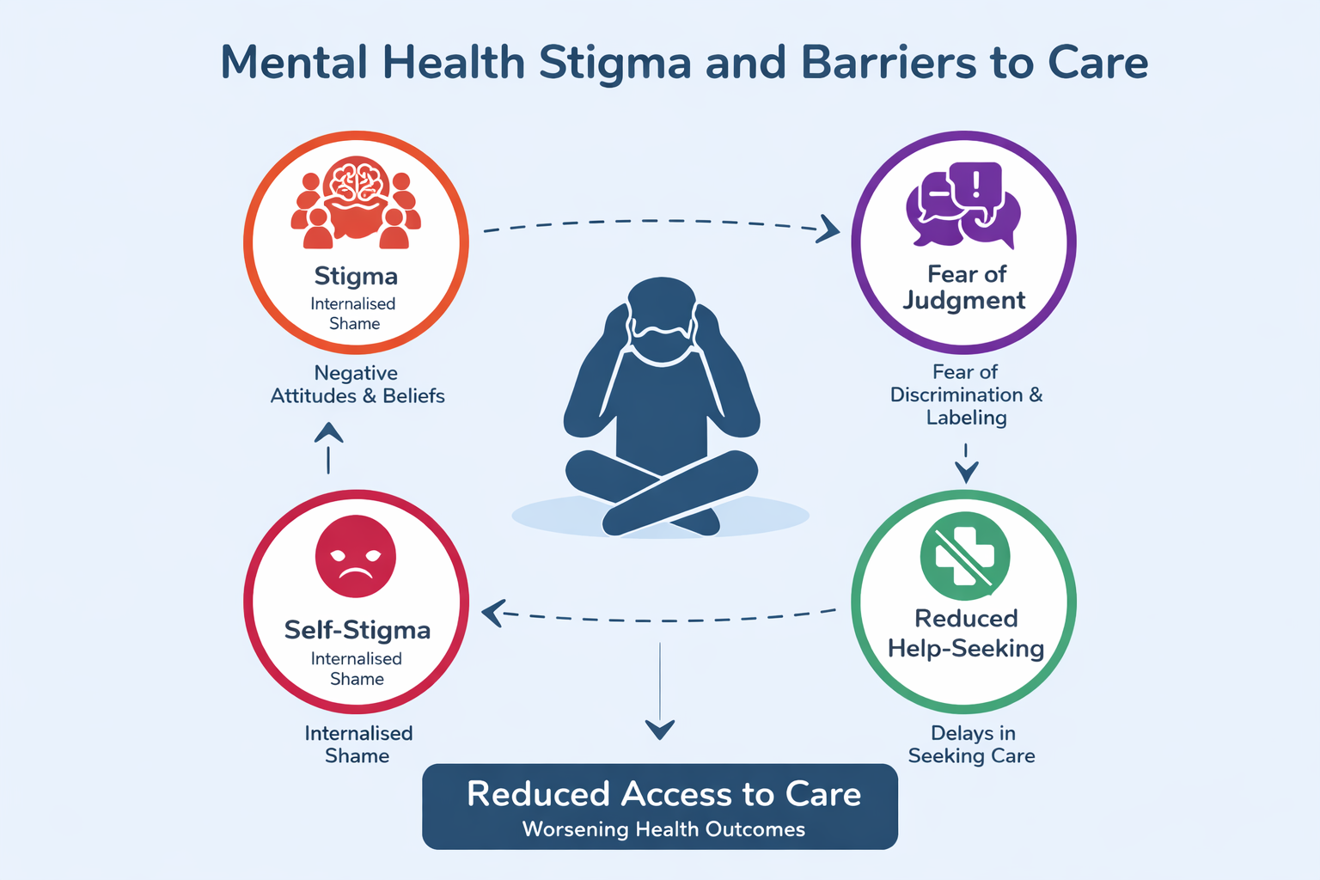

Task 5 - Podcast
https://www.rev.com/onlinevoicerecorder

Task 6 - NHS Leadership Framework Analysis Summary of the NHS Leadership Framework:
The NHS Leadership Academy developed the Healthcare Leadership Model (commonly referred to as the NHS Leadership Framework) to define the behaviours required for effective leadership within the National Health Service. Week 7 content highlights that leadership is not restricted to senior management but is expected at all levels of healthcare practice.
The model is structured around nine interconnected dimensions: inspiring shared purpose, leading with care, evaluating information, connecting services, sharing the vision, engaging the team, holding to account, developing capability, and influencing for results. These dimensions promote a balance between task-focused leadership (e.g., accountability and results) and relationship-focused leadership (e.g., compassion and teamwork).
Importantly, the framework emphasises person-centred care and continuous improvement. It encourages leaders to reflect on their behaviours and adapt their leadership style to meet the needs of both patients and staff. However, critics argue that applying all nine dimensions consistently can be challenging in high-pressure NHS environments.
Overall, the framework provides a structured approach to improving leadership effectiveness, staff engagement, and patient outcomes, aligning closely with NHS values and quality standards.

Application of One Component: “Engaging the Team”
The “engaging the team” dimension is essential for fostering creativity and improving care quality. Within the National Health Service, leaders can apply this by promoting open communication, inclusivity, and psychological safety among staff.
For example, a leader may implement regular reflective meetings where team members are encouraged to share ideas without fear of criticism. This supports creative thinking and allows innovative solutions to emerge, such as improving patient flow or enhancing communication strategies.
Furthermore, effective engagement involves recognising staff contributions and supporting professional development. According to Week 7, when employees feel valued and involved in decision-making, they are more motivated and likely to contribute to service improvement.

NHS Leadership Framework Diagram
Inspiring Shared Purpose
|
-----------------------------------------------------
| | | |
Leading with Care Evaluating Information Connecting Services
| | | |
-----------------------------------------------------
|
Sharing the Vision
|
-----------------------------------------------------
| | | |
Engaging the Team Holding to Account Developing Capability
|
|
Influencing for Results

Task 7 - Self-Reflection Journal Entry:
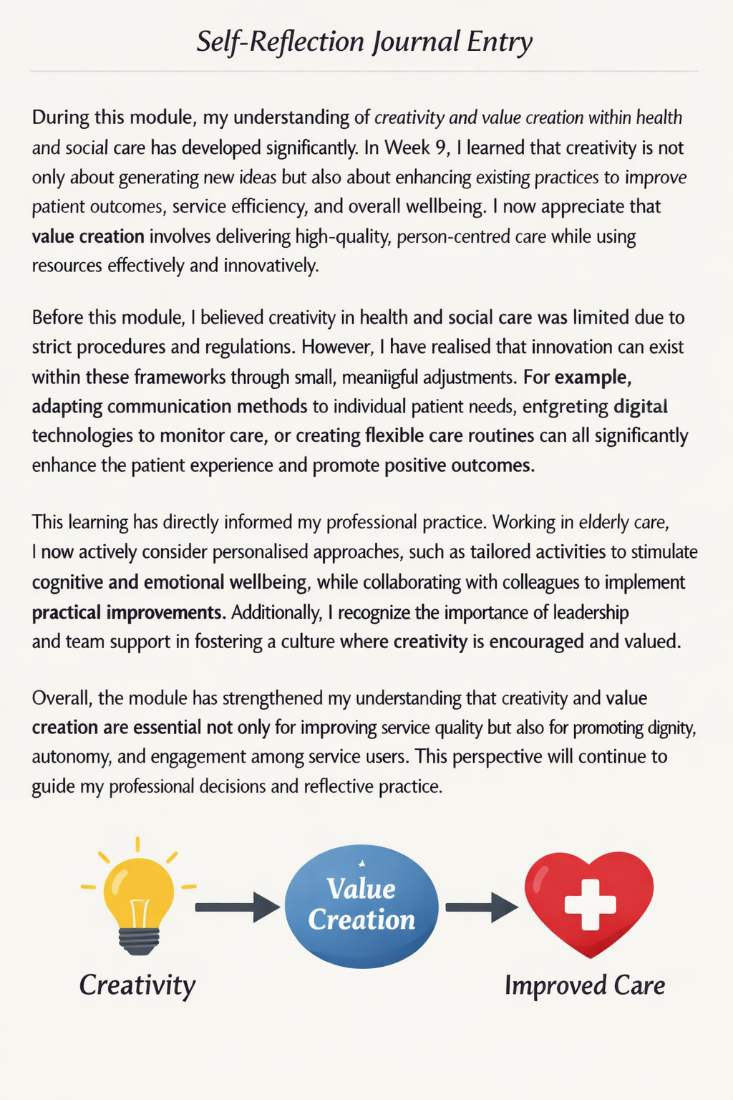

Reference List
Corrigan, P. W., Druss, B. G., & Perlick, D. A. (2014). The impact of mental illness stigma on seeking and participating in mental health care. Psychological Science in the Public Interest, 15(2), 37–70. https://doi.org/10.1177/1529100614531398
Gibbs, G. (1988). Learning by doing: A guide to teaching and learning methods. Oxford Polytechnic.
Greenhalgh, T., Wharton, J., Shaw, S., & Morrison, C. (2020). Video consultations for COVID-19. BMJ, 368, m998. https://doi.org/10.1136/bmj.m998
NHS England. (2021). Digital-first primary care: Transforming general practice in the NHS. NHS England. https://www.england.nhs.uk/digital-first/
NHS Leadership Academy. (2026). Healthcare leadership model. NHS Leadership Academy. https://www.leadershipacademy.nhs.uk
Rev.com. (2026). Online voice recorder [Audio recording]. https://www.rev.com/onlinevoicerecorder
Gulliver, A., Griffiths, K. M., & Christensen, H. (2010). Perceived barriers and facilitators to mental health help-seeking in young people: A systematic review. BMC Psychiatry, 10(113). https://doi.org/10.1186/1471-244X-10-113
Milbank Quarterly, 102(1), 233–269. https://doi.org/10.1111/1468-0009.12682

