Preparing for Employment as a Mental Healthcare Support Worker in the NHS: Skills Assessment and Career Development Report
Table of Contents
1. INTRODUCTION 4
2. ROLE AND JOB ADVERT ANALYSIS 5
2.1 Overview of Mental Healthcare Support Role 5
2.2 Vacancy Evidence 5
3. REQUIRED PROFESSIONAL COMPETENCIES 8
3.1 Therapeutic Communication Skills 8
3.2 Behavioural Risk Management Skills 8
3.3 Documentation and Care Planning 8
4. PERSONAL COMPETENCY REVIEW 10
4.1 Current Relevant Strengths 10
4.2 Development Needs 10
5. EXPERIENCE AND PROFESSIONAL VALUE 12
5.1 Unique Contribution 12
6. PROFESSIONAL IDENTITY IN MENTAL HEALTH PRACTICE 13
7. PROFESSIONAL SUPPORT NETWORK 14
8. CAREER DEVELOPMENT ACTION PLAN 15
8.1 Actions 15
9. PRESENTING SKILLS TO NHS RECRUITERS 17
10. CONCLUSION 18
11. References 19

Table of Figure
Figure 1: Mental Healthcare Support Worker 4
Figure 2: Lincolnshire NHS Mental Healthcare Support Worker advert (Screenshot) 6
Figure 3: Mental Healthcare Career Timeline 15

1. INTRODUCTION
This report examines the professional pathway towards employment as a Mental Healthcare Support Worker within the National Health Service, focusing on workforce expectations, therapeutic responsibilities, and structured preparation for inpatient mental health settings. Mental health services represent a critical component of NHS provision, with sustained workforce demand linked to rising prevalence of complex psychological conditions and increasing service utilisation (Health Education England, 2022).

  - Figure 1: Mental Healthcare Support Worker
  - Source: Collect from Internet as Example
The role requires contribution to patient safety, participation in recovery-focused interventions, and support of multidisciplinary care planning aimed at stabilisation and long-term wellbeing. Personal capability is therefore evaluated against recognised competency requirements, including behavioural observation, communication reliability, and safeguarding awareness.
A structured career development plan is consequently proposed to guide supervised experience, targeted training, and progressive professional readiness for safe participation in regulated mental healthcare environments (NHS England, 2019).

2. ROLE AND JOB ADVERT ANALYSIS

2.1 Overview of Mental Healthcare Support Role
The Mental Healthcare Support Worker position at Lincolnshire Partnership NHS Foundation Trust involves providing structured therapeutic services to an inpatient acute mental health ward. The roles involve facilitating the execution of individual treatment plans, supporting multidisciplinary workers in the administration of evidence-based interventions, and involvement in recovery-based activities that are aimed at stabilization of symptoms and encouraging patients to engage. It is also necessary that the role involves constant view of behaviour to help senior clinicians in monitoring of risk indicators and to accompany patients whose conditions might pose safety risks to themselves or other patients. Roles of behavioural support involve application of communication methods, de-escalation techniques and awareness of physical intervention which is supervised in cases where non-restrictive approaches have failed (Bowers, 2014). These roles portray identified mental health support functions that demand effective observation, communication quality, and compliance with safety protocols in organised systems of clinical governance.

2.2 Vacancy Evidence
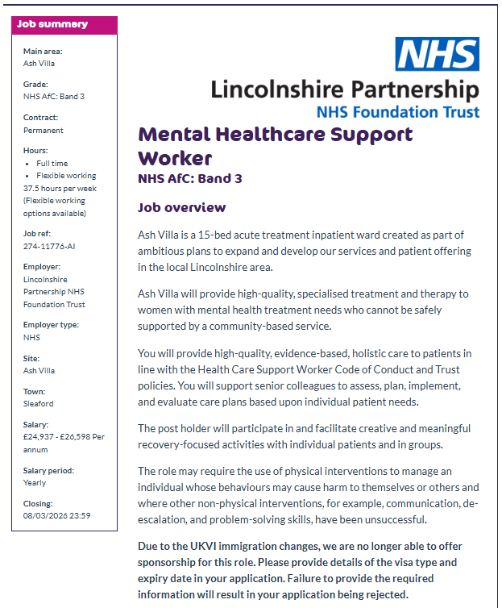
  - Figure 2: Lincolnshire NHS Mental Healthcare Support Worker advert (Screenshot)
  - Source: (NHS Job, 2026)

Table 1 — Job Requirement Summary
Category | Requirement
Patient group | acute mental health
Core duties | therapy support, care planning
Skills | de-escalation, communication
Environment | inpatient ward
The above requirements are vital in mental health practices since inpatient care includes patients who have acute mental distress, behavioural imbalance or high risks of harm. Both efficient therapy support reinforces recovery engagement, whereas precise care-planning support reinforces treatment continuity. De-escalation communication skills can decrease incidences of behaviour and improve the safety of the ward, and structured inpatient supervision can aid in stabilisation and safe discharge planning in multidisciplinary psychiatric treatment system (Stewart et al., 2015).

3. REQUIRED PROFESSIONAL COMPETENCIES

3.1 Therapeutic Communication Skills
Mental healthcare support roles require competencies in specialised therapeutic communication skills to allow safe interaction with psychologically distressed patients in acute distress. The de-escalation skills are necessary to decrease the state of agitation, avoiding escalation of behaviour and assist in collaborative treatment involvement by maintaining calm verbal communication and procedural reassurance techniques (Price and Baker, 2012). Active listening will also enhance the trust of the patient, enhance disclosure of emotional issues, and facilitate the better comprehension of the treatment needs during the recovery-oriented mental health practice. The emotional control of the staff is also crucial, since professional reactions are controlled and lead to the minimization of the intensity of conflicts and preserve psychologically safe therapeutic relationships in the context of difficult interactions (Delaney and Johnson, 2014).

3.2 Behavioural Risk Management Skills
Mental Healthcare Support Workers must also require possessing behavioural risk management competence in order to help clinical teams to maintain safe inpatient environments. Awareness of crisis support facilitates the provision of early signs of behavioural instability and quick reporting of risk indicators. The constant surveillance and formal safety monitoring can help to prevent the cases of self-harm or aggression, which are identified as essential priorities in the psychiatric inpatient safety systems (Bowers et al., 2015). Physical intervention procedures awareness is also necessary so that staff are aware of the restrictive practice protocols and use least-harm practices to supplement communication strategies in cases where they do not help (Cusack et al., 2018).

3.3 Documentation and Care Planning
There needs to be competence of documentation accuracy that facilitates assessment of multidisciplinary care plan and capturing of patient behavioural patterns that affect treatment decisions. Credible recorded observations enhance clinical communication, enhance continuity of care, and facilitate outcome-oriented psychiatric intervention planning among shift rotations (Vuckovich and Artinian, 2015).
Table 2 — Competencies vs Clinical Purpose
Competency | Clinical Purpose
Therapeutic communication | stabilises distressed patients
Risk observation | prevents safety incidents
Care documentation | ensures treatment continuity

4. PERSONAL COMPETENCY REVIEW

4.1 Current Relevant Strengths
Current preparation for mental healthcare service proves to address a range of competencies in line with the expectations of the inpatient psychiatric workforce. Emotional patience promotes a relaxed interaction with troubled persons and allows the prolonged therapeutic interaction with people in unstable behavioural expressions, which is an attribute that has been identified as the key to mental health support personnel in the recovery-oriented setting (Cleary et al., 2012). Communication skill is also structured which facilitates precise delivery of information to the multidisciplinary professionals and enhances clarity in writing about behavioural observations or in addressing patient issues. Academic research of mental health theory also helps to base knowledge of psychological conditions, risk factors, and principles of treatment interventions, which help to participate in supervised treatment practice more effectively and enhance the level of awareness of the protective role in psychiatric service environments.

4.2 Development Needs
Despite these strengths, the company still needs additional professional development in a number of areas of operation. The trust regarding dealing with acutely distressed patients should be based on the increased exposure to supervised clinical settings where the de-escalation and reassurance techniques can be trained by the professionals. There is also the need to improve crisis observation competence in ensuring that there is an amplified ability to identify behavioural risk indicators very early and to enhance accuracy in reporting the occurrence in a structured format. The lack of direct inpatient clinical practice might cause insufficient knowledge of routines in a ward, multidisciplinary documentation systems, and behavioural monitoring systems applied in acute psychiatric care (Stickley and Wright, 2011). guided reflective practice, Supervised placement involvement, ordained behavioural training, and supervised placement involvement are thus required to solidify applied mental healthcare competence and guarantee preparedness to join controlled inpatient therapeutic settings.
Table 3 — Competency Gap Analysis
Required competency | Current level | Gap identified | Development action
Therapeutic patience | good | moderate clinical exposure | supervised placement practice
Structured communication | strong | documentation depth | behavioural reporting training
Crisis observation | basic | early-risk recognition | inpatient shadowing experience

5. EXPERIENCE AND PROFESSIONAL VALUE
Academic coursework covering mental health theory, safeguarding policy, and recovery-oriented practice courses give background knowledge of the psychological condition, behavioural risk factors, and multidisciplinary treatment models applicable across inpatient psychiatric settings. The given theoretical preparation can enhance awareness of patient-centred care principles and facilitate informed involvement in the supervised clinical decision-making, which are considered the key competencies in mental health workforce preparation (Happell et al., 2015). Participation in community or voluntary support also helps to provide a real-world experience on the needs of service-users, organized interaction with vulnerable people, and comply with confidentiality demands. Experience of community interaction also enhances cultural sensitivity and enhances awareness on social determinants which affect mental health outcomes and response to treatment (Shim et al., 2014). Academic collaboration, presentations, and organised project work are transferrable skills, which are relevant to effective teamwork in the regulated settings of psychiatric services since they include the following: structured communication, emotional patience, and dependable task completion.

5.1 Unique Contribution
The value of culture is also enhanced by professional value that is cultivated through cultural mental-health awareness that occurs during interaction with different populations and makes it possible to interact with patients whose backgrounds are different. Digital literacy helps in the proper utilization of electronic care documentation systems and enhances the reliability of reporting and clinical accountability. Facilitation confidence assistance is also underpinned by experience in structured group discussions or activities, which will assist in encouraging patients to actively participate in the therapeutic sessions and recovery-oriented ward programmes aimed at enhancing engagement and social functioning and treatment adherence (Townsend and Morgan, 2018).

6. PROFESSIONAL IDENTITY IN MENTAL HEALTH PRACTICE
Professional identity within mental healthcare practice requires behaviour at par with trauma-informed practice, professional responsibility, and controlled organisational practices. Trauma informed behaviour focuses on identification of psychological vulnerability, non-coercive engagement and facilitation of patient dignity in therapeutic interactions. Ethical responsibility also encompasses confidentiality, proper reporting and observing due vigilance to deliver safe inpatient care. Conformity to the expectations of National Health Service professional conduct also presupposes reliability, respectful communication and compliance with organisational procedures of patient safety and multidisciplinary collaboration. It is also necessary that the clear professional boundaries are maintained and that the supportive engagement with no improper emotional involvement and role confusion. Regulated psychiatric care ensures patient safety and staff responsibility with coherent boundary control. Systems of professional standards underline that consistency in such behaviour reinforces the quality of the service, minimises incidences of risks and promotes recovery-oriented care delivery in contemporary mental health systems (Nursing and Midwifery Council, 2018).

7. PROFESSIONAL SUPPORT NETWORK
Professional support network Organization is a viable measure in enhancing mental healthcare employment preparation as it offers access to guidance, supervision knowledge, and awareness in recruitment. Mental health tutors are engaged in offering academic knowledge, formative feedback on clinical theory, and guidance on areas of professional development that are in line with the expectations of a psychiatric workforce. Meeting of NHS staff in workshops, preparation of placements or career events also enhances the knowledge on the actual inpatient procedures, documentation standards and therapeutic communication strategies employed in the acute services.
Placement supervisors provide on-the-job operational instructions of behavioural observation practices, risk reporting requirements, and teamwork practices in the ward, which facilitates the realistic perception of daily professional duties. The additional services offered by volunteering mentors include exposure to service-user interaction, awareness protection, and planning of support to be given and this builds confidence in the application of mental health theory in supervised settings.
This type of networking practice enhances successful recruitment since professional acquaintances tend to offer systematic references, experience advice, and role awareness. Social capital theory will be used to explain how professional ties bring social benefit to employment opportunities by increasing familiarity with particular institutions, exchange of information and employer trust when it comes to competitive hiring practices (Lin, 2001).

8. CAREER DEVELOPMENT ACTION PLAN

8.1 Actions
A structured development plan is required to support progressive readiness for Mental Healthcare Support Worker recruitment in the inpatient psychiatric services. Courses in specialised academic mental health modules obtain theoretical knowledge of what is covered in psychological disorders, safeguarding demands and recovery-based intervention principles that are required to safely participate in therapeutic intervention. Guided volunteering with mental health charities, community support services or planned wellbeing programmes also enhance exposure to vulnerable service users, routines of communication and confidentiality practice. Successful completion of known de-escalation and behavioural management training also enhances readiness to deal with agitation, identify early warning signs and react in the most suitable way according to controlled clinical safety measures. It has been shown that coordinated mental health workforce preparation which involves academic preparation, supervised practice, and behavioural safety training can greatly enhance readiness to recruitment and development of clinical competency (Happell et al., 2015).
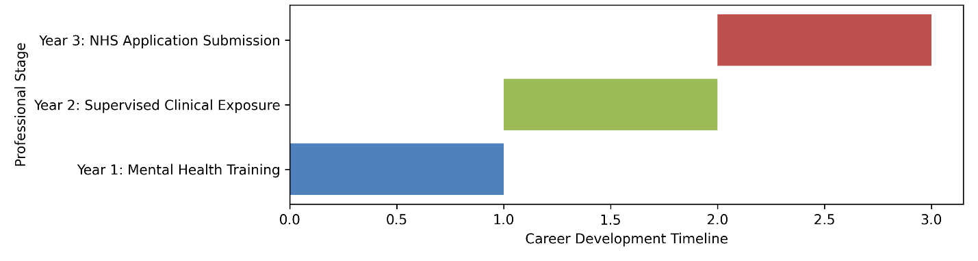
  - Figure 3: Mental Healthcare Career Timeline
  - Source: Self-Made
Table 4 — Action Plan
Action | Timeline | Outcome
Complete mental health modules | Year 1 | Verified theoretical psychiatric knowledge
Undertake supervised volunteering | Year 2 | Practical patient interaction experience
Complete de-escalation training | Year 2 | Demonstrated behavioural safety competence
Prepare NHS job applications | Year 3 | Competitive recruitment readiness

9. PRESENTING SKILLS TO NHS RECRUITERS
To present competencies to NHS recruiters, a systematic competency-grounded CV is necessary with a demonstration of clinical knowledge, awareness of safeguarding, and transferable communication abilities within the focus and scope of the responsibilities of providing mental healthcare support. The competency-based CV formats enhance the evaluation of practical preparedness and organisational fit by the employers in the recruitment of personnel in the medical field (Cottrell, 2019). When preparing behavioural interviews, one should consider structured examples of the demonstration of de-escalation awareness, reliability of teamwork, and ethical decision-making in a demanding service setting. Proof of readiness by the preparation of an organised evidence portfolio of academic certificates, protection of training confirmation and documented experience in volunteering also adds weight to credibility as it gives verifiable evidence of preparedness. Evidence shows that experience with evidence-based employability presentation results in a high success rate among candidates in the structured healthcare selection process (Brown and Hesketh, 2016).

10. CONCLUSION
This report has outlined a progressive employment preparation plan as a Mental Healthcare Support Worker by examining the role specifications, professional skills, and specific development areas. The pre-existing communication abilities, the theoretical mental health knowledge, and transferable support capabilities form a basis of safe entry into the supervised psychiatric care settings. Nevertheless, clinical exposure, behavioural management training and supervised risk observation experience would still be required in order to enhance operational confidence. Career planning, aimed at enhancing professional competence, awareness of patient safety, and long-term involvement in the changing trends of the National Health Service in the field of mental healthcare is therefore still necessitated by structured career planning and guided by specific education and experiences.

11. References
Bowers, L. (2014) ‘Safewards: A new model of conflict and containment on psychiatric wards’, Journal of Psychiatric and Mental Health Nursing, 21(6), pp. 499–508.
Bowers, L., James, K., Quirk, A., Simpson, A., Stewart, D. and Hodsoll, J. (2015) ‘Reducing conflict and containment rates on acute psychiatric wards: The Safewards cluster randomised controlled trial’, International Journal of Nursing Studies, 52(9), pp. 1412–1422.
Brown, P. and Hesketh, A. (2016) The Mismanagement of Talent: Employability and Jobs in the Knowledge Economy. Oxford: Oxford University Press.
Cleary, M., Hunt, G. and Walter, G. (2012) ‘Seclusion and its context in acute inpatient psychiatric care’, Journal of Medical Ethics, 38(9), pp. 551–555.
Cottrell, S. (2019) The Study Skills Handbook. 5th edn. London: Red Globe Press.
Cusack, P., Cusack, F., McAndrew, S., McKeown, M. and Duxbury, J. (2018) ‘An integrative review exploring the physical and psychological harm inherent in using restraint in mental health inpatient settings’, International Journal of Mental Health Nursing, 27(3), pp. 1162–1176.
Delaney, K.R. and Johnson, M.E. (2014) ‘Keeping the unit safe: Using physical assessment and emotional regulation in psychiatric nursing’, Journal of Psychosocial Nursing, 52(5), pp. 31–37.
Happell, B., Platania-Phung, C. and Scott, D. (2015) ‘Mental health nurse incentives: Improving workforce recruitment and retention’, Journal of Psychiatric and Mental Health Nursing, 22(9), pp. 679–686.
Lin, N. (2001) Social Capital: A Theory of Social Structure and Action. Cambridge: Cambridge University Press.
Nursing and Midwifery Council (2018) The Code: Professional Standards of Practice and Behaviour for Nurses, Midwives and Nursing Associates. London: NMC.
NHS Job (2026). Job vacancy: Mental Healthcare Support Worker, Lincolnshire Partnership NHS Foundation Trust, Sleaford | trac.jobs. [online] Nhsjobs.com. Available at: https://www.nhsjobs.com/job/UK/Lincolnshire/Sleaford/Lincolnshire_Partnership_NHS_Foundation_Trust/Ash_Villa/Ash_Villa-v7828896?_ts=1
Price, O. and Baker, J. (2012) ‘Key components of de-escalation techniques: A thematic synthesis’, International Journal of Mental Health Nursing, 21(4), pp. 310–319.
Shim, R.S., Compton, M.T., Rust, G., Druss, B.G. and Kaslow, N.J. (2014) ‘Race, ethnicity, and social determinants of mental health’, American Journal of Public Health, 104(5), pp. 1–8.
Stewart, D., Van der Merwe, M., Bowers, L., Simpson, A. and Jones, J. (2015) ‘A review of interventions to reduce conflict and containment in inpatient psychiatric settings’, International Journal of Nursing Studies, 52(9), pp. 1423–1433.
Stickley, T. and Wright, N. (2011) ‘The British Journal of Mental Health Nursing therapeutic communication review’, British Journal of Mental Health Nursing, 1(1), pp. 36–41.
Townsend, M.C. and Morgan, K.I. (2018) Psychiatric Mental Health Nursing: Concepts of Care in Evidence-Based Practice. 9th edn. Philadelphia: F.A. Davis.
Vuckovich, P.K. and Artinian, B.M. (2015) ‘Documentation and continuity in mental health nursing practice’, Journal of Nursing Care Quality, 30(2), pp. 134–140.

