University of Wales Trinity Saint David


Wales institute of Science and Arts

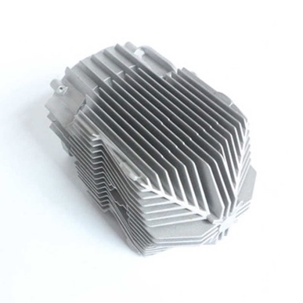
Design & Analysis of Extended Surfaces

Advanced Thermofluid Mechanics (ACMA6011)

Jamie Woodberry

2007714

December/2023

Contents
Table of Contents
1 Contents 1
2 Introduction 1
2.1.1 Equations 2
3 Task A 2
3.1 Introduction of Fins in automotive 2
3.2 Development of fin design in automotive 3
3.2.1 Figure (1) 4
3.3 Extended Surfaces in Microprocessors 6
3.3.1 Figure (2) 6
3.4 Recent advances of Heat sinks on Microprocessors 7
4 Task B 9
4.1.1 Figure 3 9
5 Task C 10
5.1 Material Properties 10
5.2 Task C (Part 1) 10
5.2.1 Figure 4 10
5.2.2 Calculations for Part 1 11
5.3 Task C ( Part 2) 12
5.4 Task C (Part 3) 13
5.5 Task C (Part 4) 14
5.5.1 Figure (5) 14
5.5.2 Calculations for Part 4 15
5.6 Task C (Part 5) 16
5.6.1 Figure (6) 16
5.6.2 Calculation for actual length/ Heat distribution 17
6 Further work 18
6.1 Aluminium Graph 18
6.1.1 Figure (7) 18
6.2 Brass Graph 19
6.2.1 Figure (8) 19
6.3 Copper Graph 19
6.3.1 Figure (9) 19
6.4 SS 304 Graph 20
6.4.1 Figure (10) 20
7 Conclusion 21
8 Appendix 22
9 Bibliography 25

Introduction

This report will cover 3 Separate tasks, firstly Task A will be research based on how fins in automotive were incorporated in the design of automotive engineering, to enhance heat transfer and the perceived advantages. From carrying out research the student can discuss when the first fin was designed for automotive to modern day, and how they have developed. Also, this report will show how extended surfaces have been incorporated into design of microprocessors and will discuss of the most recent advances of extended surface on microprocessors, and the advantages that it has gained for microprocessors. Fins in automotive are very important, the main aim of fins is to increase the surface area which will be able to increase the heat transfer. The main aim of fins in automotive is to reduce the heat from the main heat source. As this is extremely important for thermodynamics, engineers are still developing new designs on how they can maximise heat transfer.

Task B and C is analytical based on how fin lengths effect the heat loss and heat dissipation of four different metals with different thermal conductivity and heat transfer coefficient. Task B will show how optimum length of a fin (mL=2.65) is not worth increasing the length of the fin. A graph will be plotted from the result and will show that after the optimum length there will be very little change. Part C will cover four different metals, graph and calculation will be plotted showing the heat distribution and heat loss of all the metal at different lengths.

Equations
Equation for heat Dissipation
$T\left(x\right)= T_{∞}+ (T_{b}- T_{∞})\frac{cosh⁡[m\left(L-x\right)]}{cosh⁡(mL)}$
Equation for Heat Loss
$$\dot{Q}= \sqrt{hPkA_{c}} \left(T_{b}- T_{∞}\right)tanh⁡(mL)$$
Equation to find m
$$m=\sqrt{\frac{kA_{c}}{hP} }$$
Percentage Difference
$$TD=T1-T1$$
$$TAvg=\frac{T1+T2}{2}$$
$$PD=\frac{TD}{TAvg}×100$$

Task A

Introduction of Fins in automotive

In the 1800s fins were not yet introduced into automotive as the automobiles didn’t have a closed cooling system. The most efficient way to have a cooling system in engines was to have water filtered through. This technique would work, although due to the temperatures the engines would reach it would lead the water evaporating. Therefore, the approach to cooling down the engine was to refill the water each time it would evaporate. This was not too much of a problem due to the engines not working at high speeds, as automobile were just being introduced. Since cars began to become much more popular, it was inevitable that a change was needed (2020).
Fins were introduced into automotive during the early 1900s, when radiators began to be introduced into automotive. Fins in engineering are extremely important for the heat transfer, therefore fins being introduced in automotive was a huge development for design of radiators in cars. The main reason for radiators in cars was to increase the heat transfer, as the heat that is produced from the engine is extremely high. Thus, will lead to the surrounding parts and liquids also reaching high temperatures. The outcome would be the engine overheating and parts will begin to fail. Therefore, radiators were introduced to automotive to enhance the heat transfers which will avoid internal damage of engine parts (Ho et al. 2023).

Development of fin design in automotive

Figure (1)
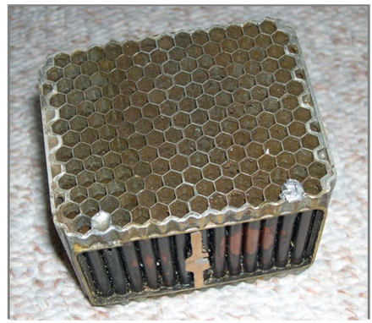
Figure 1 shows the design of the honeycomb radiator. Which was introduced in the 1900. This was designed to increase the heat transfer.

The honeycomb was the first design brought into automotive, that had a simplistic tubular design where the radiator would have engine coolant flowing through the radiator. This was designed for the airflow to flow through the tubular design where it would then cool down the coolant to prevent the engine from overheating. The design increased the surface area, which meant it enhanced the radiators efficiency dissipating the heat from the engine. Using this technique of cooling down the engine was beneficial as it worked efficiently and cooled down the liquid, that would then travel to parts in the engine at lower temperature. This design had been used for many years as it was very efficient and perceived to do the tasks that were needed (2020).
The first honeycomb radiator was designed from copper, as copper is extremely conductive. Due to copper being a great conductor of heat and it carries heat away from the engine. The disadvantage of using copper, it is a dense metal and will increase the weight significantly. With the weight of the radiator being heavy, using copper the fuel efficiency would not be as good (D M Bastidas M Criado and Bastidas 2010).

Radiators introduced extended surfaces into automotive as it is the main conductor in the engine. The honeycomb design was a great change for heat transfer in the engine, this was a stepping stone for heat transfer in the engine. Since then, companies have changed the design of radiators and use the louvered fin design, which conducts the heat better out of the engine than the original honeycomb design. This has improved the heat transfer significantly in radiators. This was needed due to automobiles becoming more powerful which led to the engine reaching higher temperatures (AnkithY et al. 2019). Other than the geometry of fins in cars to improve heat transfer, the main improvement of fins in automotive is the material. As copper and brass has a high density, automotive companies needed to find material. With copper/brass radiators being used for nearly all conductivity processes, aluminium began to get used. Although aluminium had a lower conductivity rate it was also much cheaper and lighter, although using this material would have lost some benefits of the heat transfer, companies would have gained advantages from price and weight cut from using aluminium. Therefore, aluminium was the next best to copper with still having a high conductivity rate and much less dense than copper (Jaikumar et al. 2023).

Since the development of fins in automotive, they have been used a lot more for heat dissipation to improve the efficiency of the car. Some examples where fins are used in cars are Condenser, Exhaust Manifold, and the brake rotor. Extended surfaces being designed onto the brake rotor was necessary, with cars reaching high speeds and having to slow down it would cause the brakes to get very hot. Therefore, fins had been added where they could carry the heat away from the brake rotor.

Extended Surfaces in Microprocessors

Figure (2)
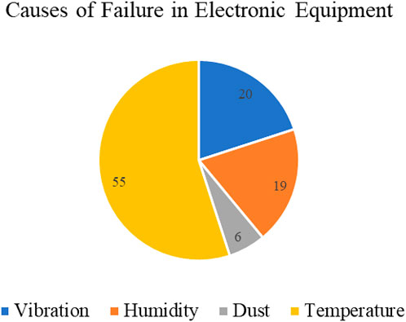 (Khattak and Ali, 2019).
Figure 3 shows the percentages of system failure in electronics. Temperature is the main failure in electronic systems by 55%, this is because of the speed that they need to work at and the storage that computers and other electronics devices hold. Thus, leads to the components overheating due to the system not having a reliable cooling system. Engineers and mathematicians are working on this problem by designing heat sinks, where these heat sinks will be able to dissipate the heat from the main heat source causing that is causing the problem. Extended surfaces in microprocessors are installed onto the component that is providing the most head, these heat sinks are reliable to some extent. As a result of computers becoming a lot more powerful it is leading to the components overheating, therefore new designs or a fan system are being installed to accelerate the heat dissipation (Gaikwad,2023).

Extended surfaces on microprocessors have taken an important role for heat dissipation, with microprocessors becoming much more compact and powerful. It was inevitable that a changed needed happen, therefore heat sinks were introduced onto microprocessors. The process of heat sinks is to increase the surface area, which can then improve the heat transfer. Heat sinks are typically manufactured from copper and aluminium as both materials have a high thermal conductivity and heat transfer coefficient. These materials assist to conduct the heat away from the microprocessor (Li & Yang, 2023).

Heat sinks are used in the same context as car radiators where the priority is to take heat away from the engine. Heat sinks are most used is computers, with computers having to run many programs at once it is needed for a cooling system. Heat sinks are used to carry away the heat away from the central processing unit (Hartle, 2010). Hartle goes on to suggest that aluminium is the most used material for a heat sink, this is because aluminium is a cheap metal with a high conductivity and is also lightweight. Hartle also suggests that copper is still used for mega computers, as they will be running much more information and working at faster speeds, therefore it is needed that copper is the material chosen. Although copper is much denser than aluminium, it is almost double the thermal conductivity which would be needed in some instances, where the weight is not a priority.

For example, as a mega computer will not be used for carrying around and being lightweight is priority, the designers of mega computers will used the best material for removing heat away from the systems inside. As these computers will be running a lot more information, it will be reaching much higher temperature than the normal microprocessors in a standard computer. Thus, it is important to use copper on where it has one of the highest thermal conductivities to remove the heat.

Recent advances of Heat sinks on Microprocessors
Microchannels
As computers are becoming much more popular and microprocessor having to handle a lot of data. Thus, a change was needed for extended surfaces and how they could improve heat dissipation. In a recent study by Jajja, this study shown that by decreasing the fin spacing you will have a better heat dissipation from the material. A recent design of a heat sink for a microprocessor, was by using water cooled mini channel heat sinks. The study shows that by using this method the base temperature will decrease by 9%, to achieve this the heat sinks needs to decrease the fin spacing and increase the volumetric flow rate which will be travelling through the heat sink (Jajja et al. 2014).

The advantages of using microchannels in heat sinks, is that it will improve the heat dissipation significantly compared to fan assisted heat sinks. This means that devices using this method will be work within safe temperature limits, which will be essential for the microprocessors that operation at high speeds and power, this will then lead increased life span, and device speed and reliability of the microprocessor.

With electronic components getting smaller and powerful, heat sink designs are going to get a lot more complicated to improve the heat dissipation. Engineers and researchers are coming up with heat dissipation techniques using various Phase Change materials, cooling fluid mixtures and innovative heat sink designs. Two LED array models were studied, aligned array and staggered array. The staggered array clearly showed better thermal performance. With weight and price of good conductivity materials, is also causing a problem with the material aspect of heat sinks. The change that is needed will be the geometry of these heat sinks to dissipate heat the best (Gaikwad, 2023).

Task B

Figure 3

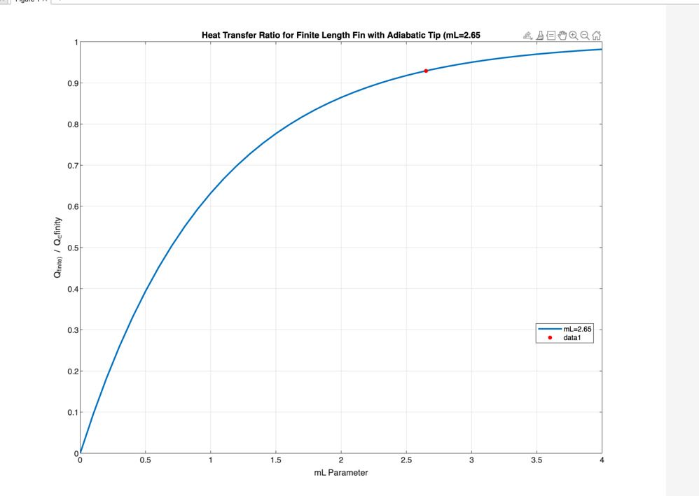

Figure 2 shows that the graph optimum finite fin length, where mL=2.65 is where engineers will work to for most beneficial value for a fin. (Red Dot is mL=2.65).

The graph shows that where 2.65 mL is near enough the maximum heat transfer rate for a fin length, beyond that point there is a slight increase rate of the heat transfer. This figure suggests that beyond that length of the fin, it does not make sense to increase the size of the fin to improve the heat transfer rate (A-R. A. Khaled,2010). Once reaching 2.65, increasing the parameter of the fin will be unnecessary waste of material and space. Therefore, when using finite length engineers will stick to this optimum value.

Task C

Material Properties
$$h=Heat transfer coefficient$$
$$k=Thermal conductivity$$
Material properties:

2024 Aluminium alloy: h = 30 W/m² K and, k = 186 W/m K
Brass (70 Cu/30 Zn): h = 30 W/m² K and, k = 99 W/m K
Copper: h = 15 W/m² K and, k = 398 W/m K
304 Stainless Steel: h = 7.5 W/m² K and, k = 16 W/m K

Task C (Part 1)

Figure 4
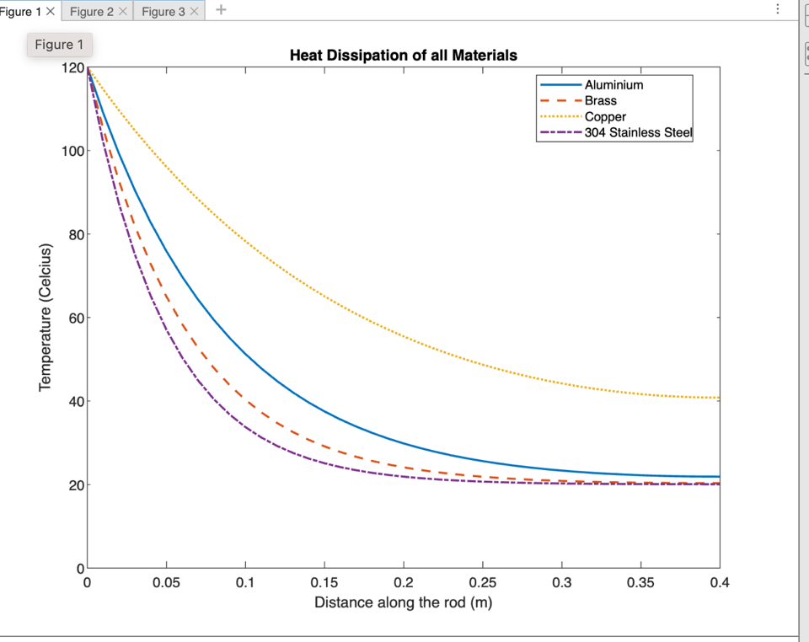

Figure 3 shows the different temperature distribution along all four rods, from values 0 to 0.4m which is the length of the rod. Analysing the graph, shows that copper has the best heat distribution. The graph shows that Copper and Aluminium have dissipated the less heat, both materials have also dissipated the heat at a slower rate. Although, copper heat dissipation is very slow compared to the other 3 materials. Here is the percentage difference between lowest conductor and highest conductor, in this case it will Copper and Stainless Steel 304. With both rods being 0.4m long, the percentage difference of heat distribution is 50.57%, this figure shows that the transfer of heat for copper 50% better than SS 304. That is an incredible difference between both the metals, and from this figure it is clear to say that stainless steel would not be suitable material for fin.

Calculations for Part 1
Given figures:
$$T_{∞}=20°c$$
$$T_{b}=120°c$$
L=0.4
X= 0 to 0.4
Calculation showing final temperature
Aluminium
$$m=11.6421$$

$T\left(x\right)= T_{∞}+ (T_{b}- T_{∞})\frac{cosh⁡[m\left(L-x\right)]}{cosh⁡(mL)}$ = 21.9 $°c$
Brass
$$m=15.9577$$
$T\left(x\right)= T_{∞}+ (T_{b}- T_{∞})\frac{cosh⁡[m\left(L-x\right)]}{cosh⁡(mL)}$ = 20.34$°c$
Copper
$$m=5.6277$$
$T\left(x\right)= T_{∞}+ (T_{b}- T_{∞})\frac{cosh⁡[m\left(L-x\right)]}{cosh⁡(mL)}$ = 40.83 $°c$
Stainless Steel 304
$$m=19.8471$$
$T\left(x\right)= T_{∞}+ (T_{b}- T_{∞})\frac{cosh⁡[m\left(L-x\right)]}{cosh⁡(mL)}$ = 20.1 $°c$

Task C ( Part 2)
Heat loss from all the materials over 0.4m of the rod.

Aluminium
$\dot{Q}= \sqrt{hPkA_{c}} \left(T_{b}- T_{∞}\right)tanh⁡(mL)$=3.8527 Wm^2
Brass
$\dot{Q}= \sqrt{hPkA_{c}} \left(T_{b}- T_{∞}\right)tanh⁡(mL)$=2.8113Wm^2

Copper
$\dot{Q}= \sqrt{hPkA_{c}} \left(T_{b}- T_{∞}\right)\tanh\left(mL\right)=3.8984$Wm^2

Stainless Steel 304
$\dot{Q}= \sqrt{hPkA_{c}} \left(T_{b}- T_{∞}\right)tanh⁡(mL)$=0.5651Wm^2

Task C (Part 3)

Transpose the equation to calculate the length of each rod based on the assumption of the optimum length $mL ≥2.65$.

$$L=\frac{2.65}{m}$$

Aluminium
$$L=\frac{2.65}{m}=0.2276 (m)$$

$\dot{Q}= \sqrt{hPkA_{c}} \left(T_{b}- T_{∞}\right)tanh⁡(mL)$=3.8152 Wm^2

From comparing the results for heat loss of aluminium at 0.4 m and aluminium’s optimum length, that the 0.4 rod permits the best heat loss. Not by a great deal only 0.977% better.
Brass
$$L=\frac{2.65}{m}=0.1661 (m)$$

$\dot{Q}= \sqrt{hPkA_{c}} \left(T_{b}- T_{∞}\right)tanh⁡(mL)$=2.7834 Wm^2

Brass also has a better heat with the 0.4 (m) rod with being 0.996% better than the optimum length of brass.
Copper

$$L=\frac{2.65}{m}=0.4709 (m)$$

$\dot{Q}= \sqrt{hPkA_{c}} \left(T_{b}- T_{∞}\right)\tanh\left(mL\right)=3.9462$ Wm^2

With copper being the best conductor of all three of these materials, it has performed better under the optimum length with producing a 1.22% better heat loss than the 0.4(m) rod.

Stainless Steel 304

$$L=\frac{2.65}{m}=0.1335 (m)$$

$\dot{Q}= \sqrt{hPkA_{c}} \left(T_{b}- T_{∞}\right)tanh⁡(mL)$=0.5595 Wm^2

Stainless steels heat also decreased by 0.995% using the optimum length rod.

Task C (Part 4)

Figure (5)
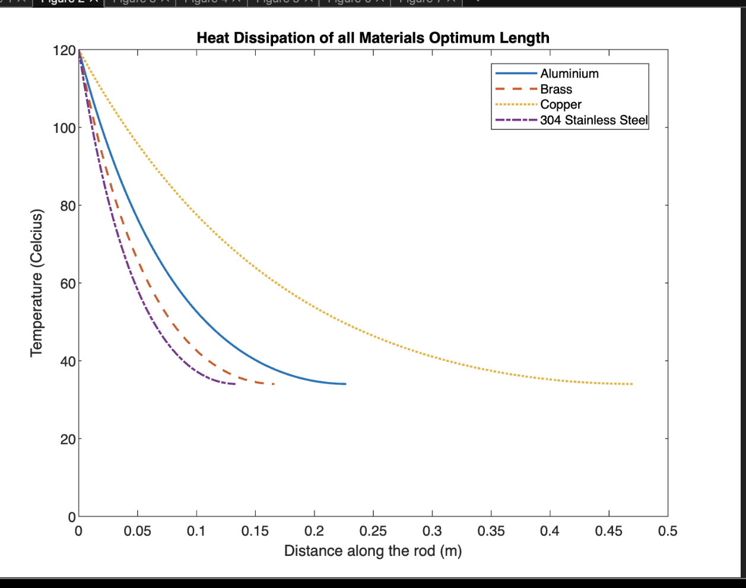
This figure shows that when using the optimum length fin final temperature at the end of the fin will be the same on all materials. This is due because a finite length fin does not emit heat from the tip of the fin. It shows that each material will eventually reach the same temperature depending on the size. Stainless steel reaches the final temperature rapid due to the material being a bad conductor of heat. Whereas copper takes a lot longer along the rob due to it conducting heat very well. By using the optimum length of the rod, it is noticeable that when all the materials are reaching 0.265 (m) that gradient of the line is beginning to flatten out. This shows that after this point not much heat distribution is occurring.

Calculations for Part 4
Aluminium
$$m=11.6421$$

$T\left(x\right)= T_{∞}+ (T_{b}- T_{∞})\frac{cosh⁡[m\left(L-x\right)]}{cosh⁡(mL)}$=34.06$°c$
Brass
$$m=15.9577$$
$T\left(x\right)= T_{∞}+ (T_{b}- T_{∞})\frac{cosh⁡[m\left(L-x\right)]}{cosh⁡(mL)}$ = 34.06$°c$
Copper
$$m=5.6277$$
$T\left(x\right)= T_{∞}+ (T_{b}- T_{∞})\frac{cosh⁡[m\left(L-x\right)]}{cosh⁡(mL)}$ = 34.06$°c$
Stainless Steel 304
$$m=19.8471$$
$T\left(x\right)= T_{∞}+ (T_{b}- T_{∞})\frac{cosh⁡[m\left(L-x\right)]}{cosh⁡(mL)}$ = 34.06$°c$

Task C (Part 5)

Figure (6)
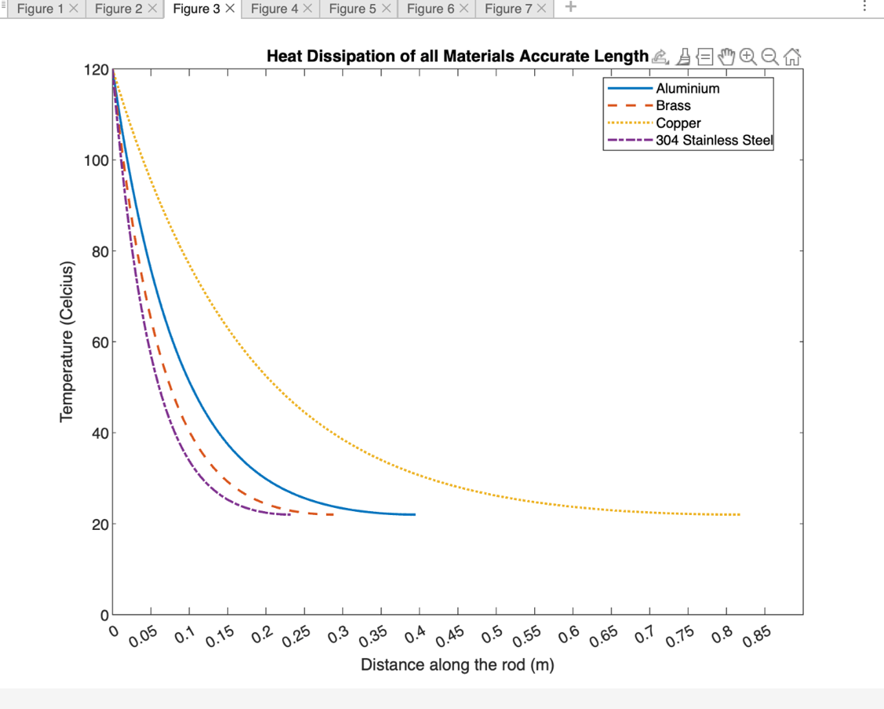

Figure 5 shows the more accurate length of all the materials. This is calculated by $\frac{-ln{0.1}}{m}$ divide by m to calculate the accurate length of the materials based on the material properties. And by doing this it was possible to plot the heat distribution of all four materials, by using the accurate lengths that had been calculated. From acknowledging these accurate lengths, it is clear to see that Copper and Aluminium are longest before the tip reaches the ambient air temperature. Copper is 0.5863 (m) longer than SS 304 before it reaches the ambient air temperature.

By comparing Part 1, Part 4 and this part, the graphs and calculation both provide that by using the accurate length of a rod, the result of heat dissipation will be the best. By almost reaching the ambient air temperature, which is the ideal outcome to come from this task. The most notable difference is copper using the 0.4(m) and the accurate length, the accurate length has dissipated heat 59.98% better than 0.4(m) rod.

Calculation for actual length/ Heat distribution

- $Aluminium=\frac{-ln{0.1}}{11.6421}=0.3956 (m)$
- $Brass=\frac{-ln{0.1}}{15.9577}=0.2886 (m)$
- $Copper=\frac{-ln{0.1}}{5.6277}=0.8183 (m)$
- $SS 304=\frac{-ln{0.1}}{19.8471}=0.2320 (m)$

Aluminium
$$m=11.6421$$

$T\left(x\right)= T_{∞}+ (T_{b}- T_{∞})\frac{cosh⁡[m\left(L-x\right)]}{cosh⁡(mL)}$ = 22 $°c$
Brass
$$m=15.9577$$
$T\left(x\right)= T_{∞}+ (T_{b}- T_{∞})\frac{cosh⁡[m\left(L-x\right)]}{cosh⁡(mL)}$ = 22 $°c$
Copper
$$m=5.6277$$
$T\left(x\right)= T_{∞}+ (T_{b}- T_{∞})\frac{cosh⁡[m\left(L-x\right)]}{cosh⁡(mL)}$ = 22 $°c$
Stainless Steel 304
$$m=19.8471$$
$T\left(x\right)= T_{∞}+ (T_{b}- T_{∞})\frac{cosh⁡[m\left(L-x\right)]}{cosh⁡(mL)}$ = 22 $°c$

Further work
All the figures below are showing the 0.4 (m) rod, Optimum length (mL=2.65) and the accurate length of the materials. This will show how the length of the rods will affect each material. The most noticeable change of the length has affected copper. As the optimum length and accurate length for the other 3 material are retrieving similar values.

Aluminium Graph

Figure (7)
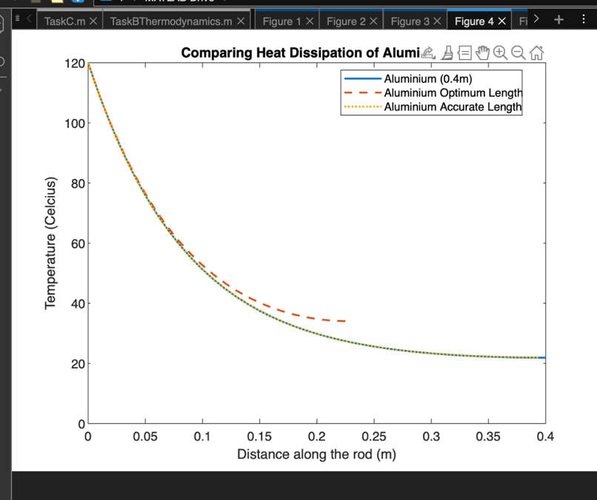

Brass Graph

Figure (8)
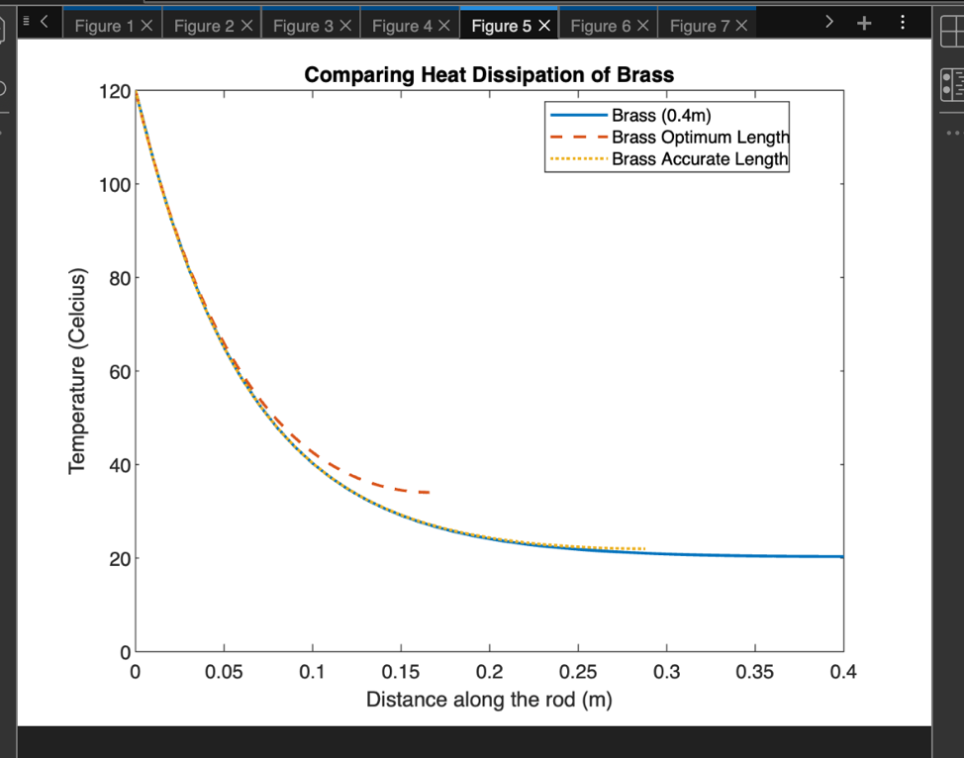

Copper Graph

Figure (9)

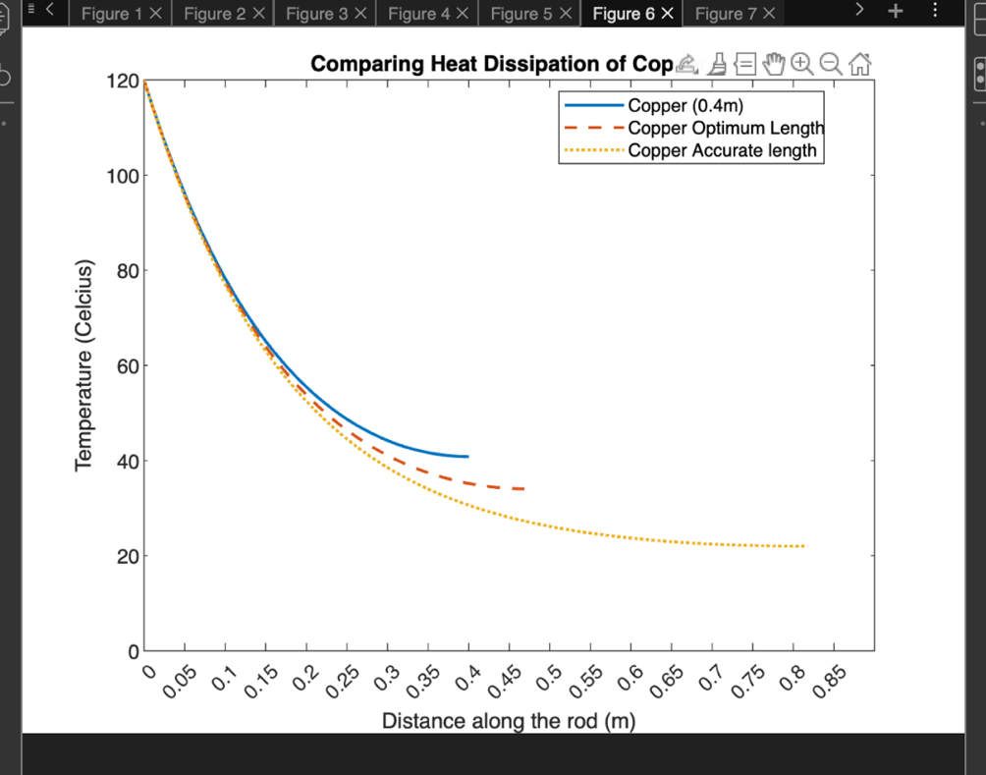

SS 304 Graph

Figure (10)

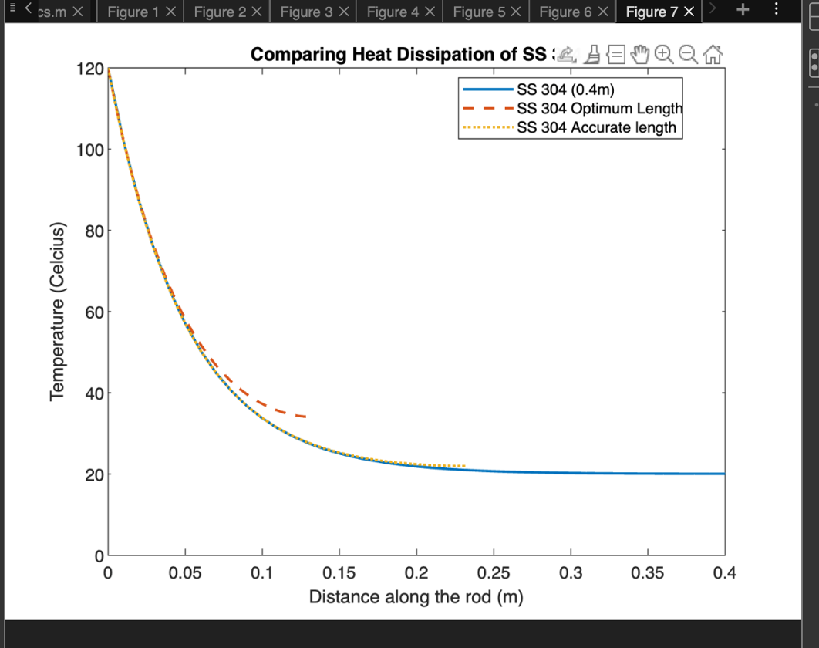

Conclusion

To conclude this report, it is clear to see with research and analytical workings that fins within systems are beneficial and will improve the heat dissipation and heat loss. By comparing all the values, Copper is by far the best metal for conducting heat away from the hot surface, although as a material it is expensive and heavy. This is a problem to use when companies are needing to produce products at low production cost and lightweight. Therefore, this report has shown that aluminium is the next best for this application. Aluminium is still achieving results that are needed to conduct heat away from the hot surface, the only problem it is not as efficient as copper for removing heat. With aluminium being a lot lighter and cheaper than copper, it is necessary to use for products that need to be compact and lightweight.

Appendix
http://www.tibtd.org.tr/2009-1/99-105.pdf

https://link.springer.com/article/10.1007/s002310000139

MATLAB code to complete Task B.

clc
clear
close all
mL_values = 0:0.1:4; %Plotting the X-axis in incrementds of 0.1
% Calculate the ratio of heat transfer for finite length fin to infinitely long fin
Q_r = zeros(size(mL_values));
for i = 1:length(mL_values)
mL = mL_values(i);
Q_r(i) = adiabatic_tip_heat_transfer_ratio(mL);
end
% Plot the results
plot(mL_values, Q_r, 'LineWidth', 2,'DisplayName','mL=2.65');
xlabel('mL Parameter');
ylabel('Q_finite) / Q_\infinity');
legend('Location', 'Best');
title('Heat Transfer Ratio for Finite Length Fin with Adiabatic Tip (mL=2.65');
grid on;
hold on;
mL_optimum = 2.65;
Q_optimum = adiabatic_tip_heat_transfer_ratio(mL_optimum);
plot(mL_optimum, Q_optimum, '.', 'MarkerSize', 15,'Color',[1 0 0],'Marker','.');
% Function to calculate the heat transfer ratio for a given mL
function ratio = adiabatic_tip_heat_transfer_ratio(mL)
% Assuming a simple relationship for demonstration purposes
ratio = 1 - exp(-mL);
end

Task 3 Codes

clc
clear
close all

% Given data
diameter = 4.76e-3; % diameter of the rod in meters
L = 0.4; % length of the rod in meters
x = 0:0.01:0.4;

%%%%%%%%%%%%%%%% Material properties
%Heat transfer coefficient
Al_h=30; %W/m^2K
Br_h=30; %W/m^2K
Cu_h=15; %W/m^2K
Ss_h=7.5; %W/m^2K

%Thermal Conductivity
Al_k=186; %W/mK
Br_k=99; %W/mK
Cu_k=398; %W/mK
Ss_k=16;
% Temperatures
T_b = 120; % temperature of the heated surface in °C
T_A = 20; % ambient air temperature in °C

%Cross sectional area
CSA= (pi.*diameter^2)/4;
%Perimeter
P= pi.*diameter;

%Calculate m for Aluminium
m_Al= sqrt(Al_h.*P/Al_k/CSA);
%Calculate m for Brass
m_Br= sqrt(Br_h.*P/Br_k/CSA);
%Calculate m for Copper
m_Cu= sqrt(Cu_h.*P/Cu_k/CSA);
%Calculate m for Stainless Steel
m_Ss= sqrt(Ss_h.*P/Ss_k/CSA);

%Heat distribution Part A

T_Al = T_A + (T_b - T_A) .* (cosh(m_Al .* (L - x)) / cosh(m_Al .* L));
T_Br = T_A + (T_b - T_A) .* (cosh(m_Br .* (L - x)) / cosh(m_Br .* L));
T_Cu = T_A + (T_b - T_A) .* (cosh(m_Cu .* (L - x)) / cosh(m_Cu .* L));
T_Ss = T_A + (T_b - T_A) .* (cosh(m_Ss .* (L - x)) / cosh(m_Ss .* L));

%Plotting all values on a graph
figure (1)
plot(x, T_Al, 'LineStyle', "-", 'LineWidth', 1.5, 'DisplayName', 'Aluminium');
hold on
plot(x, T_Br, 'LineStyle', "--", 'LineWidth', 1.5, 'DisplayName', 'Brass');
hold on
plot(x, T_Cu, 'LineStyle', ":", 'LineWidth', 1.5, 'DisplayName', 'Copper');
hold on
plot(x, T_Ss, 'LineStyle', "-.", 'LineWidth', 1.5, 'DisplayName', '304 Stainless Steel');
legend('Location', 'Best');
title('Heat Dissipation of all Materials');
xlabel('Distance along the rod (m)');
ylabel('Temperature (Celcius)');
xticks(0:0.05:0.48);
ylim ([0,120])
hold off

%%%Calculating the heat loss Part B
H_Loss_Al_ = sqrt(Al_h.*P.*Al_k.*CSA).*(T_b-T_A).*tanh(m_Al.*L)
H_Loss_Br_ = sqrt(Br_h.*P.*Br_k.*CSA).*(T_b-T_A).*tanh(m_Br.*L)
H_Loss_Cu = sqrt(Cu_h.*P.*Cu_k.*CSA).*(T_b-T_A).*tanh(m_Cu.*L)
H_Loss_Ss = sqrt(Ss_h.*P.*Ss_k.*CSA).*(T_b-T_A).*tanh(m_Ss.*L)

%Part 3
%Optimal fin length . %%mL=2.65 . L=2.65/m

L_New_Al=2.65/m_Al
L_New_Br=2.65/m_Br
L_New_Cu=2.65/m_Cu
L_New_Ss=2.65/m_Ss

x_Al = 0:0.001:L_New_Al;
x_Br = 0:0.001:L_New_Br;
x_Cu = 0:0.001:L_New_Cu;
x_Ss = 0:0.001:L_New_Ss;

H_Loss_Al_New = sqrt(Al_h.*P.*Al_k.*CSA).*(T_b-T_A).*tanh(m_Al.*L_New_Al)
H_Loss_Br_New = sqrt(Br_h.*P.*Br_k.*CSA).*(T_b-T_A).*tanh(m_Br.*L_New_Br)
H_Loss_Cu_New = sqrt(Cu_h.*P.*Cu_k.*CSA).*(T_b-T_A).*tanh(m_Cu.*L_New_Cu)
H_Loss_Ss_New = sqrt(Ss_h.*P.*Ss_k.*CSA).*(T_b-T_A).*tanh(m_Ss.*L_New_Ss)

Q4

T_Al_New = T_A + (T_b - T_A) .* (cosh(m_Al .* (L_New_Al - x_Al)) / cosh(m_Al .* L_New_Al));
T_Br_New = T_A + (T_b - T_A) .* (cosh(m_Br .* (L_New_Br - x_Br)) / cosh(m_Br .* L_New_Br));
T_Cu_New = T_A + (T_b - T_A) .* (cosh(m_Cu .* (L_New_Cu - x_Cu)) / cosh(m_Cu .* L_New_Cu));
T_Ss_New = T_A + (T_b - T_A) .* (cosh(m_Ss .* (L_New_Ss - x_Ss)) / cosh(m_Ss .* L_New_Ss));
figure (2)
plot(x_Al,T_Al_New, 'LineStyle', "-", 'LineWidth', 1.5, 'DisplayName', 'Aluminium');
hold on
plot(x_Br,T_Br_New, 'LineStyle', "--", 'LineWidth', 1.5, 'DisplayName', 'Brass');
hold on
plot(x_Cu, T_Cu_New, 'LineStyle', ":", 'LineWidth', 1.5, 'DisplayName', 'Copper');
hold on
plot(x_Ss,T_Ss_New, 'LineStyle', "-.", 'LineWidth', 1.5, 'DisplayName', '304 Stainless Steel');
legend('Location', 'Best');
title('Heat Dissipation of all Materials');
xlabel('Distance along the rod (m)');
ylabel('Temperature (Celcius)');
xticks(0:0.05:0.50);
ylim ([0,120]);
hold off

%%%Part 5
%A more accurate length of all 4 Rods
%Aluminium
AC_L_Al = -log(0.01) / m_Al
%Brass
AC_L_Br= -log(0.01) / m_Br
%Copper
AC_L_Cu = -log(0.01) / m_Cu
%Stainless Steel
AC_L_Ss = -log(0.01) / m_Ss
%New values for X
x_Al_Ac = 0:0.001:AC_L_Al;
x_Br_Ac = 0:0.001:AC_L_Br;
x_Cu_Ac = 0:0.001:AC_L_Cu;
x_Ss_Ac = 0:0.001:AC_L_Ss;
%Heat distrubution for a more Accurate Length
T_Al_Ac = T_A + (T_b - T_A) .* (cosh(m_Al .* (AC_L_Al - x_Al_Ac)) / cosh(m_Al .* AC_L_Al));
T_Br_Ac = T_A + (T_b - T_A) .* (cosh(m_Br .* (AC_L_Br - x_Br_Ac)) / cosh(m_Br .* AC_L_Br));
T_Cu_Ac = T_A + (T_b - T_A) .* (cosh(m_Ss .* (AC_L_Cu - x_Cu_Ac)) / cosh(m_Ss .* AC_L_Cu));
T_Ss_Ac = T_A + (T_b - T_A) .* (cosh(m_Ss .* (AC_L_Ss - x_Ss_Ac)) / cosh(m_Ss .* AC_L_Ss));
figure (3)
plot(x_Al_Ac,T_Al_Ac, 'LineStyle', "-", 'LineWidth', 1.5, 'DisplayName', 'Aluminium');
hold on
plot(x_Br_Ac,T_Br_Ac, 'LineStyle', "--", 'LineWidth', 1.5, 'DisplayName', 'Brass');
hold on
plot(x_Cu_Ac, T_Cu_Ac, 'LineStyle', ":", 'LineWidth', 1.5, 'DisplayName', 'Copper');
hold on
plot(x_Ss_Ac,T_Ss_Ac, 'LineStyle', "-.", 'LineWidth', 1.5, 'DisplayName', '304 Stainless Steel');
legend('Location', 'Best');
title('Heat Dissipation of all Materials');
xlabel('Distance along the rod (m)');
ylabel('Temperature (Celcius)');
xticks(0:0.05:0.85);
ylim ([0,120]);
hold off

Bibliography
- (2020) Motor Equipment News. Available at: https://motorequipmentnews.co.nz/article/high-performance-radiators-high-performance-engines-honeycomb-radiator-120-years-ago#:~:text=On%2020%20September%201900%2C%20he,the%20combustion%20action%20in%20the (Accessed: 17 November 2023).
- AnkithY, S., George, J. and Raveendran, V. 2019. Design of fins to maximize the heat transfer rate from the engine cylinder. Available at: https://api.semanticscholar.org/CorpusID:204291845.
- D M Bastidas M Criado, S.F.V.M.L.I.E.C. and Bastidas, J.M. 2010. Copper deterioration: causes, diagnosis and risk minimisation. International Materials Reviews 55(2), pp. 99–127. Available at: https://doi.org/10.1179/095066009X12506721665257.
- Gaikwad, A., Sathe, A. and Sanap, S. 2023. A design approach for thermal enhancement in heat sinks using different types of fins: A review. Frontiers in Thermal Engineering 2. Available at: https://www.frontiersin.org/articles/10.3389/fther.2022.980985.
- Ho, M.L.G., Oon, C.S., Tan, L.-L., Wang, Y. and Hung, Y.M. 2023. A review on nanofluids coupled with extended surfaces for heat transfer enhancement. Results in Engineering 17, p. 100957. Available at: https://www.sciencedirect.com/science/article/pii/S2590123023000841.
- Jaikumar, M., Sangeethkumar, E., Arjun, C.A., Godwin John, J., Hariram, V. and Ramanathan, V. 2023. Mechanical characterization of partially stabilized zirconia on aluminium alloy 6061 for automotive applications – A comprehensive approach. Materials Today: Proceedings 72, pp. 2113–2117. Available at: https://www.sciencedirect.com/science/article/pii/S2214785322053949.
- Jajja, S.A., Ali, W., Ali, H.M. and Ali, A.M. 2014. Water cooled minichannel heat sinks for microprocessor cooling: Effect of fin spacing. Applied Thermal Engineering 64(1), pp. 76–82. Available at: https://www.sciencedirect.com/science/article/pii/S1359431113008843.

