

Program | Master of Business Administration
Module Title | Marketing Management
Module Code | LCMB7024
Student Name | Imam Hossen
Student Id | 2505843
Lecturer | Dr. JAYA GOPALKRISHNAN
Word Count | 2660

Table of Contents
Element 1: STDP Analysis 3
1.1 Company Introduction 3
1.2 New Brand Concept – NikeFuel Energy Drink 3
1.3 Segmentation 3
1.4 Targeting Strategy 4
1.5 Differentiation Strategy 4
1.6 Positioning Strategy 4
ELEMENT 2 — MARKETING MIX (4Ps) 5
2.1 Product Strategy 5
2.2 Price Strategy 5
2.3 Place (Distribution) Strategy 6
2.4 Promotion Strategy 6
ELEMENT 3 — MARKETING STRATEGY PITCH 7
ELEMENT 4 — REFLECTION 8
Reference list 10
Appendices 12

Element 1: STDP Analysis

1.1 Company Introduction
Nike is an internationally acclaimed performance and sportswear company, which is known to be passionate about innovation and sporting performance (Aaker, 2012). It has a business motto which is to inspire and innovate every athlete and this motto shows a concern about empowering consumers by providing high quality products and technology (Forbes, 2023). The high brand equity of Nike can be traced in the globally spread brand and in the loyalty, it enjoys among the various consumer groups (Jobber and Ellis-Chadwick, 2019). The company has also ventured into wearable technology such as the Nike Run Club, Nike Training Club and partnership with Apple, which gives athletes an integrated digital experience (Chaffey and Ellis-Chadwick, 2019). With these innovations, brand extension into performance energy drink becomes rational, which also corresponds to the interests of consumers in the field of wellness, hydration and energy (Statista, 2024). This identity is used by NikeFuel to expand the brand into functional beverages and provide credibility and similarity to the current products (Nike, Inc., 2024).

1.2 New Brand Concept – NikeFuel Energy Drink
NikeFuel is the high-performance energy drink, which is targeted at athletes, runners, and gym-goers who want a science-based drinks of hydration and energy (Blythe, 2013). The product will be a blend of electrolytes, B-vitamins, and natural sources of caffeine in the form of green tea extract to aid in endurance, strength, and recovery (Mintel, 2023). NikeFuel comes in recyclable packages, which are in line with the modern trends of sustainability and responsible marketing (Nike, Inc., 2024; Turker, 2025). The brand is especially topical nowadays because the sports nutrition market has become more advanced, and health-conscious people start buying clean-label drinks instead of sweet ones (Statista, 2024). The competitors, including Red Bull, Monster, and Gatorade are market leaders in the energy drink segment but there is an opportunity to fill with a high-end, athlete-focused product that combines brand trust and performance technology (McMillan, 2010). NikeFuel tries to capitalise on this opportunity by providing a beverage that is both functional and enhancing the brand values of Nike, which are athletic performance and innovation (Forbes, 2023).

1.3 Segmentation
The segmentation of NikeFuel incorporates a combination of demographic, psychographic, behavioural and geographic (Wedel and Kamakura, 2000). The target demographics are consumers (any gender) aged 16–45, with medium-to-high income, such as students, athletes, and young professionals (aurthur, 2015). Psychographic segmentation emphasises on the lifestyles, self-improvement motivation, participation in sports or fitness clubs, and health and brand identity value (Blythe, 2013). NikeFuel is behaviourally oriented at people who frequent the gym 3-6 times a week, consumers of sports supplements, strong Nike brand ambassadors, and those who consume energy drinks on a weekly basis (Jobber and Ellis-Chadwick, 2019). Geographic segmentation focuses on urban and suburban markets that have established sports cultures e.g. UK, USA and Europe (Statista, 2024). Together, this segmentation will see NikeFuel react to lifestyle and behavioural trends that are very much related to performance over which the most useful consumer groups can be accurately targeted (Kotler, 1994).

1.4 Targeting Strategy
The key audiences of NikeFuel are people aged between 18 and 35 years who are gym-goers, runners, students, and young professionals (aurthur, 2015). This is a highly tech-oriented, brand-aware generation and often consumers of Nike products, including clothing, footwear, and online applications (Chaffey and Ellis-Chadwick, 2019). They are a perfect target because they tend to be the consumers of energy beverages and hydration products, use the Nike brand, and are eager to find the solutions that improve their performance (Mintel, 2023). They are also very active online and hence effective and tailored marketing campaigns can be conducted (McCarthy, 1960). With this group orientation, NikeFuel will be able to balance consumer needs with brand positioning, which will make it easy to adopt and have brand loyalty (Blythe, 2013).

1.5 Differentiation Strategy
The competitive factors that distinguish NikeFuel are product, brand, technology, image and emotional (Aaker, 2012). The product will provide a clean energy formula made of natural ingredients that will provide hydration, energy, and recovery in the same beverage (Statista, 2024). The brand differentiation is based on the history of Nike and its relations with sports success (Forbes, 2023). Technological differentiation will also be integration with the Nike Run Club app, where hydration can be logged, energy can be tracked, and performance plans can be customised (Chaffey and Ellis-Chadwick, 2019). The differentiation of images is manifested in minimalistic, smooth packaging in Nike style, which conveys the message of high performance and quality (Nike, Inc., 2024). On the emotional level, NikeFuel is inspiring consumers with the brand promise Fuel your greatness, which supports the aspiration, achievement, and brand loyalty (Jobber and Ellis-Chadwick, 2019).

1.6 Positioning Strategy
NikeFuel will be a luxury performance sports energy beverage catering to people who are athletic and active and need to use clean, science-based energy to improve their training, endurance, and day-to-day performance (Blythe, 2013). It occupies the base between conventional sports drinks and conventional energy drinks as it provides a natural performance amplifier in a reliable and aspirational brand environment (Forbes, 2023). Its value proposition focuses on the functional benefits of hydrating, energising, and recovering with the help of science and integrated technology (Statista, 2024). The improved image of NikeFuel is in line with the vision of health-conscious athletes and active consumers who value reliability of the brand, innovation and sustainability (Nike, Inc., 2024). NikeFuel provides a unique product performance, brand credibility, and motivational messaging and thus creates a differentiated and strong market position (Aaker, 2012).

ELEMENT 2 — MARKETING MIX (4Ps)

2.1 Product Strategy
NikeFuel has a core product that aims at giving athletes and fitness lovers energy boost, hydration, and performance improvement (aurthur, 2015). It is aimed at consumers who want not only to feel strong but also to be mentally alert in sport and training (Blythe, 2013). NikeFuel addresses the sports drink market by positioning itself as not a drink but a performance enhancer, which brings to the market performance-oriented benefits (Jobber and Ellis-Chadwick, 2019).
NikeFuel drink is the actual product, which comes in 330ml cans and 500ml bottles with natural caffeine in matcha and green tea, electrolytes, and B-vitamins, and no artificial preservatives (Nike, Inc., 2024). Lemon Sprint, Berry Boost, and Citrus Charge flavours are sports culture-inspired flavours, which attract the consumers due to their interest in both taste and functionality (Statista, 2024). Such a mix of natural ingredients and sport-themed flavours makes NikeFuel stand out of the pack of traditional energy drinks (Mintel, 2023).
The augmented product also improves consumer experience by use of NikeFuel app to monitor hydration, offer performance advice, and give customers points that can be redeemed into Nike vouchers (Chaffey and Ellis-Chadwick, 2019). The integration of the app will enable the gamification of fitness and promote repeated consumption, which will be of great value beyond the actual physical product (Kotler, 1994).
Branding and packaging is an important aspect with a smooth matte design with the classic Nike swoosh and colour-coded bottles that are associated with each flavour (Aaker, 2012). The environmentally friendly and sustainable materials, such as rPET bottles, fit into the Nike Move to Zero sustainability initiative, attracting greener consumers (Nike, Inc., 2024). The exclusive selling proposition (USP) of NikeFuel is evident: the first sports performance energy drink that has a complete ecosystem of integrating with a sports brand, which will offer a continuous connexion between nutrition and fitness tracking and rewards (Forbes, 2023).

2.2 Price Strategy
To demonstrate its status as a high-quality, energy drink that also has a strong performance advantage, NikeFuel uses a high price approach (Blythe, 2013). Competitor analysis shows that Red Bull costs more (2 pounds) than Monster (1.8 pounds) and Gatorade (1.5 pounds), which can be set at between 2.20 and 2.50, indicating that it is of high quality and brand worth (Statista, 2024). This low cost helps to solidify the notion that NikeFuel is a product meant to be used by serious athletes and those who prioritise their fitness (Jobber and Ellis-Chadwick, 2019).
The focus is on value-based pricing because the customers are not charged only on the drink itself but on the connexion to the Nike brand, nature-based ingredients, sport performance advantages, and interconnecting with apps (aurthur, 2015). Psychological pricing of 2.49 helps to find a balance between the premium status and accessibility, which makes the perception of exclusiveness yet affordable to the target audience (Blythe, 2013).
Bundled pricing is also used by NikeFuel to create a perception of value and influence cross selling. As an illustration, NikeFuel packs of 12 cans are sold at a reduced price or given free with the purchase of Nike running shoes facilitating the integration of the product and the overall ecosystem offered by Nike (McCarthy, 1960). Also, the combination of NikeFuel and subscriptions to the Nike Training Club motivates long-term interactions and purchase returns (Wedel and Kamakura, 2000).

2.3 Place (Distribution) Strategy
NikeFuel is sold in various platforms to ensure a high level of reach and visibility to target consumers (Blythe, 2013). Primary distribution covers Nike stores, Nike online store, gyms and fitness centres, large supermarkets such as Tesco and Sainsburys, health shops and Holland and Barrett, and online shops such as Amazon (Nike, Inc., 2024). Such a multi-channel approach will also mean that NikeFuel will be available to both amateur and serious sportsmen (Jobber and Ellis-Chadwick, 2019).
This distribution is justified by the consumer behaviour patterns; the product will be visible and relevant to the fitness enthusiast because they constantly visit the gym and health stores (aurthur, 2015). The presence of the retail stores that Nike has developed provides instant brand trust and reinforces the idea of NikeFuel as a high-quality product (Aaker, 2012). Subscription models are made easier using online distribution, which provides customers with regular deliveries and making it more convenient (Chaffey and Ellis-Chadwick, 2019).
Integration of omnichannels also leads to improvement of the customer experience through the choice of buy online pick-up in-store and app alerts to remind customers about the need to replenish (Kotler, 1994). Delivery subscriptions guarantee uninterrupted usage, with the added value of digital monitoring through the app that forms a smooth integration between the real world and the online ecosystem (Turker, 2025).

2.4 Promotion Strategy
NikeFuel implements a complex promotion mix, which supports brand awareness and sales (McMillan, 2010). The advertising campaigns are based on motivation and game performance that utilise Nike-style messages, including Fuel Your Greatness and Energy Designed for Athletes on You Tube, Instagram, and Tik Tok (Blythe, 2013). Such campaigns are aimed at existing Nike users and at those who want to buy sports and energy drinks that have certain functions (Statista, 2024).
One of them is influencer marketing, that is, cooperation with popular fitness YouTubers and Nike brand ambassadors, professional runners, and basketball players, to make it more credible and more engaging (aurthur, 2015). Product promotion can be achieved by using free trial cans at gyms, launch offers, loyalty points that will be gained with the help of NikeFuel app, and similar methods (Jobber and Ellis-Chadwick, 2019).
Experience marketing can be given through event sponsorships through marathons and sporting events, where NikeFuel hydration booths can be sampled and the actual consumer can be talked to (McCarthy, 1960). Online promotion takes advantage of the connexion with the Nike Run Club application, providing gamified challenges and rewards, including the Fuel Streaks upon the running achievements, which makes the interaction and brand loyalty stronger (Chaffey and Ellis-Chadwick, 2019).
Public relations activities are centred on sustainability, sports science relationships and cooperation with universities to advertise hydration studies, which further supports the image of NikeFuel as a responsible and scientifically supported energy drink (Nike, Inc., 2024). All these promotions work towards the premium positioning of NikeFuel in the market and fit into the greater Nike ecosystem, forming a coherent and powerful brand storey (Forbes, 2023).

ELEMENT 3 — MARKETING STRATEGY PITCH
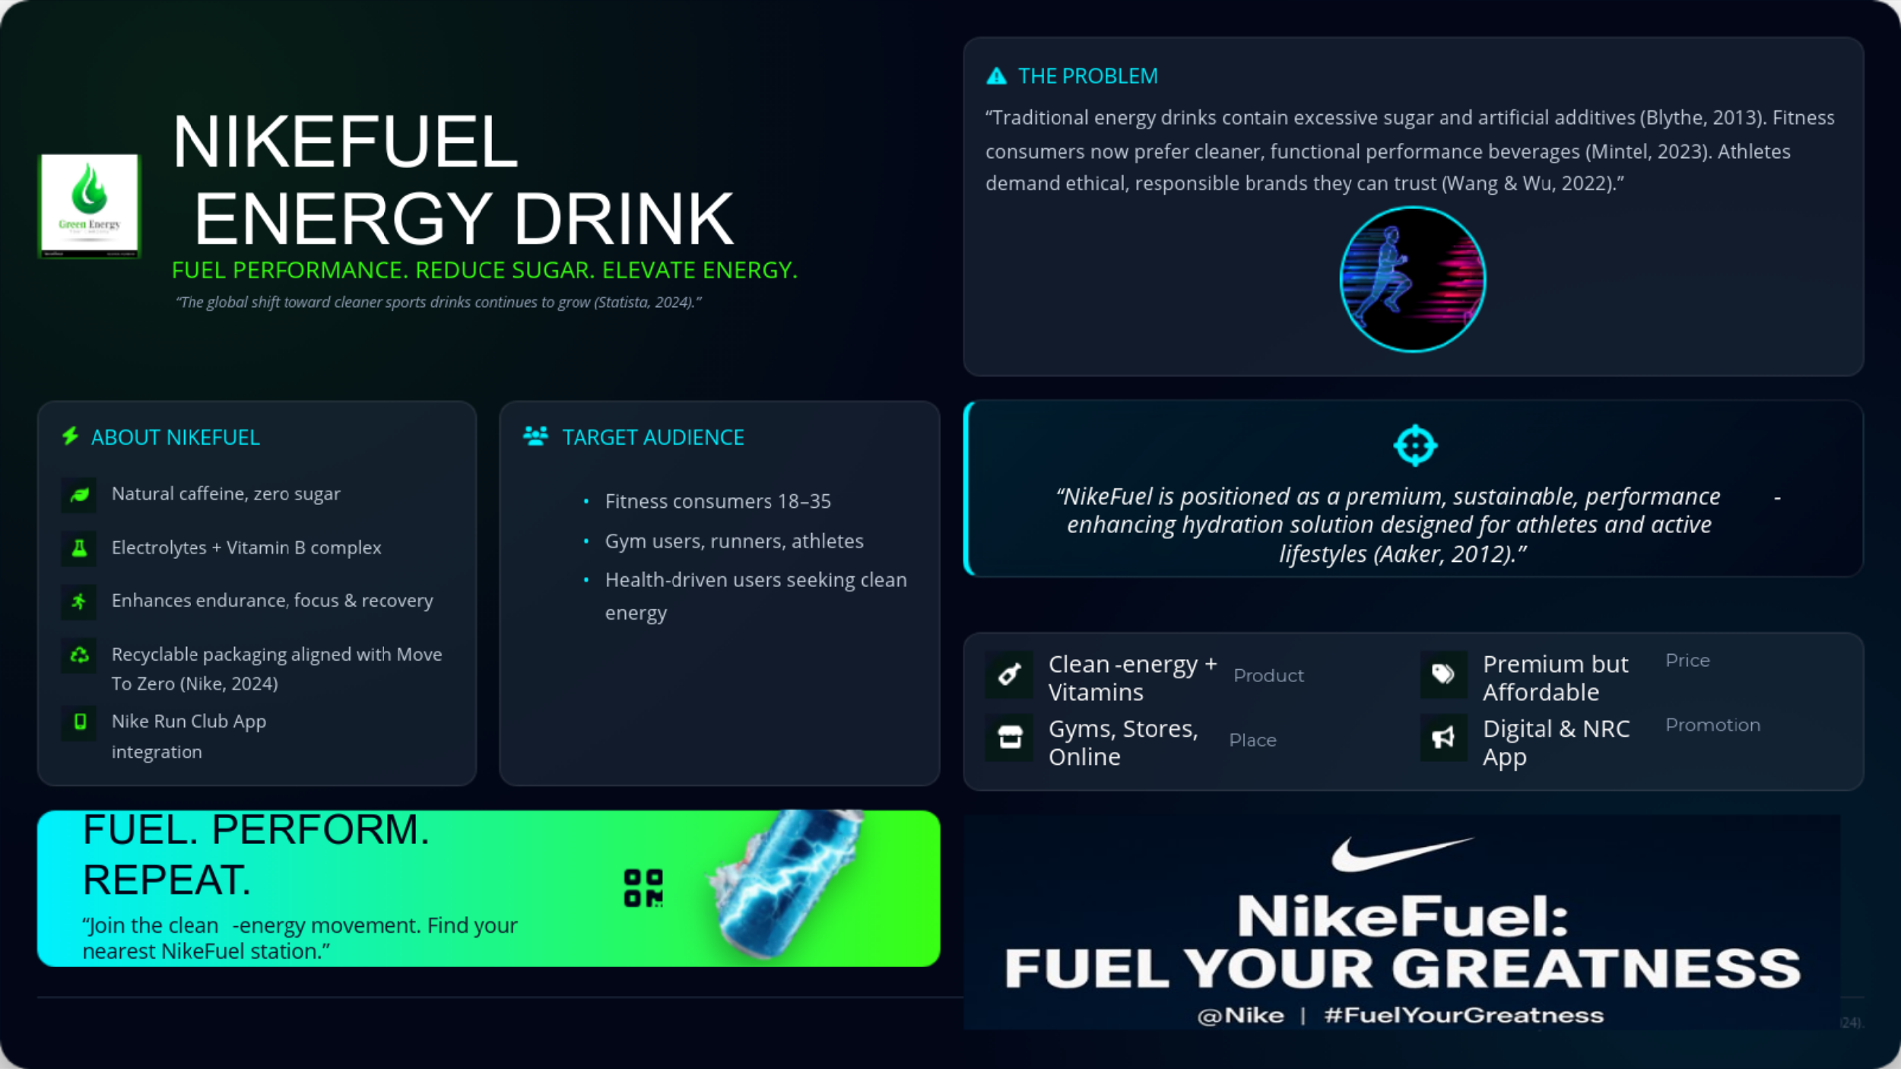
Good afternoon. Today, I am proud to present NikeFuel, Nike new brand innovation, and the first effort ever in the performance energy drink market.
Nike has always believed in assisting the athletes to achieve their potential. However, in the current fitness environment, there has been a distinct issue of many energy drinks being full of sugar, fake stimulants, and non-sport-related ingredients. NikeFuel will address this gap by providing a clean, natural, science-based energy drink that is specifically designed to meet the needs of athletes, gym, and other active people.
We will focus on the 18-35 years of age bracket of consumers who are fitness conscious and include runners, gym goers, sports lovers, and those who are loyal to the brand and one who trusts it to help him or her perform better.
Differences that NikeFuel makes are its natural caffeine, electrolytes, vitamins, sustainable packaging, and smooth connexion with the Nike Run Club app, as they enable users to monitor their hydration and get performance rewards.
The company will promote the product in a balanced manner of high-quality product design, value-based pricing, distribution in Nike Stores and gyms, and strong digital promotion with the help of influencers, events, and Nike Training Club ecosystem.
NikeFuel is not just a beverage, but a performance product.
Redefining sports hydration with us.
Power your greatness- with NikeFuel.
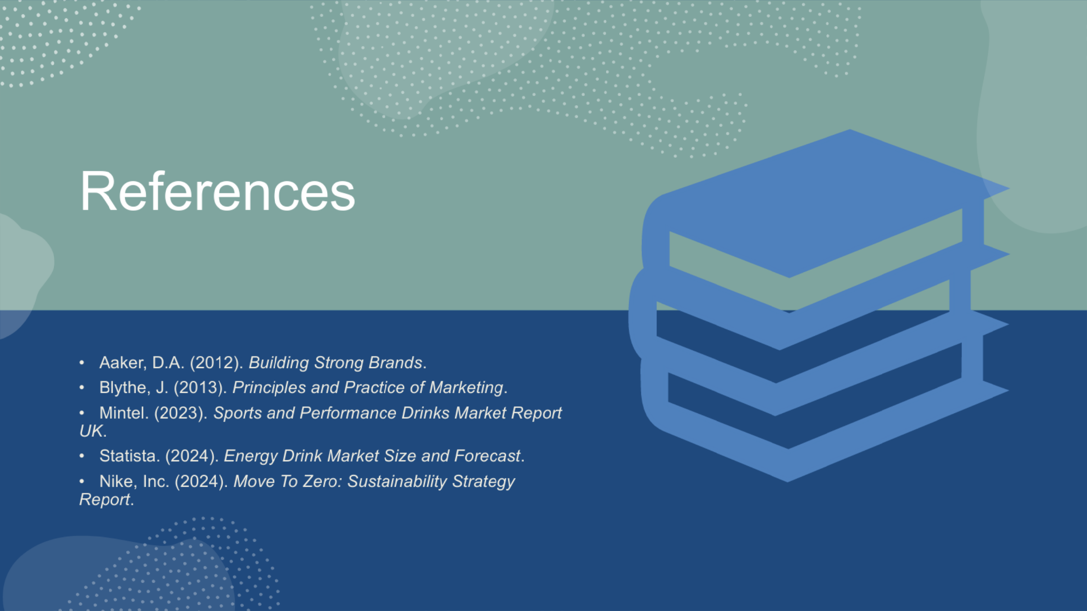

ELEMENT 4 — REFLECTION
Developing the NikeFuel brand provided me with some good experience in the field of consumer behaviour and their needs. I came to know that identifying the factors that drive consumers such as enhancing energy levels to supporting performance is important in the development of a product that will reach the target consumer. The process of brand extension helped me also to understand the dangers of the process like watering down brand equity or not being in line with consumer expectations. The exercise also tested my creativity in thinking especially in naming the product and building the concept of this product, which enhanced my skills in bringing ideas to life by turning them into concrete brand propositions.
It was especially instructive to use the STDP (Segmentation, Targeting, Differentiation, Positioning) framework. It allowed me to explain how the market is organised and understand the significance of data-based segmentation. I also realised that it is important to know the demographics, psychographics and behaviour of the customers to make informed decisions. The most difficult stage was choosing a realistic target segment because I needed to strike a balance between the market potential and feasibility. However, this practise was fruitful in terms of building a strategic focus as a guarantee that marketing activities should be targeted at the most applicable consumer segments.
The practise of marketing mix reinforced the need to synchronise the 4Ps of the marketing mix, that is, product, price, place, and promotion, with the overall strategy of the brand. I also got to understand the effects of pricing on brand perception and the fact that high-end pricing should be based on the perceived value. Another insight that I learned going through the process of packaging and design of products, including colour preferences and sustainable materials, is the consideration that design can convey brand identity. The promotion strategy brainstorming also enhanced my creativity, since I found digital campaigns, influencer partnerships, and experiences as the most effective way to attract consumers.
The pitch preparation and delivery were also beneficial to my competencies. I also enhanced my skills of summarising complex ideas in brief and conveying them in an engaging way. The process made me more confident about my ability to communicate strategic ideas and clarified the fact that visual storytelling is an extremely important aspect because sometimes the message can be communicated better with the help of visual images rather than only the use of words.
In the future, I would like to employ additional consumer data to build knowledge and make evidence-based decisions. I will also enhance my time management to facilitate effective implementation of all the marketing planning phases. The exploration of new marketing tools and improving the presentation design competencies will enable me to express the ideas better and more inventively in future brand projects.

Reference list
Aaker, D.A. (2012). Building Strong Brands. [online] Google Books. Available at: https://books.google.com/books?hl=en&lr=&id=OLa_9LePJlYC&oi=fnd&pg=PT14&dq=Aaker.
aurthur, H. (2015). Consumer-Behavior. [online] Academia.edu. Available at: https://www.academia.edu/download/38962867/Consumer-Behavior.pdf.
Blythe, J. (2013). Principles and Practice of Marketing. SAGE.
Jobber, D. and Ellis-Chadwick, F. (2019). EBOOK: Principles and Practice of Marketing, 9e. [online] Google Books. McGraw Hill. Available at: https://books.google.com/books?hl=en&lr=&id=IMovEAAAQBAJ&oi=fnd&pg=PR1&dq=Jobber.
Kotler, P. (1994). Reconceptualizing marketing: an Interview with Philip Kotler. European Management Journal, 12(4), pp.353–361. https://doi.org/10.1016/0263-2373(94)90021-3.
McCarthy, E.J. (1960). Basic Marketing: A Managerial Approach. Journal of Marketing, 42(4), p.103.
McMillan, C. (2010). Five competitive forces of effective leadership and innovation. Journal of Business Strategy, 31(1), pp.11–22. https://doi.org/10.1108/02756661011012741.
Wang, W. and Wu, J., (2022). Consumer Perceptions of Ethical Issues Arising from Chinese Private Companies’ Marketing Strategies Involving Local Officials’ Endorsement. Academic Journal of Humanities & Social Sciences, 5(8). https://doi.org/10.25236/ajhss.2022.050813.
Wedel, M. and Kamakura, W.A. (2000). Market Segmentation: Conceptual and Methodological Foundations. [online] Google Books. Springer Science & Business Media. Available at: https://books.google.com/books?hl=en&lr=&id=R4fq4IOm82YC&oi=fnd&pg=PA1&dq=Wedel.
Nike, Inc. (2024). Move To Zero: Sustainability Strategy Report. Nike.com. Available at: https://www.nike.com/my/sustainability
Nike, Inc. (2024). NIKE, Inc. Annual Report 2023–2024. Nike Investor Relations. Available at: https://investors.nike.com/investors/news-events-and-reports/investor-news/investor-news-details/2024/NIKE-Inc.-Reports-Fiscal-2024-Fourth-Quarter-and-Full-Year-Results/default.aspx
Turker, D. (2025). RESPONSIBLE MARKETING. The Routledge Companion to Responsible Business, p.209.
Chaffey, D. and Ellis-Chadwick, F. (2019). Digital marketing. Pearson uk.
Forbes. (2023). Nike’s Brand Strategy and Global Performance Analysis. Forbes Magazine. Available at: https://www.forbes.com/companies/nike/
Statista. (2024). Energy Drink Market Size and Forecast. Statista Research Department.
Available at: https://www.statista.com/outlook/cmo/non-alcoholic-drinks/energy-sports-drinks/energy-drinks/worldwide?srsltid=AfmBOorcpJKmT_33FgRzbohlrjGTguNMIv5kmZGMkzH8ahjLAeyL-DGS
Mintel. (2023). Sports and Performance Drinks Market Report UK. Mintel Group Ltd. Available at: https://store.mintel.com/report/uk-sports-and-energy-drinks-market-report-2023

Appendix : Marketing Strategy Poster – NikeFuel Energy Drink
(This poster was developed using Canva and supports Element 3: Marketing Strategy Pitch.)

