Learning in the Digital Era
ACCA4025
Assignment 1: E-Portfolio.


Terry Walcott / BSc Cloud Computing / Vasil Karabobov
(ID: 2019589)

Here I will be talking about my case study and following requirements.

Have to be done a few tasks and to showing my production skills and critical thinking in different learning era also providing a product summary of them. Creating a e-portfolio is the main task and job in this assessment and there I will explain my basic skills and insert some videos, photos, images, slides, and private information about myself. Also, I will create a webpage with different pages which are present my passion and my life as well. Also, I must attach my report and check the similarity and then to explain why is coming this number of the similarity and how to improve my skills in the future and to decrease my % of similarity. I wil explain my e-portfolio content and will navigate the user how to use it simple and easy.
I must create a poster with my colleagues and will try to upload it in my website.

My e-portfolio is about me, myself, and I. There I create a webpage with my own skills and insert a video, some .gif link supporting official pages, navigation bars and Gallery and Contact us. In “About us” I insert 2 videos about my life my future plan and my passion and information about my job and evaluation myself and my Assessments and case study process. The rest of the website is for my favorite club “Real Madrid”.

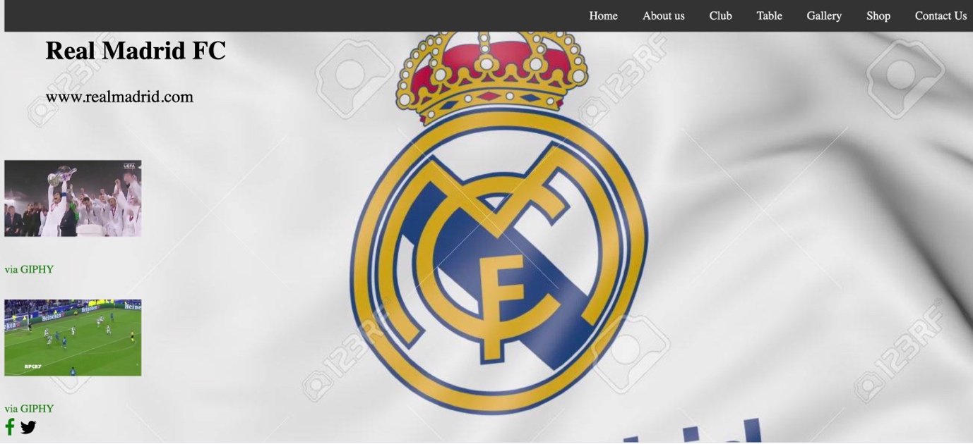

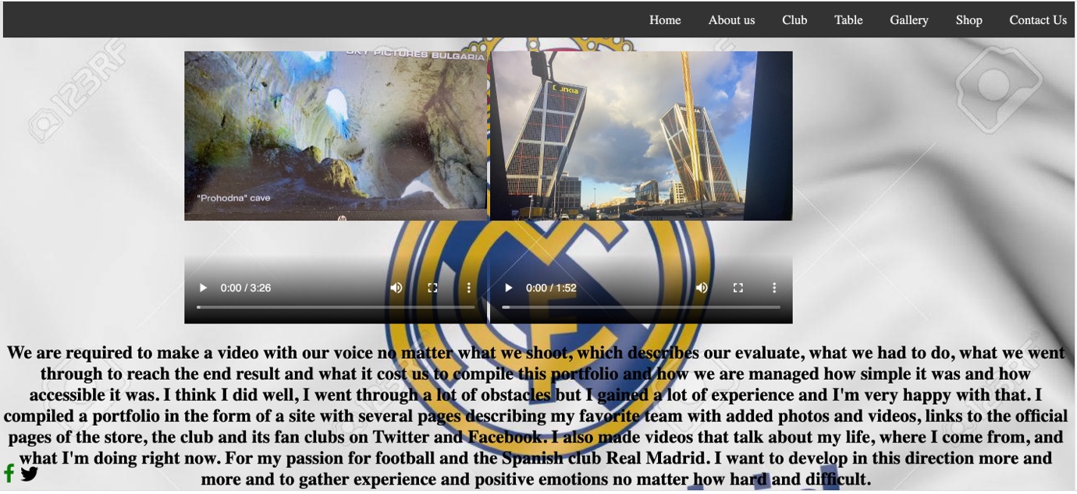

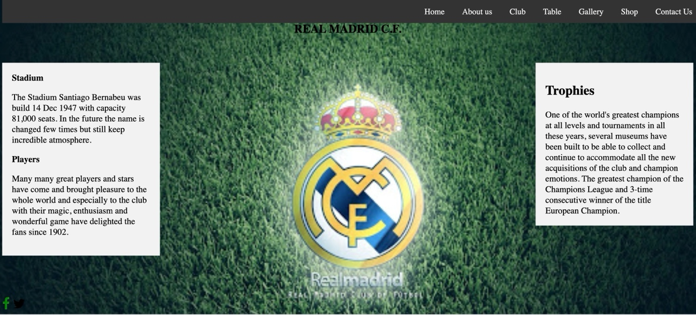

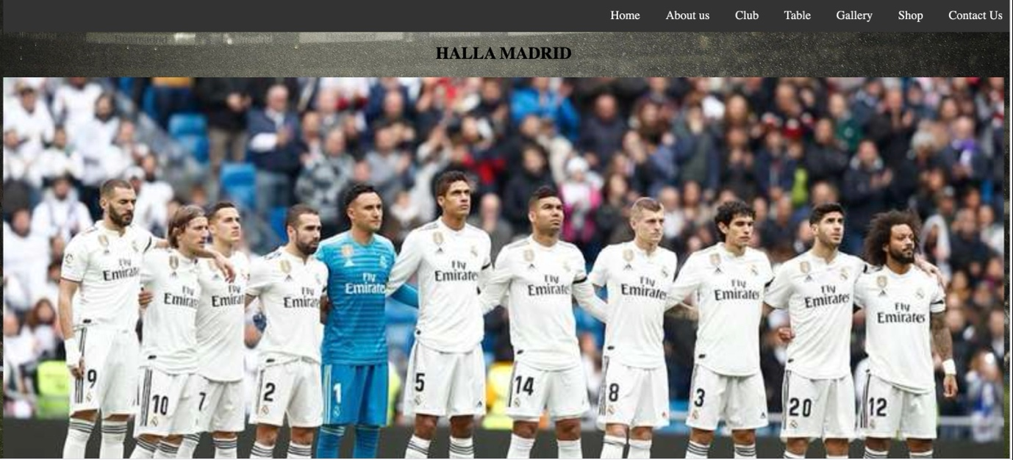

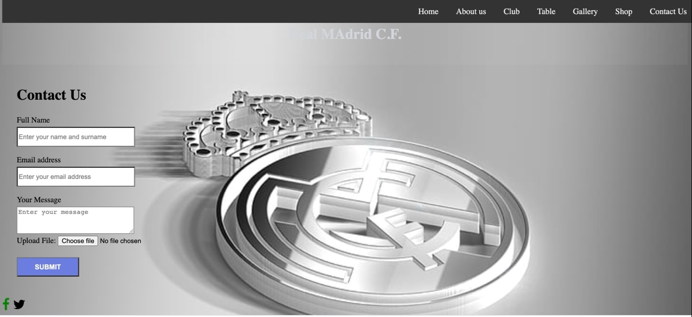

This is the URL of the Webpage / E-Portfolio www.choweche.info

