John Muir
For my John Muir Project, I will do a beach clean at Llansteffan. Llansteffan Beach and the surrounding landscape are renowned for its natural beauty. Being an estuary, it is effectively two beaches and has Llansteffan castle on the beachfront, providing a physical reminded of the area’s heritage. I believe this location is ideal for a beach clean and would benefit from it. Llansteffan has a strong history of cockle farming (http://www.llansteffan.com/llansteffan-beach), This provides a great deal of income for the local area and provides a food that the Welsh coast is famous for. However this fishing can and does produce a great deal of waste products, such as netting which can become a risk for local wildlife and even people if they become entrapped in the netting. Thus We will be going up and down the beaches cleaning up left over equipment from fisherman and general waste that may be up and down the beach. Removing this waste will help to make the beach more visually appealing to tourists as well as helping to protect the local Welsh wildlife.
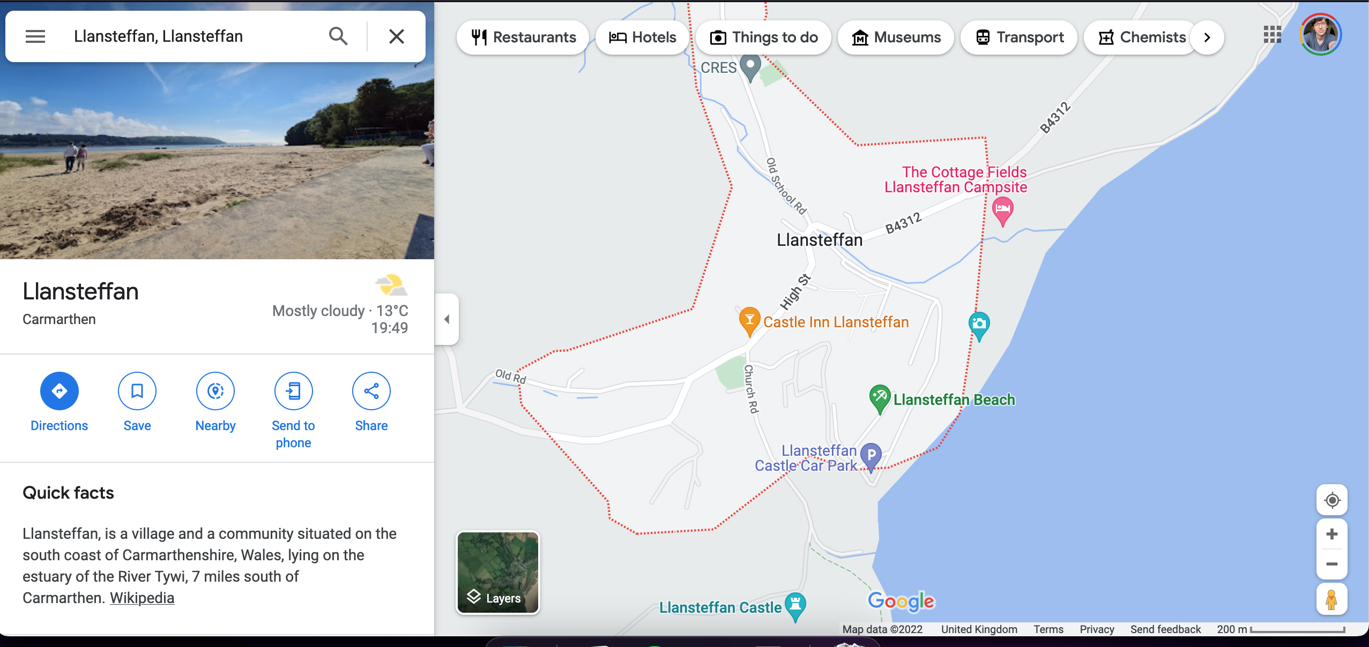
Due to the beach being adjacent to Wharley point and Llanseffan Castle (Both National Trust Sites) We would be able to take advantage of the national trust’s COASTodian Scheme (https://www.nationaltrust.org.uk/dinefwr/features/looking-after-the-carmarthenshire-coast) whereby they will help to aid the clean, providing litter-pickers and rubbish bags in exchange for us cleaning part of the Pembrokeshire Coastline. This will ensure that we are fully equipped to execute our beach clean resulting in a more clean and safe coastal area for both people and wildlife to enjoy.
Alternatively, there is the option to complete a beach clean through the Marine Conservation society(https://www.mcsuk.org/what-you-can-do/join-a-beach-clean/ ), They are a more official organisations that will allow us to setup a beach clean in a truly structured system whereby we could get more volunteers to come down and take part however we couldn’t find much information on if they provide kit so will email them to find out what they have to offer us. We have also been in contact with SurfersagainstSewage who will offer some materials in order to go execute our beach clean. They are willing to provide litter pickers, Bags and other PPE to complete a clean Safely. Carmarthen Council also have the opportunities for people to work alongside them cleaning their wilderness.
For this beach clean I will be working alongside Kai Veal, Freya Leegwater-Bright and Amy Alvarado. We are planning to execute the beach clean in Late November/Early December, this will allow us to co-ordinate with the national trust. It also allows us to check the weather week by week so if we have a window of time where the conditions are good, and we are available it is possible to head down to Llansteffan to safely execute our beach clean.
In order to evidence this clean for the John Muir Project, we will be filming on a GH5 for most of the day in between completing the clean. We will also be photographing/filming throughout the day on our phones in order to provide evidence of the clean and how it was executed.

