Microsoft Word practice: formatting a report
Topic: Rising Energy Costs and the Strain on Small Businesses
Aim: turn an unformatted fictional report into a professional document using Word for Windows (Microsoft 365 / Word 2024 or similar). Allow about 35–45 minutes to complete the exercises.
You need the companion file Word_Practice_Rising_Energy_Costs_UNFORMATTED.docx. It is deliberately plain: the headings are not yet set up as Word styles.

1. Identify the main headings and subsections
Open the practice file. Do not type section numbers into the document. Apply styles first, then let Word number the headings automatically.
Use Heading 1 for: Introduction; Current Situation; Effects on the Business; Possible Responses; Evaluation; Recommendation; Conclusion; Source note.
Use Heading 2 for: Energy use; Changes in monthly bills; Cash flow and costs; Staff and customers; Improving energy efficiency; Reviewing operating arrangements.

2. Apply Heading 1 and Heading 2
1. Click anywhere in a heading paragraph, for example “Introduction”.
2. Open Home → Styles. Choose Heading 1 for a main section, or Heading 2 for a subsection. If the style is not visible, expand the gallery using the small arrow.
3. Leave ordinary explanatory paragraphs in Normal style. Use the Title style for the report title on the cover.
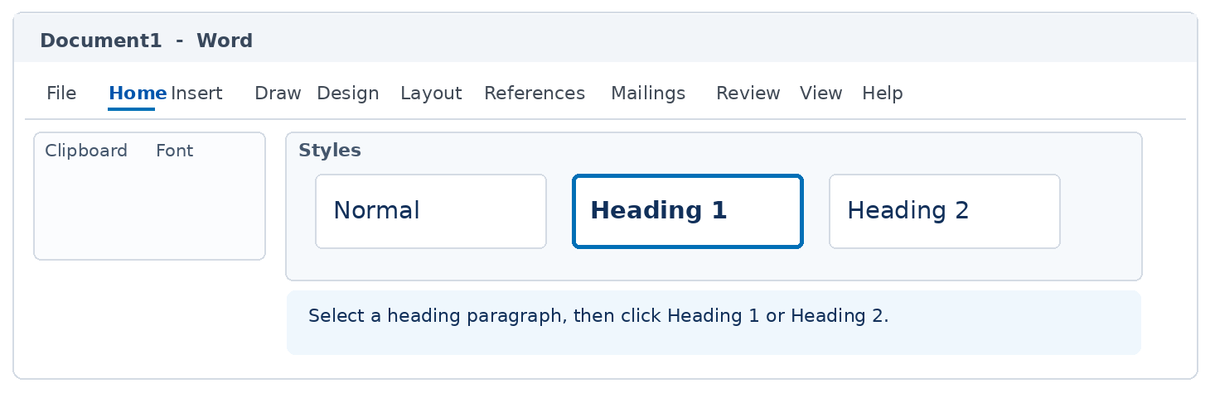
Check: headings should look different from body text because they have a Word style, not because you merely increased the font size or made the text bold.

3. Use the Navigation Pane
1. Select View → Navigation Pane, then choose Headings in the pane.
2. Confirm the main headings and indented subsections appear in the correct order. If a heading is missing, apply the appropriate style.
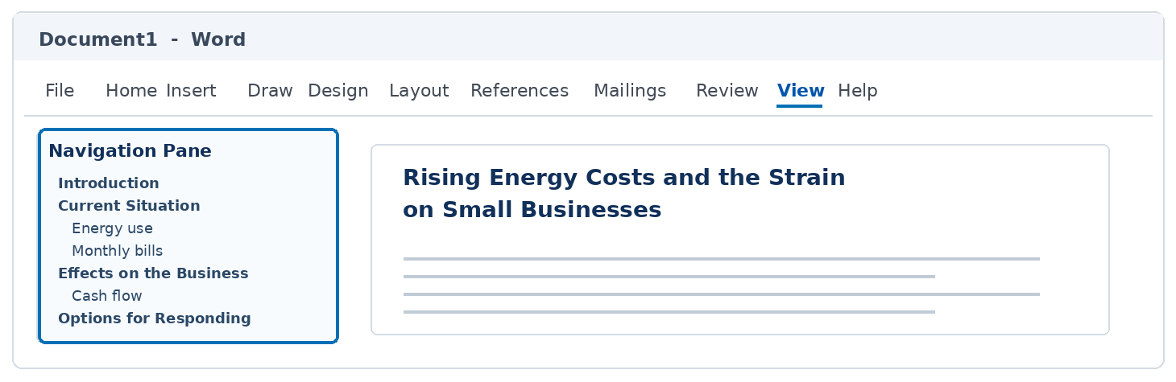

4. Create automatic section numbering
1. Click inside the first Heading 1 paragraph (“Introduction”).
2. Select Home → Paragraph → Multilevel List.
3. Under List Library, choose the template that shows Heading 1 and Heading 2, with numbering such as 1 and 1.1. Do not select an ordinary numbered list.
4. Check the hierarchy: main headings should be 1, 2, 3 … and subsections should be 2.1, 2.2 … under the appropriate main heading.
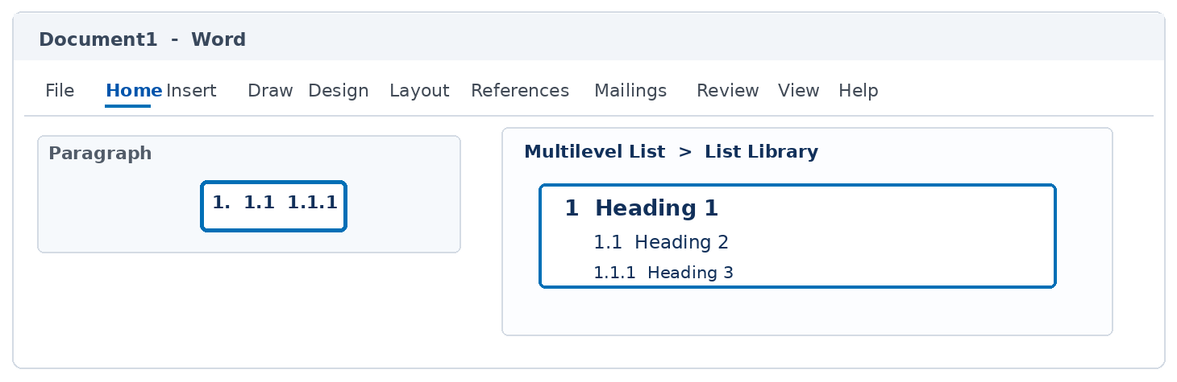
Troubleshooting: if the numbers look wrong, undo once and choose a multilevel-list template linked to the built-in heading styles. Do not correct the numbering by typing numbers manually.

5. Create and format the title page

5.1. Format the title page manually
1. Keep the practice-report label and report title at the beginning of the document, before “Introduction”.
2. Add the student name and number, module name and code, submission date, and fictional-case training note. Insert any placeholders missing from the practice file.
3. Select the cover-page text and choose Home → Paragraph → Centre (or Ctrl + E).
4. Select “Rising Energy Costs and the Strain on Small Businesses”. Apply Home → Styles → Title, or use approximately 26–28 pt, bold.
5. Format “PRACTICE REPORT – FICTIONAL CASE” at approximately 11–12 pt, bold; student/module/date details at approximately 12 pt.
6. Use paragraph spacing to position the training note towards the bottom of the cover; make it approximately 9–10 pt, italic.
Important: Use Title for the cover title, not Heading 1, or it may appear in the automatic contents page.

5.2. Alternative: use Word’s built-in cover page
1. Go to Insert → Cover Page and choose a suitable design.
2. Replace the sample title, author and date fields with the practice-report details. Add any missing fields.
3. Remove duplicate cover text if Word has inserted a new cover above the original text.
Use either the manual method (5.1) or the built-in cover-page method (5.2), not both.

6. Organise pages and create a table of contents

6.1. Arrange the title, contents and main report
1. Page 1: title page with the report title and student details.
2. Page 2: table of contents (created in Section 6.2).
3. Page 3 onwards: main report beginning with “Introduction”.
4. Position the cursor directly before “Introduction” and press Ctrl + Enter twice. This leaves a blank page for the contents between the cover and the report.

6.2. Insert an automatic table of contents
1. On the blank contents page, type “Contents” using Normal or Title style (not Heading 1).
2. Place the cursor underneath “Contents” and choose References → Table of Contents.
3. Choose Automatic Table 1 (or another automatic design), not Manual Table.
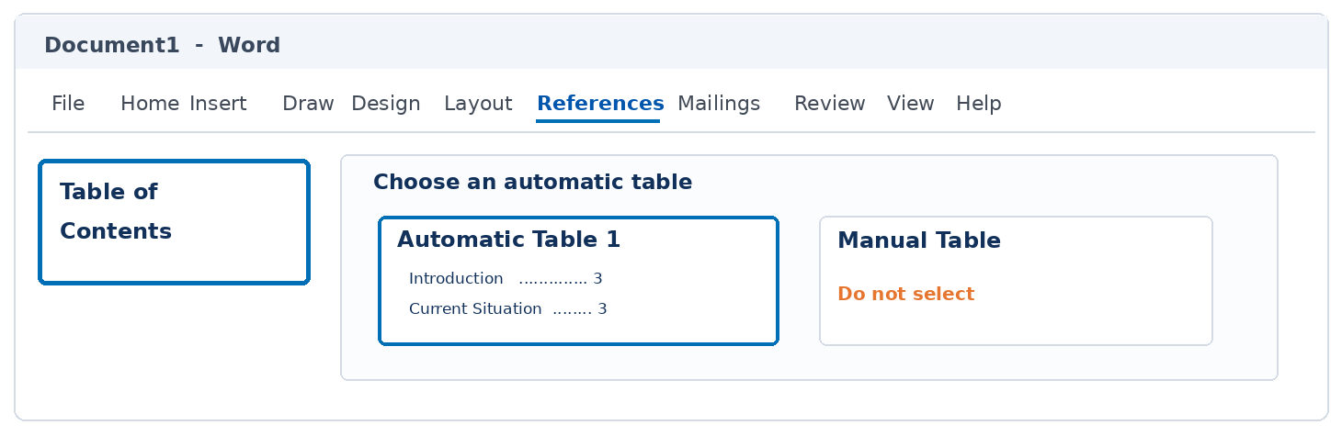
Check: Word should list the Heading 1 entries and Heading 2 subsections with page numbers. If the table is blank, recheck the heading styles.

7. Update the table of contents
1. Change the main heading “Possible Responses” to “Possible Ways to Reduce Costs”.
2. Click inside the table of contents and choose References → Update Table (or right-click → Update Field).
3. Choose Update entire table, because you changed a heading. Check that the contents page displays the new wording.
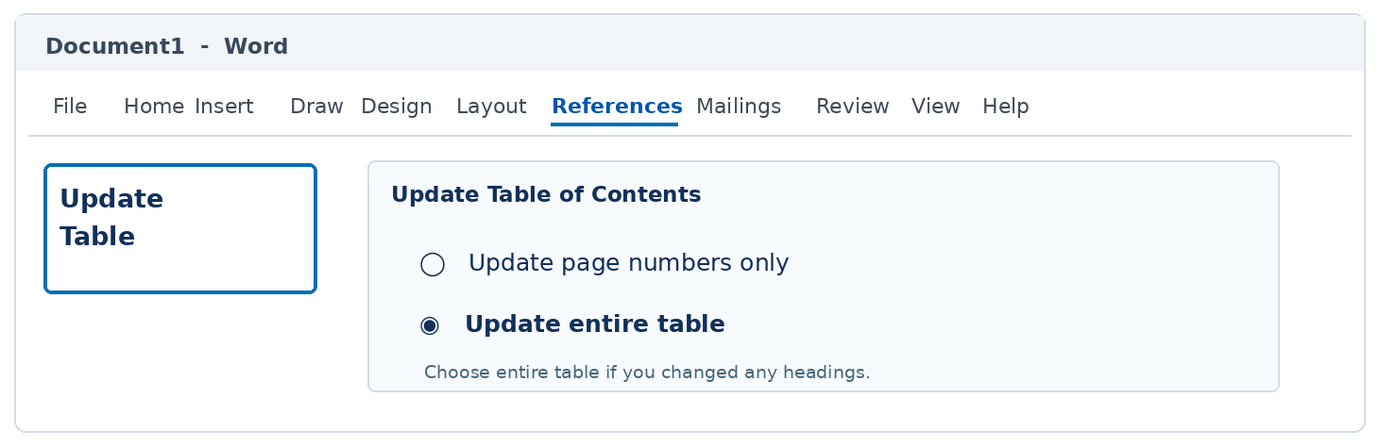

8. Add page numbers and set the cover-page display

8.1. Insert page numbers
1. Select Insert → Page Number and choose a location, such as Bottom of Page.
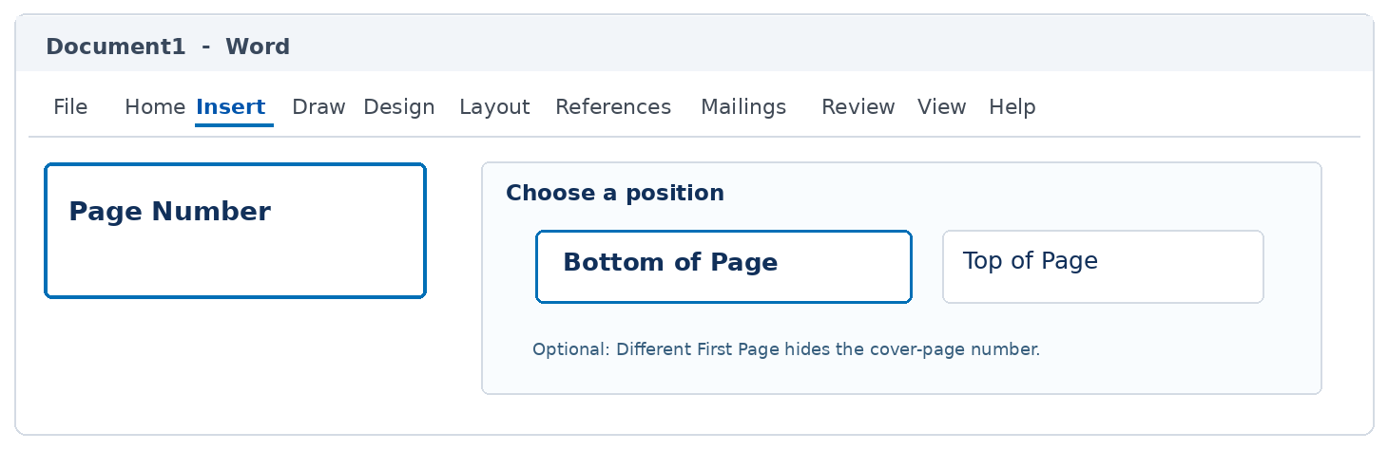

8.2. Hide the page number on the cover
1. Double-click the footer to open the Header & Footer settings.
2. Select Different First Page to hide the page number on the title page.
3. Check that the contents and report pages still show page numbers as required by the assessment.

9. Final check and save
- All main sections use Heading 1 and the six subsections use Heading 2.
- The Navigation Pane reflects the intended report structure.
- Section numbers are automatic and the contents page matches the headings.
- The cover is separate, page numbers appear as intended and ordinary paragraphs use Normal.
- Save As: Rising_Energy_Costs_Formatted_[YourName].docx

Optional: use Review → Word Count to inspect document length.

