University of Wales Trinity Saint David London
Module code: LCBB 4005

THE GLOBAL BUSINESS ENVIRONMENT
ASSESSMENT 2
ENVIRONMENTAL ANALYSIS OF THE IMPACT OF THE PANDEMIC ON THE INDUSTRY: TESLA

Student name: Luminita Capmoale ID 2030541
Lecturer name: Dr. Nadeem Mirza

14.01.2022
word count: 2 206

Table of Contents

Introduction 2

Impact of Covid 19 on global automobile industry 2

Current Megatrends in automobile industry 4

Survival and Success factors for automobile industry 6

Recommendation 8
Conclusion 8

Introduction

The automotive industry worldwide has contributed a major percentage of GDP growth in different nations in the economic arena (Naz and Siddiqui, 2020). The automobile industry is also famous for being one of the largest recruiters of employees worldwide providing them access to a better lifestyle. The manufacturing process, factory units, supply chain, and the demand in the market altogether support millions of jobs and the growth of small and medium enterprises in society (Ha, 2021).
According to Verma and Prakash (2020), the Covid-19 pandemic referred to as the Black swan event has caused several adverse impacts on the automobile industry worldwide.
The automotive market has faced a series of surprises and blows from the government's restriction on travel and movements.Moody’s, the credit rating agency, in their report, slashed the global vehicle sales forecast and provided an expected global vehicle sales decline percentage of 14% in 2020 (Naz and Siddiqui, 2020).
In this report, an analysis has been provided on Global Business Environment and marketing fundamentals of automobile industry in the period of covid-19.
The success and survival factors for the automobile industry have also been evaluated in this paper with certain recommendations at the end of the paper. Finally, a conclusion has been provided to summarise all the points presented in the report.

Impact of Covid 19 on the global automobile industry

The recent outbreak of covid-19, a novel coronavirus by the World Health Organisation has forced the global economy towards a disaster (Xu et al., 2020).

This is the same story for all sectors in the economy that are playing an important role in boosting economic growth and impacting people's life. According to Shetty (2021), vehicle sales globally have seen a negative trend in this period like other sectors. The small and medium automobile industries have been hardest hit and companies like Tesla, Fiat, General Motors, Nissan, Toyota, Jaguar Land Rover, etc. had to shut down many of their manufacturing units (European Journal, 2020).According to Yan et al. (2020), has been analysed that before the pandemic the sales in the automobile sector were rising in certain segments and making new records in the market.
However, according to the Auto Sales Forecast of 2019, the US automobile industry was expected to grow to 17 million units in the year 2020 (Verma and Prakash, 2020).
Also, according to Jacob et al., (2021) by March 2020, covid-19 has consumed the daily activities and brought economic growth to a halt.

Fig: Covid-19 effect on European light vehicle sales
(Source: Roland Berger, 2020))

Because of the covid-19 pandemic outbreak and the government’s confusion on the prospect of upcoming vaccines in the future, there were no other alternatives than imposing mandatory quarantine measures and lockdowns worldwide (IJREAM, 2020).
These restrictions meant that its customers cannot visit the dealership to buy vehicles.

According to Xu et al., (2020), the widespread activities around the world have been considered to influence the economic slowdown even in a worse manner than 2008's global financial crisis. Multiple layoffs were initiated at this time. For example, a global automobile giant call Tesla decided on suspending its production on its largest production unit in San Francisco Bay area vehicle factory on March 24th, 2020 (Naz and Siddiqui, 2020).
The company also decided on suspension of production temporarily in the New York solar roof tile factory because of health precautions (Khrulevand Saraiev, 2021).

Once the announcement was made on temporary suspension of the activities in factories and units the total share of Tesla in the market faced a huge crash of 8% within an hour.
In China, Tesla has been conducting its operations through hundred suppliers under the name of Tesla Shanghai. Tesla has also decided to restrict its activities in China as well.
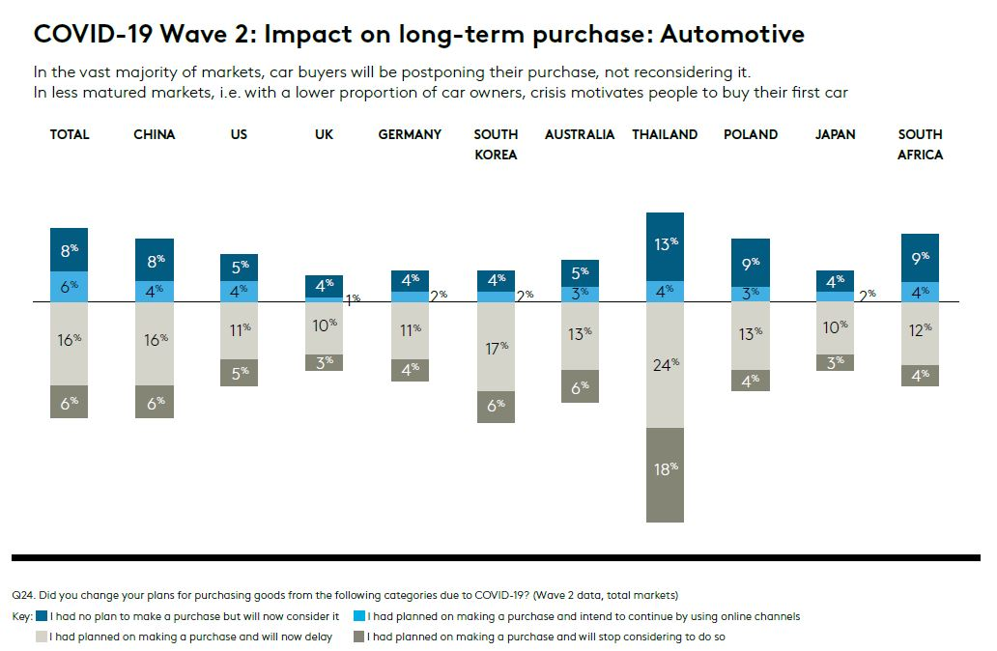
Fig: Impact of Covid 19 wave 2 on Automotive long-term purchase
(Source: European Journal, 2020)

Companies like Nissan had to shut their Barcelona manufacturing unit after experiencing losses altogether more than what it has faced in the last decade. New vehicle sales in the Global market have fallen to a level of 28.9% in April 2020 as compared to April 2019 (European Journal, 2020).
Previously the automobile sector as calculated in the year 2017 was estimated to employ nearly 14 million workers worldwide (Naz and Siddiqui, 2020). But suddenly with the closure of production units and outlets a drastic 2.5 million employees were affected directly by the first-time imposed lockdown. The major automobile companies like General Motors, Ford Motor co., Fiat, etc. also decided on shutting their activities in many areas to stop the contact was disease coronavirus getting spread amongst employees (Scientific Research and Reviews, 2019). Due to this pandemic outbreak, this industry faced an abysmal drop in investment and demand. Sudden restriction of movement resulted in a severe contraction of sectoral output and GDP in almost all the countries. Even today, after two dosages of vaccination, has provided opportunities to multiple governments to restart the economic activities, the automobile sector is yet to recover from the sales backlogs and losses (Shetty, 2021).

Current Megatrends in the automobile industry

A lot of changes have taken place in automobile industries worldwide after the pandemic has hit the industry hardest (Xu et al., 2020). The current competitors in the market such as Toyota, Ford, Tesla, GM, etc. are looking forward to more research and development and innovative products in the market which will attract customers in a huge manner (Jacob et al., 2021).
The automobile companies have adopted several changes which are expected to raise a faster pace in sales figures. Through these innovative and flexible approaches, the manufacturers and dealers are also expected to be more creative (European Journal, 2020). As modern society is looking forward to embracing digitization, the automobile industry in upcoming months is pushing to implement a major online sales drive. Most of the companies focusing away from the petrol and diesel version of cars are concentrating on the electric or battery version as well as hydrogen technology to implement in new car models (European Journal, 2020).

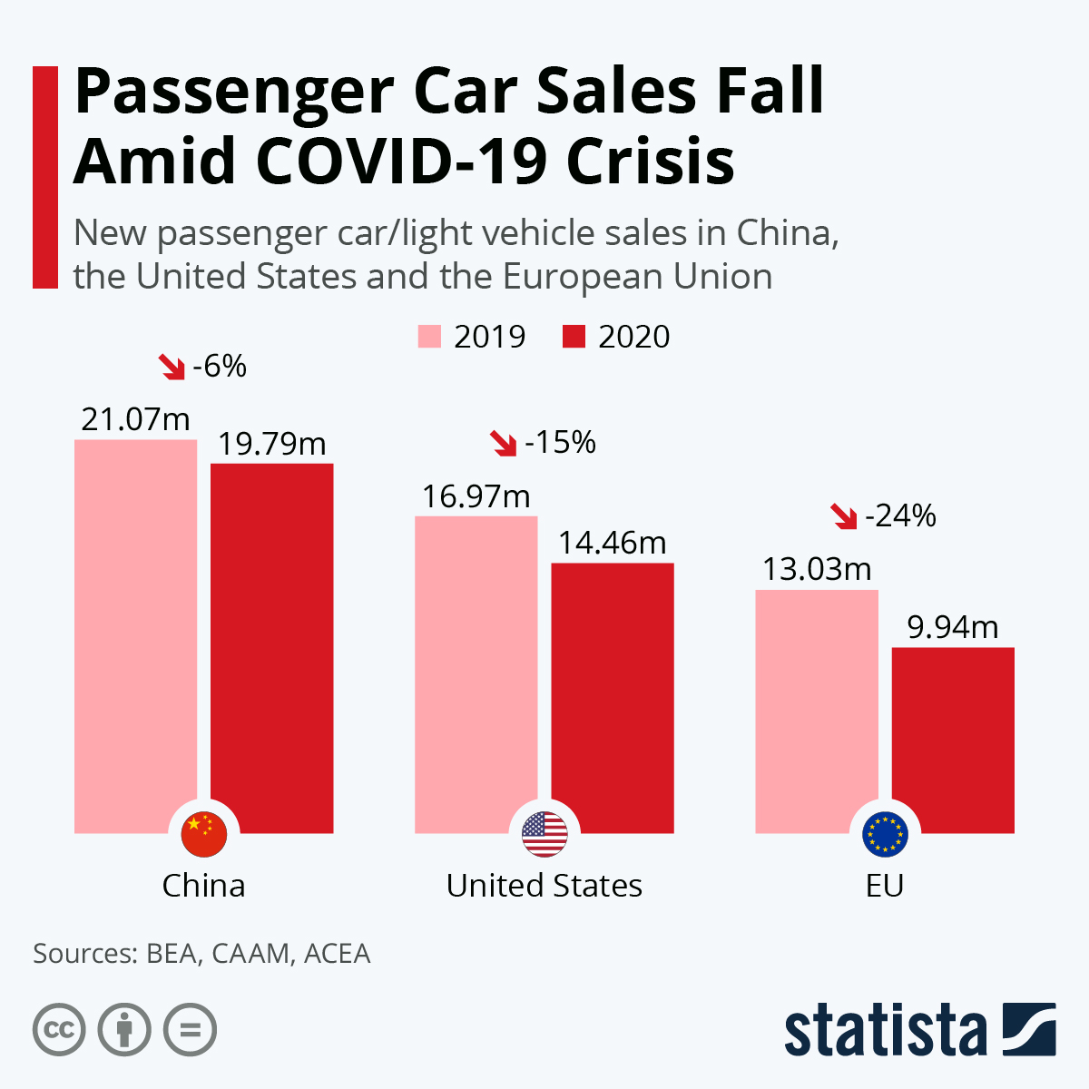
Fig: Fall in Passenger Car sales
(Source: Statista, 2020)

Digitization might become a significant strategy for automobile companies to capture the emerging market share in the coming years.
Automatic gear Technology, artificial intelligence, and internet of things, Bluetooth connectivity, providing Alexa as an intelligent device inside the car to interact with the driver and act accordingly are some of the newest features provided in even medium segment of SUVs such as MG Hector or MG Astor (Khrulevand Saraiev, 2021).
On the other hand, as per Baldwin and Tomiura (2020), companies like Hyundai, Honda, Maruti Suzuki irrespective of economic slowdown due to the pandemic in the global platform have performed well as compared to the other companies. Apart from changes like vehicle on-screen controls, digitization of accessibility, integration of technical advances in the car companies like Hyundai, Toyota, and Ford are also looking forward to touchless gas station payments and maintenance (IJREAM, 2020).

Apart from these changes the companies and dealerships are also looking forward to providing reduced interest rates and incentives in terms of car accessories as free items with the purchase of a car (Guan et al., 2020).
The companies are coming up with a lot of discount offers for potential buyers in the market to raise the possibility of increasing sales figures within two or three quarters (Jacob et al., 2021). On the other hand, companies are also focusing on autonomous vehicles as the modern generation is practically practicing social distancing after the coronavirus pandemic.

However, with the negative trend in the economic arena, the positive side of the pandemic has been successful to make people aware of the fact that owning a car can be helpful in certain emergencies (European Journal, 2020). In most of the developing and underdeveloped countries the medium and lower range of cars have seen a boost in the sales figures during the first or second phase of annulment of travel restrictions and quarantine measures once the vaccines came into the market (Ha, 2021).

In the view of Belhadi et al. (2021), this has been the trend because people have started to understand that public transport may not be in service. After all, the government decides on movement restrictions. The author further emphasizes that owning a car in case of medical emergencies, the need of travelling for some urgent work is no anymore considered a luxury. This has opened the possible door for car manufacturers to work on the implementation of multiple strategies focusing on the lower and medium range of cars in emerging markets.

Survival and Success factors for the automobile industry

The survival and success factors after the pandemic have provided several opportunities for automobile companies to increase research and development to understand the consumer behavior, market trend, and future expectations of potential buyers. For people in developing countries owning a car has become a necessity (Baldwin and Tomiura, 2020).
It has increased the opportunity for automobile companies to increase their research and development on autonomous vehicles in medium and low-price ranges for more convenience of people getting attracted towards buying a car. Additionally, the automobile industry is focusing on investing in the supply chain and improving the supply chain models (European Journal, 2020). Most of the companies are taking machine learning tools and big data analytics for this purpose. The companies are also aware that adopting such technology will provide efficiency of the supply chain (Guan et al., 2020).

On the other hand, it will create a strong background so that the companies do not face a total description because of certain outbreaks like an epidemic, pandemic, natural calamity, war situation or internal conflicts, etc.
Fig: Impact of Covid 19 on supply chains of different companies
(Source: Guan et al., 2020)

The covid-19 can also be controlled, and productions can also be revived in a faster manner following these steps (Naz and Siddiqui, 2020). The government also globally has implemented economic responses to boost the automobile sector. The International Monetary Fund or IMF has provided an economic response in terms of financial assistance to 193 countries to boost the automobile industry as well as other sectors which have been severely impacted by the coronavirus pandemic (Verma and Prakash, 2020).
Alongside that a G20 Group has decided to collectively safeguard financial stability, recover the downtrodden economic trend worldwide and revive growth by minimizing disruptions in global supply chains and trade have come up taking several measures in finance public health and ease in international business(Jacob et al., 2021).
International Labour Organisation (ILO) also took a lot of measures to promote employment retention other subsidies paid leave and short-time work to industries like an automobile for the betterment of employee's lifestyles after the pandemic (IJREAM, 2020).
Companies like Tesla, Toyota, Jaguar Land Rover, Ford Motors, etc. have decided to do major investment behind research and development after the lessons learned from the pandemic and provide a path for new and innovative ideas that can set unique standards for the industry in years to come(Baldwin and Tomiura, 2020). The automobile industry has seen new registrations for electric cars much more than the other counterparts during this lockdown period. So, the findings define that CO2 emissions have led people to desire an environmental impact rather than traditional vehicles at cheaper prices (Shetty, 2021).

Recommendation

Hence, certain recommendations can be suggested to the automobile industry:

- Rising interest in electric vehicles in the market, new work from home standards of IT companies, an emerging trend in integrated digitization has to be focused more to bring systematic changes in the automobile industry to create a new and strong supply chain model.

- However, the restart of public transportation has raised the fear of infection transmission and this has made private vehicles a more preferred option.

- Several dealers are recommended to quickly adapt Technologies such as online sales methods to reach out to customers (Khrulevand Saraiev, 2021).

- The dealers are also recommended to push sales forward through online walkthroughs and provide test drives or delivery at the doorstep.

- The automobile manufacturers have to realize that electric cars can be a game-changer in the future as a potential section of wire preferred electric cars instead of diesel-powered or gasoline-powered vehicles(Jacob et al., 2021).

- Several countries and their governments have taken policies and initiatives to subsidize the buyers of electric cars to promote a sustainable environment as the Sustainable Development Goals of the UN (Shetty, 2021).

- It is recommended that the rising consciousness of buyers towards more advanced technology and carbon emission can provide a field of potential growth and competition in the global automobile market in near future.

Conclusion

It can be concluded that the report has successfully analysed the current market trend of the automobile industry. It has also been briefly discussed how the major forces have shaped the global automobile sales and provided a path towards understanding the changing Global Business Environment for companies in the market. With the current trends of the automobile industry analysed in the report critically, it can be evaluated that companies should look towards making more innovative automobile products with less emission of CO2 and provide a competitive market price to the buyers for hype in sales in near future.

References:

Baldwin, R. and Tamiura, E. (2020) ‘Thinking ahead about the trade impact of COVID-19’, Economics in the Time of COVID-19, 59.

Belhadi, A. et al. (2021) ‘Manufacturing and service supply chain resilience to the COVID-19 outbreak: Lessons learned from the automobile and airline industries’, Technological Forecasting and Social Change, 163, p.120447.

European Journal (2020) ‘The Impact of the Rising Costs of Gasoline on Automobiles Owners in Saudi Arabia’, European Journal of Business and Innovation Research, 8(1), pp.43-51.

Guan, D. et al. (2020) ‘Global supply-chain effects of COVID-19 control measures’, Nature human behavior, 4(6), pp.577-587.

Ha, G. (2021) ‘Comparative Analysis of Management Efficiency of the Automobile Industry before and after COVID-19’, Regional Industry Review, 44(3), pp.307-325.

IJREAM (2020) ‘Status of Automobile Industry Post Covid-19’, International Journal for Research in Engineering Application & Management, pp.17-20.

IJSR (2021) ‘Hydrogen as Fuel in Automobiles’, International Journal of Science and Research (IJSR), 6(1), pp.1745-1746.

Jacob, S., Karikalan, L. and Vijay, S. (2021) ‘Experimental investigation and testing of impact absorption mechanism for automobiles’, Materials Today: Proceedings, 37, pp.627-630.

Khrulev, A. and Saraiev, O. (2021) ‘THE METHOD OF EXPERT ASSESSMENT OF THE TECHNICAL CONDITION OF AN AUTOMOBILE ENGINE AFTER OVERHEATING’, Automobile transport, (48), pp.5-16.

Naz, F. and Siddiqui, D. (2020) ‘Impact of Macroeconomic Factors on Automobiles Stocks Returns in PSX’, SSRN Electronic Journal.

Roland Berger (2021) [online] Rolandberger.com. Available at: https://www.rolandberger.com/publications/publication_pdf/roland_berger_automotive_suppliers_2020.pdf (Accessed 14 December 2021).

Scientific Research and Reviews (2020) ‘Research on Distribution Efficiency of Automobile After-sales Spare Parts Based on System Dynamics’, Scientific Research and Reviews.

Shetty, S. (2021) ‘Factors impacting Purchase Behaviour of Automobiles Post Covid-19’, Psychology and Education Journal, 57(9), pp.6154-6161.

Statista (2021) Coronavirus: impact on the automotive industry worldwide.
Available at: https://www.statistacom.proxy.library.upenn.edu/study/71599/impact-of-the-coronavirus-pandemic-on-the-auto-industry-worldwide/ (Accessed 20 December 2021).

Verma, A. and Prakash, S. (2020) ‘Impact of covid-19 on environment and society’, Journal of Global Biosciences, 9(5), pp.7352-7363.

Xu, Z., Elomri, A., Kerbache, L. and El Omri, A. (2020) ‘Impacts of COVID-19 on global supply chains: facts and perspectives’, Engineering Management Review, 48(3), IEEE pp.153-166.

Yan, Y., Zhong, S., Tian, J., and Jia, N. (2020) ‘An Empirical Study on Consumer Automobile Purchase Intentions Influenced by COVID-19’, SSRN Electronic Journal.

