BMIH6007
INTERNATIONAL MEETINGS MANAGEMENT FOR THE HOTEL INDUSTRY
ASSIGNMENT TITLE: EVENT STRATEGIC PLANNING AND DELIVERY CONSIDERATIONS FOR AN INTERNATIONAL MEETING / EVENT
STUDENT NAME: Ana Maria Moise
STUDENT ID: 2233131
LECTURER’S NAME: Kathryn Roberts

Executive summary
The report has critically evaluated the ‘Year of Legends’ marketing event by Visit Wales. This has focused on enhancing the global visibility of and hospitality performance by improving storytelling and cultural heritage. It has explored the strategic use of cultural themes and event management practices to strengthen the tourism economy.
Scope of the research
The report has focused on evaluating the background, event cycle and market objectives of the background of the event. It has also examined the management resources, budget planning and situational factors that can influence the successful execution of the event.
Key findings
- The ‘Year of Legends’ campaign has effectively showcased the culture of Wales.
- Wales has strengthened the hospitality sector by generating an estimated £150 million annual tourism expenditure.
Recommendations
- The tourism sector is suggested to promote sustainable tourism practices by aligning with circular economy principles.
- Develop rapid training programmes for the workers for effective communication.
Conclusion
The ‘Year of Legends’ has demonstrated the success of Wales that is creating a distinctive national identity. It has been found that sustaining growth will require continued innovation for promoting sustainable tourism.

Introduction

Description of the event
The ‘Year of Legends’ is a rich storytelling, tourism-focused event that aims to bring Welsh culture, modern-day legends and history to the forefront of Visit Wales’ marketing efforts. The marketing event features an unprecedented calendar of creative activities in the castles of Wales. The primary purpose of this marketing event was to boost tourism activities by promoting the traditional cultural aspects and heritage of Wales. This led to a significant increase in visitors to Wales and an economic boom for Wales. Additionally, the marketing event enhanced Wales’ engagement with tourism organisations by reflecting the theme of ‘Year of Legends’.

Background
The ‘Year of Adventure 2016’ was the first series of thematic tourism years that focused on product development and promotion of the cultural insights of Wales. In the historical background of the ‘Year of Legends’, this very first theme accelerated the number of visitors to over 40% and led to a 15% increase in day-visitor spending to Wales of 15% in the context of international tourism visits (GOV.WALES, 2025a). The introduction of the ‘Year of Legends’ resulted in a tourism expenditure of £150 million per year, with culture and heritage promotion as the main focus .

Figure 1: Wales tourism sites
(Source: BBC.com, 2025a)
This was an ambitious £5 million marketing campaign that ran in Wales, UK, Ireland, Germany and the USA (GOV.WALES, 2025b). The campaign was broadcast at Llyn Llydaw in Snowdonia, advertising an intriguing and inspiring introduction to the Welsh cultural heritage and characters.

The Event Cycle

Definition of the Event Cycle
The event cycle can be defined as the process of showcasing, Welsh cultural heritage to bring modern-day legends and epic history to life. The entire event of is structured around three primary themes, including the ‘Year of Adventure’ in 2016, the ‘Year of Legends’ in 2017 and the ‘The Sea’ in 2018 (Theroyalvictoria.co.uk, 2025). Visit Wales approved £1.28 million for 35 different projects as the pivotal parts of the ‘Year of Legends’. This included a Merlin Festival in Carmarthen to celebrate the legends of Merlin and other Arthurian characters.
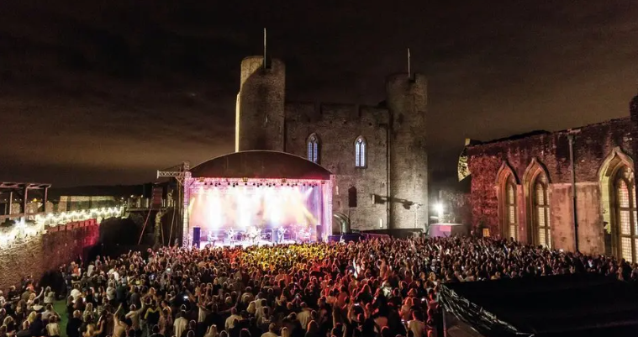
Figure 2: Merlin Festival in Carmarthen
(Source: BBC.com, 2025a)
Literature Wales was another significant part of the event that advertised the places associated with Welsh myths and epic stories. The promotion of Welsh heritage throughout this marketing event resulted in a total of 61% overseas visitors visiting the showcased sites of Wales (BBC.com. 2025a). The event cycle significantly influenced a wider celebration of Welsh legends.

Application in the marketing event
The purpose of developing this marketing event is to enhance the viability of the original event known as the ‘Year of Legends’, organised within the framework of Meeting, Incentive, Conference and Exhibition (MICE). This will help better promote the ‘Year of Legends’ campaign organised by Visit Wales. The application of this campaign will rely upon an effective embracement of the tourism theme by empowering culture tourists, business representatives and incentive groups in Snowdonia National Park within Wales. The event program will apply the key aspects from the original event of the ‘Year of Legends’, such as Welsh heritage and innovation. More specifically, this marketing event will enhance the credibility of service delivery for the Welsh hospitality and tourism industry. The total number of tourism enterprises registered in Wales was 12,625, which accounted for 11.8% of the total UK-based hospitality organisations (GOV.WALES. 2025c). A proper application of this marketing event will support growth in Welsh tourism and hospitality organisations.

Event Concept
Guests will experience multifaceted characteristics of the Welsh cultural insights on the day of this marketing campaign. The campaign will be a seven-day cultural festival and incentive trip related to the original insights from the ‘Year of Legends’.

Figure 3: Snowdonia National Park, Wales
(Source: Britannica.com, 2025)
The campaign will offer a combination of incentives, conferences, meetings and exhibitions. The campaign will take place in Snowdonia National Park. This is a popular tourism location in Northern Wales with a total area of 838 square miles (Britannica.com, 2025). This will be renowned as the A Sense of Place Summit that will cater to the international audience base of MICE.
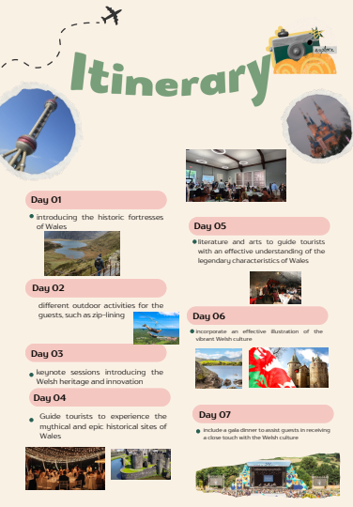
Figure 4: Event itinerary
Day 1 of the campaign will be all about introducing the historic fortresses of Wales and mapping the specific legendary locations for the guests. Day 2 will consist of different outdoor activities for the guests, such as zip-lining. This will help the guests experience the natural beauty of the location. Day 3 will consist of the keynote sessions introducing the Welsh heritage and innovation to the guests. The myth tours on Day 4 will guide tourists to experience the mythical and epic historical sites of Wales. The local dinner evenings will offer an inclusive experience to the guests about the Welsh traditional foods and cooking insights.
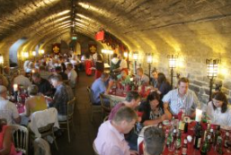
Figure 5: Gala dinner
(Source: THEACTC.com, 2025)
Day 5 will be a day full of literature and arts to guide tourists with an effective understanding of the legendary characteristics of Wales. Day 6 will incorporate an effective illustration of the vibrant Welsh culture. A gala event is a themed evening event that aims to immerse guests in a rich tapestry of Welsh culture (THEACTC.com, 2025). Similarly, Day 7 will include a gala dinner to give guests a deeper connection with Welsh culture.

Aim and Objectives of the Event
The event will aim to boost the hospitality sales and revenue of Wales throughout the promotion of Welsh culture via the ‘Year of Legends’. The SMART objectives that will assist in the effective execution of this aim are discussed below.
Goals | SMART objectives
Goals | Specific (S) | Measurable (M) | Attainable (A) | Realistic (R) | Time bound (T)
To promote the Welsh culture to a wider international audience | Advertising the origins of the ‘Year of Legends’ organised by Visit Wales | Enhancing the rate of overseas visitors by 7% | Bringing legendary culture to life | Promoting Welsh culture and heritage | 5 months
To boost the revenue of the Welsh hospitality industry | Accelerating hospitality sales in Wales | Accelerating hospitality revenue by 5% | Boosting the awareness of Welsh hospitality organisations | Enhancing the hospitality employment rate in Wales | 4 months
Table 1: SMART objectives

Event Management

Event management resources
The management of this event will require several internal and external resources to effectively achieve the strategic goals. Availability and effective reinforcement of operational resources is crucial to gain increased efficiency (Bowdin, 2023). An example of operational resources required for this event management is human resources. HR managers will be involved in developing a skilled workforce to ensure a high-quality visitor experience throughout this event. Strategic planning will be a necessary approach to support the proper conduct of this event by addressing the potential risks. Similar to operational management, strategic planning will also require some specified resources, such as data analytics tools.
Type | Resource |  | Link to the hospitality theme
Operational resource | Human Resource (HR) | Cultural consultants, event managers, catering staff, AV technicians, security agents | - Development of a culturally skilled workforce  - Managing mutual and trustworthy relationships with clients
Operational resource | Technological resource | Live streaming media platforms, event management software, translation systems, and online and offline ticketing platforms | - Supporting a bilingual delivery  - Seamless hospitality journey
Operational resource | Physical resource | Seating arrangements, ICC Wales venue, lighting, exhibition stands, stage | - Creation of an immersive atmosphere for the promotion of the ‘Year of Legends’  - Effective service delivery
Operational resource | Transport and logistics | Airport transfers, Shuttle buses, accessibility features,  signage
Planning resource | Financial planning | Human capital, forecasting software, analytical tools | - Effective resource allocation  - Improved operational efficiency
Planning resource | Risk management | Risk matrix, market insights
Marketing resource | Partnerships | Local councils, Visit Wales, and cultural organisations | - Wider promotion of the Welsh cultural principles
Marketing resource | Advertisements | Digital media platforms, emails and phone calls | - Wider promotion of the Welsh cultural principles
Table 2: Event management resources
Reinforcement of adequate resources will result in increased operational efficiency. The event will rely solely on HR managers to develop a culturally skilled workforce. This will navigate the gaps in cultural knowledge and understanding for the existing practitioners. Training and development, as well as an effective hiring approach will strengthen this resource and ensure quality service delivery for the guests. The Resource-Based View (RBV) considers the tangible and intangible resources of an organisation as the sources of gaining competitive advantage (Khanra et al., 2022). Similarly, possession of these intangible and tangible resources will ensure competitiveness for this marketing event. High availability of technological resources will enhance the quality of seamless communication and the journey of visitors in this campaign. Additionally, technical efficiency will facilitate the proposed digital marketing strategy for this event. However, a high financial burden may be a limitation of this resource plan.

Event management skills
Achieving the planned initiatives and event goals will require numerous skills. Conferences in this event will require event management expertise from MICE operations and bilingual coordination. Strong organisational and communication skills are essential assets of individuals in the context of event management (Kitchen, 2025). Problem-solving skills of event management professionals ensure a greater ability to adapt to the evolving circumstances. The hospitality landscape is shaped by rapid changes driven by shifting customer behaviour.
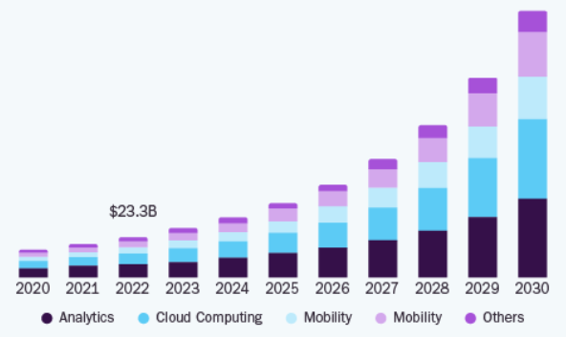
Figure 6: UK digital transformation market size
(Source: Grandviewresearch.com, 2025)
The availability of problem-solving skills will ensure greater adaptability of this event to meet the changing external and internal patterns. Proficiency in communicating in different languages is a major criterion in hospitality event management in terms of improving the quality of interactions (Cuic Tankovic, Kapeš and Benazić, 2023). The event professionals must have the ability to communicate in Welsh and English to improve the guest experience. The growth rate of the digital transformation market in Great Britain is projected to be 27.7% (Grandviewresearch.com. 2025). This represents an increasing demand for personalised customer experience and digital communication. Therefore, digital proficiency of professionals will be another key skill for meeting the evolving needs of the hospitality industry and conquering the event objectives.

Event Budget
Category | Insights | Estimated cost (£) | Estimated income (£)
Production and equipment | Infrastructure development, such as stage, lighting, seating arrangement and sound system | 25,000
Venue Hire (ICC Wales) | Hiring the conference halls, meeting rooms and auditoriums | 45,000
Transport and Logistics | Accessibility setups, local tours, signals and transfers | 15,000
Sponsorships and Grants | Local communities, government, Visit Wales and governmental councils |  | 40,000
Catering and Hospitality | Receptions, dinners, and Welsh cuisine sampling | 30,000
Merchandise and Vendor Fees | Artisan market stall offers and branded souvenirs |  | 10,000
Accommodation Partnerships | Sponsored hotel packages and incentive collaborations |  | 20,000
Marketing and Promotion | Branding, digital campaigns, online advertisements and promotional materials | 20,000
Ticket Sales (500 delegates) | £250 per delegate |  | 125,000
Staffing and Operations | Technical crew and event managers | 35,000
Contingency management | Risk management | 17,000
Total |  | 187,000 | 195,000
Table 3: Event budget
The predicted budget plan includes all the necessary activities and their estimated costs or income. Budgeting provides a financial roadmap in event management to facilitate an effective forecast of the necessary resources and their associated financial expenditure (Kitchen, 2025). The total cost for conducting this event is estimated to be £187,000 and the projected income through this event is £195,000. The major income-generating source of this event will be ticket sales, with each delegate charged £250.

Industry Trends
Two primary trends that are currently bringing several changes to the Welsh hospitality landscape are growing sustainability efforts and technological integration. The UK is one of the leading EU countries in technical advancement. The shifting consumer interest towards sustainable purchase and green tourism has brought several shifts to the current hospitality context, such as green packaging, sustainable sourcing and many more.
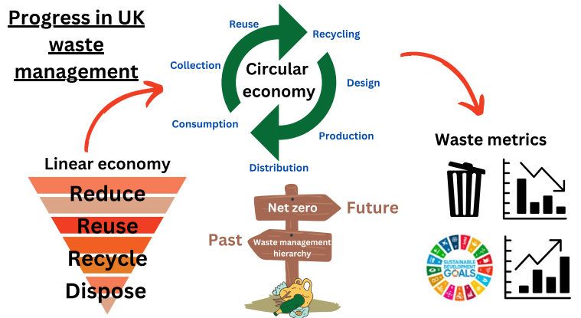
Figure 7: Numbers of sequence and accuracy
(Source: Zandieh, Thornley and Chong, 2024)
The sustainability commitment of Britain has made its corporate sectors more conscious of waste reduction and emission reduction (Zandieh, Thornley and Chong, 2024). In such a context, the promotion of green initiatives will be necessary via the ‘Year of Legends’. Additionally, the event will also need to comply with the circular economy practices to implement strict controls on waste generation and environmental protection.

Situational and Cultural Considerations

PESTLE
Dimension | Insights
Political | A Political Index Stability score of 0.51 (Theglobaleconomy.com. (2025)
Political | Parliamentary democracy
Economic | Inflationary crisis and increasing CPI to 3.8% (ONS.GOV.UK, 2025)
Economic | 892,000 visits in 2023 in Wales (GOV.WALES, 2025d)
Economic | A total employment of 11.8% of the total hospitality industry employment in the UK (GOV.WALES, 2025c)
Social | Shifting demographics
Social | Cultural diversification and ethnicity
Technological | Digital transition growth rate of 27.7% between 2025 and 2030 (Grandviewresearch.com, 2025)
Technological | Advanced cloud-based tools and digital communication
Legal | The Development of Tourism Act 1969 (Legislation.gov.uk, 2025)
Environmental | Commitment to circular economy principles
Table 4: PESTLE analysis
The external situational analysis of this event will primarily focus on the political, economic, social and technological factors. The hospitality industry of Wales is a major economic contributor with around 11.8% of the total UK hospitality employment (GOV.WALES, 2025c). This will ensure a high availability of skilled staff to execute this campaign.
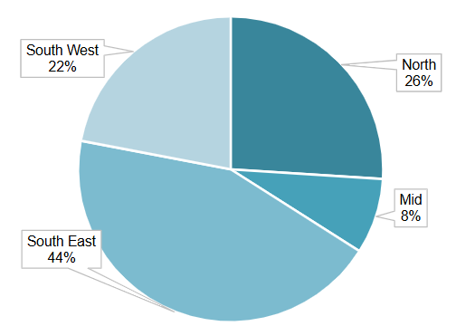
Figure 8: Employment rate of the Welsh hospitality industry by region
(Source: GOV.WALES, 2025c)
Growing digitalisation and integration of emerging technologies have also enabled the tourism and hospitality enterprises to drive seamlessness and personalisation in their services. This insight will create a supportive atmosphere to support effective event delivery by driving personalised service delivery.
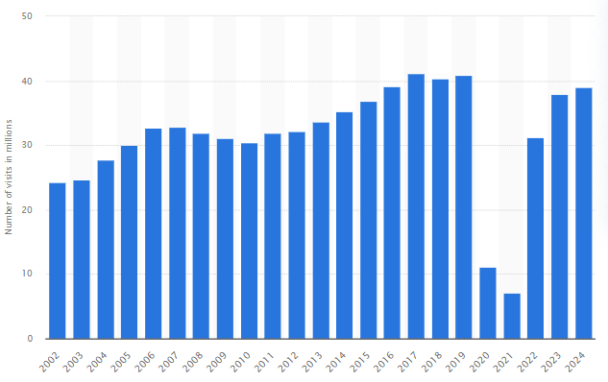
Figure 9: Number of overseas visits in the UK
(Source: Statista.com, 2025b)
However, shifting demographics may be an issue for the event in considering the cultural origins of the ‘Year of Legends’. For instance, overseas visits in Wales have dropped by 33% (BBC.com, 2025b). Overall, the number of inbound visits in the UK has decreased from 40.9 million in 2019 to 39 million in 2024 (Statista.com, 2025b). Rapid changes in visitor demographics and customer behaviour have been assessed as the primary reasons behind this decline. The UK is a leading country with high cultural diversity and a strong commitment to ethnicity. This will be an advantageous external factor to promote the cultural heritage of Wales via this marketing event.

SWOT
Strengths | Weaknesses
- High hospitality employment rate in Wales  - Advanced infrastructure  - Digital ecosystem | - Changing demographics  - Lower diversification  - Poor regulatory bodies
Opportunities | Threats
- Acceleration of sales  - Innovation in service quality | - Regulatory changes  - Data privacy issues
Table 5: SWOT analysis
The strengths of Wales include a robust employment number and increasing hospitality growth. However, changing demographics after the pandemic have led to a declining number of visitors. Here, the concept of RBV also underlies the unique strengths of the region. The event can harness the power of greater employment numbers and hospitality growth of Wales to attain a competitive advantage and sustainability.

Conclusion
The report has presented a profound portfolio of contemporary hospitality management. The analysis has proposed an inclusive plan for promoting the Welsh cultural heritage, originating from the Year of Legends’ in 2017. The event will aim to boost customer satisfaction and sales of the Welsh hospitality enterprises. Human resources are considered essential to successfully deliver this event campaign based on the development of a skilled workforce. Overall, the situational analysis has recognised a positive scope for this event by considering the current technological, social and economic dimensions of the UK.

Reference list
BBC.com. (2025a). Wales' past brought to life as part of Year of Legends | BBC.com. Available at: https://www.bbc.com/news/uk-wales-38494328 [Accessed 1 November. 2025].
BBC.com. (2025b). Tourism: Overseas visitors to Wales drop by 33% | BBC.com. Available at: https://www.bbc.com/news/uk-wales-66417213 [Accessed 1 November. 2025].
Bowdin, G.A., Allen, J., Harris, R., Jago, L., O'Toole, W. and McDonnell, I., (2023). Events management. Routledge.
Britannica.com. (2025). Snowdonia National Park | Britannica.com. Available at: https://www.britannica.com/place/Snowdonia-National-Park [Accessed 2 November. 2025].
Cuic Tankovic, A., Kapeš, J. and Benazić, D., (2023). Measuring the importance of communication skills in tourism. Economic research-Ekonomska istraživanja, 36(1), pp.460-479. Available at: https://doi.org/10.1080/1331677X.2022.2077790
GOV.WALES. (2025a). Welcome to Wales’ Year of Legends 2017 | GOV.WALES. Available at: https://www.gov.wales/welcome-wales-year-legends-2017? [Accessed 27 October. 2025].
GOV.WALES. (2025b). Wales’ Year of Legends 2017 campaign goes live | GOV.WALES. Available at: https://www.gov.wales/wales-year-legends-2017-campaign-goes-live [Accessed 30 October. 2025].
GOV.WALES. (2025c). Wales visitor economy profile: 2024 | GOV.WALES. Available at: https://www.gov.wales/wales-visitor-economy-profile-2024-html [Accessed 2 November. 2025].
GOV.WALES. (2025d). International inbound visits and spend to Wales. GOV.WALES. | Available at: https://www.gov.wales/international-inbound-visits-and-spend-wales-html [Accessed 29 October. 2025].
Grandviewresearch.com. (2025). U.K. Digital Transformation Market (2023 - 2030). Grandviewresearch.com. | Available at: https://www.grandviewresearch.com/industry-analysis/uk-digital-transformation-market-report [Accessed 29 October. 2025].
Khanra, S., Kaur, P., Joseph, R.P., Malik, A. and Dhir, A., (2022). A resource‐based view of green innovation as a strategic firm resource: Present status and future directions. Business Strategy and the Environment, 31(4), pp.1395-1413. Available at: https://doi.org/10.1002/bse.2961
Kitchen, E., (2025). Building event management skills through authentic assessment. Educational Studies, 51(5), pp.1057-1073. Available at: https://doi.org/10.1080/03055698.2024.2405808
Legislation.gov.uk. (2025). Development of Tourism Act 1969. Legislation.gov.uk. | Available at: https://www.legislation.gov.uk/ukpga/1969/51 [Accessed 29 October. 2025].
ONS.GOV.UK. (2025). Inflation and price indices. ONS.GOV.UK. | Available at: https://www.ons.gov.uk/economy/inflationandpriceindices [Accessed 29 October. 2025].
Statista.com. (2025b). Number of overseas resident visits to the United Kingdom from 2002 to 2024 | Statista.com. Available at: https://www.statista.com/statistics/287133/annual-number-of-overseas-visits-to-the-united-kingdom-uk/ [Accessed 1 November. 2025].
THEACTC.com. (2025). Gala Dinner | THEACTC.com. Available at: https://theactc.com/gala-dinner [Accessed 2 November. 2025].
Theglobaleconomy.com. (2025). United Kingdom: Political stability | Theglobaleconomy.com. Available at: https://www.theglobaleconomy.com/United-Kingdom/wb_political_stability/ [Accessed 1 November. 2025].
Theroyalvictoria.co.uk. (2025). Step back in time with Visit Wales' Year of Legends | Theroyalvictoria.co.uk. Available at: https://theroyalvictoria.co.uk/journal/step-back-in-time-with-visit-wales-year-of-legends [Accessed 30 October. 2025].
Zandieh, Z., Thornley, P. and Chong, K., (2024). Progress of waste management in achieving UK’s net-zero goal. Journal of Material Cycles and Waste Management, 26(5), pp.2601-2619. Available at: https://doi.org/10.1007/s10163-024-02003-8

