Hospital Wireless Network

Replacement Report

Nick Alexander

Student Number: P147734
Module Name: Project Management
Assignment title: Individual Report for Disaster Recovery
Module Tutor: Sue Maw

Module Code: ACDA5004

Table Of Contents

HOSPITAL WIRELESS NETWORK 1
REPLACEMENT REPORT 1
INTRODUCTION 1
PROJECT INITIATION DOCUMENT 1
DEMONSTRATION 2
IMPLEMENTATION 2
Planning- 2
Structure- 2
Design- 2
RISK MANAGEMENT 2
Finance – 3
CODE OF PRACTICE 3
Sustainability 3
ETHICAL & LEGAL 4
Resource consumption- 4
Why be ethical? 4
QUALITY ASSURANCE 4
Effectiveness 4
Productivity 4
Safety 4
Satisfaction 4
Customer satisfaction 5
Functionality 5
Reliability 5
Usability 5
REFERENCES 5

Abstract—previously, a PID was written for a suggested backup/recovery system for a hospital. The particular hospital was in an earthquake zone, so the design was to wirelessly reconnect any ward which had become disconnected from the server. The design was demonstrated and approved, so for the final section of project planning / management, this report will investigate further into areas such as risk management, sustainability, ethical and legal issues as well as quality metrics.

Introduction
As mentioned in the PID and demo, the design of the network recovery system is to have two wireless access points pre-setup in a strong box, ready to replace the cables that are currently connecting the ward’s computers to the network. This can be quickly connected to the affected computers, switched on and network connectivity would be restored. This could
be easily done (critically by any non-technical member of staff) without having to wait for IT support to arrive. [1]
Every project will have a ‘knock-on’ effect, this could be the waste that will be created during the manufacture of the product, people travelling for meetings, paper being printed etc. – This report will consider the implications of creating the system proposed in the PID.

Project Initiation Document
The PID showed a typical network design that would be in a hospital – a ward full of computers all linked back to a server by cables. Figure 1 shows the current situation designed in software called ‘Packet Tracer’:

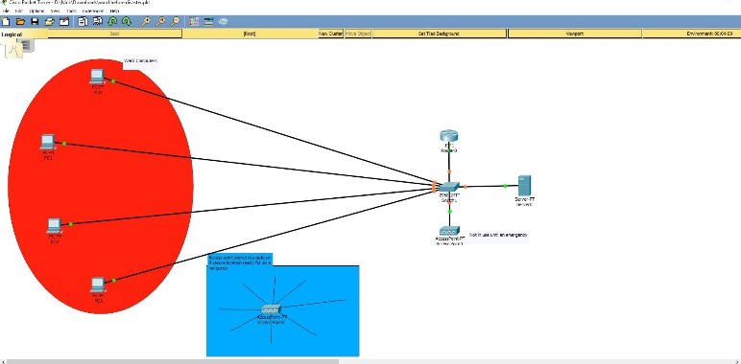
Figure 1 shows computers in a ward connected to the server by cables. The disaster recovery box (shown in blue) is stored safely until needed.

If the cables or switch etc were to be damaged in a natural disaster then they could quickly be replaced by the pre-set kit which we designed -see Figure 2:
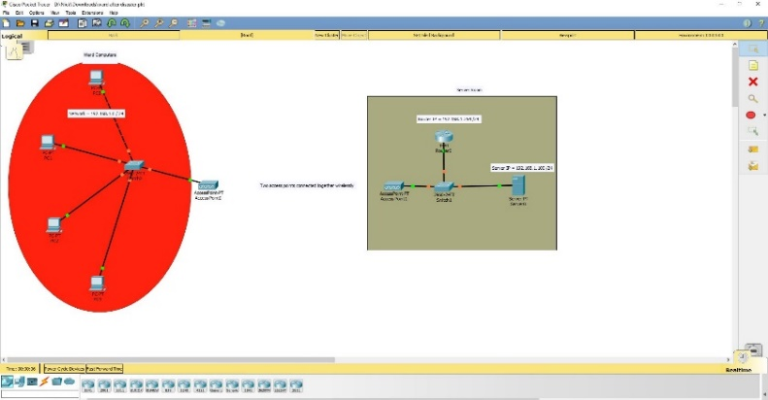
Figure 2 – After a disaster, the access points would be taken out of the box, connected to all the computers in the ward, which would link them all to the server by Wi-Fi instead of cables

Demonstration
Another part of planning this project was time management, showing which stages of the process would affect other aspects. This was designed in Microsoft Project. During the demonstration it was shown how a delay in one section affects the events later on and can delay the final date promised to the customer. Figure 3 shows the updated Gantt chart being explained during the demo. A new, reinforced case design delayed the installation date:
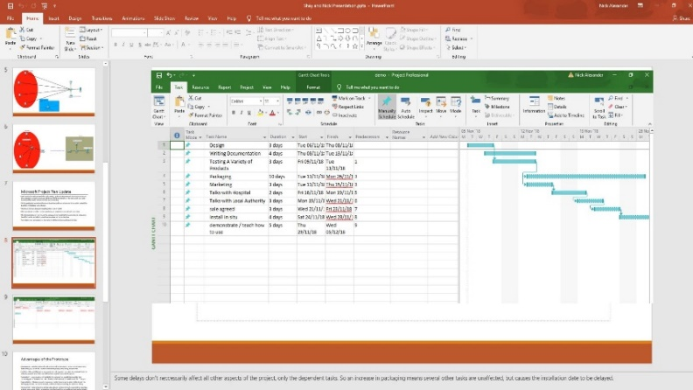
Figure 3 The updated time plan for the project created in Microsoft Project, but demonstrated in PowerPoint

Implementation

Planning-
The project will need a plan for the technical design of the wireless replacement network (how this will work, how it should be installed etc.) But also a plan for the entire project, forming a company and giving everyone designated roles to ensure that every aspect of the project (listed in Figure 3) gets completed on time.

Figure 4 shows the staff required and the role of each member:
Figure 5 - The most likely risks involved with this project, and their solutions

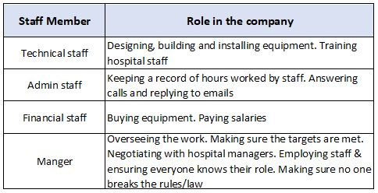
Figure 4 The staff required and their roles in the project

Structure-
Technical staff and the manager will need to meet everyday in an office/workshop in order to share ideas, work together to design the product; but financial staff and admin staff can work from home to save on travel. They can keep in touch by phone and email.

Design-
The way the wireless replacement system will work has been designed in a simulation software called ‘Packet Tracer’ as seen in Figure 1. and Figure 2. This has to then be created using standard ‘off the shelf’ products, this keeps costs down and reliability higher than a bespoke piece of hardware because of the testing and quality control already carried out by the manufacturer.

Risk Management
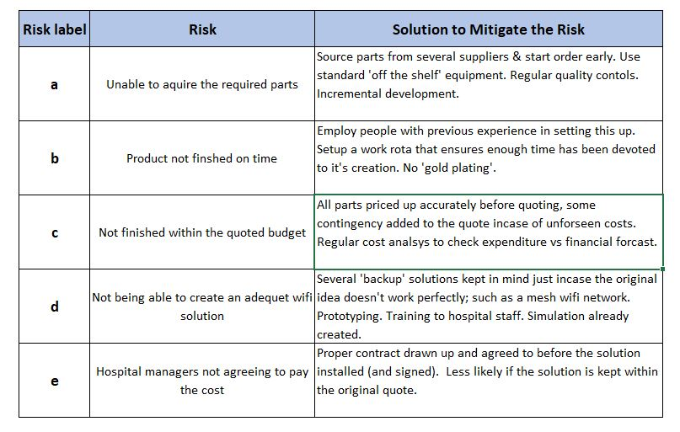
Even though the project is planned to go smoothly, there needs to be a plan in place for the eventuality of something going wrong. In order to identify the possible risks involved with this project, a table was drawn up listing the most likely risks and the required method to avoid this happening – see :

Once these risks had been identified, they were placed into a matrix to understand the ‘tolerance line’ - shown in bold in Figure 4:
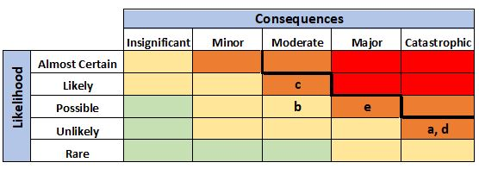
Figure 4 – A probability impact matrix of the risks identified in

So even though there are some risks in the ‘moderate’ category, these are easily manageable and anticipating them early can avoid them becoming a major obstacle in the project.

In Figure 5, ‘a’ would be catastrophic if we couldn’t acquire the parts needed, as it would jeopardize the entire project. But the parts required are so common, the chance of not being able to buy them are extremely low (even in the event of Brexit, a war, UK sanctions etc.)
‘b’ is quite a common problem – projects run over schedule regularly, but as this is a backup solution for an earthquake disaster – the consequence of being late is negligible.
As for ‘c’ – it is easy to go over the budget of any project, this should be fairly easy to avoid here as there aren’t too many people or parts involved; but if it did go over budget, this could lead to a reason for ‘e’ to happen.
Figure 5 – 1st, 2nd & 3rd order of sustainability for the backup solution
‘d’ is a technical risk which can always be solved by trying different equipment or a different method to achieve the wireless connection. Keeping in mind that too much trial and error can lead to ‘b’.
‘e’ would mean that the project might not go ahead if an agreement can’t be reached early on, this
emphasizes the need to be on time, on budget and employ staff who have relevant experience.

Finance –
As this is a fairly straight-forward device to create, using common, readily available components, there is no reason why this should go above 10% of the budget. The technical design is the main risk area of taking longer than planned, but as no circuits have to be designed/manufactured, there is no hard-coding involved it should be simple enough to set this design up and package it within the suggested timescale. One area that may delay the project is getting the medical staff to be able to attend the training during their busy shifts. Something as simple as this can add to the cost of the overall project; but can be minimized by proper planning and regular communication with the hospital

Code Of Practice

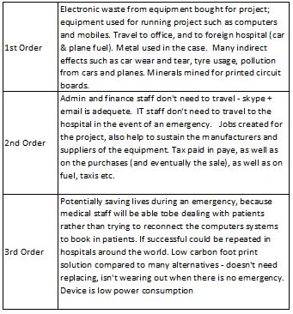
Sustainability

Looking at the table – the first order shows the immediate effects on the environment, even before the project is finished. The second order looks at the wider picture, what effect the project has had on the environment, local business, indirect consequences of the work that’s been carried out.
The third order is what effect the project will likely have in the future. Overall this project would create a small amount of electronic waste for the parts required, and use some electricity and fuel; but the positive benefits are the lives that it could save, the jobs created (and the knock-on effect which that creates for the economy). [1], [2], [3].

A code of practice ensures that all employees have guidelines to work from so that everyone’s behavior at work has clear definitions of what is acceptable. From simple ways of working such as ‘being respectful to others’ and ‘treating people fairly’ to more complex issues such as avoiding injuring people and the company’s reputation. It is all documented in the IEEE code of conduct, and is an ongoing process so that staff are kept up to date with technological developments, procedures and the latest standards [4]. Another purpose is to inform staff of how to deal with sensitive data, what can be accessed and stored and what should not be; the law is changing regularly in these areas so keeping up to date with issues such as ‘who to inform in the event of a data breach’ need to be revisited often. GDPR aims to offer this type of structure for all businesses in the UK to follow [5], [6], [7].

Ethical & Legal

When voting, most people never consider topics such as ‘IT investment’ but Brexit will undoubtedly have an effect on the industry. In the
short-term, foreign investors will likely be reluctant to invest in a UK tech firm because of the uncertainty of the economy; the companies themselves will have
to change the way they run to comply with the new rules regarding data protection for example [8].
Cloud computing in particular would be affected because ‘cloud data’ is often stored in another county and needs to comply with that country’s rules.

The computer magazine ‘Computer-Weekly’ recently posted an article reporting the reader’s predictions for Brexit – the people in favour of leaving expected the UK would gain more flexibility in the global economy; and believed it would make the UK more globally competitive [8].
But those in favour of remaining said it would give the UK less global influence and force the UK to trade internationally on less favourable terms. The author personally believes the uncertainty, the lack of investment, the retraining and adjusting to the new rules will slow everything down for 2-3 years, but after that the UK will be in a better place than before (as long as the government invests enough time and money into the sector). Innovation has always been a strength in the UK and will continue to shine in years to come. [9]
If this prediction was to come to fruition, the investment could well include backup solutions and emergency planning so ideas such as this wireless replacement system could become much more common and even sought out by emergency services.
If funding for the NHS was to include more IT services after Brexit, this deisgn could be sold to hospitals all over the UK. One possible negative result of Brexit is the travelling to middle eastern countries such as Iran maybe getting more difficult. There is already an extensive visa application process in place since the sanctions, so it may become harder or more expensive to travel there after Brexit.
WiFi transmissions are tightly controlled regarding which frequency is allowed to be used, the device would be purchased (rather than made from scratch) so the frequencies it operates at would all be legal for this country, but different countries have different rules regarding this – so the rules of the customer’s country must be checked, and the device made to comply. Brexit may well affect the rules regarding wireless frequency transmissions, and is something to keep an eye on.

Resource consumption-
For example, the metal in the case could be recycled if not needed anymore in the future. Printed circuit boards are particularly hard to recycle as they are made of so many different materials bonded together. Hopefully there will be a better way of recycling them in the future. Parts should be sourced which already use previously recycled plastic and metal.

Why be ethical?
Running an ethical business is usually not the easiest route but has many benefits such as
- Trust – a trustworthy company seen to be doing the right thing gives a strong image of honesty and loyalty (and improves business relationships, thus future work).
- Security – sticking to guidelines means you should have a safeguard against unexpected outcomes, meaning the business deal is less risky.
- Sustainability - (of the planet and relationships) ethical and honest dealings

Quality Assurance

Effectiveness
The goals for this project have been documented previously in terms of what product is expected, but in order to make it within budget, it is important to be focused, keeping the end goal in mind so as to create an item that would be 100% suited to the customer’s needs.

Productivity
Resources can be kept to a minimum during design and manufacture – such as minimal travelling, buying ethically sourced products.

Safety
It is important that all electrical goods are tested to be safe for the customer (and installer) to use without risk.

Satisfaction
The ultimate goal in a project is to make the customer happy, but for this type of product – it will only be tested properly in a disaster, so may never be needed. The aim would be to ‘paint a picture’ of a disaster during the sale of the product, and again during the training so that the medical staff can see the necessity of the device.

Customer satisfaction
This is normally rated by asking customers to fill in a questionnaire, and the overall customer experience rated, but as this is a one off sale – probably the best was would be to ask the hospital staff for feedback, making sure that the installers have been polite, respectful etc and generally following the IEEE policy; as well as being effective in their role.

Functionality
The product needs to be fully tested when installing to make sure that the wireless signal will reach the server. One measure would be to time the transfer of a 1gb file to the server using the wired system, then swap to the wireless connection and time another 1gb transfer to see the difference in data transfer speeds.

Reliability
As this is going to stay inside the metal case for the vast majority of the time, the wear and tear is minimal. Buying parts from a reputable brand should ensure stability as their testing is very thorough. Ideally, a yearly health check of their equipment would be perfect. Software can be setup to test the reliability of the connection such as QoS which shows how much information was lost between the sender and receiver.

Usability
A good metric for this is to ask 10 people to attempt to setup the devices (after receiving training) to see if they can setup the WIFI connection with no assistance. This would give a percentage as to how well the message has got across, how easy it is to setup etc. Also, timing staff using their normal hospital software while connected wired and then again wirelessly so as to get an accurate measurement of its speed and general usefulness as a replacement.

Conclusion
This document has covered a wide range of considerations from the planning stage, to developing an idea into a viable product; it also considers the implications of this product on the environment – now and in the future.
It lists the implementation plan of how this company would run and the codes of practice it would follow. The risks involved and how best to avoid them have also been covered. There are other considerations discussed too such as legal and ethical subjects, the implications of Brexit on the project. Finally how the device would work in practice and the best ways of making sure its installed correctly and some ways of testing the product, ensuring it is suitable and that the customer is satisfied.

References

[1] F. Nateghi-alahi and Y. O. Izadkhah, “13 th World Conference on Earthquake Engineering EARTHQUAKE MITIGATION IN HEALTH FACILITIES IN MEGA CITY OF TEHRAN,” Quality, no. 3116, 2004.
[2] Procurementleader, “Assessing the impact of Brexit on sustainability,” 2019. [Online]. Available: https://www.procurementleaders.com/brexit/brexit-resources/assessing-the-impact-of-brexit-on-csr-sustainability#.XEpCClz7SUk.
[3] J. vom Brocke and S. Seidel, Environmental Sustainability in Design Science Research: Direct and Indirect Effects of Design Artifacts, vol. 7286. 2012.
[4] IEEE board, “IEEE Policies 2014,” 2014.
[5] Ico, “gdpr,” gdpr guidance, 2019. [Online]. Available: https://ico.org.uk/for-organisations/guide-to-data-protection/guide-to-the-general-data-protection-regulation-gdpr/.
[6] D. Souter, D. Maclean, B. Akoh, and H. Creech, “Changing our Understanding of Sustainability: The impact of ICTs and the Internet,” no. December, 2010.
[7] Information Commisioner’s Office, “Guide to the General Data Protection Regulation (GDPR),” Guid. to Gen. Data Prot. Regul., p. n/a, 2018.
[8] C. Weekly, “What does a Brexit mean for the IT industry?,” 2019. [Online]. Available: https://www.computerweekly.com/microscope/news/450280837/What-does-a-Brexit-mean-for-the-IT-industry.
[9] T. C. I. for I. BCS, “Digital Brexit,” 2018.

