Burden/prevalence of the Long-term Condition (both worldwide and UK
statistics) and the Risk Factors/A etiology of the Health Condition

Student ID:2212621
Name of Student: Nadeie Seaied
Module code: LCHS7003

Lecturer name: Dr Aishat Baker
Assignment Title: Component1 information Booklet of long-term Condition Management

Table of Contents
Introduction 3
Understanding Diabetes 3
Definition and overview 3
Burden and Prevalence 4
Risk Factors and Aetiology 5
Impact on Individuals and Families 6
Physical impact on patients 6
Psychological Impact on Patients 6
Social and Lifestyle Impact 7
Impact on Families and Careers 7
Wider Social Implications 8
Management and Treatment in the UK 9
Medical Management 9
Lifestyle Interventions 9
Global Perspective and Equity Challenges 10
Technological Innovation 10
Models & Frameworks 10
NHS Long Term Plan 10
Wagner's Chronic Care Model 11
Policy and Strategic Context 12
Case Studies / Best Practice Examples 13
Challenges, Recommendations, and Future Directions 15
Conclusion 16
Bibliography 17

Introduction
Long-term health conditions (LTCs) are illnesses that cannot be cured, yet can be controlled, treated, and managed conditionally with properly adopted lifestyles. The health and social care system is severely affected worldwide due to changes in the atmosphere, aging, and various other social factors. The LTCs' management in the United Kingdom is a priority goal of the National Health Service (NHS) because these diseases account for most of the health service's usage and spending. Diabetes Mellitus is one of the most serious LTCs in the world and in the nation itself. This is a metabolic condition that is manifested by unbalanced control of blood glucose levels. Diabetes is a nonhomogeneous pathologic entity, and it is a combination of multiple subtypes. The most common is Type 2 Diabetes, as it comprises about 90% of diabetics in the UK, 8% are of type 1, and 2% are of rare manifestations of diabetes (Amoaku, et al., 2020). The increasing rate of this disease is due to an increase in obesity, less physical activity, and many other socioeconomic inequalities. 8.8% of people across the globe are diabetic as per a survey in 2017, and are expected to increase to 9.9% by 2045 (Standl, et al., 2019).
The consequences of diabetes are not limited to physical health, as victims experience less psychological well-being, lower quality of life, and altered family relations. Several healthcare systems provide huge funding for the treatment, such as the NHS, which donates 10.7billion pounds per year, of which 40% is for the examination and treatment of diabetes (Nick, et al., 2024). This booklet is aimed at analyzing symptoms, causes, and effects of this chronic disease on both individuals and families in the UK and worldwide.

Understanding Diabetes

Definition and overview
Diabetes mellitus is a long-term condition of the metabolism, which affects the body's ability to maintain a normal glycemic level. The cause of this pathophysiological disruption is from reduced insulin secretion, as seen with type 1 diabetes mellitus, or a reduced ability or response to insulin. This is described as insulin resistance, as observed with type 2 diabetes mellitus. The third sort of phenotype is gestational diabetes mellitus, which occurs during pregnancy but tends to clear away in the postpartum period, regardless of the increased risk of developing type 2 disease. The World Health Organization (WHO, 2021) defines a diabetic as any person whose fasting plasma glucose levels are 7.0mmol/L and above or glycated hemoglobin (HbA1c) is 6.5% or higher (American Diabetes Association, 2021).
The condition worsens with time, and without proper treatment, it can lead to harmful complications such as cardiovascular disorders, end-stage kidney disease, peripheral neuropathy, amputation of limbs, and loss of vision, among others. Although type 1 diabetes mellitus is generally a childhood disease and requires the continuous use of insulin, type 2 diabetes mellitus is the most common form of the disease and is closely related to possible risk factors, including obesity, nutrition trends, and lack of exercise.

Burden and Prevalence
Diabetes mellitus has become a health crisis of significant concern worldwide. According to the International Diabetes Federation reports in 2021, 537million adults are prevalent among the population, which is expected to increase to783million in 2045 (Hong, et al., 2022).
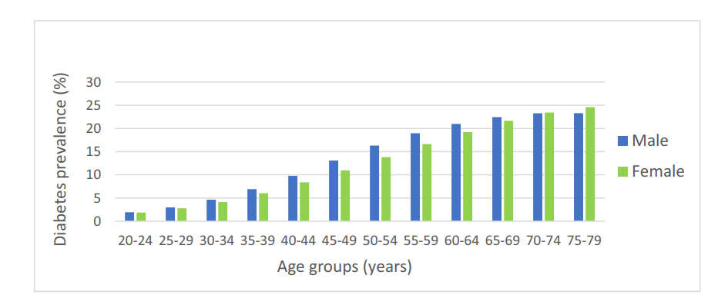
Figure 1Diabetes prevalence by age and sex in 2021: IDF Diabetes Atlas. (Hong, et al., 2022).
The rates of diabetes in the United Kingdom have reached the highest ever rate. The Diabetes UK (2023) shows that 4.6million have been diagnosed with diabetes. In the UK, one in every 5 adults is diabetic (Galvin, 2025). This increase is due to malnutrition, aging, and a more luxurious lifestyle.

Risk Factors and Aetiology
Diabetes depends on its type, which determines its aetiology. Type 1 is autoimmune, such as an immune attack on the β-cells of the pancreas, reducing insulin levels in the human body (Eizirik & Szymczak , 2023).
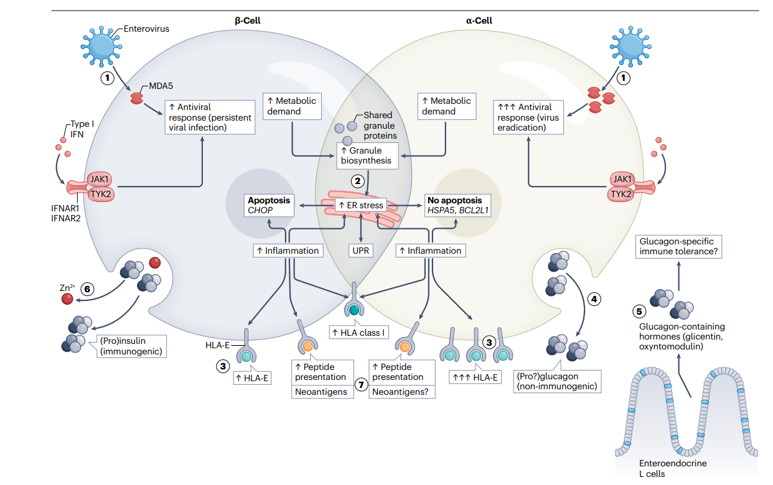
Figure 2Points of increased resistance of α-cells to different stressors (Eizirik & Szymczak , 2023).
This figure illustrates the differentiation of effects between β-cells and α-cells to viral infections and metabolic stress, leading to cell loss (apoptosis) in β-cells and enhanced inflammation typical of diabetes. These three pathways are emphasized because pathways, such as endoplasmic reticulum stress, immune activation, and antigen presentation, lead to the formation of autoimmunity and disease progression.
Causes of the process are presumed to be genetic vulnerability and particular viral inoculation. In particular, Type 2 diabetes occurs gradually with the initial insulin resistance and the external determination in the concluding episodes through insulin deficiency as the genetic rising and the environmental element play a joint role (Rachdaoui, 2020).
Central obesity in children and the lack of nutrition and physical activities are the most noticeable causes of Type 2 diabetes. Two-thirds of the United Arab adult population is overweight or obese, which compares with a strongly correlated steep rise in diabetes (Heba, et al., 2022). Other factors are age, ethnicity, and several other socioeconomic deficiencies that affect the availability of food, medicine, and education. Diabetes is a chronic disease caused by various factors, including genetic and lifestyle factors; however, lifestyle factors can be changed. The ever-increasing rate of this disease at national and international levels compels us to find solutions. These solutions should be properly managed and provide preventive measures.

Impact on Individuals and Families

Physical impact on patients
Diabetes affects a person; it affects physical health, resulting in acute and long-lasting impacts. Glycemic control worsens the effects of hypoglycemia and hyperglycemia, common causes of fatigue, dizziness, and hospitalization (Muneer, 2020). It results in various severe conditions, such as failure of the kidney, heart problems, and retinopathy (J, 2024). Ocular and dermatological infections are also predisposed in the United Kingdom when guests are diagnosed with diabetes, thereby reducing their quality of life.

Psychological Impact on Patients
Diabetes is regarded as a serious problem that can develop psychologically. Constant check-up of diet, glucose, and medication often causes stress and anxiety, leading to the development of diabetic distress, outwardly tiredness (Bi, et al., 2021). To this end, empirical results show that compared to non-diabetic populations, patients with diabetes have a higher probability of developing depression by two to three times (Eelcoa & Ryan, 2020). Type 2 diabetes is mainly due to malnutrition, which leads to low self-confidence, particularly in young generations and people from lower socioeconomic backgrounds.

Social and Lifestyle Impact
The impact of diabetes mellitus on health-related quality of life and engaging socially is very great. People affected with it need to closely control food intake and physical exercise, which often requires them to skip social events, including foods and beverages, which can be frustrating. Diabetes administration interferes with everyday life and even causes problems in people-to-people relationships, burdening the emotional level considerably. More than that, it hurts the employment opportunities, and the patients lose their jobs because of the diseases or their discrimination at work (Lavanya, et al., 2020). These aspects lead to low productivity and high presenteeism, as well as the likelihood of retiring early.
Diabetes equally affects both the physical and mental health of a person. This will adversely affect the ability of a person to connect socially with people and place himself in a stable professional position.

Impact on Families and Careers
Although this condition does not only affect the person, the impact also spreads to the family and informal caregivers. Family members often play a central role in ensuring that patients receive drug therapy, changing diet, and providing emotional support. Parents of children who are diagnosed with Type 1 diabetes have to be very conscious about their glucose and insulin levels in the body. They are very concerned about hypoglycemia anxieties, particularly at night (Abitbol & Palmert, 2021). The caregiver burnout also might have an impact on partners, careers, and the physical and emotional burden they have to face.
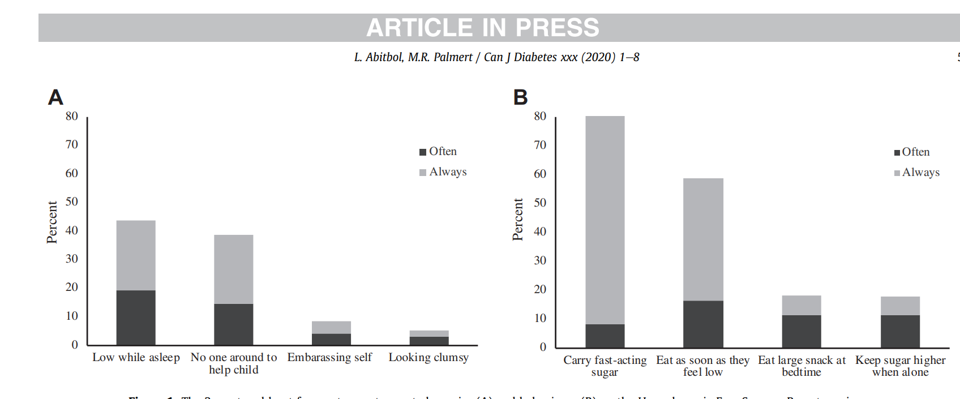
Figure 3 The 2 most and least frequent parent-reported worries (A) and behaviors (B) on the Hypoglycemia Fear Survey—Parent version (Abitbol & Palmert, 2021).
Diabetes is a disease that leads to serious health issues and emotional trauma affecting patients and their family unit, and so requires the use of extensive medical and social resources.

Wider Social Implications
At the societal level, the increasing rate of diabetes imposes a significant burden on the social care services and the National Health Service. Indirect financial costs often manifest through family loss of income, costs incurred in traveling to medical facilities, or payments in trying to adjust their homes to the complications caused by disability. Multicultural societies in the United Kingdom, such as Leicester, with 51% of a diverse population, do have conflicting cultural food issues with their clinical advice, hence worsening family conflicts (Winifred, et al., 2022). The economic cost, on the other hand, is even more costly on a global scale. Without proper healthcare facilities, the developing and middle-income nations lack the proper coordination to implement proper measures to combat the increasing prevalence. Hence, they are prone to having worse health outcomes. The economic burden, decreased efficiency, and challenges among caregivers remain universal issues, no matter their location.

Management and Treatment in the UK
Treatment of diabetes involves a complex approach that incorporates medications, appropriate changes in actions, proposed educational programs, and technological annexes. In the United Kingdom, evidence-based recommendations to the National Health Service are implemented by the National Institute for Health and Care Excellence (NICE) (Garbi, 2021). On a global level, by establishing the Global Diabetes Compact, adopted by the World Health Organization (WHO), for outcome enhancement aimed at prevention and treatment (World Health Organization, 2024).

Medical Management
UK Situation: In the United Kingdom, diabetes has been a thorn in the flesh of those people who have type 1. Most of them rely on the replacement of insulin in various types of injections a couple of times a day, or an insulin pump injector, or more often, hybrid forms of closed-loop injector systems. A key internal starting point may be the use of lifestyle modification, followed by metformin. In cases that may be discerned, sodium-glucose cotransporter-2 (SGLT2) inhibitors and glucagon-like peptide-1 (GLP-1) receptor agonists are used in the management of a type 2 diabetes mellitus diagnosis (Palmer, et al., 2021). The use of these pharmacotherapeutic agents is supported by the National Institute for Health and Care Excellence (NICE) on the principle of strong evidence attributable to their cardioprotective and Reno protective effects.
Global: The clinical practice of high-income jurisdictions across the globe has a close resemblance to the treatment paradigm pursued in the United Kingdom; denial of insulin treatment and oral pharmacotherapy is incumbent in the low and middle-income countries. As data provided by the World Health Organization indicates, inequities related to health show that half a billion people across the globe cannot afford basic insulin treatment.

Lifestyle Interventions
The National Health Service Diabetes Prevention programmer in the United Kingdom has proved able to minimize the prospects of developing type 2 diabetes by measures that consisted of eating change, physical activity, and socializing with others. Loss of weight, nutritional optimization, and determined physical exercise remain the inherent elements of the two prevention and management conditions. Lifestyle interventions have proved to be successful across the world, but their effectiveness is moderated by both cultural and socioeconomic factors. Poverty in low and middle-income environments hinders the implementation of such programs on a larger scale due to the inadequacy of the infrastructure base.

Global Perspective and Equity Challenges
In the worldwide population, which mechanisms are known and diagnosed with diabetes, about seventy-five percent of the infected patients live in low and middle-income economies, but most of the health care spending is fixed in the high-income economies. In the United Kingdom, all citizens are covered by the National Health Service, which is useful, but populations of ethnic minorities and social-economically disadvantaged individuals are disproportionately affected by diabetes and face poorer health outcomes as a result. This issue of numerous inaccessible insulin preparations, medications for treatment, and advanced technologies in medical care does not fail to generate strong inequality in diabetes treatments around the world. World Health Organization Global Diabetes Compact (2021) aims to ensure that the mentioned disparities can be closed by facilitating low-cost care and strengthening preventive methods.

Technological Innovation
The National Health Service in the United Kingdom has expanded on the use of continuous glucose monitoring gadgets and flash glucose monitoring devices, thus improving the self-management platform for patients. On the one hand, developed technologies are certainly used mainly by the high-income countries at the international level; on the contrary, the low-income and middle-income economies cannot afford them due to the high expenses.

Models & Frameworks

NHS Long Term Plan
Two policies are available to progress the type 2 diabetes (T2DM) in England to help with learning and self-management in the NHS Long Term Plan (LTP). The key one is the Healthy Living platform that was nationwide employed and was launched in 2019, addressing about 4.5 million T2DM live population. Reports highlight that 88% of the places were accepting Healthy Living and six main policies were used with consciousness campaigns, modified local resources, financial incentives, popular raise, tracking, and broadening entrance to high-need groups. The program is also effective for digital interventions, which have shown an influence of 1.6 mmol/mol decrease in HbA1c as well as 3.1 kg weight loss at 12 months (Brunton, et al., 2024). The more careful examination puts the LTP as saving nearly the same pound per pound of money in 20 years, which highlights the potential of the LTP as an evidence-based, scalable diabetes inhibition tool (Koning, et al., 2023).

Wagner's Chronic Care Model
Wagner Chronic Care Model (CCM) has also been widely supported as one of the most helpful global models for chronic illnesses because it was widely used by the American Diabetes Association (ADA) in the main care management of diabetes (Goh, et al., 2022).
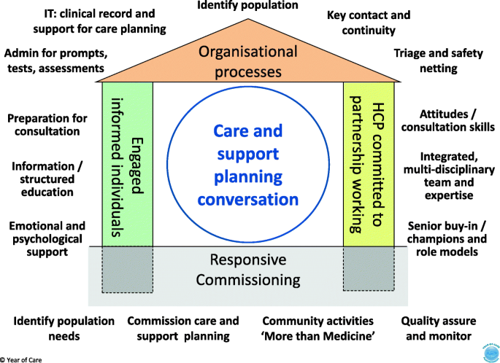
Figure 4: The constituents highlighted are those that have been reliably recognized by teams across multiple diverse health groups (Roberts, et al., 2019)
The present health status of 10.5% of adults (537 million) is assessed to increase by 12.2% percent (783 million) in 2021 due to diabetes and is assessed to include 6.7 million deaths and USD 966 billion of outflow on health in any given year (Goh, et al., 2022). CCM offers an indication-based and organized framework including six prominent features that contain organization of healthcare, community associations, self-management support, delivery system project, decision support, and clinical data systems. It is established that CCM interventions improve care organization, patient satisfaction, clinical consequences (HbA1c), and decrease hospitalization and healthcare expenditures. Its integrated, person-centered approach allows handling diabetes and comorbidities positively over a long period (Roberts, et al., 2019).

Policy and Strategic Context
Diabetes is a government policy issue that may require wholesome measures to encourage prevention, increase access to health care, and address health disparities. In the context of the United Kingdom, the NHS Long Term Plan (2019) specifically outlines diabetes management (Hugh & Jennifer, 2019) As:
1) Expansion of the NHS Diabetes Prevention Programs
2) Delivering more structured educational services
The NICE guidelines go on to provide evidence-based models of consistency in treatment and alleviate variations in the quality of care provided across regions. Obesity is the other risk factor that is related to policies, and some of the policies put in place to deal with obesity include levying higher taxes on high-caloric items and also banning the advertisement of high-caloric products.
According to the Global Diabetes Compact (2021), which was suggested by the World Health Organization, the set of strategies aimed at the international agenda is going to contribute to better access to insulin. The accessibility of healthcare medicines, which, at the same time, is going to deliver equitable treatment to citizens within the international arena. New frontiers. The Compact promotes the delivery of primary care and universal health coverage, which residents of underdeveloped countries would benefit from, all in less than a century on our planet. About a third of diabetic patients are located.
The development of technology in promoting equity in health care provision should be facilitated in the future, in conjunction with the realization of equity in health care provision. Policy frameworks in the United Kingdom or internationally should be crafted in a way that would benefit the entire section of the population, not just a small fraction of it.

Case Studies / Best Practice Examples
The instance of natural case studies that contained operative management of diabetes is an example of nurse-led diabetes self-management education (DSME) of patients with type 2 diabetes mellitus (T2DM) (Sun, et al., 2025).
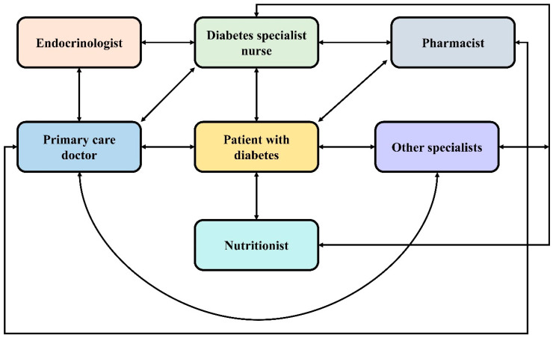
Figure 5: The chronic care model for diabetes mellitus (DM) administration. A better association is obligatory between the healthcare suppliers and specialists for operational DM management (Dailah, 2024).
Patients visible to specialist nurse brought education and occupied over intervention programs presented a noteworthy decrease in mean glucose levels and a reduction in HbA1c levels over a period of 12 months compared to patients getting usual care from non-specialist staff. Individualized advice was presented to the nurses concerning medication management, diet, exercise, and glucose management, and these added to self-care and authorization. This intervention climaxes the supreme part played by diabetes inpatient specialist nurses (DISNs) in encouraging better clinical outcomes, improved knowledge in patients, and reduced problems in hospital and community surroundings (Dailah, 2024).
Another case presents GCK-MODY (maturity-onset diabetes of the young) in a 34-year-old female whose history of hyperglycemia, which has settled since the age of 24, is slight, and the development is not progressive. However, body mass index is usually considered to be overweight, despite persistent hyperglycemia now and then, especially during pregnancy, she was first identified with type 2 or gestational diabetes.
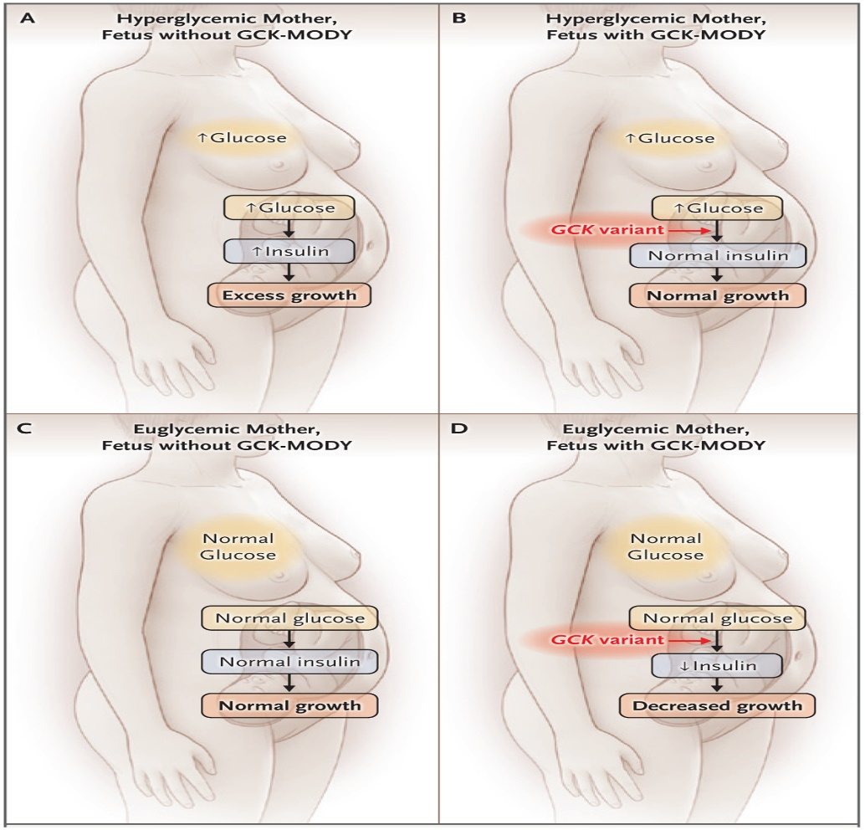
Figure 6: Consequence of Fetal GCK-MODY on the Connection between Maternal Blood Glucose Level and Fetal Development(Udler, et al., 2021)
A pathogenic form of GCK is recognized through genetic testing, which shows MODY. Routine change was the management goal; the metformin was obsolete as her hyperglycemia was slight, asymptomatic except when she was pregnant. The significance of specific consideration, screening of the family, and exact diagnosis is confirmed by the necessity to adjust insulin therapy during pregnancy, depending on the size of the fetus and its genetic state, to evade overtreatment and maximize the maternal-fetal consequences (Udler, et al., 2021).
Both of these cases highlight the genetic and lifestyle features in diabetes as a mixture, meaning that the accurate diagnosis, consideration of each case, and screening of families are vital, and with their help, one can comprehend a plan that will help manage both the UK and global occurrence.

Challenges, Recommendations, and Future Directions
The operative treatment of diabetes has continued to be delayed by developments in treatment and diagnostic equipment (Shomali, et al., 2024). Such critical gaps as a late diagnosis, an unfit allocation of health care assets, low patient adherence, and the nonappearance of a multidisciplinary method to care can also be recognized. The mutual running tools, invasive monitoring, and steady appointments to the clinic cannot be considered satisfactory in traditional management to record the level and alterations in glucose and follow up on self-management. In addition, the appearance of the disease is mixed, which makes it a hindrance to treatment scheduling in a constant manner, thus requiring the application of tailored treatment (Schimmer, et al., 2019)..
Policies are oriented toward person-centred care (PCC) and self-management provision, erected around modified education, customized nutrition and physical activity strategy, and contribution of family/caregivers (where necessary), eHealth keys, such as m- apps, web-based agendas, and remote monitoring have the potential to authorize the patient in actively handling their state at the same time evading healthcare expenditures and growing access to healthcare. Procedures of joining the PCC principles can help advance the acquiescence and ultimate potentials, seeing the requirements of users, their backgrounds, and their likes in digital tools (Guan, et al., 2023).
The meeting of artificial intelligence (AI), genomics, and digital health machinery is in the future. The prognostic models built on AI will be useful in analyzing high-risk patients, handling customized interventions, and streamlining diabetes diagnosis. Novel modalities of precision care contain continuous glucose monitoring (CGM), hybrid closed loop, and neuromodulation devices, such as tins. Taken together, all these novelties reinforce an example shift in handling diabetes reactively to proactively and build on realities to advance clinical consequences to manage healthcare inequalities

Conclusion
Diabetes is one of the major matters that requires management to attain better patient results, reduce the number of problems, and help family and society in general. It has been verified that specialized care, lifestyle variations, technologies, and prescribed programs have a substantial positive impact on the excellence of life and glycemic control. To have a maintainable effect, it is vital to address the alterations in the accessibility of health care and self-care. In the long run, the joint medical, social, and technical resolutions play important parts in dominant control and restricting the irresistible load of chronic diseases at a global and local level in the UK.

Bibliography
Abitbol, L. & Palmert, M. R., 2021. When Low Blood Sugars Cause High Anxiety: Fear of Hypoglycemia Among Parents of Youth With Type 1 Diabetes Mellitus. Canadian Journal of Diabetes, 45(5), p. 10.
American Diabetes Association, 2021. Classification and Diagnosis of Diabetes: Standards of Medical Care in Diabetes—2021. Diabetes Care, 44(1), p. 19.
Amoaku, W. M. et al., 2020. Diabetic retinopathy and diabetic macular oedema pathways and management: UK Consensus Working Group. Journal of General Internal Science, Volume 10, p. 51.
Bi, Y. et al., 2021. Contributing factors of fatigue in patients with type 2 diabetes: A systematic review. Journal Pre-proof, Volume 130, p. 32.
Brunton, L., Cotterill, S. & Wilson, P., 2024. Evaluating the National Rollout of a Type 2 Diabetes Self-Management Intervention: Qualitative Interview Study With Local National Health Service Leads Responsible for Implementation. JMIR, Volume 26.
Dailah, H. G., 2024. The Influence of Nurse-Led Interventions on Disease Management in Patients with Diabetes Mellitus: A Narrative Review. Healthcare (Basel), 12(3), p. 352.
Eelcoa, v. D. & Ryan, C. M., 2020. Diabetes mellitus in the young and the old: Effects on cognitive functioning. Neurobiology of Disease, Volume 124, p. 10.
Eizirik, D. L. & Szymczak , F., 2023. Why does the immune system destroy pancreatic β-cells but not α-cells in type 1 diabetes?. nature reviews endocrinology, Volume 19, p. 10.
Galvin, G., 2025. Number of diabetes cases hits record high in UK as experts warn of ‘hidden health crisis, UK: euro news.
Garbi, M., 2021. National Institute for Health and Care Excellence clinical guidelines development principles and processes. BMJournals, 107(12), p. 5.
Goh, L. H. et al., 2022. Effectiveness of the chronic care model for adults with type 2 diabetes in primary care: a systematic review and meta-analysis. PMC.
Guan, Z. et al., 2023. Artificial intelligence in diabetes management: Advancements, opportunities, and challenges. Cell Rep Med, 4(10).
Heba, M. et al., 2022. Prevalence and associated risk factors of overweight and obesity among adult population in Dubai: a population based cross-sectional survey in Dubai, the United Arab Emirates. BMJ Open, Volume 13, p. 9.
Hong, S. et al., 2022. IDF Diabetes Atlas: Global, regional and country-level diabetes prevalence estimates for 2021 and projections for 2045. Diabetes Research, Volume 183, p. 13.
Hugh, A. & Jennifer, D., 2019. The NHS long term plan. Editorials, 10(1136), p. 2.
J, N. M., 2024. The Impact of Co-morbidities on Quality of Life inDiabetic Patients. International Digital Organization for Scientific Research, 9(3), p. 7.
Koning, C., Pelletier, M. & Spooner, J., 2023. The national health service England diabetes prevention program—A narrative review. Journal of diabetology, 14(4), pp. 198-206.
Lavanya, V., Uma, J. & Pascale, A., 2020. Chronic illness and sustainable careers: How individuals with multiple sclerosis negotiate work transitions in a middle-income country. Journal Pre-proof, Volume 245, p. 39.
Muneer, M., 2020. Hypoglycaemia. Diabetes: from research to clinicl practice, Volume 4, p. 27.
Nick, H. B. et al., 2024. Estimation of the direct health and indirect societal costs ofdiabetes in the UK using a cost of illness mode. H e a l t h E c o n o m i c s, 10(1111), p. 8.
Palmer, S. C., Mustafa, R. A. & Tonelli, M., 2021. Sodium-glucose cotransporter protein-2 (SGLT-2) inhibitors and glucagon-like peptide-1 (GLP-1) receptor agonists for type 2 diabetes: systematic review and network meta-analysis ofrandomised controlled trials. BMJ, 10(1136), p. 14.
Rachdaoui, N., 2020. Insulin: The Friend and the Foe in the Development. International Journal of Molecular Sciences, 21(5), p. 21.
Roberts, S. et al., 2019. The Year of Care approach: developing a model and delivery programme for care and support planning in long term conditions within general practice. BMC Primary Care.
Schimmer, R., Orre, C. J., Öberg, U. & Danielsson, K., 2019. Challenges in designing digital person-centered self-management support for people with type-2 diabetes (Preprint). JMIR Diabetes, 4(3), p. 10.
Shomali, M. et al., 2024. The critical elements of digital health in diabetes and cardiometabolic care. Front. Endocrinol, Volume 15.
Standl, E., Khunti, K., Tina, B. H. & Schnell, O., 2019. The global epidemics of diabetes in the 21st century: Current situation and perspectives. European Journal of PreventiveCardiology, 26(2), p. 8.
Sun, J., Fan, Z., Kou, M. & Wang, X., 2025. Impact of nurse-led self-management education on type 2 diabetes: a meta-analysis. Front. Public Health, Volume 13.
Udler, M. S., Powe, C. E. & Austin-Tse, C. A., 2021. Case 6–2020: A 34-Year-Old Woman with Hyperglycemia. N Engl J Med, p. 745–753.
Winifred, E. et al., 2022. Health Communication and Inequalities in Primary Care Access during the COVID-19 Pandemic among Ethnic Minorities in the United Kingdom: Lived Experiences and Recommendations. International Journal of Environmantal Research and Public Health, 19(22), p. 23.
World Health Organization, 2024. Guidance on global monitoring for diabetes prevention and control. USA: World Health Organization.

