

Undergraduate assignment feedback form
(to be completed by marker)

Student Name: Daegan Simpson

Module Code: HPAN6006  Module title: Political Anthropology: Theorising to Power | Student number: 1003107
For completion by marker:
Comments:

Marker’s signature: |  | Date:
Provisional mark:
NB. All marks are provisional until confirmed by the final examination board.
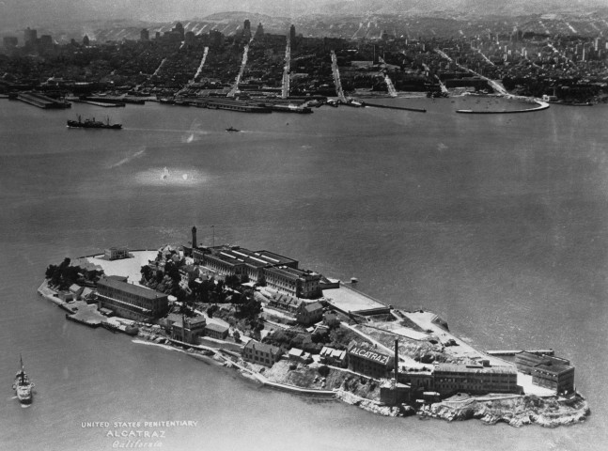
Indians of All Tribes – A Unified Protest
A Brief History of Colonisation
Europeans arrived in America in the early 16th century. By the 1700’s, the indigenous population of America declined by 56 million people. This was partially due to European aggression and partially due to diseases such as smallpox and cholera that came along with the settlers. The number of victims in this time was so great that a paper was published discussing how the sheer amount less people had caused effects on the global climate (Koch et al., 2019).
So What Does Indigenous Actually Mean?
Cobo describes indigenous people as having a pre-colonial historical relation to their territory, that they are distinct from surrounding societies and are often a minority within these, working to preserve their ethnic traditions and identities (Cobo, 2014).

A working definition stated in a meeting in 1974 to plan the 1975 conference that formed the World Council of Indigenous Peoples went as such: “The term indigenous people refers to people living in countries which have a population compossed of differing ethnic or racial groups who are descendants of the earliest populations living in the area and who do not as a group control the national government of the countries within which they live.” (Hohmann and Weller, 2018)

American Indian Protests
In 1969, a group named Indians of All Tribes (IoAT) attempted to claim Alcatraz Island after the San Francisco American Indian Center was burned. This was after an unsuccessful attempt by Mohawk Richard Oakes and a small group of protestors that lasted one night. According to the San Fransisco Chronicle, Oakes stated that their occupation of the land should grant them the rights that the white man’s occupation of the land apparently granted them
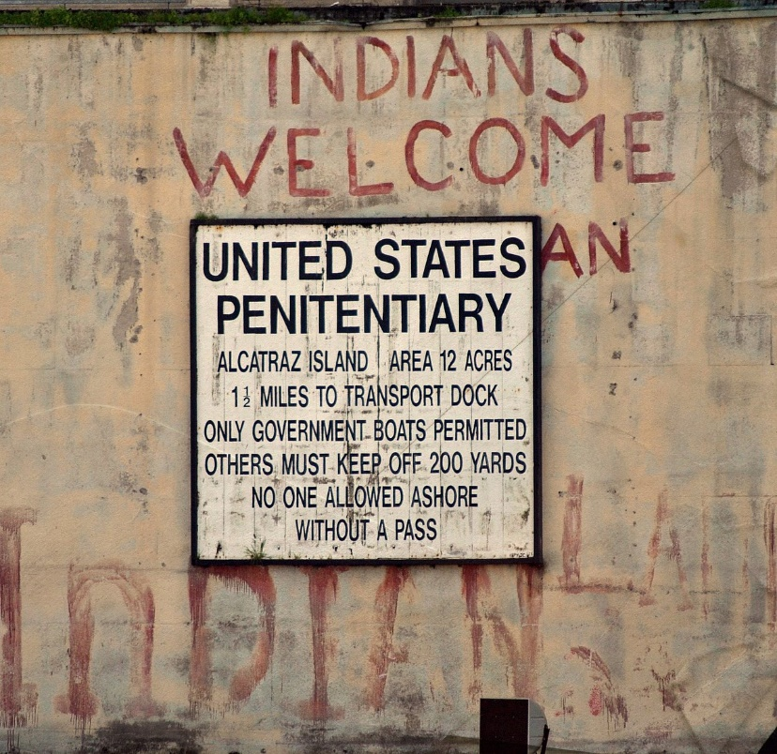
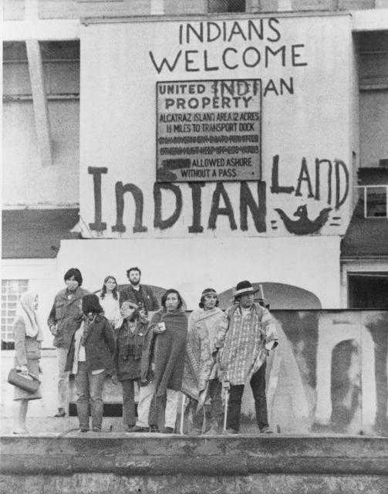

Less than two weeks later, the IoAT seized Alcatraz with a group of 89 men, women, and children. This occupation lasted for 19 months despite government warning. During this time, they released a satirical proclamation, offering to purchase the island for $24 in beads and cloth, a similar price paid to them for an island in the past, and declared that by the white man’s standards, the disused island was fit for an Indian Reservation, as it was isolated, had no water, sanitation, educational, or health care facilities, and the population was held as prisoners (Eagle and Association, 1992). This was a pivotal moment in modern American Indian history and a victory for the Red Power movement.

The Longest Walk of 1978 was the last major act of the Red Power movement, which declined along with direct activism in the late 1970’s. Several thousand protestors walked 3,200 miles from Alcatraz to Washington DC.
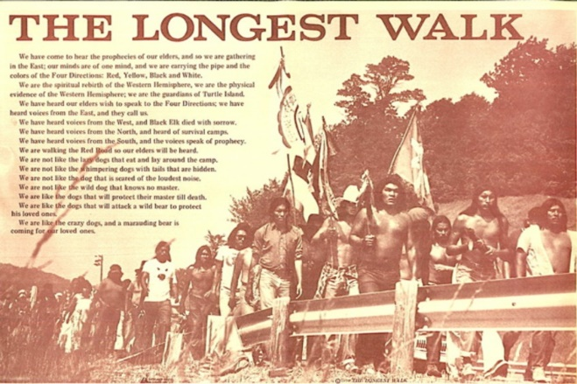

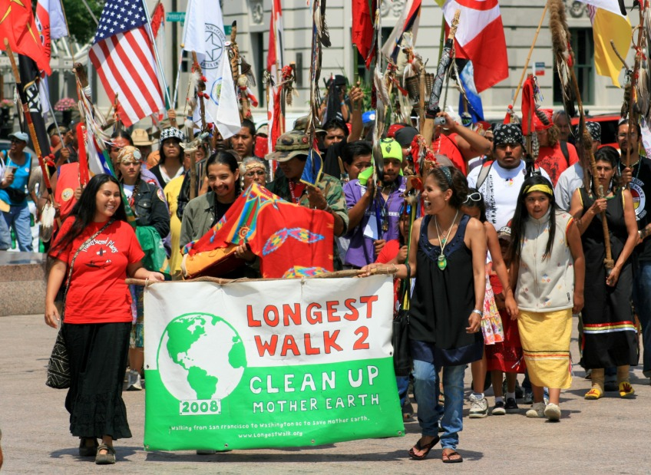
Although many acts discussed here are dated, the Longest Walk 2, organised by the American Indian Movement, occurred in 2008. Representatives of over 100 Indian nations, and other indigenous groups such as Maori walked 8,200 miles from San Francisco Bay to Washington DC. This shows that although the Red Power movement did aid in indigenous rights, many of the issues faced are still relevant today.

800 American Indians repeat the ‘Longest Walk’ - Timeline - Native Voices [WWW Document], n.d. URL https://www.nlm.nih.gov/nativevoices/timeline/594.html (accessed 3.5.19).
Alcatraz: Looking Back at the Rock, 50 Years Later, 2013. . Time. URL http://nation.time.com/2013/03/21/alcatraz-looking-back-at-the-rock-50-years-later/ (accessed 3.5.19).
American Indian Movement occupies Wounded Knee - Timeline - Native Voices [WWW Document], n.d. URL https://www.nlm.nih.gov/nativevoices/timeline/535.html (accessed 3.5.19).
Andrews, E., 2014. Native American Activists Occupy Alcatraz Island, 45 Years Ago [WWW Document]. HISTORY. URL https://www.history.com/news/native-american-activists-occupy-alcatraz-island-45-years-ago (accessed 3.9.19).
Cobo, M., 2014. Study of the Problem of Discrimination Against Indigenous Populations [WWW Document]. URL https://www.un.org/development/desa/indigenouspeoples/publications/2014/09/martinez-cobo-study/ (accessed 3.9.19).
Eagle, A.F., Association, G.G.N.P., 1992. Alcatraz! Alcatraz!: the Indian occupation of 1969-1971. Heyday Books.
Hohmann, J., Weller, M., 2018. The UN Declaration on the Rights of Indigenous Peoples: A Commentary. Oxford University Press.
‘Indians of All Tribes’ group occupies Alcatraz Island - Timeline - Native Voices [WWW Document], n.d. URL https://www.nlm.nih.gov/nativevoices/timeline/520.html (accessed 3.5.19).
Koch, A., Brierley, C., Maslin, M.M., Lewis, S.L., 2019. Earth system impacts of the European arrival and Great Dying in the Americas after 1492. Quaternary Science Reviews 207, 13–36. https://doi.org/10.1016/j.quascirev.2018.12.004
‘Longest Walk’ draws attention to American Indian concerns - Timeline - Native Voices [WWW Document], n.d. URL https://www.nlm.nih.gov/nativevoices/timeline/546.html (accessed 3.5.19).

Undergraduate assignment feedback form
(to be completed by marker)

Student Name: Daegan Simpson

Module Code: HPAN6006  Module title: Political Anthropology: Theorising to Power | Student number: 1003107
For completion by marker:
Comments:

Marker’s signature: |  | Date:
Provisional mark:
NB. All marks are provisional until confirmed by the final examination board.

Analysis of ‘When will we stop stereotyping people?’
The source is a 3:08 minute video named When will we stop stereotyping people? It is part of an animated series created by SomethinElse for the BBC, and was posted on the BBC website on the 19th of October 2018. The series is titled An A-Z of -isms, and covers a wide range of academic concepts, including such topics as Neoliberalism, Existentialism, Absurdism and Hedonism. There are currently twenty-one videos in the series, which appears to be ongoing as new titles are added. The video is narrated by Professor Evelyn Alsultany, an Associate Professor in the Department of American Studies and Ethnicity at the University of Southern California. Other videos in the series are narrated by other relevant academics or experts.
Although not explicitly stated in the title, this video gives an explanation and analytical breakdown of Said’s concept of Orientalism. Edward Said developed this concept in his 1978 book titled Orientalism. Orientalism is the term used to explain the stereotyping European portrayal of the Orient. (Said, 1995, p.7) Alsultany draws on Said to define this as a view of the East as ‘inferior, uncivilised, and all around weird.’ (Alsultany, 2018). To Said, this sets Europe as the opposite of the orient; as ‘superior, civilised, and all around wonderful’ (Alsultany, 2018), enforcing the ‘Western’ identity (Said, 1995, p.7)
A point made in the video is that the word Orient itself derives from the Latin oriens, meaning East, and refers to the continent of Asia (Alsultany 2018) The use of the word Orient here promotes a Western-centric world, placing Asia as the opposite of ‘global West’. Quoting Said, Alsultany states that Orientalism is therefore “...the form of “knowledge” … that authorises and justifies the assertion of western power over the East” (Alsultany, 2018). The issue that comes with portraying another culture as such an opposite is that this will result in many of the cultural differences being exaggerated; these are often fetishized, romanticised, or demonised, according to Alsultany’s analysis of Said; “…just about everything and everyone seems highly exotic and strange, or worse, fanatical and dangerous.” (Alsultany, 2018). This leaves no room for the many nuances in between and misses out all of the everyday people along the way.
Edward Said was born in Jerusalem and received an education at British English-speaking schools in Cairo, before relocating to the United States at 16. Here, he attended multiple exclusive schools. With a multicultural upbringing and a strong idea of the Western viewpoint, he was able to shed light on the issues with the way the East was viewed and understood in the Western world, and vice-versa.
The video attempts to introduce the key concepts and ideas of Said’s theory of Orientalism in bitesize chunks of information. We live in a world where information is increasingly digital and concise; to find something out one is more likely to use an online search engine than visit a library. The people who are most likely to access such a video are also the people most unlikely to sit down and read a printed version of Orientalism from cover to cover. Therefore, this video does an excellent job of disseminating the concepts of Orientalism to a modern generation. It cannot be denied, however, that a bitesize video cannot do justice to the magnitude and significance of Said’s work. Said himself states that “…without examining Orientalism as a discourse one cannot possibly understand the enormously systematic discipline by which European culture was able to manage – and even produce – the Orient politically, sociologically, militarily, ideologically, scientifically, and imaginatively during the post-Enlightenment period.” (Said, 1995, p.3). Said claims that Orientalism holds such a position of authority that any kind of study of the Orient must consider the limitations imposed by Orientalism on both thought and action. Indeed, it is so relevant and present in any discussion on the Orient that, as Said writes: “…it is the whole network of interests inevitably brought to bear on (and therefore always involved in) any occasion when that peculiar entity “the Orient” is in question” (Said, 1995, p.3).
Said wrote Orientalism nearly half a century ago and it was received and accepted as a legitimate theory at the time and to this day. However, the title of the video still asks the question “when will we stop stereotyping people?”, which suggests that Said’s theory is still very much needed in the modern world.
As the video itself is only three minutes long and is not widely distributed, it is not overly significant to the pre-established discourse. Said’s book Orientalism from which the content is drawn, however, is a pioneering study that developed a new discourse, bringing light to the creation of these opposing ascribed identities. The video is obviously aimed at a target audience of non-academics or those new to the discourse. It is brief and concise, and avoids complex discussions, using clear animation to demonstrate every point made throughout the video. Being part of a series created for the BBC, the video remains unbiased and factual. Although the video is clear and concise, and does well to introduce the concept of Orientalism, one issue still stands. Said’s discussion of Orientalism is lengthy and has many more aspects to it than a three-minute video is able to sum up. Although as stated, the video introduces the concept very well, summarising it and making it much more of an accessible source for students.

Alsultany, E., 2018. Orientalism and Edward Said: How to stop stereotyping? - BBC Ideas [WWW Document]. When will we stop stereotyping people? URL https://www.bbc.com/ideas/videos/when-will-we-stop-stereotyping-people/p06p97cr?playlist=the-a-z-of-isms (accessed 3.3.19).
Said, E.W., 2006. Orientalism. Penguin Books India.
The Editors of Encyclopaedia Britannica, 2018. Edward Said | American professor and literary critic. Encyclopedia Britannica.

