3/24/2025 LDE Assignment 1

E-Portfolio
Module Name: Learning In the Digital Era Module Code: ACCA 4025

Student Name: ANANE FRIMPONG
Student ID: 2436557
Group: 1

Lecturer’s Name: Koushik Modak

E-Portfolio Link: https://sites.google.com/view/anane-portfolio/home

University of Wales Trinity Saint David
LONDON CAMPUS

Contents
Introduction 3
Task 1: Essential Academic and Employment Skills for the future career Path. 3
a) Report on Essential Academic and Employment Skills 3
b) Evaluation of Task 1 (a) based on Similarity report 4
IEEE References 5
Task 2: Collaborative Mind Map and Individual Poster 6
Mind Map (Collaborative) 6
POSTER 6
Task 3: Virtual Collaboration and Scribbr 7
a) Report on Virtual Collaboration 7
b) Step-by-step process of using Scribbr with visuals 8
IEEE References 9
Task 4: E-Portfolio Creation and Evaluation 9
a) E-Portfolio Creation 10
Task 2 12
Task 3 13
Task 4 15
Conclusion 15
E-PORTFOLIO 16

Introduction
This e-portfolio will present how my academic, digital, and professional skills have developed during the module Learning in the Digital Era. It consists of a sequence of practical activities that are centered around key academic skills, group work and collaboration, virtual communication tools, and use of online platforms including Google Sites and RefWorks. All of the tasks enabled me to gain confidence in terms of research, referencing, producing online material, and collaborating in digital settings. The portfolio reflects my skills to utilize modern technologies, professional communication skills and my capacity to use skills that are valuable both in my studies and in my future profession in the computing industry.

Task 1: Essential Academic and Employment Skills for the future career Path.

a) Report on Essential Academic and Employment Skills
A well-developed academic and job skill base is fundamental in achieving success in education as well as employment. The academic skills are critical thinking, research skills, digital literacy, and good communication. Critical thinking aids the students to analyze information, find reliable sources and make decisions. High-quality assignments and professional problem-solving are facilitated by research skills, including academic database search and evidence-based assessment. In the modern workplaces that are technologically oriented, it is important to have digital literacy i.e. the ability to use tools such as MS Office, online collaboration tools and referencing tools. Academic writing and verbal presentation are communication skills, which enhance teamwork and professional conduct.
Other skills that make someone workplace ready include time management, teamwork, adaptability, and problem-solving. Time management enables one to plan activities, beat time, and eliminate stress. Teamwork skills also equip the learners to work with colleagues in various settings, which is vital since majority of organizations depend on group projects. Flexibility enables people to react with a lot of certainty to emerging problems, and problem-solving assists in innovation and efficiency at the workplace.
These skills will enable me to fulfill the expectations of the industry in my selected profession in Computing and IT. Digital literacy will help me to employ the use of programming tools, data platforms, and collaborative technologies. The good communication will assist me in being able to convey technical concepts to both technical and non technical audiences. Teamwork and flexibility will enable me to complete my tasks with confidence in dynamic IT settings where teamwork and life-long learning are indispensable.
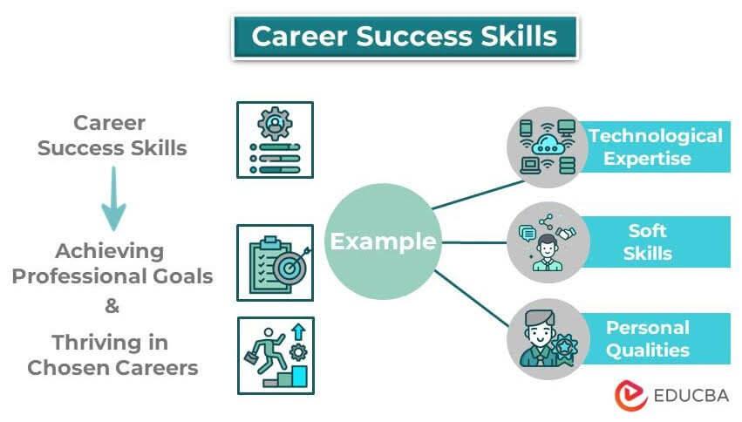
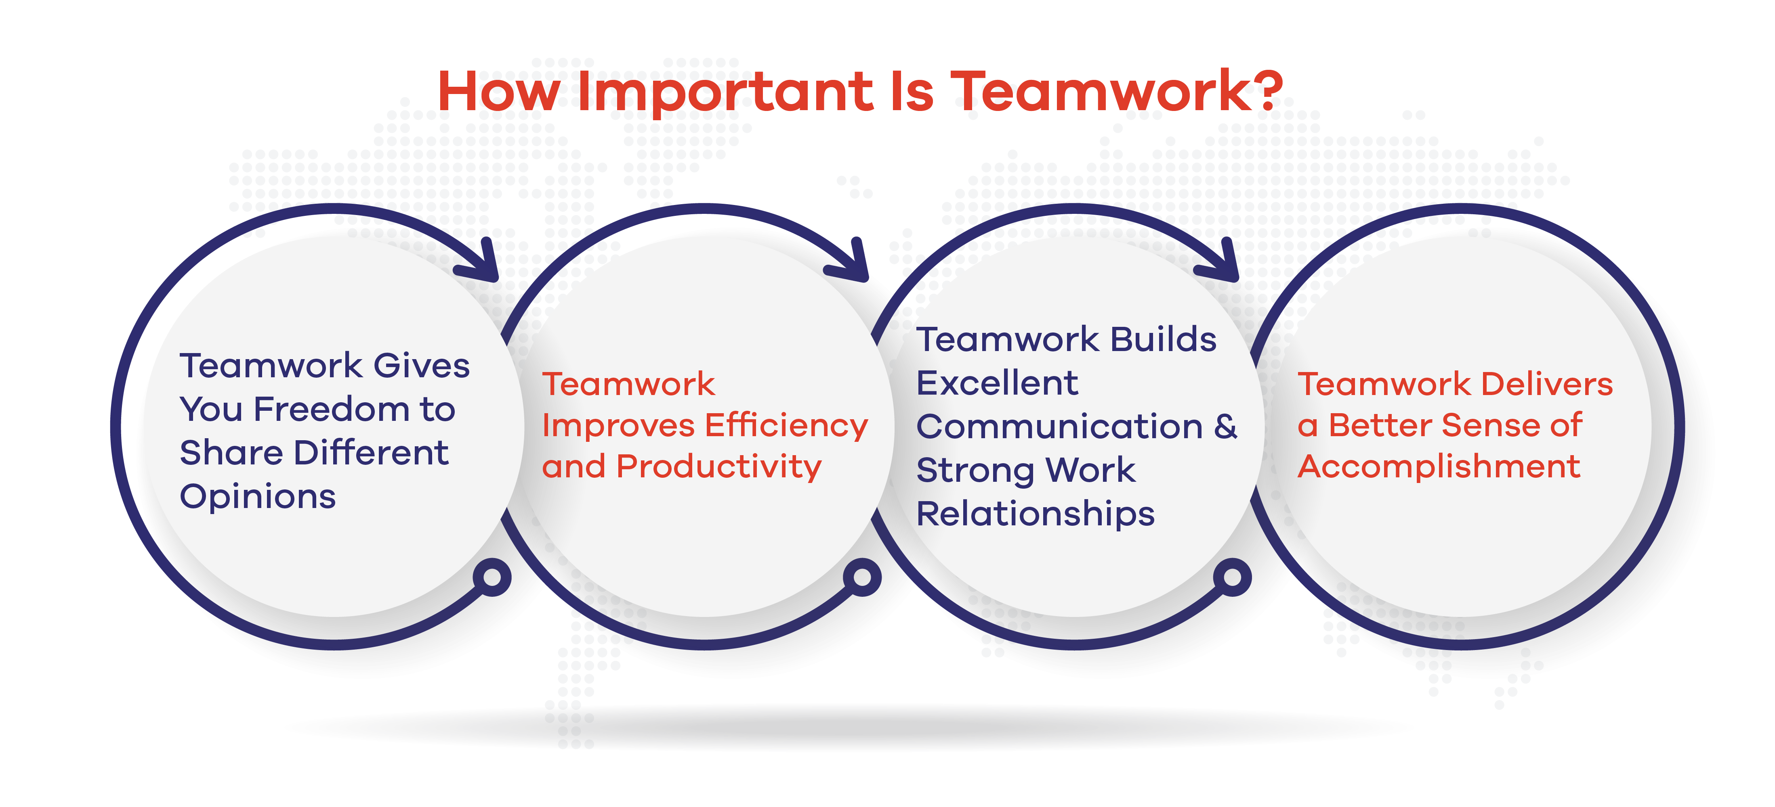

b) Evaluation of Task 1 (a) based on Similarity report
The score on Turnitin in my similarity feature was 4%, and I have observed that even after that, some typical academic expressions were detected. To make it even lower next time, I can paraphrase more thoroughly, not use long direct phrases and make sure that every idea is rewritten completely and in my own words. I would also have greater sentences of my own. With the Generic Assessment Criteria, I would rate myself at 95%, as the work satisfies the criteria, contains academic text, proper referencing, and illustrations. Nevertheless, I can continue to do a better job with the inclusion of a more critical discussion and enhancement of my academic tone in future assignments.
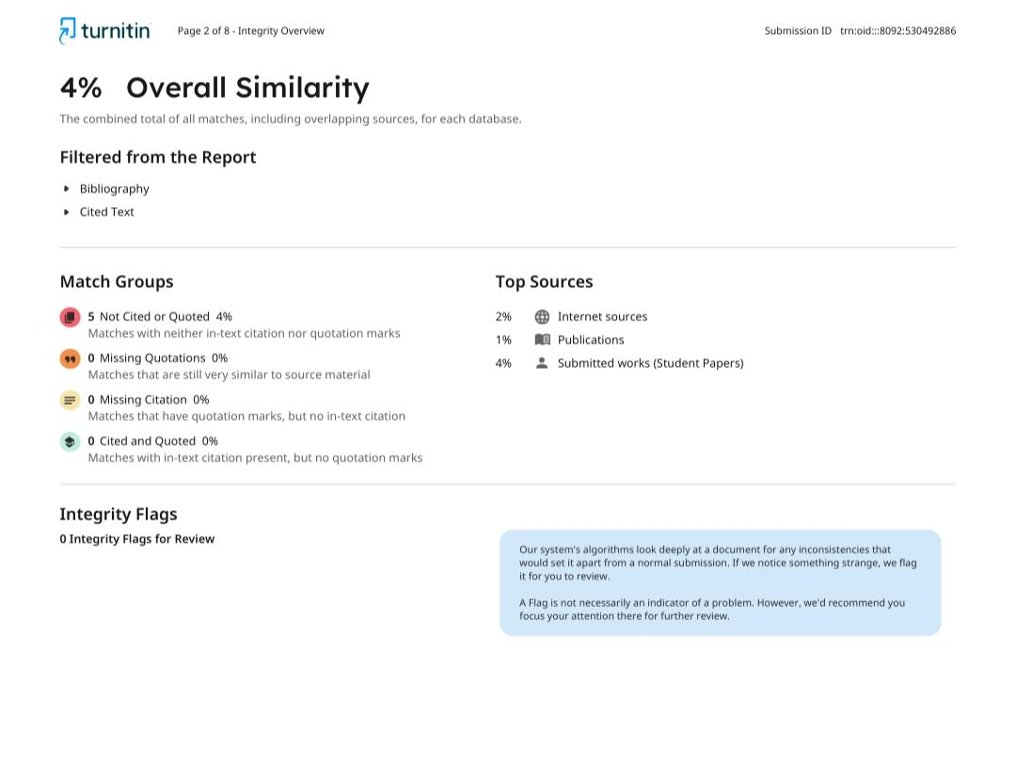

IEEE References
[1] K. Shivam, “10 reasons Why Skill‐Based Education is important in 2025,” 21K School Pakistan, Jul. 17, 2025. https://www.21kschool.com/pk/blog/why-skill-based-education-is-important/
[2] T. Schultheiss, C. Pfister, A.-S. Gnehm, and U. Backes-Gellner, “Education expansion and high-skill job opportunities for workers: Does a rising tide lift all boats?,” Labour Economics, vol. 82, p. 102354, Feb. 2023, doi: 10.1016/j.labeco.2023.102354.
[3] IPapathanasiou, C. Kleisiaris, E. Fradelos, K. Kakou, and L. Kourkouta, “Critical Thinking: the development of an essential skill for nursing students,” Acta Informatica Medica, vol. 22, no. 4, p. 283, Jan. 2014, doi: 10.5455/aim.2014.22.283-286.
[4] B. Sumaiya, S. Srivastava, V. Jain, and V. Prakash, “The role of effective communication skills in professional life,” World Journal of English Language, vol. 12, no. 3, p. 134, Apr. 2022, doi: 10.5430/wjel.v12n3p134.

Task 2: Collaborative Mind Map and Individual Poster

Mind Map (Collaborative)
https://uowtsd-my.sharepoint.com/:i:/g/personal/2436557_student_uwtsd_ac_uk/IQCAzqSxSimqSoTW3jIb6SMRAZcmhbzmKruohEbK6IotesM?e=7lRTdm

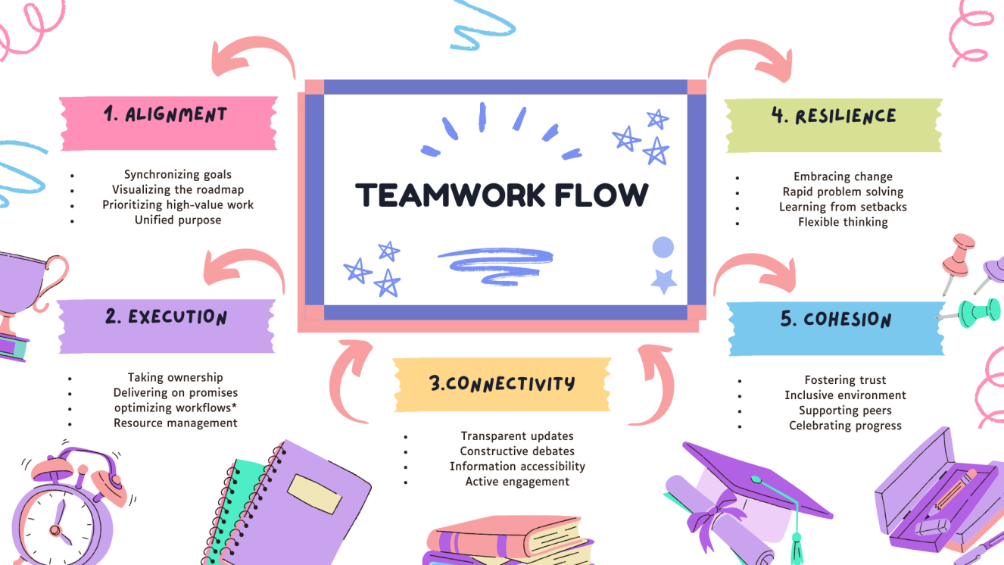

POSTER
https://uowtsd-my.sharepoint.com/:i:/g/personal/2436557_student_uwtsd_ac_uk/IQCAzqSxSimqSoTW3jIb6SMRAZcmhbzmKruohEbK6IotesM?e=7lRTdm

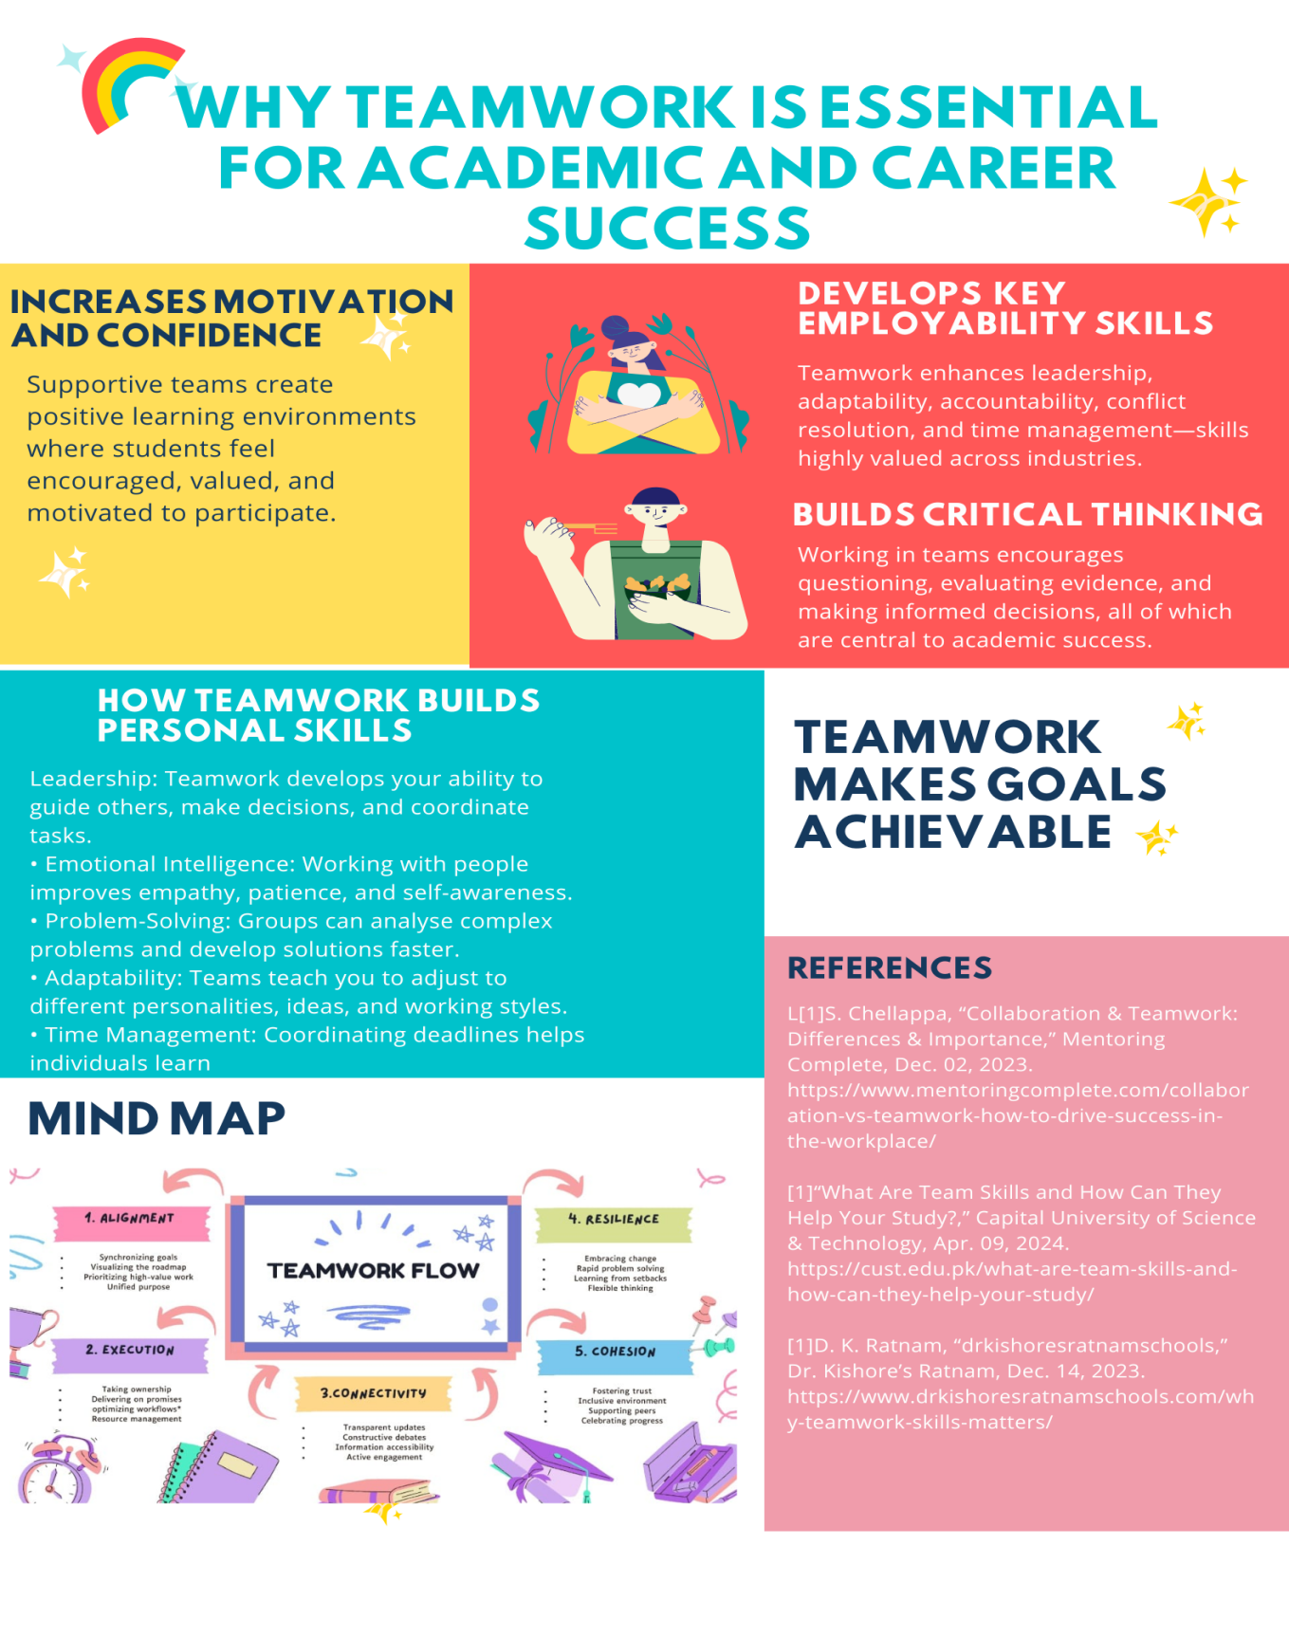

Task 3: Virtual Collaboration and Scribbr

a) Report on Virtual Collaboration
Virtual collaboration involves the application of digital technology and the internet to enable people or groups to collaborate without necessarily being physically in the same venue. Education and workplaces have made it an important skill today due to the prevalence of global, remote, and hybrid teams in organizations. Good virtual collaboration is associated with better communication, productivity, creativity and flexibility [1].
The primary benefit of virtual collaboration is the fact that people can collaborate anywhere in the world. Microsoft Teams, Zoom, Google Meet, and Slack are tools that can assist teams in real-time communication using video meeting, chat, and file sharing [2]. They are also compatible with asynchronous work and hence team members can contribute at their convenience provided that they are available. This minimizes time and maximization of efficiency.
The other advantage is enhanced organization and management of resources. Such cloud-based applications as Google Drive and OneDrive enable collaboration members to save, edit, and view documents in real time. This avoids misunderstandings that might come as a result of having various versions of the same file and having to deal with information that is not updated [3]. Virtual teamwork is also more inclusive since it enables students or employees who cannot get to work regularly because of distance or mobility problems to contribute to the work of the group.
Nonetheless, virtual collaboration is also associated with its difficulties. These are communication barriers, technical, and domestic distractions. The absence of body language or slow communication can be a problem in understanding among teams. It is due to this that the digital professionalism, effective communication, and coordination of a team are essential in making an online teamwork a success . Setting common objectives, roles and free communication enhance teamwork.
Altogether, virtual collaboration is quite significant to academic projects and contemporary careers. It assists people in developing digital literacy, collaboration, flexibility, and time-management, which the employers highly prize. An adequate learning of online collaboration tools will equip students with the ability to work remotely and collaborate in a global team.

b) Step-by-step process of using Scribbr with visuals
To complete this task, I used Scribbr as my automatic referencing tool.

Screenshot 1: Generating in IEEE style
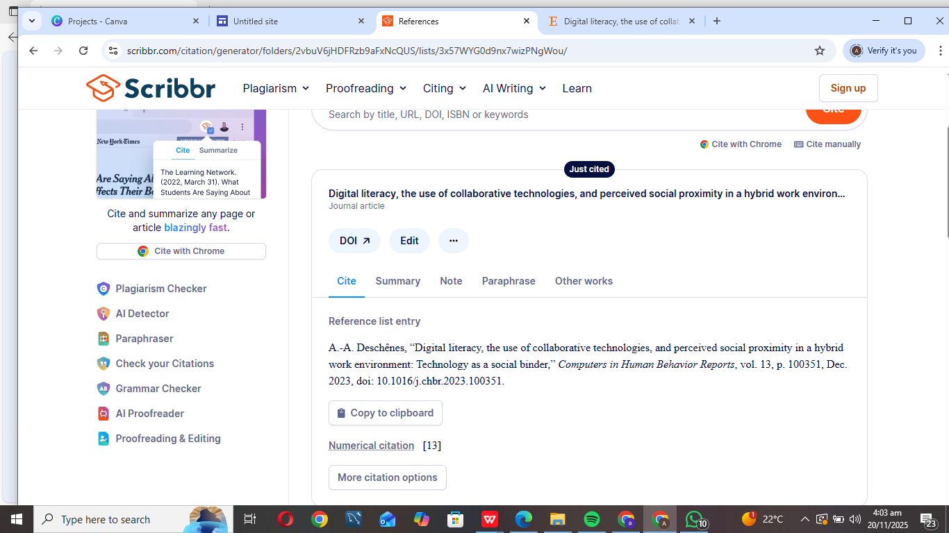
Screenshot 2: Automatic export to word option
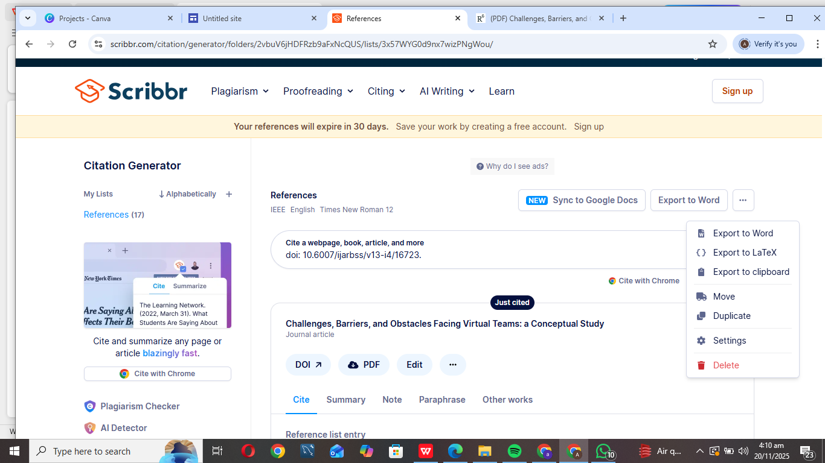

Screenshot 3: List of References
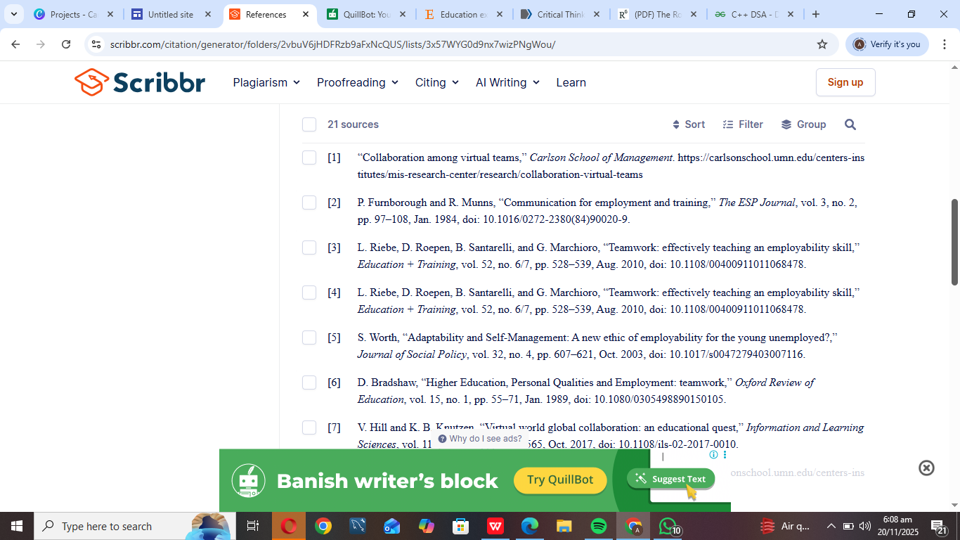

IEEE References
[1] “Collaboration among virtual teams,” Carlson School of Management. https://carlsonschool.umn.edu/centers-institutes/mis-research-center/research/collaboration-virtual-teams

[2] P. Furnborough and R. Munns, “Communication for employment and training,” The ESP Journal, vol. 3, no. 2, pp. 97–108, Jan. 1984, doi: 10.1016/0272-2380(84)90020-9.

[3] L. Riebe, D. Roepen, B. Santarelli, and G. Marchioro, “Teamwork: effectively teaching an employability skill,” Education + Training, vol. 52, no. 6/7, pp. 528–539, Aug. 2010, doi: 10.1108/00400911011068478.

Task 4: E-Portfolio Creation and Evaluation

a) E-Portfolio Creation
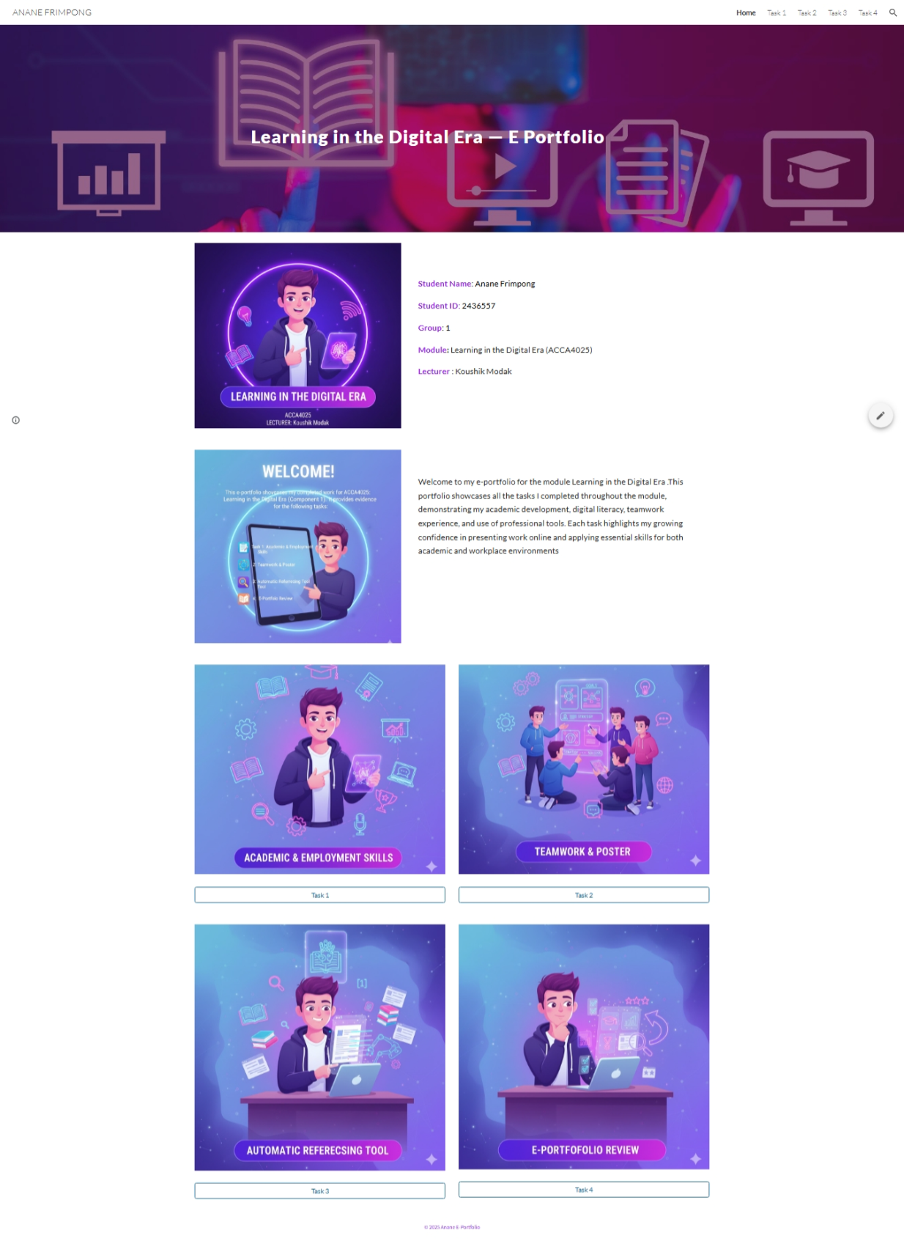
Task 1
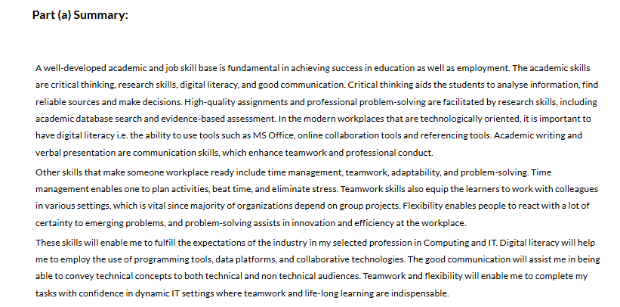

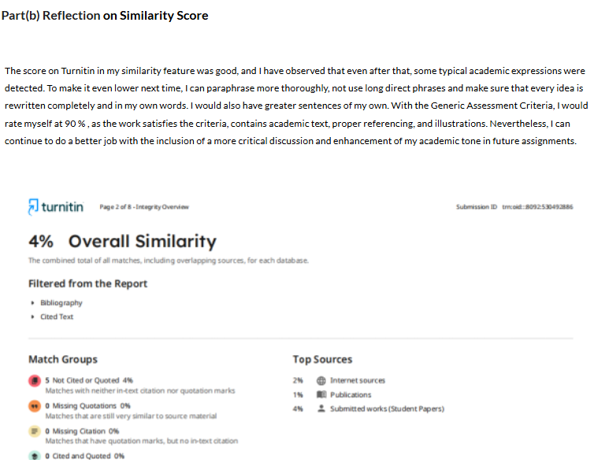

Task 2
https://uowtsd-my.sharepoint.com/:i:/g/personal/2436557_student_uwtsd_ac_uk/IQCAzqSxSimqSoTW3jIb6SMRAZcmhbzmKruohEbK6IotesM?e=7lRTdm
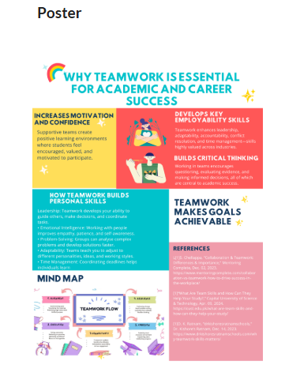
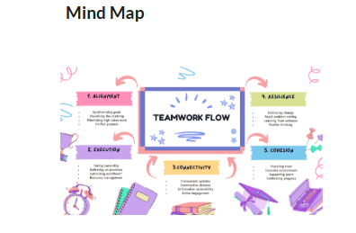

Task 3
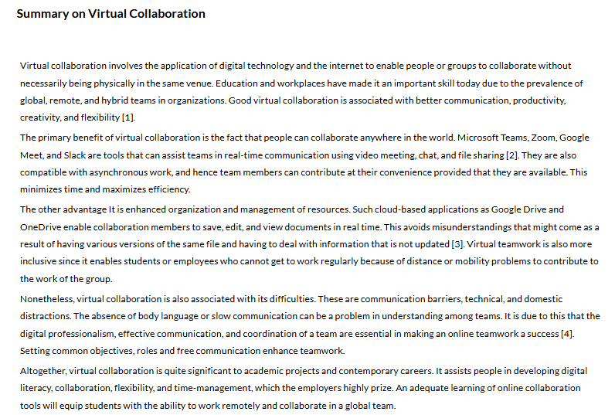

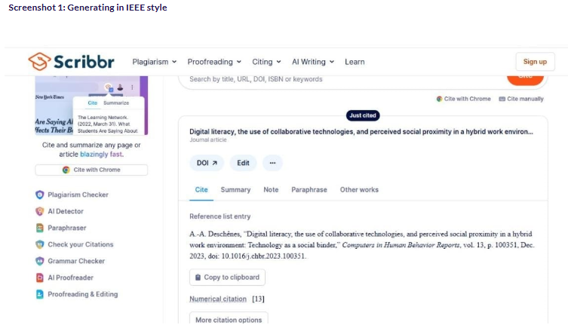
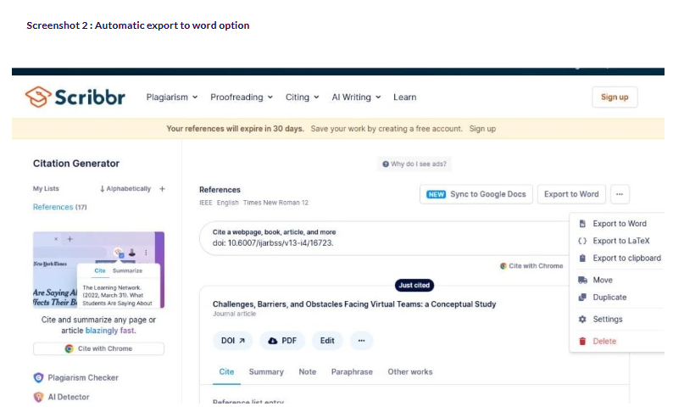
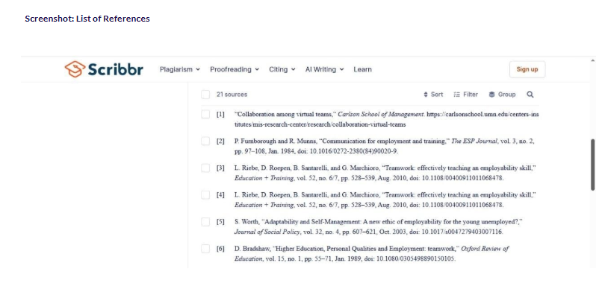

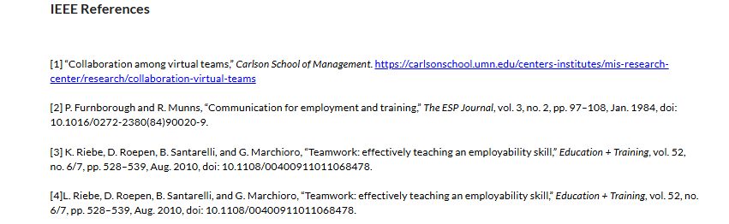

Task 4
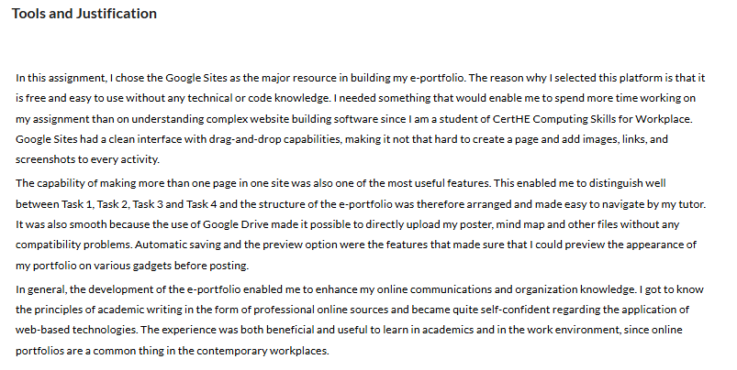

Conclusion
By doing this e-portfolio, I have enhanced my digital literacy, teamwork skills, academic writing, and professional communication skills. By working on poster creation, virtual teamwork, and in working with automatic reference making tools, I obtained practical experience on the use of widely-used technologies in the educational process and workplace. The creation of the portfolio via Google Sites has equally enhanced my creativity and assurance to portray academic work on the internet. However, all in all, this project has not only enabled me to become an independent learner but has also equipped me with the necessary skills that will see me achieve my future success in higher education and in my future career in computing.

E-PORTFOLIO
https://sites.google.com/view/anane-portfolio/home


