Name student: Mariana Cocos
Student Number: 2024061
Module Title: Assessment 1- Project Management LCBB5005
Lecturer: Sadeque Shaikh

Crossrail (London’s Elizabeth line)
PROJECT MANAGEMENT

Table of Contents
1. Introduction 3
2. Project background 4
2.1 Introduction 4
2.2 Elisabeth Line Project Data 4
2.3 SWOP Analysis 5
2.4 Summary 7
3. Budgeting and Funding 8
3.1 Introduction 8
3.2 Budget Analysis 8
3.3 Risks and Assumptions 10
3.4 Summary 11
4. The analysis of stakeholders and efficiency of control mechanisms 12
4.1 Introduction 12
4.2 Power Interest Grid 12
4.3 Summary 12
5. Conclusion and Recommendations 13
Bibliography 14
Appendices 16

Table 1. Crossrail, Elizabeth line. Project Data. Adapted from (Pollalis & Lappas, 2019) and (Crossrail, 2022) 4
Table 2. Elisabeth line SWOP Analysis of the initial plan 6
Table 3. The estimation of Elisabeth line budget. Source: National Audit Office (2019) 9
Table 4. Causes of costs change. Source: National Audit Office (2019) 9
Table 5. Elisabeth Line. Risk Assessment Register 10

Figure 1. Elisabeth line stakeholders based on interest grid. Adapted from (Wasilewski & Weber, 2017) 12
Figure 2. Program Management Structure. Source: (Pollalis & Lappas, 2019) 16
Figure 3. Elisabeth Line, project initiation and development. Source; Crossrail Learning Legacy 17
Figure 4. Elisabeth line structure and governance agreements. Source: Croft et al. (2016) 18

Appendix 1. Program management structure 16
Appendix 2. Project Initiation and development 17
Appendix 3. Crossrail Structure and Governance 18

- Introduction

Elizabeth line is a complex Crossrail program and is considered the largest infrastructure project in Europe, with massive investments due to its size (Pollalis &Lappas, 2019). The vision behind the cross-rail is to connect families, friends, and communities through an accessible railway network. Sometimes called a megaproject involved many challenges before its opening in May 2022. Additionally, the Elizabeth line has yet to open fully, and its full timetable is expected to come into effect in 2023 (Crossrail, 2022).
This report aims to critically evaluate the Cross Rail Project (Elizabeth Line) with a particular focus on budgeting and timing, including expected stages and the actual delivery of the project. Additionally, the quality is analysed, the role of the stakeholders and risk factors.
The evaluation is centred on the initial plan and identifies gaps that could have contributed to significant delays.
The methodology used for this paper is SWOP analysis, where strengths, weaknesses, opportunities, and problems are identified and discussed. Besides that, the project management principles are considered project life-cycle methodology, which refers to project stages such as initiation, planning, execution and closing (Williams, 2008). References and arguments are supported by existing project management theory to increase the viability of the report.
The structure of this report is as follows; First, it provides a project background, including the project vision, mission, and objectives, as well as a brief presentation of key aspects and facts. Second, the body of the report focuses on critically evaluating the management of budgeting and identification of risks that were overlooked, resulting in delays in project delivery and disruptions. The following section highlights the role of the stakeholders and the impact they had on the project; as noted by Winch (2004), stakeholders are essential elements in project complexity, and their power must be addressed. Finally, the report discusses the efficiency of project control mechanisms and concludes by providing an overview of what has been discussed and recommendations to increase the efficiency of project management.

Project background

Introduction

London’s Elizabeth line was designed to improve transportation across the UK by increasing the capacity of central London’s rail transport system by 10% (Pollalis & Lappas, 2019) and decreasing overcrowding of London Underground stations (Tucker, 2016). Additionally, the new rail is designed to transform the daily commute of Londoners (Morris, 2022) by reducing queues. The formal plans for the construction of a railway across the middle of London were proposed in 19 centuries; however, due to its complexity and high funds required, it got approval from the government in 1990 (Transport for London, 2022) and with a joint sponsorship between Department of Transport and TFL in 2001 the permission was given to start construction.
The project vision is to provide accessible and innovative transportation across the UK; the mission is to provide a world-class railway (Wood, 2016); the principles and values are to achieve its mission through the application of safety measures, advanced systems, effective collaboration, and integrity.

Elisabeth Line Project Data

Project name | Crossrail, Elizabeth line
Project type | Megaproject, Railway line
Location | Greater London, Berkshire, Buckinghamshire, England
Area/Length | 118km/73miles
Capacity | 200 million passenger journey per year
Number of trains and their system | 24 trains per hour, advanced train systems
Owner | Transport for London
Project Team | Contractor: 96% construction and logistic contracts  Engineer/Designer: Various Firms  Facility Project Manager; Crossrail  Consultants; various
Project lifespan | At least 120 years
Status | Over 95% completed, fully opens in 2023
Funding model | Public-multisource funding  UK Government
Sponsored by | Jointly sponsored by TFL and DFT (Department for Transport)
Estimated initial costs versus actual costs | Original budget 14 .8 billion, Actual estimated 19 billion
Delivery method | Construction Management

Table 1. Crossrail, Elizabeth line. Project Data. Adapted from (Pollalis & Lappas, 2019) and (Crossrail, 2022)

The project name was initially Crossrail and later changed to Elisabeth line in honour of HM Queen Elisabeth the second. The railway location is across Greater London, Berkshire, Buckinghamshire, England, with lengths of 73 miles and a capacity of 200 million passenger journeys per year. Regarding the number of trains and their systems, it has 24 trains per hour and advanced train systems to deliver step-change in customer experience through high quality and design outputs (Transport for London, 2017). The owner of Elizabeth line is Transport for London; however, it was jointly sponsored by TFL and DFT, and the funding model includes public multisource funding and the UK government, where the estimated initial costs were 14.8 billion and actual costs are estimated at 19 billion, 4.2 billion above the estimated costs.
The delivery of the project is through construction management, and the project team working on it is pretty large; the contractor forms an estimated 96% of construction and logistic contracts, the engineers/designers come from various firms, and the facility project manager is from Crossrail with various consults including multiple opportunities for internships were provided. The projected lifespan is at least 120 years. Currently, the Elisabeth is integrated with existing transport routes but only partially operates as initially planned (Table 1. Crossrail, Elizabeth line. Project Data. Adapted from (Pollalis & Lappas, 2019) and (Crossrail, 2022).

SWOP Analysis

This section focuses on evaluating the initial project plan using SWOP Analysis (main strengths of the project, the weaknesses identified, further opportunities and significant problems). According to de Silva et al. (2015), the sustainability strategy for delivering the £15 billion Crossrail project in the UK lays out fundamental sustainability themes and performance indicators to track progress. The strategy was based on holistic approaches referring to balancing social, environmental and economic performance. It was built on the premise that it would deliver network efficiency and conectivity (Dongen & Rajabalinejad, 2018); however, the delivery of this strategy involved higher costs and the need to restructure and adapt to changes.
Strengths | Weaknesses
-Innovative, faster, and better journeys  -Delivery of sustainable outcomes such as relieving overcrowding in London underground, 10% extra rail capacity and decreasing trip times across London (Pollalis & Lappas, 2019)  -The strategic plan involved creation of the transport infrastructure  needed to support the economic growth  -The project was based on Crossrail – safety, inspiration,  respect, collaboration, and integrity.  -Effective design of the programme management structure (See Figure 4. Program Management Structure. Source: (Pollalis & Lappas, 2019)(Pollalis & Lappas, 2019)  (Pollalis & Lappas, 2019)) | -Elisabeth line is a mega project which in itself very complex  -Inappropriate setting of required costs  -Project wasn’t delivered based on the timeframe set  -The 14.8 billion funding included contingency and inflation  -High level of investigation, planning and designing  -Overspends and changes in leadership (Topham, 2022)
Opportunities | Problems
-High-frequency services  -Shorter journey times  -The travel experience is more comfortable on the spacious trains and in the new and newly refurbished stations.  -Jobs and business opportunities  -The Elisabeth line will add an estimated £42bn to the economy of the UK | -Need for Restructuring  -Problems with digital signalling  -Complex design difficult to grasp  -Problems with budget and schedule  -Failure to manage costs, schedules and changes based on initial planning set.

Table 2. Elisabeth line SWOP Analysis of the initial plan
The Elisabeth project had many strengths that overweight the weaknesses. First, the program was focused on innovative, faster, and better journeys across the UK. Second, it aimed and delivered sustainable outcomes such as relieving overcrowding in London underground. It has archived 10% extra rail capacity and decreased trip times across London (Pollalis & Lappas, 2019). The strategic plan involved the creation of the transport infrastructure required to support economic growth. At the project's base were values such as safety, inspiring collaboration, and integrity, which have been considered during all project stages. Also, the programme management structure was effectively designed (See Figure 4. Program Management Structure. Source: (Pollalis & Lappas, 2019)) and brought many other advantages for the community.
As Elisabeth Line is a megaproject, it involves major challenges and uncertainties that are sometimes difficult to foresee. Megaprojects are very complex regarding planning, finance management, involvement, and stakeholder relationships. As discussed earlier, despite many years of planning, it has not been delivered as per the time frame and budget. The initial budget of 14,8 billion included contingencies and inflation which is a major drawback of the project as the need to search for further funding opportunities arose that could lead (Shenhar & Holzmann, 2017) to further delays in the delivery. Based on Shenhar & Holzman's (2017) findings on contingency theory applied to megaprojects, three aspects allow a megaproject to succeed: clear strategic vision, total alignment, and ability to adapt to complexity. Thus, it seemed that leadership struggled to adapt to the changes needed to meet the requirements. The overspending and ultimate changes in leadership (Topham, 2022) are among a few other weaknesses of the project. Along project stages, there were various problems such as the need for restructuring, problems with digital signalling, complex design, which was difficult to grasp, problems with the budget and schedule and failure to manage costs, schedules and changes based on initial planning set.
Even if major drawbacks have been identified, the project provided great opportunities such as high-frequency services, shorter journey times, the travel experience being more comfortable on the spacious trains and in the new and newly refurbished stations, jobs, and business opportunities along with an estimated £42bn to the economy of the UK mush over the investments involved.

Summary

To summarise this section discussed the background of Elisabeth line project with a particular focus on initial program. The project was developed many years and it has delivered the outcomes set such as transforming the daily commute of Londoners and increase accessibility to transportation nevertheless, challenges such as higher costs and delays, which could have been avoided with a better project control, have been shadowing the huge progress made.

- Budgeting and Funding

Introduction

Budgeting plays a crucial role in every project, particularly in megaprojects with high funds. According to Verma & Naidoo (2021), the primary purpose of a project budget is to control costs within the agreed budget and deliver the envisioned project goals, which would mean that all additional or unexpected costs are also considered. This section analyses the project's budgeting set, including the assumptions by category and potential risks.

Budget Analysis

The initial budget estimated for Elisabeth Line was 14.8 billion, and the actual spending reached a 19bilion. As the Elisabeth line is not fully opened based on a report by Hakimian (2022), TFL financial officer is unsure whether an additional £825M that's funded will be sufficient to complete it. The lack of transparency of costs and multiple changes in estimation could undermine the credibility and competencies of those responsible for managing the project. Even if the initial and actual budget may project variances, a higher actual budget is unfavourable. The project's complexity is undeniable, and various uncertainties and risks may arise; however, these should have been forecasted in the planning stages. According to Buck (2017), the gap between costs and existing funding may require an equilibrium which could involve cutting unnecessary expenses, choosing cheaper supplies coming up with strategies to reduce costs. However, it could have been possible because of the need to deliver on quality and safety of passengers.
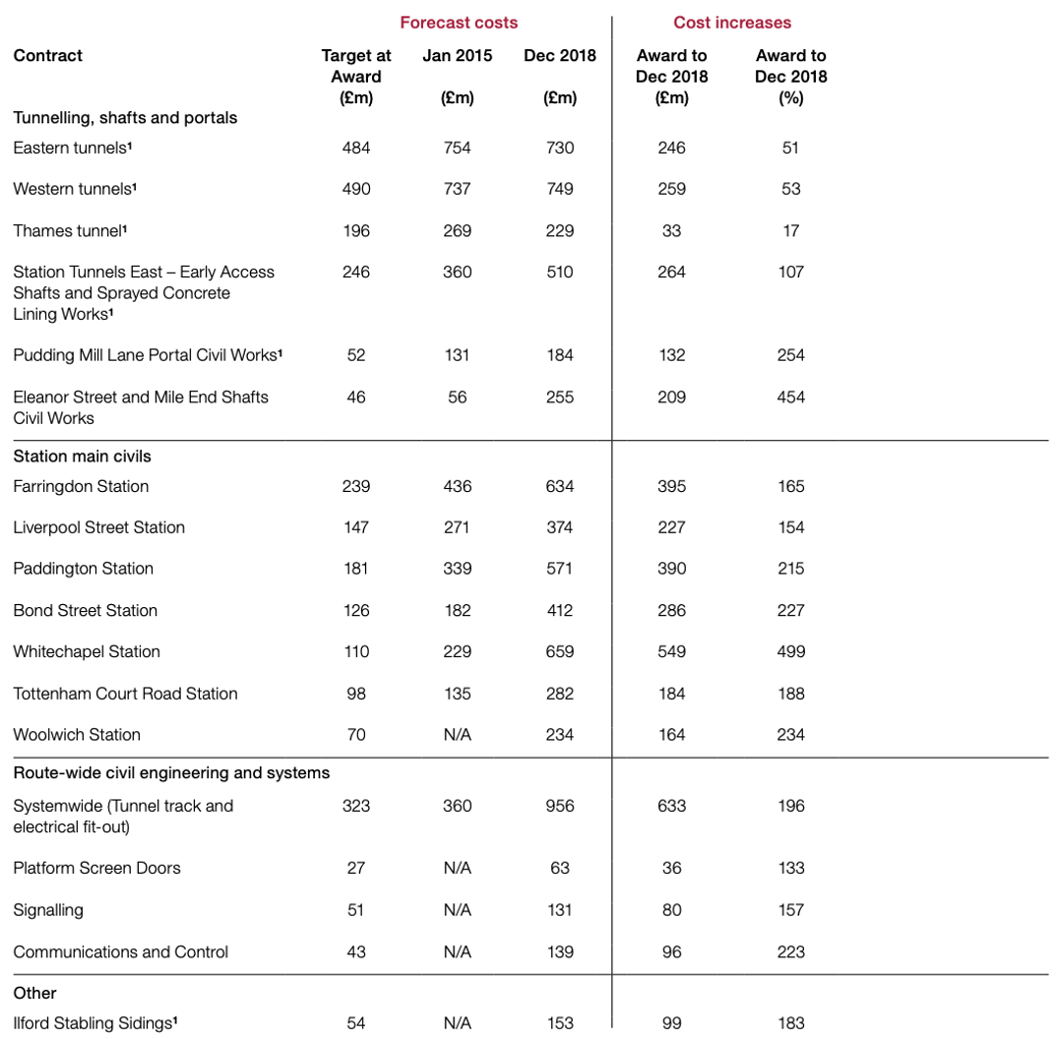
Table 3. The estimation of Elisabeth line budget. Source: National Audit Office (2019)
The projections from National Audit Office suggest that the projects could have been enough to cover existing costs; however, the costs could increase in the processes; therefore, the estimated reserve is insufficient to cover additional costs See Table 4. Causes of costs change. Source: National Audit Office (2019. The main reasons costs have increase is because of changes particularly increase of costs, unexpected external forces such as Covid-19 that generate programme changes and delays. Based on National Audit Office (2019) the following categories caused a change in costs, design, commercial settlement, schedule change, new scope, and other aspects.

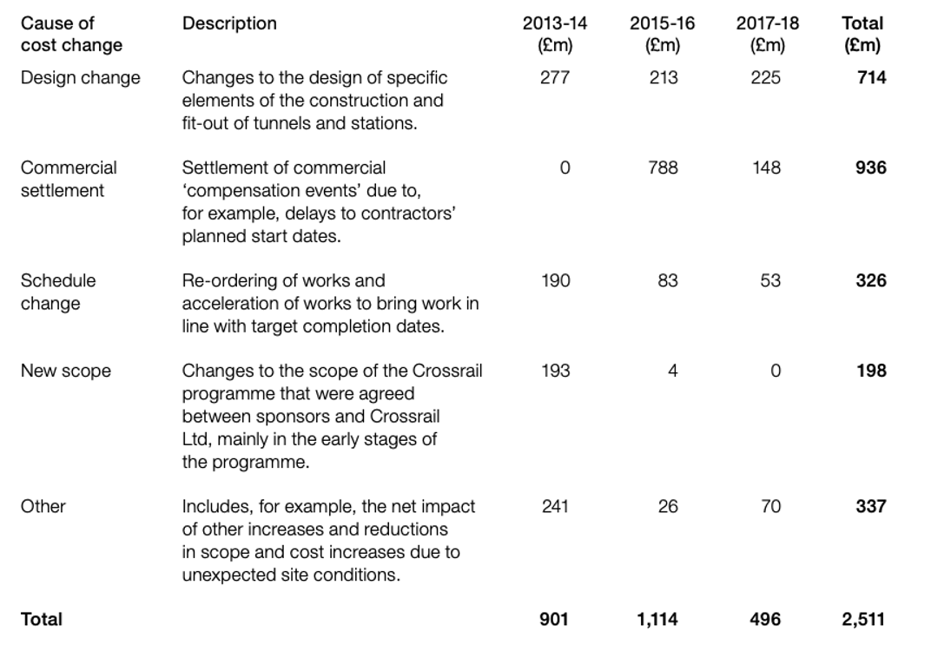

Table 4. Causes of costs change. Source: National Audit Office (2019)

Risks and Assumptions

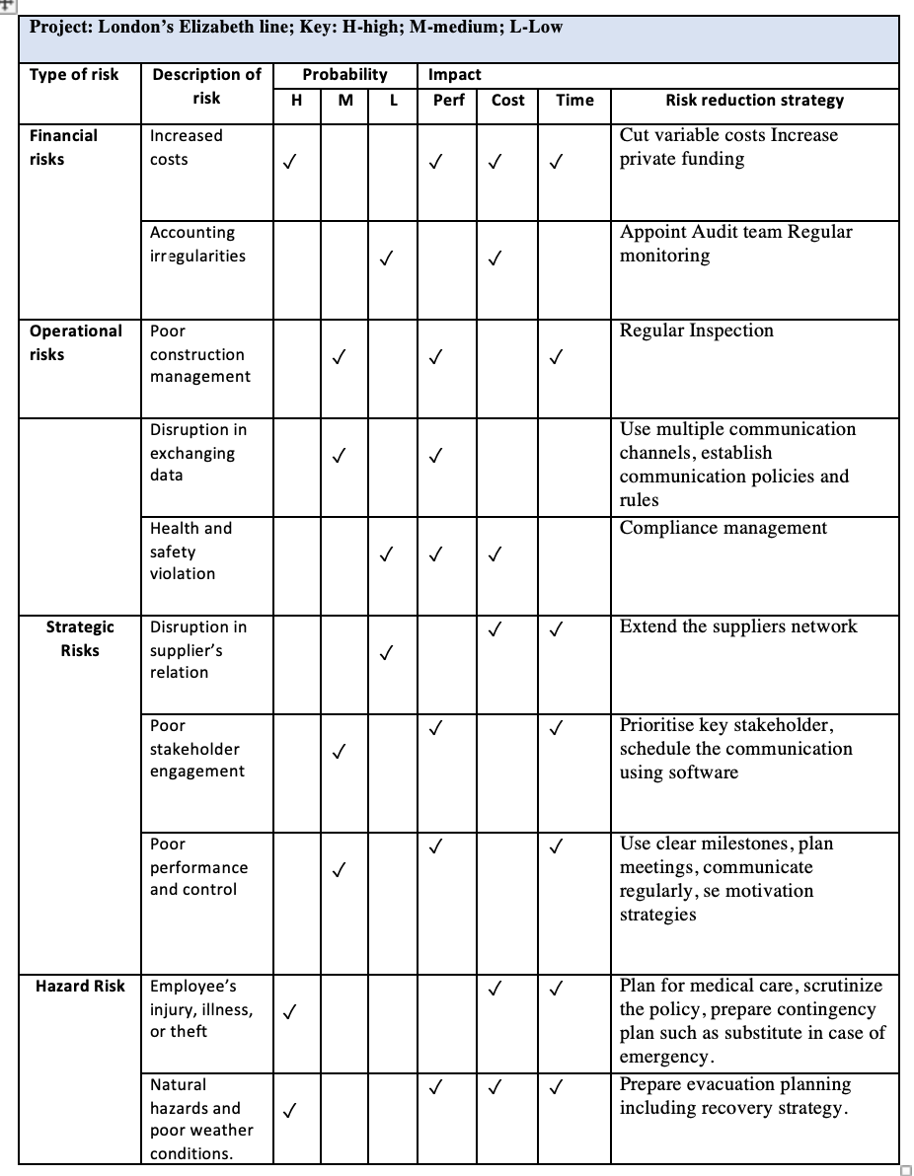
Considering the complexity of the Elisabeth Line project, it has been influenced by both internal and external factors and risks that should have been carefully analysed. According to Chapelle (2019), among the significant risks that impact projects include financial risks, operational risks, strategic risks, and hazard risks; thus, applying necessary strategies to minimise those risks, failing to do so, can be detrimental to the project.

Table 5. Elisabeth Line. Risk Assessment Register

Based on the risk assessment conducted on London’s Elisabeth Line initial project, it has been deducted that there is a high probability of financial risks that consequently will impact performance, cost, and time (See: Table 5. Elisabeth Line. Risk Assessment Register). Similarly, Montague Report (2004) showed that financial estimation must be cautiously treated. It could have been appropriate to increase the funding to alight it with project objectives to minimise financial risk; additionally, cutting unnecessary costs or reconsidering variable costs could have minimised the risk. In terms of operational risks, such as poor construction management and disruption in exchanging data, the probability is medium and may impact performance. To minimise the risks, regular review of the progress and identifying additional risks could help prevent significant disruptions (Winch, 2004). Other risks faced by the Elisabeth line include strategic risks and hazard risks that could have been better monitored and managed at a leadership level which has been an issue (See the assessment Table 5. Elisabeth Line. Risk Assessment Register).

Summary

As discussed in this section Elisabeth had issues in term of completing the project within the budget set which has impacted upon performance, time and it involved higher costs, thus it is important to treat the financial projections with extreme caution.

The analysis of stakeholders and efficiency of control mechanism

Introduction

Stakeholders play a crucial role in the efficiency of the project; if their position on the project changes, it could lead to disruptions or failure to complete it successfully. According to Pirozzi (2019), the stakeholder's contribution can be foundational, and in the case of Elisabeth line, the contribution from all stakeholders played a crucial role. However, considering Wasieleski & Weber's (2017) interest grid, different stakeholders, which refers to groups, also have different places on the grid.

Power Interest Grid
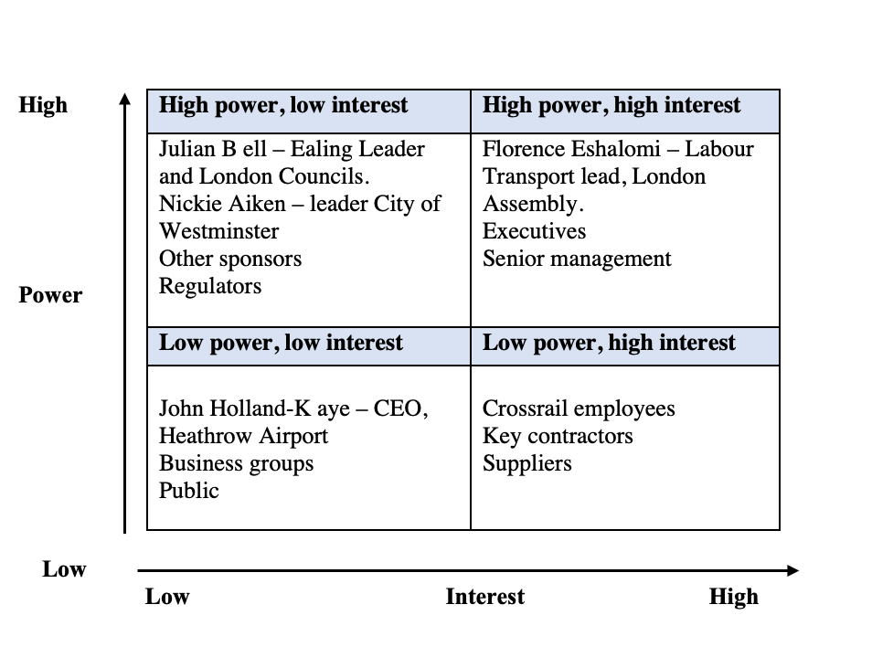

Figure 1. Elisabeth line stakeholders based on interest grid. Adapted from (Wasilewski & Weber, 2017)
Some important stakeholders were placed in the interest grid based on their power and interest in the project. Based on Croft et al. (2016) projections of Crossrail structure and governance (See Appendix 3. Crossrail Structure and Governance). The stakeholders from all project levels, including sponsors, industry partners, project development team, and stakeholders from the rail programme, are all interconnected with each other and contribute to the realisation of the project; thus, a high degree of collaboration and a more formal integration is required along with adapting to changing environments (Croft et al., 2016). Having a transparent view of the role each play in the project's success will support the decision-making processes in meeting the objectives and increase project performance (Wood, 2016).

Summary

Understanding the role of stakeholders in the project is important as it ensure effective management and increasing the collaboration or providing necessary information to keep them up to date with the progress made or other risks involved.
5. Conclusion and Recommendations

This report aimed to critically evaluate the Cross Rail Project (Elizabeth Line) with a particular focus on budgeting, timing, stakeholders, and risk factors. Elisabeth line is one of the notable and challenging projects dues to its size and the enormous investments required; nevertheless, it has been successfully launched even if not fully completed. The investigations in the initial planning releveled significant issues in terms of meeting the schedule and costs, which could have been improper management of potential risks, external factors such as Covid-19 and delays related to it, poor assessment of financial risks and gaps in leadership. As megaprojects are complex, some lessons and recommendations are drawn to improve project management efficiency. It is recommended to anticipate major disruptions and delays by preparing contingency plans concerning funding, ensuring effective collaboration between stakeholders, including awareness of budgeting to avoid overspending, conducting regular reviews of the progress made and foreseeing potential problems to address them on time.

Bibliography
- Buck, M., 2017. Crossrail project: finance, funding and value capture for London’s Elizabeth line. Proceedings of the Institution of Civil Engineers, pp. 1-8.
- Chapelle, A ., 2019. Operational Risk Management: Best Practices in the Financial Services Industry.. United Kingdom: Wiley.
- Chris Croft BEng, M. B. F. F. S. A. B. C. M. A., 2016. Lessons learnt from structuring and governance arrangements: perspectives at the construction stage of crossrail, Learning Legacy Crossrail .
- Crofts, S., 2016. Health and Safety Performance Index (HSPI). Crossrail Learning Legacy.. [Online]
Available at: https://learninglegacy.crossrail.co.uk/documents/hspi/
[Accessed 04 May 2021].
- Crossrail, 2022. Phase Openning. [Online]
Available at: https://www.crossrail.co.uk/project/our-plan-to-complete-the-elizabeth-line/phased-opening#
[Accessed 23 November 2022].
- De Silva, M. a. R. P. 1. n. 4., 2015. “Delivering Crossrail, UK: A Holistic Approach to Sustainability.”. Engineering Sustainability, 168(4).
- Dongen , L. & Rajabalinejad, M., 2018. Framing success: The Netherlands railways experience. International Journal of System of Systems Engineering, 8(4), pp. 312-313.
- Montague, A., 2004. Crossrail Review , London: Crossrail UK.
- Morris, S., 2022. Crossrail: Top 22 facts about the Elizabeth line. [Online]
Available at: https://www.standard.co.uk/news/uk/crossrail-top-22-facts-about-elizabeth-line-b1001756.html
[Accessed 23 November 2022].
- National Audit Office , 2019. Completing Crossrail , https://www.nao.org.uk/wp-content/uploads/2019/05/Completing-Crossrail.pdf.
- Pirozzi, M ., 2019. The Stakeholder Perspective: Relationship Management to Increase Value and Success Rates of Projects.. United States: CRC Press.
- Pollalis, S. N. & Lappas, D., 2019. Crossrail -Elizabeth Line London, UK. The Zofnass Program at Harvard, pp. 1-16.
- Principles for Responsible Investment , 2019. Reporting Framework Review. [Online]
[Accessed 04 May 2021].
- Shenhar, A. & Holzmann, V., 2017. The Three Secrets of Megaproject Success: Clear Strategic Vision, Total Alignment, and Adapting to Complexity. Project Management Journal , 48(6).
- Topham, G., 2022. Elizabeth line: Crossrail complete after decades of struggle – a photo essay. [Online]
Available at: https://www.theguardian.com/uk-news/2022/may/23/building-the-elizabeth-line-london-tube
[Accessed 23 November 2022].
- Transport for London , 2017. Elisabeth line; Design Idiom. [Online]
Available at: https://content.tfl.gov.uk/elizabeth-line-design-idiom.pdf
[Accessed 23 November 2022].
- Tucker, W., 2016. Crossrail project: the execution strategy for delivering London’s Elizabeth line. Proceedings of the Institution of Civil Engineers, 170(5), pp. 3-14.
- Verma, R. & Naidoo, V., 2021.. Contemporary Challenges for Agile Project Management.. United States: IGI Global.
- Wasieleski, D. & Weber, . J., 2017. Stakeholder Management. United Kingdom: Emerald Publishing Limited.
- Williams, ., 2008. The principles of project management. Switzerland: Sitepoint.
- Winch, G. M., 2004. Managing Project Stakeholders. In: Project Management . Jogh Wiley&Sons, pp. 321-339.
- Wood, R., 2016. Performance Assurance Framework.. [Online]
Available at: https://learninglegacy.crossrail.co.uk/documents/performance-assurance-overview/
[Accessed 4 May 2021].

Appendices
Appendix 1. Program management structure

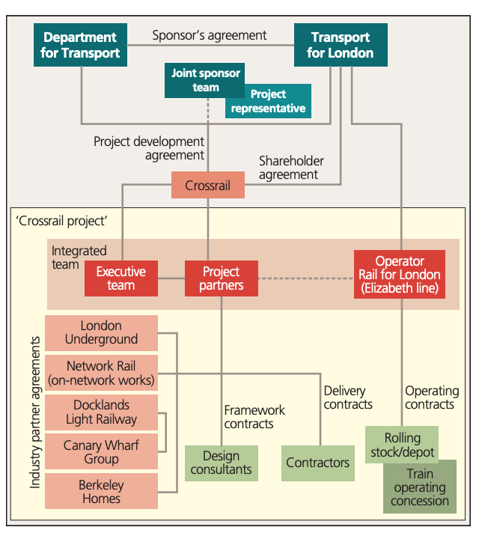

Figure 2. Program Management Structure. Source: (Pollalis & Lappas, 2019)

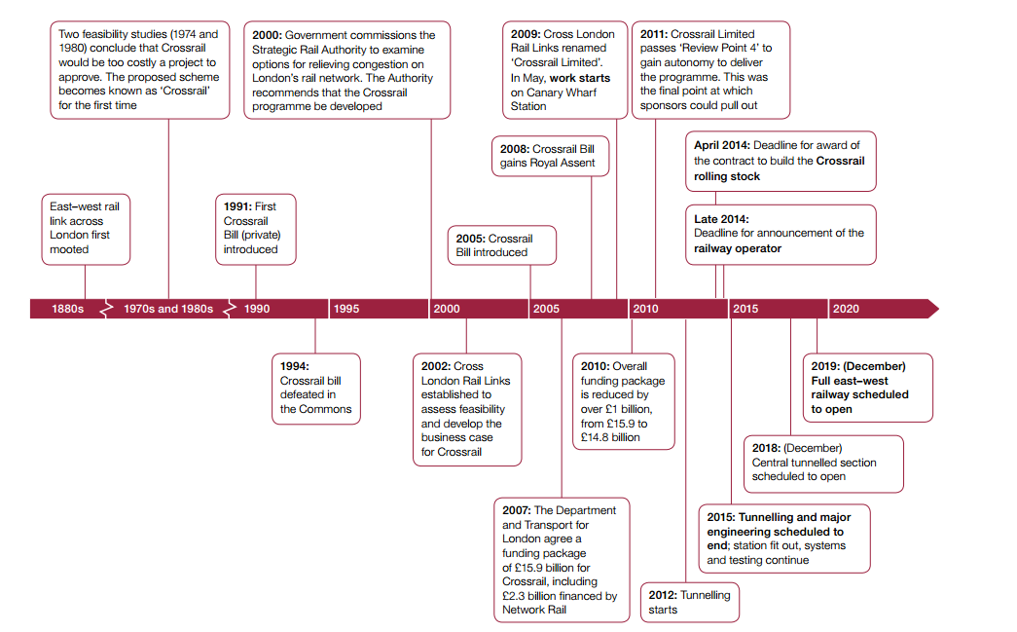
Appendix 2. Project Initiation and development

Figure 3. Elisabeth Line, project initiation and development. Source; Crossrail Learning Legacy

Appendix 3. Crossrail Structure and Governance

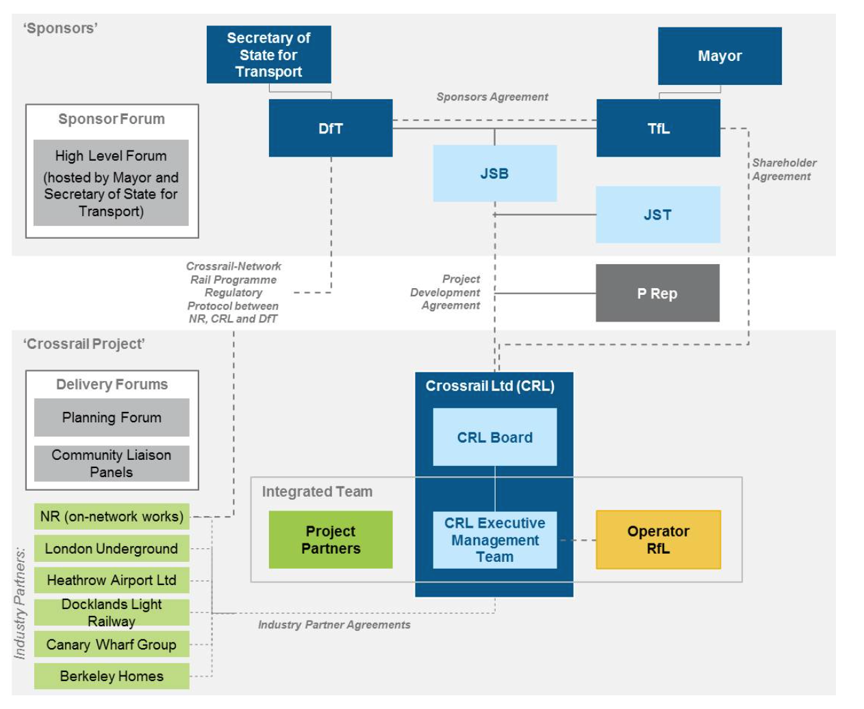

Figure 4. Elisabeth line structure and governance agreements. Source: Croft et al. (2016)

