Introduction - Folk Horror, a brief history
Ari Asters Midsommar (2019) has been analysed from different perspectives since its cinematic release in the summer of 2019, with many journalists, theorists and fans of film sharing opinions on the pivotal characters, the gruesome sacrificial scenes and even the colour theory used.
This essay will consider how the Asters feature film explores theories linked to Hauntology, Rites of Passage, liminality and trauma. This will be completed through an analysis of the structure and content of the film and the crucial elements that place it within the Folk Horror genre. Relevant theorists such as Mark Fisher ‘The Weird and the Eerie’ (2016), William Burns ‘Ghost of an Idea, Hauntology, Folk Horror and the Spectre of Nostalgia’ (2014) and Michel Van Gennep ‘Rites of Passage’ (1960) will be used to support the analysis of the film. The documentaries ‘Woodlands Dark and Days Bewitched’ (2021) and ‘A History of Horror with Mark Gatiss, Home Counties Horror’ (2010) will also be considered throughout the essay. This introduction will make use of different theoretical sources to discuss a brief history on the resurging subgenre of Folk Horror. Introducing the key elements of Folk Horror and the three films that were integral to its rise in popularity in the late 60’s and 70’s, that are still referenced and used as inspiration today.

With its first known use by Oscar James Campbell in a 1936 article in the English Journal, the term folk horror has been defined in many ways throughout its history. However, Adam Scovell’s description that:
‘It is and functions like a genre, so I think the best way to see it is a mode in a musical sense, where there is a set of key notes, but they are providing a different context because they are played in a different order’ (Woodlands Dark and Days Bewitched, 2021)
Scovell’s unwillingness to give it a firm definition, allows us to interpret the term more freely, considering that it doesn’t matter what order the elements are arranged in, as long as the film contains them, potentially seeing more folk in horror films than first perceived. These ‘Key notes’ or elements of folk horror typically focus on isolation both psychologically and geographically, folk religion and paganism, dark aspects of nature and superstition and sacrifice. With a focus on locationality, ‘Folk horror is very much about our connection to the land’ (Woodlands Dark and Days Bewitched, 2021). The ‘Back to land’ movement and the rejection of modernity and ‘Civilized society’ (Burns, 2024) from the city dwellers in the early 60’s inspired peoples ‘Yearn for the old again’ (Woodlands Dark and Days Bewitched, 2021), moving outwards towards the countryside. This shift in focus proved inspiration for the British film industry and over the following years many Folk Horror films would be released, within which the ‘Unholy Trinity’ would be born.
Cult classics of the Folk Horror genre, the ‘Unholy Trinity’ consists of three Films, Michael Reeves’ ‘Witchfinder General’ (1968), Piers Haggard’s ‘The Blood on Satan’s Claw’ (1971) and Robin Hardy’s ‘The Wicker Man’ (1973). These three films set the tone for British Folk Horror with their isolated communities, ritualistic ceremonies and human sacrifices, all played out in broad daylight. ‘The Wicker Man’ (1973) being the most referenced of the three, highlights the contrast in ‘The old ways and the new’ (Woodlands Dark and Days Bewitched) with the rejection of Christianity by the inhabitants of Summerisle and their acceptance of the old Pagan ways, leading them to commit ritualist sacrifices to ensure a healthy crop growth in the coming year. The film shows a brutal deception of the main protagonist, a Christian policeman lured to the island under the premise of investigating a missing girl, only to find himself burned alive at the films horrific ending.
Michael Reeves’ ‘Witchfinder General’ (1968) sits within the same space as ‘The Wickerman’ (1973) with a focus on the brutality of the people, as the Witchfinder hunts and sacrifices those he suspects are witches in the 1645 English countryside. ‘The Blood on Satan’s Claw’ (1971) differs from the previous two films as the horror appears to come from the earth. Found in a field and it is farmed, the film revolves around a haunting or possession of the country folk one by a demon attempting to rebuild its body. Although the sacrificial acts within the film are completed by the people, unlike the two previous films they appear no longer in control, taken over by the supernatural entity.
These films paved the way for others to begin exploring the eerie landscape of Folk Horror, shown in the range of films and television that followed such as BBC’s ‘A Ghost Story for Christmas’ (1971-1978), HTV’s ‘Children of the Stones’ (1977) and Ari Asters ‘Midsommar’ (2019).

Ari Asters Midsommar (2019)
Throughout the history of film, we often see a director and writers use of what has been named the Three Act Structure to form the storyline of a film. This structure will follow a protagonist through their ‘Hero’s Journey’ and cross over the three sections like a rite of passage. Ari Aster created his film Midsommar (2019) to follow this journey and although not marked by clear sections, with a deeper analysis on the films’ storyline; the three parts become clearer, following the ideas of separation, initiation / transition, and incorporation. In his book ‘Ghost of an idea: Hauntology, folk horror and the spectre of nostalgia’ (2024) William burns theorises how three parts can also be observed within the components of the Folk Horror genre, being an:
‘1. Exploration of how natural landscapes, their isolated inhabitants, and cultural heritage intertwine;
2. Fanatical resistance to progress, materialist doctrines, and linear accounts of time;
3. Clash of belief systems resulting in violence.’ (Burns, 2024)
In Midsommar (2019), we see both of these three-part structures feature as the basis of the storyline and within the visual elements of the film. Therefore, this section of the essay will also be broken down into three parts, so that the film can be analysed following Ari Asters focus on the protagonist’s journey.

Part 1 – Separation
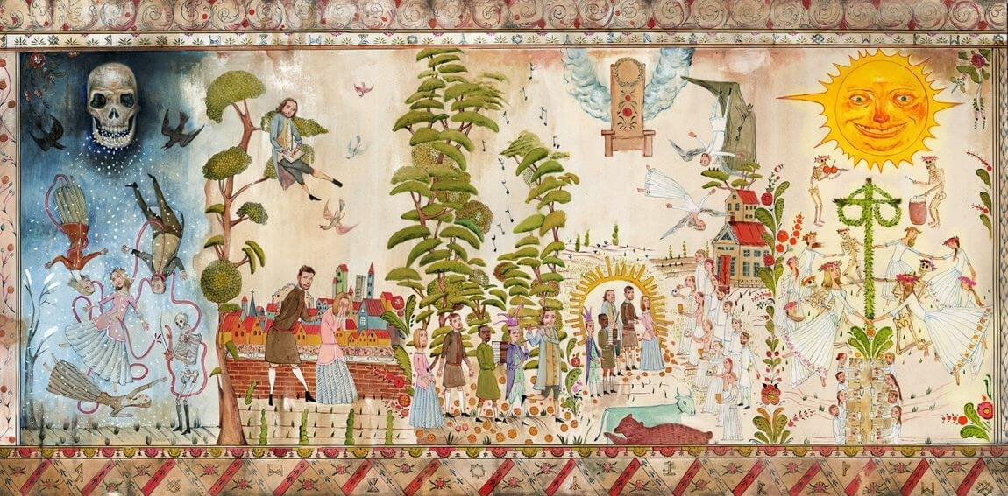
The film begins with a melodic folk tune sounding from an unknown source and a pictographic tapestry that will serve as a prediction for the events that we are soon to witness. We are briefly given the opportunity to observe a vague outline of the story yet to come, shown through the almost seasonal sections of the tapestry; a dark beginning with signs of death, a journey of characters travelling from city to forest, to new community, and finally depictions of ritual and a looming sun staring with a fiery, unnerving gaze. The image of the tapestry is paired with ‘A harp sounding with rich harmonies’ (McManus, 2024) introducing the viewer to the folkloric themes that will be the focus of Ari Asters self-described “Break-up movie” and the musical element that will include folk sounds made with instruments, vocals and expressive breath work.
Figure 1. ‘Midsommar’ (2019) [0:00:20 – 0:00:40]

The tapestry shown in Figure 1. shows no clear signs of location and gives the viewer a feeling of uneasiness or unheimlich, a term coined by Sigmund Freud in his 1919 essay Das Unheimliche. We observe the ‘The familiar as strange’ (Fisher, 2016) as separately the imagery we see such as: people, plants, animals and buildings along and symbols of a skull, sun and angel wings; are all recognisable. However, when placed together in an unfamiliar, story board display they appear strange, and the tale being told through the tapestry feels unfamiliar.
The film moves into its bleak, dark beginning with an aerial shot of a dense and snowy forest, leading us to our first encounter with the protagonist Dani sat at her laptop expressing concern on the phone to her long-term partner over a cryptic email sent from her sister, whom we are soon to learn suffers with bipolar disorder. The mood is low and the feeling uneasy; reflected not only in Dani’s dimly lit apartment but also in the quiet, unlit home of her parents, where we see them laying unresponsive in their beds as the phone next to them buzzes with multiple missed calls from their increasingly worried daughter.
The eerie sound of Dani’s quiet attempts to contact her parents and sister is contrasted in the atmosphere of the diner, where her partner Christian sits with his friends and fellow Anthropology graduates discussing his deteriorating relationship. These two contrasting spaces show a reflection of the people that inhibit them, Dani is in a dark place both mentally and physically, shown isolated and alone in her apartment, following a typical element of the Folk Horror genre. Christian, however, is surrounded by his friends, and other patrons of the diner with a buzzing or humming sound that conveys the highly technological space the city folk live in. We will see this contrasted later in the film by the lack of modern civilization and the folkloric sounds that are enclosed in that space. Conversation between the male characters is interrupted and the background sounds quieten as the viewer is alerted that something terrible has happened; signalled by the harsh, guttural scream we are able to recognise as coming from Dani. As the camera moves through the dark house which has been shown only in small shots, the reality of the situation is revealed, and we see that Dani’s calls and emails to her sister were left unseen, as the devastating murder-suicide by Carbon monoxide poisoning is shown and proving that those closest to us can inflict the deepest wounds. This harsh opening to the film sets our understanding of the trauma that Dani has endured from the very beginning, her trauma isolating her further from her distant partner and the friends she will eventually travel to a new community with.
Using conversation with Dani, the Swedish character Pelle takes the opportunity to express his sympathies for her recent devastating loss. This conversation initiates our first encounter with a disruption in time, as she rushes from the room distressed, opening a door and walking through the threshold, she appears in an aeroplane bathroom instead, still suffering from a panic attack. Dani’s trauma is shown in this ‘Gap in memory’ that we as the viewer perceive and ‘Fatally undermines the characters’ sense of their own identity’ (Fisher, 2016) as we observe her slipping further into her trauma fuelled depression. This scene is accompanied by a low beating hum and a turbulent shaking of a cloudy view from the plane, disturbing and disorientating the viewers perspective on the space and time the film is moving through. This shift in spatiality transports us out of the first act with the use of sound and ‘Renders time as an audible materiality’ (Fisher, 2012).
Part 2 – Initiation / Transition
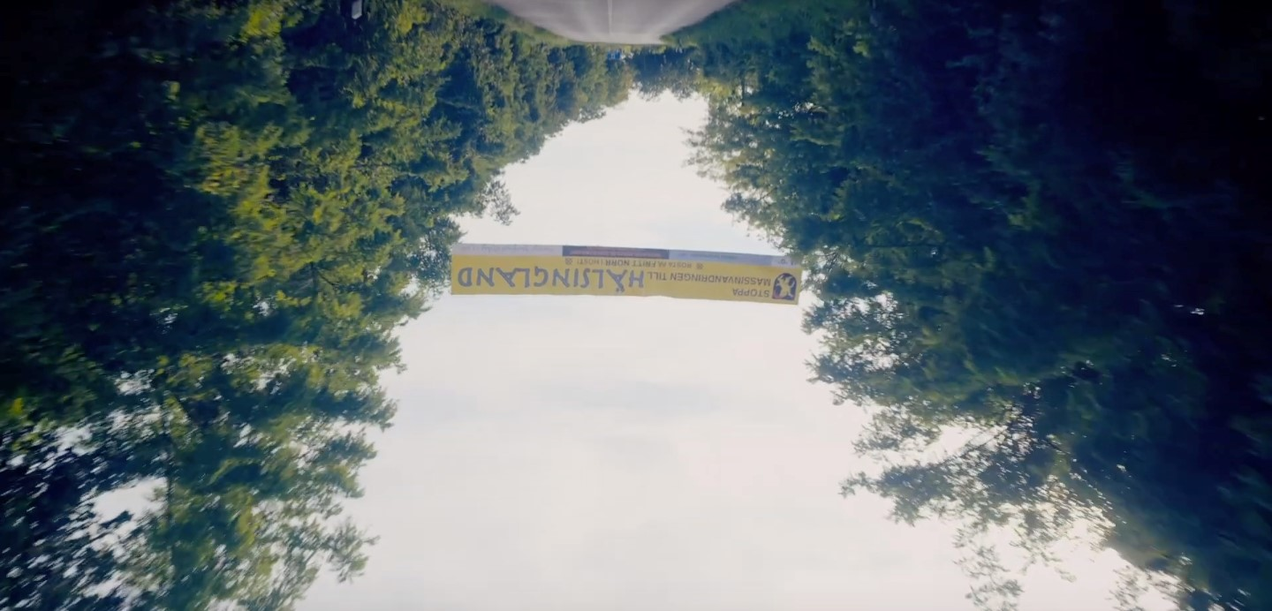
Crossing a physical threshold, from America to Sweden; Dani and the group of travelling graduates begin their journey towards the ‘Unvisited vastness’ (Fisher, 2016) of the of Harga community and begin the second step in the three-act structure: initiation and transition. The journey sees no other forms of civilization and the only understanding of location the viewer is given is the discussion between characters that tells us they are traveling in the opposite direction of Stockholm and a banner showing that they are entering the area of Hälsingland. At this point the camera has flipped, shown in Figure 2. and the viewer is given a disorientated upside-down view of the journey ahead.
Figure 2. ‘Midsommar’ (2019) [0:24:55]

Turning off the road, the travellers enter a field containing only returning Hargan locals and the people they have brought with them to experience the Midsummer celebration. The scene is brightly lit and the colours more saturated, marking a clear transition from the first act. This will be the unrecognisable space where they spend their first night in Sweden, under the influence of hallucinogenic drugs and the ‘Rare phenomenon of round-the-clock sunlight’ that leaves the viewer with ‘A queasy restless feel’ as the ‘Terror moves out of the darkness and into the light (Newman, 2019). The ‘consumption of plant substances that provide hallucinations or otherwise alter sensibilities’ (Alexander and Norbeck, 2025) act as a rite of passage for the group of travellers as they are all encouraged to take them before they journey into the community of Harga. The book Rites of Passage (1960) by Arnold Van Gennep discusses theories on Pre Liminal, Threshold, and Post Liminal Rites that can be used to examine how this act of taking drugs together can be viewed as a Threshold Rite, being ‘Executed during the transitional stage’ and also presents an understanding of why the group must wait before continuing their the journey to Harga as ‘Foreigners cannot immediately enter the territory of the tribe or village’ (Van Gennep, 1960). This rites ceremony also initiates Dani’s second ‘Gap in memory’ (Fisher, 2016) as we observe her disassociation from reality and subsequent ‘bad trip’ where she has a vision of her deceased sister behind her in a mirror, her ‘Unresolved past, that comes back’ (Woodlands Dark and Days Bewitched, 2021) to haunt her.
Now able to enter Harga the group of travellers cross a territorial passage, under a wooden, sun shaped arch as they ‘Leave one world behind’ and ‘Enter a new one’ (Van Gennep, 1960), the locality of which has no detectable features linking it to known civilization. This new space presents an isolated community that features traditional structures, a bear and communal spaces that will prove that the ‘Landscape is far more than a backdrop’ (Riley, 2018) but can been seen to facilitate a ‘Psychological relationship between people and place’ (Woodlands Dark and Days Bewitched, 2021) within the film.
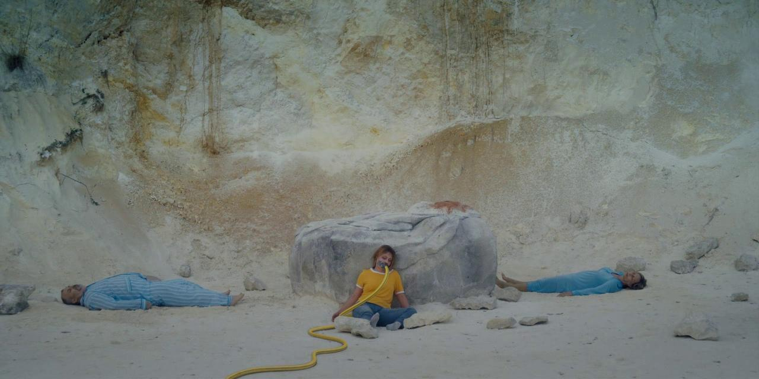
The first of the Midsummer ceremonies takes place at the top of short cliff. Dani, along with her partner Christian and the Hargan folk wait at the base of the cliff with the us as the viewer sharing their perspective, focussing up towards two elderly Hargans stood at the cliffs edge. This upward shot is reflective of Piers Haggards The Blood on Satan’s Claw (1971) eerie opening scene, where he felt it was ‘Important to have the camera low’ giving the viewer a ‘Feeling that we are somehow in the earth’ (Gatiss, 2010). Before we get chance to fathom what will happen next, the first Hargan steps off the edge, perishing at the base where the non-locals stand in disbelief at what they have just witnessed. The shouting and noise muffle and the people surrounding Dani blur as the second Hargan’s graphic plummet does not result in an instant death. His wails of agony are mimicked by the crowd of Hargans, who shout, scream and breathe heavily in tandem with the dying man as he is subsequently killed with mercy by mallet, revealing the violent nature of the community.

Figure 3. ‘Midsommar’ (2019) [1:16:10]

Following the first Midsummer ceremony, the film captures a rare glimpse of darkness at nighttime as Dani experiences a night terror, the shocking sacrifices traumatising her as she envisions her partner and his friends abandoning her at Harga and again reliving the death of her family, now joined by the graphic deaths of the elderly Hargans, seeing ‘Something where there should be nothing’ (Fisher, 2016) in the dark night. The haunting vision she experiences in her night terror, shown in Figure 3. where the two deceased Hargans are replaced with her parents. This ‘nagging persistent memory that will not go away’ (Burns, 2024) shows them laying silently in the clothes they passed in, with her sister sat peacefully in the centre leaning against the rock that acted as a tool in the deaths of the Hargans, with her own tool for death taped to her mouth. This dissociation shows how we can ‘project ourselves and our inner realities onto the countryside’ (Burns, 2024).
. The remainder of the second act see’s her internal ‘Conflict with antagonistic forces’ (Brutsch, 2015) as she tries to understand the brutal Hargan rituals and the non-Hargan visitors making crucial mistakes such as urinating on a sacred tree, photographing a religious text and simply asking to leave the community. These acts result in the drawn out and mainly unseen disappearances of all non-Hargans with the exception of Dani and Christian.
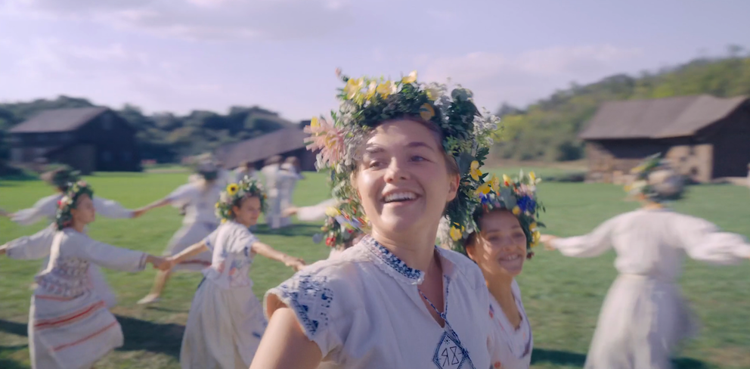
Part 3 – Incorporation
Figure 4. ‘Midsommar’ (2019) [1:42:10]

The third act begins similarly to the second with the consumption of hallucinogenic drugs, in the form of a tea. Dani has been dressed in the clothing of the Hargan people and has been encouraged to participate in a midsummer ceremony, the May Pole Dance. Linked by hands and arms, Dani and the other female Hargans dance and spin in circles around the may pole, shown in Figure 4. as the folkloric melody sounds out, stopping and changing direction with the pauses of music. Dizzy and disorientated, Dani appears to begin understanding and speaking the Swedish Hargan language that was once foreign to her, as the dancers bump into each other and fall one by one till only she remains twirling alone. When the music stops, she is crowned ‘May Queen’ and surrounded by the excited community within whom she sees the faces of her, mother, father and sister. This vision this time appears less distressing, with them dressed in all white resembling the new community she is slowing becoming part of.
During the celebration, Christian is facing his own version of incorporation to the Harga community as he is led away from the crowd by a female Hargan. The large wooden building he enters is empty of all furniture but instead houses thirteen unclothed women, one of which lays waiting, whom he is encouraged to impregnate. The scene is uncomfortable both for the viewer and the character, who under the influence of drugs appears unwilling to participate but forcibly encouraged by the other women present, highlighting a ‘Complete breakdown of values’ (Gatiss, 2010) from the Hargan folk as the group moan and grunt with the rape that pursues. Through a keyhole Dani observes the forced rape of her partner, and believing it to be consensual breaks down, fleeing the scene crying with grief from what she perceives as the loss of a relationship. She is joined by a group of Hargan women who, like the group that still occupies Christian, mimic her cries; slowly getting louder till they reach a grief ridden scream. Once Christan’s act of incorporation is completed, he runs from building terrified and unclothed. Seeking refuge in a smaller wooden barn, he is faced with one of the missing travellers, tied, cut and hung up in an obvious ritualistic killing. There he is found and with a puff of powder to the face, he will become permanently paralysed.
In the final scenes we observe Dani in her last transition from outsider to one of the Harga. Encased in a cloak of colourful flowers, she sits upon a stage visibly upset despite being crowned as the May Queen and awaiting the final Midsummer ceremony. A yellow ‘Chapel’ seen throughout the film, closed to both the travellers and the Harga Folk; is opened and revealed to be the place in which nine human sacrifices will be burned, finalising the Midsummer festival. It is announced that eight of the sacrifices have been chosen, with Dani to choose the ninth. Given a choice between an unknown Hargan male and Christian sat completely paralysed, she choses Christian and his fate is set. Placed inside the skin of the bear we saw at the beginning of the second act, Christian is sat in the centre of the yellow building surrounded by the eight other sacrifices: four non-local sacrifices, wicker reconstructions of the two elderly Hargans previously sacrificed, and two live Hargans who have supposedly volunteered. The yellow building is set alight with the sacrifices burning within, the Hargan folk begin to wail, scream, run and fall, showing their ‘Shared consciousness’ (Woodlands Dark and Days Bewitched, 2021), and just like the fiery ending scene in The Wickerman (1973) the films ‘Horrific conclusion’ is ‘Played out in daylight’ (Gatiss, 2010). The final shot sees Dani’s frowning face changing from that of sadness to a smile. ‘We begin as Dani loses a family, and we end as Dani gains one’ (Wilkinson and Aster, 2019).

Conclusion
The question posed at the beginning of this essay asked how Ari Asters ‘Midsommar’ (2019) explores theories linked to Hauntology, Rites of Passage, liminality and trauma. Through the film we are able to observe how Aster has created a feeling of liminality both within the physical and psychological space that the protagonist Dani finds herself in. Dani, in an uncomprehensible grief fuelled state is isolated often filmed in single close-up shots, with her surroundings blurred or physically distanced from her partner. In many scenes we see her struggling to follow or understand conversations the Hargan folk have in Swedish and with the Asters intentional choice to not subtitle these conversations, the viewer is also left feeling isolated.
We observe Dani disassociate continually through the film, haunted by the trauma she has endured, with visions of her family, beginning as graphic and disturbing still images of their deaths. As the film progresses the visions continue, evolving and ending with them appearing within the crowd of Hargans, seemingly approving of her transition from outsider to one of the community. These moments of disassociation, night terrors and ‘Bad trips’ deepen the layers of liminality as both Dani and us as the viewer are disorientated by her declining sanity and her inability to distinguish real life from dreams and haunting visions.
The surrounding space she finds herself in, although open and spacious gives the viewer a ‘Feeling of claustrophobia in this place where you can see everything’ (Woodlands Dark and Days Bewitched, 2021), with the dark nature of the Hargan community ‘Hidden behind the façade of beautiful flora and fauna’ (Burns, 2024).
The film depicts many ceremonies and Rites of Passage, through the consumption of hallucinogenic drugs, crossing of thresholds, communal meals serving as a ‘Sacrament of communion’ (Van Gennep, 1960), and the participation of initiation ceremonies. Van Gennep’s ‘Rites of Passage’ states that ‘They must stop, wait, go through a transitional period, enter, be incorporated’ (Van Gennep, 1960), this understanding of Transitional Rites follows Dani’s journey through the film, with her being the only character that we see complete all stages of the rites presented.
She is given space to grieve through the untraditional communal methods of the Hargan people, with the mimicking breathwork, crying and wailing sharing the grief between them. These moments in the film provide Dani with the support she has been lacking in her regular life and in turn deepens her connection with the Hargan community and the land that they inhabit reminding both Dani and the viewer of ‘Our connection with our own landscapes and where we fit into our wider environments’ (Woodlands Dark and Days Bewitched, 2021).
The film begins with the unfathomable loss of Dani’s family, but as it the nine sacrifices meet their final end, we see that Dani has transitioned. Crossing the final threshold into the Hargan community, she has found a new family, but as the viewer we are left still in a liminal space, unsure of what her future will hold.

Bibliography

Fisher, M. (2012) ‘What is Hauntology?’, Film Quarterly, Vol. 66, No. 1, Pages 16-24, University of California Press.
Accessed on:
https://www-jstor-org.ezproxy.uwtsd.ac.uk/stable/10.1525/fq.2012.66.1.16?sid=primo&seq=3

Fisher, M. (2016) ‘The Weird and the Eerie’, London: Repeater Books.

Burns, W. (2024) ‘Ghost of an Idea, Hauntology, Folk Horror and the Spectre of Nostalgia’, Oxford: Headpress.

Midsommar (2019) Directed by Ari Aster [Film]. A24
Accessed on:

McManus, L. (2024) ‘Processing Trauma Sonically in Ari Aster’s Midsommar (2019): Hauntology, Harmonic Signifiers, and Diegetic Vocality’, online: Quarterly Review of Film and Video, Routledge, Taylor and Francis Group.
Accessed on:
https://www.tandfonline.com/doi/full/10.1080/10509208.2024.2432119

Newman, K. (2019) ‘Demons by Daylight’, Volume 29, Issue 8, O nline: Sight and Sound.
Accessed on:
https://research-ebsco-com.ezproxy.uwtsd.ac.uk/c/onvpsy/viewer/html/7qlnfd4skb

Van Gennep, A. (1960) ‘Rites of Passage’, The University of Chicago Press, London: Routledge and Kegan Paul Ltd.
Accessed on:
https://archive.org/details/theritesofpassage/page/n5/mode/2up

Woodlands Dark and Days Bewitched, A History of Folk Horror (2021) Directed by Kier-La Janisse [Documentary]. Severin Films.
Accessed on:

Riley, J.A. (2018) ‘Folk Horror: Hours Dreadful and Things Strange. Edited by Adam Scovell’, Volume 51, Issue 4, Online: The Journal of Popular Culture.
Accessed on:
https://onlinelibrary.wiley.com/doi/epdf/10.1111/jpcu.12695

A History of Horror with Mark Gatiss: Part 2, Home Counties Horror (2010) Directed by John Das and Rachel Jardine [Documentary]. BBC.
Accessed on:

Alexander, B.C and Norbeck, E. (2025) ‘Rite of Passage’, Online: Encyclopaedia Britanica.
Accessed on:

Brutsch, M. (2015) ‘Three Act Structure: Myth or Magical Formula?’, Journal of Screenwriting, Volume 6, Number 9, Online: Intellect Ltd.
Accessed on:
https://intellectdiscover-com.ezproxy.uwtsd.ac.uk/docserver/fulltext/josc/6/3/josc.6.3.301_1.pdf?expires=1745856807&id=id&accname=trincol&checksum=AA41E870D4DA2A038E204A7C21E80A4A

Wilkinson, A. (2019) ‘Ari Aster on his new film Midsommar: I keep telling people I want it to be confusing’, Online: Vox.
Accessed on:
https://www.vox.com/culture/2019/7/2/18744431/ari-aster-midsommar-interview-spoilers

