  Component One: Student Journal (learning log) 750 words +/- 10%  Contribution to Overall Module Assessment: 25% | Student No: | 2240761
 | Module Title: | Operating Hotel Facilities
 | Module Code: | BMIH4004
 | Lecturer: | Lisa-Marie Bassler
I performed a variety of duties in the Premier Inn's East Rotherham housekeeping department to keep the public spaces and guest rooms tidy and clean. These duties included managing and organising linen, sanitising, and stripping rooms, arranging rooms with fresh linens, and using a variety of cleaning agents to maintain the highest standards of hygiene.

I felt that every task I completed improved the hotel's overall guest service experience. Making sure that guest rooms were spotless and ready for arriving guests required close attention to detail. The housekeeping department uses a significant quantity of materials, which include departmental equipment and supplies as well as decorative items for guest rooms (Cassado, 2012, p. 68). The right tools for the job determine cleaning efficiency, not the quantity of tools used (Balderston, 1944/1935, p. 2) and to improve guest satisfaction with the cleanliness of their accommodations, cleaning products such as Suma D10 Spray and Sprint 200 Spray were used to achieve spotless mirrors, surfaces, and high-touch areas. The hotel is three stories high with no lift, which added to the experience. This meant that carrying heavy, dirty linens to the ground floor needed extra effort and coordination.

When I think back on my feelings during the placement, I felt a range of emotions. The fast-paced atmosphere was thrilling, but it also presented difficulties, especially when working as a team to meet deadlines. “We all experience pressure regularly – it can motivate us to perform at our best” (Mullins & Christy, year, p. 92). There were moments when the physical demands of the job felt too much to bear, like climbing stairs and carrying heavy loads of linen. But the feeling of success that came from overcoming obstacles and cooperating as a team was very satisfying.

Upon assessing my abilities and performance, I identified multiple skills, such as proficient communication, effective time management, and problem-solving. While effective time management enabled me to meet deadlines and sustain productivity, clear communication with team members ensured that tasks were coordinated smoothly. But I also saw areas where I could do better, like strengthening my physical endurance and effectiveness when lifting large objects and increasing my understanding of particular cleaning techniques and supplies.

My placement experience helped me better appreciate how important the housekeeping department is to the overall satisfaction of visitors. The effectiveness and efficiency of room preparation were directly impacted by operational duties like handling and sorting linen, which in turn affected the comfort and experience of visitors. For example, making sure that every lining-room from every floor had everything required, made room setup faster and overall operations went more smoothly. It's crucial to keep the linen rooms neat, orderly, and clean to provide the highest standards for visitors (Holiday Inn, Academy Portal, n.d., para. 1).

One of the most important things I've learned from my placement experience is how crucial attention to detail is to preserving neatness and order. I also learned more about the collaborative nature of the hospitality industry and the value of excellent teamwork and communication in accomplishing shared objectives. In addition, I understood how crucial it is to keep learning and growing to adjust to the ever-changing demands of the industry.

My placement experience changed the way I thought about the hospitality sector and made me appreciate how much effort and commitment it takes to provide great guest experiences. I now understand that jobs in hospitality have many facets and offer fulfilling chances for both career and personal development.

I have created an action plan to improve my abilities and understanding in the housekeeping department going forward. This entails actively seeking feedback from the managers to identify areas for improvement, becoming more familiar with a wider range of cleaning products and procedures, and pursuing additional training on safely and efficiently handling heavy loads. I also intend to give my physical health and self-care top priority to maintain my ability to give my all in this demanding yet rewarding role.

Overall, the housekeeping department placement experience I had at Premier Inn was quite helpful and allowed me to develop the critical skills I will need to succeed in the hospitality industry and in understanding the hospitality sector. My commitment to personal development and enhancing the remarkable guest experiences that characterise the hospitality sector is demonstrated by my practice of self-analysis and ongoing development.

Component Two: Health and Safety Guide
Contribution to Overall Module Assessment: 25%

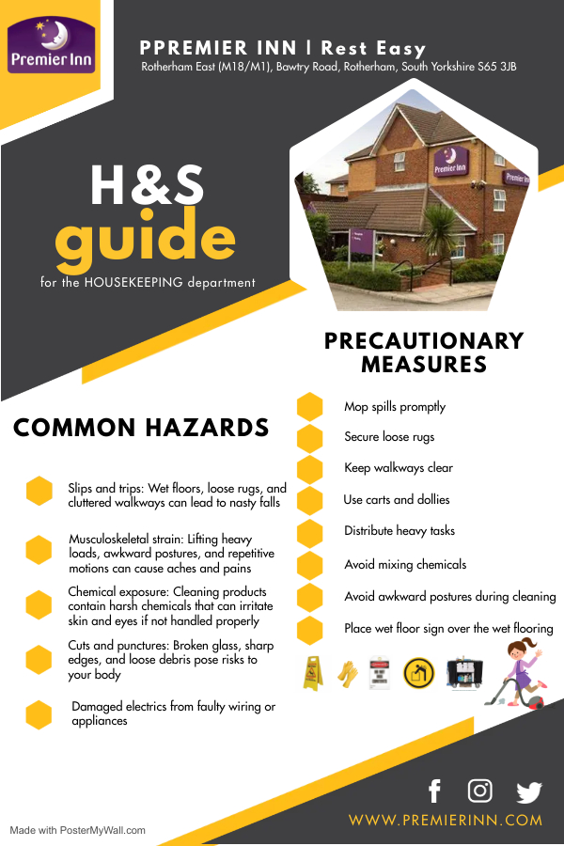
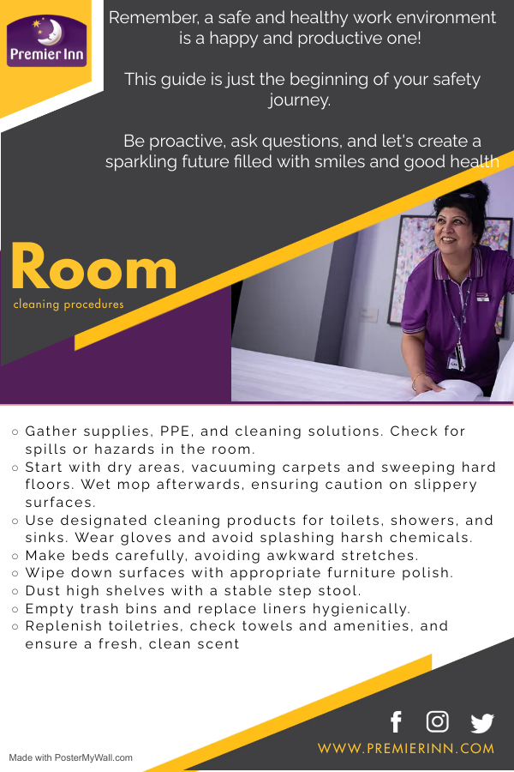

Reference List

Balderston, L. R. (1944). Housekeeping Handbook: How to Do It. Philadelphia: J. B. Lippincott Company. Retrieved from https://ia800905.us.archive.org/22/items/housekeepinghand00bald/housekeepinghand00bald.pdf
Cassado, M. A. (2012). Housekeeping Management (2nd ed.). Hoboken, New Jersey: John Wiley & Sons, Inc.
Holiday Inn Academy n.d., Linen Room Equipment, viewed on 31/01/2024, https://academy.whitbread.co.uk/pluginfile.php/443629/mod_scorm/content/1/index_lms.html#/id/635fde3d60c7ac391b95c670.
Mullins, L. J., & Christy, G. (2016). Management & Organisational Behaviour (11th ed.). Harlow: Pearson.

