Student name: | Rajwinder Kaur
Student ID number: | 2214604
Programme: | BA (Hons) Business Management
Module: | Leadership and Management Theory and Practice
Module code: | LCBB 6022
Module Lead:  Lecturer: | Rebecca Stewart | Internal Verifier: | Dr Liyanage Sampath Rodrigo
Assignment Title: | Component 2: Coursework: Essay | Word count | 2178

Contents Page
Introduction …………………………………………….……………………………………. 3
Managerial functions…………………………………………………………………………. 3
Critically evaluating why controlling is essential in organizations of all types……………… 4
Linking relevant leadership and management theories/models to controlling ………………. 6
Discussing the challenges associated with controlling ………………………………………7
How managers can mitigate these challenges ………………………………………………..9
Conclusion …………………………………………………………………………………...10
References …………………………………………………………………………………...11

Essay: Critically evaluating why controlling is essential in organizations of all types
Introduction
Management remains indispensable in contemporary business because organizations now operate in conditions such as technological disruption, hybrid work, regulatory intensity, geopolitical volatility and heightened stakeholder scrutiny, all of which increases difficulty of coordinating people and resources effectively (Cosa and Torelli, 2024; Grisold et al., 2024). Within this context, management is not simply administrative oversight but integrated practice of planning, organizing, leading and controlling in order to translate strategic intent into operational outcomes (Henri, 2006). Of these functions, controlling is often the least appreciated because it is frequently reduced to inspection, bureaucracy or surveillance, when in fact it is mechanism through which managers establish standards, monitor performance, identify deviations and initiate corrective action and organizational learning (Gerdin, 2020; Henri, 2006). Without control, planning becomes speculative, organizing becomes mechanical and leadership risks degenerating into rhetoric unsupported by evidence of execution or accountability (Bedford, Malmi and Sandelin, 2016). However, badly designed controls may increase anxiety, promote gaming, prioritise short-term goals, and decrease trust, undermining the performance they attempt to protect (Mundy, 2010; Widener, 2007). This essay argues that controlling is essential across organizations of all types because it aligns behaviour with purpose, protects value and enables adaptation, but that its effectiveness depends on whether leaders design and implement control systems that are strategically aligned, ethically credible and responsive to current and future organizational needs.
Managerial functions
The classical managerial functions are planning, organizing, leading and controlling, and they should be understood as mutually reinforcing rather than sequentially separate activities (Henri, 2006). Planning establishes objectives and priorities, organizing distributes resources and responsibilities, leading mobilizes commitment and direction, and controlling tests whether actual performance corresponds with intended outcomes (Gerdin, 2020). Critically, controlling is the function that prevents management from becoming aspirational rather than operational, because it links goals to evidence, evidence to judgement and judgement to corrective action (Henri, 2006; Bedford, Malmi and Sandelin, 2016). Overall, control is what makes the other functions credible in practice (Gerdin, 2020).

Critically evaluating why controlling is essential in organizations of all types
Controlling is essential in all organisations because they all face same fundamental problem which is how to align resources, decisions, and behaviours with stated objectives under uncertainty. Control ensures profitability, productivity, compliance, and strategic execution in private firms and stewardship, legitimacy, and demonstrable value in public and third-sector organisations (Gov.UK, 2025; Local Government Association, 2024). The universality of this requirement weakens any argument that sees controlling as a restricted business issue rather than key governance and organisational accountability mechanism (Grisold et al., 2024). An organization may differ in mission, ownership or funding model, but not any of organization can operate effectively if it lacks the capacity to detect failure, assess variance and intervene before problems escalate into systemic breakdown (Bedford, Malmi and Sandelin, 2016).
The strategic importance of controlling is particularly visible in high-risk and tightly regulated environments, where weak controls produce consequences far beyond inefficiency (Federal Aviation Administration, 2024). The Boeing case demonstrates this starkly, as regulatory investigations following the 737-9 MAX crisis exposed significant deficiencies in manufacturing quality assurance and compliance processes, illustrating that inadequate control can compromise safety, damage legitimacy and provoke severe external intervention (Federal Aviation Administration, 2024; Boeing, 2024). This example matters because it reveal that control is just not about monitoring cost or productivity, but also about preserving organizational reliability in contexts where failure is socially and commercially catastrophic (Boeing, 2024). Likewise, UK government guidance on risk, controls and assurance makes clear that public organizations require robust control frameworks to reduce waste, misallocation and delivery failure which is clearly confirming that controlling is indispensable wherever managers are expected to justify responsible use of resources and achievement of outcomes (Gov.UK, 2025).
However, the necessity of controlling should not be confused with the claim that more control is always better, because excessive or misdirected control can itself become a source of organizational dysfunction (Mundy, 2010). Wells Fargo is the clearest illustration of this contradiction, because the organization did not fail through an absence of measurement, targets or oversight, but through the dominance of control mechanisms that incentivized the wrong behaviour while failing to restrain misconduct ethically or institutionally (Consumer Financial Protection Bureau, 2016; Office of the Comptroller of the Currency, 2016). This case shows that controlling is not simply the act of monitoring activity, but the design of a system that shapes what employees perceive to matter, what risks are ignored and what behaviours become normalized under pressure (Widener, 2007). The critical issue, therefore, is not whether organizations control, but whether they control intelligently, proportionately and in ways that reinforce rather than distort organizational purpose (Mundy, 2010).
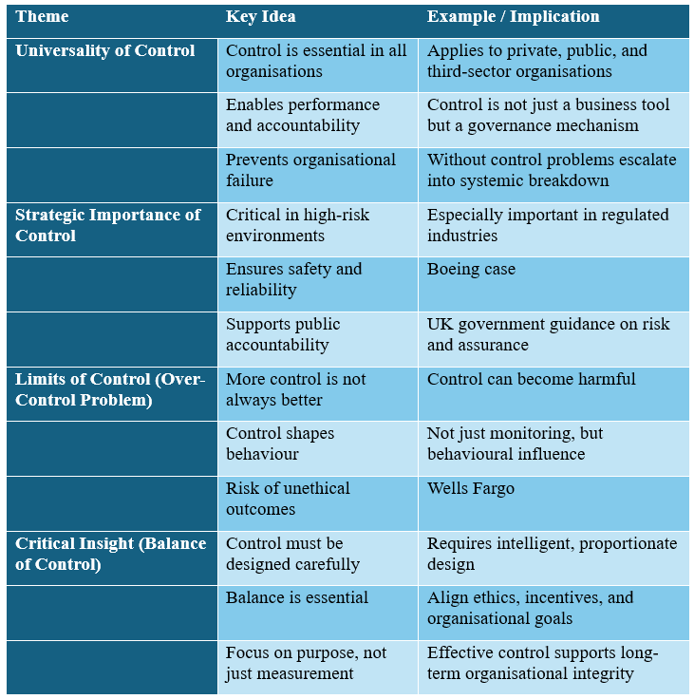
Figure 1: Importance, Risks, and Balance of Organizational Control
Linking relevant leadership and management theories/models to controlling
Contingency theory offers powerful critique of simplistic control design because it rejects notion of universally optimal control system and instead argues that effective controls must reflect strategy, uncertainty, structure, technology and task characteristics (Bedford, 2015; Bedford, Malmi and Sandelin, 2016). This matters because organisations frequently adopt standardised dashboards or imported performance frameworks without sufficiently interrogating whether those controls actually fit realities of their work, which can produce misleading data, compliance theatre and ineffective priorities (Cosa and Torelli, 2024). A strong cost-control method might help in situations where things are predictable, but it might be damaging in situations where new ideas are needed or where knowledge is important and where trying new things, being uncertain, and adapting are key to success (Bedford, 2015). So, contingency theory makes the analysis more specific by showing that control is necessary because of the circumstances, rather than because there are general models.
Simons’ levers of control framework further strengthens this analysis by distinguishing between diagnostic and interactive uses of control systems, thereby exposing the limits of treating control as a purely technical exercise (Bisbe and Otley, 2004; Mundy, 2010). Diagnostic controls are necessary because they support accountability, performance monitoring and variance correction, especially where outputs can be specified clearly in advance (Widener, 2007). Yet, diagnostic control alone is insufficient in volatile environments and organisations need interactive control systems that foster dialogue, challenge assumptions, and allow leaders to continuously engage with strategic uncertainty and emerging risk (Bisbe and Otley, 2004; Dávila et al., 2024). This is significant point of evaluation because it suggests that controlling is most effective not when it becomes tighter in narrow sense, but when it becomes more intelligently balanced between discipline and learning (Mundy, 2010). Thus, management performance relies less on control intensity than on how leaders utilise control to concentrate attention, encourage reflection, and enable adaptation.
Leadership theory adds a further critical dimension by showing that control systems derive much of their practical force from the ethical and cultural context in which they operate (Cheffi et al., 2023). Formal controls has behaviour expectations. Leadership behaviour, communication, and trust determine whether formal controls are valid, developmental, or coercive (Nguyen and Hoai, 2023). Ethical leadership strengthens control by signalling that standards exist to protect collective purpose rather than merely intensify pressure for individual output, while mindful leadership improves internal control effectiveness by increasing organizational sensitivity to anomalies, weak signals and emerging threats (Cheffi et al., 2023; Nguyen and Hoai, 2023). This is especially relevant to leading and managing people, because it underlines that control cannot be separated from motivation, engagement and the social interpretation of managerial intent (Koeswayo, Haryanto and Handoyo, 2024). A system that appears technically sound may still fail if employees regard it as punitive, inconsistent or morally unconvincing (Cheffi et al., 2023).
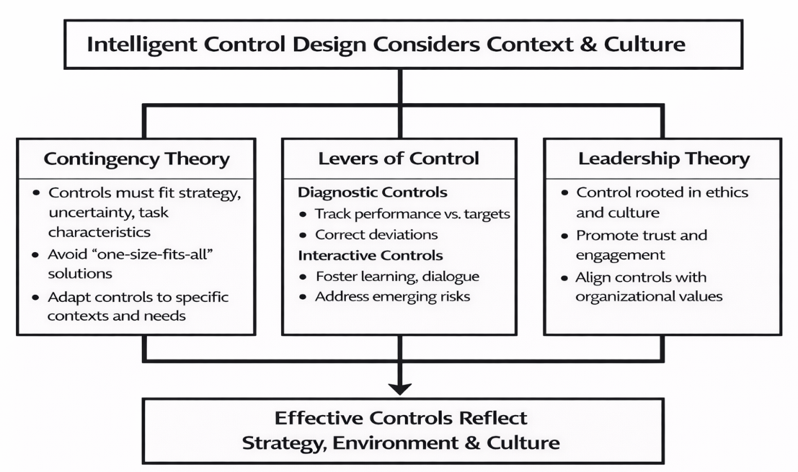
Figure 2: Intelligent control design considers Context and Culture (Self-Created)

Discussing the challenges associated with controlling
One of most important challenge is metric fixation, which affects attention and conduct by prefer things that are simple to measure over to those that are really essential (Widener, 2007). Narrow targets may offer perception of accuracy while encouraging staff to focus on measure rather than purpose especially when incentives are strongly linked to numerical outputs (Mundy, 2010). The Wells Fargo scandal demonstrates this vividly, because intense sales targets created a climate in which unethical practices became rationalized as performance achievement, revealing that control can produce deviance when it rewards numbers while neglecting judgement, ethics and customer welfare (Consumer Financial Protection Bureau, 2016; Office of the Comptroller of the Currency, 2016). Such situations challenge idea that greater measurement improves management.
A second challenge is increasingly decrease boundary between legitimate control and intrusive surveillance in digital workplaces (Grisold et al., 2024). Technologies that generate constant streams of behavioural data may appear to offer managers superior visibility, but they also risk reducing employees to monitored outputs while decrease trust, autonomy and dignity (Flassak et al., 2023; Grisold et al., 2024). For example, European Data Protection Board (2024) said, Amazon France Logistique should have been fined for tracking practices that were too intrusive which showing that digital control can cause legal, moral and social issues if managers fail to look at it fairly. This is very important problem for groups in future because the growth of digital control technologies could make tracking better while it also make people less committed to organization if leaders has less or no clear ethical limits (Grisold et al., 2024).
Third challenge is that modern organisations work in environments too complicated to be controlled effectively through unchanging, delayed signs alone (Davila et al., 2024). Traditional control systems are often better at explaining what has already gone wrong than at identifying what is beginning to change, which limits their strategic usefulness in dynamic settings shaped by technological disruption, stakeholder pluralism and interdependent risks (Cosa and Torelli, 2024). Because performance is complex, causation is difficult to trace and success cannot be determine by output, this is particularly difficult in knowledge intensive and public service organisations (Local Government Association, 2024). As a result, managers may seem authoritative while implement rules in past (Davila et al., 2024).
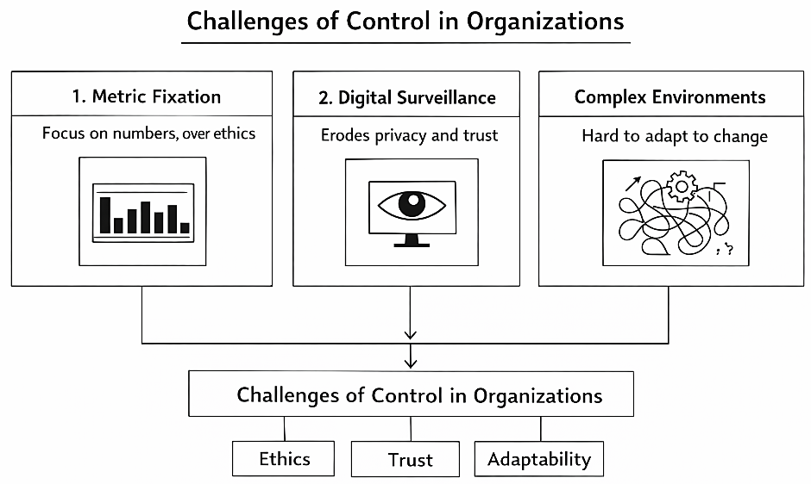
Figure 3: Challenges of Control in Organization (Self-Created)

How managers can mitigate these challenges
Managers can mitigate these challenges only by moving beyond narrow, compliance-oriented models of control toward more balanced and strategically intelligent systems. First, they should create control packages that include financial, operational, psychological, and strategy measures. This way, no one number can become too important and change the organization's goals (Bedford, Malmi, and Sandelin, 2016; Gerdin, 2020). This is superior approach because it allow managers for assess performance holistically, incorporat safety, ethics, quality, innovation and long term capability rather than privileging short-term output alone (Bedford, 2015). Second, managers should apply control contingently by match control intensity and form to task uncertainty, strategic context and workforce characteristics, rather than assuming that tighter measurement is universally effective (Bedford, 2015; Dávila et al., 2024). Where uncertainty is high, interactive controls such as structured dialogue, cross functional reviews and challenge sessions are more valuable than further layers of rigid target enforcement because they enhance organizational learning and responsiveness (Bisbe and Otley, 2004; Mundy, 2010).
Third, leaders must make controlling ethically credible and socially sustainable by involving employees in target-setting, clarifying why performance data are collected and setting explicit limits on monitoring practices (Flassak et al., 2023; European Data Protection Board, 2024). Participation matters because people are more likely to accept demanding controls when they perceive them as fair, purposeful and proportionate rather than as arbitrary tools of managerial domination (Flassak et al., 2023). Finally, organizations should embed controlling within a wider architecture of governance, risk management, internal audit and speak-up mechanisms so that problems are surfaced early and corrective action is owned clearly at managerial and board levels (Office of the Comptroller of the Currency, 2024; Gov.UK, 2025). This is essential for enhancing the effectiveness of leaders and managers because it shifts control from a narrow reporting exercise to a capability for disciplined judgement, ethical accountability and strategic adaptation in the face of future uncertainty (Nguyen and Hoai, 2023; Boeing, 2024).
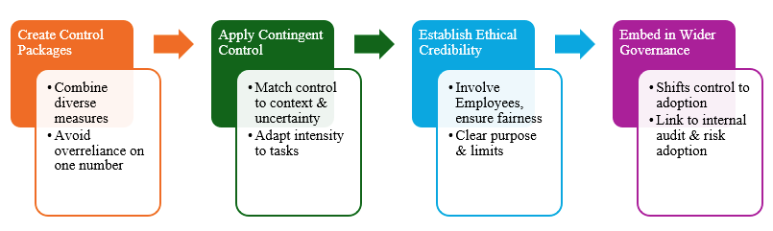
Figure 4: Strategically Intelligent Control (Self-Created)

Conclusion
Controlling is essential in organizations of all types because it is the mechanism through which objectives are translated into accountable action, deviations are detected and resources are protected against waste, misconduct and strategic drift. The analysis has shown that controlling is not narrow technical function but central determinant of organizational effectiveness, governance quality and leadership credibility across private, public and non-profit settings. At the same time, the essay has critically demonstrated that control is never neutral: it can enhance discipline, learning and trust when designed intelligently, or it can generate gaming, surveillance, resistance and ethical failure when reduced to blunt measurement and coercion, as illustrated by Wells Fargo, Boeing and Amazon France Logistique. Theoretical perspectives such as contingency theory and the levers of control framework therefore matter because they show that effective control depends not on maximal oversight but on strategic fit, dynamic balance and leadership judgement. Ultimately, high-performing organizations are distinguished not by whether they control, but by whether their leaders can design and implement control systems that are rigorous without being oppressive, measurable without being reductionist and adaptable enough to meet both present demands and future organizational needs.
Reference List
Bedford, D.S. (2015) Management control systems across different modes of innovation: Implications for firm performance. Management Accounting Research, 28, pp.12-30.
Bedford, D.S., Malmi, T. and Sandelin, M. (2016) Management control effectiveness and strategy: An empirical analysis of packages and systems. Accounting, Organizations and Society, 51, pp.12-28.
Bisbe, J. and Otley, D. (2004) The effects of the interactive use of management control systems on product innovation. Accounting, organizations and society, 29(8), pp.709-737.
Boeing (2024) Chief Aerospace Safety Officer Report 2024. Chicago: Boeing. Available at: https://www.boeing.com/content/dam/boeing/boeingdotcom/safety/caso/caso-report-2024.pdf. (Accessed: 11 March 2026).
Cheffi, W., Zahir-ul-Hassan, M.K., Farooq, M.O., Baqrain, A. and Mansour, M.M.H. (2023) Ethical leadership, management control systems and circular economy in SMEs in an emerging economy, the UAE. Journal of Business Research, 156, p.113513.
Consumer Financial Protection Bureau. (2016) Consumer Financial Protection Bureau fines Wells Fargo $100 million for widespread illegal practice of secretly opening unauthorized accounts. Report, September, CFPB, Washington, DC. Available at: https://www.consumerfinance.gov/about-us/newsroom/consumer-financial-protection-bureau-fines-wells-fargo-100-million-widespread-illegal-practice-secretly-opening-unauthorized-accounts/. (Accessed: 12 March 2026).
Cosa, M. and Torelli, R. (2024) Digital transformation and flexible performance management: A systematic literature review of the evolution of performance measurement systems. Global Journal of Flexible Systems Management, 25(3), pp.445-466.
Dávila, A., Derchi, G.B., Oyon, D. and Schnegg, M. (2024) External complexity and the design of management control systems: a case study. Management Accounting Research, 63, p.100875.
European Data Protection Board (2024) French SA fined Amazon France Logistique €32 million. Brussels: EDPB. Available at: https://www.edpb.europa.eu/news/national-news/2024/employee-monitoring-french-sa-fined-amazon-france-logistique-eu32-million_en. (Accessed: 14 March 2025).
Federal Aviation Administration (2024) Updates on Boeing 737-9 MAX aircraft. Washington, DC: FAA. Available at: https://www.faa.gov/newsroom/updates-boeing-737-9-max-aircraft. (Accessed: 12 March 2025).
Flassak, K., Haag, J., Hofmann, C., Lechner, C., Schwaiger, N. and Zacherl, R. (2023) Working from home and management controls. Journal of Business Economics, 93(1), pp.193-228.
Gerdin, J. (2020) Management control as a system: Integrating and extending theorizing on MC complementarity and institutional logics. Management Accounting Research, 49, p.100716.
GOV.UK (2025) Grants standards: Risk, controls and assurance. GOV.UK. Available at: https://www.gov.uk/government/publications/grants-standards/7-risk-controls-and-assurance-html (Accessed: 15 March 2026).
Grisold, T., Seidel, S., Heck, M. and Berente, N. (2024) Digital Surveillance in Organizations: T. Grisold et al. Business & Information Systems Engineering, 66(3), pp.401-410.
Henri, J.F. (2006) Management control systems and strategy: A resource-based perspective. Accounting, organizations and society, 31(6), pp.529-558.
Koeswayo, P.S., Haryanto, H. and Handoyo, S. (2024) The impact of corporate governance, internal control and corporate reputation on employee engagement: a moderating role of leadership style. Cogent Business & Management, 11(1), p.2296698.
Local Government Association (2024) Improvement and assurance framework for local government. London: LGA. Available at: https://www.local.gov.uk/publications/improvement-and-assurance-framework-local-government. (Accessed: 12 March 2026).
Mundy, J. (2010) Creating dynamic tensions through a balanced use of management control systems. Accounting, Organizations and society, 35(5), pp.499-523.
Nguyen, N.P. and Hoai, T.T. (2023) Internal controls driven by mindfulness toward enhanced ethical behaviors: Empirical evidence from Vietnam. Heliyon, 9(7).
Office of the Comptroller of the Currency (2016) OCC assesses penalty against Wells Fargo, orders restitution for unsafe or unsound sales practices. Washington, DC: OCC. Available at: https://www.occ.gov/news-issuances/news-releases/2016/nr-occ-2016-106.html . (Accessed: 14 March 2026).
Office of the Comptroller of the Currency (2024) Formal agreement with Wells Fargo Bank, N.A. Washington, DC: OCC. Available at: https://www.occ.gov/static/enforcement-actions/eaAA-ENF-2024-72.pdf. (Accessed 13 March 2026).
Widener, S.K. (2007) An empirical analysis of the levers of control framework. Accounting, organizations and society, 32(7-8), pp.757-788.

