

Module: Population Health and Digital Health Promotion
Public health problem: Obesity
Digital intervention: mHealth app for weight management and obesity care
Module code: LCHS7007
Student Name: Seethakumari Ganasala
Student ID: 2226332
Lecturer name: Diola Bijlhout

Table of Contents
Part A 3
Blog 1 3
Impact of MHealth app for weight management and obesity care for digital health promotion 3
Conclusion…………………………………………………………………………………………7

Blog 2….……………………………………………………………………………..…………...8
Impact of Just-in-time adaptive(JITAI) in mHealth app for weight management and
obesity care for digital health promotion……………………………………………………….8
Conclusion……..…..……………………………………………………………………….……11

Part B is poster……...……………………………………………………………..….…12

References…………………………………………………………………………………………13

Part A

Blog 1

Impact of MHealth app for weight management and obesity care for digital health promotion



Health problem and justification
Different physical disorders can cause different issues and problems in the proper functioning of different organs. It sometimes restricts proper expression to different changes in the human body. Obesity is a similar disorder that initiates different health issues. This disorder involves excessive body fat that hampers the proper functionalities of different organs and increases different risks of health problems (Taylor et al., 2022). The main reason for obesity is excessive calorie intake beyond the sustainable range of the human body. A fixed rate of calorie intake can be burned through different physical activities. Excessive intake affects the Body Mass Index of a person and hampers the proper circulation of calories.
It initiates some excess calories stored in the body and causes obesity. An obese person has a BMI that ranges more than 25. It makes huge changes in a person's lifestyle and increases different health issues. It also hampers the normal ability to answer different physical challenges (Dounavi and Tsoumani, 2019).
Use of the app in addressing the problem
The app helps in addressing the problem of obesity effectively. It is a free phone app that everyone from every financial background can access without extra charges. There are different chatbots and social media interaction platforms that help the affected people in recognition of the health problem. These apps are developing and showing different advertisements on social media to acknowledge people about the problem. Different transformations are suggested for people to develop behavioural interventions for proper weight management. These apps help monitor dietary charts and physical activities (Radcliffe et al., 2021).
Evidence of promoting health through the app
The mobile app helps reduce obesity-related issues and challenges that may affect the proper participation of a human being in any social or organisational performance. Obesity is a rising problem that is hampering the different functionalities of the human body. The mobile app helps in reducing different impacts of obesity and managing the weight of the affected people as well (Puig et al., 2019).
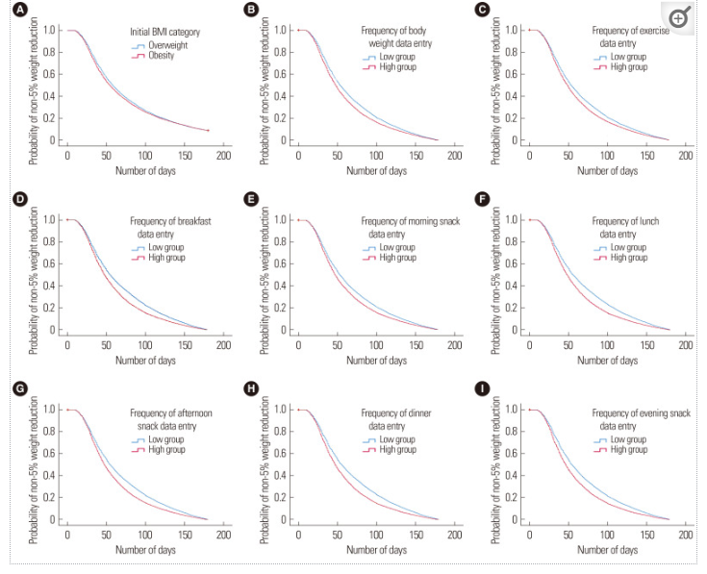
Figure 1: Changes in obesity reduction by using the mHealth app
(Source: Turner-McGrievy et al., 2020)
The 1st figure helps to understand different changes in the weight management and obesity care of the people who have started using this app to develop their health. It shows the changes in the BMI index (Turner-McGrievy et al., 2020). The app records different data on weight development and different meal intake amounts. It helps in reducing different inefficiencies of obesity and managing weight.
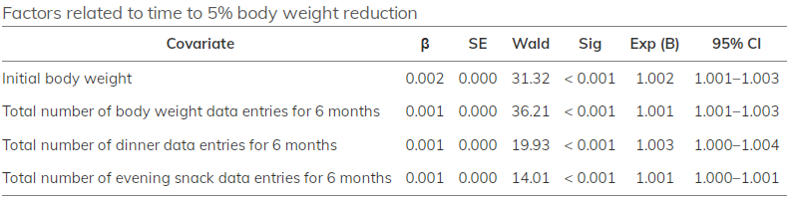
Figure 2: Different factors for body weight reduction
(Source: Zaman et al., 2021)
The second figure shows different factors that help in the reduction of weight. It records different data on the development of calorie intake and changes in BMI index (Zaman et al., 2021). The following link will help the patients to get all the necessary details about the app and its efficiencies. This app is highly helpful for supporting the patients in different health problems. The app is known as Meditech.Click below link you will get more information about this app.
https://home.meditech.com/en/d/mobileappssupport/pages/mhealthsupport.htm

Impacts
Advantages
- It is easily accessible to all users.
- It helps increase health benefits (Chan and Chen, 2019).
- It records different information that helps in reducing the negativity of obesity.
- It also makes a good change in the behavioural interventions of normal people (Holzmann and Holzapfel, 2019).
Disadvantages
- Lack of proper knowledge of using this app to improve the efficiencies of the application (Sakane et al., 2023).
- Monitoring different diet charts of people is difficult with this application.
- Mismanagement of different data is also difficult with this application.
- It isn't easy to calculate nutritional information as well.
Recommendations
- It is important to guide the users. There must be an inclusion of proper guidelines with the application.
- Diet charts should be measured and developed properly and specifically for each user.
- There must be proper management of different data to properly develop knowledge about the users (Han and Rhee, 2021).
- Different nutritional information should be calculated with proper relevance for helping the users.
- There should also be a proper system to consult with different dieticians for proper guidance.

Conclusion
This app helps to depict different inefficiencies and issues in public health easily. Easy detection of different problems and issues helps in finding easy solutions to the problems. This app aims to provide good health and satisfactory health development services. Different facilities of this app help in properly developing the country's healthcare system.

Blog 2

Impact of Just‐in‐time adaptive interventions (JITAI) in mHealth app for weight management and obesity care for digital health promotion
Health problem and justification
Obesity is a rising problem that creates problems in the proper expression of human beings in different social and organisational performances (Lucassen et al., 2021). Obesity is a physical disorder that causes different issues that reduce human impacts. It is a problem where different inefficiencies in calorie intake increase problems in the BMI index and increase fat in the human body (Goldstein et al., 2020). It is seen from different statistics that almost 35% of adults are overweight among whom almost 11% have obesity. Almost 65% of people from the world population are getting killed by obesity. 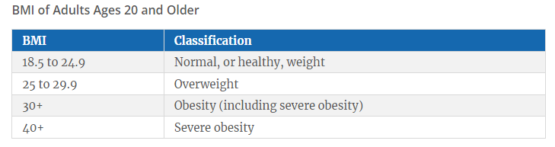
Figure 3: BMI Index of adults
(Source: Lucassen et al., 2021)
This problem is increasing several issues in the health management of different people. People have started to face different issues and health problems, which sometimes can be fatal (Gewirtz and Minen, 2019). 44% of diabetic patients, 23% of chronic heart diseases patients and almost 7% to 41% of cancer patients are seen to have obesity as well.

Use of the app in addressing the problem
The mHealth app is helping different people suffering from obesity. The app's efficiency helps people reduce their problems and increase different health efficiencies. But some misconceptions and mismanagement of the app are affecting the application. The JITAI is an intervention that helps in designing different provisions that help in supporting different latest features. These provisions of the latest features help increase the application's efficiency (Globus et al., 2021). JITAI stands for Just-in-Time Adaptive Interventions, which is an advanced form. It helps the applications to use integrated mHealth sensors. These interventions aim to provide the proper types or amounts of support at the proper time. It helps an individual to change their behaviour through different adaptations. This technology utilises different dynamic approaches based on their behaviour. It generates different physical activities that help in reducing obesity. Click below link..
https://www.uofmhealth.org/patient-visitor-guide/patient-portal. This is the official link of the Michigan Medicine. This app is helping the patients with different additional and related links that help the patients in different additional services. There are different latest interventions that help the patients to get effective services as well.

Evidence of promoting health through the app
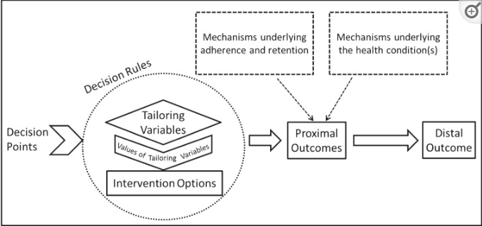
Figure 3: Components of JITAIs
(Source: Gruber et al., 2021)
Different components of JITAIs help understand different scopes that help develop different rules. These rules develop different variables, increasing different outcomes' efficiencies (Gruber et al., 2021).
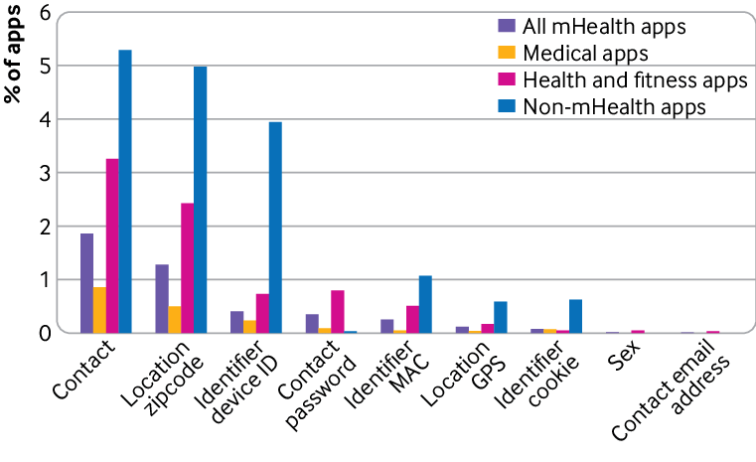
Figure 4: Differences in mHealth app and mHealth app with JITAI
(Source: Dugas, Gao and Agarwal, 2020)
This figure helps to understand the differences between the normal mHealth app and the mHealth app with JITAI. This latest invention helps provide users with the latest and satisfactory services (Dugas, Gao and Agarwal, 2020).
Impacts
Advantages
- It helps immediately recognise the different impacts of obesity on healthcare management (Lu et al., 2022).
- It helps in changing the behavioural interventions of different people as well.
- Proper use of JITAIs helps in emerging different trans-disciplinary changes in user behaviours (Liu, Deliu and Chakraborty, 2023).
Disadvantages
- The databases lack different scopes of development in weight management variables.
- More formal diet requirements must be included in these applications (Liao et al., 2020).
Recommendations
- There must be proper inclusion of different weight management variables so that it helps in proper speculation of different health promotions.
- The healthcare system must include Proper diet requirements (Hinchliffe et al., 2022). It helps the users in adopting proper healthcare management.
- Different dieticians and health advisors should be included, which may help the users properly (Goldstein et al., 2021).

Conclusion
Some advanced features are included in the mHealth app, which helps in advanced healthcare systems. It helps in providing developed facilities to the users. This app is easily accessible, and affordable services are offered to the users. It helps the patients access different advanced services, including different facilities like easy calling, advanced healthcare facilities and many more.

Part B

POSTER

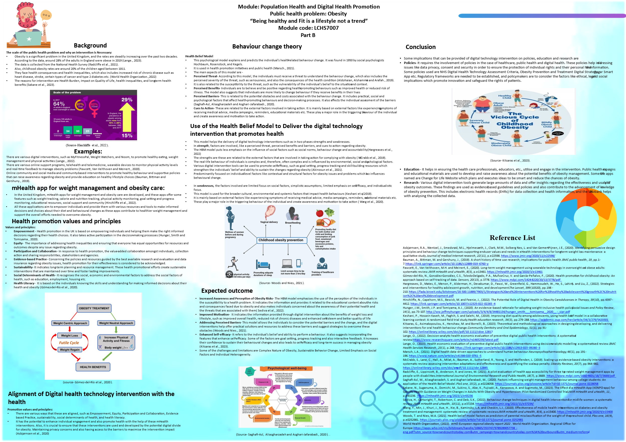

Reference
Asbjørnsen, R.A., Wentzel, J., Smedsrød, M.L., et.al.,(2020). Identifying persuasive design principles and behaviour change techniques supporting end-user values and needs in eHealth interventions for long-term weight loss maintenance: a qualitative study. Journal of medical Internet research, 22(11), p.e22598. Available at: https://www.jmir.org/2020/11/e22598/

Bauman, A., Bittman, M. and Gershuny, J., (2019). A short history of time use research; implications for public health. BMC public health, 19, pp.1-7. Available at: https://link.springer.com/article/10.1186/s12889-019-6760-y

Dounavi, K. and Tsoumani, O., (2019). Mobile health applications in weight management: a systematic literature review. American Journal of preventive medicine, 56(6), pp.894-903. Available at: https://www.sciencedirect.com/science/article/pii/S074937971930025X

Dugas, M., Gao, G. and Agarwal, R. (2020). Unpacking mHealth interventions: a systematic review of behaviour change techniques used in randomised controlled trials assessing mHealth effectiveness. Digital health, 6, p.2055207620905411. Available at: https://journals.sagepub.com/doi/pdf/10.1177/2055207620905411

Fawcett, E., Van Velthoven, M.H. and Meinert, E., (2020). Long-term weight management using wearable technology in overweight and obese adults: systematic review. JMIR mHealth and uHealth, 8(3), p.e13461. Available at: https://mhealth.jmir.org/2020/3/e13461

Gewirtz, A. and Minen, M., (2019). Adherence to behavioural therapy for migraine: Date knowledge, mechanisms for assessing adherence, and methods for improving adherence. Current pain and headache reports, 23, pp.1-6. Available at: https://www.ncbi.nlm.nih.gov/pmc/articles/PMC6838777/

Goldstein, S.P., Thomas, J.G., Foster, G.D., et.al., (2020). Refining an algorithm-powered just-in-time adaptive weight control intervention: a randomised controlled trial evaluating model performance and behavioural outcomes. Health informatics journal, 26(4), pp.2315-2331. Available at: https://journals.sagepub.com/doi/pdf/10.1177/1460458220902330

Goldstein, S.P., Zhang, F., Klasnja, P., et.al., (2021). Optimising a just-in-time adaptive intervention to improve dietary adherence in behavioural obesity treatment: protocol for a micro randomised trial. JMIR Research Protocols, 10(12), p.e33568. Available at: https://www.researchprotocols.org/2021/12/e33568/

Gómez-del-Río, N., González-González, C.S., et.al.,(2020). Health promotion for childhood obesity: An approach based on self-tracking of data. Sensors, 20(13), p.3778. Available at: https://www.mdpi.com/1424-8220/20/13/3778/pdf

Gruber, S., Neumayr, B., Schrefl, M. and Niebauer, J., (2021), October. Towards Multi-level Modeling of Just-in-Time Adaptive Interventions (JITAIs) in Mobile Health. In 2021 ACM/IEEE International Conference on Model Driven Engineering Languages and Systems Companion (MODELS-C) (pp. 541-545). IEEE. Available at: https://jku-win-dke.github.io/MULTI2021/slides/MULTI2021-Gruber.pdf

Han, M. and Rhee, S.Y., (2021). Effectiveness of mobile health applications for 5% body weight reduction in obese and overweight Adults. Journal of Obesity & Metabolic Syndrome, 30(4), p.354. Available at: https://www.ncbi.nlm.nih.gov/pmc/articles/PMC8735823/

Hargreaves, D., Mates, E., Menon, P., Alderman, H., Devakumar, D., Fawzi, W., Greenfield, G., Hammoudeh, W., He, S., Lahiri, A. and Liu, Z., (2022). Strategies and interventions for healthy adolescent growth, nutrition, and development. The Lancet, 399(10320), pp.198-210. Available at: https://fada.birzeit.edu/bitstream/20.500.11889/7903/1/Strategies%20and%20interventions%20for%20healthy%20adolescent%20growth%2C%20nutrition%2C%20and%20development.pdf

Hinchliffe, N., Capehorn, M.S., Bewick, M. and Feenie, J., (2022). The Potential Role of Digital Health in Obesity Care. Advances in Therapy, 39(10), pp.4397-4412. Available at: https://link.springer.com/article/10.1007/s12325-022-02265-4

Holzmann, S.L. and Holzapfel, C., (2019). A scientific overview of smartphone applications and electronic devices for weight management in adults. Journal of Personalized Medicine, 9(2), p.31. Available at: https://www.mdpi.com/2075-4426/9/2/31/pdf

Hunger, J.M., Smith, J.P. and Tomiyama, A.J., (2020). An evidence‐based rationale for adopting weight‐inclusive health policy. Social Issues and Policy Review, 14(1), pp.73-107. Available at: http://ww.jeffreyhunger.com/uploads/3/4/4/8/34481134/hunger_smith___tomiyama__2020__-_sipr.pdf

Keshani, P., Hossein Kaveh, M., Faghih, S. and Salehi, M., (2019). Improving diet quality among adolescents, using health belief model in a collaborative learning context: A randomised field trial study. Health education research, 34(3), pp.279-288. Available at: https://academic.oup.com/her/article/34/3/279/5420301

Kitsaras, G., Asimakopoulou, K., Henshaw, M. and Borrelli, B., (2023). Theoretical and methodological approaches in designing, developing, and delivering interventions for oral health behaviour change. Community Dentistry and Oral Epidemiology, 51(1), pp.91-102. Available at: https://onlinelibrary.wiley.com/doi/pdf/10.1111/cdoe.12817

Lange, O., (2022). Decision-analytic health economic evaluation of preventive digital public health interventions: A systematised review. Available at: https://www.researchsquare.com/article/rs-1465239/latest.pdf

Lange, O., (2023). Health economic evaluation of preventive digital public health interventions using decision-analytic modelling: a systematised review. BMC Health Services Research, 23(1), p.268. Available at: https://link.springer.com/article/10.1186/s12913-023-09280-3

Liao, P., Greenewald, K., Klasnja, P. and Murphy, S. (2020). Personalised heart steps: A reinforcement learning algorithm for optimising physical activity. Proceedings of the ACM on Interactive, Mobile, Wearable and Ubiquitous Technologies, 4(1), pp.1-22. Available at: https://www.ncbi.nlm.nih.gov/pmc/articles/PMC8439432/

Liu, X., Deliu, N. and Chakraborty, B., (2023). Microrandomized Trials: Developing Just-in-Time Adaptive Interventions for Better Public Health. American Journal of Public Health, 113(1), pp.60-69. Available at: https://ajph.aphapublications.org/doi/pdf/10.2105/AJPH.2022.307150?role=tab

Lu, S.C., Xu, M., Wang, M., et.al.,(2022). Effectiveness and minimum effective dose of app-based mobile health interventions for anxiety and depression symptom reduction: systematic review and meta-analysis. JMIR Mental Health, 9(9), p.e39454. Available at: https://mental.jmir.org/2022/9/e39454

Lucassen, D.A., Lasschuijt, M.P., Camps, G., et.al.,(2021). Short and long-term innovations on dietary behavior assessment and coaching: present efforts and vision of the Pride and Prejudice consortium. International journal of environmental research and public health, 18(15), p.7877. Available at:https://www.mdpi.com/1660-4601/18/15/7877

Marsch, L.A., (2021). Digital health data-driven approaches to understand human behaviour. Neuropsychopharmacology, 46(1), pp.191-196. Available at: https://www.nature.com/articles/s41386-020-0761-5

McCrabb, S., Lane, C., Hall, A., Milat, A., et.al., (2019). Scaling-up evidence-based obesity interventions: a systematic review assessing intervention adaptations and effectiveness and quantifying the scale-up penalty. Obesity Reviews, 20(7), pp.964-982. Available at: https://onlinelibrary.wiley.com/doi/am-pdf/10.1111/obr.12845

Puig, E.P., Robles, N., Saigí-Rubió, F., et.al., (2019). Assessment of the efficacy, safety, and effectiveness of weight control and obesity management mobile health interventions: systematic review. JMIR mHealth and uHealth, 7(10), p.e12612. Available at: https://mhealth.jmir.org/2019/10/e12612

Radcliffe, E., Lippincott, B., Anderson, R. and Jones, M. (2021). A pilot evaluation of health app accessibility for three top-rated weight management apps by people with disabilities. International Journal of Environmental Research and Public Health, 18(7), p.3669. Available at: https://www.mdpi.com/1660-4601/18/7/3669/pdf

Saghafi-Asl, M., Aliasgharzadeh, S. and Asghari-Jafarabadi, M., (2020). Factors influencing weight management behaviour among college students: An application of the Health Belief Model. PloS one, 15(2), p.e0228058. Available at: https://journals.plos.org/plosone/article?id=10.1371/journal.pone.0228058

Sakane, N., Suganuma, A., Domichi, M., Sukino, S., et.al., (2023). The Effect of a mHealth App (KENPO-app) for Specific Health Guidance on Weight Changes in Adults With Obesity and Hypertension: Pilot Randomized Controlled Trial. JMIR mHealth and uHealth, 11, p.e43236. Available at: https://mhealth.jmir.org/2023/1/e43236

Sharma,S., (2023). IndiaCelebrating.com. Available at: https://r.search.yahoo.com/_ylt=AwrNO_OPxMNkL_MA8ZSJzbkF;_ylu=c2VjA3NyBHNsawNpbWcEb2lkAzIwMmIxYWIyMTc4NDk5MTQ0M2ZhZWUwYzA5N2YwZWY0BGdwb3MDOTQEaXQDYmluZw--/RV=2/RE=1690580240/RO=11/RU=https%3a%2f%2fwww.indiacelebrating.com%2fessay%2fobesity-essay%2f/RK=2/RS=AnoReegNaUoXCzdwcy_YNoyZqJA-

Taylor, L., Ranaldi, H., Amirova, A., et.al., (2022). Using virtual representations in mHealth application interventions for health-related behaviour change: A systematic review. Cogent psychology, 9(1), p.2069906. Available at: https://www.tandfonline.com/doi/pdf/10.1080/23311908.2022.2069906

Turner-McGrievy, G.M., Crimarco, A., Wilcox, S., et.al.,(2020). The role of self-efficacy and information processing in weight loss during a mHealth behavioural intervention. Digital Health, 6, p.2055207620976755. Available at: https://journals.sagepub.com/doi/pdf/10.1177/2055207620976755

Wang, Y., Min, J., Khuri, J., Xue, H., Xie, B., Kaminsky, L.A. and Cheskin, L.J., (2020). Effectiveness of mobile health interventions on diabetes and obesity treatment and management: systematic review of systematic reviews. JMIR mHealth and uHealth, 8(4), p.e15400. Available at: https://mhealth.jmir.org/2020/4/e15400

Woods, T. and Nies, M.A. (2021). Health belief model factors as predictors of parental misclassification of the preschool child's weight. Plos one, 16(9), p.e0252981. Available at: https://journals.plos.org/plosone/article?id=10.1371/journal.pone.0252981

World Health Organization, (2022). WHO European regional obesity report 2022. World Health Organization. Regional Office for Europe. Available at: https://apps.who.int/iris/bitstream/handle/10665/353747/9789289057738-eng.pdf?utm_source=townandcountrytoday.com&utm_campaign=townandcountrytoday.com%3A%20outbound&utm_medium=referral

Zaman, T., Alzahrani, A., Khozium, M.O., et.al., (2021). Obesity Management using Mobile Health Applications: A Case Study from Umm Al-Qura University, Saudi Arabia. Available at: https://annalsofrscb.ro/index.php/journal/article/download/6727/5064

