
Life After Loss

A help guide for those learning to cope with life after the loss of a partner

A tool for health professionals to support the bereaved in old age.
December 2019.
Section 1: Executive Summary

Contents

Section 1 Section 3
Executive Summary Coping with life after loss

Section 2 Section 4
Introduction Conclusion

Executive Summary
Over the years, bereavement and grief has undergone dramatic changes that have been instrumental to understanding how, as humans, we experience the loss of a loved one in old age (Hall, 2014).
This help guide aims to provide the understanding of how bereavement and grief can be processed, while offering methods for coping with life after loss.

The loss of a loved one in old age may cause changes to daily life for the bereaved where tasks may become difficult to manage. (Bratt et al.,
Section 1: Executive Summary

2016). During development in later life, the loss of a loved one partnered with social and physical decline leaves a high chance for negative grief results (Spahni et al., 2014).
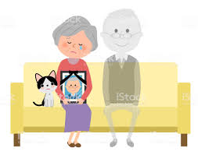
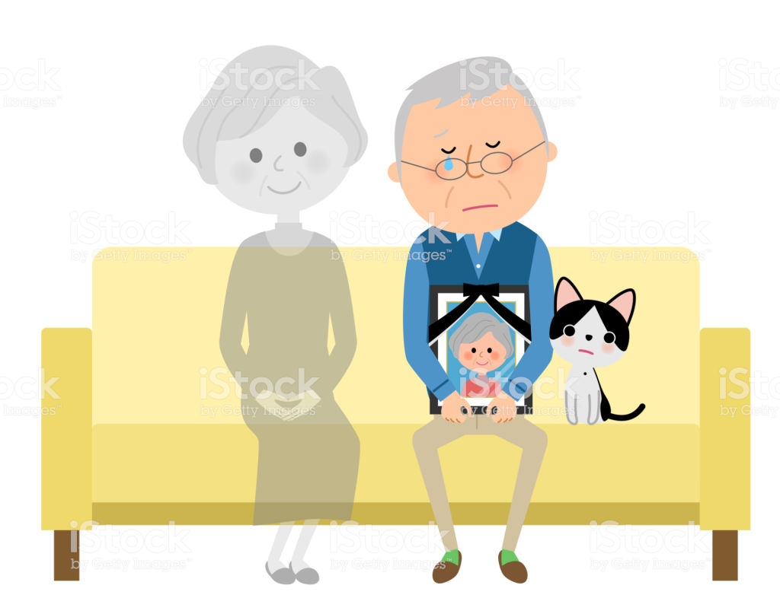

Negative physical, psychological, social, economic and practical changes can be associated with the death of a long-term spouse (Spahni et al., 2014). Compared to fellow peers in marriage, individuals whom are bereaved display symptoms of depression, raised loneliness rates, decreased satisfaction of life, more negative emotions and increased stress (Bennett & Soulshy, 2012).

Section 2: Introduction

Introduction
Defined as a biological, normative transition through old age – spousal bereavement can be seen as a stressful event in life that comes with considerable consequences on well-being and tasks carried out daily (Spahni et al., 2014).
With various reactions to the loss of a long-term spouse that in turn come with different outcomes on the well-being on those bereaved, a generalised assumption of the ramifications of spousal loss during old age would not be appropriate (Spahni et al., 2014).
Throughout the field of psychology, clinicians and researchers have carried out studies into the many natural ways to process grief using foundation theories such as the bereavement theory (Hall, 2014), ‘griefwork’ theory (Kübler-Ross, 1969).
These foundation theories have been the base for many expanded theories of grief and bereavement, which will be explored throughout this report.

Section 2: Introduction

Historically, Kurt Lewin (1952) presented key concepts in transition and change. The first concept presented by Lewin (1952) is the quasi-stationary social equilibria theory. The quasi-stationary social equilibria theory is used to describe the balance/imbalance of “force fields” that can be used to determine if social structures can retain an equilibrium or if they adapt to state changes (Elrod & Tippett, 2001).
The second concept is how the dissolution of change can be simplified into a process of three steps:

- Unfreezing 2. Moving 3. Freezing

The steps shown above are one of the earliest process of change models, although the model doesn’t come without its own problems and issues of its own by being rigid and unmoving in structure. Over the years, the initial work by Lewin and others have been modified and reconstructed by many researching grief (Elrod & Tippett, 2001).

Section 3: Coping with life after loss

Coping with life after loss

With bereavement and grief being an integral part of life as human beings, it can be seen as the price one pays to love and be loved (Hall, 2014). Grief researchers building upon historical grief works have since thought of grief to be completing a number of phases, tasks or stages that can be predictable (Hall, 2014).
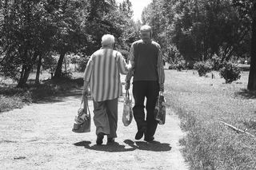

One of the most well-known grief models has been presented by Kübler-Ross (1969). Based on clinical work alongside those that are dying, Kübler-Ross (1969) model looked at anticipated grief; how one responds to a diagnosis being terminal (Hall, 2014).
Section 3: Coping with life after loss

This model became known as the five stages of grief:


The five stages of grief implies that failing to complete one or more of the stages may results in complications (Hall, 2014). Despite being able to capture the attention of both professionals and non-professionals alike, the suggestion that one must progress through each stage has been both criticised and rejected (Hall, 2014).
Although appealing, stage models are naïve to the complex and diverse nature of the grieving process while failing to address the psychological, physical and social needs that the grieving and/or bereaved experience (Hall, 2014).
While the five stages of grief model is well-known, there are two grief theories that are both influential and comprehensive: the Dual-

Section 3: Coping with life after loss

Process Model of Grief (Stroebe & Schut, 1999) and the Task-Based Model (Worden, 2008). Both these models are used by both health professionals and patients with frameworks and interventions that enhance and guide a patient’s self-efficacy and awareness (Hall, 2014).
The Dual-Process Model of Grief (Stroebe & Schut, 1999) defines grief as a fluctuating process between two conflicting modes of function.
Loss orientation and Restoration orientation

During the mode of ‘loss orientation’ the bereaved will engage with an emotion-focused form of coping, while expressing and exploring a range of emotion responses that come with losing a loved one (Hall, 2014). During the mode of ‘restoration orientation’ the bereaved will engage with a problem-focused form of coping, which is vital for focusing on the adjustments following losing a loved one (Hall, 2014).
The Dual-Process Model of Grief (Stroebe & Schut, 1999) suggests that coping may shift depending on moments and cultures.

Section 3: Coping with life after loss

The Task-Based Model (Worden, 2008) suggests that to grief is an active process involving the engagement of four separate tasks.
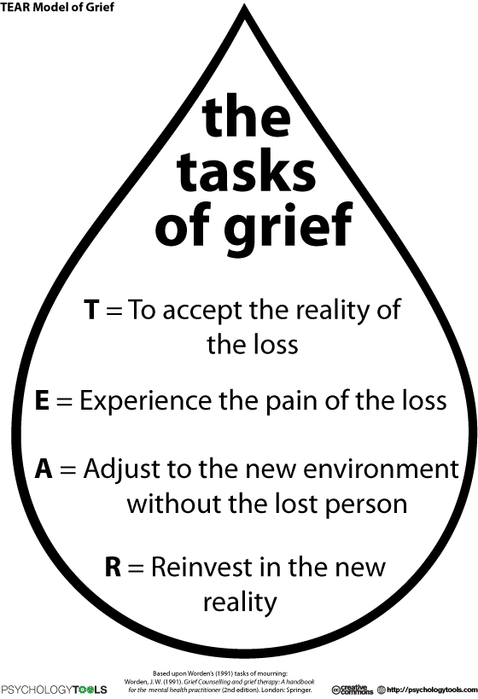

Section 3: Coping with life after loss

Coping with life after loss – Interventions
While there is ample research and evidence showing that interventions are not seen as effective for those grieving generally, it can be effective for the grieving that are high risk or are experiencing confusion during their grieving process (Hall, 2014).
The use of antidepressant medication is seen to do very little to reduce and address core grief complications, while the use of grief counselling is valued and highly supported provided the health professionals carefully assess and tailor the counselling to the patient (Hall, 2014).
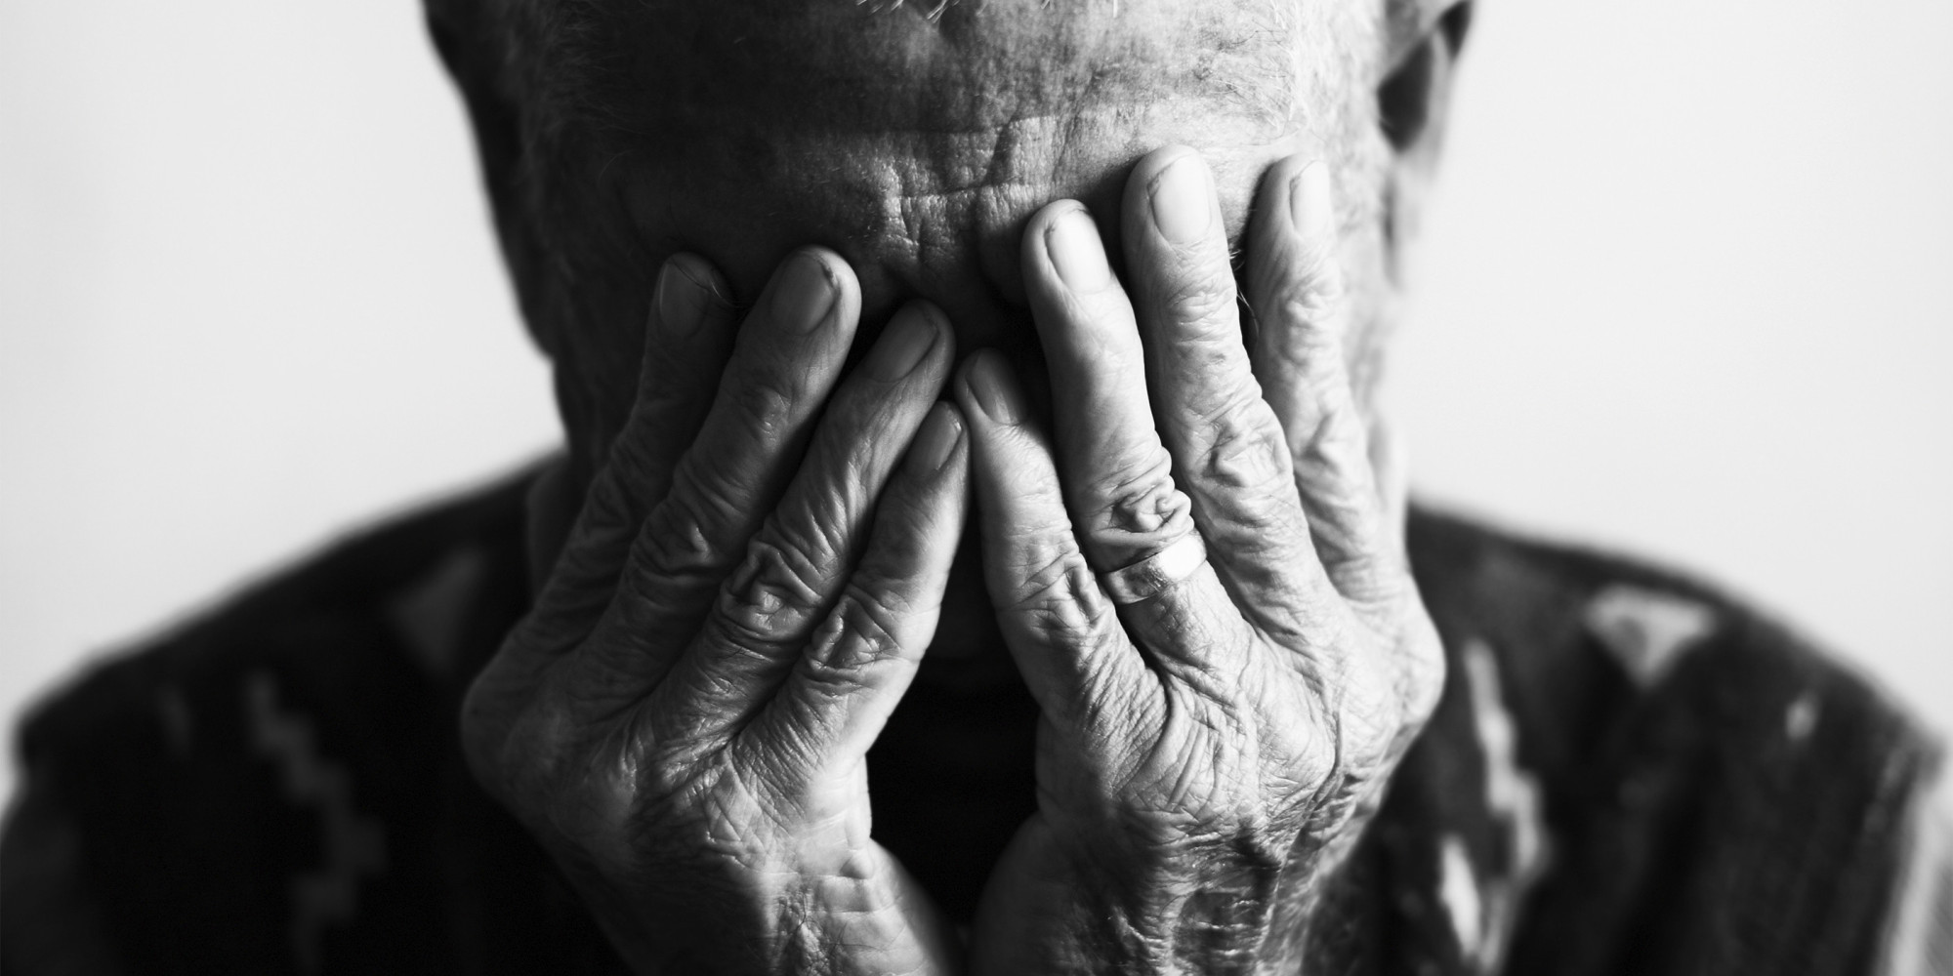

Section 4: Conclusion

Conclusion
While expanding clinical research has furthered the understanding of bereavement and grief symptoms and processes, there is no model that can be generalised to the many (Hall, 2014). Any and all interventions need to be tailored to the individual to be able to grieve specific types of loss (Hall, 2014).

Life After Loss
Learning to cope with life after loss

The loss of a loved one in old age may cause changes to daily life for the bereaved where tasks may become difficult to manage. (Bratt et al., 2016).

If you are struggling to come to terms with the loss of a loved one, please contact a healthcare professional.
Life After Loss
Learning to cope with life after loss

While grief is a natural part of life, it is important to engage with all stages that come with grief in order to process your grief.

If you are struggling to come to terms with the loss of a loved one, please contact a healthcare professional.

References
Bennett KM, Soulsby LK. (2012). Wellbeing in bereavement and widowhood. Illness Crisis Loss; 20:321–337.
Bratt, A. S., Stenström, U., & Rennemark, M. (2017). Effects on life satisfaction of older adults after child and spouse bereavement. Aging & mental health, 21(6), 602-608.
Elrod, P. D., & Tippett, D. D. (2002). The “death valley” of change. Journal of organizational change management, 15(3), 273-291.
Hall, C. (2014). Bereavement theory: recent developments in our understanding of grief and bereavement. Bereavement Care, 33(1), 7-12.
Kübler-Ross, E. (1969). On death and dying. New York: Macmillan.
Lewin, K. (1952). “Group decision and social change” in Readings In Social Psychology, Henry Holt, New York, NY.
Stroebe, M.S,. Schut, H. (1999). The dual process model of coping with bereavement: rationale and description. Death Studies 23(3) 197-224.
Worden, J.W. (2008). Grief counseling and grief therapy: a handbook for the mental health practitioner (4th ed.). New York: Springer.
All images have been taken from Google Images.

