Title Of The Report | Report 2
Module Name | STRATEGIC CHANGE AND ORGANISATION
Name of the Tutor | Dr. Gladius kulothungan
Code of the Module | LCDB7005
Student ID | 1812015
Submission Deadline | 20-09-2019

Table of Contents
Introduction 3
Company overview 3
M&S Change programme 3
Level of competition 4
Threat of substitute 5
Threat of new entrants 5
Bargaining power of buyers 5
Lewin Change management model 6
Unfreeze the changes 6
Execute the changes 6
Refreeze the changes 7
Conclusion 7
Reference List 8

Introduction
This report analysis the recent change programme of M&S. The major change programme that took place to the M&S are transformational changes and shifting their retail shop to online to save the cost. M&S is a British multinational retailer selling high quality clothing, foods hall and home products. Moreover, this report investigates the reason for the M&S to implement the change programmes to the company (M&S, 2018). Furthermore, Porter five forces has been analysed to investigate the external environment of the M&S. Through this model this report aims to investigate the influence factors that for M&S for their changes. Finally, Lewin change management model has been articulated to evaluate the change pregame. The advantage and the disadvantages of the M&S change programme has been identified.

Company overview
M&S was founded by Michael marks and Thomas spencer in Leeds in 1894. It is considered one of the UK’s largest enduring brand and department store. The company is specialise is selling foods, drinks, apparel and household. To be a diverse company has recently diversified into financial products such as insurance and credit cards. Due of poor product offering and inconsistent supply Chain Company was in financial difficulties in early 2000s. However, company has gradually overcome the situation after the appointment of Sir Stuart rose as the CEO in 2004, who brought significant change programme to the company : such as aggressive marketing campaign rigorous cost cutting, extensive store refurbishment. Following the market competition company is implanting various changes as part of the strategic policy and to compete with the market and to sustain in the market (M&S, 2018).

M&S Change programme
One of the major changes programme of the company was to announce technology transformation programme. This is a company’s long term strategy with the purpose of company to grow with technological advancement. In addition, company is planning to design more agile and customer friendly, faster and commercial technology that will work with the business to deliver growth. Moreover, through the change programme company is aiming to benefit the business along with the customers.
The company is aiming to deliver extra efficiency of extra £30 by2021/22, which will be more customer centric approach. Although there is a one of cost of £25m to implement the change programme (BBC, 2019).
Under the company transformation programme, M&S management is going to address following sectors:
- Closing down some of the retail shop and shift to the online.
- Opening and franchises of its retail business in Hong Kong and mucus.
- The announcement of new technology and transformation programme (The Telegraph, 2019)

External factor analysis through M&S change programme
In this part of the analysis, porter five forces can be establish to investigate the external factor analysis of M&S. This will help the research by understanding why organisation took the decision to make the changes.
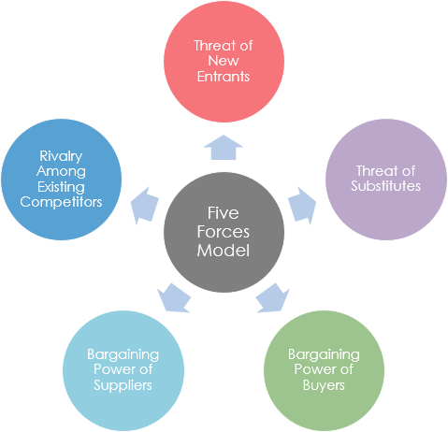
Figure 1: Porter five forces

Level of competition
According to Bartton and Gold (2017) the level of competition in the industry is significant. They have also argued that the change pregame for the M&S was necessary to compete with the competitors and for company’s technological advancement. M&S market competition is high in the market as its facing competition from both supermarket and such as Asda, Tesco , Sainsbury’s, and from the retail such as: Zara, Next and John Lewis. Therefore in this case the level of competition is high and the change programme is necessary in order to minimise the risk from the both sector. Those existing companies are already making digital changes in their organisation therefore it is important for M&S to follow the market trend in order to sustain in the market.

Threat of substitute
As per the threat of substitute product concern, the risk is high for the M&S. In terms of substitute of product all the food and retailers are the competitors of M&S. This suggests that the threat of substitute is high. Moreover, (Cook, 2015) the competition in the retails sector in significantly high now days due e commerce. It will be difficult for the companies to survive in the market if they don’t come out from their traditional business model and advance their business technology.
Fernie et al. 2018 suggest that substitute for the M&S is high especially in the retail sector. The current trend of E-commerce is in upper trend. This suggests that M&S not only have to compete with the street retailer but also they have to compete with the E-commerce industries. However, as per the report requirement concern to overcome the challenge of threat of substitute positive change to the organisation is vital. In contrary, Burke (2017) argued that there could be a risk in change management in line with the substitute competitors. He articulated that if the company cannot implement the appropriate change to the organisation may not be able to take proper benefit out of it.

Threat of new entrants
Threat of new entrants in retail and food industries is high due to e-commerce. In addition, due to E-commerce there is an easy access in online retail. In line with these threats, M&S has changed their management and business policy to close street retail to focus in online. Bartton and Gold (2017) analysed that this is strategic management change by the M&S. They have also argued that non - branding and chip e-commerce is another threat for the M&S. Therefore, the decision of operating big part of the operation in online is a significant move by the company.

Bargaining power of buyers
Bargaining power of buyers is more in retail industry, mostly in retail and food industries due its availability. In the case of M&S buyer has more power over the M&S. As per the M&S change management concern, if the price of the goods goes up due to management and structural changes then the change implication is alarming for the company. Cook (2015) articulated that one of the main vision of M&S changes programme is to reduce cost so that customer have save on their expenses.

Lewin Change management model
This part of the analysis the Lewin change management model for the M&S.
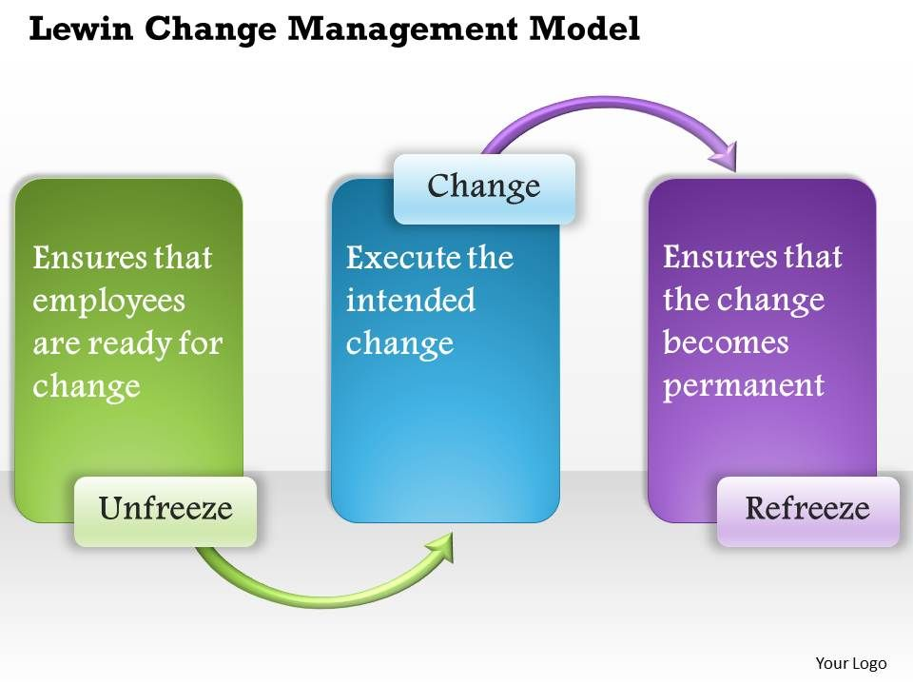
Figure 2: Lewin change model

Unfreeze the changes
According to the M&S annual report (2018) company had a long observation through employee engagement to under whether the employees are ready for the changes. Company also articulated that as the competitors was changing their business structure it is necessary for the company to implement changes in the organisation. Moreover, technology transformation is one of the key change programme for the M&S, hence it is vital for the company to ensure adequate facilities are in the place for the employees so that they can be familiar with the changes.

Execute the changes
Executing the intended changes is the second step of Lewin model. In the case of M&S is already executing the changes. Part of the company’s 5 yeas plan company will close its 100 stores by 2022 as a cost saving strategy. According to the BBC, (2018) although it is not a great news for the employees but it is vital for the retailer’s future. As per the executing the plan concern company have already closed 21 of their outlets. Under its plan company wants to move third of its sales in online and plan to have fewer and larger homeware store in better location. According to the daily express report (2018) through this changes 872 employees will lose their job which is alarming for the company. He also critics that company’s change plan is more about customer and profit oriented but not for the employees.

Refreeze the changes
Refreeze is the last and vital prat of the Lewin change model. This point explains that the change should be permanent for the company otherwise the change programme will not be successful. According to the M&S vision Statement Company’s change programme will be for the long term vision. This suggests company’s change programme is for the long term. Ellis and Abbott (2018) analysed this view and articulated that if companies long term plan is to mainly the shop closer and focusing on E-commerce, with a matter of time M&S will be online retailer. Burke (2015) has different views, who argued that long term technological and cost savings strategy is vital for the company otherwise company will have a high competition in the market.

Conclusion
In the sum up, it is important to conclude whatever has been discussed above. M&S has a five years vision for their change programme. Their two major change programmes are transformational changes and shifting retail business to e-commerce. Through this programme company is aiming to open 150 stores in overseas. However, as part of the plan company has already closed down 21 of their retail shop with the aim of saving cost. There has mix opinion about the M&S change programme. One side of the opinion is M&S had to make the decision considering the external environment such as: market competition, E-commerce effect and digitalisation. Other side of the arguments are employees will be demotivated because of the changes. It has been found around 850 employees will lose their jobs due to M&S change programme , more specifically for the street outlet closure. It has also been found that employees will be in fear of job losses. Despite this argument M&S has assured that employees will have chance to work into their E-commerce and necessary training will be provided to employees for all the changes that company made. There has been argument that for last few years the sales and profit falls which was another for the change programme implementation. Finally, after all the changes company wants to ensure a sustainable profit and at the safe satisfaction will remain high.

Reference List
Ayers, James B., and Mary Ann Odegaard. Retail supply chain management. CRC Press, 2017.
BBC, 2019. M&S shop closer (Online) Available at: https://www.bbc.co.uk/news/business-46876749 [Accessed date: 13-09-2019]
Burke, W.W., 2017. Organization change: Theory and practice. Sage Publications.
Bratton, J. and Gold, J., 2017. Human resource management: theory and practice. Palgrave.
Cook, N.D., 2015. Crisis management strategy: Competition and change in modern enterprises. Routledge.
Cummings, S., Bridgman, T. and Brown, K.G., 2016. Unfreezing change as three steps: Rethinking Kurt Lewin’s legacy for change management. Human relations, 69(1), pp.33-60.
Cameron, E. and Green, M., 2015. Making sense of change management: A complete guide to the models, tools and techniques of organizational change. Kogan Page Publishers.
Ellis, P. and Abbott, J., 2018. Applying Lewin's change model in the kidney care unit: movement. Journal of Kidney Care, 3(5), pp.331-333.
Fernie, J. and Sparks, L. eds., 2018. Logistics and retail management: emerging issues and new challenges in the retail supply chain. Kogan page publishers.
Hornstein, H.A., 2015. The integration of project management and organizational change management is now a necessity. International Journal of Project Management, 33(2), pp.291-298.
Hammad, A., 2015. Strategic Change and Its Management to Expand Business Through Implementation of Models: A Case Study of Boots UK. Available at SSRN 2676800.
Haleem, F. and Jehangir, M., 2017. Strategic Management Practices by Morrison PLC, UK. Analysis, Lessons and Implications. Middle East Journal of Business, 12(3).
Hayes, J., 2018. The theory and practice of change management. Palgrave.
Hussain, S.T., Lei, S., Akram, T., Haider, M.J., Hussain, S.H. and Ali, M., 2018. Kurt Lewin's change model: A critical review of the role of leadership and employee involvement in organizational change. Journal of Innovation & Knowledge, 3(3), pp.123-127.
M&S Annual Report 2015 (Online) Available at: https://corporate.marksandspencer.com/annualreport [Accessed date: 03-09-2019]
Moreno-Izquierdo, L., Ramón-Rodríguez, A.B. and Perles-Ribes, J.F., 2016. Pricing Strategies of the European Low-Cost Carriers Explained Using Porter's Five Forces Model. Tourism Economics, 22(2), pp.293-310.
M&S Annual Report 2016 (Online) Available at: https://corporate.marksandspencer.com/annualreport [Accessed date: 05-09-2019]
M&S Annual Report 2017 (Online) Available at: https://corporate.marksandspencer.com/annualreport [Accessed date: 01-09-2019]
M&S Annual Report 2018 (Online) Available at: https://corporate.marksandspencer.com/annualreport [Accessed date: 12-09-2019]
The Daily Express. M&S shop closer (Online) Available at: https://www.express.co.uk/life-style/life/1130409/marks-and-spencer-uk-store-closures-full-list-stores-closing-near-me [Accessed date: 10-09-2019]
Van Alstyne, M.W., Parker, G.G. and Choudary, S.P., 2016. Pipelines, platforms, and the new rules of strategy. Harvard business review, 94(4), pp.54-62.

