Luke Colwill (2528776)
Task 1a: Produce a written summary on essential skills for study and employment using IEEE.
Developing crucial employability skills is essential for success, particularly in higher education and the profession of computing. One essential skill is approachability, employers appreciate individuals who are approachable as this can encourage collaboration, teamwork with others and sharing ideas to help performance. [1]
Two equally important skills to support being approachable in the workplace are reliability and trust. Students who are reliable are expected to contribute more often, follow policies and procedures and manage time well. Research implies that organisations that are highly trusted will experience reduced stress, positive engagement and efficiency between individual employees. These traits are of high importance in computing duties, where groups will seek assistance from others to fix problems and maintain effective systems [2]
Trust is one of the biggest essential skills needed in both employment and education. When an employee or student is trusted their levels of production and esteem are proven to be boosted. Enhanced performance will have positive impacts for both employers and educational professionals. [3]
Listening is a crucial essential skill especially when learning, listening will also be vital in both the workplace environment and educational environment to reach and achieve targets set by either employers or educational professionals.
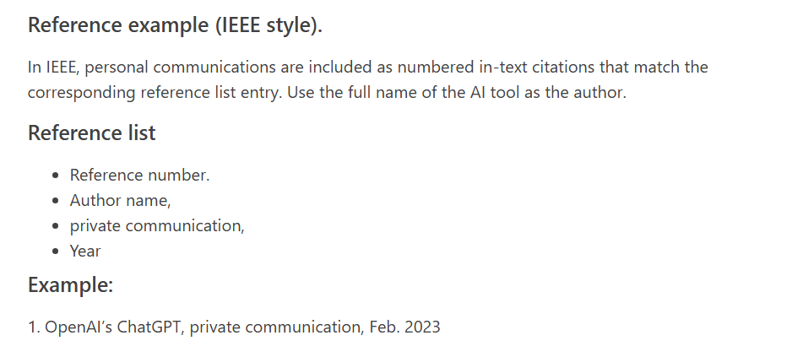
For example, listening and learning how to use IEEE to reference. [4]

Having technical proficiency to use digital tools to complete tasks. For example, using Artificial Intelligence (AI) to help with referencing while learning, or with using AI to help with proofreading a user guide.
Task 1b.
There are many ways artificial intelligence can be help in the workplace. Artificial intelligence can be used to automate processes helping with workers efficiency and consistence.
AI can also be used to check for malware and malicious activity in web mail. Recently in my place of work we have introduced Darktrace email software, Darktrace uses AI to monitor emails to understand how the business works and can block unknown threats based on the language used between employees, suppliers and customers.
Artificial intelligence can also be useful for personalizing an end users PC to their needs I have recently used Microsoft Copilot to help design a script for setting a user’s proxy details. The script will help the user with having a quick and simple option for setting the proxy details.
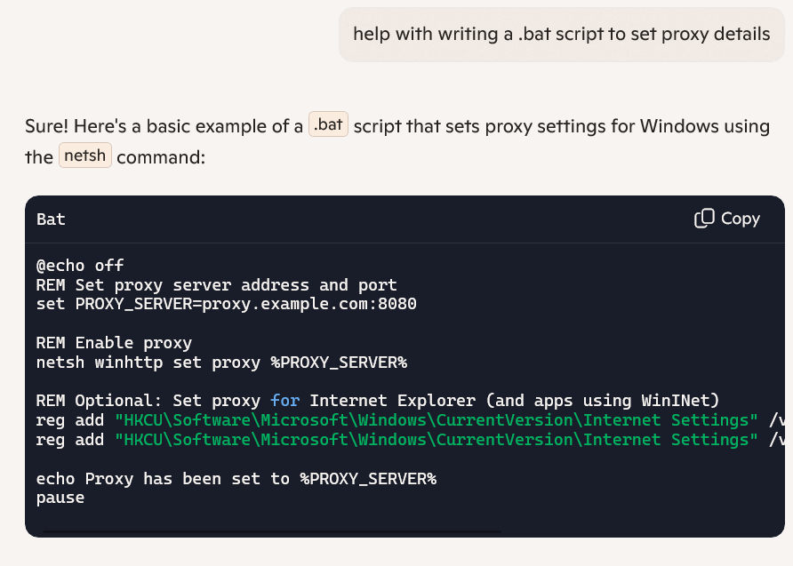
I have also used AI to help write a script to switch an end user’s laptop from a static ipv4 address to a wireless DHCP IP address. The script is an easier way to help the end user when working remotely or at the office. The .bat file is pre-configured, and the user selects option 1 or 2.
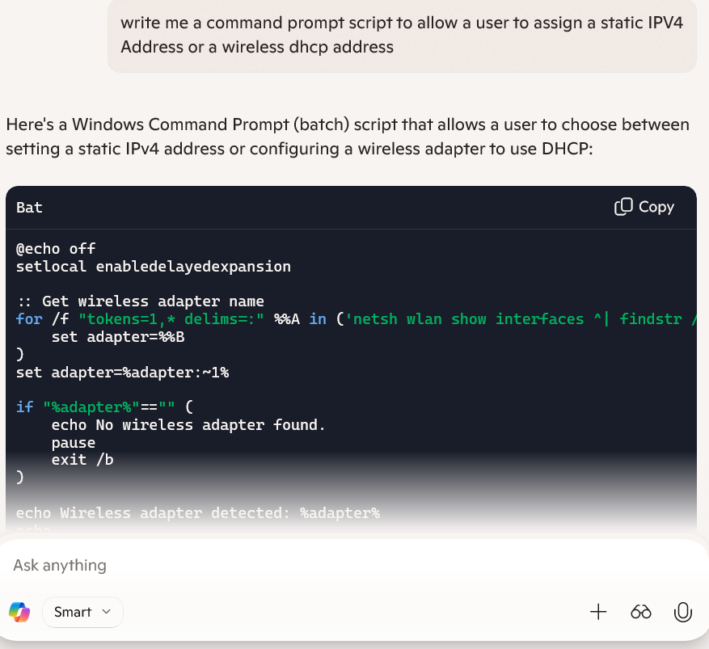

[1] | N/A, “Arwana,” 13th September 2024. [Online]. Available: https://arwana.co.uk/article/7-essential-skills-every-team-leader-needs/. [Accessed 31st January 2026].
[2] | A. Gravells, “ProQuest Abook Central,” N/A N/A 2010. [Online]. Available: https://ebookcentral.proquest.com/lib/trinity/reader.action?docID=680095&c=RVBVQg&ppg=18. [Accessed 31 January 2026].
[3] | A. S, “Linkedin,” NA 10 2024. [Online]. Available: https://www.linkedin.com/pulse/building-trust-workplace-four-pillars-reliability-empathy-aidan-salvi-ivvpc#:~:text=These%20statistics%20are%20not%20surprising,encompasses%20dependability%20in%20interpersonal%20interactions.. [Accessed 26 01 2026].
[4] | N/A, “UWTSD,” n/a 02 2023. [Online]. Available: https://digitalservices.uwtsd.ac.uk/library/academic-and-infoskills/referencing-handbooks/. [Accessed 26 01 2026].
[5] | [Online]. Available: https://ebookcentral.proquest.com/lib/trinity/reader.action?docID=680095&c=RVBVQg&ppg=18.
References

