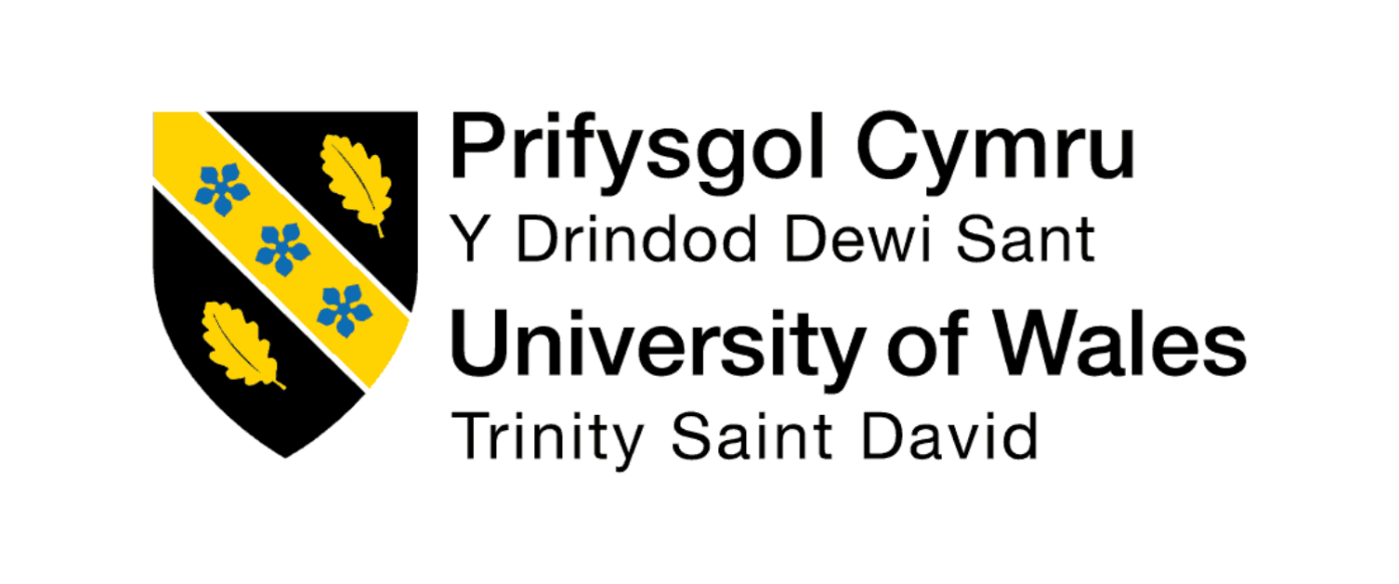

The Influence of National and International Labour Markets on HRM and IHRM Strategies

Programme: Master of Business Administration
Module: Human Capital Management
Module Code: LCMB7023
Lecturer: Ejike Udeogu (Birmingham)
Internal Verifier: Vasilios Tavlaridis Hoang Nguyen

Student Name: Alima Niva
Student ID Number: 2431109
Word Count: 2,749
Submission Deadline: Friday 17th October 2025
Table of Contents
Introduction 3
1.0 Technological Advancements and Their Impact on HRM and IHRM 4
1.1 Transformation of Labour Markets 4
1.2 Implications for HRM Strategies 4
1.3 Implications for IHRM Strategies 5
2.0 Demographic and Geopolitical Factors Influencing Labour Markets 7
2.1 Demographic Shifts 7
2.2 Geopolitical Influences 7
2.3 HRM and IHRM Strategic Responses 8
3.0 Addressing Skills Gaps and Talent Shortages through Strategic HRM 9
3.1 The Nature of Skills Shortages 9
3.2 Strategic HRM Approaches 9
3.2.1 The Talent Management Cycle 10
3.2.2 Recruitment and Employer Branding 10
3.2.3 Learning and Development 11
3.2.4 Retention and Engagement 11
3.3 Governmental and Institutional Roles 11
3.4 Strategic Implications 11
4.0 Reflective Analysis: Personal Capabilities for the International Labour Market 12
4.1 Introduction 12
4.2 Technological Capability 12
4.3 Communication Skills 12
4.4 Teamwork and Collaboration 12
4.5 Leadership 13
4.6 Self-Directed Learning 13
4.7 Summary of Reflection 13
Conclusion 14
References 15

Introduction
Human Capital Management (HCM) has become part of the international competitiveness aspect, and organisations heavily depend on trained human resources to keep innovating and expanding. The national and the global labour market are to a great extent intertwined, and this influences the strategies adopted by the Human Resource Management (HRM) and International Human Resource Management (IHRM) (Smerek, Milota and Simockov, 2021). Based on the rapidly evolving technological setting, demographic and geopolitical shifts, people management has become more than an administrative position but a leadership requirement in a strategic way.
The integration of the labour markets and heightened interdependence amongst the economies are a result of globalisation. This has created a heterogeneous, mobile and technology proficient workforce that requires dynamic HR approaches. The traditional HR practices have in most organisations changed into strategic tools of innovation and management of diversity as well as competitive advantage (Lina, 2018). HRM is now interested in the development of flexible and inclusive practices that are responsive to the changing expectations of the employees, whereas IHRM is interested in coordinating these practices within the multinational country and cultural contexts. The capacity to strategically manage human capital to compromise global standardisation and local sensibility has become a major issue for the long-term sustainability, as organisations increasingly go international (Salam and Rami, 2025).
This report is a critical analysis of how these shifting factors affect the strategies of HRM and IHRM. It is divided into four big parts, the first is the consideration of the impact of technological advancements on HRM and IHRM; the second is determination of the impact of demographic and geopolitical changes on employment markets, the third is how organisations are managing global skill shortages, and the last section is a reflective discussion on the HRM and IHRM readiness of the author himself to global employability, and particularly, in relation to technology, communication, teamwork, leadership and self-directed learning.

1.0 Technological Advancements and Their Impact on HRM and IHRM

1.1 Transformation of Labour Markets
The world has witnessed technological improvement that has transformed the labour markets, which scholars have termed the Fourth Industrial Revolution. The organisation, performance, and rewarding of work are changing due to the influence of automation, robotics, and digitalisation. The World Economic Forum (2023) shares the opinion that by 2025, approximately 85 million jobs would be displaced through automation, yet an estimated 97 million new jobs with high technology skills would emerge. This transformation marks the end of manual labour around the world as it was before in favour of high-skilled, knowledge-intensive work.
The digitalisation has also broadened the global access to the labour market by means of online platforms and remote working solutions. The platforms of the gig economy, like Upwork and Fiverr, have created a possibility of workers providing services to the international market, leading to the chance of flexible employment and causing traditional job security to be less significant (De Stefano, 2020). This has, in turn, resulted in more dynamism in the national labour markets where flexible and hybrid work arrangements are now the order of the day. On an international scale, the digital transformation has helped multinational corporations (MNCs) to operate distributed teams based on geographical boundaries using digital tools.

1.2 Implications for HRM Strategies
HRM in domestic settings are forced to respond to these changes in technology by adopting innovation in their recruitment, performance management, and learning. Recruitment systems based on data analytics and AI have become the key to finding, attracting, and recruiting employees (Brougham and Haar, 2021). The technologies also enable HR professionals to evaluate employee performance, anticipate turnover, and enhance workforce planning.
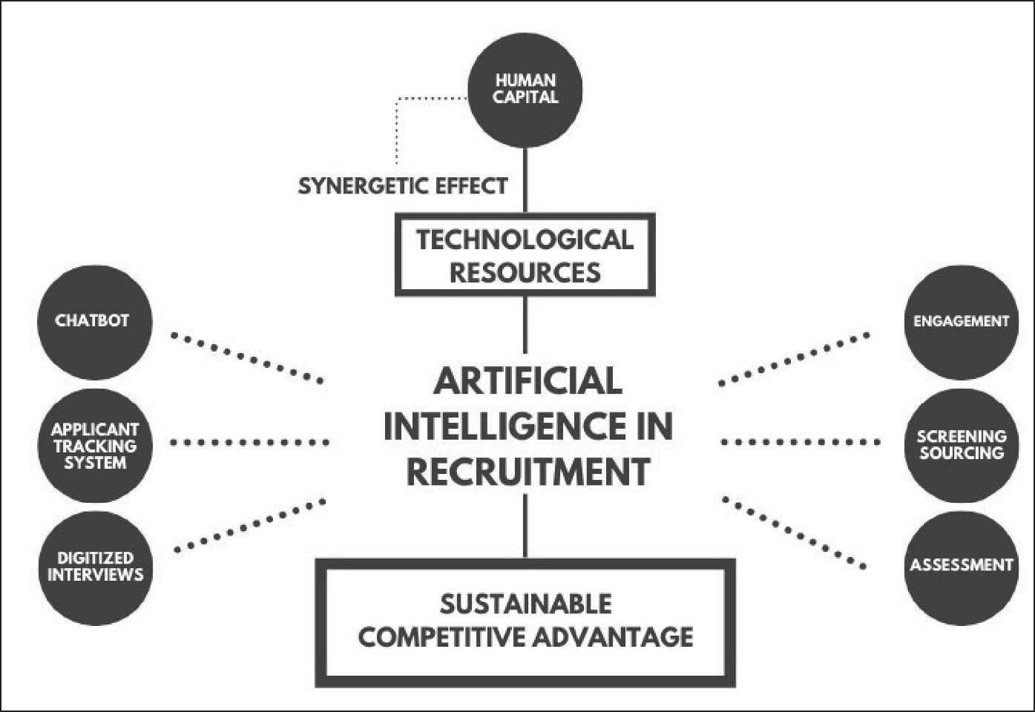
Figure 1: Artificial intelligence in Recruitment, Source: Mehrotra & Khanna. (2022)

Nevertheless, there are also ethical and psychological issues with the introduction of technology. Employees can fear losing their jobs to automation, or they can feel lost in highly digitalised workplaces. It is therefore important that HRM not only bring in new technologies but also regulates their social effects. To achieve trust and successful adoption, it is important to have effective change management, communication, and employee engagement.
Moreover, HRM needs to focus on reskilling and upskilling programs. Due to the rapid development of technologies, employees require ongoing development in order to stay relevant. Companies are fascinated by e-learning systems, in-house learning institutions and competency models to facilitate lifelong learning. Such programs not only bridge the skill gaps but also increase employee motivation and retention (Hasan et al., 2024).

1.3 Implications for IHRM Strategies
At the international level, IHRM is being complicated even further because, with the rise in technological developments, talent mobility across borders has also risen. Remote working technologies allow organisations to hire a person who has worked in several countries without the need to move to the country. This tendency facilitates diversity and at the same time puts IHRM in the challenge of handling virtual cross-cultural teams (Becker and Gerhart, 2016).
According to Tung (2016), global HR managers should develop cultural intelligence and digital leadership competencies to manage the work of cross-time zone and culturally diverse teams. Managers are now forced to develop the norms of communication and provide equal participation through virtual collaboration tools like Zoom, Slack, and Microsoft Teams, which are used by international firms.
Moreover, IHRM must deal with foreign legal and ethical standards regarding online job opportunities. Employee information management is highly regulated by law due to data protection laws like the General Data Protection Regulation (GDPR) of the European Union. Thus, IHRM approaches should find a compromise between technological innovation and compliance, privacy and ethical responsibility (Vargas, Budz and Onete, 2021).

2.0 Demographic and Geopolitical Factors Influencing Labour Markets

2.1 Demographic Shifts
Demographic transitions have a great impact on national and international labour markets. The workforce structures in the world are being changed by population ageing, low fertility rates and migration patterns. According to the United Nations (2022), the global population above 60 years of age will have increased twice by 2050, which will result in a deficit of employees in developed nations. The trend exerts a strain on governments and organisations to keep older employees with improved working hours, ergonomic changes, and retraining programs (Taylor, 2020).
Simultaneously, younger generations coming to the workforce, especially Millennials and Generation Z, are pursuing new demands that include flexibility, diversity, and purpose. Inclusivity, ethical leadership, and work-life balance are some of the values that such employees appreciate, forcing the HRM to redesign employment practices that meet the changes in employee values. The increasing diversity of the international workforce also requires organisations to adopt the strategies of inclusive recruitment, pay equity, and diversity management to ensure the promotion of equality and innovation (Ferdy Leuhery et al., 2024).

2.2 Geopolitical Influences
Geopolitical forces also affect the global labour markets. The effects of the political instability, conflicts and trade disruptions have a direct influence on the workforce mobility and organisational strategy. The migration patterns, supply chains, and flows of talent have been disrupted due to Brexit, the war between Russia and Ukraine, and the tension between the United States and China, as an illustration (ILO, 2023). These accidents have increased labour crises in some areas that are also in the manufacturing, logistics and healthcare sectors.
HR professionals should be able to address the volatility using strategic workforce planning and risk mitigation strategies. When it comes to domestic situations, HRM should predict the shortage of labour and invest in the development of the local workforce. In global arenas, expatriate security, law-abiding, and cross-national communication are issues that IHRM must deal with during crises. The global talent mobility programs and cross-cultural leadership training that multinational organisations use to achieve operational resilience are frequent (Zaman, 2022).

2.3 HRM and IHRM Strategic Responses
HRM and IHRM should be more flexible and culturally aware to face the problem of demographics and geopolitics. Domestically, HRM must reinforce diversity and inclusion programs, enhance gender balance, and develop policies that support employees with diverse backgrounds. Good practice has been exhibited in organisations such as IBM and Unilever, where flexible work and a mentoring programme to support women in leadership are promoted (Nataliana, Parulian and Daspar, 2025).
Internationally, IHRM should augment trans-cultural communication, offer international leadership education, and set up international careers that will enable employees to move across the global platform. Dowling, Festing, and Engle (2017) state that the key to successful IHRM is striking a balance between global and local responsiveness, which is referred to as the so-called global consistency/local responsiveness principle. This enables them to exercise equal HR values while MNCs adjust to cultural and legal differences in foreign nations.
These approaches allow HRM and IHRM to reduce the risks of demographics and geopolitics efficiently and establish agile, diverse, and sustainable global workforces.

3.0 Addressing Skills Gaps and Talent Shortages through Strategic HRM

3.1 The Nature of Skills Shortages
Skills shortages are among the most persistent global HR challenges. According to the World Bank (2024), shortages are most acute in STEM (science, technology, engineering, and mathematics), healthcare, and hospitality sectors. Rapid technological innovation has created new roles that outpace traditional education systems. Simultaneously, demographic ageing reduces the availability of experienced workers.
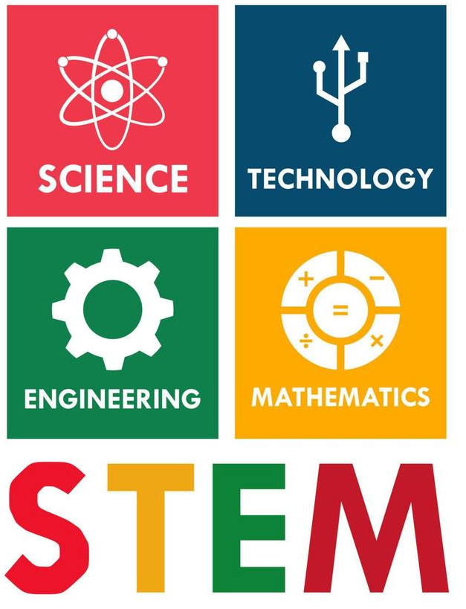
Figure 2: Science,Technology, Engineering and Mathematics Source: Vecteezy

3.2 Strategic HRM Approaches
Skills shortages are among the most persistent global HR challenges. According to the World Bank (2024), shortages are most acute in STEM (science, technology, engineering, and mathematics), healthcare, and hospitality sectors. Rapid technological innovation has created new roles that outpace traditional education systems. Simultaneously, demographic ageing reduces the availability of experienced workers.

3.2.1 The Talent Management Cycle
The Talent Management Cycle is a holistic model that connects workforce planning, the recruitment, development, and retention in a cyclical process that builds organisational capacity.
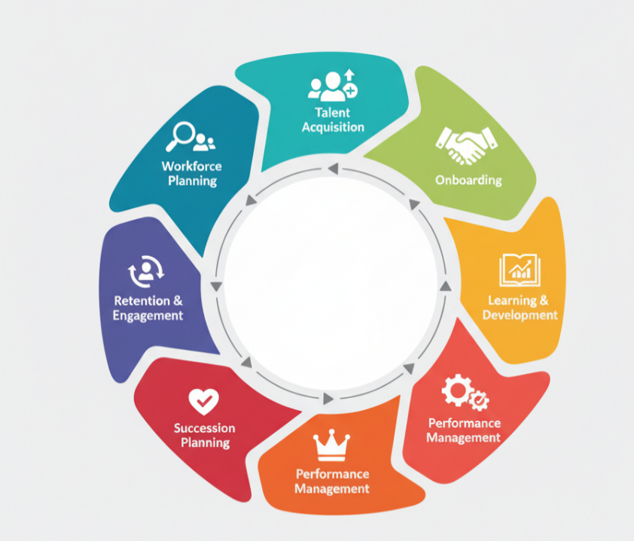
Figure 3: The Talent Management Cycle Source: CIPD, (2024)

The model shows that talent management is an ongoing process. This starts with workforce planning, which predicts the skills required, and then recruitment and onboarding to ensure effective integration of employees. Capability development is guaranteed through learning and development, whereas performance management is a way to remain on track with the organisational objectives. The succession planning presents the successors, and the engagement strategies improve the retention and motivation. This is a cyclic procedure that makes organisations adaptive to both labour market and technological changes (Siambi, 2022).

3.2.2 Recruitment and Employer Branding
Recruitment has become dependent on digital and predictive analytics to detect potential talent. Social media campaigns, virtual job fairs, and AI-based applicant tracking systems are used in organisations to simplify the process of selection. The employer branding power is demonstrated through the example of Google; the culture of innovation makes the organisation more attractive to the best employees (Ore and Sposato, 2021).

3.2.3 Learning and Development
The high rate of technological change necessitates a change from fixed models of training to continuous learning models. Senge (2010) supports the concept of learning organisations, which integrate learning into the day-to-day work operations. As an example, organisations such as Amazon have created in-house learning academies which assist in reskilling employees in digital positions. HRM should incorporate identical lifelong learning programs to establish internal human pipelines.

3.2.4 Retention and Engagement
Retaining talent is important in the face of competition for talent in the world. Current performance management tools are focused on employee engagement, flexibility, and personal development. Working models and cultures that are more inclusive are more likely to reduce retention, especially in younger and global mobile workers. Analytics should help HRM determine areas of risk in retention and establish interventions in a targeted manner.

3.3 Governmental and Institutional Roles
Governments have a role in eliminating labour market imbalances through education reforms, apprenticeship schemes, and skills development policies. To illustrate, the Apprenticeship Levy in the UK facilitates industry-academia partnerships, and the SkillsFuture programme in Singapore facilitates lifelong learning. These efforts can be facilitated by IHRM through international collaborations and cross-border talent exchange programmes.

3.4 Strategic Implications
HRM must be strategic and not responsive in planning the workforce. The future HR leader ought to exploit AI-based analytics, inclusive leadership, and continuous leadership. The resilience and sustainability of organisations in the uncertain global labour market will be determined by the capability to respond to demands, which is more flexible than expertise.

4.0 Reflective Analysis: Personal Capabilities for the International Labour Market

4.1 Introduction
The need to be adaptable, think critically, and develop intercultural awareness is a necessary skill in a fast-changing job market, as students with postgraduate qualifications are ready to work in international job markets. This part provides a critical evaluation of my existing strengths in technology, communication, teamwork, leadership and self-directed learning as a student. Gibbs’ (1988) Reflective Cycle is applied to evaluate strengths and weaknesses and to identify actionable improvement strategies.

4.2 Technological Capability
As a student, I have gained a high level of technological skills with the help of academic research, online cooperation, and the application of digital learning platforms like Microsoft Teams, Zoom, and learning management systems. These experiences have boosted my trust in online communication and information management. Nevertheless, I understand that I still have little or no familiarity with the latest HR analytics tools and AI-based systems. To overcome this, I will enroll in online HR analytics and digital transformation certified programs to enhance my technology-focused job employability (Khuzaini et al., 2024).

4.3 Communication Skills
Effective communication is one of my strongest competencies. Throughout my MBA studies, I have successfully presented group projects, written analytical essays, and participated in peer discussions, which have developed both my written and verbal communication skills. Nonetheless, I sometimes experience hesitation when presenting to large or diverse audiences. To improve, I will seek more opportunities for public speaking and cross-cultural interaction, perhaps through academic societies or volunteering roles that require active engagement.

4.4 Teamwork and Collaboration
Working on team-based assignments has improved my collaboration skills significantly. I actively contribute to discussions, share responsibilities, and support conflict resolution within groups. I have learned to respect cultural differences and varying working styles, which is essential in international environments. However, I occasionally adopt a supporting role rather than leading discussions. In future projects, I aim to take more initiative by facilitating team coordination and goal setting.

4.5 Leadership
Leadership has been an area of steady growth during my postgraduate studies. I tend to practise a transformational leadership style that emphasises motivation, empathy, and collaboration (Bass and Riggio, 2006). In group tasks, I often encourage members to contribute their perspectives, creating an inclusive environment. However, I must strengthen my assertiveness in decision-making and enhance conflict-handling abilities. Engaging in leadership workshops and assuming leadership roles in student organisations will support my development.

4.6 Self-Directed Learning
Self-directed learning has been one of my most developed skills as a student. I consistently engage in independent research, maintain academic discipline, and utilise online resources to expand my understanding of HRM concepts. Yet, I sometimes struggle to balance academic workload with personal well-being. To improve, I plan to implement time management frameworks such as SMART goals and digital planning tools like Trello to enhance efficiency and maintain motivation.

4.7 Summary of Reflection
Overall, my postgraduate experience has enabled me to gain significant development of global employability skills. I possess strong communication, flexibility, and collaboration skills, whereas my weaknesses are in managerial aggressiveness and tech-friendly issues. Due to my consistent learning, cross-cultural interaction, and digital upskilling, I hope to become a global competent HR professional who will be able to impact the work of multinational organisations in terms of their strategic workforce development.

Conclusion
This report has indicated that technology, demographic changes, and geopolitical developments play a vital role in the dynamics of the national and international labour markets. According to these forces, HRM as well as IHRM requires agile, evidence-based and inclusive strategies that not only concentrate on organisational goals but also development of employees.
The work structure has been changed by technological innovation, and it demands continuous learning and digital progress. Demographic and geopolitical shifts, on the contrary, position organisations in a difficult position of establishing fair and flexible employment models that recognise diversity and strategic orientation. The recruitment, learning, retention, and policy alignment must be included in the holistic SHRM approach to counter the global skills deficits.
The personal reflection also reveals the necessity to be flexible, become a leader and be capable of learning during life to achieve success in the competitive global world. The dynamic environment of labour markets requires HR managers and learners who are soon to join their ranks to be more resilient, digitally smart and culturally aware to enable them to thrive in the globalised labour market.

References
Bass, B.M. and Riggio, R.E. (2006). Transformational Leadership. 2nd ed. Mahwah: Lawrence Erlbaum.
Becker, B.E. and Gerhart, B. (2016) ‘The impact of human resource management on organisational performance: Progress and prospects’, Academy of Management Journal, 59(1), pp. 779–801.
Brougham, D. and Haar, J. (2021) ‘Smart technology, artificial intelligence, robotics, and algorithms (STARA): Employees’ perceptions of our future workplace’, Journal of Management & Organisation, 27(2), pp. 1–19.
CIPD (2024) Talent management: factsheet. Available at: https://www.cipd.org/en/knowledge/factsheets/talent-factsheet/
De Stefano, V. (2020) ‘The rise of the “just-in-time workforce”: On-demand work, crowdwork, and labour protection in the gig economy’, Comparative Labour Law & Policy Journal, 41(2), pp. 471–504.
Dowling, P., Festing, M. and Engle, A. (2017). International Human Resource Management. 7th ed. London: Cengage.
‌Ferdy Leuhery, Nely Salu Padang, Karyono Karyono, Dewi Puspitasari and Loso Judijanto (2024). Workplace Diversity and Inclusion: Strategies for Effective Implementation and Benefits to Organisational Culture. Dinasti International Journal of Economics, Finance & Accounting, [online] 5(4), pp.4647–4653. doi: https://doi.org/10.38035/dijefa.v5i4.3373
Gibbs, G. (1988) Learning by Doing: A Guide to Teaching and Learning Methods. Oxford: Oxford Polytechnic.
‌Hasan, N.M., Haque, M.A., Nishat, S.S. and Hossain, M.M. (2024). Upskilling and Reskilling in a Rapidly Changing Job Market: Strategies for Organisations to Maintain Workforce Agility and Adaptability. European Journal of Business Management and Research, [online] 9(6), pp.118–126. doi: https://doi.org/10.24018/ejbmr.2024.9.6.2502
International Labour Organisation (ILO) (2023) World Employment and Social Outlook: Trends 2023. Geneva: ILO.
Khuzaini, Idzani Muttaqin, Budi Setiadi, M. Irpan and Syahrial Shaddiq (2024). Human Resource Management in the Transformative Digital Era. International Journal of Religion, [online] 5(11), pp.4006–4021. doi: https://doi.org/10.61707/h58ygw76
Lina, M.A. (2018). Impact of Globalisation on Human Resource Management. Global Disclosure of Economics and Business, [online] 7(2), pp.51–62. doi: https://doi.org/10.18034/gdeb.v7i2.109
Mehrotra, S. & Khanna, A. (2022) ‘Recruitment Through AI in Selected Indian Companies’, Metamorphosis: A Journal of Management Research, 21(1), pp. 31–39.https://journals.sagepub.com/doi/abs/10.1177/09726225211066220 Original work publiched 2022)
Nataliana Bebasari, Parulian Parulian and Daspar Daspar (2025). The Role of Women’s Leadership in Enhancing Work-Life Balance and Flexible Work Arrangements: A Study in the Financial Industry. Ilomata International Journal of Social Science, [online] 6(1), pp.123–134. doi: https://doi.org/10.61194/ijss.v6i1.1425
Salam Basim and Rami Kamak (2025). Human Resource Management in the Developing Countries. Human Resource Management Studies, [online] pp.167–180. Available at: https://www.researchgate.net/publication/390564390_Human_Resource_Management_in_the_Developing_Countries [Accessed 15 Oct. 2025].
Senge, P. (2010). The Fifth Discipline: The Art and Practice of the Learning Organisation. London: Random House.
Siambi, J. (2022). Leadership Succession Planning and Organisation Transition: A Review of Literature. International Journal of Managerial Studies and Research, [online] 10(3), pp.16–30. doi: https://doi.org/10.20431/2349-0349.1003003
Smerek, L., Milota Vetráková and Šimočková, I. (2021). International Human Resource Management System. [online] Available at: https://www.researchgate.net/publication/350654148_International_Human_Resource_Management_System [Accessed 15 Oct. 2025].
Taylor, P. (2020) ‘Ageing labour markets and the future of work’, Work, Employment and Society, 34(6), pp. 1137–1156.
Tung, R. (2016) ‘New perspectives on human resource management in a global context’, Journal of World Business, 51(1), pp. 142–152.
United Nations (2022) World Population Prospects 2022. New York: UN. https://www.un.org/development/desa/pd/sites/www.un.org.development.desa.pd/files/wpp2022_summary_of_results.pdf
Vargas, V.M., Budz, S. and Onete, B.C. (2021). The relationship between human resources activities and the General Data Protection Regulation. Proceedings of the International Conference on Business Excellence, [online] 15(1), pp.552–559. doi: https://doi.org/10.2478/picbe-2021-0050
Vecteezy (no date) STEM science technology engineering and mathematics education vector illustration. Available at: https://www.vecteezy.com/vector-art/5412273-stem-science-technology-engineering-and-mathematics-education-vector-illustration
World Bank (2024). World Development Report 2024: Jobs and Skills for a Changing Economy. Washington, DC: World Bank. https://www.worldbank.org/en/publication/wdr2024
World Economic Forum (2023). The Future of Jobs Report 2023. Geneva: WEF. https://www.weforum.org/publications/the-future-of-jobs-report-2023/
Zaman, S. (2022). Countering the Intercultural impediments among expatriates as an IHRM practice. ResearchGate. [online] doi: https://doi.org/10.13140/RG.2.2.16892.21124

