
Basic IT Information @ UWTSD
INDUCTION TASKS
...
Gwybodaeth Sylfaenol am Wybodaeth Technoleg
TASGIAU ANWYTHO

Joining eduroam

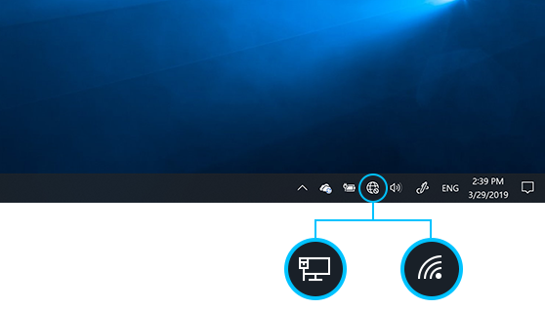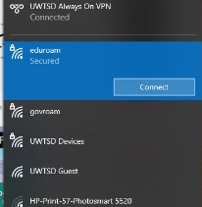
Find the wifi setting on your device . Click and connect to eduroam.

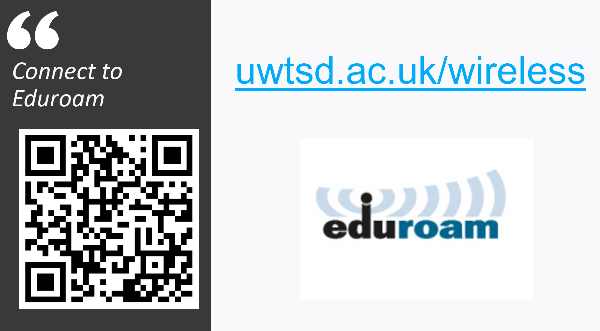
Username = uwtsd student email address (1234567@student.uwtsd.ac.uk)

Password = password that you set up for your email address

TASK : Complete signature for e-mail. Go to – Settings - Account – Signatures & Create!
Name / Enw:
Programme / Rhaglen:
Level / Lefel:

Send an e-mail to Mache: m.tgonzalez@uwtsd.ac.uk
Danfonwch at Heddwen : heddwen.davies@uwtsd.ac.uk

HWB
HWB website: www.hwb.uwtsd.ac.uk
AND/OR Download the app TASK: find your timetable and share it with your neighbour. Make sure you know where your first lecture is on Monday morning. If unsure whether you are enrolled on all modules – ask your program manager in the Q&A session during induction week.
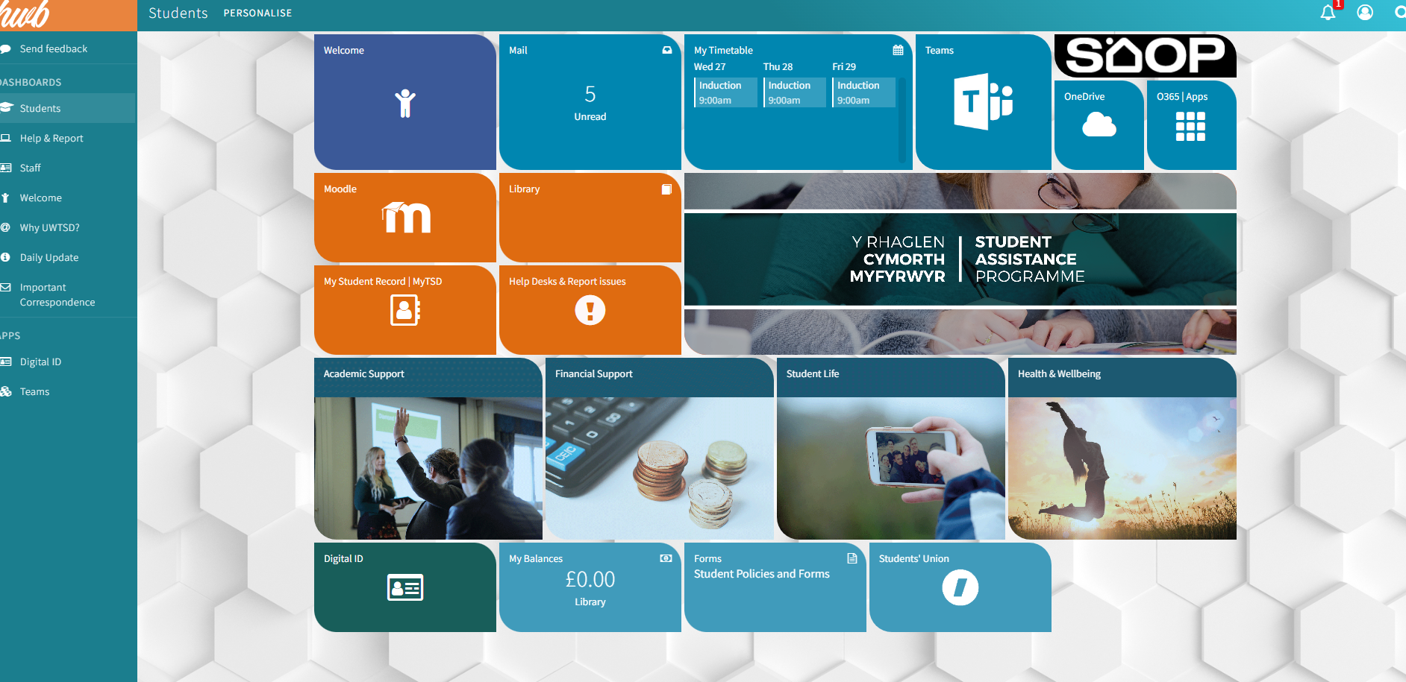
O365 APPS:
All Microsoft apps online access to or download
Teams: Information from your programme manager.
MyTSD: Enrolment, Course administration and organisation
Moodle: Virtual Learning Environment (VLE): Content for your modules

Moodle

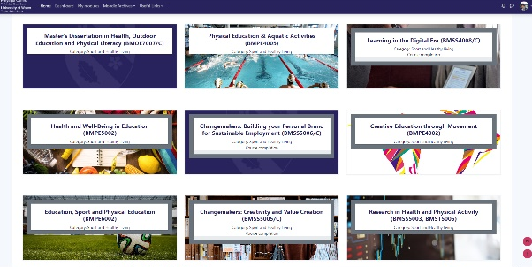
Tiles for each module. Each module will have:
- Lecture content and resources
- Additional reading
- Module/Semester plan
- Assessment information
- The place to hand in your assessments (Turnitin)
- Extra info and resources your lecturers would like you to have
TASK : Complete Profile Page one side A4, include : photo / name / likes / dislikes & how did you hear about the course, strengths and weaknesses. Save the Profile Page by labelling clearly. Due in 3pm Friday 25th September, 2026. To submit – go to - Moodle – Academic Skills / Sgiliau Academaidd – Scroll to Turnitin – Click and upload Profile Page.

MyTSD
All organisation of your degree and administration (behind the scenes info)
The top menu bar is the most important
Marks and exam board decisions: Find your overall marks (end of a semester or end of a year).
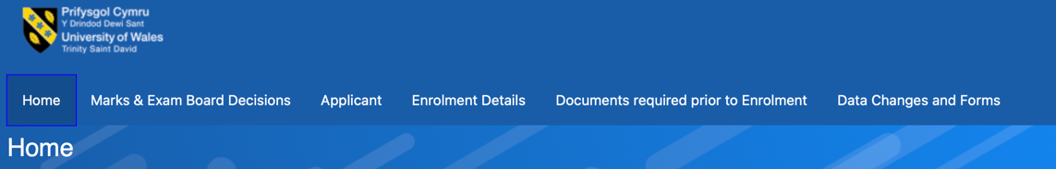

Data changes and forms: Here you have all the info to:
- Change programme
- Withdraw from programme
- Change module
- Extenuating circumstances form (if there is an issues with assessment submission – speak to you Programme Manager for more info on this).

TASK : Check that you are enrolled onto modules (Enrolment Details tab). Remember ... If unsure whether you are enrolled on all modules – ask your program manager in the Q&A session during induction week.

O365 Apps
These are available online and as downloadable apps for your laptop, phone and / or computer.
Outlook: Access to your student emails. Lectures and the university will only be using this email address from now on. Please check it regularly. This is the preferred medium used by lecturers to communicate.
Teams: Alternative communication about your programmes may come via Teams from your programme managers and lecturers.
OneDrive: You have access to a big amount of storage through your student account – utilise this to store your work etc, as it will be on the cloud. OneDrive can be downloaded so that the files are available from your laptop.
Word/ PowerPoint/ Excel: Software for your assessments and lecture work.
TASK : Add your photo to your Teams Account
TASK : During the week - download Word and Power Point apps and install onto your laptop. Recommend that you download outlook (Uni E-mail account) to your phone.

Complete these InfoSkills contents

TASK: Access and complete the following
- Finding and Using Information: https://digitalservices.uwtsd.ac.uk/library/academic-and-infoskills/finding-and-using-information/
- Academic Integrity & Refrencing Basics (Prioritise Units 1 & 3): https://moodle.uwtsd.ac.uk/course/section.php?id=152564

Timetable via HWB
This is updated regularly because of room changes, semester changes etc. This will be as up-to-date as possible.

All other tiles
All other tiles will be filled with helpful and supported information, guidance and resources. Most likely these will also be free of charge as part of your student fees. Things that you will find in the other tabs:
- Student services: help with your assessments
- Financial information
- Accommodation
- Parking
- Counselling services
- Bursaries
- IT help: passwords, access, software downloads, hardware issues.



