Module: Character & Creature Animation (Level 5)  Module Code: M5X02059 | Gareth Lewis P147797  BA 3D Computer Animation  7th May 2019
The Bill Murray School of Animating
Five short animations

Introduction
This report outlines the process and production of five short character animations exploring themes provided in the assignment brief.

Following a discussion on method and preparatory work, the process for each animation is described individually and in more detail. Critical reflections are employed to highlight progress, problems and opportunities for further development.

Method
While working with the classical twelve principles of animation (Johnston and Thomas, 1981), further foundations have also been applied (O' Connor, 2018) (see appendix).

Workflow initially involved investigating themes and referencing still and moving images. The results were taken into Maya, through a block-out phase of animation where stepped key-frames were employed to define extremes and approximate the timing of movement. “Tween” frames were inserted as necessary before converting the animation curves to splines. These splines could then be manipulated in Maya’s Curve Editor. Curve shapes would define extremities of movement and ease-in/out of tweened frames. Scaling and movement of individual or multiple frames could also be employed to fine-tune timing.

The work was produced in Maya using Animation Studios’ AdvancedSkeleton plugin and free character rigs. These can be found on their website (www.animationstudios.com.au/character-rigs). The Tuna rig was chosen for its versatility, quality of rigging, comprehensive controllers and ease of use. This character rig has been used throughout the sequences.

The Tuna rig is a cartoon-like human in appearance with approximately realistic proportions. The animations reflect this balance of the stylised versus realism, exaggeration in action and movement employed where necessary.

Preparation
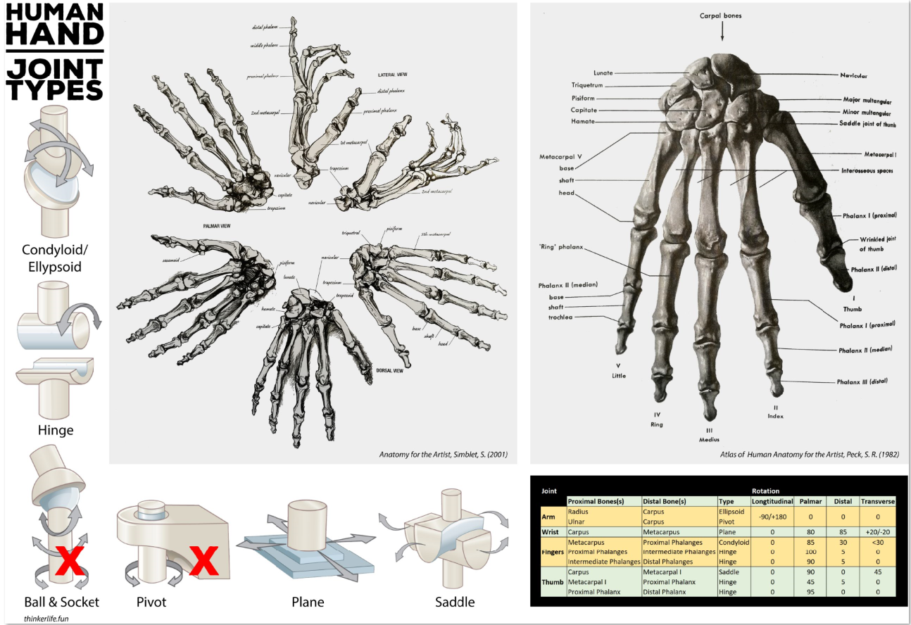  Images compiled from  (Simblet, 2001), (Peck, 1982), (Lumen Learning, 2019) | Early work looked at the structure of human and animal anatomy to provide a sound base for the development of both realistic and more exaggerated, cartoon-like animation.  Investigations into joint types, axes and ranges of movement were summarised into information sheets to be used as reference.  The movement of the musculature could then be built around this framework, taking into account mass and momentum.
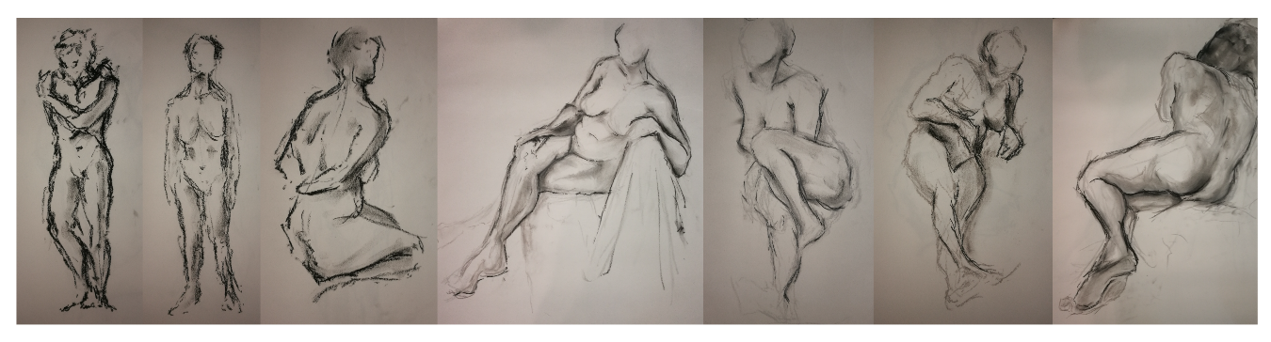
Life drawing sessions provided valuable insight into form and pose. Time-limited exercises forced rapid assessment and application of lines through the figure. While these are static poses, an appreciation can be gleaned for the weight, centre of gravity and the underlying structures of the body.

These exercises would all prove useful when building key-poses and creating convincing movement.

Sequence One - Goosebumps
This sequence is intended to present a character reacting to the feeling of a presence approaching from behind.  To set the scene, our protagonist is engrossed in his studies. The intention here is twofold;  - To create a feeling of anticipation and  - To serve as a contrast to the action that follows  Moving from a relaxed pose, the character’s demeanour turns as he feels the presence. Sitting bolt upright, he freezes, his actions |  |  | 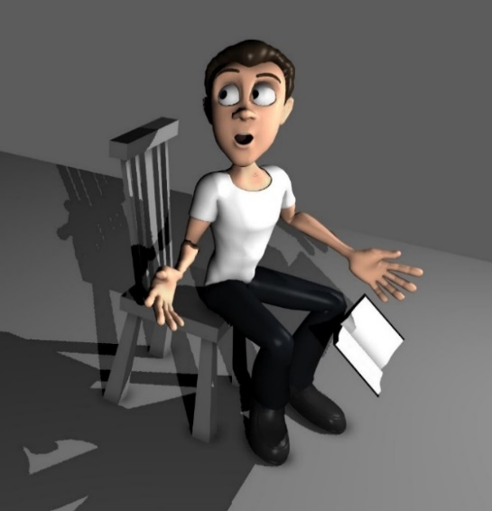
becoming twitchy and eyes darting. Akin to a child drawing up a blanket for protection, he hides quivering behind his book.
Timing was crucial here. There are contrasts between where the character is settled, brief moments where he is frozen and then an explosion of panic. These accents (O' Connor, 2018) in acting and animation combine to produce a convincing and interesting animation.

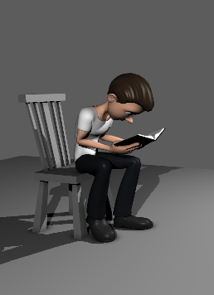 | 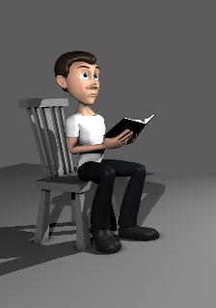 | 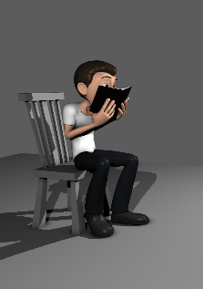 |  | 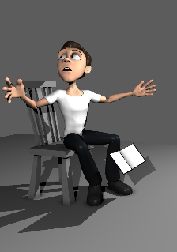 | 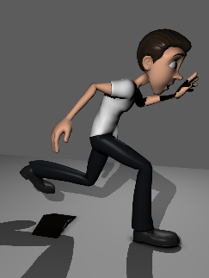
Critique

There are several problem areas in this sequence ranging from conception to execution.

The basic premise, in this restricted form, works well enough but the actions of the character may appear ambiguous throughout, especially in the moments he is hiding behind his book. A shivering, shuddering motion assists and the addition of sound also proved to be a boon in this respect.
The timing of the run is problematic. Leaping from the chair into great strides is one solution but more exploration could have resulted in a different approach. The time-limited format of these animations was also a factor here.

Sequence Two – Slapstick #1
Slapstick is a visual artform. It is a performance that takes circumstance, jeopardy, mishap and even violence, condensing them into an exaggeration of reality for comedic effect.  It can toy with the audience’s expectations. The viewer can be pre-warned, the fate of protagonist telegraphed well in advance. It can also carry them along with the character and amuse with shock and surprise. | 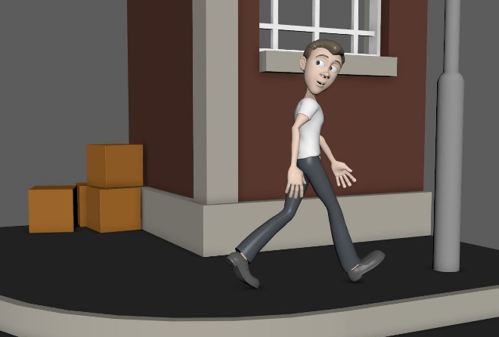
This sequence takes broad influences from early slapstick stars (such as Buster Keaton and Harold Lloyd) and the cartoon schadenfreude of Chuck Jones. The audience is invited to laugh at the misfortune of the protagonist.

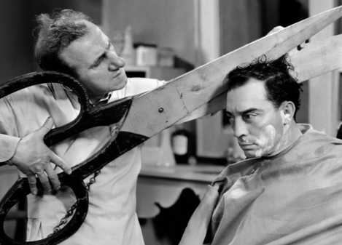 | 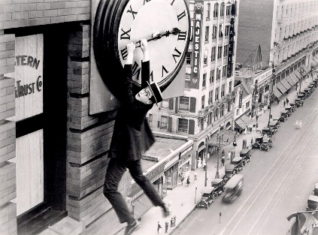 | 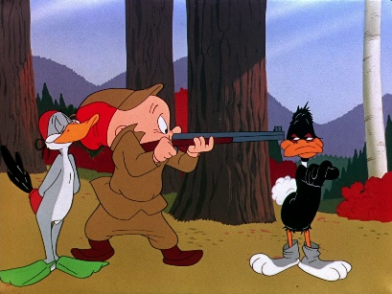
Buster Keaton (What-No Beer, 1933) | Harold Lloyd (Safety Last! 1923) | (Rabbit Fire, 1951)

There is a small story arc of caution, relief, confidence and downfall. While the audience may suspect his fate in plenty of time, the character becomes aware of the impending impact only a fraction of a second before it happens.

He emerges gingerly from his hiding place before shuffling to a confident flick and turn. Hitting the lamp-post without breaking stride, the force of the impact is exaggerated, his limbs are thrown into the air in extreme, cartoon-like, key poses.

There are points in the animation that require the use of both inverse and forward kinematics (IK and FK).  Where the hands appear fixed to an object, IK was used. Movement of the hands and arms was dependent on wrist and elbow IK constraints.  Blending this fixed IK to a dynamic FK movement proved challenging but effective. | 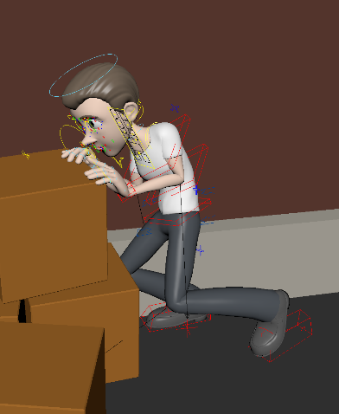 | 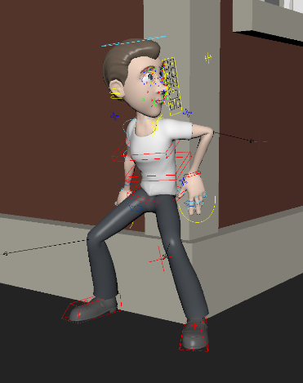

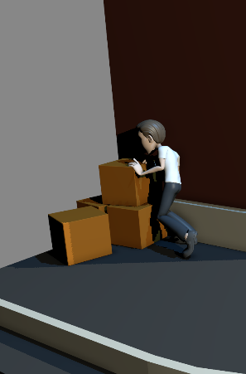 | 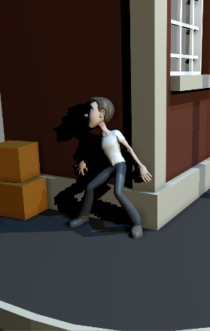 | 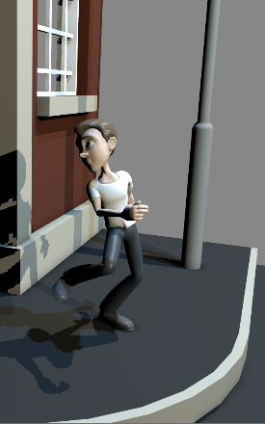 | 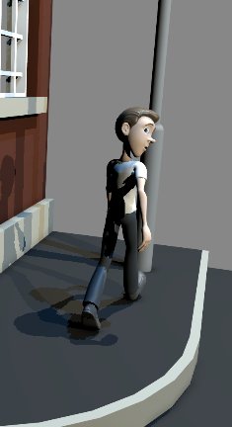 | 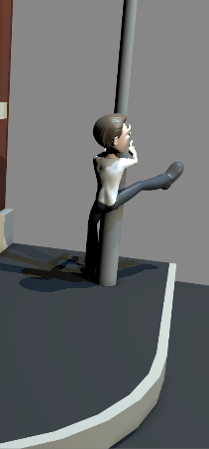

Critique

The character’s stumble as he stands from his hiding position works well enough. The crabbing, sideways movement also adds some appeal. There is a small shuffle before the character turns with a confident look back.
The timing of the turn is unsure. This proved difficult to achieve convincingly. Again, the use of sound assists in conveying impact and comedic effect as the character hits the lamp-post.
Sequence Three – A Star is Born
Concentrating on portraying feeling through poses and facial expression.  Based on an excerpt from the song Overjoyed (Bastille, 2012), the character is singing his heart out. The lyrics and delivery combine in a bitter-sweet performance which is reflected in the character’s movement and expression.  The final rendering presents the character in a strong spotlight.  While appearing the simplest task in terms of whole-body movement, the emphasis here is on delivery of a heartfelt performance and a subtle, yet strong lip-sync. |  | 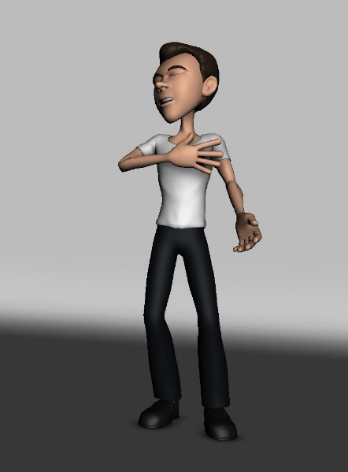
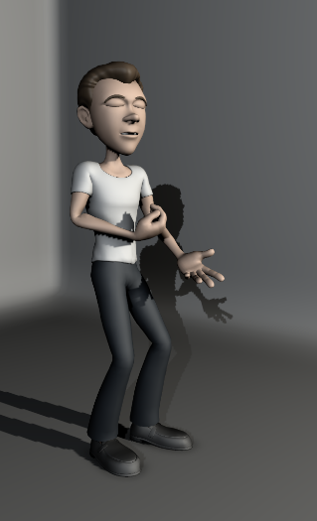 | 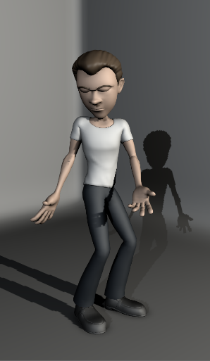 | 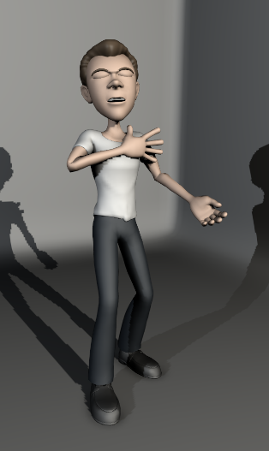 | 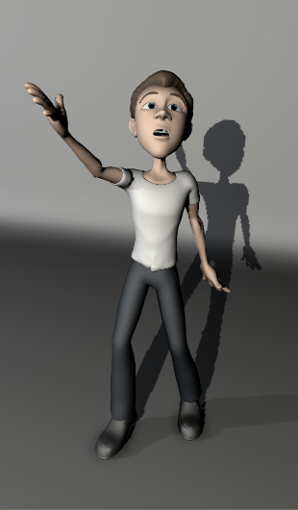
Critique

There could be more effective staging in this sequence. The character’s movement provides a convincing performance but the lighting (relying on a spotlight and point fill) is not as dramatic as the subject demands. This is, in part, due to the need to present the whole character in shot for assessment.
The animation as a whole could be more dynamic. There was a balance to be found between taking poses to extremes and faithfully portraying the mood of the performance.

Sequence Four – Slapstick #2
The second slapstick sequence takes direct influence from a Buster Keaton sketch (The Bell Boy, 1918). Without bangs, knocks and banana skins, this is not overtly slapstick but still an example of physical comedy. A routine much imitated by mime artists, the character is seen to be cleaning a window only to break the illusion by passing through the imaginary pane (plane?).

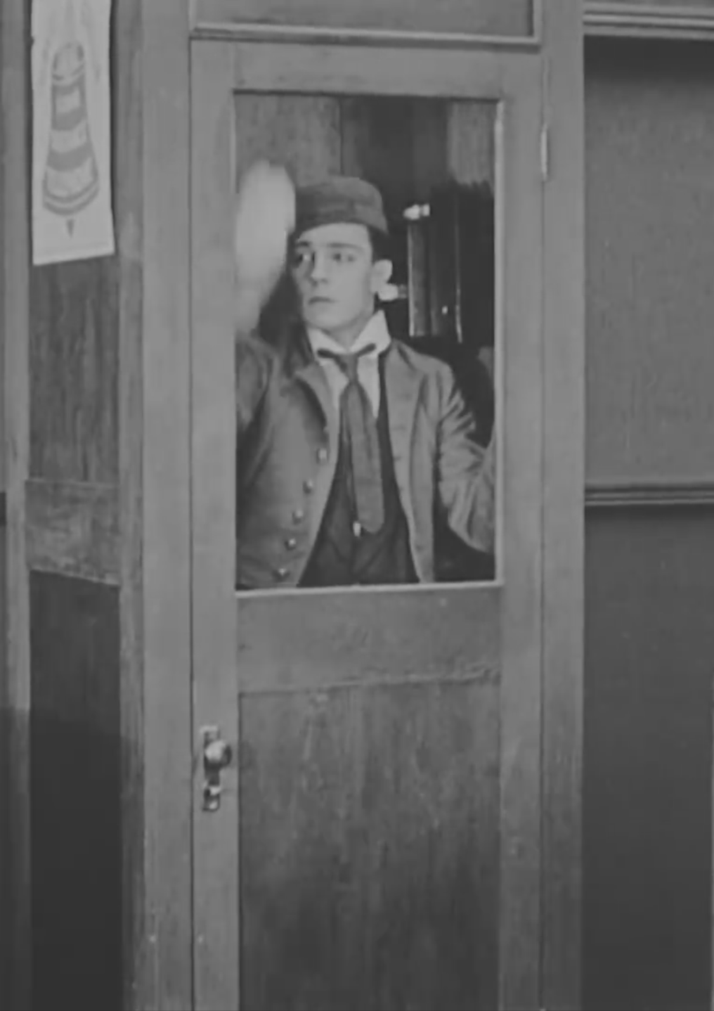 | 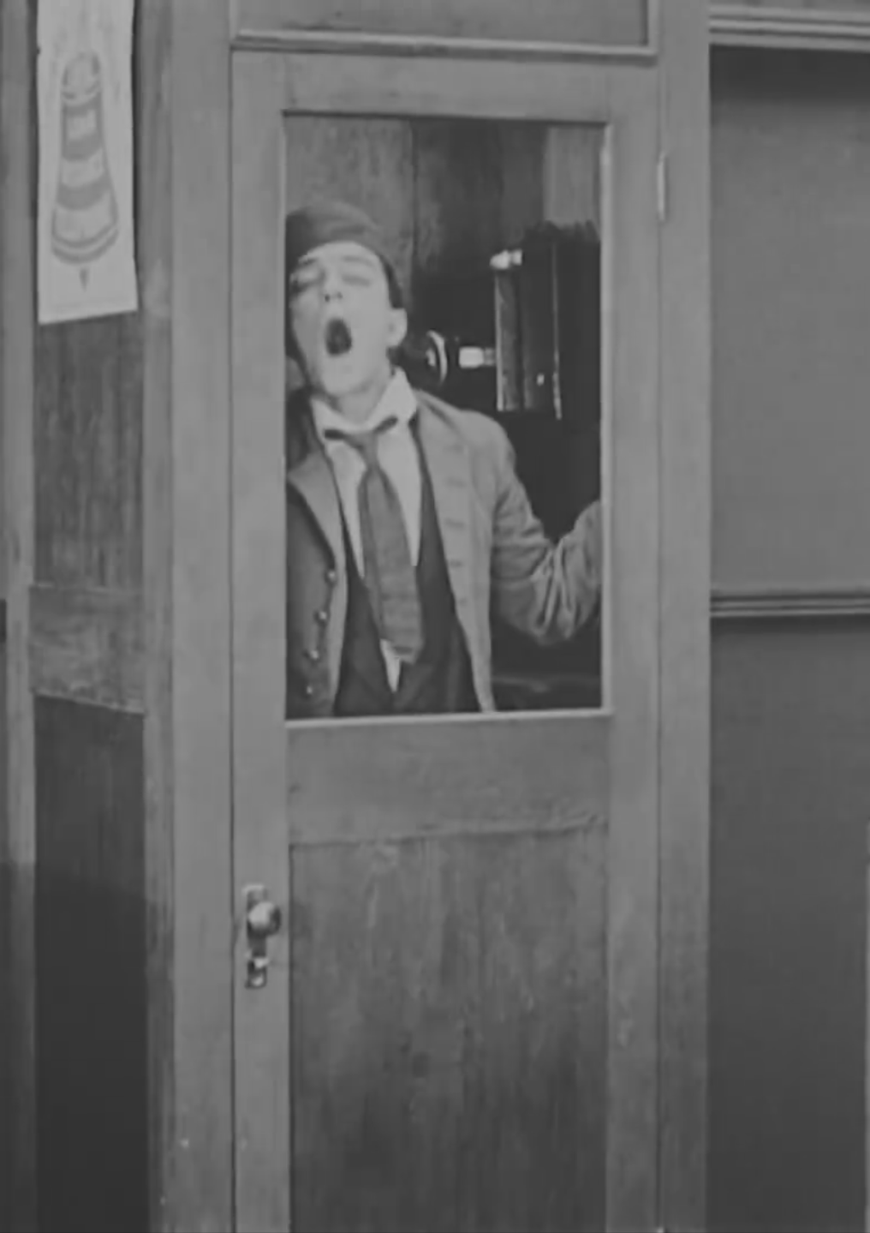 |  | 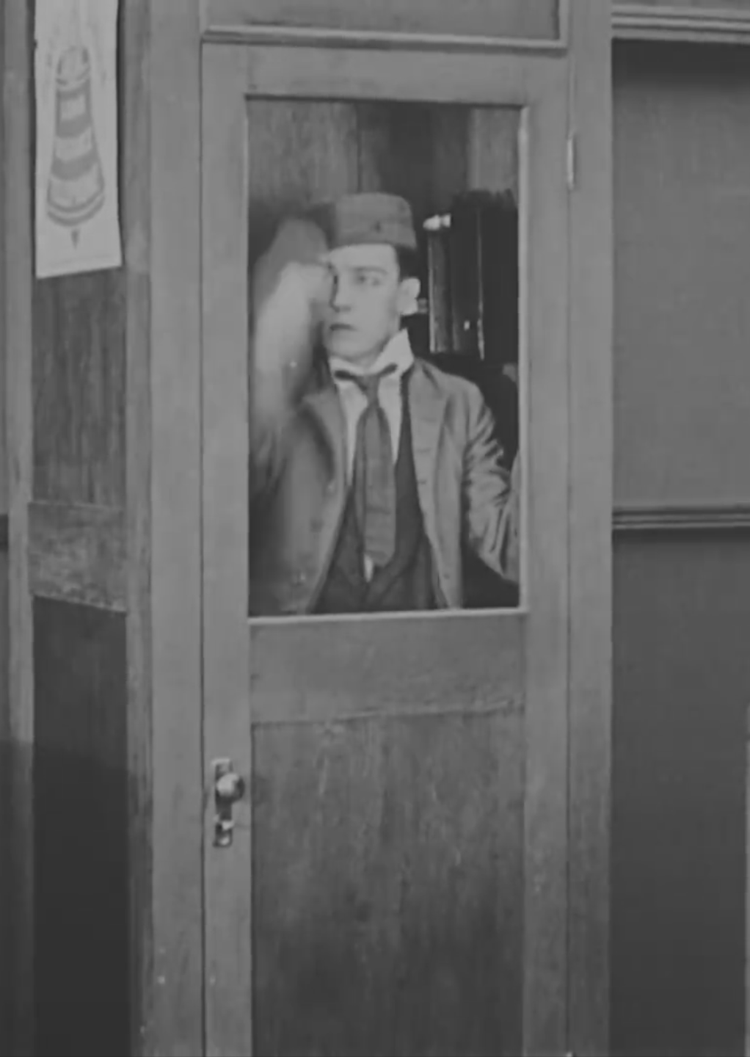 |  |  | 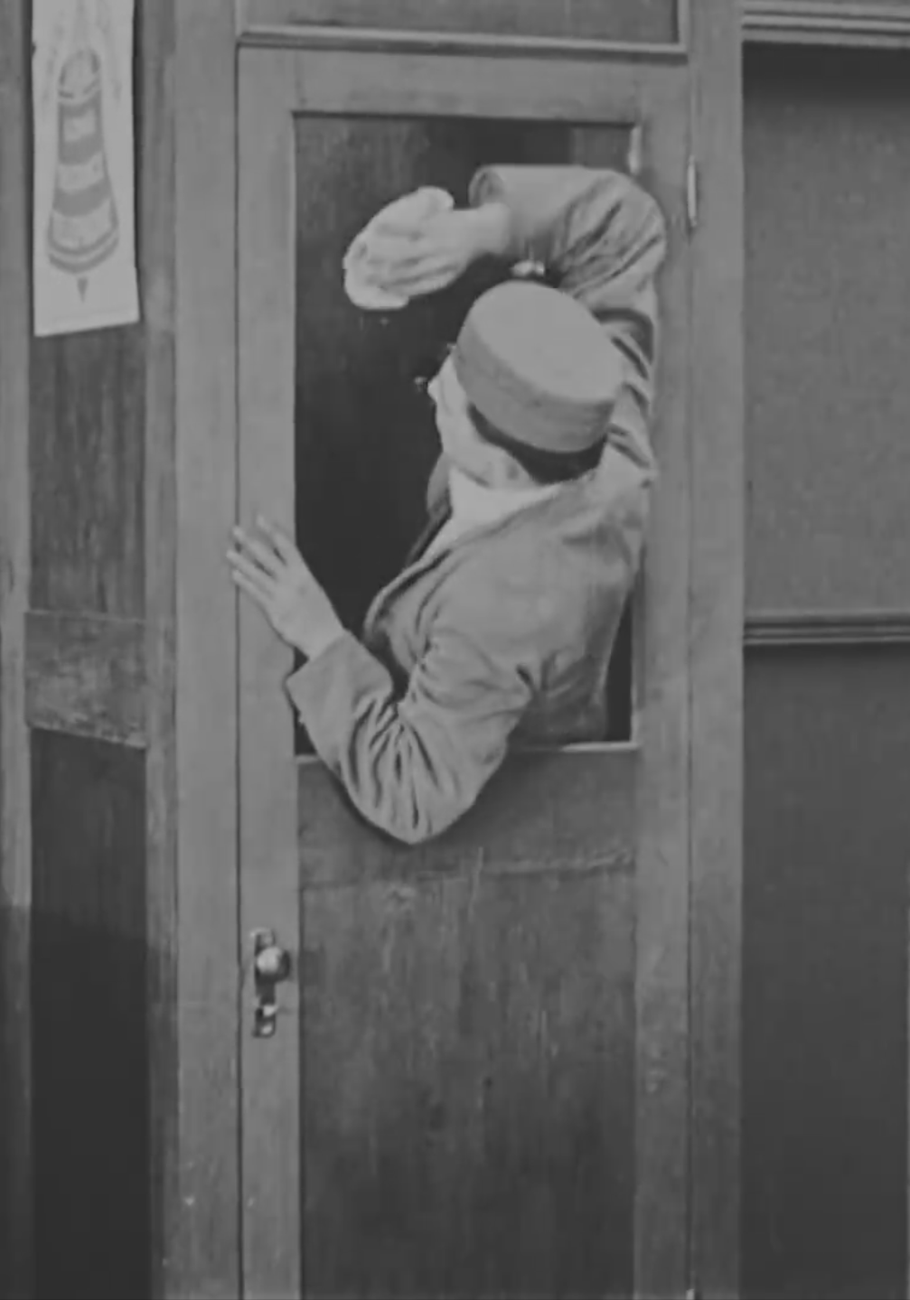
The Bell Boy (1918)
Keaton’s mime is utterly convincing until, choosing his moment, he lets the audience in on his joke. The real punchline is delivered in the reinstatement of the illusion as he continues to polish the glass from the outside.

The illusion of an invisible barrier could be achieved using inverse kinematics to restrict the moving hand to the plane. This approach would also allow for the rest of the character’s body to display anticipation and follow-through without breaking the illusion until the intended moment.

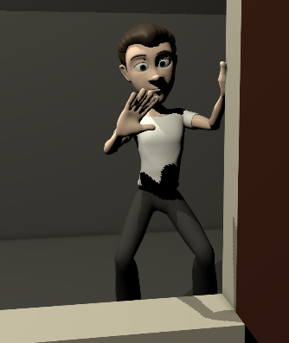 |  | 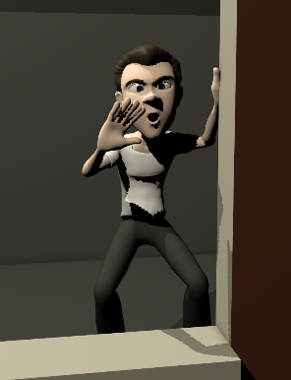 |  |  | 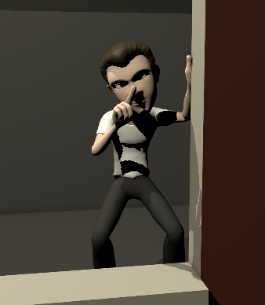 | 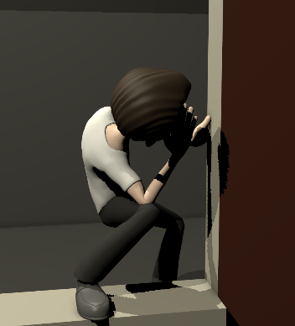
As it is only the character’s movement that can convince the audience that there is a pane of glass between them and the character, the use and abuse of overshoot and follow through (O’Connor, 2008) could also assist in the illusion. Where the viewers’ expectation would be for momentum to carry the hand, it is stopped against the invisible barrier.
The final part of the visual trickery is in the character’s eyeline. He is intently focussed on his work. Not his hand, but the surface that is beneath it.

In the final sequence, sound has been added to reinforce the visual effect.
Critique  The most problematic area proved to be in the posing of the turnaround. Several versions of the pose and transition were explored before finding a believable solution.  Where full control of the character’s movement may make this illusion, the static hand, easier to achieve, the CG character lacks Keaton’s |  |  |  | 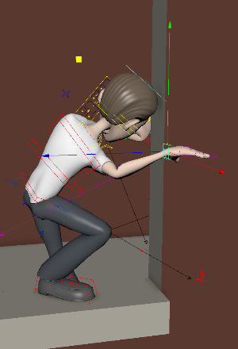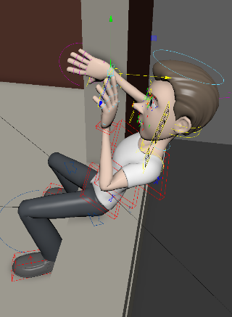
awareness of space and the real-life performer’s ability to feel the world around them. In animating, the simple acts of stepping up, leaning and turning a gap become a process of fine tuning minutae. A swift, natural movement can easily become bogged down and turgid, overworked.
In this respect, the sequence is reasonably effective but the knee and foot movement especially could benefit from a greater degree of reference and observation.

Sequence Five – Bushido
After the day’s tribulations, our protagonist has taken a stiff drink to calm his nerves. Pausing to rest, he spots a figure in red approaching. He attempts to straighten himself and challenge his assailant.

Requiring a convincing, drunken performance, references first looked towards Edmondson’s Eddie Hitler (Bottom, 1995) and Aykroyd’s Louis Winthorpe III (Trading Places, 1983). Both performances are exaggerated for comedic effect and display some well-trodden techniques.

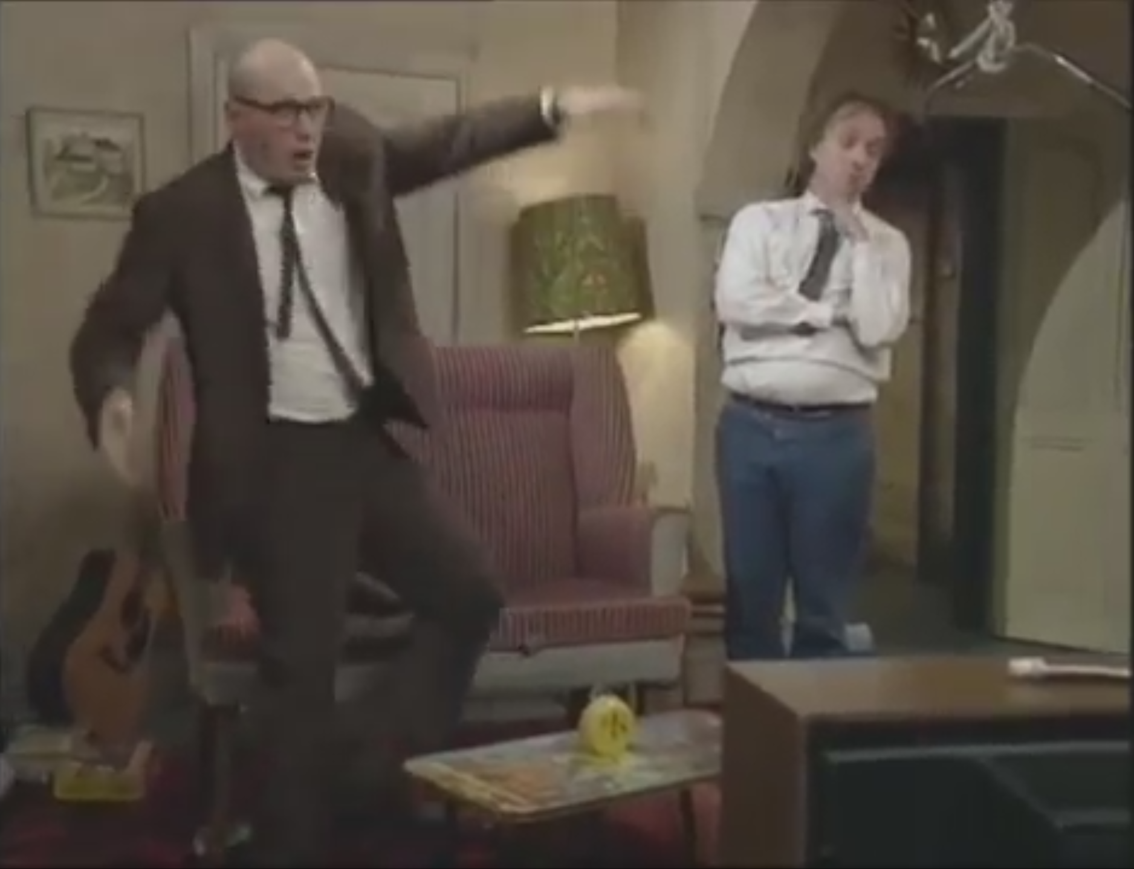 |  | 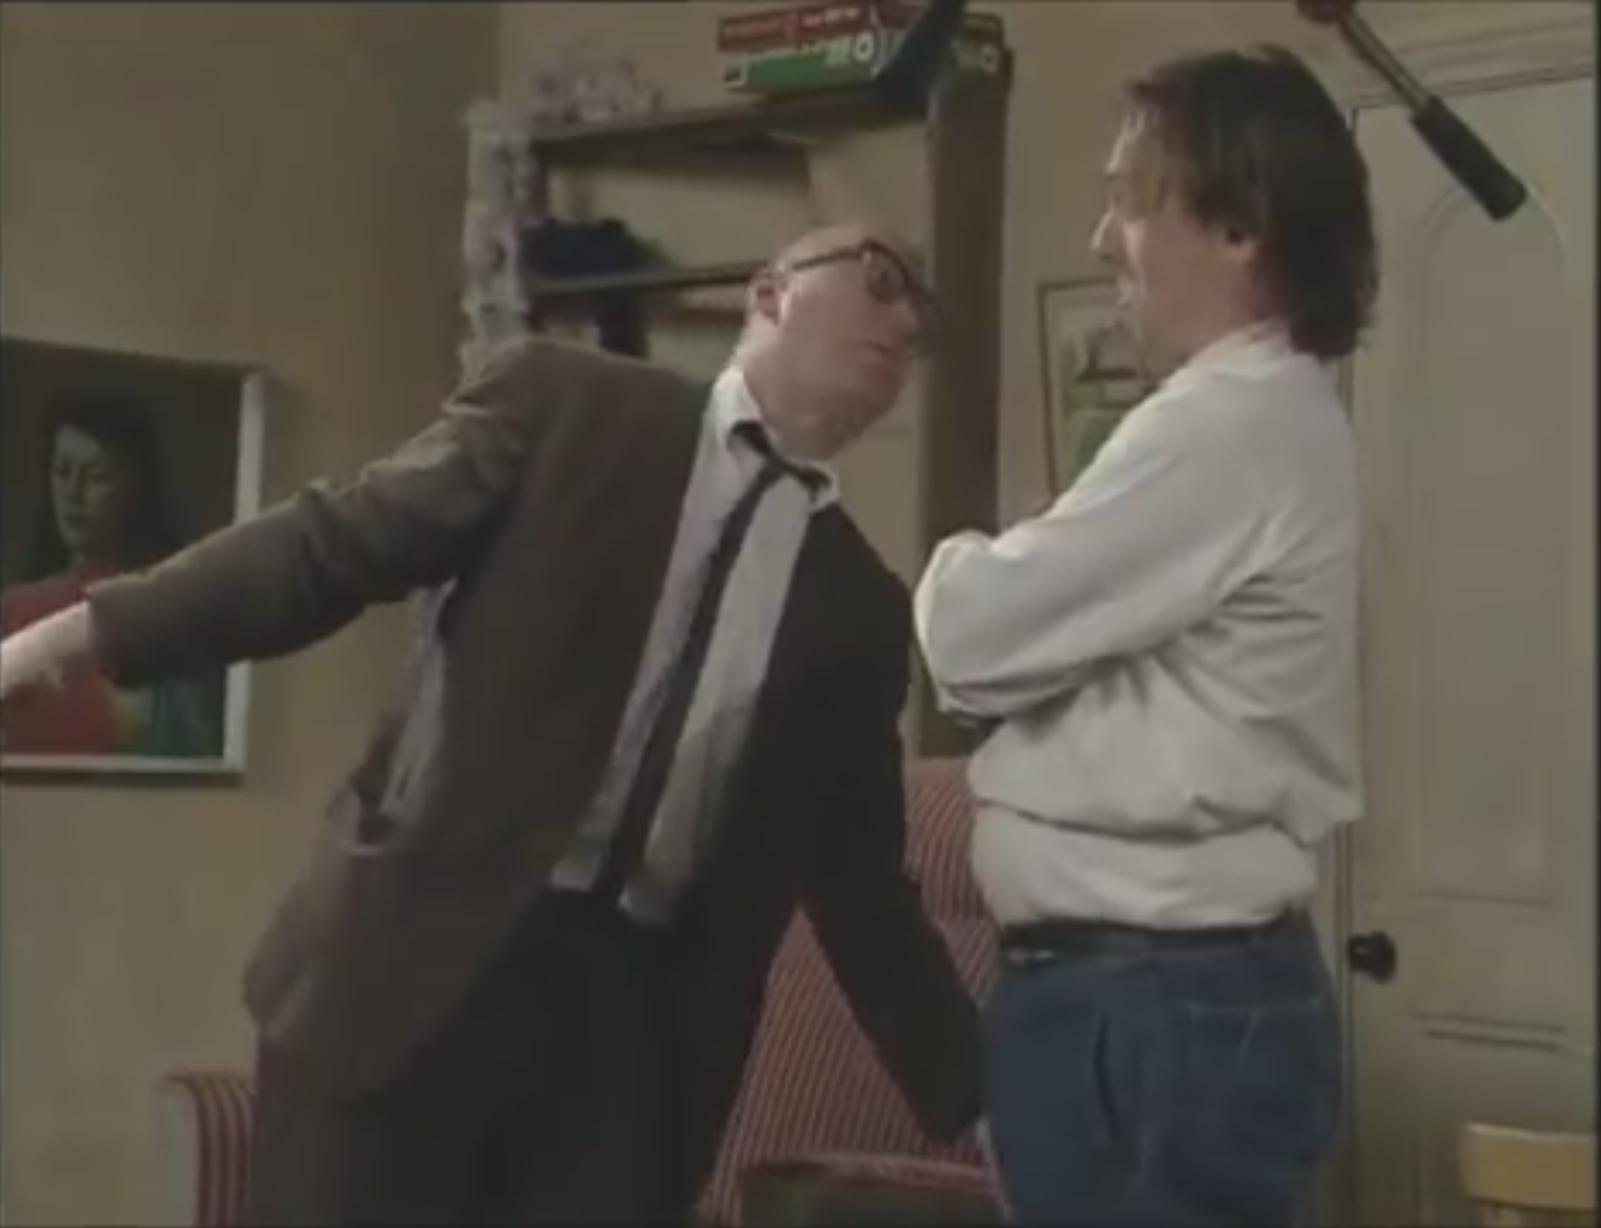 |  | 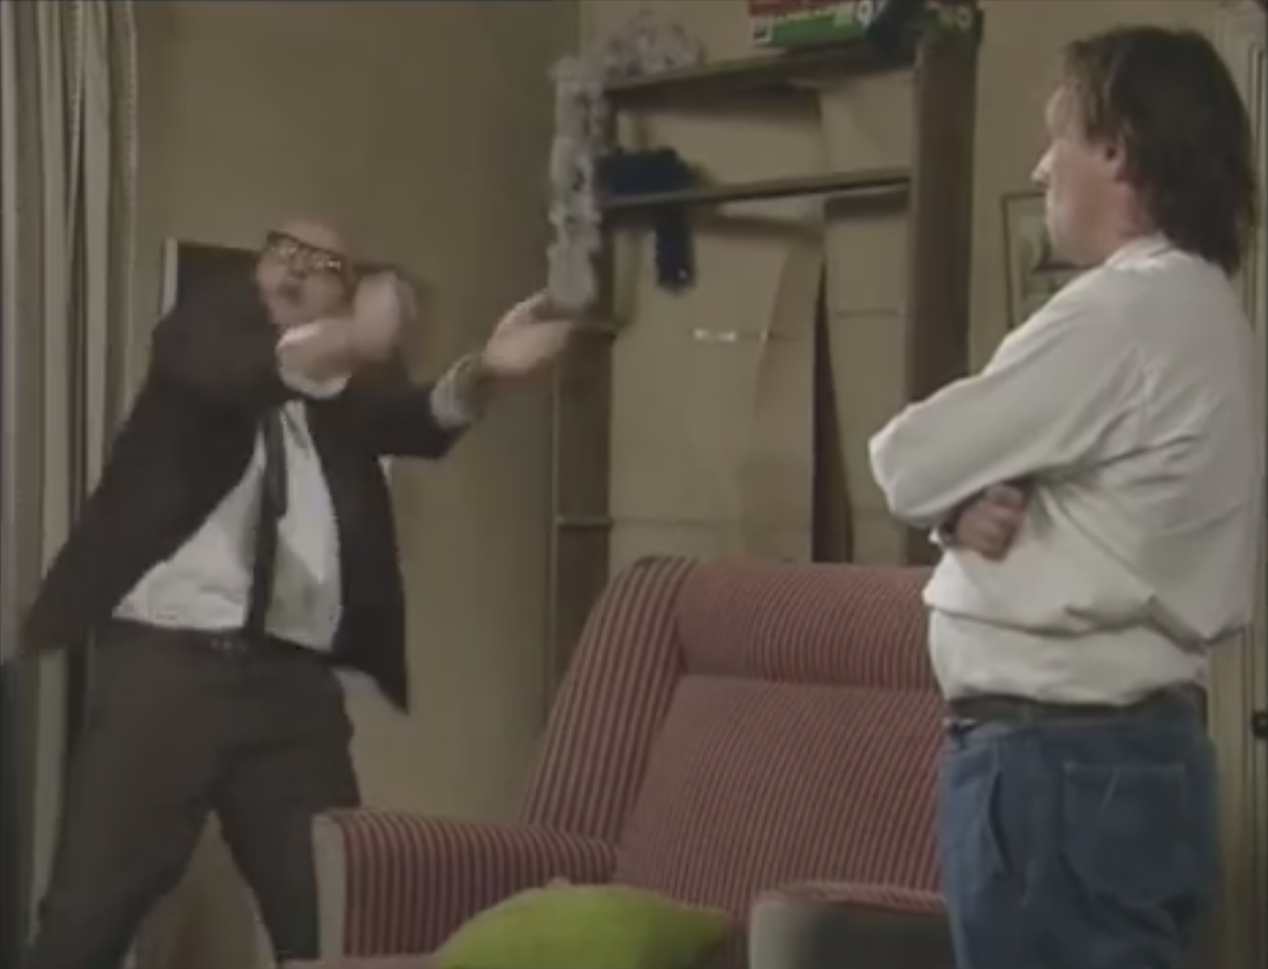
(Bottom, 1995)
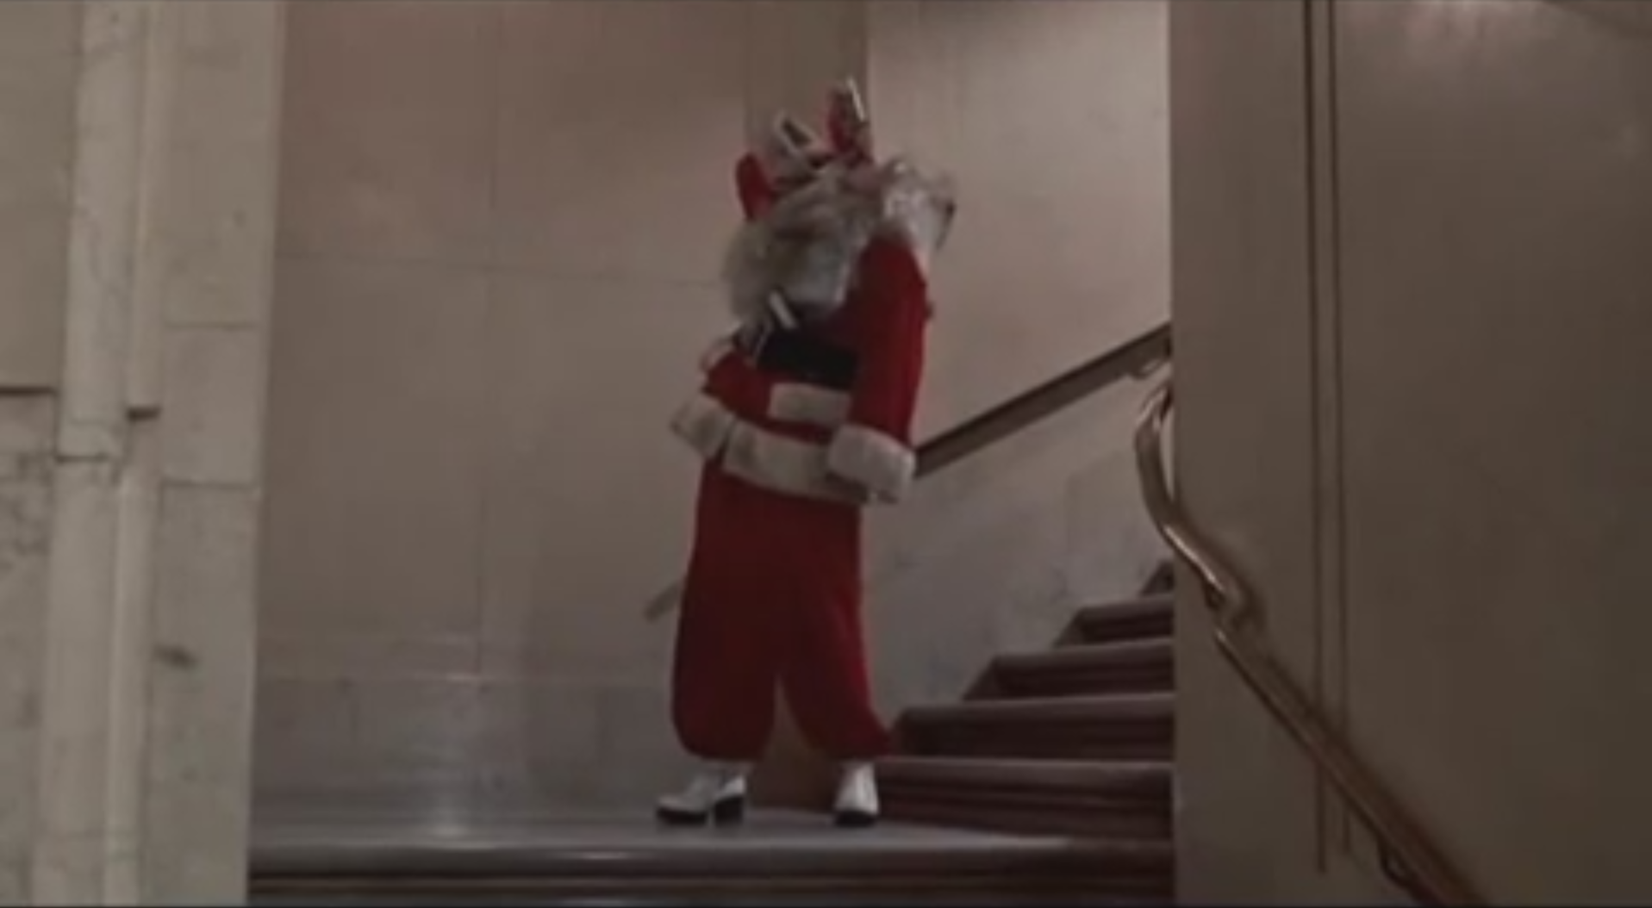 |  | 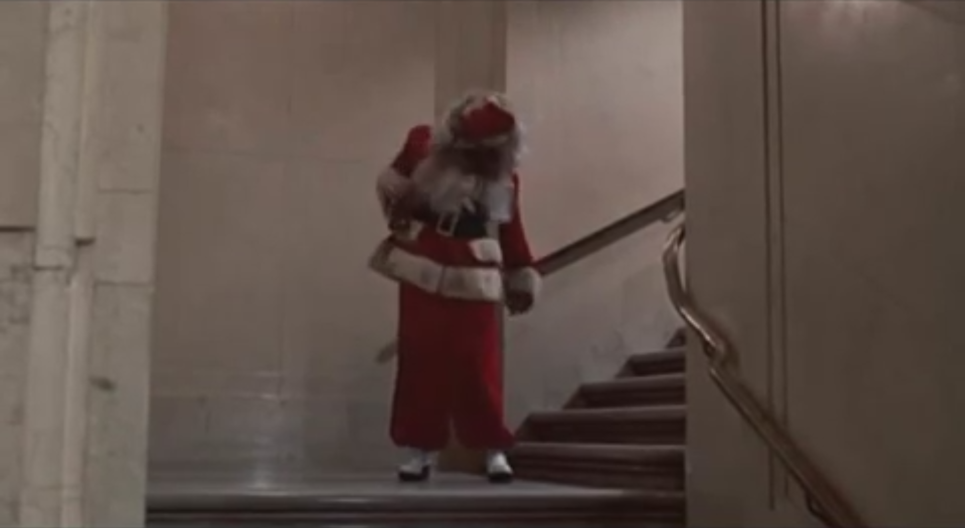 |  | 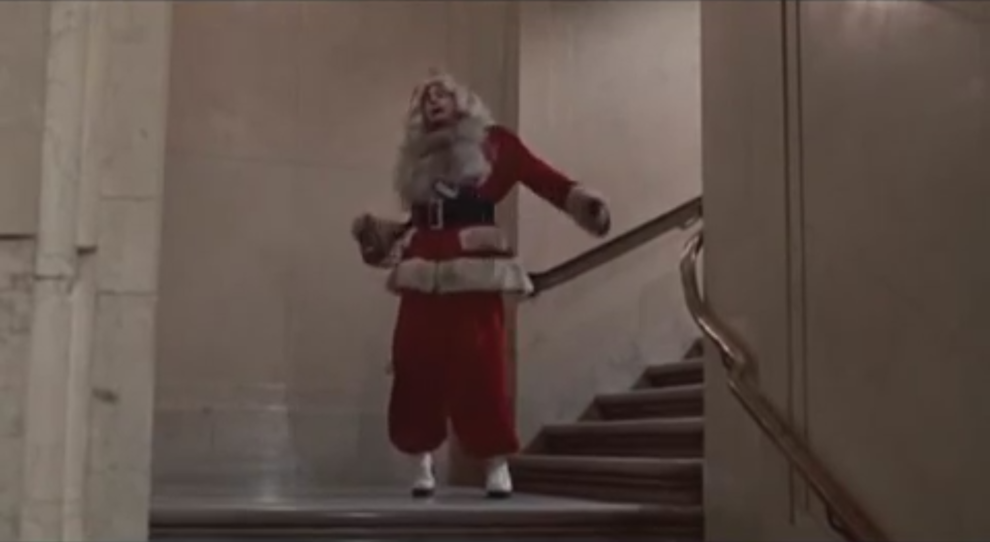
(Trading Places, 1983)
While Edmondson’s performance is more dynamic, much more exaggerated, common traits can be seen:
- Centre of gravity – Always off balance, there is almost constant movement in the effort to remain upright
- Elasticity – This movement imbues a rubber-like quality to the character where limbs appear to bend awkwardly, fluidly at times, jerking at others
- Lack of coordination – An apparent lack of control and spatial awareness
- Leading actions – The head appears to have more mass and therefore momentum/ follow-through (O' Connor, 2018)
- Unpredictability – These factors combine in varying measures to produce movement differing in speed and direction, both staccato and glissando.

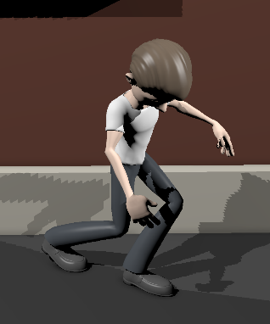 | 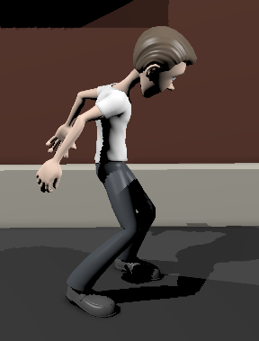 |  | 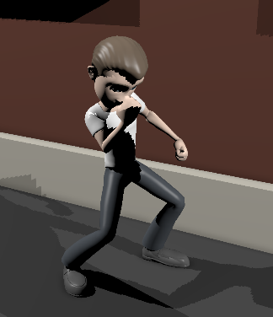 |  | 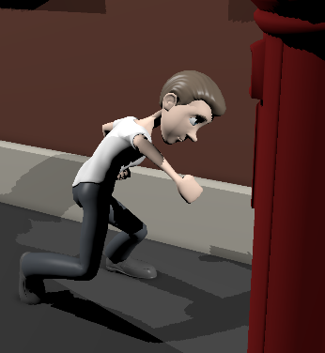
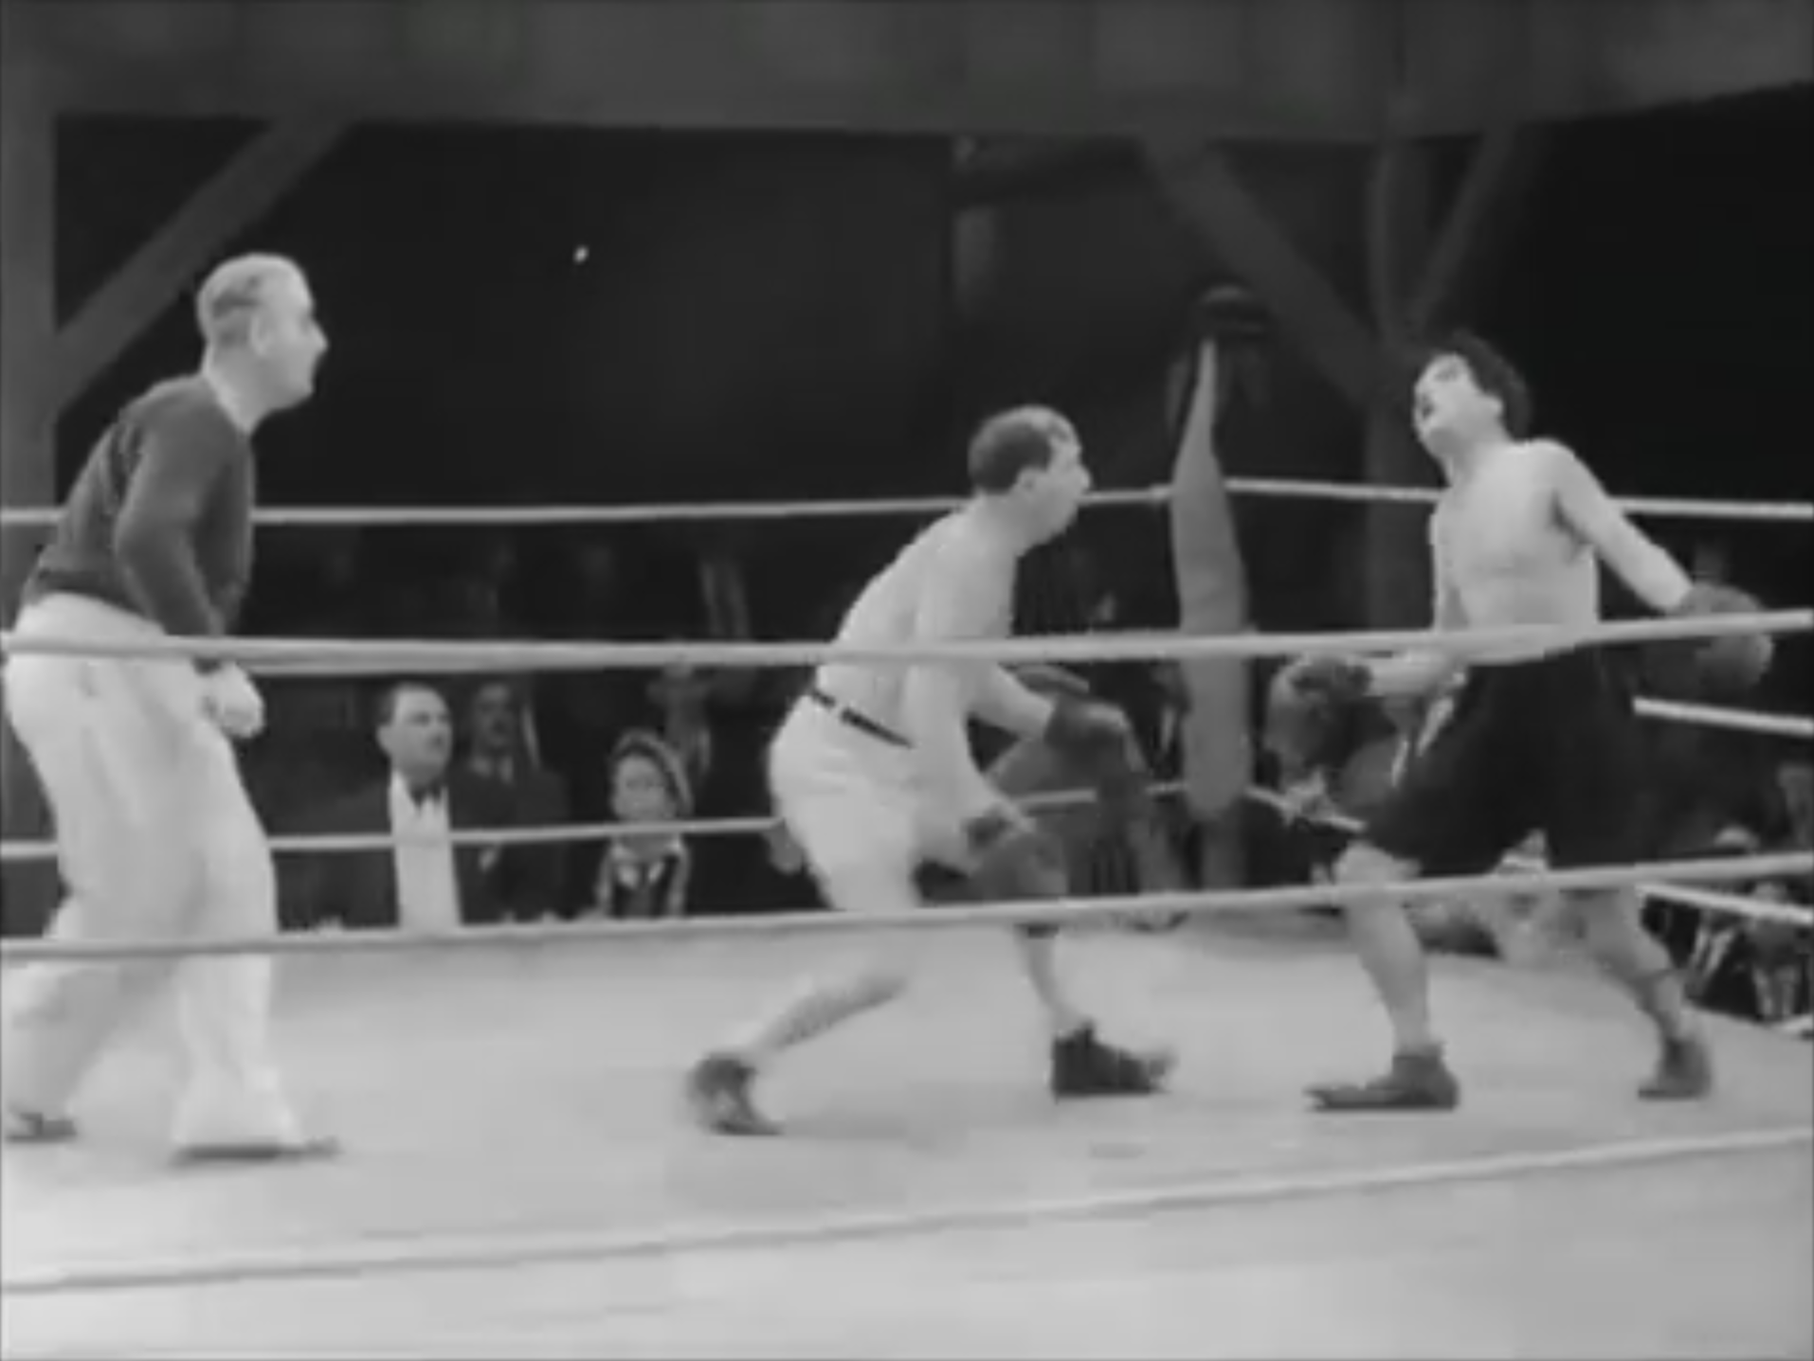 |  | 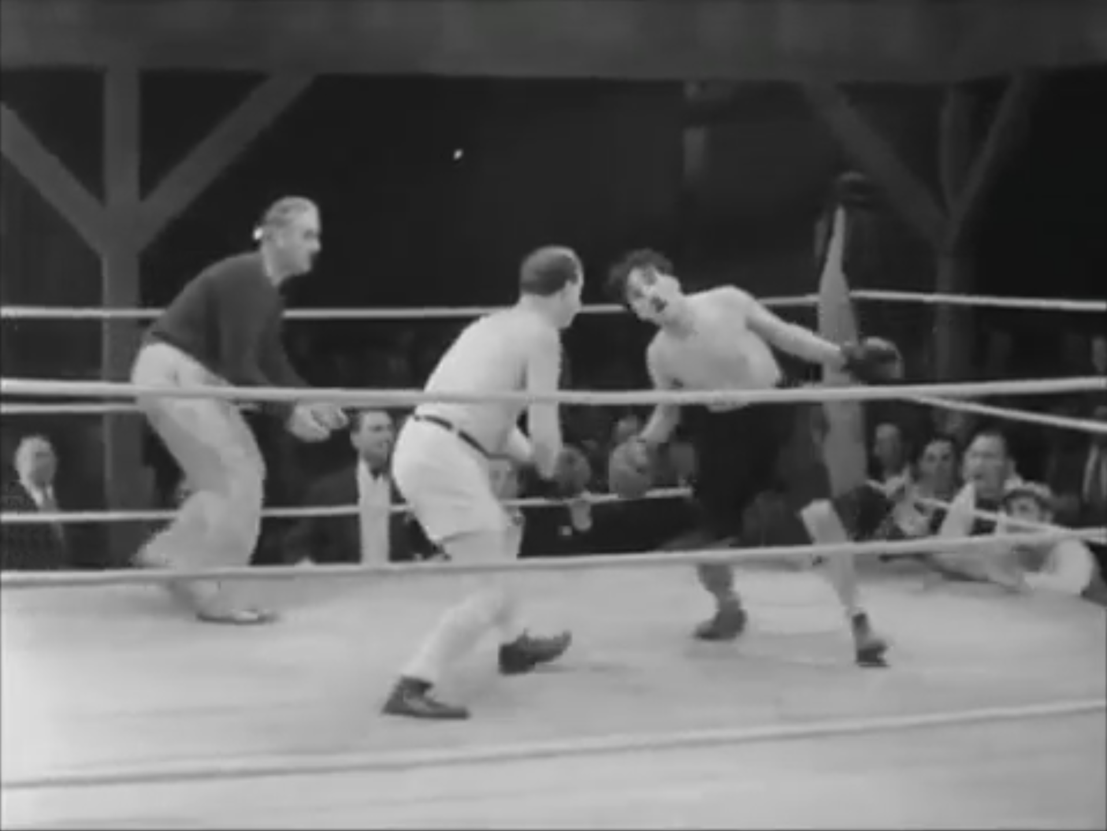 |  | 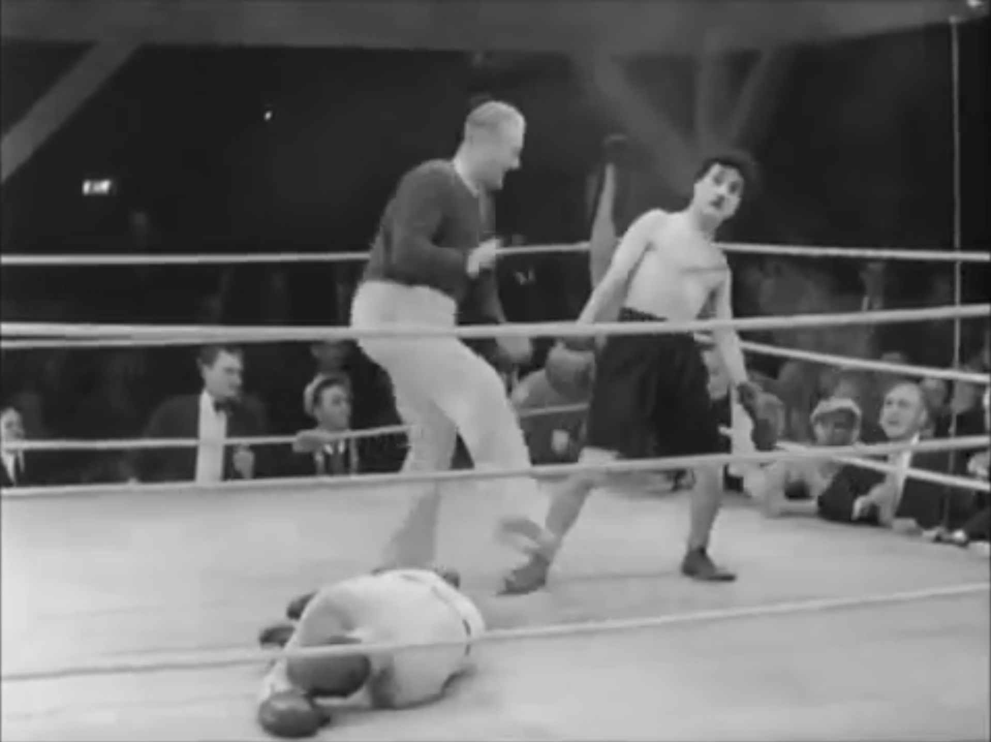
(City Lights, 1931)
Critique

Timing, as ever, remains an issue. The larger, wobbling, drunken movements are quite effective but micro movements (small steps or staggers with opposing action) could enhance the animation.
The punch and fall movements suffer from less convincing weight and momentum. Where they may be close to the stylised movements of the sequence as a whole, they don’t quite maintain the timing, anticipation and follow through that could really deliver the performance.

Rendering, Compilation and Presentation
The resulting animations were rendered in Arnold. Raytracing and sample values were kept low to produce a clean image, free of noise, that would render quickly and efficiently.
Many of the materials used in the ready-made rig displayed inappropriate specular levels. These were modified in Maya’s Hypershade to reduce the apparent glossiness.

Lighting rigs were set up to produce effective illumination, interesting shadows and suggest time of day. It was also important for the character to remain readable for assessment purposes.

Rendered sequences were then imported into Adobe Premiere where sound was added. A selection of effects has been used (freesound.org, 2009) and a gypsy jazz soundtrack (Latché Swing, 2008).
The sequences have been presented both as separate shorts and a single, longer compilation.

Conclusion
Although the resulting animated sequences prove quite effective, there are a number of areas that require more work and therefore provide opportunities for learning.

In planning and preparation, the importance of referencing both still and moving images is of utmost importance. More work could have been completed in these areas alongside a more thorough analysis of the shots as they progressed.

Timing remains an issue. This is most apparent in moments requiring faster movement such as running and falling. It may be beneficial to examine these sections in isolation.

Turning a character in motion proved very challenging and may be due to the added complication of introducing another axis of movement. The influences on secondary action are felt to stack multiplicatively, rapidly complicating the process. Learning to methodically breakdown these actions could provide a solution.
With all this said, the process of bringing a static object to life, making the audience believe in the character and forget about the animator, is never going to be simple. This assignment represents another step along the way to understanding the art and techniques of this process.

Reference
animation-studios. (2019). Advanced Skeleton Character rigs | Animation Studios. [online] Available at: https://www.animationstudios.com.au/character-rigs [Accessed 26 Apr. 2019].
Bastille (2012). Overjoyed. Virgin.
Bottom, (1995). [TV programme] BBC.
City Lights. (1931). [film] Directed by C. Chaplin. United Artists.
Courses.lumenlearning.com. (2019). Types of Synovial Joints | Biology for Majors II. [online] Available at: https://courses.lumenlearning.com/wm-biology2/chapter/types-of-synovial-joints/ [Accessed 26 Apr. 2019].
Freesound.org. (2019). Freesound - Freesound. [online] Available at: https://freesound.org/ [Accessed 2 May 2019].
Latché Swing (2008). Hungaria. [Online] Free Music Archive. Available at: http://freemusicarchive.org/music/Latch_Swing/demo_2008/Hungaria [Accessed 2 May 2019].
Johnston, O. and Thomas, F. (1981). The Illusion of Life. New York: Disney Editions.
O' Connor, D. (2018). 21 foundations of animation. [online] Angryanimator.com. Available at: http://www.angryanimator.com/word/2018/04/23/21-foundations-of-animation/ [Accessed 28 Apr. 2019].
Peck, S. (1982). Atlas of human anatomy for the artist. Oxford: Oxford University Press.
Rabbit Fire. (1951). [film] Directed by C. Jones. Warner Bros.
Safety Last!. (1923). [film] Directed by F. Newmeyer. Pathe Comedy.
Simblet, S. and Davis, J. (2001). Anatomy for the artist. London: Dorling Kindersley.
The Bell Boy. (1918). [film] Directed by R. Arbuckle. Paramount.
Trading Places. (1983). [film] Directed by J. Landis. Paramount.
What-No Beer?. (1933). [film] Directed by E. Sedgwick. MGM.

Bibliography
Aubrey Daniels International. (2019). Behavior Watch: Spooked. [online] Available at: https://www.aubreydaniels.com/institute/behavior-watch/spooked [Accessed 26 Apr. 2019].
Blair, P. (2007). Cartoon animation. Laguna Hills, Calif.: Walter Foster.
Kundert-Gibbs, J. and Kundert-Gibbs, K. (2009). Action!. Indianapolis, Ind.: Wiley Pub.
Lewton Bus. (2019). Tobe Hooper Gutted Film with THE TEXAS CHAINSAW MASSACRE. [online] Available at: https://lewtonbus.net/in-memoriam/tobe-hooper/ [Accessed 26 Apr. 2019].
Muybridge, E. (1955). Human Figure in Motion. Massachusetts: Dover Publications.
Osipa, J. (2010). Stop staring. Indianapolis, Ind.: Sybex.
Roberts, S. (2004). Character animation in 3D. Oxford: Focal.
Webster, C. (2005). Animation - The Mechanics of Motion. Amsterdam: Elsevier.
Whitaker, H. and Halas, J. (1997). Timing for animation. Oxford: Focal Pr.
Williams, R. (2001). The animator's survival kit. London: Faber and Faber.

Appendix
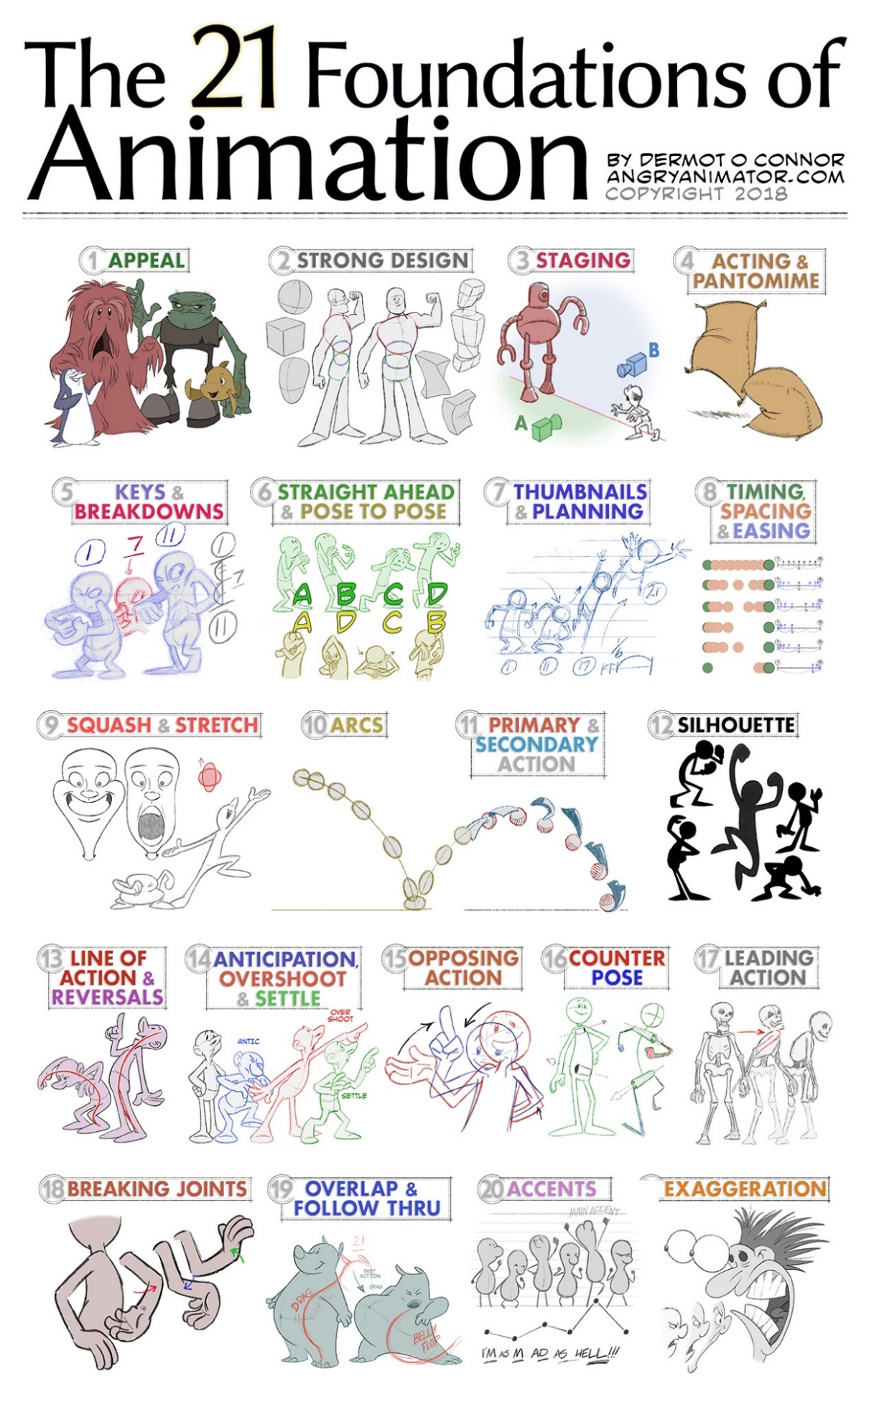

(O' Connor, 2018)

