Wendy Barrier 2019211

Leading and implementing workplace change

BMSW6103

Dennis Pepple

Table of content

- Introduction. Page2

- Power and culture. Pages 3 and 4

- Workplace conflict. Pages 4 – 9

- Conflict resolution. Pages 9 – 12

- Conclusion. Page 12

- Reference list. Page 13

- Introduction
This report will be looking at power and culture and their effects on workplace conflict. Discussing two change models Lewin’s and the NHS Model the report looks at how the models would work in the situation of the national health services conflict. As the NHS falls deeper into failing statistics and staff fighting for better working conditions, higher wage and more staff, can these models help to make the changes needed for the staff to return to work and the NHS to survive the conflict. This report then moves on to culture and how it affects conflict, it looks at Ting Toomey’s face theory and Kilmann and Thomas’s five strategies to handle conflict. Do these models work in the case of the NHS and can these, models be applied. The NHS has been declining for some time and with obstacles such as covid nineteen and the cost-of-living crisis the NHS has had better times. Using various models for change and for conflict resolution can the NHS thrive again or is privatisation the answer. The report looks at how if at all the conflict in the national health service can be resolved.

- Power and Culture

What is power? Robert Dahl suggest that power is simply a way to control someone’s behaviour. If someone has power over, you they can then get you to do whatever they would want. There are many more similar theories such as Max Weber and Bertrand Russell. All theories seem to agree that power is a way of ensuring the end results are achieved by enforcing power to control. But surely, we can only do what we are able, so how can power get the desired results if the person does not have the skill set to complete the desired result. Talcott Parson says that we can only achieve the result if power is used as an agreement to bring the changes to complete the desired result. Nicos Poutantaz prefers to say that the power is a mechanism to bring about the change (Luke’s, 1986). Over the years there have been various models collated, some say there are five types of power others say seven and some say eight. Looking at what all off the models have in common are four aspects, reward, expert, referent and coercive.
Reward, offering rewards to employees will often encourage them to work smarter. Expert is gaining power because you have the knowledge and experience to gain admiration from your staff. Referent will gain you power by being honest and integral. The fourth coercive this gains power by threat, making employee’s work harder by threatening their wage or job security. This last one is possibly the most common but is advised against (Eatough, no date).
What is culture? Culture is simply our way of life. Our religion, the food we eat, the clothes we wear, our music, our language and so much more. We make our choices in life with our culture at the forefront. Many countries have different cultures, France, consider their country to be rich in culture with their traditions, music, art and food drawing many visitors from other countries to France (Pappas and Mckelvie 2022). Throughout your lifetime you acquire pieces of culture, and these contribute to your individual personal growth. In fact, the actual word culture comes from the Latin “colere” which means “to cultivate”.
Power in organisations
When it comes to power it is an essential part of the business world and the structure of any company would be less likely to succeed without some form of control. When gaining control at an organisation power is extremely important. For example, the power of a wage makes the individual come to work. The power of promotion will encourage some people to work harder. They are other ways to encourage good attendance and performance, Asda offer a bonus scheme where you lose some of the bonus if your attendance to work is low, Hayley Tatum, Asda’s People Director, said: “This pay-out is only possible thanks to the continued hard work and dedication of our store colleagues. They did a fantastic job serving millions of customers last year, often in challenging circumstances due to the pandemic, and their bonuses are well deserved” (Tatum, no date). Other companies in particular retail offer a gift if a customer takes the time to compliment your service. However, in different cultures the importance of structure that will help gain power over the employee can be very different. for instance, a woman of an older age may just be looking to earn a wage until retirement and the power to get to work will be a wage, whereas a younger woman might well be looking to get to the top position in her field of work and will therefore be encouraged by promotion. organisation culture is the practiced method of getting things done. It encompasses the values, practices and procedures of the organisation, and brings the workforce together with the values that bind them as a company (Rebello, 2022). Organisational culture will better succeed if the company know and understand each team members individual cultural background, this will minimise conflict and help the managers and leaders gain power over the individual employee.

- Workplace Conflict
Today has a major conflict happening in the country’s National health service, with long waiting lists, lack of staff, strike action and the covid pandemic still being at large. There are many factors that have caused this breakdown in the system. The NHS once world famous and world envied for the free treatment anyone could receive is now on its knees, battling with the government over lack of pay lack of staff and generally unhappy staff. The NHS has been deteriorating over the last ten years with waiting times rising and patient care needs increasing. Looking at the bigger picture as waiting times are rising so is the need for care, for example urgent care for people with cancer should be 62 days of waiting for a referral, this target has not been met since 2013. However, the amount of people needing urgent care has also risen by almost 50% between 2013 and 2018. The increasing needs are not being met (Gray, 2020). All these factors along with the nurses and ambulance staff considering their wage too low has cause them to take strike action. If the NHS is to survive then changes need to be made, staff need to feel more valued, waiting times need to be met and the population of the UK need to have their faith restored in their beloved NHS. There have been several models of change introduced over the years, looking at Kurt Lewin’s three step model, he suggests unfreezing, make the change then refreeze. The model below does this but, in more detail, the unfreezing is when there is a realization that there needs to be a change and the decision is made to act. In the NHS the realization of the problem must
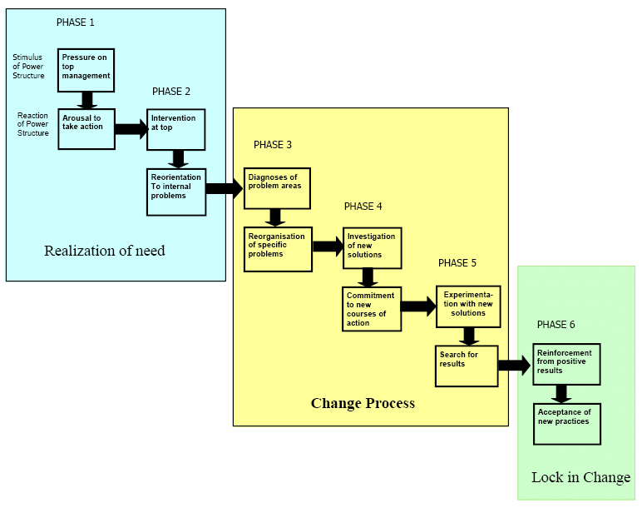 Figure 1 (Kiitam, “et al.” 2016).

have been clear when waiting times were missed and lifesaving operations were put on hold. However, it seems to have taken strike action for the changes to be brought to the forefront of the management view. The NHS need more staff. At present hospital staff are covering unstaffed shifts, staying later than their shifts even doing double shifts. The staff are pretty much exhausted. A recent survey showed that nine out of ten nurses believe that people don’t understand what they actually do, at the beginning of the covid pandemic people saw nurses as heroes and week after week stood in the street and clapped for them. But nurses are expected now to act like heroes giving off a superhuman façade. They are however not as people think, they are actually human and need a work-life balance to be able to function in their job safely. (Nurse.org. no date). The average nurses wage is below the level of inflation and is below the private sector wage. There are an estimated 17,000 nursing posts unfilled on any given day in the UK and one in nine nurses left active service last year (The Nuffield Trust 2022).

In 2012 the NHS change model was developed. The model works on the principle that most leaders favour either intrinsic or extrinsic approach to change. The model works on the strengths that both are necessary for impactable and sustainable change. The model has eight components to be considered when planning and implementing change. The model is for large or small changes. Incorporating free critical elements, large-scale change, change model for health and care and established improvements approaches. Taken together all the elements of the framework can enable the navigation of complex and system changes wide changes.

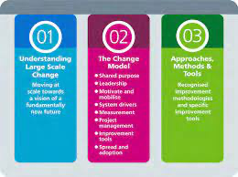
Figure 2 (NHS England).

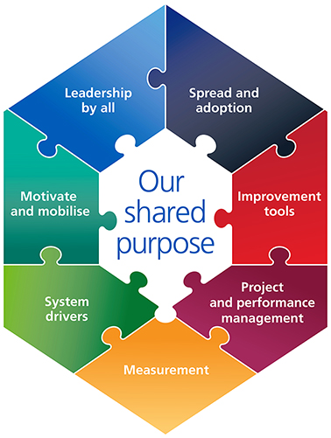
Figure 3 (NHS England).
Looking at each component of the model firstly in the centre is shared purpose, shared purpose is what happens when a Team come together and underline their beliefs or values with a common Challenge Visual goal. It is important to develop a shared purpose before moving on to the rest of the model or the rest of the change project. Spread and adoption is the element of the change model where information is shared and then adopted. In other words, this part of the model is where everybody actively shares what they know with others then the “others” use it. Improvement tools is the use of other models that can be called on to help with the change. An example of this would be the Everett Rogers five-step approach. Knowledge, every think you need to do before you start the change. Persuasion, influence the team on the benefits of the change. Decision, adopt the change. Implementation, put the changes in place. Confirmation, seek reinforcement of the change after it is made. (Sahin, no date). Project on performance management, the creation of clear plans and ongoing reviews with milestones. Measurements, measuring outcomes to ensure the desired result of being achieved. System drivers, when we are changing things, we need to know with the time and the conditions alright. System drivers include personal incentives. the then the next step would be to experiment with the solution. Motivate and mobilise this is about staff and stakeholders engaging and being a part of the change. Leadership by all, this approach is based on the theory of shared leadership and sharing the responsibility through collaboration.
Choose your battles!
When it comes to workplace changes it seems important to know when and which battle you should choose. With the amount of conflict in and around the NHS then it must be a case of selecting which conflict to resolve first. With inflation still heading upwards and the nurses and ambulance staff striking for more pay, even junior doctors are threatening strike action, the need for care is dire. People are actually dying as lifesaving operations are being cancelled. All of the change models that can be used do not supply more money and this is what is needed. The government offers only a percentage of what is being asked for and the staff are still refusing it. It is inevitable that inflation will come down again, as the war in the Ukraine settles down or comes to an end. Fuel prices are set to settle down. The NHS staff are wanting a pay rise that is in line with inflation, but inflation fluctuates and will go down as the country settles down and there is an end to the current crisis. The government have given the lower income population crisis payments so would a one-off payment be an option. The government have stepped in and given people on low incomes several cost-of-living payments, a total of over eight million people, have received payments of over one thousand pounds in all. Should this payment be reserved just for the population on some form of benefit, if the NHS staff were to be given a similar payment scheme to get them through the crisis along with a more affordable pay rise could well be the solution and gat the strikes over and done with. However, the NHS still need to fill the positions that are going unfilled. The need for more staff is clear but this would take a while as nursing is a highly trained job and can’t just be filled by untrained staff. There is a need for training but also a possibility for lesser skilled jobs, for instance they NHS employ domestic staff that clean the wards and make the patients beds. These are untrained in anything medical but are trained in the area they need to be trained. A solution to the lack of nurses maybe to train midway nurses that only do tasks such as monitoring patients and changing dressings. This would free up more qualified nurses to complete more skilled task. If this was a solution agreed on, then the next step would be to experiment with the solution. Find, train and put these staff in place. If successful then the refreeze process would be implemented, or lock in the change. When locking in the change or refreezing this should be done with constant monitoring and evaluation as the changes might only work temporarily and the whole model may need to be reworked at any given time. Unfortunately, the NHS does not need one single solution. With strikes demands for higher pay and working conditions, Kurt Lewin’s model may have to be used on each existing problem. Also, the NHS are not fighting with their managers they are fighting with the government. So, the government must approve any solution that could bring an end to strike action. Whatever the changes are there needs to be a vision that is clear, and everyone is working towards. Gaining the trust of the NHS worker is essential now more than ever as the trust in the system has been lost. Without the trust the staff will not all be working towards the same vision. Amanda Prichard, the chief executive of NHS England presents herself as a very confident leader, she knows what she is talking about when it comes to the NHS, as she has worked for them for twenty-five years, she refers to it as nine thousand days. Her pride in the NHS is clear as she boasts about its achievements. But with all of her confidence and charisma how will she handle the state of today’s NHS. For all its faults the NHS has been admired by many countries and when it came to tackling the covid pandemic it was second to none, even without the correct safety equipment. There have been many models on organisational change, some can be extremely complicated, but the afore mentioned Kurt Lewin’s model appears to be very simple, unfreeze, change, refreeze. But don’t let the simplicity fool you, it is a practical plan that can deal with a complex situation (Levasseur 2001). The support of politicians is a must, if Amanda is to get government backing on pay rises and NHS funding. Having looked at some organisational change models and some solutions, this report can only spectulate on solutions and which change model would work best but what is clear is that Amanda Prichard has a hard job ahead of her and to have the suport of politicans would do nothing if not help her tasks ahead. Its can only be possible for any of the models and solutions to work with a powerful leader that will work on a solution whilst understanding and taking care of there teams needs. Kurt Lewins model does not include the evaluation of the change after the refreeze takes place, so how can the organisation be confident that it has worked. The NHS model does look at evaluating after the change is made but does appear to be very complicated, and includes using another model of choice. When looking at this model it appears that just implementing the choosen change model, Everett Rodgers it finds this to be the more possible sucsesful model. When working though the five steps it does the same as Lewins but it adds the seeking of reinforcment of the changes made, which adds the monittor and evaluating stage after the change has been made. Unfortunatly there is a lack of funds within the NHS, so if the pay rise is given and new staff are employed where does the money come from.
- Conflict Resolution
Conflict is a struggle or disagreement or arugment between two parties that can not agree on a solution to completing a goal, or simply a difference of opinion. We see conflict regularly iin our daily life be it on the news, within our family, in the workplace and even on the steets. Conflict can often occur betwwen different cultures due to many things but possibly the lack of understanding others cultures can lead to conflict. In 1985 Stella Ting Tooney conceived the theory of understanding peoples culture to manage rapport and disagreements. Peoples culture differs dependant on their belifes, religion, nationality and customs. Culture is simply a way of life. A organisation will employ people with different cultures and these must be understood and taken into concideration. If the organisation is small or large and employs 5 or 500 staff the chances are there will be staff of different cultures. The difference in public and private self presentaion depening on ones culture. Larger countries tend to have a more individualistic culture Ting Tooney discribes this as “I” and “we” in countries such as america and austraila put more emphasize on themselves whilst smaller countries seem to lean more towards team work (Ting-Toomey 2014). The differences are also apparent in cases of conflict, the more individualistic culture tend to dominate in conflict, where a collectivist culture will be less so. Ways in which the different cultures behave in conflict:
Domination– An individualistic approach to make decisions by dominating or controlling.
Avoiding– A collectivistic approach of staying away from the conflict
Obliging– A collectivistic approach of giving up
Compromising– An individualistic approach to negotiate to come to a solution.
Integrating– an individualistic approach to work together to reach a solution (in Cultural Communication, 2014).

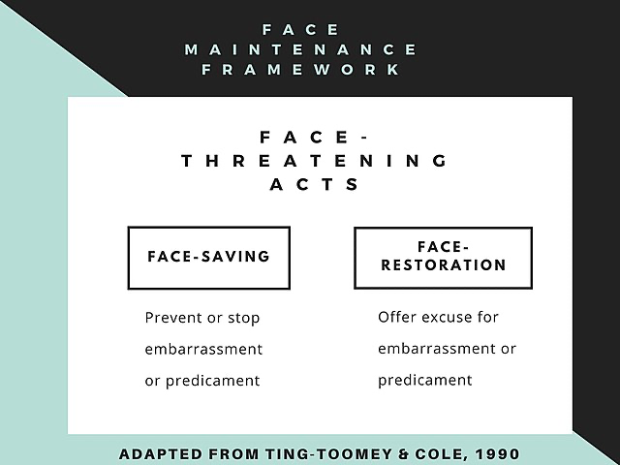
Cultural differences are in society and how we relate or respond to the differences is how conflict can emerge. Ting Toomey’s theory is about maintaining “face”. Face is nothing but an identity a persona we apply to keep up a public image of ourselves. And the expression saving face is exactly what this is all about. How much importance do we put on maintaining our face over others. An individualist culture will want to maintain face more than a collectivistic, this is because collectivist cultures are more likely to avoid conflict. According to Ting Toomey people from different cultures face conflict in different ways. (Cultural, 2014).
Different cultures manifest themselves in many other ways, different parts of the world tend to have different work ethics, different organisational structure, different ways of communication are just a few examples. But is this culture description a one fits all kind of thing. It is said that the United Kingdom has a culture where people like to apologise, but surely every Brit does not. Brits are known for queuing but do all brits’ queue. So, it follows that not all workplace culture will be the same (Ashiq, 2021). The vast majority of companies in Britain have a very clear hierarchy, managers are generally known to be autocratic, managers wear suits, hold secluded meetings and keep work life very separate from home life. But with the population of the UK becoming more and more diverse this can surly no longer be the case. To succeed in business in the UK understanding culture extremely important if not vital, both employees and employer need to have a strong understanding of culture. (Bradford Jacobs, 2023). According to the 2021 census of the 5.9 million, in England and Wales, 9.3% are people from Asian ethnic groups, 6.2% white but not from British heritage. 9% are other ethnic groups (Gov.com2022). when it comes to conflict resolution understanding other cultures can be an integral part of the process. Ting Toomey’s face to face model is not alone in the conflict resolution theory’s, there is also the Thomas and Kilmann’s five strategies to handle conflict.
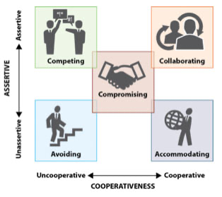
Avoiding, when people withdraw from conflict, feeling discomfort in the conflict situation. For the facilitator this is extremely accommodating but a good idea might go withheld. Although this avoids the conflict altogether nothing g. is resolved.
Competing, this is a good strategy when it comes to war and is how sporting games are played. In the workplace however competing will not solve a problem.
Accommodating, giving way to someone else’s idea, accommodating is cooperative but not assertive. This is very similar to avoidance and can leave an issue unresolved.
Collaborating, when the group are both assertive and cooperative, allowing others to contribute and taking onboard their ideas.
Compromising again assertive and cooperative, however compromising will be allowing everyone to contribute and then splitting the difference.
Just like “death and taxes” conflict is inevitable because no two individuals have exactly the same needs and cultures, conflict is a natural part of life especially in an organisation. (The Participation Company, 2021)
Is resolving the conflict in the NHS caused by cultural difference and is the fact that it goes unresolved about maintaining face? The Nation Health Service is a massive part of the United Kingdoms culture. However, the United Kingdom is a multicultural country and becomes more so on any given day. Multiculturalism dates to 1707, although most think it was when there was an influx of migrants during the second world war. Either way there are many different cultures living in the United Kingdom. Can it be argued then that the British culture is a thing of the past? And in turn the national health service is a thing of the past. There are many who think it should be privatised. Many politicians in fact. This would indeed solve many problems as funding would no longer be an issue. But then how do people pay for their treatment? National insurance contributions were originally put in place to cover these costs, but they also cover other things such as pension payments, sickness benefits and other benefits. With an aging generation and many people on benefits of one type or another less and less money is available for the NHS. (Taylor & Francis. 2016) The conflict is between the NHS and the government, with the NHS staff walking out of the workplace to strike for higher wages and more staffing, and the government stressing that there is no money available. A compromise needs to be met as neither group want to lose face. Both Ting Toomey and Thomas and Kilmann’s, suggest compromise. Meeting halfway would be the best solution but if there is just not the finances to meet in the middle what then. The staff are not going to be accommodating or avoiding and the government don’t have the budget to be accommodating or avoiding. So, talks and meeting between the two carries on until something changes. Communication is key, both sides need to know their objectives, what they want as an outcome. They need to be aware of what response from the other party they are seeking and be aware of the overall purpose of the action they are taking.
Strike action is not taken lightly and there must have been serious thought put into the discission to strike. In 2017 a letter was sent to NHS staff from at the time CEO of NHS England, thanking them for all their hard work during the highly pressurised winter period, it stated that following the budget statement there was an action plan in place to turn around A&E performance. They wanted to avoid a repeat of the winter period next winter. The plan was to be freeing up beds and managing A&E demand. (NHS England, 2023). In 2023 just five years later the staff have walked out of work for a series of strikes because apart from the fact they want a higher wage, euro news reported patients being treated in corridors and ambulances queuing outside A&E departments whilst patients cannot be moved on to wards due to lack beds. Whilst there is still enormous pressure from covid there is also winter flu to contend with and they are still battling the back log from the pandemic. Over 13,000 beds are being taken up by patients who are medically fit but cannot be discharged as there is no social care for them to be discharged to (Euronews,2023). This being said, how can the staff at the NHS trust the leader.

- Conclusion.
The problems the national health service is going through is said to be cause by the cost-of-living crisis and covid nineteen, in researching for this report its very clear the problems were occurring long before either the pandemic or the rise in cost of living. The report found declining figures on waiting list, urgent lifesaving operations and even a correspondence dated January 2017 thanking the staff for their hard work through a pressurised winter period. The statistics date back over a decade so, not covid nineteen or the cost of living. Yes, these have substantially added to the woes but are not the cause, no matter the cause can any of the models help or resolve the situation. The NHS need to choose their battles, take onboard the changes that are needed and then make the changes needed the most. Employing more staff would defiantly solve a lot of the problems but will anyone sign themselves up for all the training needed for such a low wage. By making the changes will the conflict be resolved, one would hope! But then nether the government or the staff want to lose “face”. It is hoped that all parties can come to a compromise, with both Ting Toomey and Kilmann and Thomas using compromise in their theories. A meet in the middle wage increases perhaps. As this report suggested is more staff with less training and less responsibility a possible compromise, or a one-off crisis payment. The only way both sides will save face is to compromise. This report also looked at culture and how the United Kingdom is multicultural, the national health service is part of British culture so is British culture outdated and should the NHS be privatised.

- Reference list

Ashiq, W. (2021) 10 things you should know about UK culture as an international student, Great British Mag. Available at: https://greatbritishmag.co.uk/uk-culture/10-things-you-should-know-about-uk-culture/ (Accessed: March 19, 2023).
Change model guide - NHS england (no date). Available at: and (Accessed: February 28, 2023).
Cultural Communication, I.C. (2014) Face-negotiation theory, Communication Theory. Available at: https://www.communicationtheory.org/face-negotiation-theory/ (Accessed: March 16, 2023).
Eatough, erin (no date) The 5 types of power effective leaders use, The 5 Types of Power Effective Leaders Use. Available at: https://www.betterup.com/blog/types-of-power (Accessed: February 6, 2023).
England's NHS to move patients out of hospitals amid bed shortage (2023) euronews. Available at: https://www.euronews.com/2023/01/09/englands-nhs-to-move-patients-out-of-hospitals-amid-major-bed-shortage#:~:text=England's%20National%20Health%20Service%20(NHS,one%20of%20its%20toughest%20winters. (Accessed: March 21, 2023).
Ferner, R.E., Aronson, J.K. and Heneghan, C., 2019. Crisis in the supply of medicines. BMJ, 367.
Gray, J. (2020) How the NHS has changed since 2010, in numbers, HuffPost UK. HuffPost UK. Available at: https://www.huffingtonpost.co.uk/entry/nhs-changes-numbers-2010s_uk_5dfcdd1fe4b05b08bab44aeb (Accessed: February 20, 2023).
Kiitam, Andres & Mclay, Allan & Pilli, Tonu. (2016). Managing conflict in organisational change. International Journal of Agile Systems and Management. 9. 114. 10.1504/IJASM.2016.078575.
Levasseur, R.E., 2001. People skills: Change management tools—Lewin's change model. Interfaces, 31(4), pp.71-73.
Lukes, S. ed., 1986. Power (Vol. 2). NYU Press.
Majority of nurses feel they are misunderstood, survey reveals (no date) Nurse.org. Available at: https://nurse.org/articles/nurses-feel-misunderstood-survey/ (Accessed: March 11, 2023).
Mchale , jean v (no date) The impact of Brexit on the NHS, University of Birmingham. Available at: https://www.birmingham.ac.uk/research/perspective/impact-of-brexit-on-the-nhs.aspx (Accessed: February 20, 2023).
Multiculturalism in contemporary Britain: Policy, law and theory (2016) Taylor & Francis. Available at: https://www.tandfonline.com/doi/full/10.1080/13698230.2017.1398443#:~:text=What%20we%20think%20of%20as,(1992). (Accessed: March 20, 2023).
Nursing strikes: Facts and figures on UK nursing staff (2022) The Nuffield Trust. Available at: https://www.nuffieldtrust.org.uk/resource/nursing-strikes-facts-and-figures-on-uk-nursing-staff#nurses-leaving-the-nhs (Accessed: March 11, 2023).
Pappas, S. and McKelvie, C. (2022) What is culture?, LiveScience. Purch. Available at: https://www.livescience.com/21478-what-is-culture-definition-of-culture.html (Accessed: February 7, 2023).
Population of England and Wales (2022) GOV.UK Ethnicity facts and figures. Office for National Statistics. Available at: https://www.ethnicity-facts-figures.service.gov.uk/uk-population-by-ethnicity/national-and-regional-populations/population-of-england-and-wales/latest#:~:text=The%202021%20Census%20data%20shows,other'%20ethnic%20group%20(6.2%25) (Accessed: March 20, 2023).
Rebello, K.P. (2022) Council post: The impact of culture in the Workplace, Forbes. Forbes Magazine. Available at: https://www.forbes.com/sites/forbesbusinessdevelopmentcouncil/2021/12/01/the-impact-of-culture-in-the-workplace (Accessed: February 7, 2023).
Sahin, I. (no date) Detailed review of rogers’ diffusion of innovations theory and ... Available at: https://files.eric.ed.gov/fulltext/ED501453.pdf (Accessed: March 16, 2023).
Six phases of change in relation to Lewin model based on waterfall ... (no date). Available athttps://www.researchgate.net/figure/Six-phases-of-change-in-relation-to-Lewin-model-based-on-Waterfall-model-Royce-1970_fig1_307622640 (Accessed: February 19, 2023).
Stella Ting-Toomey on face-negotiation theory (2014) YouTube. YouTube. Available at: https://www.youtube.com/watch?v=bQJcMas_dnw (Accessed: March 16, 2023).
Tatum, H.T. (no date) Asda store colleagues to share £27.8m bonus pot, Corporate. asda Available at: https://corporate.asda.com/newsroom/2022/02/25/asda-store-colleagues-to-share-27-8m-bonus-pot (Accessed: February 1, 2023).
The Participation Company (2021) 5 conflict resolution strategies we all use, The Participation Company. Available at: https://theparticipationcompany.com/2016/06/5-conflict-resolution-strategies/#:~:text=Kenneth%20Thomas%20and%20Ralph%20Kilmann,to%20be%20in%20a%20conflict. (Accessed: March 20, 2023).
This text provides general information. Statista assumes no liability for the information given being complete or correct. Due to varying update cycles, statistics can display more up-to-date data than referenced in the text. (no date) Topic: National Health Service (NHS) UK, Statista. Available at: https://www.statista.com/topics/3128/national-health-service-nhs-uk/ (Accessed: March 21, 2023).
United Kingdom Work Culture (2023) Bradford Jacobs. Available at: https://bradfordjacobs.com/countries/europe/uk/uk-work-culture/ (Accessed: March 19, 2023).

