
Financial Analysis and Investment Appraisal
Yitong Liu
2500637

September 2, 2026
University of Wales Trinity Saint David

Part A: Financial Performance Analysis of Whitbread plc

EXECUTIVE SUMMARY
This report evaluates Whitbread plc’s financial performance in 2024/25 using selected ratios across profitability, liquidity, gearing, efficiency and investor return.
The analysis shows a clear weakening in profitability. Operating profit margin fell from 19.08% to 17.59%, while ROCE declined from 6.53% to 5.99%. This reflects weaker UK trading, cost pressure and lower returns from capital employed. Liquidity also weakened, with the current ratio falling from 96.19% to 81.36%. However, much of this change was linked to the reclassification of a £450 million bond due in October 2025 rather than a sharp rise in operating liabilities. Gearing increased from 59.14% to 62.79%, partly because of new borrowing, higher lease liabilities and a lower equity base. Total asset turnover remained close to 0.30 times, showing no clear improvement in asset productivity. Basic EPS also fell from 161p to 141p, a decline of 12.42%, despite a lower weighted average share count.
The main priorities are therefore to improve operating margins, apply stricter return targets to new investment, maintain sufficient liquidity, control leverage and improve returns from existing assets. Future share buy-backs should be supported by stronger underlying earnings rather than used to offset weaker profit performance.

Table of Contents
Part A: Financial Performance Analysis of Whitbread plc
EXECUTIVE SUMMARY 1
1.INTRODUCTION 4
2.FINANCIAL RATIO ANALYSIS 5
2.1 Operating Profit Margin 5
2.2 Return on Capital Employed 6
2.3 Current Ratio 7
2.4 Gearing Ratio 8
2.5 Total Asset Turnover 9
2.6 Earnings Per Share 10
3.CONCLUSION 12
4.RECOMMENDATIONS 13
Part B: Investment Appraisal and Financing Recommendations for Beard Plc
5.EXECUTIVE SUMMARY 16
6.INTRODUCTION 17
7.INVESTMENT APPRAISAL USING NPV 18
8.EVALUATION OF THE PREFERRED INVESTMENT OPTION 19
8.1 Internal Rate of Return (IRR) of the Option C 19
8.2 Why NPV Is the Preferred Investment Appraisal Method 19
8.3 Why Non-discounting Methods Remain Popular 20
8.4 Other Factors Before the Investment Decision 21
9.INVESTMENT POLICY 22
9.1 Project Ranking 22
9.2 Optimal Investment Allocation and Total NPV 22
10.FINANCING OPTIONS 23
10.1 Internal Funds 24
10.2 Bank Loans and Debt 24
10.3 New Equity 25
11.CONCLUSION 27
12.REFERENCES LIST 28
13. WORKINGS 35
14.APPENDIX 42

1.INTRODUCTION
Whitbread plc is a listed company whose core business is hotel operations, mainly through its Premier Inn brand in the UK and Germany (Whitbread plc, 2025). The 2024/25 Annual Report (2025) shows that the company faced two major pressures in its UK market: persistently weak demand and a significant rise in operating costs. At the same time, accommodation revenue in Germany increased by 21% year on year (Whitbread plc, 2025), indicating a growing divergence in regional performance. Despite management's continued expansion in Germany and the restructuring of the UK portfolio through the Accelerating Growth Plan, including the exit from lower-return restaurants and the closure of some lower-return rooms, the Group's adjusted profit before tax fell by 14%, from £561 million in 2023/24 to £483 million in 2024/25 (Whitbread plc, 2025). This substantial decline has raised concerns among investors and the Board about the sustainability of earnings.
Financial ratio analysis provides a structured way to examine how a company creates value. Nissim and Penman (2001) distinguish operating activities from financing activities within financial statement analysis. This provides a rigorous basis for distinguishing internally generated operating performance, such as profit margins and asset turnover, from financing effects, such as leverage and interest coverage. Based on this framework, the report uses consolidated financial statement data prepared under IFRS and examines ratios across five areas: profitability, liquidity, financial leverage, operating efficiency and investor returns. The analysis not only explains the quantitative reasons behind changes in individual ratios but also focuses on the underlying relationships between them.

2.FINANCIAL RATIO ANALYSIS

2.1 Operating Profit Margin
Non-specialists may mistake revenue growth for improved profitability. However, higher labour, energy and other operating costs can offset that growth and even narrow profit margins (PwC, 2026). Calculating the Operating Profit Margin (OPM) regularly helps a business assess whether additional revenue translates into operating profit. This can also indicate whether cost controls are working (Ishikawa, Gemba and Oda, 2025). For Whitbread’s management, changes in the ratio can therefore help identify potential problems with operating efficiency or the cost structure (Soliman, 2008).
The calculations in Working 1 show that Whitbread’s operating profit margin fell from 19.08% in 2023/24 to 17.59% in 2024/25. For every £100 of revenue, the company earned £1.49 less operating profit than in the previous year, indicating a weaker ability to convert revenue into operating profit. The income statements in Appendices 1 & 2 show that revenue fell by £38.0m, whereas operating costs decreased by only £1.7m. Costs therefore did not fall in proportion to revenue (Whitbread plc, 2025, p. 162).
Weaker demand in the UK may help explain the revenue pressure. Initial estimates published in February 2025 showed no quarterly growth in UK real GDP in the third quarter of 2024, followed by growth of just 0.1% in the fourth quarter. Real household expenditure was also unchanged in the fourth quarter, indicating weak economic and consumer spending growth towards the end of Whitbread’s financial year (Office for National Statistics, 2025). This is consistent with the weaker UK market demand reported by Whitbread, although it does not establish that macroeconomic conditions caused the decline in its operating profit margin. The implementation of the company’s strategy may also have contributed to the lower margin. Under its Accelerating Growth Plan, Whitbread began moving away from lower-returning branded restaurants, leading to an 11% fall in UK food and beverage revenue (Whitbread plc, 2025). Part of the revenue decline therefore resulted from a planned change in the business. The lower margin reflects several factors and does not, on its own, demonstrate that the restructuring programme failed or that cost management deteriorated.

2.2 Return on Capital Employed
Operating profit margin shows how much operating profit a company retains from every £100 of revenue. Return on capital employed (ROCE) shows how much annual operating profit it generates for every £100 of capital employed (Aldubhani et al., 2022). ROCE therefore considers the capital required to generate operating profit. It helps a business assess whether the capital committed to its operations produces corresponding returns and compare capital performance across different years (HM Revenue & Customs, 2016).
Working 2 shows that ROCE, calculated using year-end capital employed, fell from 6.53% to 5.99%, a decline of 0.54 percentage points (Whitbread plc, 2025). This indicates that Whitbread’s ability to generate operating profit from its capital weakened in 2024/25. The company therefore needs to monitor whether its investment projects deliver returns as planned.
In 2024/25, the Group reported £241m of expansionary capital expenditure on its UK and German development projects and the Accelerating Growth Plan (Whitbread plc, 2025a, p. 42). This expenditure shows that the business continued to invest despite lower current returns. However, it does not establish that expansion caused the decline in ROCE. Management estimated that hotels in Germany would take four to five years to mature (Whitbread plc, 2025). Some investments may therefore need more time to deliver their expected returns. However, after updating its cash flow forecasts, Whitbread recognised £22m of impairment across five German sites (Whitbread plc, 2025). This suggests that a normal development period cannot explain all underperforming investments. Management should compare each hotel’s actual performance with its original investment forecasts, taking account of its opening date. Projects that consistently fall below expectations should then be reviewed.

2.3 Current Ratio
Unlike profitability ratios, the current ratio focuses on short-term financial obligations and often reflects a company’s ability to repay its debts. If a business performs poorly, repaying its liabilities becomes increasingly difficult. Once its creditworthiness is compromised, the company will immediately face the liquidation of its existing assets by creditors. A business in liquidation is unlikely to continue trading. Its shares, which represent its future value, will then instantly lose their value (Kirkham, 2012). Companies generally expect their current ratio to exceed 200%. The higher the ratio, the better, as this indicates less pressure to repay short-term debts (Kirkham, 2012; Seretidou, Billios and Stavropoulos, 2025).
The current ratio fell from 96.19% in 2023/24 to 81.36% in 2024/25（Working 3）. Remaining below 100% for two consecutive years shows that current assets did not fully cover current liabilities at year-end. It also indicates a further weakening in short-term debt coverage. However, a single ratio cannot fully assess actual repayment pressure. The liability structure therefore needs to be considered carefully. Current liabilities in 2024/25 included a £450m corporate bond due in October 2025. In the previous financial year, this debt was not yet due within one year and was therefore excluded from current liabilities (Whitbread plc, 2025). After excluding this one-off reclassification, the remaining operating current liabilities totalled £869m, largely unchanged from £870m in 2023/24. This suggests that the decline in the current ratio mainly resulted from the accounting reclassification of existing long-term debt approaching maturity, rather than a widespread increase in core operating liabilities such as trade payables. Management therefore needs to plan for the repayment of the maturing debt and actively coordinate funding with shareholder distributions (Kirkham, 2012).

2.4 Gearing Ratio
The gearing ratio measures the proportion of debt in a company’s financing structure. It shows how much of every £100 of debt and equity financing comes from debt (Myers, 2001). While the current ratio focuses on short-term debt coverage, gearing measures reliance on debt financing. Debt may provide tax benefits, but it can also create financial pressure. A higher or lower ratio is therefore not necessarily better (Myers, 2001). Analysing gearing helps a company assess its financing structure and the financial risks associated with investment.
Working 4 shows that Whitbread’s gearing rose from 59.14% to 62.79%. Debt accounted for more than half of debt and equity financing in both years, and the increase indicates greater relative reliance on debt. In Whitbread’s case, this increase also reflected higher borrowings. As discussed in the current ratio analysis, Whitbread issued £400m of bonds in February 2025, partly to refinance existing debt. The previous £450m bond was not due until October 2025. Both bonds therefore remained outstanding at year-end, increasing the total debt balance (Whitbread plc, 2025a, p. 193). He and Xiong (2012) explain that debt maturity and financing market conditions affect refinancing risk. Securing funds in advance may therefore reduce the uncertainty of raising finance close to maturity. The higher year-end gearing does not necessarily indicate an overall deterioration in financial risk. Lease liabilities also increased by £135.4m, contributing to the rise in gearing. Meanwhile, the statement of changes in equity recorded £178.1m in dividends and £252.0m under share buy-backs, commitments and cancellations, which reduced shareholders’ equity (Whitbread plc, 2025a, pp. 164, 194).
However, net cash flows from operating activities fell from £877.9m to £761.7m. The new bonds also carried a coupon of 5.5%, compared with approximately 3.38% on the bond due in 2025 (Whitbread plc, 2025a, pp. 166, 193). Before committing to investment, dividends and share buy-backs, the company should therefore assess whether cash flows can cover interest, lease payments and maturing debt. It should also test its ability to meet these obligations if revenue falls further.

2.5 Total Asset Turnover
Asset turnover helps assess a company’s overall operating efficiency and how effectively it uses its assets (Chen, 2010). A higher ratio indicates that the company generates more revenue from its assets, while a lower ratio indicates less efficient revenue generation. However, asset turnover differs across industries because of differences in capital intensity and business models (Selling and Stickney, 1989). Retail businesses, for example, tend to generate high sales relative to their asset base and therefore have higher asset turnover. In contrast, utilities and real estate businesses have substantial assets and generate less revenue per unit of assets, resulting in lower turnover. Comparisons are therefore more meaningful between similar companies within the same industry.
Working 5 shows that Whitbread’s total asset turnover remained close to 0.30 times in both years. This indicates no clear improvement in the group’s overall ability to generate revenue from its assets. Whitbread reported weaker UK market demand than in the previous year, with Premier Inn UK’s revenue per available room (RevPAR) falling by around 2%. Additional rooms offset this decline, keeping total accommodation revenue broadly unchanged (Whitbread plc, 2025). However, this means that the larger room portfolio had not yet produced growth in total accommodation revenue. By comparison, Dalata’s UK hotel portfolio achieved like-for-like RevPAR growth of 2.8% in 2024. Occupancy increased by 1.9 percentage points and the average room rate rose by 0.4% (Dalata Hotel Group plc, 2025). This example shows that market pressure does not prevent all hotels from improving revenue per available room. Whitbread therefore needs to distinguish the effects of regional demand, room pricing and hotel maturity on revenue performance, rather than attributing the results solely to weaker market conditions. Management should therefore monitor occupancy and RevPAR separately for mature and newly opened hotels, comparing actual revenue with investment forecasts. For mature hotels that remain below expectations, it should review pricing, sales channels and local demand. For newly opened hotels, it should assess whether revenue growth is progressing in line with the planned timetable for reaching maturity (Enz, Canina and Lomanno, 2009).

2.6 Earnings Per Share
Earnings per share allows shareholders and investors to view company performance from an investment perspective because it converts total corporate earnings into earnings attributable to each ordinary share. This makes changes in shareholder earnings easier to observe and compare (Almeida, 2019). For this reason, changes in EPS should not be assessed in isolation. It is also important to identify whether the change comes from underlying profit or from changes in the number of shares. Hribar, Jenkins and Johnson (2006) found that share repurchases can increase EPS and that some firms use this effect to meet analysts’ earnings forecasts. Examining EPS can therefore provide an additional perspective when analysing a decline in profit.
Basic EPS fell from 161p in 2023/24 to 141p in 2024/25, representing a decrease of approximately 12.42%. However, this decline should be considered alongside changes in Whitbread’s share base. The weighted average number of ordinary shares fell from 193.9 million to 179.3 million. During the same year, the Group repurchased and cancelled 8.9 million shares at a cost of approximately £264.3 million (Whitbread plc, 2025). Previous research shows that share repurchases can increase or protect EPS through this denominator effect (Almeida, Fos and Kronlund, 2016). In Whitbread’s case, however, profit attributable to ordinary shareholders fell from £312.1 million to £253.7 million. This decline was greater than the reduction in the weighted average number of shares. The benefit of the smaller share base was therefore not sufficient to prevent EPS from falling. This is significant because it shows that the decline in EPS was mainly driven by weaker underlying earnings rather than by changes in the share base alone. The share repurchase partially cushioned the fall in EPS, but it could not offset the effects of weaker UK trading, cost pressures and restructuring during the year (Whitbread plc, 2025). The 12.42% decline in EPS therefore indicates that earnings available to each ordinary share weakened despite Whitbread reducing its equity base. However, EPS should not be treated as the sole measure of shareholder value, because investor returns also depend on dividends, share-price movements and wider capital allocation decisions (Almeida, 2019).

3.CONCLUSION
This report assessed Whitbread’s financial performance using the most relevant ratio from each of the five main ratio categories. The selection was based on Whitbread’s hotel business model, asset structure and current strategy.
The results show that profitability weakened in 2024/25 because of softer UK trading and higher cost pressure. Asset efficiency also declined, while the fall in EPS shows that weaker performance reduced earnings available to shareholders. Liquidity and leverage should be viewed in the context of Whitbread’s capital-intensive and lease-based business model. Overall, Whitbread’s main challenge is not only to grow revenue, but also to improve how efficiently its assets and capital generate sustainable earnings.

4.RECOMMENDATIONS
Ratio result | Industry evidence | Recommendation | Practical action
Operating profit margin fell from 19.08% to 17.59%. Profit declined faster than revenue. | Major hotel groups increasingly focus on cost control, revenue management and higher-return capacity rather than growth alone（IHG, 2025）. | Improve operating margin before further expansion. | Set margin targets for UK hotels and F&B operations. Review sites that remain below target and consider restructuring, conversion or exit.
ROCE declined, showing weaker returns on capital employed. | Hyatt and Accor have reduced capital tied up in owned assets and shifted investment towards higher-return, asset-light growth( Hyatt Hotels Corporation, 2024). | Set stricter return requirements for new investment. | Use a minimum ROCE threshold for major UK and German projects. Redirect capital away from low-return assets.
The liquidity result shows limited short-term headroom. | Travelodge’s experience shows that high fixed costs can quickly create liquidity pressure when demand falls.(Travelodge, 2020). | Maintain a stronger liquidity buffer. | Stress-test cash flows against weaker demand and ensure enough cash is available to cover short-term operating, interest and lease obligations.
The leverage result highlights the importance of debt and lease commitments. | IHG links shareholder distributions to balance-sheet strength and credit quality(IHG, 2025). | Keep leverage within a clear internal limit. | Review debt, lease commitments and buy-backs together. Reduce discretionary capital returns if leverage becomes too high.
Asset turnover weakened, suggesting lower asset productivity. | Hyatt and Accor have improved capital efficiency by disposing of lower-return assets and focusing on stronger-performing operations(Accor,2025). | Improve returns from the existing asset base. | Rank hotels and related assets by revenue and return. Convert, sell or close assets that remain weak over time.
Basic EPS fell from 161p to 141p, a decline of 12.42%.The lower share count softened the fall but did not offset weaker profit. | IHG returns surplus capital only after operating and balance-sheet needs are met(IHG, 2025). | Focus on underlying earnings rather than using buy-backs to support EPS. | Approve future buy-backs only when profit, liquidity and investment returns are strong enough to support them.

Part B: Investment Appraisal and Financing Recommendations for Beard Plc

5.EXECUTIVE SUMMARY
This report assesses Beard Plc’s proposed four-year expansion programme by comparing three investment options: retail expansion, internet sales, and the production of purses and wallets. The analysis uses NPV as the main appraisal method, supported by IRR, capital rationing analysis and a review of non-financial factors that may affect the investment decision.
The financial analysis shows clear differences between the three options. Option C provides the highest individual NPV, while Option B also creates positive value. Option A produces a negative NPV and is therefore financially weaker. Under the £1.5 million funding limit, the analysis identifies a combined investment approach using Option C and part of Option B to make better use of the available capital.
The report also considers the limits of relying only on financial indicators. Market conditions, customer demand, supply-chain capability and internal resources may all affect whether the forecast returns can be achieved in practice. In addition, three financing routes are reviewed: internal funds, debt finance and equity finance. Their effects on liquidity, financial risk and shareholder control are compared to support the Board’s final financing decision.

6.INTRODUCTION
Beard Plc, a producer of high-quality handbags, is currently considering a four-year expansion plan. The management has identified three investment options. This report will apply relevant investment appraisal techniques to evaluate the financial feasibility of each option and consider the main factors that may influence the investment decision. Relevant financial principles will also be applied to support the analysis, before identifying the financing option that is most suitable for the company.
Investment Options Overview
Option | Project | Initial investment | Year 1 | Year 2 | Year 3 | Year 4
A | Expand the existing retail outlet to include all products | £600,000 | £100,000 | £180,000 | £210,000 | £260,000
B | Develop internet sales | £900,000 | £220,000 | £270,000 | £350,000 | £400,000
C | Produce purses and wallets | £1,000,000 | £250,000 | £310,000 | £400,000 | £430,000

All three projects are assessed over four years. Corporation tax is assumed at 25%, capital allowances are 20% on a straight-line basis, and all cash flows arise in the year stated

7.INVESTMENT APPRAISAL USING NPV

Item | Option A：Retail Expansion | Option B ：Internet Sales | Option C ： Purses and Wallets
Initial investment | £600,000 | £900,000 | £1,000,000
Annual capital allowance | £120,000 | £180,000 | £200,000
Year 1 after-tax cash flow | £105,000 | £210,000 | £237,500
Year 2 after-tax cash flow | £165,000 | £247,500 | £282,500
Year 3 after-tax cash flow | £187,500 | £307,500 | £350,000
Year 4 after-tax cash flow | £225,000 | £345,000 | £372,500
PV of Year 1 cash flow | £99,750 | £199,500 | £225,625
PV of Year 2 cash flow | £150,150 | £225,225 | £257,075
PV of Year 3 cash flow | £161,250 | £264,450 | £301,000
PV of Year 4 cash flow | £184,500 | £282,900 | £305,450
Total PV of future cash flows | £595,650 | £972,075 | £1,089,150
NPV | −£4,350 | £72,075 | £89,150

Table 1: Investment Appraisal In NPV

（For detailed calculations, see Working 7, Working 8 and Working 9 in the Appendix）

A positive NPV means that the present value of expected future cash flows exceeds the initial investment after allowing for the cost of capital(levy, 2025). Based on the Table 1 results, Option C is the most financially attractive investment, with the highest positive NPV of £89,150. Therefore, from a financial perspective, Option C is the preferred investment at this stage.

8.EVALUATION OF THE PREFERRED INVESTMENT OPTION

8.1 Internal Rate of Return (IRR) of the Option C
Based on the NPV analysis, Option C currently appears to offer the strongest financial return. However, further financial assessment provides a more reliable basis for the investment decision. Working 10 therefore calculates the IRR of Option C, which is approximately 8.57%. IRR is the discount rate at which a project’s NPV equals zero (Johnstone, 2008). The case information shows that Beard Plc’s cost of capital is 5%. Since the IRR of 8.57% is higher than 5%, the project’s expected return exceeds its cost of capital. This also supports the positive NPV result and provides further evidence that Option C is financially attractive.

8.2 Why NPV Is the Preferred Investment Appraisal Method
From a financial perspective, NPV is well suited to capital investment decisions because it compares the initial investment with the present value of future cash flows. It considers the time value of money, uses cash flows over the full life of the project and links the decision directly to value creation. Research on large UK manufacturing companies found that NPV was widely used in strategic investment decisions because managers valued its ability to show how much value a project could add (Alkaraan and Northcott, 2006).
From a business perspective, NPV also helps management make the assumptions behind an investment more visible. This is useful where future returns depend on demand, technology and operating capability. Research on fashion retailers in London shows that technology investment differs widely in both adoption and implementation, which creates different operating risks (Alexander and Kent, 2021). For Beard Plc, this is relevant to projects such as internet sales, where expected benefits depend not only on investment cost but also on how effectively the new channel is introduced and used.
However, NPV is not a complete decision rule. Its result depends on forecast cash flows and the discount rate selected. Strategic investments may also involve risks and benefits that are difficult to express in financial terms (Alkaraan and Northcott, 2006). NPV should therefore provide the main financial basis for the decision, while operational and strategic factors should also be considered.

8.3 Why Non-discounting Methods Remain Popular
Although discounted methods such as NPV and IRR are widely used to assess investment returns, non-discounting methods remain common in management decision-making (Graham and Harvey, 2001). As discussed in Section 8.2, NPV provides a strong basis for investment appraisal because it considers the time value of money and links investment decisions to value creation. However, NPV is not the only useful measure. In practice, firms often use several appraisal methods together rather than relying on a single technique. Evidence from UK companies shows that Payback Period and Accounting Rate of Return continue to be used alongside NPV and IRR (Arnold and Hatzopoulos, 2000).
Payback Period and Accounting Rate of Return are two common non-discounting investment appraisal methods. Payback Period shows how long it takes to recover the initial investment, which can help managers assess liquidity pressure and short-term risk. ARR focuses on accounting returns and can be compared more easily with budgets and internal performance targets. These methods therefore provide a different view of investment performance and can complement discounted cash-flow methods (Alkaraan and Northcott, 2006). For management, their value is not limited to financial appraisal. They can help identify issues such as slow capital recovery or weak accounting performance during the life of a project. This can support quicker management responses when problems arise (Cowling and Wilson, 2025). Non-discounting methods should therefore be used as a complement to discounted methods rather than as a replacement for them.

8.4 Other Factors Before the Investment Decision
Although financial indicators are usually the first consideration when evaluating an investment, they cannot capture every factor that may affect the outcome. Business conditions can change quickly, so Beard Plc should also consider its market position and operating capability before making an investment decision.
First, management should assess whether the current macroeconomic environment is suitable for expansion. Economic conditions, inflation, geopolitical tensions and trade policies can all affect consumer willingness to spend. For example, the British Retail Consortium reported in 2025 that global trade tensions and new tariffs were disrupting supply chains and weakening overall demand in the UK retail sector (British Retail Consortium, 2025). This suggests that an investment that appears attractive under current assumptions may become less profitable if external conditions change.
Second, Beard Plc should confirm that customers have sufficient willingness to purchase its products. This means that the market research function should conduct a detailed analysis of consumer behaviour. A 2025 UK consumer survey showed that spending intentions remained cautious and that fashion was not a spending priority for many consumers, although younger groups showed stronger interest in the category (PwC, 2025). Beard Plc should therefore assess its target customer groups before relying on projected sales.
Third, if Beard Plc plans to combine online and offline sales, management should assess whether the company has sufficient resources to support this model. This includes supply-chain capacity, inventory management, order fulfilment, digital systems and staff capability. Without these resources, expected sales growth may not translate into successful implementation (Hübner, Wollenburg and Holzapfel, 2016).

9.INVESTMENT POLICY

9.1 Project Ranking
Option | NPV generated per £1 invested | Equivalent percentage
A | −0.00725 | −0.73%
B | 0.08008 | 8.01%
C | 0.08915 | 8.92%
Table 2: NPV Generated per £1 Invested

Beard Plc currently has £1.5 million available for the investment portfolio. Based on the calculated NPV generated per £1 invested, the current ranking is Option C > Option B > Option A. Option A has a negative NPV and therefore does not create financial value, so it should be excluded from the investment portfolio.
When capital is limited, the way in which funds are allocated across competing projects becomes important. Capital rationing means that a company may not have sufficient funds to undertake every available investment opportunity, even where some projects have positive NPVs. In this situation, management needs to compare projects according to the value generated from the limited capital available and allocate funds to the combination that maximises overall value (Magni et al., 2020). Research on capital rationing also shows that project ranking becomes particularly important when several investment opportunities compete for a fixed amount of finance (Wong, 2000). Therefore, Beard Plc should prioritise the projects that generate the greatest NPV relative to the amount invested before deciding how the £1.5 million should be allocated.

9.2 Optimal Investment Allocation and Total NPV
Project | Investment | Proportion | NPV
Option C | £1,000,000 | 100% | £89,150
Option B | £500,000 | 55.56% | £40,041.67
Option A | £0 | 0% | £0
Total | £1,500,000 |  | £129,191.67
Table 3: Final investment Policy
Based on the ranking in Section 9.1, Beard Plc should prioritise Option C and invest the full £1,000,000 required. The remaining £500,000 should then be allocated to Option B. As the projects are divisible, this allows the company to undertake approximately 55.56% of Option B.
This investment policy uses the full £1.5 million available and generates a total NPV of approximately £129,192. Option A is excluded because its negative NPV would reduce the value created by the overall investment portfolio. Detailed calculations are provided in Working 12.

10.FINANCING OPTIONS
Three financing options are presented below for the Board’s consideration. Each option will be assessed in terms of its main advantages, disadvantages and potential impact on Beard Plc before a final financing decision is made.
Option | Financing Method | Main Issue to Consider
Option 1 | Use Internal Funds | Effect on cash and working capital
Option 2 | Use Bank Loans or Other Debt | Interest cost and repayment pressure
Option 3 | Raise New Equity | Ownership dilution and shareholder control
Table 4: Three Financing Options

10.1 Internal Funds
Internal funds can be understood as using the company’s own profits to finance investment. The reasons for choosing this method are simple. First, the company does not need to pay interest, which avoids the pressure of borrowing. Second, it does not dilute the ownership or control of existing shareholders. Third, the financing process is relatively simple because the company does not need to issue new shares (Myers, 1984; Frank and Goyal, 2003).
However, this method requires the company to have stable cash flow, a healthy operating position and sufficient retained earnings. If a company does not have these conditions but still chooses to use internal funds, its liquidity and working capital may be weakened, which could affect daily operations (Fazzari and Petersen, 1993). A typical example is that the company may not have enough cash to pay suppliers, while its ability to meet short-term liabilities may also decline (Koussis, Martzoukos and Trigeorgis, 2017).

10.2 Bank Loans and Debt
Debt finance refers to raising funds by borrowing from banks, financial institutions or other lenders. Common forms of debt finance include bank loans, medium-term notes and corporate bonds. Companies may choose debt finance for several practical reasons (Ferran, Howell and Steffek,2023). First, it allows the business to keep its own cash available for unexpected operating needs and reduces the risk of liquidity pressure caused by a large one-off investment. Second, unlike equity finance, debt does not require the issue of new shares or the introduction of new shareholders. This means that the ownership percentage of existing shareholders is not diluted and the existing governance structure can be maintained. Third, debt finance may reduce the after-tax cost of financing. In many corporate tax systems, interest payments are tax deductible (Beattie, Goodacre and Thomson，2006). Modigliani and Miller (1963) explain that, when corporate tax is considered, debt can increase firm value through the tax benefit of interest payments.
However, debt finance also creates clear financial obligations and risks. The company must pay interest and repay the principal even if the investment does not generate the expected return. This fixed payment pressure can become more serious during an economic downturn (Beattie, Goodacre and Thomson, 2006). Myers (1984) also highlights that, under information asymmetry and financial distress costs, high levels of debt can increase financial risk, especially when operating cash flows are unstable. If Beard Plc’s main business is strongly affected by changes in consumer demand and sales growth slows, a high interest burden may reduce operating cash flow. This could then affect normal activities such as paying suppliers and maintaining inventory levels. Debt finance is therefore more suitable for businesses with stable profitability and sufficient capacity to meet repayment obligations.
For Beard Plc, the decision on how much debt to use should not depend only on the expected return from the investment. The company should also consider its historical financial performance and maintain an adequate liquidity buffer (Opler et al., 1999). This would allow the financing arrangement to support business expansion without placing excessive pressure on financial stability.

10.3 New Equity
Equity finance allows a company to raise funds by issuing new shares through methods such as rights issues, private placements or public offerings. Unlike debt finance, equity does not create a legal obligation to repay the capital or make regular interest payments. It therefore does not create the same fixed financial burden as debt (Bolton and Freixas, 2000). This method can be suitable when a company is going through a major business transformation, particularly where the investment period may be relatively long. For example, if Beard Plc plans to develop an intelligent warehousing system to support its online sales channel, the investment may take several years to generate returns. Equity finance may therefore provide greater financial flexibility during this period. Research also shows that firms may use equity to maintain lower leverage and build financial flexibility when future investment needs are important (Byoun, 2021). The main advantage is that equity finance does not increase the company’s debt ratio. This can help preserve financial flexibility and reduce the pressure created by additional borrowing. It may also be useful when credit conditions tighten or borrowing costs rise, because the company is less dependent on debt finance (Byoun, 2021; Kisgen, 2006).
However, as discussed in the previous sections, equity finance also has disadvantages compared with the other two financing methods. New share issues may dilute the ownership and control of existing shareholders. Different methods of issuing equity can also have different effects on dilution, particularly where existing shareholders do not participate in the new issue (Burkart and Zhong, 2023). Equity issues can also involve significant issuing and underwriting costs. Evidence from UK rights issues and open offers shows that these costs can be material (Armitage, 2000). New shareholders may also expect dividends, which may reduce the company’s flexibility in using retained earnings (Brav et al., 2005).
This provides an important consideration for Beard Plc. If its debt ratio is already close to a level regarded as high within its industry, for example above 60%, equity finance could be considered as a way of improving the capital structure. However, the Board should carefully assess the level of dilution, the method of issuing shares and the effect on corporate governance. A rights issue may provide greater protection for existing shareholders because they are given the opportunity to maintain their proportionate ownership (Burkart and Zhong, 2023). The final decision should therefore balance financial stability, shareholder preferences and the company’s strategic objectives.

11.CONCLUSION
To assess Beard Plc’s three investment options, we combined Net Present Value (NPV) and Internal Rate of Return (IRR) metrics with a review of strategic fit and operational feasibility. The analysis shows that Option C offers the highest standalone value: its NPV is £89,150 and its IRR is 8.57%, comfortably above the company’s 5% cost-of-capital hurdle. If capital were unlimited, Option C would be the clear choice.
Under the £1.5 million budget constraint, however, an all-or-nothing approach isn’t optimal. Our portfolio model points to a better mix: allocate the full £1 million to Option C and use the remaining £500,000 to fund 55.56% of Option B. This combination puts every pound to work while lifting total NPV to roughly £129,192. By contrast, Option A carries a negative NPV and should be dropped from consideration.
It’s also important to remember that financial figures don’t tell the whole story. Before making a final call, the Board needs to look beyond the numbers at market receptiveness, genuine customer demand, and whether supply chains and internal resources can absorb the added load. Equally critical is how the investment will be financed—whether through retained earnings, new debt, or fresh equity. Each path affects liquidity, risk exposure, and shareholder control in different ways. Ideally, the chosen structure will support the rollout without undermining financial stability, striking a balance between near-term growth ambitions and long-term health.

12.REFERENCES LIST
Accor (2025) Full-year 2024 results: Another record year. 20 February. Available at: https://press.accor.com/full-year-2024-results-another-record-year/?lang=eng (Accessed: 7 October 2026).
Aldubhani, M.A.Q., Wang, J., Gong, T. and Maudhah, R.A. (2022) ‘Impact of working capital management on profitability: Evidence from listed companies in Qatar’, Journal of Money and Business, 2(1), pp. 70–81. doi: 10.1108/JMB-08-2021-0032.
Alexander, B. and Kent, A. (2021) ‘Tracking technology diffusion in-store: A fashion retail perspective’, International Journal of Retail & Distribution Management, 49(10), pp. 1369–1390. doi: 10.1108/IJRDM-05-2020-0191.
Alkaraan, F. and Northcott, D. (2006) ‘Strategic capital investment decision-making: A role for emergent analysis tools? A study of practice in large UK manufacturing companies’, The British Accounting Review, 38(2), pp. 149–173. doi: 10.1016/j.bar.2005.10.003.
Almeida, H. (2019) ‘Is it time to get rid of earnings-per-share (EPS)?’, The Review of Corporate Finance Studies, 8(1), pp. 174–206. doi: 10.1093/rcfs/cfy010.
Almeida, H., Fos, V. and Kronlund, M. (2016) ‘The real effects of share repurchases’, Journal of Financial Economics, 119(1), pp. 168–185. doi: 10.1016/j.jfineco.2015.08.008.
Armitage, S. (2000) ‘The direct costs of UK rights issues and open offers’, European Financial Management, 6(1), pp. 57–68. doi: 10.1111/1468-036X.00111.
Arnold, G.C. and Hatzopoulos, P.D. (2000) ‘The theory-practice gap in capital budgeting: Evidence from the United Kingdom’, Journal of Business Finance & Accounting, 27(5–6), pp. 603–626. doi: 10.1111/1468-5957.00327.
Beattie, V., Goodacre, A. and Thomson, S.J. (2006) ‘Corporate financing decisions: UK survey evidence’, Journal of Business Finance & Accounting, 33(9–10), pp. 1402–1434. doi: 10.1111/j.1468-5957.2006.00640.x.
Bolton, P. and Freixas, X. (2000) ‘Equity, bonds, and bank debt: Capital structure and financial market equilibrium under asymmetric information’, Journal of Political Economy, 108(2), pp. 324–351. doi: 10.1086/262121.
Brav, A., Graham, J.R., Harvey, C.R. and Michaely, R. (2005) ‘Payout policy in the 21st century’, Journal of Financial Economics, 77(3), pp. 483–527. doi: 10.1016/j.jfineco.2004.07.004.
British Retail Consortium (2025) Taking stock report 2025. Available at: https://brc.org.uk/news-and-events/news/associate-insight/2025/taking-stock-report-2025/ (Accessed: 7 October 2026).
Burkart, M. and Zhong, H. (2023) ‘Equity issuance methods and dilution’, The Review of Corporate Finance Studies, 12(1), pp. 78–130. doi: 10.1093/rcfs/cfac029.
Byoun, S. (2021) ‘Financial flexibility demand and corporate financial decisions’, Financial Review, 56(3), pp. 481–509. doi: 10.1111/fire.12258.
Chen, M.-H. (2010) ‘The economy, tourism growth and corporate performance in the Taiwanese hotel industry’, Tourism Management, 31(5), pp. 665–675. doi: 10.1016/j.tourman.2009.07.011.
Cowling, M. and Wilson, N. (2025) ‘The puzzle of UK (under-) investment: Is investment short-termism just a supply-side problem in capital markets?’, British Journal of Management, 36(1), pp. 184–201. doi: 10.1111/1467-8551.12833.
Dalata Hotel Group plc (2025) FY 2024 results. 6 March. Available at: https://dalatahotelgroup.com/wp-content/uploads/2025/03/FY2024-Results-Announcement-and-FS.pdf (Accessed: 26 September 2026).
Enz, C.A., Canina, L. and Lomanno, M. (2009) ‘Competitive pricing decisions in uncertain times’, Cornell Hospitality Quarterly, 50(3), pp. 325–341. doi: 10.1177/1938965509338550.
Fazzari, S.M. and Petersen, B.C. (1993) ‘Working capital and fixed investment: New evidence on financing constraints’, The RAND Journal of Economics, 24(3), pp. 328–342. doi: 10.2307/2555961.
Ferran, E., Howell, E. and Steffek, F. (2023) Principles of corporate finance law. 3rd edn. Oxford: Oxford University Press. doi: 10.1093/oso/9780198854074.001.0001.
Frank, M.Z. and Goyal, V.K. (2003) ‘Testing the pecking order theory of capital structure’, Journal of Financial Economics, 67(2), pp. 217–248. doi: 10.1016/S0304-405X(02)00252-0.
Graham, J.R. and Harvey, C.R. (2001) ‘The theory and practice of corporate finance: Evidence from the field’, Journal of Financial Economics, 60(2–3), pp. 187–243. doi: 10.1016/S0304-405X(01)00044-7.
He, Z. and Xiong, W. (2012) ‘Rollover risk and credit risk’, The Journal of Finance, 67(2), pp. 391–430. doi: 10.1111/j.1540-6261.2012.01721.x.
HM Revenue & Customs (2016) ‘EM3094 – Examining accounts: Business ratios: Return on capital’, Enquiry Manual. Available at: https://www.gov.uk/hmrc-internal-manuals/enquiry-manual/em3094 (Accessed: 26 September 2026).
Hribar, P., Jenkins, N.T. and Johnson, W.B. (2006) ‘Stock repurchases as an earnings management device’, Journal of Accounting and Economics, 41(1–2), pp. 3–27. doi: 10.1016/j.jacceco.2005.10.002.
Hübner, A., Wollenburg, J. and Holzapfel, A. (2016) ‘Retail logistics in the transition from multi-channel to omni-channel’, International Journal of Physical Distribution & Logistics Management, 46(6–7), pp. 562–583. doi: 10.1108/IJPDLM-08-2015-0179.
Hyatt Hotels Corporation (2024) Hyatt reports third quarter 2024 results. Available at: https://investors.hyatt.com/news/investor-news/news-details/2024/Hyatt-Reports-Third-Quarter-2024-Results/default.aspx(Accessed: 7 October 2026).
InterContinental Hotels Group PLC (2025) Full year results for the year to 31 December 2024. 18 February. Available at: https://www.ihgplc.com/en/news-and-media/news-releases/2025/full-year-results-for-the-year-to-31-dec-2024 (Accessed: 7 October 2026).
Ishikawa, T., Gemba, K. and Oda, T. (2025) ‘Impact of sales methods on profitability in the Japanese software industry: Resource allocation perspectives’, Innovative Marketing, 21(1), pp. 212–224. doi: 10.21511/im.21(1).2025.17.
Johnstone, D. (2008) ‘What does an IRR (or two) mean?’, The Journal of Economic Education, 39(1), pp. 78–87. doi: 10.3200/JECE.39.1.78-87.
Kirkham, R. (2012) ‘Liquidity analysis using cash flow ratios and traditional ratios: The telecommunications sector in Australia’, Journal of New Business Ideas & Trends, 10(1), pp. 1–13. Available at: https://research.usc.edu.au/esploro/outputs/journalArticle/Liquidity-Analysis-Using-Cash-Flow-Ratios/99450390202621(Accessed: 26 September 2026).
Kisgen, D.J. (2006) ‘Credit ratings and capital structure’, The Journal of Finance, 61(3), pp. 1035–1072. doi: 10.1111/j.1540-6261.2006.00866.x.
Koussis, N., Martzoukos, S.H. and Trigeorgis, L. (2017) ‘Corporate liquidity and dividend policy under uncertainty’, Journal of Banking & Finance, 75, pp. 200–214. doi: 10.1016/j.jbankfin.2016.11.015.
Levy, M. (2025) ‘Projects with no cost of capital’, Financial Management, 54(1), pp. 177–191. doi: 10.1111/fima.12482.
Magni, C.A. and Marchioni, A. (2020) ‘Average rates of return, working capital, and NPV-consistency in project appraisal: A sensitivity analysis approach’, International Journal of Production Economics, 229, article 107769. doi: 10.1016/j.ijpe.2020.107769.
Modigliani, F. and Miller, M.H. (1963) ‘Corporate income taxes and the cost of capital: A correction’, The American Economic Review, 53(3), pp. 433–443.
Myers, S.C. (1984) ‘The capital structure puzzle’, The Journal of Finance, 39(3), pp. 575–592. doi: 10.1111/j.1540-6261.1984.tb03646.x.
Myers, S.C. (2001) ‘Capital structure’, Journal of Economic Perspectives, 15(2), pp. 81–102. doi: 10.1257/jep.15.2.81.
Nissim, D. and Penman, S.H. (2001) ‘Ratio analysis and equity valuation: From research to practice’, Review of Accounting Studies, 6(1), pp. 109–154. doi: 10.1023/A:1011338221623.
Office for National Statistics (2025) GDP first quarterly estimate, UK: October to December 2024. 13 February. Available at: https://www.ons.gov.uk/economy/grossdomesticproductgdp/bulletins/gdpfirstquarterlyestimateuk/octobertodecember2024(Accessed: 26 September 2026).
Opler, T., Pinkowitz, L., Stulz, R. and Williamson, R. (1999) ‘The determinants and implications of corporate cash holdings’, Journal of Financial Economics, 52(1), pp. 3–46. doi: 10.1016/S0304-405X(99)00003-3.
PwC (2025) PwC consumer sentiment survey – Summer 2025. Available at: https://www.pwc.co.uk/industries/retail-consumer/insights/consumer-sentiment-survey/summer-2025.html (Accessed: 26 September 2026).
PwC (n.d.) Hotels must accelerate transformation as cost pressures hit the bottom line. Available at: https://www.pwc.co.uk/industries/hospitality-leisure/insights/hotel-operating-efficiency-in-spotlight-with-rising-costs-on-track-to-outstrip-revenue-growth.html (Accessed: 26 September 2026).
Selling, T.I. and Stickney, C.P. (1989) ‘The effects of business environment and strategy on a firm’s rate of return on assets’, Financial Analysts Journal, 45(1), pp. 43–53. doi: 10.2469/faj.v45.n1.43.
Seretidou, D., Billios, D. and Stavropoulos, A. (2025) ‘Integrative analysis of traditional and cash flow financial ratios: Insights from a systematic comparative review’, Risks, 13(4), article 62. doi: 10.3390/risks13040062.
Soliman, M.T. (2008) ‘The use of DuPont analysis by market participants’, The Accounting Review, 83(3), pp. 823–853. doi: 10.2308/accr.2008.83.3.823.
Travelodge Hotels Limited (2020) Travelodge announces proposed company voluntary arrangement. 3 June. Available at: https://www.travelodge.co.uk/sites/default/files/Project_Athena_CVA_Launch_Announcement.pdf (Accessed: 7 October 2026).
Whitbread plc (2024) Annual report and accounts 2023/24. Available at: https://cdn.whitbread.co.uk/media/2024/05/Whitbread-PLC-Annual-Report-and-Accounts-2023_24_Single_pages.pdf(Accessed: 26 September 2026).
Whitbread plc (2025a) Annual report and accounts 2024/25. Available at: https://cdn.whitbread.co.uk/media/2025/05/Whitbread-PLC-Annual-Report-and-Accounts-2024-25.pdf (Accessed: 26 September 2026).
Whitbread plc (2025b) FY25 results. 1 May. Available at: https://cdn.whitbread.co.uk/media/2025/05/Whitbread-FY25-RNS.pdf (Accessed: 26 September 2026).
Wong, H.T. (2000) ‘Capital rationing: The general case and a better criterion for ranking’, Journal of Economics and Finance, 24(1), pp. 90–96. doi: 10.1007/BF02759698.

13. WORKINGS
Working1: Operating Profit Margin
$$\text{Operating Profit Margin}=\frac{\text{Operating Profit}}{\text{Revenue}}×100$$
2023/24: £ (564.8/2,959.9) $×$100 = 19.08%
2024/25: £(514/2,921.9) $×$100 = 17.59%
Working 2: ROCE
$$\text{ROCE}=OPerating Profit/(Assets-Current liabilities)×100\%$$
2023/24: 564.8/(3519.4+5131.5)x 100%=6.53%
2024/25: 514/(3334.5+5251.2)x 100%= 5.99%
Working 3: Current Ratio
$\text{ Current ratio}=\frac{\text{Current assets}}{\text{Current liabilities}}$x 100%
2023/24: 837.2/(155.6+ 10.3+11.5+ 10.2+ 670.5+ 12.3)= 0.96:1/96.19%
2024/25:1073.1/(450+ 167+ 27.6+ 1.4+ 12.2+ 660.8)= 0.81: 1/81.36%
Working 4: Gearing Ratio
$$\text{Gearing ratio}=\frac{\text{Debt}}{\text{Debt}+\text{Equity}}×100\%$$
23/24: 5093.3/（5093.3+ 3519.4）x 100 = 59.14%
Borrowings = 994.9
Lease Liabilities = 155.6+ 3942.8 = 4098.4
Debt = 994.9 + 4098.4 = 5093.3
24/25: 5626.2/8960.7 x 100 = 62.79%
Borrowings= 450+ 942.4= 1392.4
Lease Liabilities = 167+ 4066.8= 4233.8
Debt=1392.4+ 4233.8= 5626.2
Debt + Equity= 5626.2+ 3334.5 = 8960.7
Working 5: Total Asset Turnover
$$\text{Total asset turnover}=\frac{\text{Revenue}}{\text{Average total assets}}$$
$$\text{Average total assets}=\frac{\text{Opening total assets}+\text{Closing total assets}}{2}$$
23/24: （9942.8 + 9521.3）/ 2= 9732.05
2959.9/9732.05 = 0.3
24/25: (9521.2+ 9904.7)/ 2= 9713
2921.9/9713= 0.3
Working 6: Earnings Per Share
$$\text{ EPS }=\frac{\text{Profit attributable to ordinary shareholders}}{\text{Average ordinary shares}}×100$$
23/24: 312.1/193.9= 1.61/share X100= 161
24/25: 253.7/179.3= 1.41/share X100= 141
141-161= −20/share
(20/161) x 100= -12.42%
Working 7: Option A
- Capital Allowance: 600,000 X 20% = 120,000
- Taxable cash flow:
Year 1 Year 2 Year 3 Year 4
-20,000. 60,000. 90,000. 140,000
Year 1: 100,000-120,000= -20,000
Year 2 : 180,000-120,000= 60,000
Year 3 : 210,000-120,000= 90,000
Year 4: 260,000-120,000= 140,000
- Corporation tax= 25%
Year 1: -20,000 x 25%= -5,000
Year 2: 60,000 x 25%= 15000
Year 3: 90,000 x 25%=22,500
Year 4: 140,000 x 25%= 35,000
- After tax cash flow
Year 1: 100,000-(-5,000)= 105,000
Year 2: 180,000- 15,000= 165,000
Year 3: 210,000-22,500= 187,500
Year 4: 260,000-35,000= 225,000
- Present Value
Year 1: 105,000 x 0.95= 99,750
Year 2: 165,000 x 0.91= 150,150
Year 3: 187,500 x 0.86= 161,250
Year 4: 225,000 x 0.82= 184,500
Total: 595,650
- NPV= 595,650-600,000= −4,350
Working 8: Option B
- Capital allowance: 900,000 x 20%= 180,000
- Taxable cash flow:
Year 1 Year 2 Year 3 Year 4
40,000. 90,000. 170,000. 220,000
Year 1: 220,000- 180,000 = 40,000
Year 2: 270,000-180,000= 90,000
Year 3: 350,000-180,000= 170,000
Year 4: 400,000-180,000= 220,000
- Corporation tax at 25%
Year 1: 40,000 x 25%= 10,000
Year 2: 90,000 x 25%= 22,500
Year 3: 170,000 x 25%= 42,500
Year 4: 220,000 x 25%= 55,000
- After tax cash flow:
Year 1: 220,000- 10,000 = 210,000
Year 2: 270,000-22,500 = 247,500
Year 3: 350,000-42,500 = 307,500
Year 4: 400,000- 55,000 = 345,000
- Present values
Year 1: 210,000 x 0.95= 199,500
Year 2: 247500 x 0.91= 225,225
Year 3: 307,500 x 0.86= 264,450
Year 4: 345,000 x 0.82 = 282,900
Total: 199,500+ 225,225 + 264,450 + 282,900= 972,075
- NPV= 972,075-900,000= 72,075
Working 9: Option C
- Capital Allowance: 1000,000 x 20%= 200,000
- Taxable cash flow
Year 1: 250,000- 200,000= 50,000
Year 2: 310,000- 200,000= 110,000
Year 3: 400,000-200,000= 200,000
Year 4: 430,000- 200,000= 230,000
Year 1 Year2 Year 3 Year 4
50,000. 110,000. 200,000. 230,000
- Corporation tax at 25%
Year 1: 50,000 x 25%= 12,500
Year 2: 110,000 x 25%= 27,500
Year 3: 200,000 x 25% = 50,000
Year 4: 230,000 x 25% = 57,500
- After -tax cash flow
Year 1: 250,000-12,500= 237,500
Year 2: 310,000-27,500= 282,500
Year 3: 400,000-50,000= 350,000
Year 4: 430,000-57500= 372,500
- Present value
Year 1: 237,500 x 0.95= 225,625
Year 2: 282,500 x 0.91= 257,075
Year 3: 350,000 x 0.86= 301,000
Year 4: 372,500 x 0.82 = 305,450
Total: 1089,150
- NPV: 1089,150- 1000,000= 89,150
Working 10: IRR on option C
Year 0: −1,000,000
Year 1: 237,500
Year 2: 282,500
Year 3: 350,000
Year 4: 372,500
Assume at 8%: 13,746
Assume at 9%: -10183
IRR: 8%=(13,746/(13,746+ 10183) )x 1%= 8.57%
Working 11: NPV generated per 1 pound invested
Option A: -4,350/600,000=-0.00725
Option B: 72,075/900,000= 0.08
Option C: 89,150/1,000,000= 0.09
Working 12:
Investment on Option C：1,000,000
Investment on Option B: 500,000
NPV on option C: 89,150
Option B: 500,000/900,000= 55.56%
72,075 x 500,000/900,000= 40,041.67
89150 + 40041.67= 129,192

14.APPENDIX
Appendix 1: Consolidated Income Statement 23/24 years
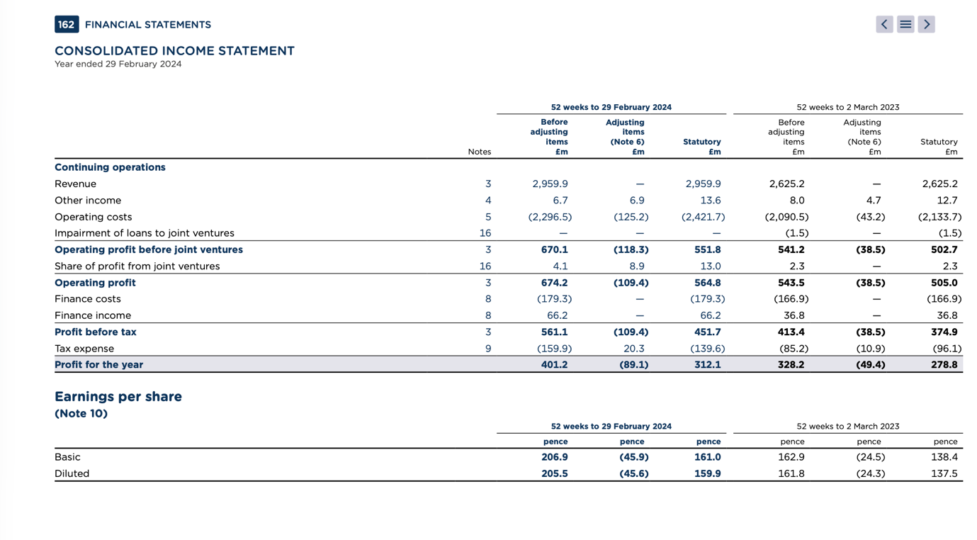
Appendix 2: Consolidated Income Statement 24/25 years
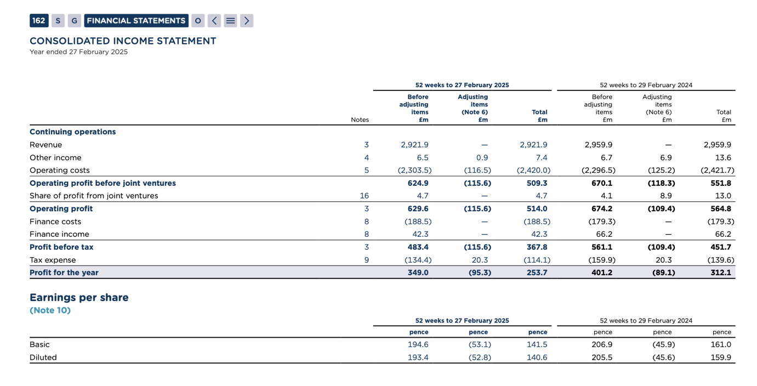
Appendix 3: Consolidated Balance Sheet 24/25 years
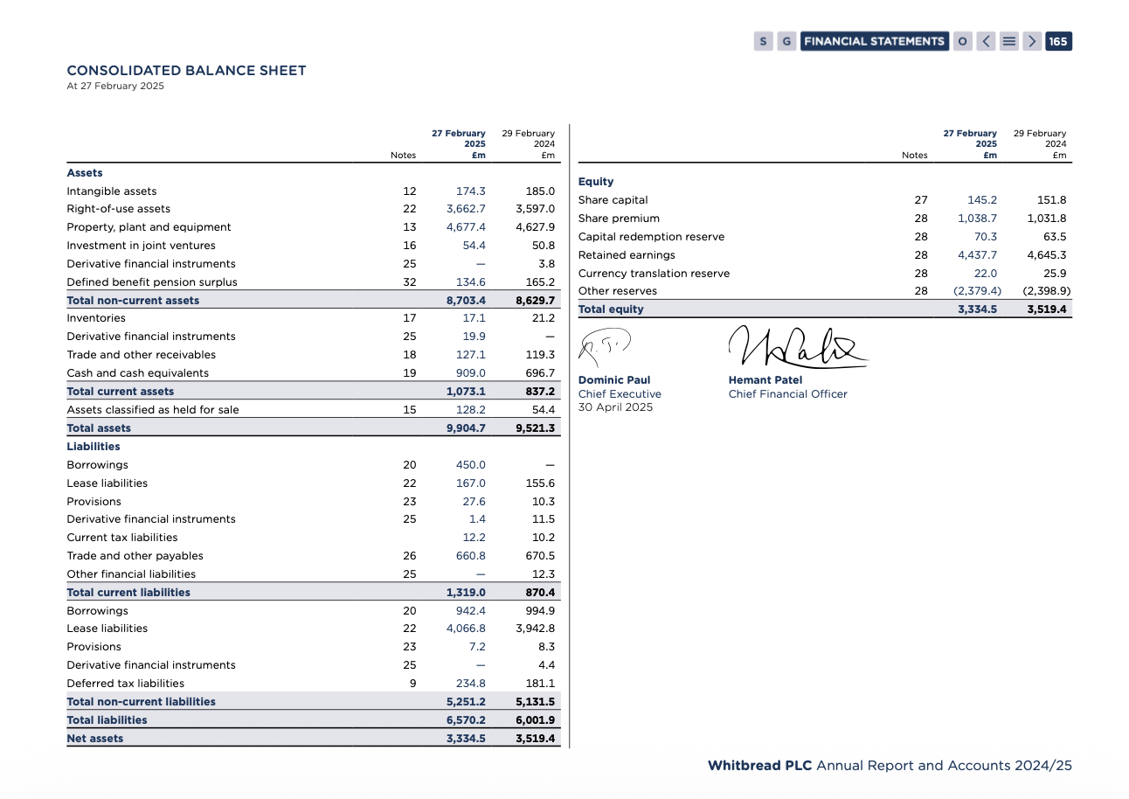
Appendix 4: Consolidated Balance Sheet 23/24 years
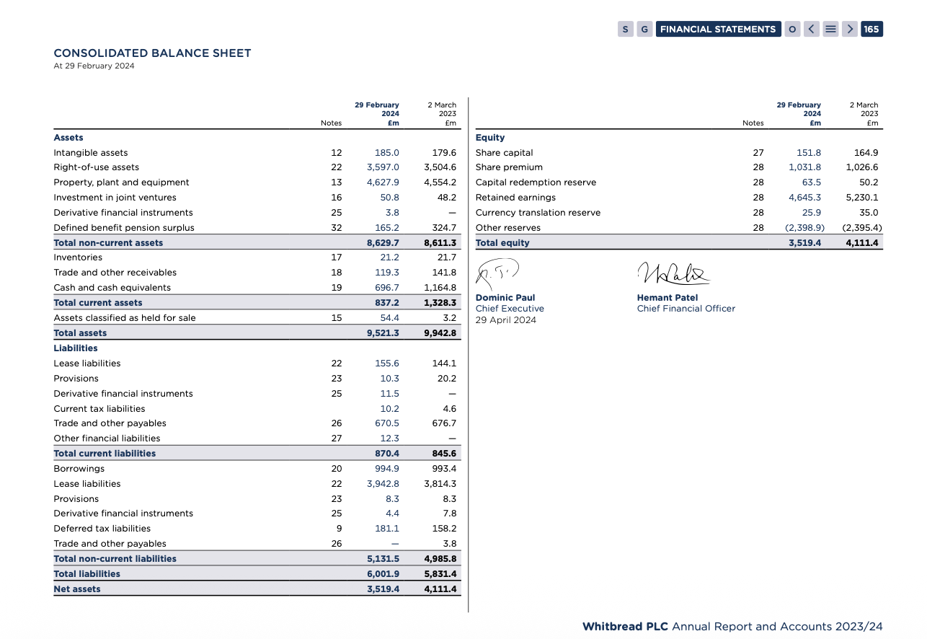
Appendix 5: Earnings per share 24/25
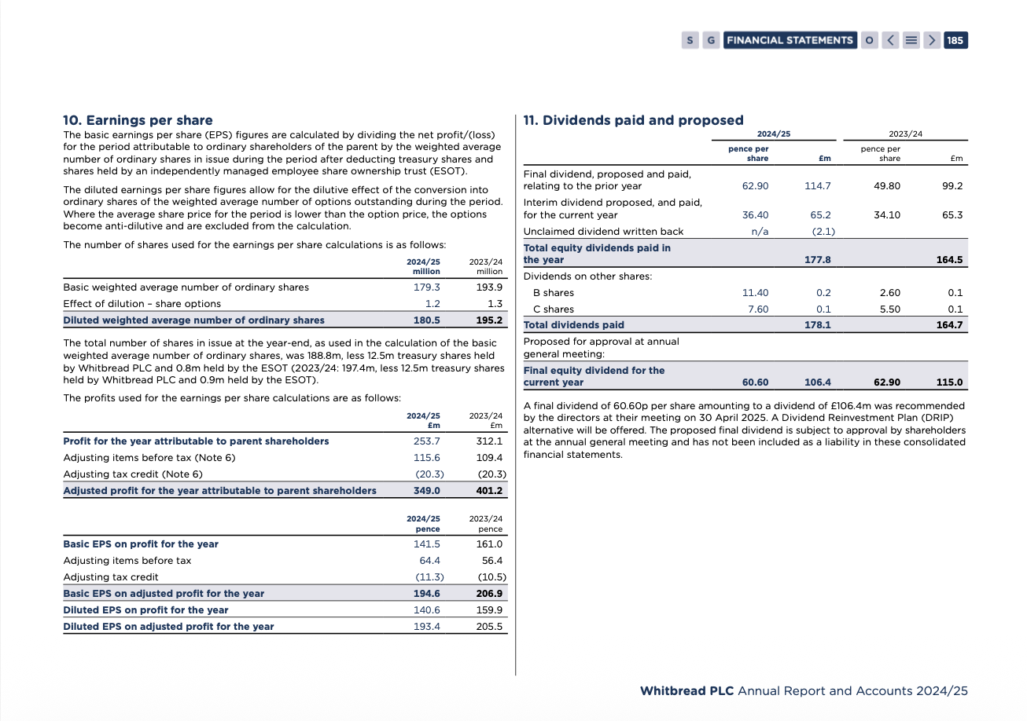
Appendix 6: Earnings Per Share 24/23


