
Business Plan
Managing Enterprise in 21st Century


Student Name: Maria Diana Nita
Student ID:2128458

Executive Summary
A proper business plan is helping to increase the growth of the business in a systematic way, in this topic it is to elaborate the business plan of a new company in the bakery industry. The aims, objectives, as well as legal status of the business, are discussed in the below section briefly. This new business called Super-Bakery would be established as a new food and beverage outlet that would serve baked products such as desserts, cakes, sandwiches, and fresh ground cafes. In addition to this, the business plan entails taking into account a particular marketing strategy and in addition to highlighting the sources from which funding would take place.

Task 1

Introduction
According to Phillipson et al., (2019, p. 235), a business plan is one type of document that defines in detail an organisation’s objectives as well as how it plans in order to achieve its both short-term and long-term goals. A business plan allows an entrepreneur to arrange significant parts of a new business from the moment it is created. The activity of a business plan entails allocating into activities of operation, investing activities, and activities of finance. The actions of operations are the most important part as it directly impacts the business performance.

Business overview
The proposed business plan would be Super-Bakery that would create and sell baked food that is flour-based in an oven like cookies, bread, cakes, pastries, pies, and donuts. This bakery would be utilized as a retail business from a physical outlet in the form of a store that sells goods of baked nature to customers, or it could be built as a wholesale business that sells baked goods to food institutions and retailers. Super-Bakery would also deliver to the customers in the form of catering and deliveries. In addition to this, this bakery would also serve as a cafe and cake shop for the customers.

Business Name
The name of this business is Super-Bakery which would involve selling various food items like desserts, sandwiches, fresh ground cafes, and cakes. In addition to this, the bakery would serve catering services and deliver food items directly to customers in specific circumstances. It would also serve as a cafe and cake shop for customers.

Legal status
As per Ritter and Schanz (2019, p. 325), the legal structure of this business would be of a sole proprietorship or sole trader ship because in this way the business person gets to keep all the profits to himself. A sole trader business does not have any separate legal identity from its owner. The advantage of sole trader ship is that it is easy to set up along with getting to keep all the profits that are earned from business transactions. In addition to this, the sole trader makes all the decisions in this business. The limitations are in the form of difficulty in raising money along with unlimited liability.

Service
Super-Bakery would sell various sorts of bakery products such as cakes, deserts, fresh ground cafes and sandwiches. In addition to this, the bakery would also operate catering services and deliver food items directly to customers under specific situations. Moreover, the bakery would not just serve as a bakery but also as a cafe and cake shop for the customers.

Aims
The aim of Super-Bakery is to expect a collection of a number of regular customers via offering a broad range and varied products such as cakes, desserts, sandwiches, and fresh ground cafes along with easy accessibility of prices. It aims to satisfy the common health and diet needs of the customers.

Mission statement
The mission of Super-Bakery is to serve good quality bakery products and create joyful, and happy moments in people’s life.

Objectives
The objective of Super-Bakery is as follows-
- To offer new promotions and loyalty cards
- To recruit a sales assistant in a couple of weeks
- To make sweets that contains less calories
- To collaborate and cooperate with a couple of shops within a time period of 2-3 months
- To gain new customers in a new market

Marketing strategy
4Ps of marketing
Product
As cited by Ferrell et al., (2021), Super-Bakery would sell baked food items of various and broad ranges such as cakes, pieces of bread, deserts, sandwiches, and fresh ground cafe. In addition to this, the bakery would also sell pastries, pies, and donuts.
Price
As mentioned by Ali and Anwar (2021), Super-Bakery would follow a competitive pricing strategy in the food and beverage marketplace as it would allow the business to keep benefits through strategically setting the price above, same, or below other competitors in the marketplace. In this way, the business would aim for accessibility of prices.
Place
As per Abiodun and Kolade (2020), the business of Super-Bakery would be based on the location of Rhonda for selling to the customers as Treorchy is a great place for doing business. One other benefit of choosing this location is that first and foremost it would be the only shop in town.
Promotion
As opined by Sheth (2021, p. 11), Super-Bakery for its promotion would use both traditional and non-traditional forms of promotion. It would utilize social media platforms such as Instagram, Facebook, and its own website to promote its products. In addition to this, the business would use radio advertising and leaflets to promote awareness of its brand as well as its products.

STP
Segmentation
As postulated by Liu et al., (2019), the customers of Super-Bakery would be segmented into geographical and demographic segmentation. Demographic in the form of age, location and income and geographic by location and country.
Target market
Age group | 13-65 years
Income group | Lower middle to high income
Target location | Rhonda, Treorchy.

Positioning
Super-Bakery would serve high quality baked goods within an affordable price range.
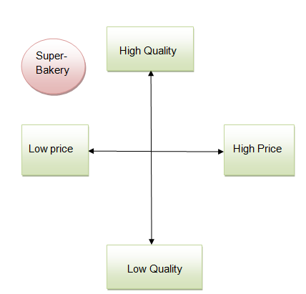
Figure 1: Positioning Map
(Source: Developed by the Learner)

Location
Super-Bakery would be located in Rhonda for promoting its business. The specifications of this location are 114 Bule St, Treorchy CF42 6AU and almost 7,681 people live in this area. It has been observed that there are a minimum number of bakery shops in Rhonda and for this reason, Super-Bakery would choose this location to grow its business as well as reach its target audiences in a proper way. It is also found that Treorchy is one of the greatest locations in order to grow the business in a systematic way. It is expected that Super-Bakery would grow its business properly in this area and expand its business rapidly.

Human Resources
Human resources are playing a vital role in a company to increase productivity as well as efficiency in a systematic way (Das and Devi, 2020, p. 40). Human resources would also play a crucial role in Super-Bakery farms. Human resources managers would recruit as well as select equipped candidates for their business. It can be said that HRM would provide them with the necessary training to increase their skills and knowledge in the corresponding field to increase the productivity of this company in a proper way. Human resources managers would provide workplace safety to the staff members of this company and be aware of their requirements in the work field.

Financial resources
According to erez-Alaniz et al.,(2023), Super-Bakery would finance its business operations through various and wide range of sources of funding such as grants from the government counting as 20% which would assist in establishing the business outlet, free money, and funds for supporting the establishment of new business in the marketplace. In addition to this, the savings of the business person would count as 70% and would serve as a financial resource for setting up the business. Moreover, the business owner would tap into interest-free money or zero-interest loans from the bank for establishing this new business. Additionally, some particular amounts of money along with extra help from family and friends would count as contributing 10% to the business funding.

Costing
The cost of the operations of this new business of Super-Bakery would amount to 35,000 pounds taking into account wages, profits, salary, and other expenses along with rest expenses and transportation costs.

Pricing
As stated by Ali and Anwar (2021), Super-Bakery would utilise a competitive pricing strategy in which the prices of the products such as cakes, desserts, sandwiches, and fresh ground cafes would be based on the prices of the competitors in the food and beverage marketplace. The use of this method is based on the prices of competitors which are public in the food and beverage marketplace but it would not take into consideration the value that customers would put into the products. This particular pricing strategy would also contribute to meeting the aims and objectives of this business establishment in the form of gaining new customers for the new business.

SWOT
Strengths  - Quality of the items  - Low prices  - New flavours extremely visible on main road | Weaknesses  - Increase prices of the items in the recent times  - Lots of resources would be spent on promotion as well as marketing
Opportunities  - Seasonal cakes would be available  - Variety of products  - Specially baker  - Wedding cake | Threats  - Long waiting time  - Cost of ingredients  - Energy cost is rising  - Feedback of customers

Analysis
Strengths: Super-Bakery’s all products would be high quality as well as in low pieces so this company would take a competitive pricing strategy that will be the main strength of this farm. On the other hand, the new flavours of this company are extremely visible on the main road of Rhonda is another strength of this company.
Weaknesses: Increased prices of the bakery products are one of the main weaknesses of this company as well as it has been observed that lots of resources would be spent on marketing and promotion of the business.
Opportunities: Seasonal cake would be available in this bakery shop which would attract more customers, as well as there would be a variety of flavours and sizes that would be the main opportunities of this company.
Threats: Energy cost is rising rapidly in the present times as well as the cost of ingredients would be the main threat to this company.

PESTLE
Factors | Analysis | Impacts
Political | - Government regulation  - Government instability | Strong political structures as well as institutions support the development of new business in the UK (Moorman, 2020, p. 388).
Economical | - GDP rate  - Unemployment rate | The unemployment rate and lower GDP rate would create an issue for the bakery business (Hantzsche et al., 2019, p. 5).
Social | - Changes in lifestyle  - Experiences of Customers | It has been found that changes in the lifestyle of UK people in the aspect of food habits would be one of the opportunities of this company. Customer experiences would play a crucial role in this organization in order to expand its business in a systematic way.
Technological | - Upgraded technology  - Communication and information | Upgraded technology would be used by Super-Bakery to increase the productivity of this company. Hydro bond technology would be applied by Super-Bakery company to make a perfect dough while trying to make bakery items. Bakery companies also use vacuum cooling chambers as it would provide an alternative to traditional cooling procedures (Ranjbaran and Datta, 2019, p. 209).
Legal | - Employment Law 1996  - HSWA Act 2010 | Through Employment Law 1996 as well as HSWA Act 2010, this organization would provide workplace safety to its workers in the workplace.
Environmental | - Needs of environment  - Environmental policy | Super-Bakery would maintain the environmental policy in a proper way to grow the business properly.

Cash flow estimation
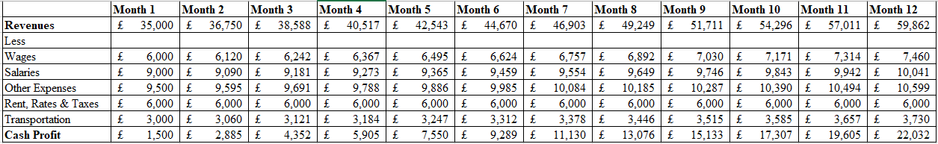
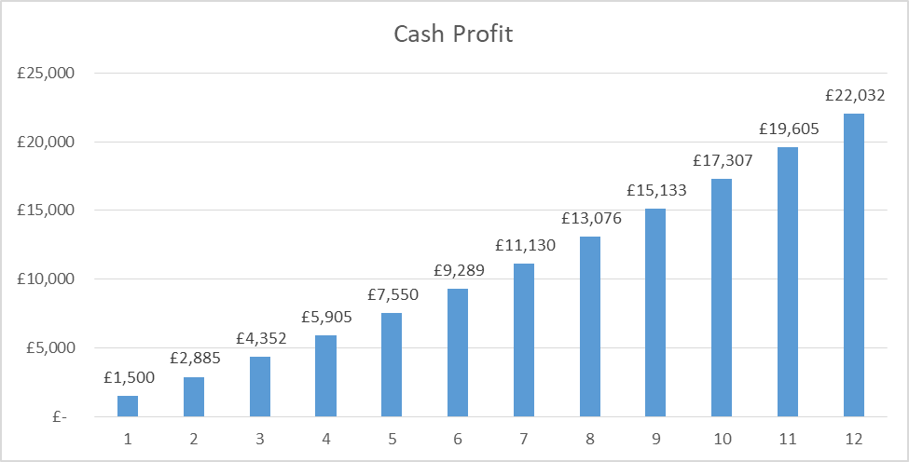
Figure 2: 12 months Cash flow statement
(Source: Developed by author)

Market Research
Researchers have stated that the market size, measured by revenue of the bakery items production industry, is almost 8.5 pounds billion in 2023 (ibisworld.com.2023). It has been observed that the market size of this industry is expected in order to increase by almost 0.5% this year. The market size of the bakery industry in the United Kingdom is faster than the economy total. It can be said that the bakery industry in this country is the 10th ranker manufacturing industry by the size of the market (ibisworld.com.2023). A study has shown that low revenue volatility, as well as demand in supermarkets, are the two primary factors that impact the growth of the bakery industry in the United Kingdom.

Radio Advertising
As cited by Sama (2019, p. 54), radio advertising is the practice of buying ad spots on popular radio stations in order to promote the business in a proper way. It has been observed that there are three types of radio advertising used as well as accepted and these are live road, produced spots as well as sponsorships (Kang et al., 2020, p. 47). Radio provides promotional opportunities as well as influences customers to purchase a product from the company. Super-Bakery would use radio advertising methods to grow its business rapidly as well as reach its target customers with frequency. Through radio advertising, Super-Bakery would increase its productivity and efficiency properly.

Conclusion
This topic is discussed the business plan of a new company that would operate from Rohinda, Trearochy. In this context, it is also discussed the importance of a business plan as well as the marketing strategy of the company in proper way. SWOT and PESTLE analysis of this company is also discussed briefly in the above section. External environmental factors are regarded as PESTLE analysis, on the other hand, SWOT is regarded as internal environmental factors that affect Super-Bakery in its business. Radio advertising would be a better idea for this company to grow its business in the market.

References
Journals
Abiodun, E.A. and Kolade, O.G., 2020. Marketing strategies impact on organizational performance. International journal of scientific & technology research, 9(1), pp.1758-1762. https://www.researchgate.net/profile/Anthony-Eniola/publication/338924733_Marketing_Strategies_Impact_On_Organizational_Performance/links/5e3335db458515072d70f615/Marketing-Strategies-Impact-On-Organizational-Performance.pdf
Ali, B.J. and Anwar, G., 2021. Marketing Strategy: Pricing strategies and its influence on consumer purchasing decision. Ali, BJ, & Anwar, G.(2021). Marketing Strategy: Pricing strategies and its influence on consumer purchasing decision. International journal of Rural Development, Environment and Health Research, 5(2), pp.26-39. https://aipublications.com/uploads/issue_files/4IJREH-APR20212-Marketing.pdf
Das, R.C. and Devi SC, A., 2020. Conceptualizing the Importance of HR Analytics in Attrition Reduction. International Research Journal on Advanced Science Hub, 2, pp.40-48. https://rspsciencehub.com/article_1400.html
Hantzsche, A., Kara, A. and Young, G., 2019. The economic effects of the UK government's proposed Brexit deal. The World Economy, 42(1), pp.5-20. https://onlinelibrary.wiley.com/doi/abs/10.1111/twec.12770
Kang, J.A., Hong, S. and Hubbard, G.T., 2020. The role of storytelling in advertising: Consumer emotion, narrative engagement level, and word‐of‐mouth intention. Journal of Consumer Behaviour, 19(1), pp.47-56. https://onlinelibrary.wiley.com/doi/abs/10.1002/cb.1793
Liu, J., Liao, X., Huang, W. and Liao, X., 2019. Market segmentation: A multiple criteria approach combining preference analysis and segmentation decision. Omega, 83, pp.1-13. https://www.sciencedirect.com/science/article/pii/S0305048317306503
Moorman, C., 2020. Commentary: Brand activism in a political world. Journal of public policy & marketing, 39(4), pp.388-392. https://journals.sagepub.com/doi/pdf/10.1177/0743915620945260
Perez-Alaniz, M., Lenihan, H., Doran, J. and Hewitt-Dundas, N., 2023. Financial resources for research and innovation in small and larger firms: Is it a case of the more you have, the more you do?. Industry and Innovation, 30(2), pp.189-232. https://www.tandfonline.com/doi/pdf/10.1080/13662716.2022.2036597
Phillipson, J., Tiwasing, P., Gorton, M., Maioli, S., Newbery, R. and Turner, R., 2019. Shining a spotlight on small rural businesses: How does their performance compare with urban?. Journal of Rural Studies, 68, pp.230-239. https://www.sciencedirect.com/science/article/pii/S0743016717312548
Ranjbaran, M. and Datta, A.K., 2019. Pressure-driven infiltration of water and bacteria into plant leaves during vacuum cooling: A mechanistic model. Journal of Food Engineering, 246, pp.209-223. https://www.sciencedirect.com/science/article/pii/S0260877418304758
Ritter, M. and Schanz, H., 2019. The sharing economy: A comprehensive business model framework. Journal of cleaner production, 213, pp.320-331. https://www.researchgate.net/profile/Martin-Ritter/publication/329778650_The_sharing_economy_A_comprehensive_business_model_framework/links/5c6e7aeba6fdcc404ec2190e/The-sharing-economy-A-comprehensive-business-model-framework.pdf
Sama, R., 2019. Impact of media advertisements on consumer behaviour. Journal of Creative Communications, 14(1), pp.54-68. https://journals.sagepub.com/doi/pdf/10.1177/0973258618822624
Sheth, J., 2021. New areas of research in marketing strategy, consumer behavior, and marketing analytics: the future is bright. Journal of Marketing Theory and Practice, 29(1), pp.3-12. https://www.researchgate.net/profile/Jagdish-Sheth/publication/348399244_New_areas_of_research_in_marketing_strategy_consumer_behavior_and_marketing_analytics_the_future_is_bright/links/6021f92392851c4ed55b8471/New-areas-of-research-in-marketing-strategy-consumer-behavior-and-marketing-analytics-the-future-is-bright.pdf

Website
ibisworld.com.2023 IBISWorld. Available at: https://www.ibisworld.com/united-kingdom/market-size/bread-bakery-goods-production/ (Accessed: March 14, 2023).
Books
Ferrell, O.C., Hartline, M. and Hochstein, B.W., 2021. Marketing strategy. Cengage Learning. https://books.google.com/books?hl=en&lr=&id=SewfEAAAQBAJ&oi=fnd&pg=PP1&dq=marketing+strategies&ots=PgVBBAHe6c&sig=dEu7cOHG08hl8H-D_Lwo6lRmK3Q

