

University of Wales Trintiy Saint David

‘2D Diffusion Equation model using the Explicit Finite Difference Method (Report)’
Computational Methods

Taylor Davies (2214080)
27/01/2025

Table of Contents
1. Introduction 4
2.1 The governing equation of the problem 5
2.2 Background Information 5
2.2 What is the heat equation and its Importance 5
2.3 Mathematical Definition for a 2D Geometry with No Heat Source Term 6
3 Numerical method chosen to discretise the governing equation. 7
As the governing equation has been defined, parameters that will be used within the heat transfer mathematical model which is the Explicit Finite Difference Method can be generated. The Taylor Series is used to generate difference approximations for first and second derivatives. 7
3.1 Starting Point: Taylor series 7
3.1.1 Taylor Series Expansion 7
3.2 Derivation of Difference Approximations 7
3.2.1 Forward Difference Approximation 7
3.2.2 Backward Difference Approximation 8
3.2.3 Central Difference Approximation 8
3.2.4 Central Difference Approximation to the 2nd Derivative 9
3.3 Explicit Finite Difference Scheme 9
3.3.1 Spatial Second Derivatives 9
3.3.2 Temporal First Derivatives 10
3.4 Discretion of the Spatial Domain 10
3.5 Discretisation of the Temporal Domain 10
3.6 Explicit Finite Difference Form of the Heat Equation 10
3.6.1 Introduction of the Fourier number 11
3.7 Stability Criterion 11
4. The initial, boundary conditions and analytical solution. 11
4.1 Initial Domain Condition 11
4.2 Constant Boundy Conditions 11
4.3 Analytical Solution 12
6. Validation of the code. 18
7. Sensitivity analysis of the code. 20
7.1 Grid Spacing 20
7.2 Time Step 21
7.3 Tolerance 22
8 Main model’s limitations. 23
8.1 Limitations due to the Numerical Method: 23
8.1.1 Round-Off Error 23
8.1.2 Truncation Error 23
8.1.3 Complex Geometry 23
8.1.4 Stability 23
8.2 Limitations due to the coding 23
9 Suggested improvements and future developments. 24
10 Conclusion. 25
11. References. 26
12. Appendix. 27

Figure 1: Parabolic Heat Equation (R and G, 1977) 7
Figure 2: Heat Equation with no internal Heat source 7
Figure 3: Discretised form of the heat equation (Lienhard V and Lienhard IV, 2024) 9
Figure 4: Derivation of Taylor Series Expansion in respect to X and Y 10
Figure 5: Time derivative of T using forward difference Approximation 10
Figure 6: Finite Difference Form of Heat Equation 11
Figure 7: Summary of Boundary Conditions 13
Figure 8: Analytical Solution of temperature distribution (Chang and Ma, 2001) 13
Figure 9: Physical Constants 14
Figure 10: User input for plate dimension 15
Figure 11: Initialising Matrix 15
Figure 12: Temperature input and boundary condition 16
Figure 13: Timestep and Fourier Number 16
Figure 14: Thermal Equilibrium Loop 17
Figure 15: Displaying time taken to reach thermal equilibrium 17
Figure 16: Analytical Solution 18
Figure 17: Displaying all results in command window 18
Figure 18: Numerical Solution 19
Figure 19: Analytical Solution 19
Figure 20: Error Map 20
Figure 21: Graph Displaying results in Table 1 21
Figure 22: Graph Displaying Results in Table 2 22
Figure 23: Graph Displaying Results in Table 3 23

Introduction
This report explores the numerical modelling of heat conduction using the explicit finite difference method (FDM). The heat equation, a fundamental concept in heat transfer introduced by Joseph Fourier, describes the distribution of thermal energy over time in each domain. The report covers the mathematical formulation of the heat equation for a two-dimensional geometry without heat sources and details the discretisation process using Taylor series expansions. Key aspects such as initial and boundary conditions, code implementation, validation, and sensitivity analysis are examined. Limitations related to numerical accuracy and computational efficiency are discussed, along with potential improvements, including advanced numerical techniques and optimisation strategies to enhance the model's stability and accuracy for future applications.

The governing equation of the problem

Background Information
The heat equation is a pivotal concept in the study of heat conduction and diffusion processes. It was first introduced by Joseph Fourier in his seminal work, Théorie analytique de la chaleur (The Analytical Theory of Heat), published in 1822. Fourier's work laid the foundation for the field of heat transfer and has since been instrumental in various scientific and engineering applications (Narasimhan, 1999).

2.2 What is the heat equation and its Importance.
The heat equation outlines the distribution of thermal energy within a specific area as time progresses. It is based on the concepts of energy conservation and Fourier's law regarding heat conduction. The equation essentially models how heat diffuses through a material, which is a fundamental process in thermodynamics and heat transfer (Engineer, 2023). The heat equation is shown below:
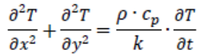
Figure 1: Parabolic Heat Equation (R and G, 1977)

2.3 Mathematical Definition for a 2D Geometry with No Heat Source Term
For a two-dimensional (2D) region with no internal heat sources, the heat equation is given by:
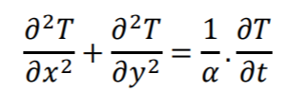

Figure 2: Heat Equation with no internal Heat source.

Numerical method chosen to discretise the governing equation.

As the governing equation has been defined, parameters that will be used within the heat transfer mathematical model which is the Explicit Finite Difference Method can be generated. The Taylor Series is used to generate difference approximations for first and second derivatives.

3.1 Starting Point: Taylor series.
To generate the difference approximations for first and second derivatives, the Taylor Series expansions are used. This is required for the forward, backward, central, and central to the second-order derivative approximations.

3.1.1 Taylor Series Expansion
The Taylor series expansion for a function $f(x)$ around a point $(x_{0})$is given by:
$$f\left(x\right)=f\left(x_{0}\right)+f^{'}\left(x_{0}\right)\frac{(x-x_{0})}{1!}+f^{''}\left(x_{0}\right)\frac{{(x-x_{0})}^{2}}{2!}+…+\sum_{n=0}^{∞}{f^{(n)}(x0)\frac{{(x-x_{0})}^{n}}{n!}}$$

3.2 Derivation of Difference Approximations
Using the Taylor series, we can derive the forward, backward, and central difference approximations.

3.2.1 Forward Difference Approximation
Using the Taylor Series expansion at $(x_{0})$ and $(x_{0}+h)$:
$$f\left(x_{0}+h\right)=f\left(x_{0}\right)+f^{'}\left(x_{0}\right)\frac{h}{1!}+{f^{''}\left(x_{0}\right)\frac{h}{2!}}^{2}+{f^{'''}\left(x_{0}\right)\frac{h}{3!}}^{3}+…$$
From this the equation can be rearranged to isolate $f\left(x_{0}\right)$ which will allow to subtract $f\left(x_{0}\right)$ from both sides.
$$f\left(x_{0}+h\right)=f\left(x_{0}\right)+hf^{'}\left(x_{0}\right)+\frac{h^{2}}{2!}+{f^{''}\left(x_{0}\right)+\frac{h}{3!}}^{3}f^{'''}\left(x_{0}\right)+…$$
To then obtain the forward difference approximation for the derivative is then completed by dividing both sides by ‘h’:
$$\frac{f\left(x_{0}+h\right)-f\left(x_{0}\right)}{h}=f^{'}\left(x_{0}\right)+\frac{h}{2!}+{f^{''}\left(x_{0}\right)+\frac{h}{3!}}^{2}f^{'''}\left(x_{0}\right)+…$$
The forward difference approximation for the first derivative is then the following: $f^{'}\left(x_{0}\right)≈ \frac{f\left(x_{0}+h\right)-f\left(x_{0}\right)}{h}$

3.2.2 Backward Difference Approximation
For the backward difference approximation we expand at $(x_{0})$ and $(x_{0}-h)$:
$$f\left(x_{0}-h\right)=f\left(x_{0}\right)-hf^{'}\left(x_{0}\right)+{\frac{h}{2!}}^{2}f^{''}\left(x_{0}\right)-{{\frac{h}{3!}}^{3}f}^{''}\left(x_{0}\right)+…$$
The following equation is then rearranged:
$$\frac{f\left(x_{0}-h\right)-f\left(x_{0}\right)}{h}{=-f}^{'}\left(x_{0}\right)+\frac{h}{2!}+{f^{''}\left(x_{0}\right)-\frac{h}{3!}}^{2}f^{'''}\left(x_{0}\right)+…$$
The backward difference approximation for the first derivative is then:
$$f^{'}\left(x_{0}\right)≈ \frac{f\left(x_{0}\right)-f\left(x_{0}-h\right)}{h}$$

3.2.3 Central Difference Approximation
For the central difference approximation, we consider the expansions at $(x_{0}+ h)$ and $(x_{0}-h)$:
$$f\left(x_{0}+h\right)=f\left(x_{0}\right)+hf^{'}\left(x_{0}\right)+\frac{h^{2}}{2!}+{f^{''}\left(x_{0}\right)+\frac{h}{3!}}^{3}f^{'''}\left(x_{0}\right)+…$$
$$f\left(x_{0}-h\right)=f\left(x_{0}\right)-hf^{'}\left(x_{0}\right)+{\frac{h}{2!}}^{2}f^{''}\left(x_{0}\right)-{{\frac{h}{3!}}^{3}f}^{''}\left(x_{0}\right)+…$$
To isolate the first derivative $f^{'}\left(x_{0}\right)$ the two equations need to be added as shown:
$$f\left(x_{0}+h\right)-f\left(x_{0}-h\right)=2[hf{\left(x_{0}\right)+\frac{h}{3!}}^{3}f^{'''}\left(x_{0}\right)+…]$$
This can then be simplified into the following equation:
$$\frac{f\left(x_{0}+h\right)-f\left(x_{0}-h\right)}{2h}{=-f}^{'}\left(x_{0}\right)+{\frac{h}{3!}}^{2}f^{'''}\left(x_{0}\right)+…$$
From this the central difference approximation can be created:
$$f^{'}\left(x_{0}\right)≈ \frac{f\left(x_{0}+h\right)-f\left(x_{0}-h\right)}{2h}$$

3.2.4 Central Difference Approximation to the 2nd Derivative
Following a procedure similarly to the one show we can derive the central approximation to the second derivative by adding the two approximations:
$$f\left(x_{0}+h\right)=[f\left(x_{0}\right)+hf^{'}{\left(x_{0}\right)+\frac{h}{2!}}^{2}f^{''}\left(x_{0}\right){+\frac{h^{3}}{3!}f}^{'''}\left(x_{0}\right)+…]$$
$$f\left(x_{0}-h\right)=[f\left(x_{0}\right)-hf^{'}{\left(x_{0}\right)+\frac{h}{2!}}^{2}f^{''}\left(x_{0}\right){-\frac{h^{3}}{3!}f}^{'''}\left(x_{0}\right)+…]$$
From adding the two approximations we create the following:
$$f\left(x_{0}+h\right)+f\left(x_{0}-h\right)=2[f\left(x_{0}\right)+{\frac{h}{2!}}^{2}f^{''}\left(x_{0}\right){+\frac{h^{4}}{4!}f}^{(4)}\left(x_{0}\right)+…]$$
The equation is this rearranged to the following:
$$\frac{f\left(x_{0}+h\right)-2f\left(x_{0}\right)+f\left(x_{0}-h\right)}{h^{2}}{=f}^{'}'\left(x_{0}\right)+{\frac{h}{12}}^{2}f^{(4)}\left(x_{0}\right)+…$$
Then finally this allows to create the central difference approximation to the 2nd derivative:
$$f^{''}\left(x_{0}\right)≈ \frac{f\left(x_{0}+h\right)-2f\left(x_{0}\right)+f\left(x_{0}-h\right)}{h^{2}}$$

3.3 Explicit Finite Difference Scheme
The following section shows the discretisation for the spatial and temporal domains. Below is the discretised form of the heat equation which will be used within the heat transfer model.
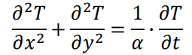
Figure 3: Discretised form of the heat equation (Lienhard V and Lienhard IV, 2024)

3.3.1 Spatial Second Derivatives
The objective is to use the central difference method, a numerical approach for approximating derivatives using values at surrounding sites, to approximate the second derivatives of T. The two equations below are derived from the Taylor series expansion in respect to X and Y.
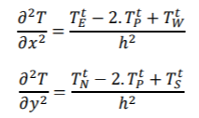
Figure 4: Derivation of Taylor Series Expansion in respect to X and Y

3.3.2 Temporal First Derivatives
The time derivative of temperature T is approximated using the forward difference method, given by the equation:
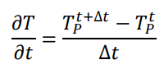
Figure 5: Time derivative of T using forward difference Approximation.
This formula provides an estimate of how the temperature T at point P changes over time.

3.4 Discretion of the Spatial Domain
To calculate temperature data, the spatial domain discretisation process divides the physical region into smaller grid points. The numerical solution of the heat equation cannot be implemented without this procedure. In this instance, a mesh of grid points in both the x and y axes is used to set up the two-dimensional spatial grid.
A particular temperature value will be represented by each grid point, which will be updated iteratively in accordance with the numerical technique used. The central difference method will be used to approximate the second derivative in both the x and y dimensions.

3.5 Discretisation of the Temporal Domain
Temperature readings are updated at brief intervals across time as part of the temporal domain discretisation process. We must estimate the first derivative in relation to time because the heat equation is time dependent.
Until the system reaches thermal equilibrium or the target time is reached, the simulation iterates over time, updating the temperature at each grid point.

3.6 Explicit Finite Difference Form of the Heat Equation
Using the equations shown above these can now be inputted back into the heat equation, shown in figure X.
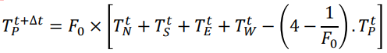
Figure 6: Finite Difference Form of Heat Equation

3.6.1 Introduction of the Fourier number
In transient heat transfer problems, the Fourier number (Fo), a dimensionless number, describes how heat conduction compares to heat storage. In the case of this report, it is the relationship of heat transfer and storage within the aluminium plate. The Fourier numbers equation is shown below:
$$F_{0= \frac{α×∆t }{h^{2}}}$$

3.7 Stability Criterion
The stability requirement for this mathematical model guarantees that the simulation's outcome will always be accurate. The simulation will become unstable if the stability criterion's requirements are not fulfilled, making it a crucial component of the model.
$$0 < F_{0 }< \frac{1}{4}$$

4. The initial, boundary conditions and analytical solution.

4.1 Initial Domain Condition
The following condition states the initial temperature of the plate is uniform (0˚C) with the plate’s dimensions specified with a user input within the script. The objective is to observe the temperature distribution through the plate until it reaches thermal equilibrium.
$$T\left(x,y,0\right)=0 0<x<Xdim 0<y<Ydim$$

4.2 Constant Boundy Conditions
The boundary condition below states that the top row of the matrix will have a temperature which will be inputted by user input in the script and then the bottom row of the matrix will be negative the input.
$$\frac{T\left(x,0,t\right)=-T0}{T\left(x,Ydim,t\right)=T0}\} for 0 ≤ x ≤ Xdim and 0 ≤ t ≤ thermal equilibrium$$

The following Initial and boundary conditions are summarised in Figure X below:
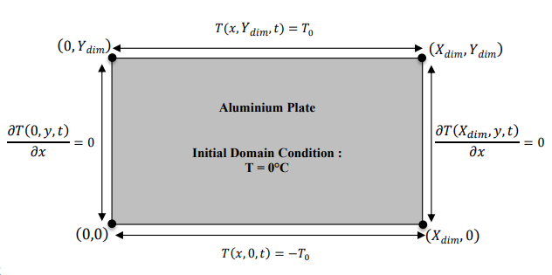
Figure 7: Summary of Boundary Conditions

4.3 Analytical Solution
To verify the code works we will be comparing the numerical solution against the analytical solution. The given equation represents the temperature distribution $T(x,y$) in a rectangular plate in two dimensions with specific boundary conditions. The analytical that is incorporated within the code is:
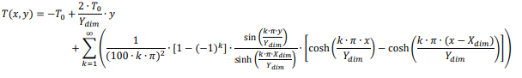
Figure 8: Analytical Solution of temperature distribution (Chang and Ma, 2001)

- Codes’ details and explanations.
This section of the report covers the codes’ details along with explanations saying exactly what the purpose of the code is. The aim of the code is to calculate how long thermal equilibrium takes through an aluminium plate with user temperature and plate sizes inputted.
The first segment of the code involves defining the physical constants for aluminium. These values are then used to calculate thermal diffusivity of the material. The constants defined are thermal conductivity, density, and specific heat capacity.
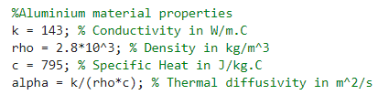
Figure 9: Physical Constants
The next segment of the code covers the users input to specify the dimensions of the aluminium plate and to input the grid spacing. The length and the width of the plate will be inputted in metres (the SI unit) and the grid spacing needs to be a factor of both dimensions. To ensure this is policed a while loop with the ‘rem’ function to ensure that the remainder of the input dimensions and grid spacing is always 0. If an incorrect value is inputted, then the script will ask to specify a different grid spacing.
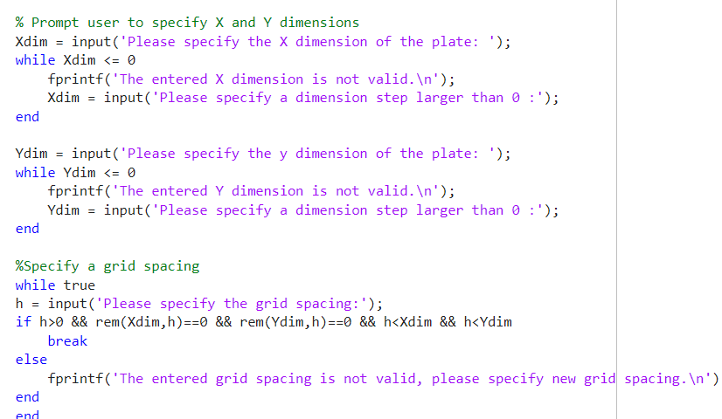
Figure 10: User input for plate dimension.
Following on the next section of the code is used to generate the number of rows and columns based on the dimensions of the plate and the grid spacing. Using the number of rows and columns generated a matrix specified as T1 is created which is filled with zeros. This will allow us to add the required variables which is specified by the user.
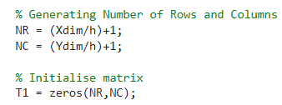
Figure 11: Initialising Matrix
In the code shown in figure X it asks the user to input the temperature desired to be at the north boundary. The boundary conditions are set with user input being applied to the top row and the bottom row to be negative to the user input, for example if the user inputs 50ºC as the North Boundary, the South boundary will be -50ºC.
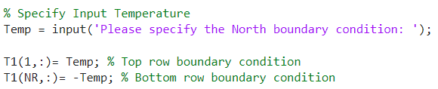
Figure 12: Temperature input and boundary condition.
The code prompts the user to enter a positive timestep. A while loop checks that the timestep is greater than zero; if not, the user is asked to enter a new value. The code then calculates the Fourier number, which must be below 0.25. If it exceeds this limit, the user is prompted to enter a smaller timestep within a calculated limit. Once a valid timestep is provided, the code displays ‘This is a stable Fourier Number.’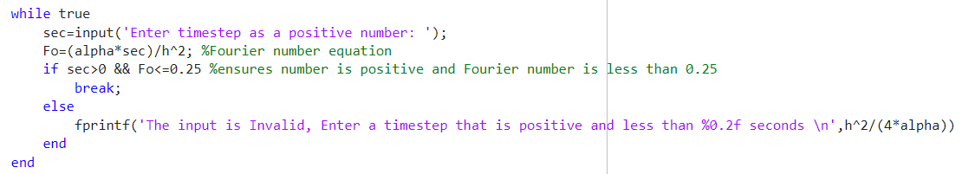
Figure 13: Timestep and Fourier Number
The next part of the code is used to calculate the Numerical Solution for equilibrium to occur through the aluminium plate specified by the user. T2 and T_Prev are initialised in retrospect to T1. A tolerance (CC) is defined, and Error (E) is set to be greater than the tolerance initially. While loop is used which repeats continuously until the highest difference between consecutive temperature matrices falls below the tolerance. The temperature at each grid point is calculated and updated using the finite difference method. Then finally the maximum difference between the revised and previous temperature matrices is determined to assess convergence. Once T2 is calculated this is then displayed in a temperature map using the following code below.
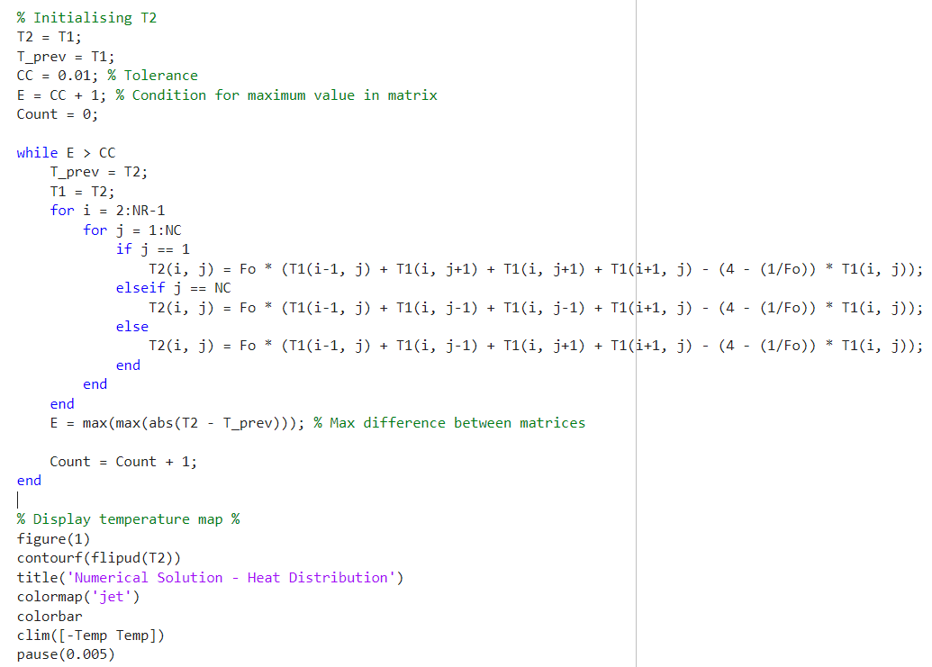
Figure 14: Thermal Equilibrium Loop
The result is also displayed in text format showing how long it will take in seconds and hours for it to reach thermal equilibrium, this is displayed in the code below:
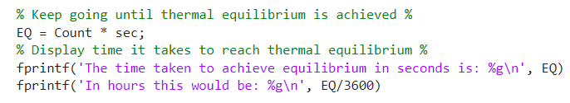
Figure 15: Displaying time taken to reach thermal equilibrium.
To ensure that our code is correct, it has a section which displays the analytical solution. Similarly to the Numerical solution there is a temperature map displayed along with the matrix visually represented within the command window. The analytical solution is initialised used the user inputs for the dimensions of the plate previously in the code and then filled with zeros. The analytical solution is then applied to this matrix allowing for an accurate comparison. This is shown in the code in figure 16.
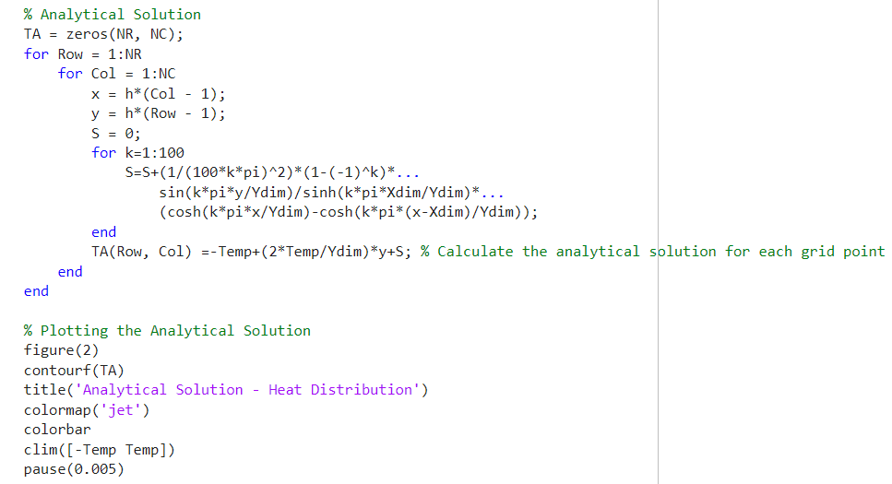
Figure 16: Analytical Solution
Finally, the section shown below calculates the difference between the Numerical and Analytical solution, this just visually shows the user the difference via an ErrorMap and displays the matrix with the error’s showing.
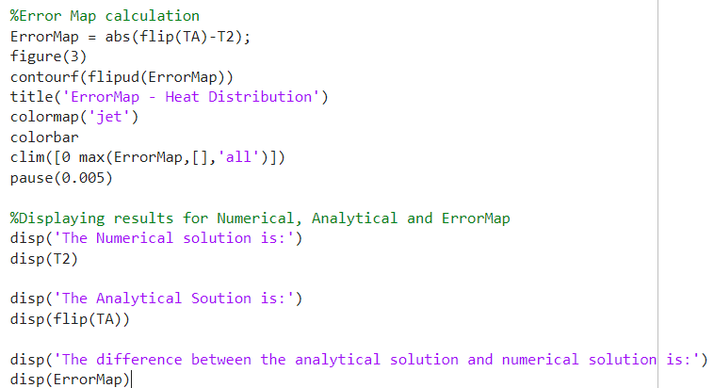
Figure 17: Displaying all results in command window.

Validation of the code.
It is important to validate the code above to ensure it performs as expected. To verify its accuracy, we will run the code and compare the numerical solution with the analytical result.

Validation specifications:
X: 5
Y: 5
North Boundary: 50
Grid Spacing: 1
Time Step: 3600
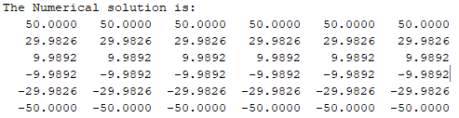

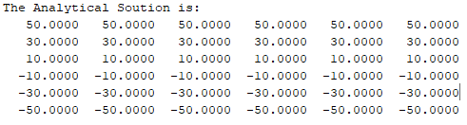

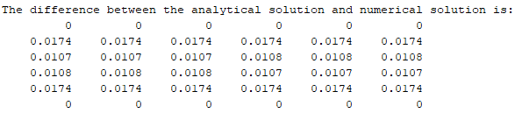
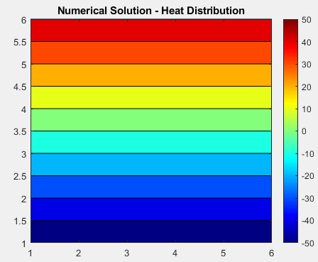
Figure 18: Numerical Solution
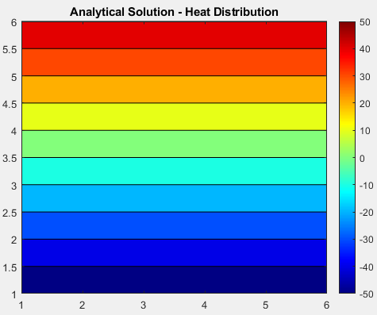
Figure 19: Analytical Solution

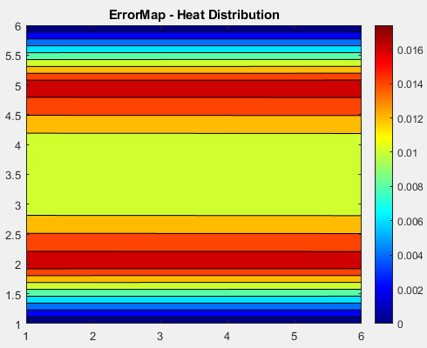
Figure 20: Error Map

From the results above we can see that there is a small discrepancy between the numerical and analytical solution. When displaying the differences in the temperature map it is visually almost identical which is a positive outcome. In the results above we can see an error of 0.0174. In respect to the dimension of the plate this error is acceptable. From the test above it can be determined that the code is validated.

Sensitivity analysis of the code.
Sensitivity analysis is a technique used to determine how different values of an independent variable affect a particular dependent variable under a given set of assumptions.

Grid Spacing
In figure X and X shows the results of the sensitivity analysis to see how thermal equilibrium is affected when adjusting the variable grid spacing. From the results we can see and the grid spacing is reduced the time taken to reach thermal equilibrium is also reduced. This is likely due to more accurate numerical simulations due to a more precise resolution. Numerical methods inherently introduce truncation errors, which could be more significant with coarse grid spacing. These errors can accumulate and lead to discrepancies between the numerical and analytical solution.
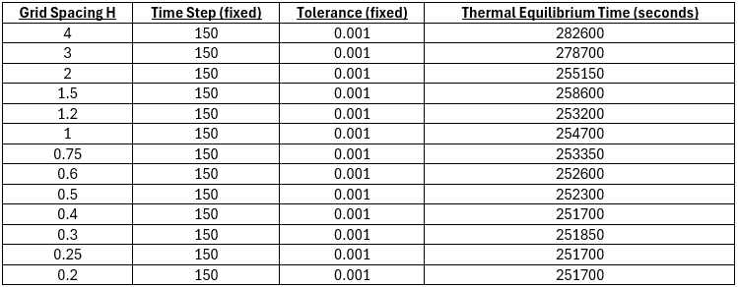
Table 1: Grid Spacing Variable Results
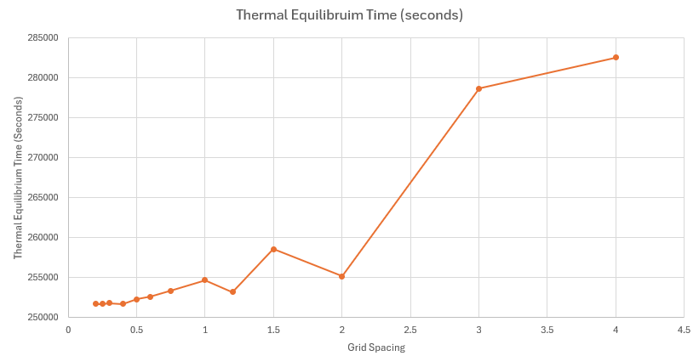
Figure 21: Graph Displaying results in Table 1

Time Step
The time step in the simulation determines the intervals at which the temperature calculations are performed. Larger time steps mean fewer iterations are required to reach equilibrium, but each iteration covers a longer period, potentially leading to less precise results and numerical instability. A factor to consider when deciding on a timestep is that a smaller time step may lead to more iterations however this will also potentially increase the round off error.
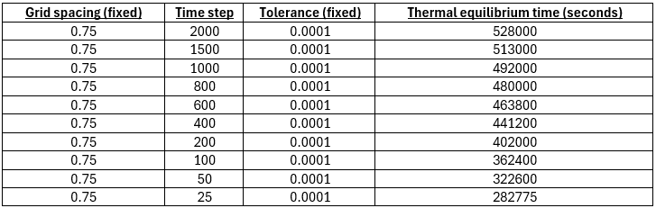
Table 2: Timestep Variable Results

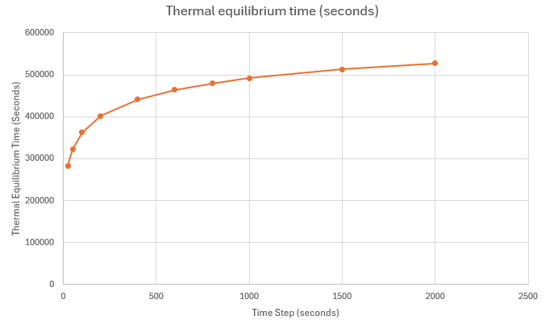
Figure 22: Graph Displaying Results in Table 2

Tolerance

The table's findings demonstrate how the tolerance level and thermal equilibrium time relate to one another in a system with constant grid spacing (h) and time step. The thermal equilibrium time greatly increases as the tolerance lowers. This could be due to stricter tolerances allowing the script to reach a more precise result. Achieving higher precision requires the system to iterate longer to reduce error margins, leading to longer simulation times. On the other hand, having longer run times could result in more round off errors.

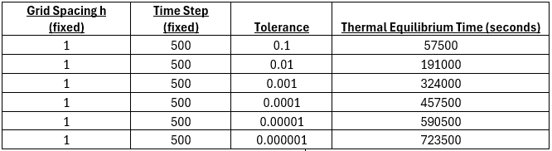
Table 3: Tolerance Variable Results
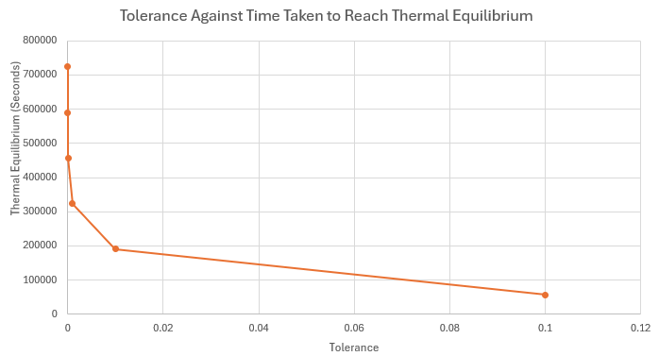
Figure 23: Graph Displaying Results in Table 3

Main model’s limitations.
The script shown above is a great indication of a numerical method however it is not a great display of the physics associated with the heat transfer model. It is important to highlight the limitations of the model.

Limitations due to the Numerical Method:

Round-Off Error
Round off errors are likely to arise since a computational model is being used. This is because outcomes cannot be calculated with infinite precision. Before evaluating the entire phrase, the result must be snapped (rounded) to the closest representable number. Round-off error is the distance between the calculated (intermediate) value and the nearest representable number, which can be half a unit in the last place or, in the worst-case scenario, ulp (unit in the last place) (Solovyev et al., 2019).

Truncation Error
The use of numerical finite-difference approximations to solve partial differential equations is restricted by truncation error. The Taylor series expansions used in the explicit finite difference method to estimate derivatives result in truncation errors. The ignoring of higher-order terms results in truncation error, which causes differences between the analytical and numerical solutions (Lantz, 1971).

Stability
For the explicit finite difference method to be conditionally stable, it must satisfy the Courant-Friedrichs-Lewy (CFL) stability condition. Numerical instability may result from an excessively large time step in relation to the grid spacing, which could cause oscillations or divergence in the solution (Langtangen and Linge, 2016).

Limitations due to the coding
Because large-scale simulations require fine spatial and temporal precision, MATLAB programs that use explicit FDM may become inefficient. Small time steps are necessary for stability in the explicit technique, resulting in many iterations.

Suggested improvements and future developments.
Several enhancements could be taken into consideration to improve the current model. First, using implicit numerical techniques, like fully implicit finite difference methods (FDM) or the Alternating Direction Implicit (ADI) scheme, can improve accuracy and computational efficiency by addressing stability difficulties and enabling bigger time steps (Suárez-Carreño and Rosales-Romero, 2021). We noticed in figure X that the model is extremely sensitive to the tolerance value used within the model.

Investigating different numerical methods such as the Boundary Element Method (BEM), Finite Element Method (FEM), and Finite Volume Method (FVM) could also be an improvement. These techniques offer more adaptability for managing intricate geometries and boundary conditions, which the present finite difference method could find challenging (Baskharone, 2013)
Furthermore, it is essential to improve the method for modelling thermal equilibrium. To obtain more physically relevant findings, energy-based convergence criteria could be added to the current approach, which depends on temperature variations between rounds.
By improving grid resolution in regions with significant temperature variations, adaptive mesh refinement (AMR) can further increase efficiency while preserving accuracy and cutting down on calculation time. Simulations for bigger models may also be accelerated by incorporating parallel computing techniques, such as GPU acceleration.

Conclusion.
In conclusion, this report examined the numerical modelling of heat conduction using the explicit finite difference method. The heat equation was formulated for a 2D domain, and the discretisation process was detailed using Taylor series expansions. The model's accuracy was validated through comparison with analytical solutions, and sensitivity analyses were conducted to assess the impact of grid spacing, time step, and tolerance. While the model provided valuable insights, limitations such as numerical stability and computational efficiency were identified. Suggested improvements include implementing implicit methods, exploring alternative numerical techniques, and optimizing code performance. Overall, the findings highlight the importance of selecting appropriate numerical parameters to achieve reliable and efficient heat transfer simulations for engineering applications.

11. References.

12. Appendix.

