Short Film Production

I approached the process with the intention of understanding filmmaking/editing. I started with learning what it takes to edit which starts with creating a rough edit of the film and edit further to refine. Despite this, the editor required us not to go too crazy on the special effects as we don’t have a big budget, so we need to be aware of what will look realistic. I’ve been researching short films as well as watching a workshop from award winning director and actor Blake Ridder on the strategies of filmmaking to understand how to make mine successful see appendix 1.

As a team we were collaborating successfully with a lot of ideas being developed leading on to 5 creative ideas: The Street/Black Widow, Killer Pandemic, Pandemic, Wylde and Host. It was narrowed down to Wylde and Host, so pitches were created to establish what the audience would prefer to watch leading on to the Host being the favourite and being the most logical for covid friendly.
The summary is 4 friends are in counselling from losing their friend in a car accident they caused, during the session a host appears on screen and causes screens to glitch meaning they will die.The 4 ways each will die is what caused their friend to die such as driving, alcohol, music and phones. The characters are Maddie, Izzy, Adam, William, Host/ the desist and counsellor. Maddie dies through music blaring into her headphones, Izzy through a phone call, Adam being run over by his own car and William with alcohol.

Izzy is a challenging character due to her emotional status from beginning to end which changes from nervous to then fed up too panicked to scared to shock.She hates when maddie is rude as well as the tension between maddie and adam as she feels as though she is in the middle.

I researched the role of a producer through having a video session with Dan Bailey (producer) I wanted to know how a producer works in context with a film see appendix 2. Combined with this new knowledge I decided to explore the role of lighting as I haven’t explored that aspect of the industry and thought it would be a challenge. I have learned the types of lighting and used the knowledge to create a lighted background for each character, see images in appendix 3. The film is set at 4:30 so it will be dark. The lighting I picked for Izzy was key lighting so a lamp to brighten my face, Host low key lighting so a lamp but dimmed and red LED lights to show the audience needs to focus on the host. Maddie backlit but changed to key lighting with lamp, Adam natural lighting of ceiling lights, William natural light and the counselor natural light.
From pitching ideas it was clear we needed to think about the audience and find a way for the narrative to build up and then climax as well as drip feeding the audience information. In addition, how will the quality of the film be affected? could there be a mixture of shots for example a camera shot or a phone shot, as well as considering how the character is portrayed through the camera.

I interlinked techniques from Script and Rehearsal module of eventing, intentions etc, see appendix 4 for images. Furthermore, see appendix 5 for Uta Hagen, background of Izzy.

In the script Izzy is constantly referring to forgiveness, however the background of the bedroom and costume, see appendix 6 for images, gives the impression of her religion so the references were removed.

Despite this, collaboration was important especially as to the order of when each character died. It was decided William will die first as he is drinking from the start. Maddie second as wearing headphones leading onto only her hearing the music, Adam looks out for himself so he closes his laptop and goes outside which leads onto him being run over and then Izzy being the last member and her confessing over her own guilt of innocence. The feedback from Dan and Keiron is to aim for the dialogue of name calling required to be every so often which elucidates more reactions in the deaths, as well as that the quality of overlaying is adequate but I need to concentrate on what I want the audience to emotionally feel rather than with insults.

Through improving Keiron, Brett and Dan was pleased and discussed to the team the insults improved and the quality has stepped up, despite this the reactions within the characters accusing each other of the deaths should be altered as it's harsh to accuse a person of a massive incident.The pacing is important especially between performance and editing such as cut to a bigger screen to make it obvious of the character.

As the script starts off with eulogies it needs to be short I’ve edited mine to start with “Jackson introduced…” so it’s clear to the audience who she is speaking about. As well as this I need to be loose and appear as though I’m moving on. On page 6 Izzy’s line “by forgiving each other” is removed due to the background being transparent to the audience of her religion. To receive additional criticism on the script, showed it to other teams and it was suggested that we aim to consider the camera angles, lighting to pull off this zoom call, but some were unsure of the character William being killed off early as they wanted to learn his characteristic traits further. I understand in an audience perspective why they would want to but to ensure the audience will stay gripped it was decided for less dialogue and more actions. I agreed with the cues needing to be picked up quicker.

Despite this, to ensure my acting is to the highest standards for filming, I will take the independent comments which consist of being careful with my monologue to not make it too emotional to the point I don’t project enough and the dialogue becomes distorted. The intention is right but I need to control the volume for example like I am getting mad in a library to keep the scene alive as well as keeping the naturalistic approach with the distances between me and the camera.

However, during the weeks leading up to the filming day the collaboration of the team became strenuous and I took on the role of producer creating schedules for rehearsals. However, many were not turning up to or were being an hour late; this caused conflicts and reduced rehearsal times. In addition, the contribution of some were inadequate which required more work from the rest of the team, this was apparent in the 2nd pitch. Despite the difficulties the group had the same ambition of creating a successful film which showed in the script and occasionally in rehearsals.

In addition, I contributed with exploring with colours in editing for a pre shoot of Adam, see appendix 7 for images.

Moreover, I was conscious of my monologue as it needed to be as accurate and naturalistic for a confession. I rehearsed through using the technique of filming and watching it back to identify improvements or what to retain, as well as this I was exploring camera angles such as medium shots, see appendix 8. Through the feedback the suggestion of keeping that off centre camera angle with the crucifix however, I will pull back on the crying as are losing the dialogue as am giving away important plot details but keep the fear as I can still be rigid and scared at the same time. I tried it that way and I felt the improvement especially watching back. I continued trying different ways to see the outcome. For example seeing Jackson in the bedroom as if he was there with me, this worked but looked too much and I needed more subtleness. Although, I was happy with the results, I got requested to try another approach of discarding the originals and use shock as well as fear as the driving emotion, and to use a big close up shot as though I am talking to Jackson through the camera, I loved this idea as this was so simple and felt more naturalistic to the character.

Evaluation:

I believe the film was successful as my portrayal of Izzy was clear, however in some scenes the cogherent of fear and concern was lost. To improve when I watch back my independent videos I will critically reflect on it to ensure I am giving the best of my ability. In addition, I noticed the pace of the line“maddie calm down” was not quick enough and coming across staggered, I will improve on this through more rehearsing with my opposing cast member of the scene. In context of the film my character works due to she is the first character to be seen through a caller ID which suggests to the audience this character is involved. Moreover, I found acknowledging and reacting to the glitch difficult as I had to imagine it happening as well as in unison with each other, I felt as though this had been achieved through rehearsing and it came across in the film. Despite this, I have suggested to the editor the option of the current scene of my monologue should be changed to a close up as I felt it was more successful then the scene the editor chose as it doesn’t show the fear and panic of being about to die clearly.
Altogether, I have learnt from the experience nothing is impossible there are no excuses to not create a film as it gives the advantage of being more creative with ideas and to explore techniques such as camera angles etc.

Word count: 1641

Appendix:

- I watched 15 films including the genres of horror, comedy and psychological thrillers to get an idea of how each is portrayed in a variety of ways. Will we do this again is a comedy created over zoom and I found it interesting how it kept the audience compelled while each of them being in 1 space and the main reason was the pace and the difference in what each character brought such as awkwardness.The series Staged had predominantly influenced the decision on filming the piece as well as acknowledging the quality of the zoom needs to be and what lighting works best for the scene. Along with The Interview is a psychological thriller on social control. It captivated me with the quick pace, the circumstance changing instantly from an ordinary interview to a questionable one. Due to the film being horror a film that had similarities towards ours was Rot which was a guy being in a car accident and reliving the moment and getting phone calls that are disgruntled and a woman repeating do you remember? Leading onto becoming an inspiration for our film. Additionally, in Blake Ridder’s workshop I recognised the production process:

Idea
Outline/script
Location, casting, shot list/equipment
Rehearsal, planning
Production
Editing
marketing

That to make a successful film as long as I persisted with these steps the film will come together. I found him inspiring due to going from an extra to an award winning director through his goals, process, networking through youtube and persisting in his career choice.

Furthermore, I wanted to explore a variety of strategies and approaches to filmmaking. For example, on the Learning About Film website it suggested writing the idea in 50 words to ensure the idea is clear but if I can’t do this then I need to rethink my idea. Planning shots and location is vital to knowing how the film is going to be produced especially if it needs to be covid friendly. I will use these techniques when planning and organising especially the 50 words as that will help me to acknowledge if my idea is simple. I also watched 5 tips for shooting a short film by moment on youtube, their first first step is pre production including idea, storyboard, shots, editing ahead of what I want to achieve from the film, the 2nd is gear such as cameras or phones, the 3rd is communicating your idea which is vital to creating a project, the 4th is be flexible as during filming an actor might not be able to perform or the weather could interrupt, the 5th is post-production which involves editing.I already knew being flexible is important as well as communicating but I never thought of processing editing at the beginning which I will use this idea throughout the journey.

- Through email Dan explained types of producers. A producer is ahead of the project and is from the beginning to the end including sales, distribution, premiers/screenings but not editing. But, on a feature film the producer could be on the same film for up to 5 years based on the size and success of it. Additionally, the director or writer will have to discuss with the producer before any changes can be made to the script or casting as the producer is in rehearsals. Another type of producer is a production manager where they will recruit the crew, book catering, accommodation etc. The organisation goes straight through line producers and production managers. I have never explored in-depth producers but from the talks and email it has got me interested in exploring this side of the industry.

- Lighting background images
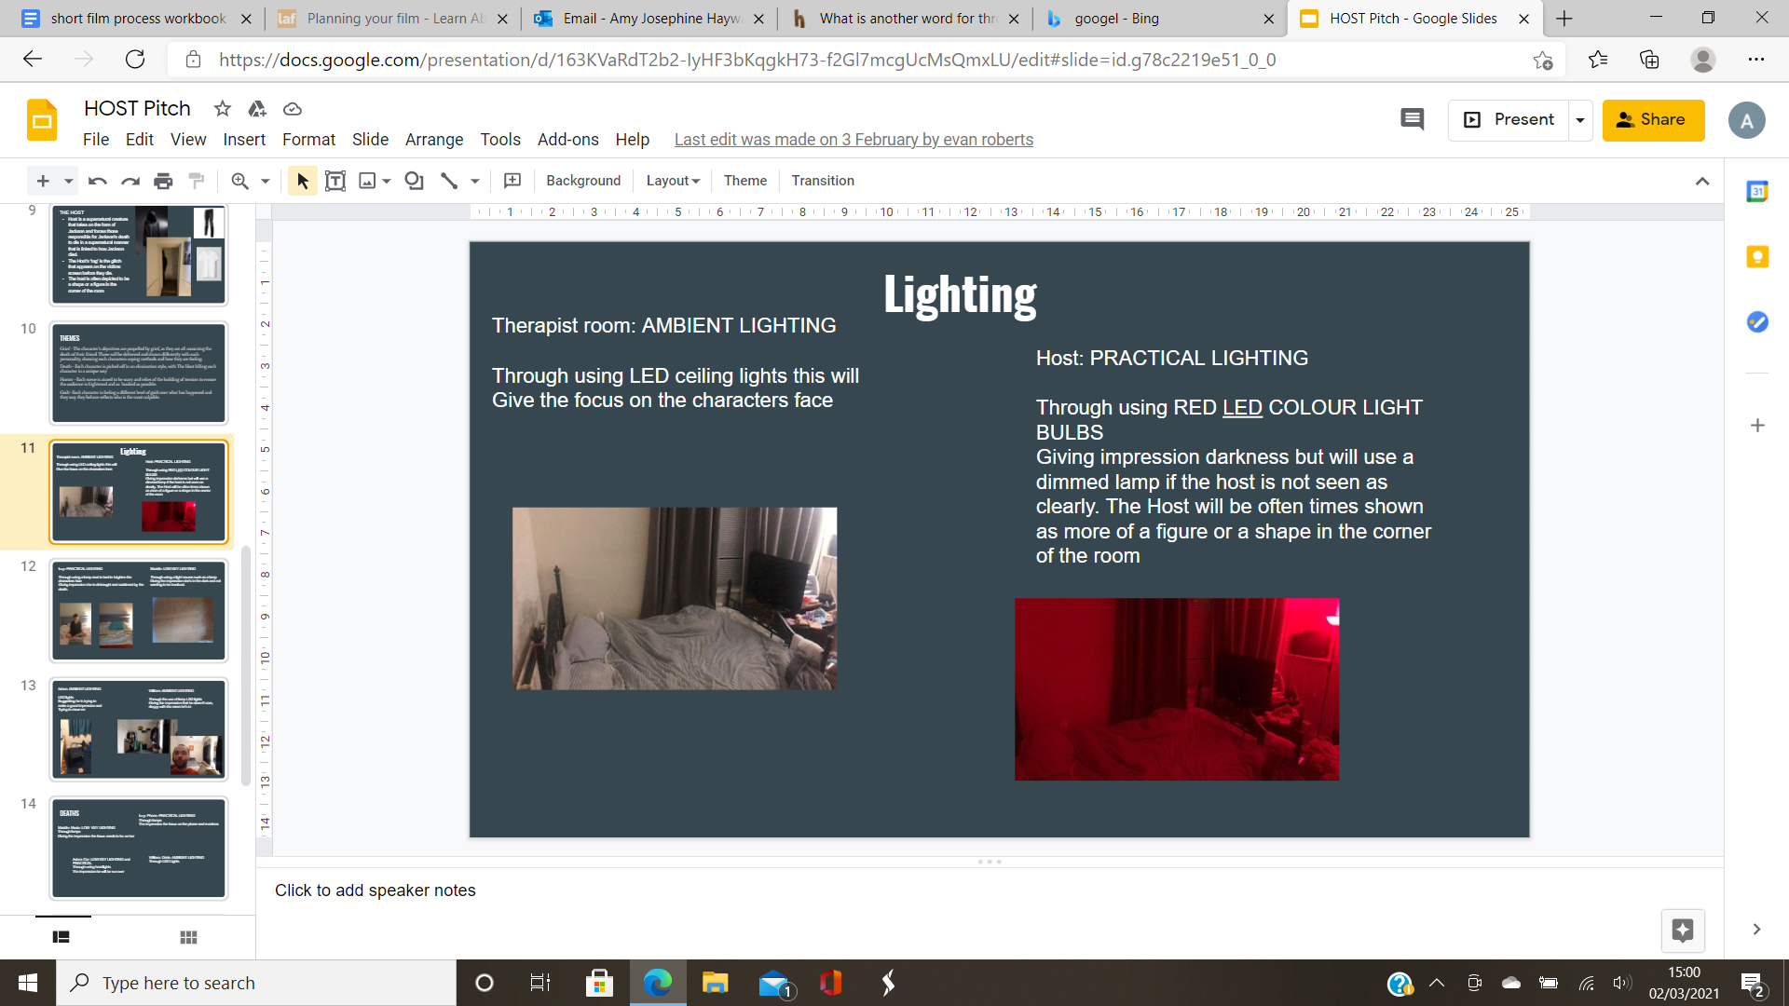
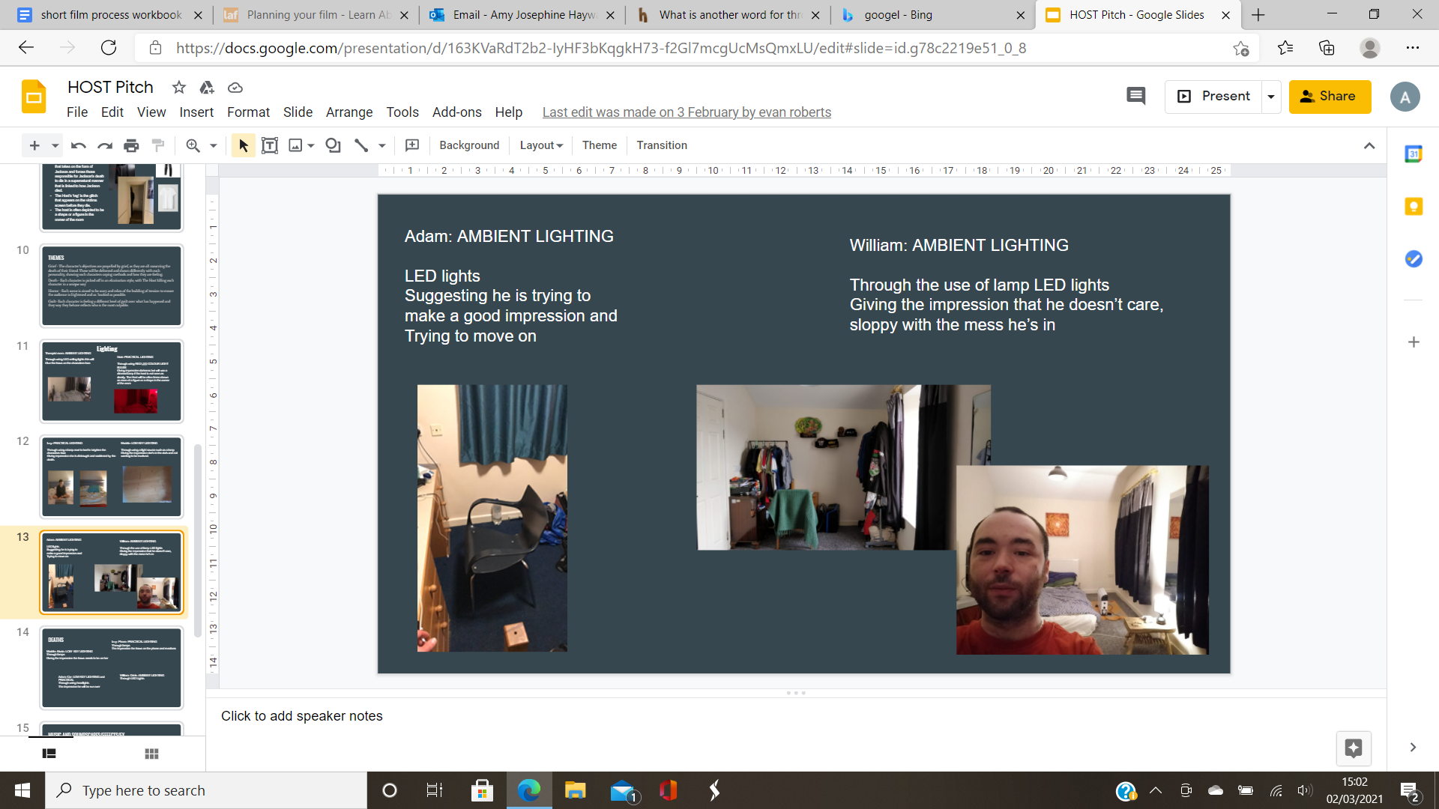
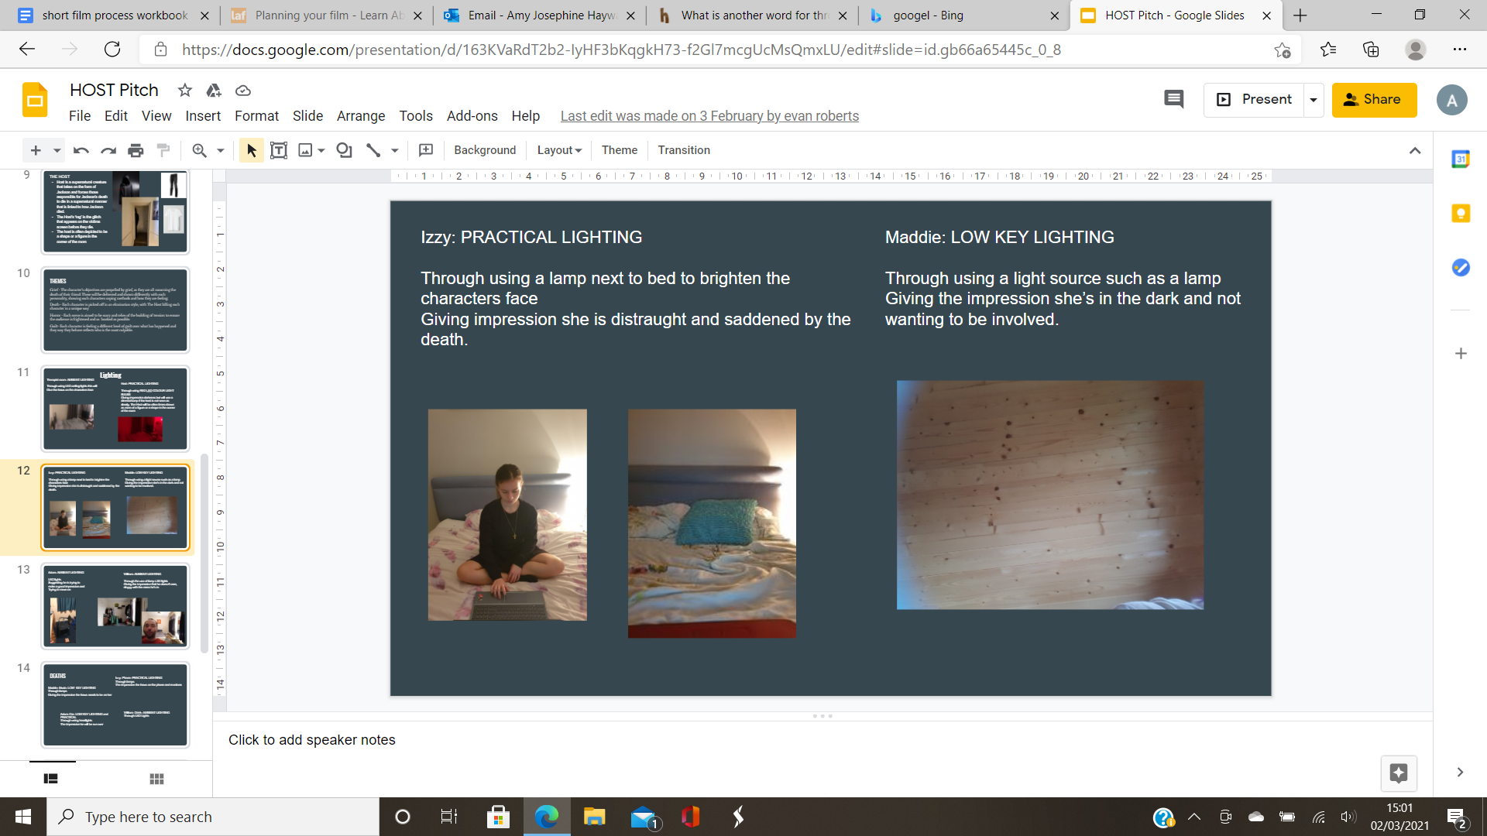
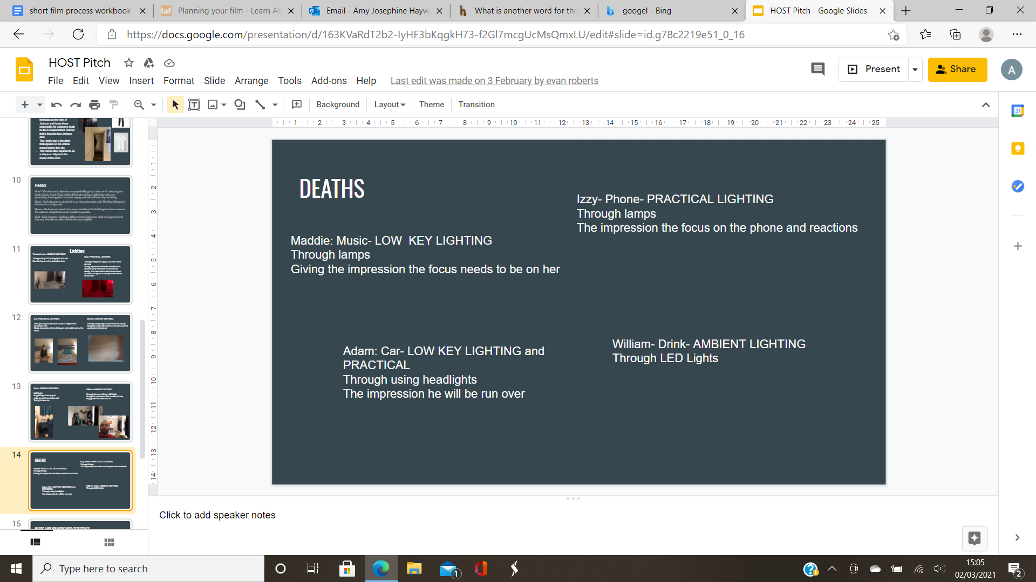

- Images of eventing script

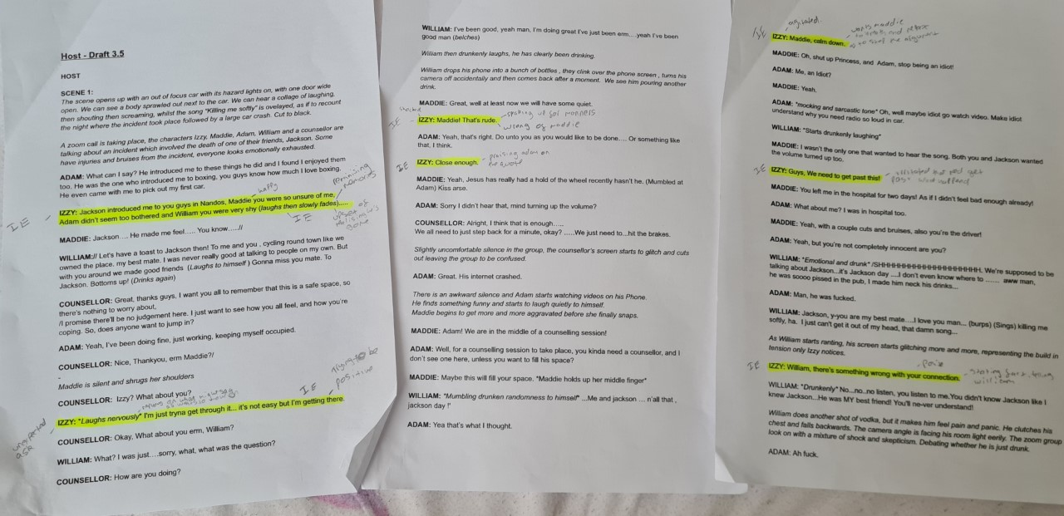

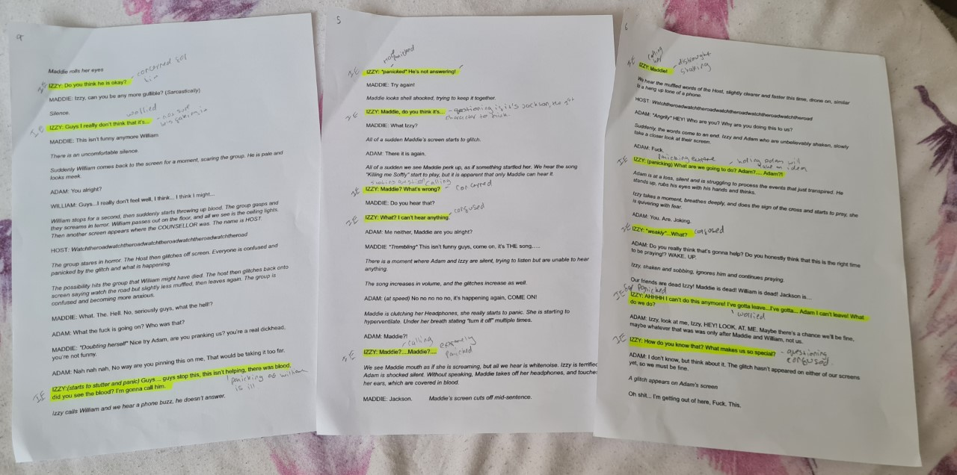

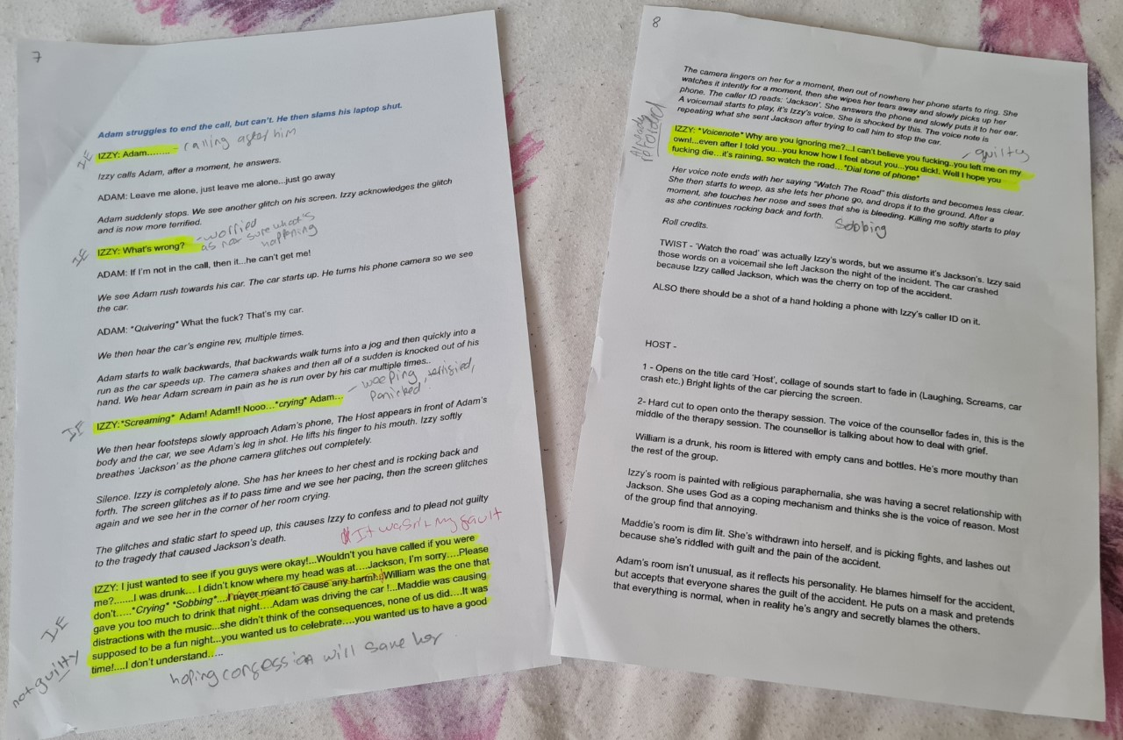

- Izzy’s Uta Hagen and background

Who am I?

- Izzy, 20, studying biology at university of wales, in love with jackson
- She is distraught as she lost someone she loved
- She turned to God for forgiveness and comfort leading on to helping her to try and move on
- She perceives herself as someone who is upset but is being comforted by religion and mentions it sometimes, she wants to help the others to feel comfort and forgiveness
- She is wearing a black dress with a black cardigan and a multicoloured cross necklace due to being in mourning over the loss of Jackson.

What are the circumstances?

- It is 4:30 in the evening, 17th february 2021
- In her bedroom at a uni house
- There is a bed, window, wardrobe and a bedside table
- She is in a therapy session with the group due to the death of Jackson because of the car accident
- She expects for a relief and to move on

What are my relationships?

- Towards Maddie she is kind and caring but Maddie is not a fan of Izzy for some reason that Izzy is unclear of
- Towards Adam she is kind but doesn't have the same outlook on life due to her wanting to help others and him thinking of himself.
- Towards William she tries to interact with him but is clear he struggles with new people, throughout their friendship he becomes more confident around her and starts connecting with her.
- She is in a relaxed place as she is in her bedroom
- The objects she connects to is her bible and cross

What do I want?

- The objective is for her to feel forgiveness and peace with the event as well as helping her friends to feel the same.

What is my obstacle?

- Her friends are refusing her help and guidance

What do I do to get what I want?

- Help her friends see this through and get the same relief

Background: Before university she was a slight party girl she loved going to the pub with her friends but when she turned up at university she dialed down the party girl side as she knew she had to be mature when she suddenly realised that is what university is all about she stopped. She is studying biology due to being quite intelligent and wanting to go into that profession. Jackson sat next to her in class, he introduced himself first and came across as sweet and kind. They quickly become friends. He invited her to go to nandos with his friends. Maddie came across as unsure of her, Adam came across as not being too bothered and William came across as shy and innocent. After that, they all became friends and started to hangout more in places such as the cinema, drives, parties, pub, restaurants etc. But, they would hang out just the two of them in secret and quickly become a relationship.

- Images of Izzy’s bedroom and costume

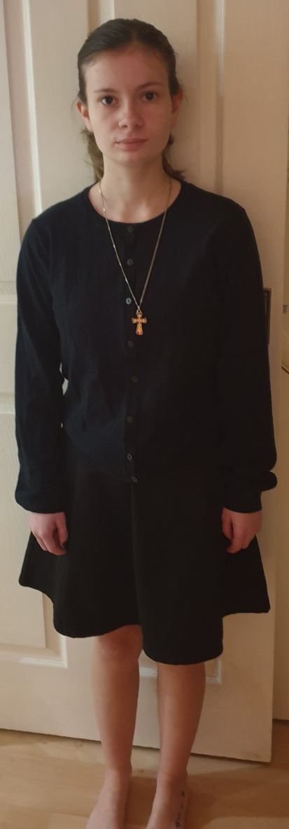
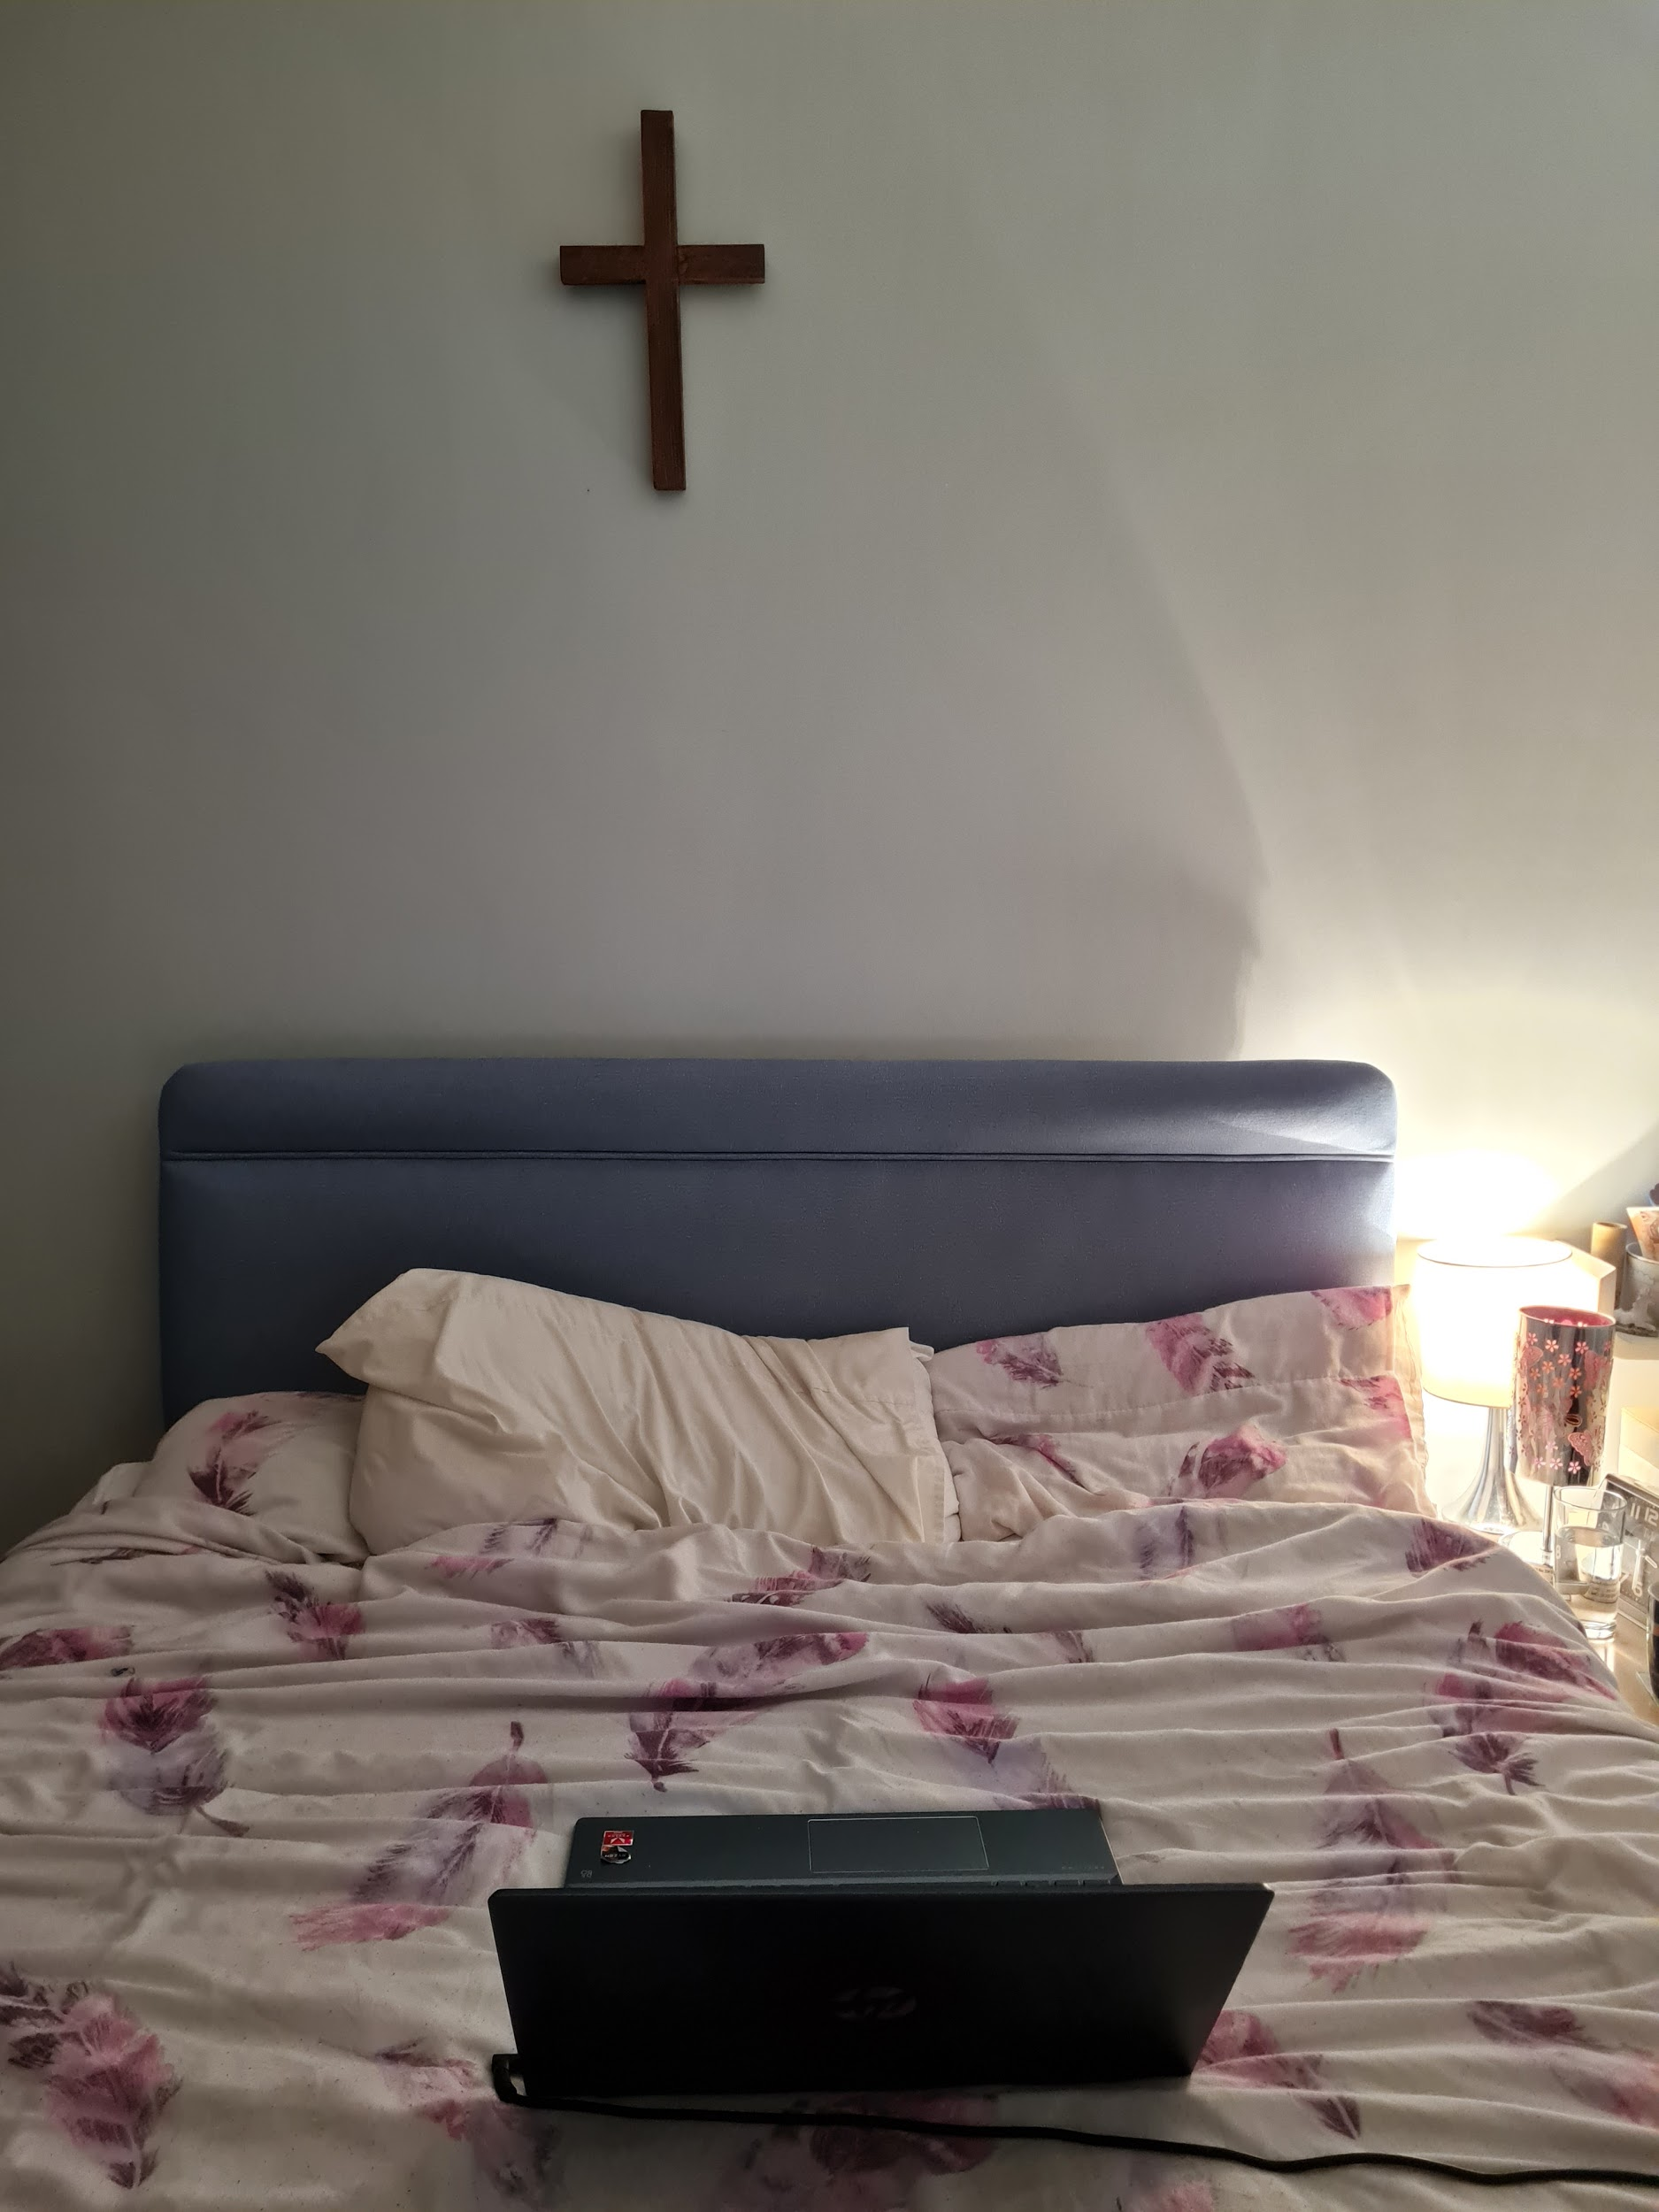

- Editing Images

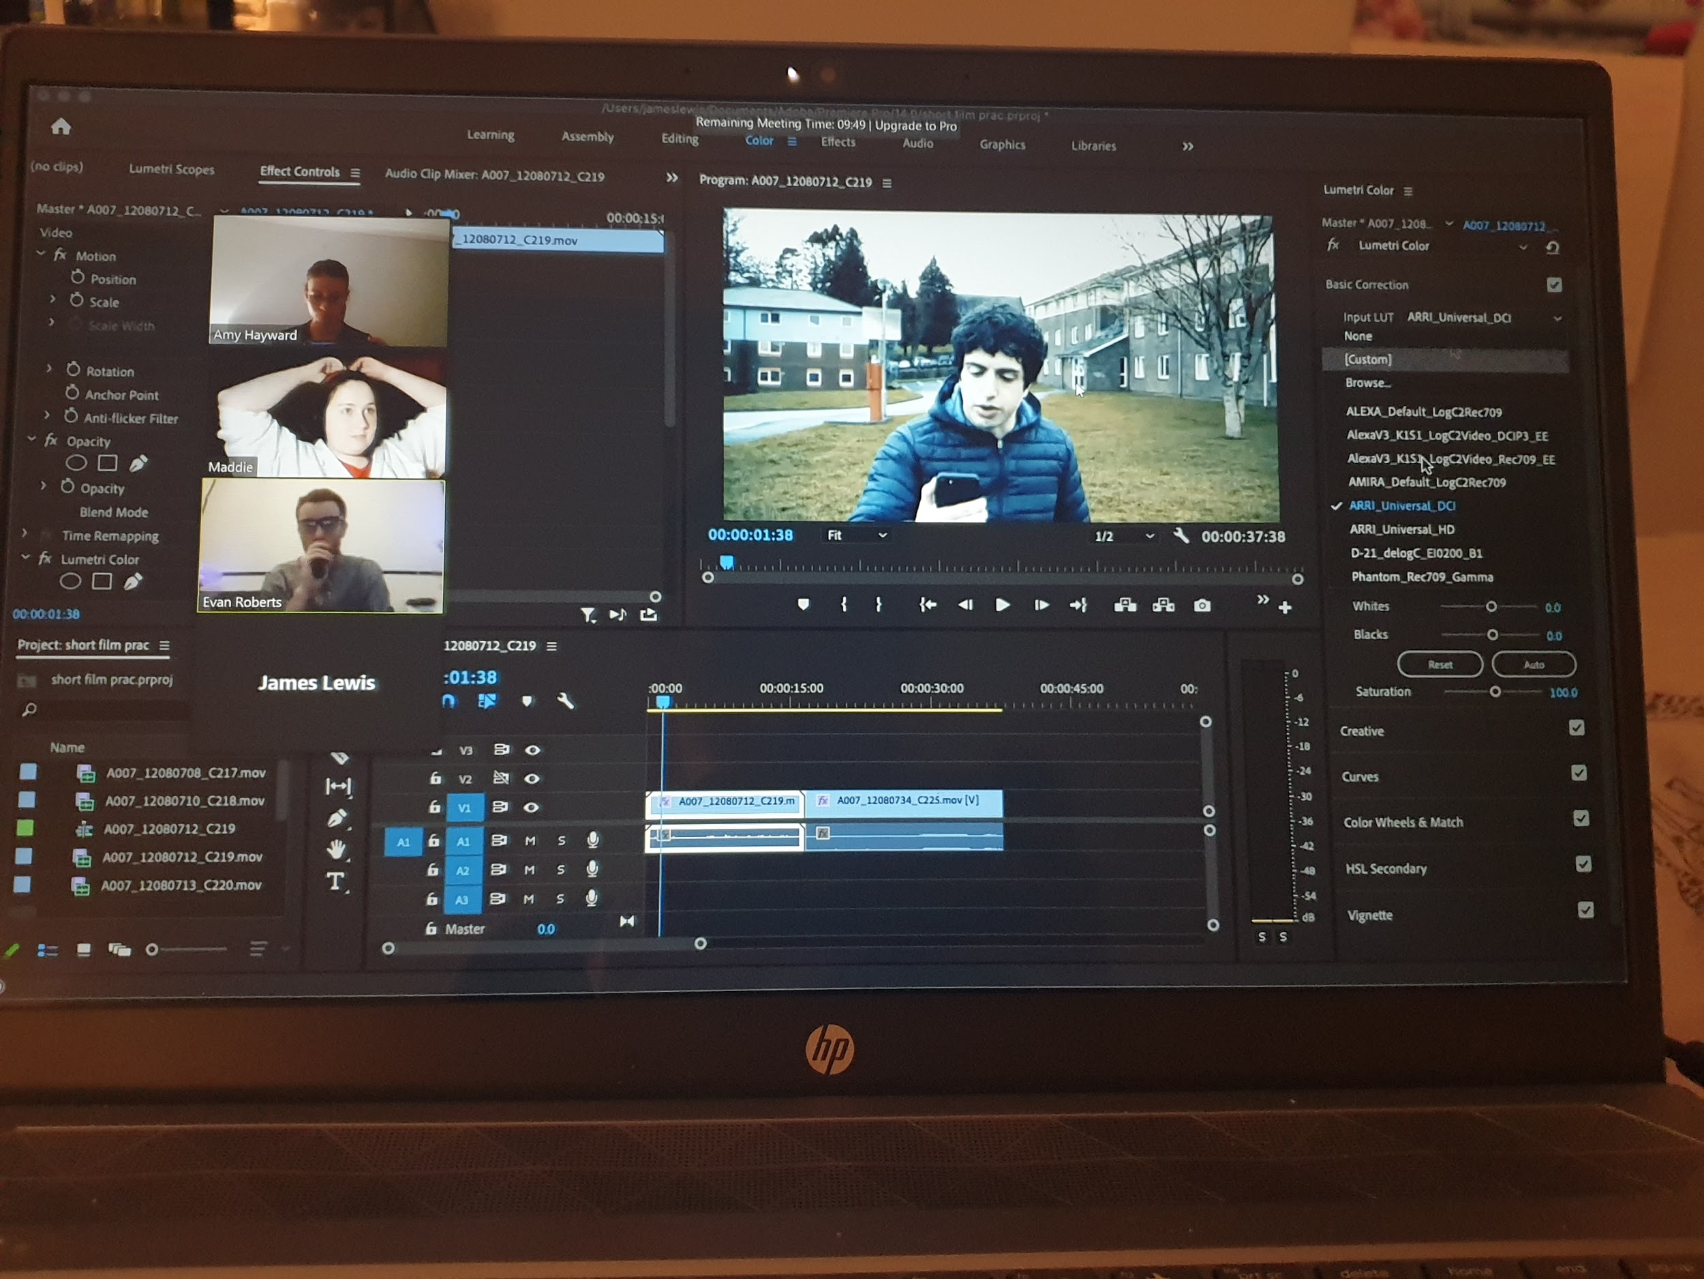
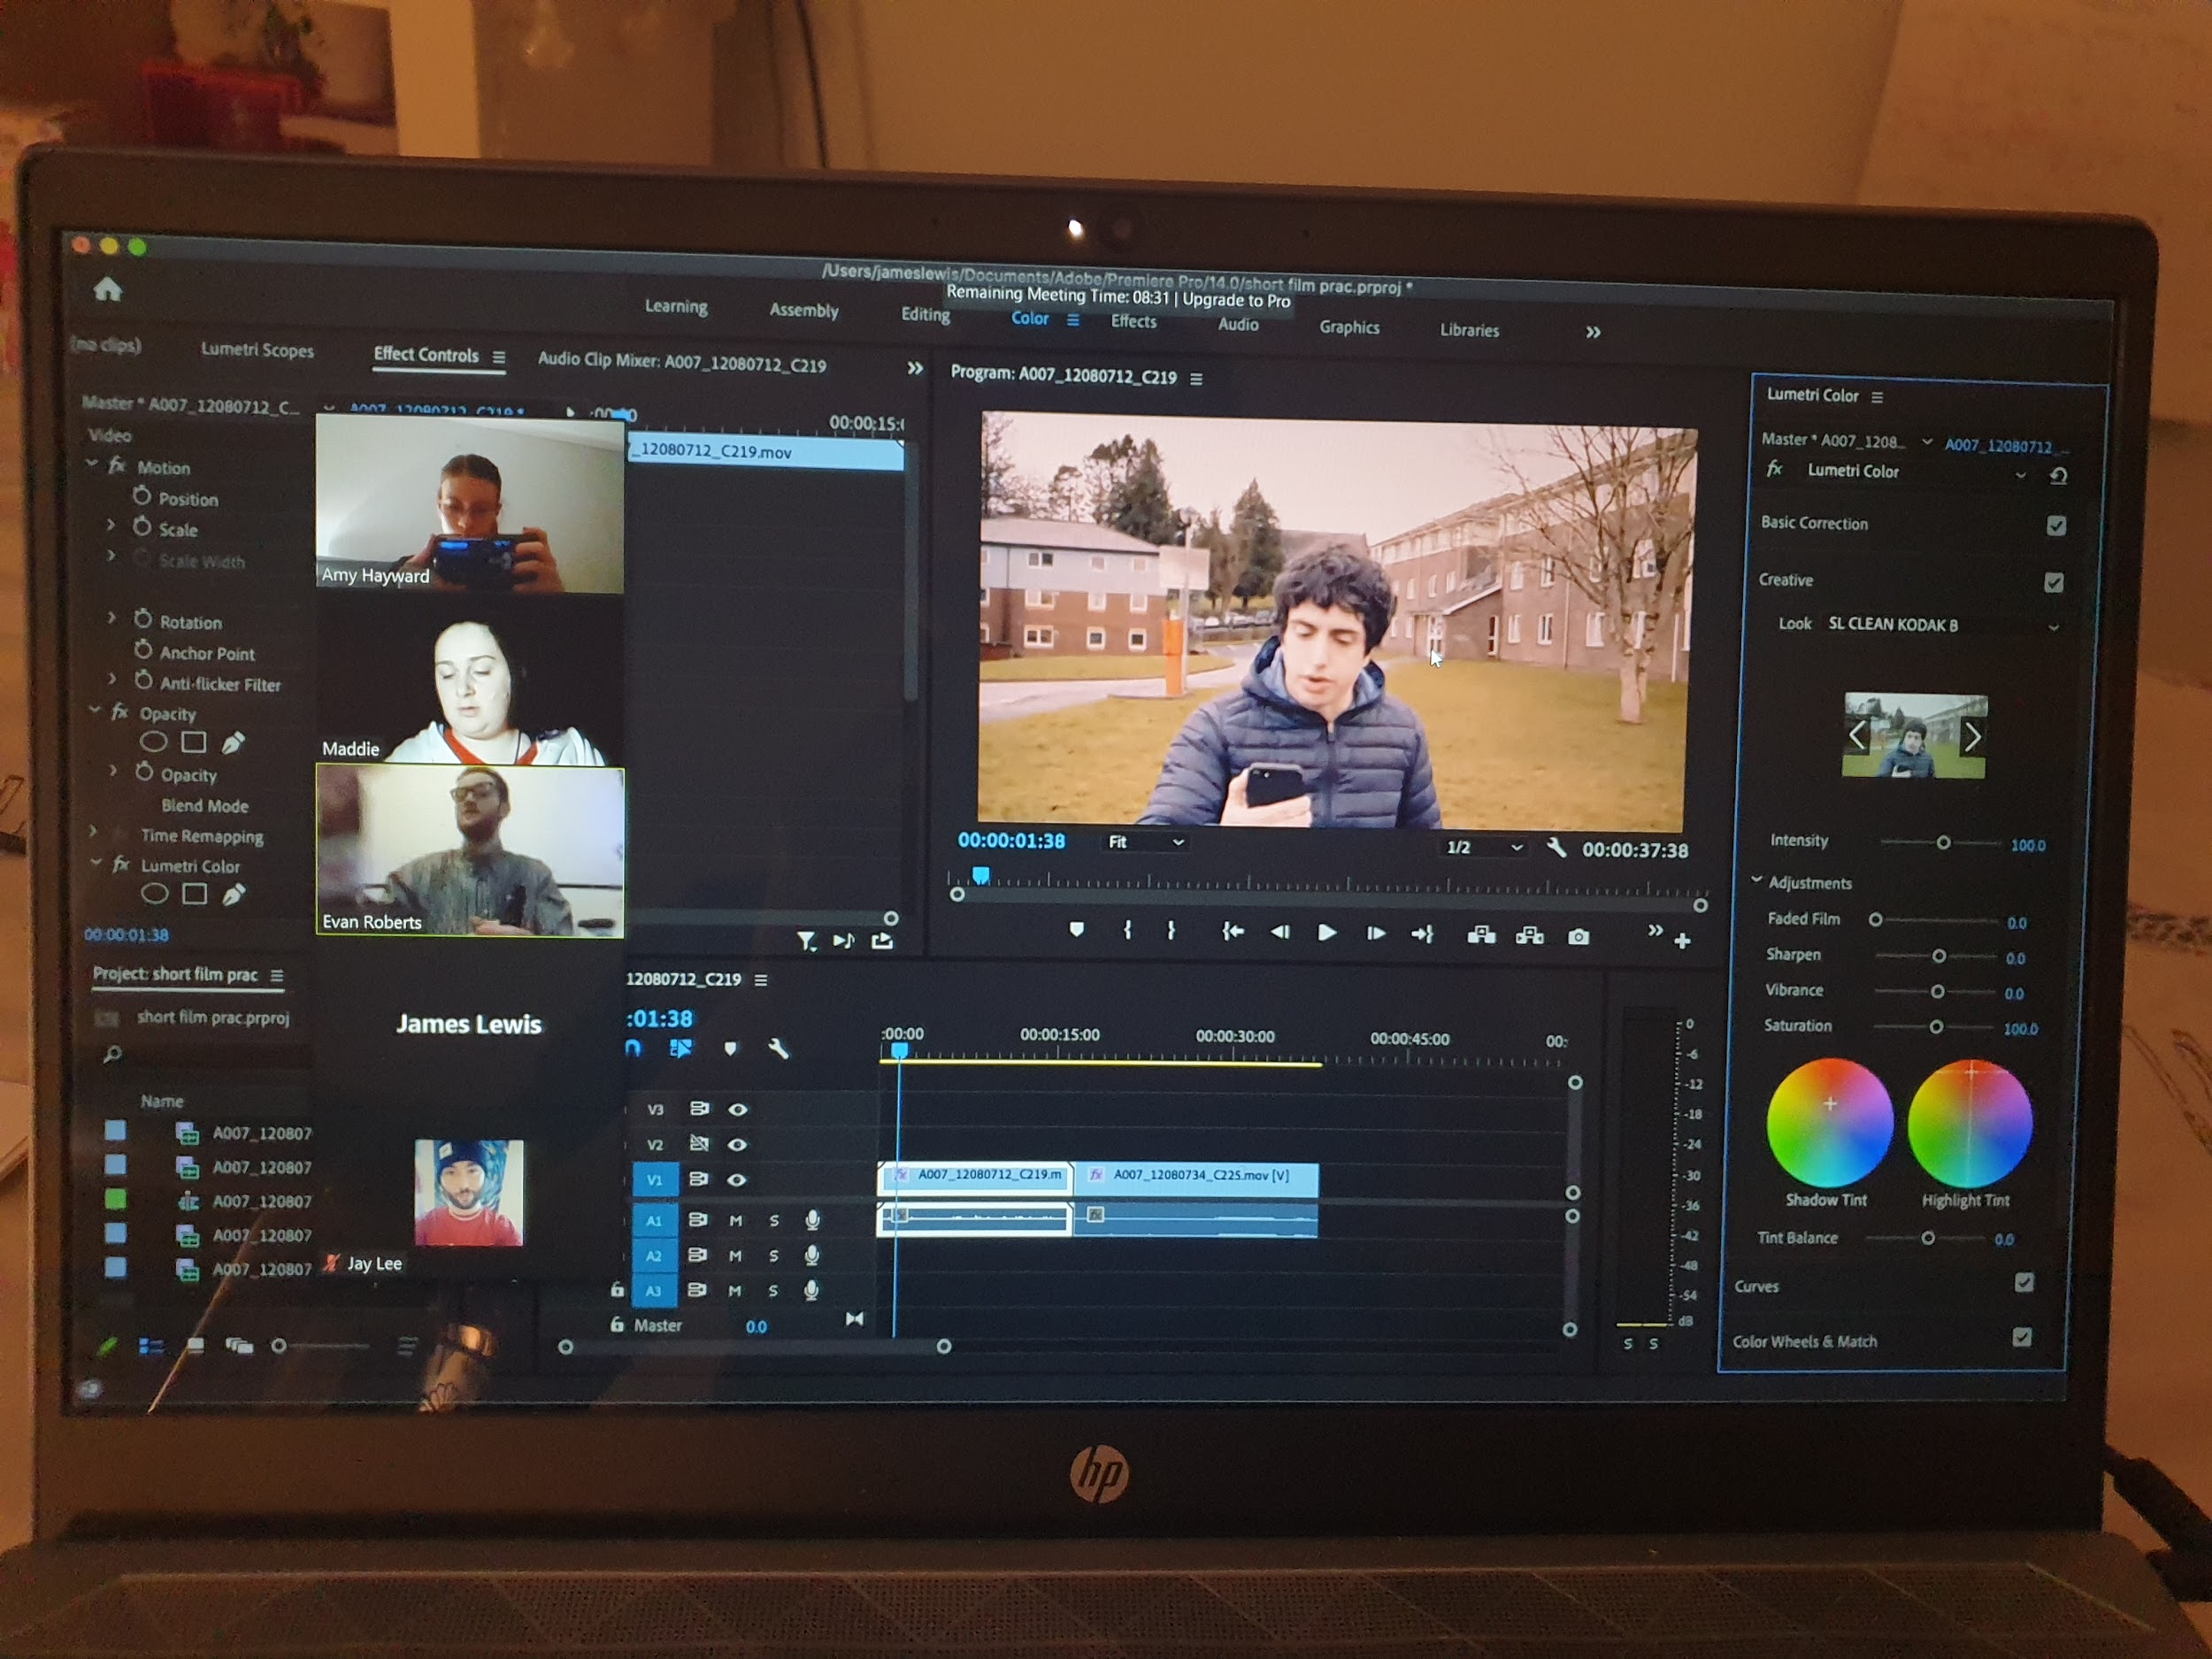

- Camera Angle

To understand the type of camera angles I viewed the shot types on the Short Film Production resources tile to explore my options rather than just a medium close up shot on zoom. To start, I viewed the lists of shots and angles which one would suit best in terms of location. I experimented with my camera cannon on a tripod, with a side angle medium shot on the left and I loved how it would make the audience feel as though they are in the room with Izzy going through the journey especially with the monologue. Despite this, I looked at other options such as trying the same shot angle from the front, I did not like this due to it not having the effect as the first shot. Furthermore, I used my phone stacked on books behind my laptop to get the same height as my laptop camera; this however did not work due to Izzy needing the phone for the phone call as well as the issue of it falling over during filming. I selected the side angle medium shot I then experimented with close ups, I tried a medium close up shot but this was too close leading onto the audience unable to see the background and I preferred the background to give a clue of who Izzy is rather than just dialogue.

This is the medium shot I chose while experimenting

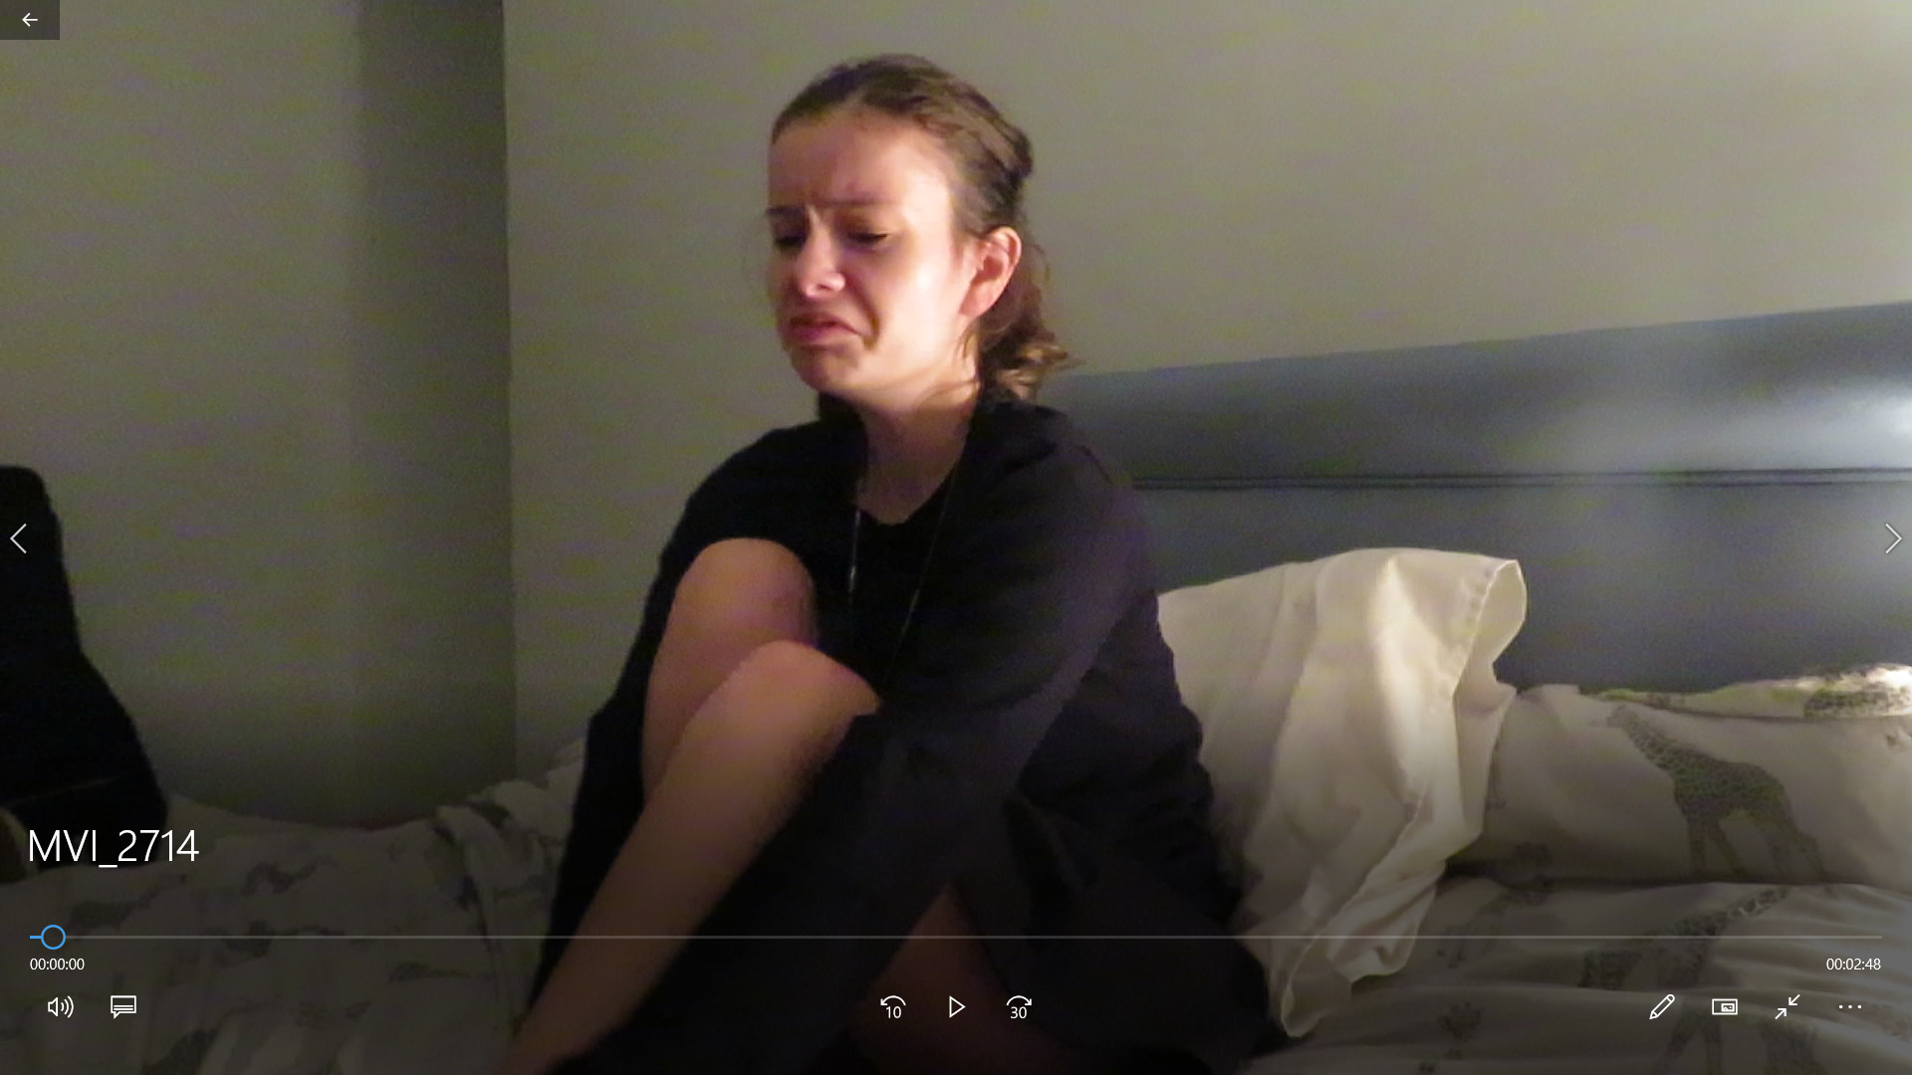

Bibliography:

- ALTER (30th May 2019) HORROR SHORT FILM “THE BLUE DOOR” Available at: Horror Short Film “The Blue Door” | ALTER Exclusive | BAFTA Nominee - YouTube
- BARRANCE, T., 2021. PLANNING YOUR FILM. [online] Learn About Film. Available at:https://www.learnaboutfilm.com/making-a-film/organising-filmmaking-process/planning-film/
- BBC Iplayer (10th June 2020) STAGED Available at: BBC iPlayer - Staged - Series 1: 1. Cachu Hwch
- BomBay Sapphire Global (27th April 2013) ROOM 8 Available at: Room 8 - Winner of the BAFTA for Short Film 2014 - YouTube
- Corridor (31st March 2018) ROT Available at: ROT - Silent Hill - YouTube
- Cite This For Me. (2021). Save Time and Improve your Marks with CiteThisForMe, The No. 1 Citation Tool. [online] Available at: https://www.citethisforme.com
- DAISIE (26th February 2020) JOURNEY INTO FILMMAKING Available at: Journey into Filmmaking - Workshops - Daisie
- Jake Russel (16th July 2014) DUST Available at:DUST - Short film starring Alan Rickman & Jodie Whittaker - YouTube
- Kacey Baker (12th August 2020) TEMPLE OF ZOOM Available at: Temple Of Zoom (Comedy Short Film) - YouTube
- Liv McNeil (17th June 2020) NUMB Available at: Numb - a short film - liv mcneil - YouTube
- marshallcurry (21st December 2019) THE NEIGHBORS WINDOW Available at:The Neighbors' Window - Oscar Winning Short Film - YouTube
- Moment (2nd February 2018) NILES GIVE YOU 5 TIPS FOR SHOOTING A SHORT FILM Available at: Niles Gives You 5 Tips For Shooting A Short Film - YouTube
- Pendoon (12 January 2013) 2 +2=5 Available at: 2+2=5 | Two & Two - [MUST SEE] Nominated as Best Short Film, Bafta Film Awards, 2012 - YouTube
- Pippa Molony (30th July 2020) WILL WE DO THIS AGAIN Available at: Will We Do This Again? (Zoom Short Film 2020) - YouTube
- Short Films - GGC Life TV (21st August 2018) MONDAY Available at: 'MONDAY' - Short Film | Inspirational & Funny [2018] - YouTube
- Short of the Week (15th April 2019) WORK Available at: Work | BAFTA-Nominated Short Film by Aneil Karia | Short of the Week - YouTube
- Short of the Week (31st January 2020) THE INTERVIEW Available at: The Interview | A Psychological Thriller Short Film by Barnaby Roper - YouTube
- Short of the Week (22nd September 2020) CRAIG SHOULDN’T SMOKE WEED Available at: Craig Shouldn't Smoke Weed | A Comedy Short Film - YouTube
- SonduckFilm (31st October 2018) HOPE A PSYCHOLOGICAL THRILLER Available at: Hope | A Psychological Thriller / Action Short Film - YouTube
- UWTSD (anonymous) FILMING: LIGHTING Available at: Filming: Lighting (uwtsd.ac.uk)
- UWTSD (anonymous) FILMING: SHOT TYPES Available at:Filming: Shot Types (uwtsd.ac.uk)

Craig Shouldn't Smoke Weed | A Comedy Short Film - YouTube DUST - Short film starring Alan Rickman & Jodie Whittaker - YouTube Hope | A Psychological Thriller / Action Short Film - YouTube 'MONDAY' - Short Film | Inspirational & Funny [2018] - YouTube Numb - a short film - liv mcneil - YouTube Room 8 - Winner of the BAFTA for Short Film 2014 - YouTube BBC iPlayer - Staged - Series 1: 1. Cachu Hwch Temple Of Zoom (Comedy Short Film) - YouTube The Interview | A Psychological Thriller Short Film by Barnaby Roper - YouTube Horror Short Film “The Blue Door” | ALTER Exclusive | BAFTA Nominee - YouTube The Neighbors' Window - Oscar Winning Short Film - YouTube 2+2=5 | Two & Two - [MUST SEE] Nominated as Best Short Film, Bafta Film Awards, 2012 - YouTube Will We Do This Again? (Zoom Short Film 2020) - YouTube Work | BAFTA-Nominated Short Film by Aneil Karia | Short of the Week - YouTube
Journey into Filmmaking - Workshops - Daisie
Planning your film - Learn About Film
Niles Gives You 5 Tips For Shooting A Short Film - YouTube
Filming: Lighting (uwtsd.ac.uk)
Filming: Shot Types (uwtsd.ac.uk)

