

Task 1 – Reading Task Template
Upload your photo of your A3 in-class notes here:
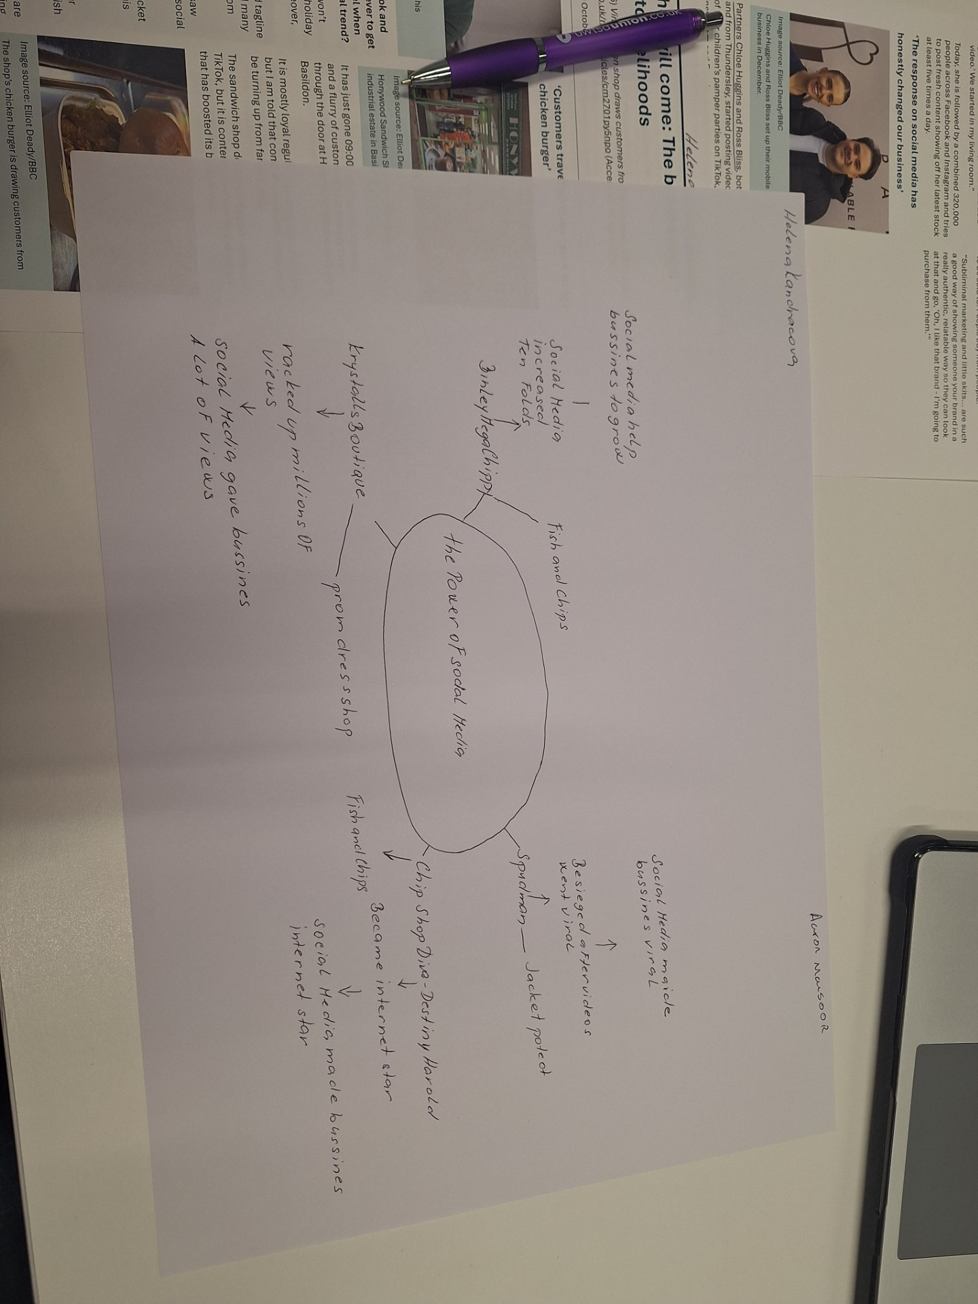

1. Answer these questions using the sentence starters below
a. What is the main idea of the text?
The main idea is that to show how social media effects business
b. What are two key points?
One key point is how social media effects businesses
Another key point is how the people effect businesses
c. What part of the text did you find most important? Why?
The most important part is analysis of all data that way you can see the changes due to social media
d. Was anything unclear or difficult to understand?
I was not sure about the process of the mind map
e. How did your group help you understand the text better?
My group helped me by completing the mind map in a group
3. One sentence reflection
Question: What did you find challenging about this task?
The hardest part was completing the mind map.

