UNIVERSITY OF WALES TRINITY SAINT DAVID
ACCA5033
Changemakers: Creativity and Value Creation

COMPONENT 2
PROJECT MANAGEMENT & INNOVATION

Design and Evaluation of an Accessible Smart Home Support System
for Older Adults and Family Carers

Responsive Web Application Prototype

Name | Muhammad Moazzam
Student ID | 2419336
Course | BSc (Hons) Applied Computing

Table of Contents

1. Introduction 3
2. Task 1: Project Management 3
2.1 Project scope, proposed solution and resources 3
2.2 Project timeline, schedule and constraints 4
2.3 Development method 4
2.4 Project design 5
Design Piece 1: Prioritised requirements specification 5
Design Piece 2: Proposed system architecture 6
3. Task 2: Enterprise and Innovation 7
3.1 Innovation option and company context 7
3.2 PEST analysis: Amazon and smart-home services 7
3.3 SWOT analysis: Amazon and Alexa Smart Properties 8
3.4 Development, deployment, maintenance and evolution in a large organisation 9
4. Task 3: Project Reflection 10
5. Conclusion 11
Reference List 12
Appendices 13
Appendix A: Detailed project schedule and milestones 13
Appendix B: Initial risk register 14
Appendix C: Suggested evidence to add during implementation 15

1. Introduction
This report develops the project-management and innovation plan for the proposed project, Design and Evaluation of an Accessible Smart Home Support System for Older Adults and Family Carers. The project will create a responsive web prototype that presents simulated reminders, home-status information, alerts and carer updates through a simple interface. The need is socially relevant because almost five million people in England and Wales reported providing unpaid care in the 2021 Census [2]. The report defines the scope, schedule, development method and design artefacts, evaluates the innovation environment through Amazon and Alexa Smart Properties, and reflects on skills, social value and risk. Accessibility, privacy and user-centred design are treated as core requirements rather than additions because WCAG 2.2 is intended to make web content usable by people with a wide range of disabilities [1].

2. Task 1: Project Management

2.1 Project scope, proposed solution and resources
The scope is limited to designing and evaluating a responsive web prototype. It will not connect to live sensors, diagnose health conditions, provide continuous emergency monitoring or operate as a medical device. Simulated data will represent reminders, door status, movement, temperature and alerts. Two linked perspectives will be provided: an older-adult view with large controls and plain language, and a family-carer view showing only agreed updates. The solution is therefore an information layer that explores how smart-home data can be translated into understandable actions without replacing human care.
Deliverables will include prioritised requirements, user stories, wireframes, a responsive prototype, accessibility checks, a short usability test and an evaluation. Success will be judged through task completion, participant comments, selected WCAG 2.2 Level A and AA checks, and clear privacy choices. Acceptance of ageing-in-place technology depends on usefulness, ease of use, support, privacy and personal circumstances [9], so these factors shape the requirements.
The prototype may use HTML5, CSS3 and JavaScript, with Figma for wireframes, GitHub for version control and a small JSON file or database for simulated information. Testing will include browser tools, keyboard navigation, contrast checks and a screen reader. A laptop, modern browsers, test mobile devices and consenting pilot participants are the main resources. Secure-development practices will be included throughout the lifecycle, following NIST guidance [4].

2.2 Project timeline, schedule and constraints
The work is planned over twelve weeks, as shown in Figure 1. Early weeks establish scope and requirements, the middle period develops the interface through two prototype sprints, and the final weeks test, improve and document the result. Constraints include limited time, a small participant sample, simulated rather than clinical data, browser differences, internet availability, privacy expectations and false-alert design. Participants may also require larger text or extra time. New ideas will enter a backlog, but only items that directly support the aim will be prioritised.

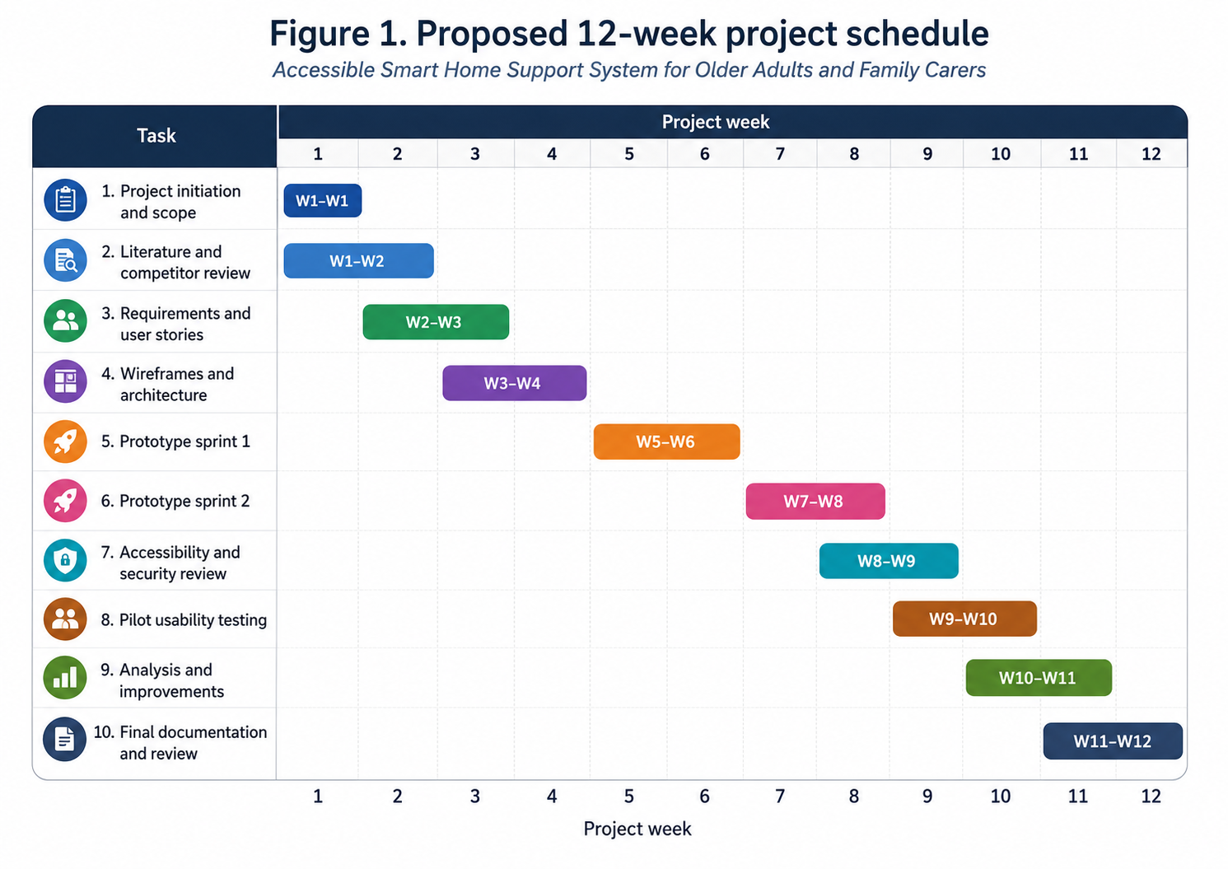
Figure 1. Proposed twelve-week Gantt chart for the prototype project.

2.3 Development method
An iterative Agile approach based on Scrum is suitable because requirements may change after feedback. Scrum uses a Product Backlog, short Sprints, inspection and adaptation [3]. The project will use two-week cycles: select requirements, design and build them, test the increment, record feedback and revise the backlog. Weekly reviews will compare progress with the Gantt chart. The Definition of Done will require responsive behaviour, readable labels, keyboard access, basic error handling, updated documentation and no unresolved high-priority accessibility issue. Early testing should expose misunderstandings before substantial time is spent on code.

2.4 Project design
Two design artefacts translate the idea into a buildable project. Table 1 is a MoSCoW requirements specification for sprint planning and acceptance testing. Figure 2 shows the two user views, web interface, application services, simulated inputs, storage and notifications. It also makes consent, role-based access, logging, accessibility testing and data minimisation visible as cross-cutting controls.

Design Piece 1: Prioritised requirements specification

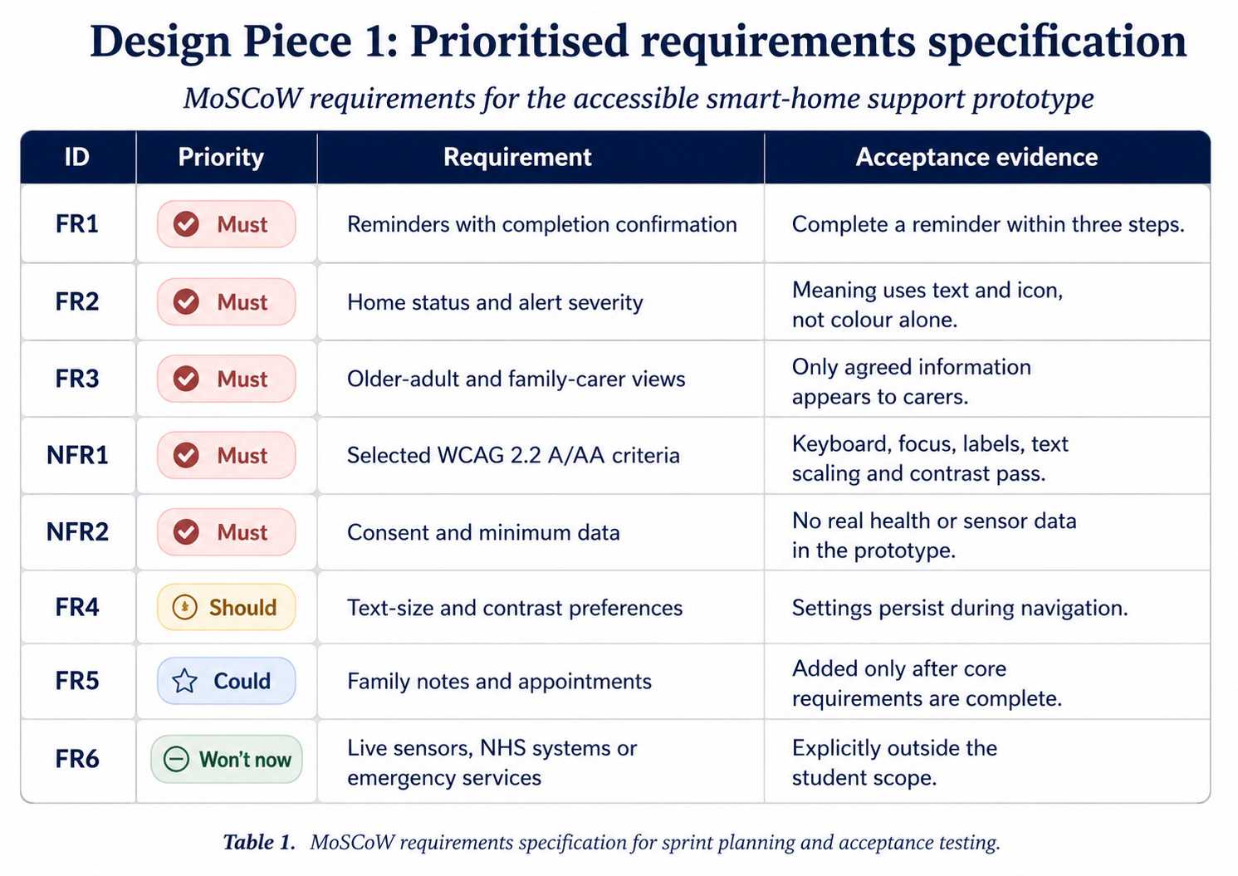Table 1. MoSCoW requirements specification. The full traceability and test record would be maintained during development.

Design Piece 2: Proposed system architecture
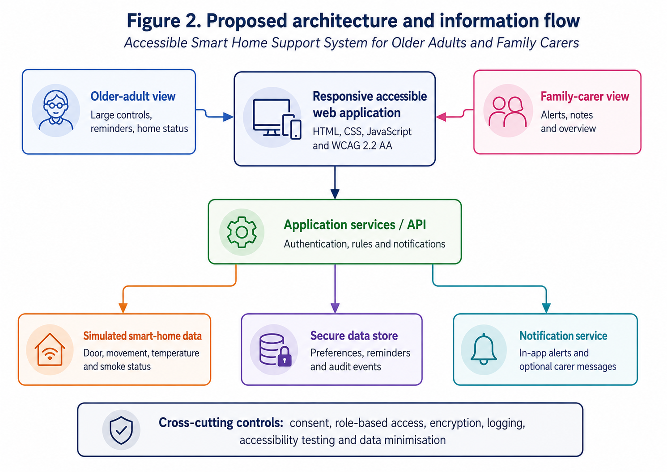
Figure 2. Proposed architecture and information flow for the accessible smart-home support prototype.

3. Task 2: Enterprise and Innovation

3.1 Innovation option and company context
The Innovation option is selected. Amazon is relevant because Alexa Smart Properties manages Alexa-enabled devices at scale, including in senior-living environments [5]. The proposed prototype is not committed to Amazon services; the company is used to examine the environment, strengths and risks surrounding smart-home support.

3.2 PEST analysis: Amazon and smart-home services
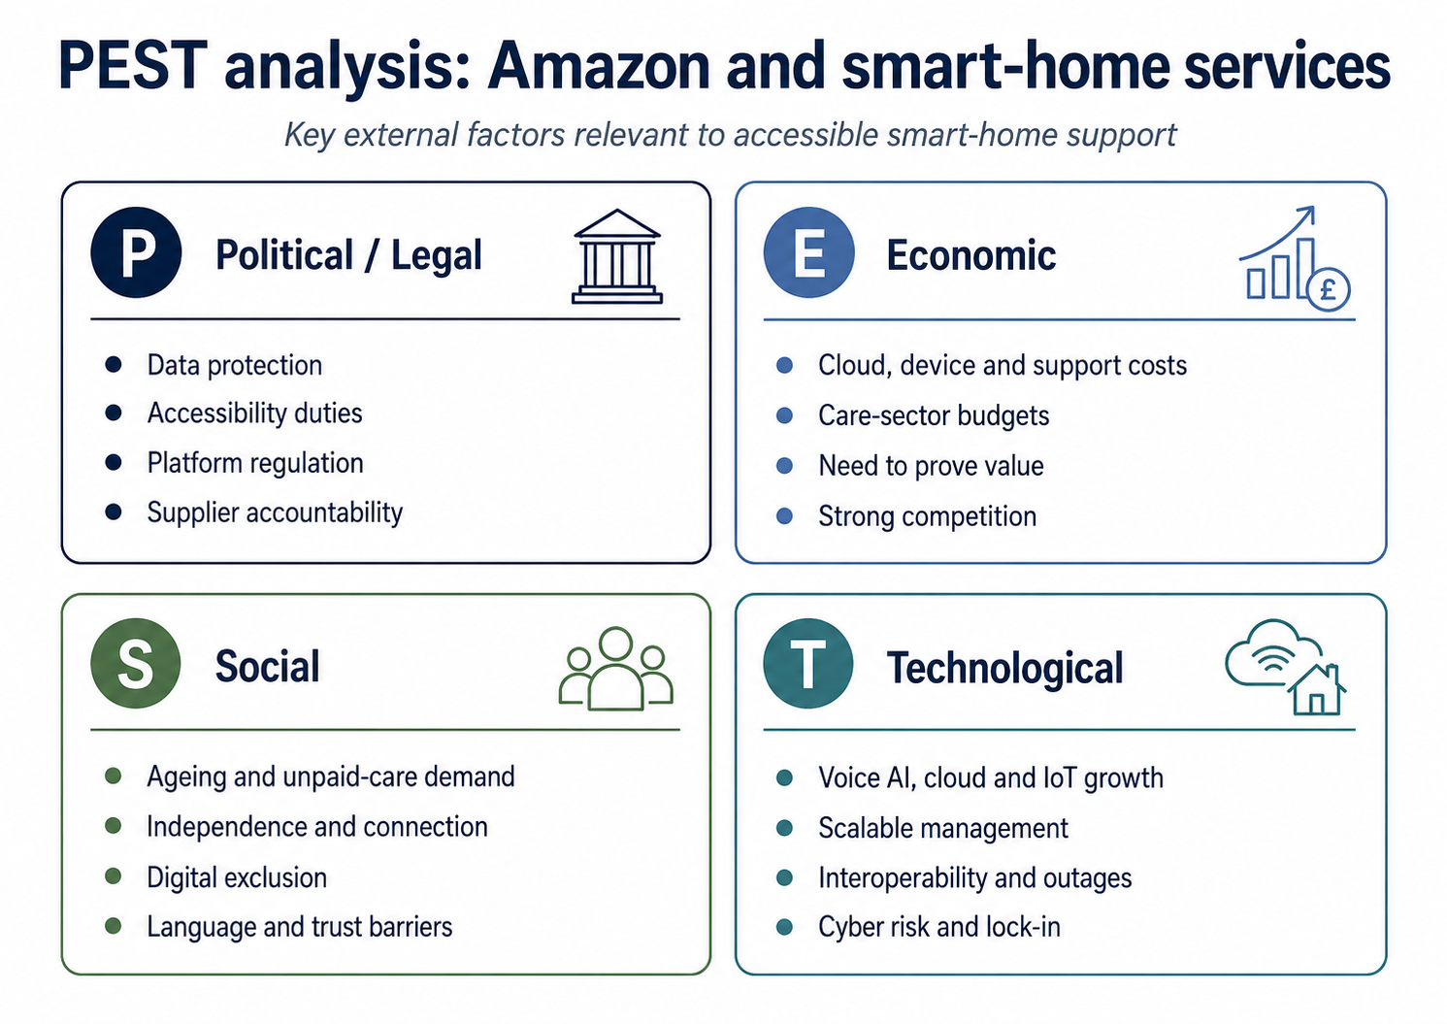Table 2. PEST analysis for Amazon in relation to smart-home and senior-living services.

3.3 SWOT analysis: Amazon and Alexa Smart Properties
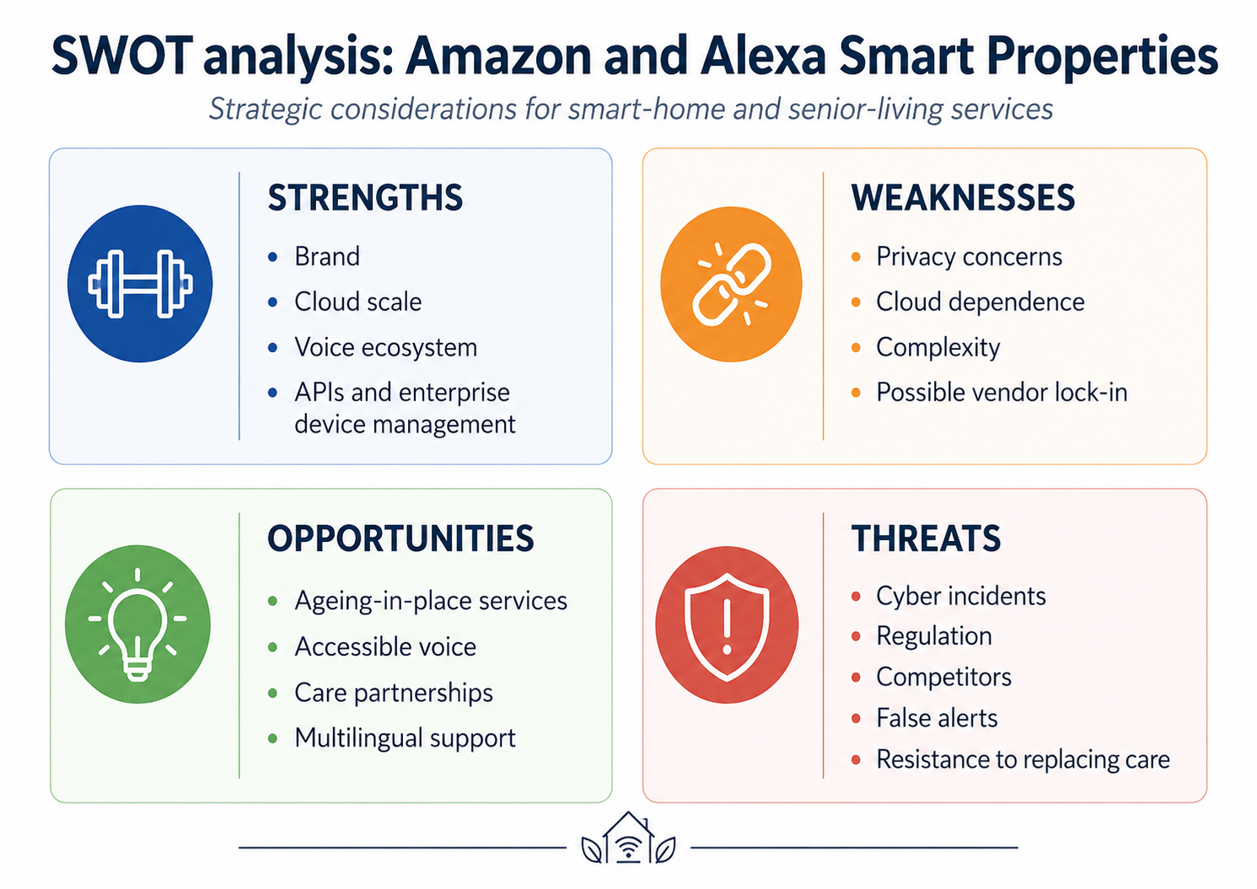
Table 3. SWOT analysis for Amazon and Alexa Smart Properties.
The tables show that technical capability alone does not determine success. UK data-protection expectations require transparency, purpose limitation, minimisation, security and accountability [7]. Public-sector implementations must also address WCAG 2.2 AA and accessibility statements [8]. Amazon's annual report identifies competition, regulation, infrastructure investment, economic conditions and security as continuing risks [6]. Alexa Smart Properties demonstrates opportunities in reminders, calling, device control and large-scale management [5], but cloud dependence and privacy concerns may reduce trust. The lesson for this project is to borrow useful ideas from large ecosystems while keeping the prototype transparent, consent-based and portable.
Legal compliance and ethical acceptability are related but different. A lawful system could still be intrusive if it collects more household information than users expect, makes carers too powerful or uses urgent colours to pressure behaviour. The service should therefore explain the purpose of every data item, allow permissions to be reviewed, provide non-digital alternatives and avoid using engagement as evidence of wellbeing. Procurement should also examine supplier access, data location, deletion, subcontractors and exit arrangements. These controls would reduce dependence on promises made by a platform provider and make accountability visible to residents, families and care organisations.

3.4 Development, deployment, maintenance and evolution in a large organisation
If implemented within a large organisation, the project would need a controlled product lifecycle and a multidisciplinary team of users, service designers, developers, accessibility specialists, information-governance staff, cybersecurity professionals, operations staff and a product owner. Requirements would be maintained as user stories and acceptance criteria in a prioritised backlog. Discovery would investigate needs and processes, alpha would test uncertain ideas, beta would integrate services with a limited group, and live operation would use measured releases and support arrangements.
Development would use version control, code review, automated unit and integration tests, accessibility regression checks and threat modelling. NIST's Secure Software Development Framework supports adding security practices throughout preparation, software protection, production and vulnerability response [4]. A continuous-integration and delivery pipeline would build and test each change before release; continuous delivery aims to maintain a deployment-ready artefact that has passed a standard test process [11]. Separate development, test and production environments, secrets management, dependency scanning and approval gates would reduce release risk.
Cloud services should be assessed against operational excellence, security, reliability, performance, cost and sustainability, the six AWS Well-Architected pillars [12]. Monitoring would cover availability, response time, failed logins, alert delivery, accessibility defects and unusual access. Maintenance would include incident response, backups, patching, supplier review and accessibility audits. Evolution would be evidence-led: approved analytics and user feedback would enter the backlog, while post-incident reviews would identify systemic improvements. Before real household or health-related information was introduced, the organisation would complete a data-protection impact assessment and configure role-based permissions so carers see only agreed information. Release governance would include a named service owner, support hours, severity levels, rollback procedures and communication plans for outages. Performance measures should combine technical indicators with user outcomes, such as successful task completion, reduced confusion and accessibility defects resolved. Regular reviews would decide whether a feature should be improved, replaced or retired, preventing an ageing service from becoming unsafe or impossible to support.

4. Task 3: Project Reflection
This project provides a practical opportunity to develop technical, research and professional skills together. My first development priority is responsive front-end design. I have experience with computing concepts, but this project requires me to turn accessibility guidance into working interface decisions, including focus order, keyboard navigation, visible labels, colour contrast, scalable text and meaningful error messages. WCAG 2.2 gives a structured standard, but applying it will require testing rather than assuming that a visually attractive page is accessible [1]. I also intend to improve JavaScript, requirements engineering, version control, prototyping and systematic usability evaluation.
A second learning area is project management. The backlog and Sprint structure will help me break a broad idea into small deliverables, set priorities and respond to evidence. The Gantt chart provides an overall deadline, while iterative reviews provide flexibility within it. I will maintain a project log recording decisions, problems, changes and lessons. This should improve my ability to estimate effort, explain trade-offs and recognise when a feature should be deferred. Working with potential users will also develop communication skills because questions must be neutral, understandable and respectful, particularly when discussing care, home routines and privacy.
The potential contribution to society is the project's main motivation. A clear support interface could help some older adults understand reminders and home information while allowing family carers to receive agreed updates. It may support confidence and communication, but it must not promise safety that it cannot provide. Technology acceptance research shows that older people judge solutions in relation to personal need, expected benefit, support and concerns, rather than accepting technology simply because it is available [9]. The positive contribution therefore lies in inclusive design and informed choice. Even if the prototype is not deployed, it can produce design recommendations showing how accessibility and consent should shape smart-home services.
The project also faces serious challenges. Recruitment may be difficult and a small convenience sample will not represent all older adults or carers. Participants may have very different visual, cognitive, motor and digital needs. I will reduce this risk by describing the sample honestly, offering larger text and extra time, avoiding claims of generalisability and recording conflicting feedback. A further risk is scope expansion. Reminders, sensors, messaging, emergency functions and care coordination could become several separate systems. I will control this through the MoSCoW specification and by using simulated data.
Privacy and security present the greatest potential harm. Home-activity information can reveal routines, absence, vulnerability and relationships. The prototype will therefore collect no real sensor or medical information, use participant codes, minimise stored data and explain who can see each item. Current ICO guidance places lawfulness, fairness, transparency, purpose limitation, minimisation, accuracy, storage limitation, security and accountability at the centre of processing [7]. In a future working system, encryption, multi-factor authentication, audit logs, secure updates and a formal data-protection impact assessment would be required.
Other risks include internet failure, false alerts, inaccessible design, development delays and over-reliance on a single platform. Mitigation will include clear status messages, confirmation before important actions, offline-safe explanations, progressive enhancement, browser testing, regular backups and maintaining a simple exportable data model. The interface will state that it is not an emergency service. Most importantly, user testing will be treated as a source of challenge rather than confirmation. If participants cannot complete a task or distrust a feature, the design or project claim must change. This reflective approach should help me become a more responsible computing practitioner who can connect technical work with real social consequences. I will evaluate my own progress through the quality of the project log, the number of requirements supported by evidence, accessibility problems found before final testing and my ability to explain design decisions. These measures are more useful than simply counting features because a smaller, understandable and well-tested prototype would represent stronger learning than a larger but unreliable system.

5. Conclusion
The proposed project is achievable because it limits development to an accessible responsive prototype using simulated smart-home information. A twelve-week iterative plan, prioritised requirements, architecture diagram and controlled scope provide a realistic route from research to evaluation. The Amazon PEST and SWOT analysis shows that smart-home innovation offers genuine opportunities but is shaped by regulation, cost, trust, competition and cybersecurity. In a large organisation, Agile product management, secure development, continuous delivery, accessibility assurance and operational monitoring would be required throughout the lifecycle. The project can develop valuable computing and project-management skills while contributing evidence about inclusive support for older adults and carers, provided that privacy, consent, human care and honest limitations remain central.

Reference List
[1] World Wide Web Consortium, “Web Content Accessibility Guidelines (WCAG) 2.2,” W3C Recommendation, 12 Dec. 2024. [Online]. Available: https://www.w3.org/TR/WCAG22/. [Accessed: 27-Jul-2026].
[2] Office for National Statistics, “Unpaid care, England and Wales: Census 2021,” 19 Jan. 2023. [Online]. Available: https://www.ons.gov.uk/peoplepopulationandcommunity/healthandsocialcare/healthandwellbeing/bulletins/unpaidcareenglandandwales/census2021. [Accessed: 27-Jul-2026].
[3] K. Schwaber and J. Sutherland, The Scrum Guide: The Definitive Guide to Scrum, Nov. 2020. [Online]. Available: https://scrumguides.org/. [Accessed: 27-Jul-2026].
[4] M. Souppaya, K. Scarfone and D. Dodson, Secure Software Development Framework (SSDF) Version 1.1, NIST SP 800-218, Feb. 2022. doi: 10.6028/NIST.SP.800-218.
[5] Amazon, “Alexa Smart Properties for Senior Living,” 2026. [Online]. Available: https://developer.amazon.com/en-GB/alexa/seniorliving. [Accessed: 27-Jul-2026].
[6] Amazon.com, Inc., Annual Report on Form 10-K for the fiscal year ended 31 December 2025, filed 6 Feb. 2026. [Online]. Available: https://www.sec.gov/Archives/edgar/data/1018724/000101872426000004/amzn-20251231.htm. [Accessed: 27-Jul-2026].
[7] Information Commissioner’s Office, “A guide to the data protection principles,” updated 2026. [Online]. Available: https://ico.org.uk/for-organisations/uk-gdpr-guidance-and-resources/data-protection-principles/a-guide-to-the-data-protection-principles/. [Accessed: 27-Jul-2026].
[8] Government Digital Service, “Meet the requirements of equality and accessibility regulations,” GOV.UK, 23 Feb. 2024. [Online]. Available: https://www.gov.uk/guidance/meet-the-requirements-of-equality-and-accessibility-regulations. [Accessed: 27-Jul-2026].
[9] S. T. M. Peek, E. J. M. Wouters, J. van Hoof, K. G. Luijkx, H. R. Boeije and H. J. M. Vrijhoef, “Factors influencing acceptance of technology for aging in place: A systematic review,” International Journal of Medical Informatics, vol. 83, no. 4, pp. 235–248, 2014, doi: 10.1016/j.ijmedinf.2014.01.004.
[10] S. Majumder et al., “Smart Homes for Elderly Healthcare—Recent Advances and Research Challenges,” Sensors, vol. 17, no. 11, art. 2496, 2017, doi: 10.3390/s17112496.
[11] Amazon Web Services, “What is Continuous Delivery?” 2026. [Online]. Available: https://aws.amazon.com/devops/continuous-delivery/. [Accessed: 27-Jul-2026].
[12] Amazon Web Services, “AWS Well-Architected Framework,” 2024. [Online]. Available: https://docs.aws.amazon.com/wellarchitected/latest/framework/welcome.html. [Accessed: 27-Jul-2026].

Appendices

Appendix A: Detailed project schedule and milestones
Week | Planned activity | Milestone / evidence
1 | Confirm aim, scope, deliverables and ethics boundaries | Approved scope statement and backlog
2 | Literature and competitor review; initial stakeholder assumptions | Evidence notes and research summary
3 | Requirements, user stories, personas and acceptance criteria | Prioritised requirements specification
4 | Wireframes, architecture and usability-task design | Design review milestone
5–6 | Prototype Sprint 1: navigation, reminders and home status | First testable increment
7–8 | Prototype Sprint 2: carer view, preferences and alerts | Feature-complete prototype
9 | Accessibility, security and cross-browser checks | Issue log and corrected build
10 | Pilot usability session and feedback recording | Pilot evidence and findings
11 | Analysis, prioritised improvements and limitations | Revised prototype and evaluation
12 | Final report, references, quality checks and submission | Submission-ready project package

Appendix B: Initial risk register
ID | Risk | Likelihood | Impact | Mitigation | Owner
R1 | Scope growth | High | High | MoSCoW prioritisation, backlog review and explicit exclusions | Project owner
R2 | Difficulty recruiting suitable participants | Medium | High | Begin early, offer adjustments and avoid dependence on one participant group | Researcher
R3 | Privacy or ethical harm | Low | High | Simulated data, informed consent, participant codes and data minimisation | Researcher
R4 | Prototype not sufficiently accessible | Medium | High | WCAG checklist, keyboard and screen-reader testing, user feedback | Developer
R5 | False or confusing alert design | Medium | High | Plain language, severity categories, recommended action and confirmation testing | Designer
R6 | Technical delay or data loss | Medium | Medium | Version control, weekly backups, small increments and fallback static prototype | Developer
R7 | Internet or browser incompatibility | Medium | Medium | Progressive enhancement, cross-browser testing and clear offline messaging | Developer
R8 | Overclaiming safety or effectiveness | Low | High | Prominent disclaimer, simulated evaluation and cautious reporting | Project owner

Appendix C: Suggested evidence to add during implementation
- Version history or GitHub commit screenshots showing iterative development.
- Before-and-after wireframes following user or tutor feedback.
- Accessibility test results, including keyboard navigation and contrast checks.
- An anonymised pilot feedback record and evidence of changes made.
- A requirements traceability table linking each requirement to design, implementation and test evidence.

