

BSc (Hons) Professional Police Practice

LEVEL 5 - 40 Credits

Workbook title: Competency Based Workbook 2 (PCDA)

(SOUTH WALES POLICE, GWENT POLICE AND UWTSD)

Learner name: Ieuan Rees______________________________

Learner’s University Registration Number:
_2124740______________________________

FACULTY OF BUSINESS AND MANAGEMENT
PUBLIC SERVICE PROGRAMME

Module title: Professional Police Practice 2 (PCDA) BMPP5000D

Workbook Guidance

Please read these notes carefully; they provide essential information.

What is the workbook for?

The purpose of this workbook is to enable learners to demonstrate and provide evidence of how they meet the learning outcomes set by the College of Policing, for the BSc programme. Essentially, you are being asked to outline your experiential learning based upon your theoretical understanding in a range of operational situations.

- Wellbeing and Resilience
- Decision-making and Discretion
- Vulnerability and Risk
- Public Protection
- Maintaining Professional Standards
- Leadership and Team-working
- Policing the roads
- Information and intelligence
- Conducting Investigations

You may wish to use the same incidents as you’ve outlined in the Occupational Competence Portfolio.

How should the workbook be presented?

Blank electronic copies can be found on Moodle of this workbook. You must submit this document electronically therefore it is important that you save your work regularly and upload the final typed version through Turnitin on Moodle.

Word count policy can be found in chapter 7 of the Academic Quality under section 7.7 (this applies to presenting work above and under the specified word count).
(https://www.uwtsd.ac.uk/media/uwtsd-website/content-assets/documents/academic-office/aqh-chapters/chapters---en/Chapter_07_Assessment_Taught_Programmes_Pages_72-79-UPDATED-05-11-2019.pdf)

Reflective practice is a core aspect for your workbooks and although there is a variety of useful resources on Moodle, there is one particular book, that is specifically based on reflective practice in policing, here is a link to one chapter from Selina Copley’s Reflective Practice for Policing Students:
https://moodle.uwtsd.ac.uk/pluginfile.php/298870/mod_resource/content/1/Reflective%20Practice%20for%20Policing%20Students%20-%20Selina%20Copley%20Chapter5.pdf

How is the workbook assessed?

Advice and support about the completion of this workbook will be provided by university staff as part of your initial training day. Your tutor constable and in-force training staff will not be involved in assessing or marking your workbook after it has been submitted.

Dates of workbook submission will be made available during the initial training day and posted on Moodle.

Once submitted your workbook will be assessed and marked independently.

Confidentiality

It is important that no individual can be identified either directly or indirectly from the information in the workbook. Therefore, you must:

- adhere to guidance in the Student Handbook about unfair practice and plagiarism.
- not identify individuals including witnesses, victims or offenders by name.
- not write information that enables any individual to be identified indirectly through the description you provide. This includes references to names, colleagues, places (including hospitals, schools, town, villages, streets) specific incidents which were high profile and could be identified due to past publicity, other professionals or any other personal information including medical or other conditions.
- take personal responsibility for adhering to confidentiality rules.
- not include any dates of any incidents or anything that specifically identifies an actual incident.

Please be aware that any content that is deemed to be inappropriate, disrespectful, or abusive will not be tolerated. Following review of any content of this nature the information will be shared with the employer of the student responsible.

Should any health and wellbeing concerns be raised because of disclosures made by the student within this workbook, the employer of the student will be informed.

NOTE

Your workbook will be submitted electronically via Turnitin on Moodle. Guidance on this is in the Student Handbook.

Remember that the workbook is YOUR responsibility you must not rely on the assessor or anyone else to pick up any confidentiality breaches as this is your work and you must accept full responsibility for confidentiality. Meeting all the confidentiality requirements is very important.

Dyslexia and other special circumstances

If you have any condition that you feel may affect your ability to deal with any part of the programme, please see the Student Handbook for further guidance. The University has a Student Services Unit that may be able to help but it is the learner’s individual responsibility to contact them.

Guidance:

- Your workbook must contain the items specified in the table below (clearly identified and in the order given);
- You should use this particular document to insert your text / answer within each section of this workbook;
- You should upload your completed document as a saved pdf file of this workbook; if this is not possible then a Worddoc file is acceptable. Do not send a scanned file from a photocopier, an apple.dot file or a Microsoft publisher file as Turnitin will not be able to assess them, despite you being able to upload them.

Contents

Workbook | Area of Professional Practice | Word count
Task 1 | Wellbeing and Resilience | 1250
Task 2 | Decision-making and Discretion  Vulnerability and Risk  Public Protection | 1750
Task 3 | Maintaining Professional Standards  Leadership and Team-working | 1750
Task 4 | Policing the roads  Information and intelligence  Conducting investigations | 1750
Task 5 | Individual Learning Plan | 1500 equivalent
 | Total | 8000
 | Bibliography

Task 1

Relevant areas of the National Policing Curriculum:
Wellbeing and Resilience

Having achieved Independent Patrol Status, reflect on the impact of organisation culture within policing on your wellbeing and resilience (organisation change, retaining personal values in a wider organisational culture).

Consider the risks of conforming to organisational culture.

Illustrate your strategies for maintaining wellbeing and resilience.

1250 words (+/- 10%: include your actual word count at the end of each section)

ANSWER:

Since becoming an independent police officer my personal experience is that there is a difference in the culture from being a student officer to then becoming an independent officer.

I am going to reflect on South Wales policing cultures and how that may vary depending on varying factors such as location and environment, how my own experiences of this have impacted me both positively and negatively. I will also look at how this has personally impacted me and what I do I order to combat any pressures of the job.

Policing culture is often something that is in the media particularly in the case of the Metropolitan police as of late due to incidents involving Wayne Cousins with the murder of Sarah Everard The Economist (2021) and David Carrick Anonymous, (2023) who was accused of multiple allegations of rape against women.

My experience of Policing culture is that the culture of policing can be very induvial, during my time in South Wales police I am been on four different teams, and I can safely say that each team has its own culture so its not as simply as each Police force area has a good or bad culture. Equally teams are made up of individuals who each have their own personality which can either contribute positively or negatively towards what the culture may be.

In an article published by Cox and Kirby (2018) they discuss and evaluate the impact of policing-based degree along with the culture within the police, as I noted above my experience is that there is no one culture it very much depends on the team you are one and this article reinforces this point and discusses the impact it has on individuals.

This article by Cox and Kirby has strong credibility as they have had over 300 students studying criminal justice law participate in their article meaning that their findings are coming from a reliable source.

Within the article there are many subheadings that discuss different aspects of policing and within that there are the students’ opinions which vary but, overall, they are negative opinions that appear to have an impact on them. The conclusion of this article reflects on whether a policing degree would change police culture and the simple answer is that there is no evidence to support that claim.

Being a police officer, you are exposed to many situations which could have an impact on your both your physical and or mental wellbeing, during the last year in which I have been on active duty I have witnessed decomposing bodies, fatal road traffic collisions, attended serious domestic violence incidents and exposed myself to dangerous situations to try and help other. These situations can be intense and have the potential to leave long lasting impression on you.

In and article conducted by Purba and Demou, (2019) their article looks at the impact that policing can have on police officers when they are exposed to different situations and environments. The article discusses how stressful the job of a police officer is, but there are also suggestions within he article that police officers are good at finding coping mechanisms to essentially normalise the situations they came across.

Purba and Demou also look at what type of mental health issues police officers suffer from the most with anxiety, depression, stress, burnout, and emotional exhaustion taking the top positions.

The articles conclusion is that police officers’ mental health is at risk due to the and the nature of the job and that in general is there is a lack of support from supervisors and the organisational forces in general. There is also no evidence to suggest that there is any one active coping strategy that helps reduce stress factors.

As already mentioned, police culture can depend on varying factors like the team and the geographical environment. Should an individual officer not conform with that team’s culture then there could be long terms issues such as tension and animosity within the group.

In an article published by Irizar, Jackson, Gage, Bell, Piper, Fallon, Goodwin (2022) they look at the drinking culture within the police service and the impact that this can have, although it is quite conclusive that the drinking culture is not the same as it once was it is still a big thing within the police.

As outlined in the article there are multiple health implications to excessive drinking which include both physical and mental health issues, this is the issue with conforming to police cultures is that there are potential long-term consequences for the participation of taking par tin traditional police culture practices.

Something that I have always done that has helped with my own mental wellbeing is to keep physically fit and activate, as I believe this helps me keep focused. I also believe a focus of physical recovery is important when working more than 50 hours a week and it helps the body prepare for the next shift and therefore builds up physical resilience.

Authors ZhiFeng, Bing, Xingtong, Dongxu, HaiHong and Dongmei have produced an article that discusses the benefits that physical exercise can have on a person’s mental wellbeing particularly after dealing with a traumatic incident.

The authors look closely at how physical exercise affects someone’s mental health and the findings conclude that people who take part in high levels of physical activity are less likely to suffer from things like stress and anxiety compared to someone who does not participate in any physical activity. Equally there are other impacting factors that can help stimulate a person’s mental health like diet and quality of life.

The article doesn’t seem to specify what high levels of physical exercise is, so it is unclear how much exercise is needed according to the article but interestingly it does state that mental health can be improved from do physical exercise both before and after a traumatic event.

As well as physical exercise I feel physical recovery is important to limit the damage I have done to my body during exercise, this allows me to be fully functional when I am in work without feeling the physical soreness that comes with exercise allowing me to perform to a higher standard.

In an article published by McPhee and Lightfoot (2017) they look closely at the effect that hot and cold treatment has on the body with hot and cold submersion treatments.
The article focuses on what happens to the body after exercise with muscle becoming sore damaged during in exercise and what can be done to get those muscles back to a pre-exercise state.

The article does show evidence to suggest that hot and cold treatments do benefit the body however the article concludes with further research needed to be conducted as different levels of exercise, different levels of intensity and different types of training will all be varying factors on how much of an impact this treatment will have on the human body.

Word Count- 1155

Task 2

Relevant areas of the National Policing Curriculum:
Decision-making and Discretion, Vulnerability and Risk, Public Protection.

You must choose an incident, for example a domestic related incident, and reflect on how you made decisions in complex and unpredictable circumstances using dynamic risk assessment.

Give a brief description of the problem including social and legislative contexts and any relevant cultural, ethnicity and language issues.

Evaluate decisions made during the incident and your use (or otherwise) of the National Decision Model. Explain the rationale behind your decisions and your considerations when recording details of the incident. Consider your ethical approach to the decision. Outline the consequences of your decision making.

1750 words (+/- 10%: include your actual word count at the end of each section)

ANSWER:

To give a brief background on the incident, I attended a call with a colleague where there were reports of a male standing on the wrong side of a bridge above the river Taff. This was in December, so the water was cold, and the river was in flood, upon our arrival the male was walking away from the bridge with members of the public. My colleague approached the male and tried to engage in conversation with him first however it was clear he was suffering with his mental health.

The male ran away from both of us almost immediately, my colleague who was a taser carry has tried to taser the male to stop him from potentially jumping from the bridge and causing himself injury or worse. The taser has been unsuccessful and the male has jumped off the bridge and into the river below.

I have gone down the other side of the bridge and down the riverbank shortly followed by my colleague, this incident happened at night and trying to see him in the water was challenging. I have managed to pick him up with my torch and have begun to give him instructions to swim to the bank, my colleague has begun to take her police equipment off with the intention of entering the water. My previous background before joining the police was an outdoor pursuits instructor and I was aware of what the risk was and a verbal argument with my colleague has broken out as I would not allow her to go into the water.

Fortunately, the male has managed to swim close to the bank where me and colleague could grab him and get him out of the water.

During this incident the situation was ever changing and as a result the Police National Decision Model (NDM) was forever being spun in my head and second by second decisions were changing.

The risk of the situation was also changing and changing quickly, from our arrival the risk was low and within a minute of being there the risk became exceptionally high.

Below is an image obtained form the college of policing website (2023) of the NDM.
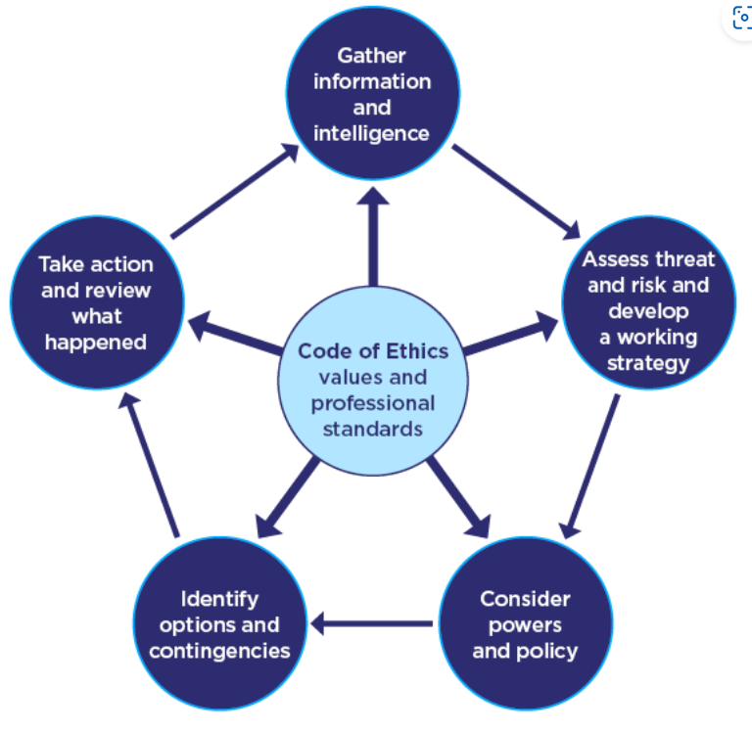
Upon initial arrival of the call like any call the first thing you do is gather information which included why the male was on the bridge in first place ad this will help us gain an understanding of the males’ mentality which will then help with what decisions get made next.

Failing to gather information or intelligence would mean that the next steps within the NDM would be more difficult as there is no starting point to work from.

I accessed the risk which was initially low due to the male being with officers away from the bridge, but it was clear the male was heavily intoxicated through drink and drugs and his mental health was suffering. The working strategy was to identify why the male felt the need to potentially end his life and establish if there were any friends or family who could be with him or anything we could immediately do to improve the situation. The reasoning behind this was to insure that the male knew that we were on his side and that we were not going to make any rash decisions.

I considered what powers I had being Section 136 of the mental Health act; Neither myself nor my colleague have used our police powers under the mental health act as this something that we use as a last resort due to how traumatic it can be.

One of our contingencies could have been to place the male in handcuffs but I did not deem this ethically correct, as did not want someone suffering with their mental health thinking that they were in the wrong. We were also trying to build a connection with the male and did not want him to think he was being arrested as his mental health was clearly suffering, which is an ongoing issue within the emergency services, however it became clear as the incident went on there were consequences for taking a more subtle approach.

In an article published by Genziani, Gillard, Samuels and Chambers (2020) they discuss the impact of emergency services utilising their powers to detain someone under the mental health act. The article looks at how Police Officers feel when sectioning someone and the impact it has with officer saying that when they go to mental health related calls you try to build a rapport with the person and when you then utilise your powers that person no longer trusts you.

This is how I felt during this incident as after the male was removed from the river he was sectioned and during the time I spent in hospital with the male became anxious and aggressive due to the process.

This article is focused specifically on the emergency services within London their experiences which will likely differ to other geographical locations, but the power remains the same and the impact on officers has the potential to be the same across the UK.

However, where use of force was concerned all changed very quickly with the male running away from officers my colleague decided that the best option was to use force in the form of a taser which when that proved ineffective the risk became higher. When the male entered the water, the risk became massive.

In an article written by Sheridan and Hepper (2022) they review the effectiveness of the taser used by police officers in the UK with 68.5% of all taser discharges being effective, the article discusses various reasons as to why taser may not be effective for example not having enough spread on the body so therefore not producing the spread of electricity needed.

This does however justice the use of taser during this incident and had it been effective the risk of injury would have been taken away from the male and both myself and my colleague.

Due to the male entering the water our police powers and policies are not effective at that point and our options quickly became either call of further emergency services such as fire and ambulance or act ourselves which is what ended up happening.

Failure for myself or my colleague to not take any action and wait for further emergency services could have easily resulted in the male becoming seriously injured or eventually dying.

As a result of our actions, we were able to get the male out of the water and treat him for hypothermia until the paramedics arrived on scene, due to the features of the river in which the male jumped into there would have been a very high chance that we would not have been able to help him if he didn’t get out at the location that he did.

This incident is something that me and colleague reviewed heavily at the time and still 7 months on we still talk about it and review what we could have done differently if anything, should I be in this situation again then I would be putting handcuffs to rear of someone immediately. Despite me previously saying I do not want people to think we are against them by placing handcuffs on them, but this would have been the safest option and the chances of that person then being ale to run and jump off a bridge far less slightly and we would have had more control over that person. This would have also insured that no police officers were put at any further risk.

Reviewing incidents like this are helpful as it gives you an understanding of how your colleagues viewed the situation compared to your opinion and it also allows you think of what you may do differently.

From a public perception standpoint placing handcuffs on someone would likely not look good and members of the public may not understand why a use of force is needed.

In a report conducted by the Independent Officer for Police Conduct (2015) a report was published on the police use of force within which it looks at the public perception of Police use of force. The report suggests that 83% of the public trust the police to use reasonable force, however this is not the full story.

The findings go onto show that people over the age of 55 have the most trust in police to use reasonable force, Black minority ethnic groups have less trust in the police to use reasonable force in particular younger ethnic minority groups and that the public had limited awareness of types of use of force police have at their disposal.

Unfortunately, this report does not give any details of the public perception of use of force in a mental health incident making it difficult to say how use of force would have been perceived during the incident I was involved in, unfortunately there do not seem to any statistics around mental health use of force incidents available.

All incidents will be logged and recorded on our South Wales Police system and in a situation like this is vital to make sure that our logs are correct as if this incident were to happen again then there are exact details which could be passed onto attending officers for them to be aware of.
I would consider what forms and referrals would be needed to put onto the log to offer help to the male to ensure that he doesn’t end up in a similar situation again and any use of force forms would also need to be recorded and justified.

Word Count- 1605

Task 3

Relevant areas of the National Policing Curriculum:
Maintaining Professional Standards, Leadership and Team-working

Evaluate theories of team dynamics as a means of developing team cohesion (reasons why some teams cannot function, theories and models relating to team dynamics, ways to improve team cohesion).

Consider why inter-personal conflict can occur within a team and outline what strategies can be adopted to enhance individual and team performance.

Consider how team dynamics within the police service can result in failing to comply with professional standards requirements (Code of Ethics, policies, procedures, protocols or legislation).

1750 words (+/- 10%: include your actual word count at the end of each section)

ANSWER:

In this task I will look at theories of team dynamics evaluating their success and how these models may relate into a Police environment.

I will evaluate the theory of the Tuckman Team Model an image of which is shown below.
This image was taken from a page written by S. Last of BCcampus (2023)
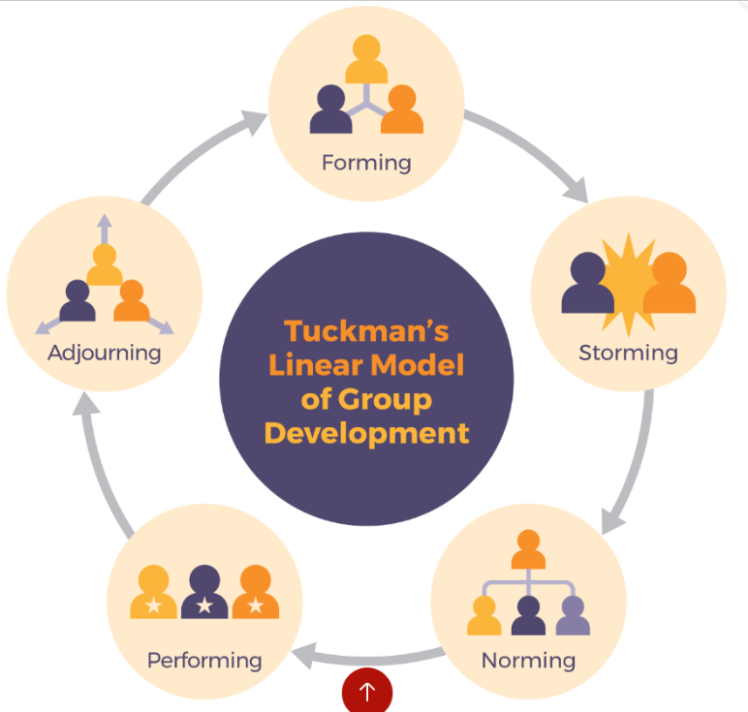
To give a brief background around the theory psychologist Bruce Tuckman came up with a theory that explains the process that all teams go through.

In an article published by Natvig and Stark (2016) they discuss the effectiveness of Tuckman’s model in a small group nursing-based environment, this was a project that was carried out the test the effectiveness of the model. The project is based around a team who are tasked with setting the standards for what the workload will be within a nursing setting.

Forming

The authors note that this aspect of the experiment the forming stage took place over a 2-month period, the authors do address the fact that no ground rules for the team was established. The article also refers to the lack of commitment regarding members of the team.

Storming

This aspect of the theory took place over 4-month period and several issues became apparent such as, lack of focus, not meeting deadlines, lack of responsibility taken on and issues amongst the team. It is also noted that the project completion time has had to be increased by 5 months and during their time so far little progress has been made.

Norming

This stage last roughly 3-months and it outlines how the team leader was not often around during this time, however the article does go onto to say how the team developed more structure and became more efficient as a team.

Performing

This area last for 2 months and during this time a new team leader was appointed, the article goes onto to say how all team members have taken on responsibility a taken ownership of their respective sections.

Adjourning

This stage showed more how the team has developed and reviewed what measures must be put in place to continue their success.

Although the above is brief overview of the article the conclusion of the article is that Tuckman’s model served a good framework and to improve the team dynamics then there should be more planning involved in the early stages, it was also made clear that as par ton any team you need a leader but picking the right leader with, the right skill set is vital for success.

The article does not state how many people are in the team only that it was a small team which is make sit difficult to full evaluate its success as larger number teams will be logistically challenging.
The Tuckman’s theory does appear to show an accurate theory with the team developing issues at the start of their journey and progressing until they have ironed out the issues.

During this team’s journey there appeared to be multiple reasons as to why the team was not functioning during the storming stage this is likely due to a lack of planning and poor leadership which was later identified, it is likely that all new teams will go through a similar process before they find the perfect team dynamic.

Task 4
Relevant areas of the National Policing Curriculum:
Policing the roads, information and intelligence and conducting investigations.

Explain how information and intelligence can be used in the disruption of the more prevalent criminal activity (e.g. drug smuggling, human trafficking, child sexual exploitation, counterfeit goods, organised crime groups and ‘county lines’) by effective policing of the roads.

Outline how ANPR can be used as investigative resource when disrupting criminal activity.

1750 words (+/- 10%: include your actual word count at the end of each section)

ANSWER:

Task 5
Individual Learning Plan

The second learning outcome identified in the accompanying module descriptor (BMPP 5000D) asks that you create an individual learning plan to meet your identified needs through reflection upon your continuing practice. This shows confidence in your ability to manage your own learning in response to evolving circumstances in the workplace.

This task differs from the PDPs that you have completed in your previous workbooks in that this learning plan allows you to assess what level you believe you are in key knowledge, skills and experience against where you believe you (and the force) consider you should be – now and in the coming 6 to 12 months of your placement. This should then be used to target future development need.

1500 words equivalent. Please note that this is not the actual number of words used in completing the table, the count reflects the thought and research behind it.

It will count towards the overall equivalent word count of 8000 words expected from this module.

ANSWER:

Knowledge, Skills and Experience Assessment

 | REQUIRED |  |  | RATING |  |  | DEVELOPMENT NEED
KNOWLEDGE | Low  1-4 | Med  5-7 | High  8-10 | Low  1-4 | Med  5-7 | High  8-10
SKILLS | Low  1-4 | Med  5-7 | High  8-10 | Low  1-4 | Med  5-7 | High  8-10
EXPERIENCE | Low  1-4 | Med  5-7 | High  8-10 | Low  1-4 | Med  5-7 | High  8-10

Bibliography
The bibliography should only include sources referenced within the workbook using the Harvard referencing system. Information about referencing in written assignments and how to avoid plagiarism can be found on Moodle. It is important that you are aware of the importance of ensuring that the work submitted is your original work.

Anonymous, (2023) ‘Predators in the police’, The Economist, 446(9330th ed.), pp. 21-22. Available at: https://www.proquest.com/docview/2767441758?accountid=130472&parentSessionId=ezDqPyO1mHRvNSUz8O0Fs2vEj1oNUaLXy6I73cSEB3Q%3D&pq-origsite=primo (Accessed 19 June 2023).

A. Purba, and E. Demou, (2019) ‘The relationship between organisational stressors and mental wellbeing within police officers: a systematic review’, BMC Public Health, 19(Accessed 28 June 2023).

C. Cox, and S. Kirby, (2018) ‘Can higher education reduce the negative consequences of police occupational culture amongst new recruits?’, Police occupational culture, 41(5th ed.), pp. 550-562. Available at: https://www.proquest.com/docview/2076098560?accountid=130472&parentSessionId=Vxgx4oMKWwra1r%2FGvUc1GZLgnrcyyLq0Vse%2BWN%2FSFkc%3D&pq-origsite=primo (Accessed 28 June 2023).

C. O. Policing, (2023). The National Decision Model [Online]. College Of Policing. Available at: https://www.college.police.uk/app/national-decision-model/national-decision-model (Accessed: 7 July 2023).

D. Natvig, and N. L. Stark, (2016) ‘Project Team Analysis Using Tuckman's Model of Small-Group Development’, Journal of nursing education, 55(12th ed.), pp. 675-681. Available at: https://www.proquest.com/docview/1844061935?accountid=130472&parentSessionId=oRYucjHmwPwzQm4yPnVmkRlJAMiujSBq5a%2FtLbP0Gsk%3D&pq-origsite=primo (Accessed 9 July 2023).

I. O. F. P. Conduct, (2015). Police use of force [Online]. Policeconduct.gov.uk. Available at: https://www.policeconduct.gov.uk/sites/default/files/Documents/research-learning/BMRB_use_of_force_report.pdf (Accessed: 8 July 2023).

J. S. McPhee, and A. P. Lightfoot, (2017) ‘Post-exercise recovery regimes: blowing hot and cold’, The Journal of Physiology, 595(3rd ed.), pp. 627-628. Available at: https://physoc-onlinelibrary-wiley-com.ezproxy.uwtsd.ac.uk/doi/full/10.1113/JP273503 (Accessed 7 July 2023).

M. Genziani, S. Gillard, L. Samuels, and M. Chambers, (2020) ‘Emergency workers’ experiences of the use of section 136 of the Mental Health Act 1983: interpretative phenomenological investigation’, BJPsych Bulletin, 44(6th ed.), pp. 250-254. Available at: https://www.proquest.com/docview/2462337095?accountid=130472&parentSessionId=fuhSFrKhoi%2BOM9cvoFMsOTblzVDbParjadTCiN%2FfpH0%3D&pq-origsite=primo (Accessed 8 July 2023).

P. Irizar et al (2022) ‘‘It’s a crutch’: A qualitative exploration of UK police employees’ experiences of at-risk alcohol consumption or abstinence1’, Policing: A Journal of Policy and Practice, 17(2023rd ed.), pp. 0-52. Available at: https://academic.oup.com/policing/article/doi/10.1093/police/paac052/6697040 (Accessed 28 June 2023).

R. D. Sheridan, and A. E. Hepper, (2020) ‘An analysis of officer-reported TASER X2™ probe discharge effectiveness in the United Kingdom’, Journal of Forensic and Legal Medicine, 91Available at: https://www-sciencedirect-com.ezproxy.uwtsd.ac.uk/science/article/pii/S1752928X22001147 (Accessed 8 July 2023).

S. Last, (2023). Five Models for Understanding Team Dynamics [Online]. BCcampus. Available at: https://pressbooks.bccampus.ca/technicalwriting/chapter/understandingteamdynamics/ (Accessed: 9 July 2023).

The Economist (online), What Sarah Everard’s murder means for the Metropolitan Police: In the spotlight. 2021.

Z. Wang et al (2023) ‘Relationship between physical activity and individual mental health after traumatic events: a systematic review’, European Journal of Psychotraumatology, 14(2nd ed.), (Accessed 7 July 2023).

