
APPENDIX GA36a

LEVEL 4 ASSESSMENT SPECIFICATION

Student name: | David Williams | Student ID number: | 1810541/1
Programme: | BSc (Hons) Computing Portfolio
Module: | Internet Technology and Security
Module code: | ACCA4018 | Contribution to Overall Module Assessment (%): | 50%
Lecturer: | Dr Carlene Campbell | Internal Verifier: | Dr Kemi Ademoye
Assignment Title: | Synthesize a solution to a potential real life scenario | Word count (or equivalent): | 2500
Submission deadline: | 10th January 2019 | Return date of provisional marks & written feedback:
Submission method: | All written assessments, where practical and possible, must be submitted via Turnitin unless otherwise instructed by the Lecturer. (Please DO NOT put this assessment specification into Turnitin or it will match many similarities with other students’ submissions.)  Alternative submission method (if applicable):  Late submission of the assessment will result in a late penalty mark. Penalties for late submission: Up to one week late, maximum mark of 40%. Over one week late, 0%. Only the Extenuating Circumstances Panel may approve a change to submission dates.
Academic honesty / referencing: | Academic honesty is required. In the main body of your submission you must give credit to authors on whose research and ideas your work is based. Append to your submission a reference list that indicates the books, articles, etc. that you have used, cited or quoted in order to complete this assessment.

Module Learning Outcomes
(from module syllabus)
- Demonstrate systematic understanding of security policies and measures to mitigate internal and external attacks and threats in a network.

TASK DESCRIPTION

Synthesize a solution to a potential real life scenario

Background:
The proliferation of mobile Internet devices such as laptops, tablets, smartphones, mobile phones, PDAs and even Satnavs is called IT consumerism. Because people use these mobile devices to connect to the Internet to make payments for services, email, blogging, social interaction, shopping, entertainment, research etc, there is immense pressure on IT managers and IT policy makers in corporate environments to allow employees, senior staff, and even clients of the companies to access their corporate networks using their personal mobile devices. The use of these personal Internet mobile devices to access corporate networks is called Bring your Own Device (BYOD) also referred to as Bring Your Own Technology (BYOT).

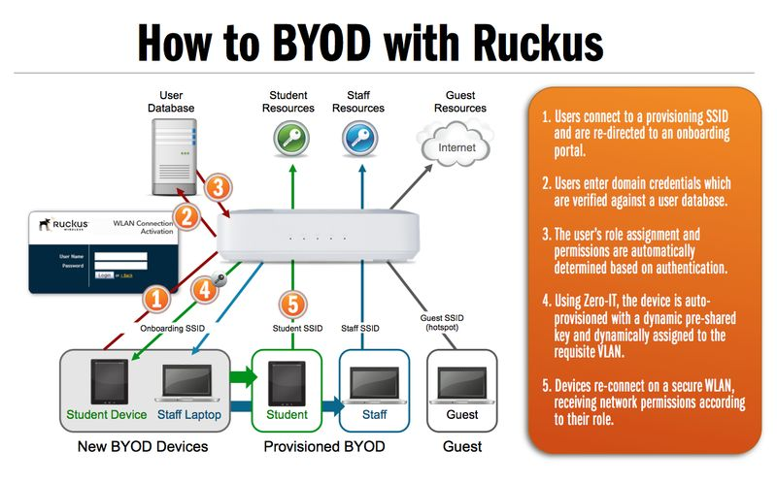
Figure 1: BYOD deployment at a corporate LAN.

Scenario:
Hyper-fort is a consultancy company specializing in the energy sector. Hyper-fort has extensive presence around the globe. The company uses cloud services to deliver IT services to its staff and clients. It is estimated that almost 95% of the company's network is wireless based. The company also has a massive online presence and social media presence to promote its activities.

Because of its large staff and customer base, the company has recently come under immense pressure to allow both its staff and customers to use their personal devices to access the company's network/resources. Security of personal staff's data and client's data is the company's major concern. The company is also concerned about protecting its intellectual properties, which is worth billions.

You are an IT Security Consultant hired by Hyper-fort to recommend guidelines on a comprehensive security policy that covers all aspects of its enterprise network, including online and offline resources.

You are asked to state all assumptions made in your report.

Task:
The principal feature of BYOT, which makes it attractive to users is that the user owns, maintains and supports their device. This poses so many security challenges to the data controllers at the enterprise network. The security of customer data, employee data, and intellectual properties is the main concern.

From the scenario given above, develop a comprehensive BYOT framework that covers all aspects of the company's enterprise network. This implementation must be submitted on Moodle.
- The framework should reflect your study stream this could include but not limited user policy, device management policy, security policy etc.
- A data flow diagram showing the implementation of your BYOT management architecture is required.
- Use appropriate software such as Cisco Packet Tracer or any other suitable tools to demonstrate the configuration of the Hyper-fort Ltd enterprise network.
  - The countermeasures employed for the implementation should demonstrate secured and restricted access to the company such as their services, email, blogging, social interaction, etc.
- Select a Mobile Device Management Software for your BYOT and explain the rationale for your choice.
- Write the advantages and disadvantages of BYOT (Think of increase in productivity as opposed to risks).

Your design should also assess the following issues and mitigate threats emanating from them when used in the proposed BYOT to be deployed at Hyper-fort.

- What type of data is retained by the mobile devices connecting to Hyper-fort network?
- What is the potential for data leakage when the participating devices leaves the office environment?
- How to address the blending of personal and business usage when devices are in office.
- What strategy to deploy to deal with different brands of devices.
- What strategy to deploy to deal with different Operating System platforms.
- What strategy to deploy to deal with different application on user devices.
- What mitigating strategy will be deployed when the owner of a participating device leaves their employment or the device is lost, stolen, or fails.

GUIDANCE FOR Students IN THE COMPLETION OF TASKS

Report Requirements:
- The report should be 2500-3000 words.
- The report should be typed and font size should be 12 Times New Roman.
- The lines or the bars in the same figures should use different line styles if they are not in colour.
- The figures should be clear enough so that all the captions will be clearly readable.
- You are required to produce a full progress and configuration of your network.

Report format:
- Abstract
- Introduction
- Related work (Research aspect/literature review focus)
- Problem formulation, if necessary (this will outline the problem that you will investigate and implement)
- Implementation (Discuss of the implementation through medium/method use e.g. simulation or practical experiment)
- Results/Findings & discussions
- Conclusion, recommendation and future work (From your findings what do you recommend, discuss or state these. What can be done in the future to improve on your findings will be the future work).

NOTE: The guidance offered below is linked to the five generic assessment criteria overleaf.

- Engagement with Literature Skills (15%)
Your work must be informed and supported by scholarly material that is relevant to and focused on the task(s) set. You should provide evidence that you have accessed an appropriate range of sources, which may be academic, governmental and industrial; these sources may include academic journal articles, textbooks, current news articles, organisational documents, and websites. You should consider the credibility of your sources; academic journals are normally highly credible sources while websites require careful consideration/selection and should be used sparingly. Any sources you use should be current and up-to-date, mostly published within the last five years or so, though seminal/important works in the field may be older. You must provide evidence of your research/own reading throughout your work, using a suitable referencing system, including in-text citations in the main body of your work and a reference list at the end of your work.

Guidance specific to this assessment: Your work must include articles published by peer reviewed journals, conference proceedings, books, and related website (e.g. IEEE, ACM, Science direct). Information from website such as how, wiki, forums, etc. will not be accepted.

Marks will be awarded for:
- Diversity of sources and materials used
- Key concepts discussed
- Appropriate summaries of articles and level of critical appraisal of literature
- Application of appropriate referencing conventions (9 marks allocated for proper and appropriate referencing)

- Knowledge and Understanding Skills (15%)
At level 4, you should be able to demonstrate knowledge of the underlying concepts and principles associated with your area(s) of study. Knowledge relates to the facts, information and skills you have acquired through your learning. You demonstrate your understanding by interpreting the meaning of the facts and information (knowledge). This means that you need to select and include in your work the concepts, techniques, models, theories, etc. appropriate to the task(s) set. You should be able to explain the theories, concepts, etc. to show your understanding. Your mark/grade will also depend upon the extent to which you demonstrate your knowledge and understanding.

Guidance specific to this assessment: On chosen topic, your work must demonstrate understanding of concepts and underlying principles. You should explain and analyse the scenarios you have derived for the company from your chosen topic in a meaningful way. The security policy you create will be the blueprint that dictates your scenarios for the campus.

This will be assessed by
- Depth of the research
- Strength of the statements
- Structure of the paper
- Quality of the report
- Following IEEE format

- Cognitive and Intellectual Skills (40%)
You should be able to present, evaluate and interpret qualitative and quantitative data, in order to develop lines of argument and make sound judgements in accordance with basic theories and concepts of your subject(s) of study. You should be able to evaluate the appropriateness of different approaches to solving problems related to your area(s) of study and/or work. Your work must contain evidence of logical, analytical thinking. For example, to examine and break information down into parts, make inferences, compile, compare and contrast information. This means not just describing what! But also justifying: Why? How? When? Who? Where? At what cost? You should provide justification for your arguments and judgements using evidence that you have reflected upon the ideas of others within the subject area and that you are able to make sound judgements and arguments using data and concepts. Where relevant, alternative solutions and recommendations may be proposed.

Guidance specific to this assessment: Your work must demonstrate critical analysis and evaluation of chosen technologies. Your work must also justify your choice and provide evidence that your choice is better than other methods.

This will be assessed by the quality of your comments and conclusions, throughout the report:
- Innovative approach used in designing a complete countermeasure solution for the campus.
- Key observations and impact identified to support security measures for future growth.
- Observations are well thought through and discussed
- Organisation of ideas and evidence
- Analysis of the findings

- Practical Skills (20%)
At level 4, you should be able to apply the basic underlying concepts and principles to evaluate and interpret these within the context of your area of study. You should be able to demonstrate how the subject-related concepts and ideas relate to real world situations and/or a particular context. How do they work in practice? You will deploy models, methods, techniques, and/or theories, in that context, to assess current situations, perhaps to formulate plans or solutions to solve problems, or to create artefacts. This is likely to involve, for instance, the use of real world artefacts, examples and cases, the application of a model within an organisation and/or benchmarking one theory or organisation against others based on stated criteria.

Guidance specific to this assessment: You must use software such as Packet Tracer, or any other suitable networking tools to demonstrate the network design you have adopted.

This will be assessed by the network or web/database model construction based on:
- The configuration of the infrastructure (LAN/WAN, WEB/DATABASE, etc. technology use)
- The countermeasures employed for the implementation
- Implementation of secured access and restricted access to the necessary site(s)
- Application used
- Protocol involved

- Transferable Skills for Life and Professional Practice (10%)
Your work must provide evidence of the qualities and transferable skills necessary for employment requiring the exercise of some personal responsibility. This includes demonstrating: that you can communicate the results of your study/work accurately and reliably, and with structured and coherent arguments; that you can initiate and complete tasks and procedures, whether individually and/or collaboratively; fluency of expression; clarity and effectiveness in presentation and organisation. Work should be coherent and well-structured in presentation and organisation.

Guidance specific to this assessment: You must submit a report which should be approximately 2,500 – 3,000 words in length. The report should be presented in an academic way (IEEE/ACM format) and therefore must include an abstract, an introduction, a conclusion and a list of references. The report must be submitted via Turnitin as well.

This will be assessed based on the written and presentational quality of your report:
- Flow
- Professionalism
- Comprehension (grammar and spelling)
- Completeness and presentation of report

Student FEEDBACK FORM

This section details the extent to which the assessment criteria are demonstrated by you, which in turn determines your mark. The marks available for each category of skill are shown. Lecturers will use the space provided to comment on the achievement of the task(s), including those areas in which you have performed well and areas that would benefit from development/improvement.

Generic Assessment Criteria | Marks available | Marks  awarded
1. Engagement with Literature Skills
.
A good diversity of sources and materials have been used to back up the content with key concepts discussed and appropriate summaries of articles and level of critical appraisal of literature shown. |  | 8.5
 | 15 | 8.5
2. Knowledge and Understanding Skills

Good in-depth research shown and a strong strength of the statements given.  The report lacks an introduction and an abstract which was required |  | 9
 | 15 | 9
3. Cognitive and Intellectual Skills

Some very good compare and contrast statements made, with well thought out observations and good analysis of the findings made.  Good appropriate recommendations for future growth considered and an organised use of ideas and evidence given. |  | 26
 | 40 | 26
4. Practical Application Skills

An adequate overview of the company’s network infrastructure designed using Packet Tracer given, with a detailed DFD diagram showing the implementation of the proposed solution. |  | 15
 | 20 | 15
5. Transferable Skills for Life and Professional Practice

The report demonstrates that you can communicate the results of your study/work accurately and reliably, with structured and coherent arguments.  You have demonstrated that you can initiate and complete tasks and procedures, whether individually and/or collaboratively; fluency of expression; clarity and effectiveness in presentation and organisation. Work should be coherent and well-structured in presentation and organisation |  | 5
 | 10 | 5

Assessment Mark (Assessment marks are subject to ratification at the Exam Board. These comments and marks are to give feedback on module work and are for guidance only until they are confirmed. ) | Late Submission Penalties (tick if appropriate) |  | 63.5%
 | Up to 1 week late (40% Max) |  | 63.5%
 | Over 1 week late (0%) |  | 63.5%

GENERIC ASSESSMENT CRITERIA

Level 4
In accordance with the Framework for Higher Education Qualifications, at the end of Level 4 students will be expected to have demonstrated knowledge of the basic underlying concepts and principles of a subject, and an ability to evaluate and interpret these within the context of that area of study. They should be able to present, evaluate and interpret qualitative and quantitative data in order to develop lines of argument and make sound judgements in accordance with basic theories and concepts of their subject(s) of study. They will have learned how to evaluate different approaches to solving problems, and will be able to communicate the results of their study/work accurately and reliably, and with structured and coherent arguments. They will be able to undertake further training and develop new skills within a structured and managed environment and will have the qualities and transferable skills necessary for employment requiring the exercise of some personal responsibility.

Level 4 | FAIL | MARGINAL FAIL | SATISFACTORY  (3rd / Pass) | GOOD  (2.2 / Pass) | VERY GOOD  (2.1 / Merit) | EXCELLENT  (1st / Distinction) | EXCEPTIONAL  (1st / Distinction)
Category | 0-29% | 30-39% | 40-49% | 50-59% | 60-69% | 70-84% | 85-100%
Engagement with literature (including reading, referencing,  academic conventions and  academic honesty) | Little or no evidence of reading and/or reliance on inappropriate sources.  Views and findings mostly unsupported and non-authoritative.  Referencing conventions used incoherently or largely absent. | Poor engagement with essential reading. No evidence of wider reading. Reliance on inappropriate sources, and/or indiscriminate use of sources. Heavily reliant on information gained through class contact. Inconsistent and weak use of referencing. | Engagement with a limited range of mostly relevant and credible sources but with some reliance on information gained through class contact. Some omissions and minor errors.  Referencing conventions evident though not always applied accurately or consistently. | Engagement with an appropriate range of literature, including sources retrieved independently. Some over-reliance on texts rather than other sources. Referencing may show minor inaccuracies or inconsistencies. | Engagement with a wide range of literature, including sources retrieved independently.  Selection of relevant and credible sources. Generally sound referencing, with no/very few inaccuracies or inconsistencies. | Engagement with an extensive range of relevant and credible literature. Consistently accurate application of referencing. | Exceptional engagement with an extensive range of relevant and credible literature. High-level referencing skills consistently applied.
Knowledge and understanding (Knowledge of the basic underlying concepts and principles of a subject.) | Major gaps in knowledge and understanding of the basic underlying concepts and principles of the subject matter. Inclusion of irrelevant material. Substantial inaccuracies. | Gaps in knowledge of the basic underlying concepts and principles, with flawed or superficial understanding. Some significant inaccuracies and/or irrelevant material. | Limited knowledge and understanding of the basic underlying concepts and principles within the subject area. Some elements may be missing. | Knowledge of the basic underlying concepts and principles is accurate with a good understanding of the field of study but lacks depth and/or breadth. | Competent knowledge of the basic underlying concepts and principles. Exhibits very good understanding. | Excellent knowledge and understanding of the basic underlying concepts and principles of the subject. | Exceptional, detailed knowledge and understanding of the basic underlying concepts and principles
Cognitive and intellectual skills  (Evaluate underlying concepts and principles of a subject and interpret qualitative and quantitative data in order to develop lines of argument and make sound judgements.) | Wholly or almost wholly descriptive work. Little or no evaluation of the underlying concepts and principles.  Failure to develop arguments, leading to illogical or invalid judgements. Minimal or no use of  evidence to back up views. | Largely descriptive work, with superficial evaluation of the underlying concepts and principles. Weak interpretation of data, flawed development of arguments and judgements. Information accepted uncritically, uses generalised statements made with scant evidence and unsubstantiated opinions. Ideas sometimes illogical and contradictory. | Limited attempt at evaluation of the underlying concepts and principles, tending towards description.  Can interpret qualitative and quantitative data but with some errors. Some evidence to support emerging arguments and judgements but these may be underdeveloped or with a little inconsistency / mis-interpretation. | Good evaluation of the underlying concepts and principles. Can interpret qualitative and quantitative data, with minor errors.  An emerging ability to use evidence to support the argument.  Mostly valid arguments and logical judgements. | Sound evaluation of the underlying concepts and principles. Can interpret qualitative and quantitative data accurately. Ability to devise arguments using evidence to make mostly appropriate and valid judgements. | Excellent evaluation of the underlying concepts and principles. Can interpret qualitative and quantitative data accurately and with some insight. Excellent ability to devise arguments using evidence and make appropriate and valid judgements. | Exceptional evaluation of the underlying concepts and principles based evidence. Outstanding interpretation of qualitative and quantitative data.  Exceptional ability to devise arguments using evidence and make wholly appropriate and valid judgements.
Practical skills  (Different approaches to solving problems in particular contexts.) | Limited or no use of taught, basic methods, materials, tools and/or techniques.  Little or no appreciation of the context of the application.  Very weak evidence of different approaches to problem-solving in particular contexts. | Rudimentary application of taught, basic methods, materials, tools and/or techniques but without consideration and competence. Flawed appreciation of the context of the application.  Weak evidence of different approaches to problem-solving in particular contexts. | An adequate awareness and mostly appropriate application of basic methods, materials, tools and/or techniques.  Basic appreciation of the context of the application.  Can identify problems in particular contexts and propose basic alternative approaches or solutions though there may be errors. | A good and appropriate application of basic methods, materials, tools and/or techniques.  Clear appreciation of the context of the application.  Good evidence of different approaches to problem-solving in particular contexts and proposes mostly appropriate solutions. | A very good application of a range of basic methods, materials, tools and/or techniques.  Very good consideration of the context of the application. Very good evidence of different approaches to problem-solving in particular contexts and proposes appropriate solutions. | An advanced application of a range of taught, basic methods, materials, tools and/or techniques.  The context of the application is well considered, and insightful.  Excellent evidence of different approaches to problem-solving in particular contexts and proposes appropriate solutions. | Exceptional levels of application and deployment skills in particular practical contexts. Outstanding identification of problems in particular contexts and formulation of wholly appropriate, thoughtful solutions / different approaches.
Transferable skills for life and professional practice  (Communicate the results of their study/work accurately and reliably, and with structured and coherent arguments; the qualities needed for employment requiring the exercise of some personal responsibility within a structured and managed environment.) | Work is poorly structured, disorganised, inaccurate and/or confusingly expressed. Very weak use of language and/or very inappropriate style. Failure to work effectively individual or as part of a group. Little or no evidence of the skills for employment requiring the exercise of some personal responsibility. | Work is poorly presented in a disjointed manner. It is loosely, and at times incoherently, structured, with information and ideas often poorly expressed. Weak use of language and/or inappropriate style. Flawed approach to individual or group work, meeting only partial obligations to others. Limited evidence of the skills for employment requiring the exercise of some personal responsibility. | Mostly ordered presentation and structure in which relevant ideas / concepts are reasonably expressed. Work may lack coherence and/or accuracy in places. Can work as part of a group, meeting most obligations to others but perhaps with limited involvement in group activities.  Demonstrates the basic skills for employment requiring the exercise of some personal responsibility, with some areas of minor weakness. | Mostly coherent, organised and accurate work, in a suitable structure and is for the most part clearly expressed. Can work effectively independently and/or as part of a team, with clear contribution to group activities.  Demonstrates the skills for employment requiring the exercise of some personal responsibility, with some areas of strength and some of minor weakness. | Work is accurate, coherent, fluent, well-structured and organised.  Can work effectively independently and/or as part of a team, with very good contribution to group activities. Demonstrates very good skills for employment requiring the exercise of some personal responsibility, with just occasional minor weakness. | Work is coherent, very fluent and is presented professionally. Can work effectively independently and/or as part of a team, with an excellent contribution to group activities. Demonstrates excellent skills for employment requiring the exercise of some personal responsibility with an appetite for further development. | Work is accurate, exceptionally coherent, very fluent and presented well. Can work effectively independently and/or as part of a team, with an exceptional contribution to group activities. Demonstrates exceptional skills for employment requiring the exercise of some personal responsibility with an appetite for further development.

THIS DOCUMENT IS ALSO AVAILABLE IN WELSH

David Williams

Synthesize a Solution to a Potential Real Life Scenario
Internet Technology and Security

Contents
Abstract 2
Research 3
Incompatibility 4
Policies 5
User Policy 5
Device Management Policy 5
Security Policy 5
Benefits and Detriments of BYOT 6
Advantages 6
Disadvantages 6
Potential Issues and Solutions 7
Retained Data 7
Data Leakage 7
Personal and Business Usage 7
Different Brands, Operating Systems and Applications 7
The Potential Loss, Theft and/or Fault of a Device 7
Conclusion 8
References 8
Further Reading 8

Abstract
For the purposes of this assignment, I have been tasked with creating a Bring Your Own Technology (more commonly denoted as BYOT) infrastructure that can be used by a business. This includes any and all research made, the advantages and disadvantages of BYOT, policies that could be included in such a system, any recommendations regarding software/methods as well as any issues that could be encountered.
The business in question, Hyperfort, has expressed interest in delving into experimenting with BYOT due to the increasing demand of customers and employees wishing to use their own devices in order to view their work/service. Hyperfort’s biggest concern is the potential security risks that could develop with the implementation of BYOT. As such, this will be a major focus in the following documentation. By completing these aforementioned tasks, I should have a comprehensive BYOT that meets it’s required needs.
Good

Research and Implementation
During my investigation regarding the background of BYOT/BYOD, I came across this infographic with guidance for implementing a BYOT system (courtesy of https://www.ncsc.gov.uk/guidance/byod-executive-summary):
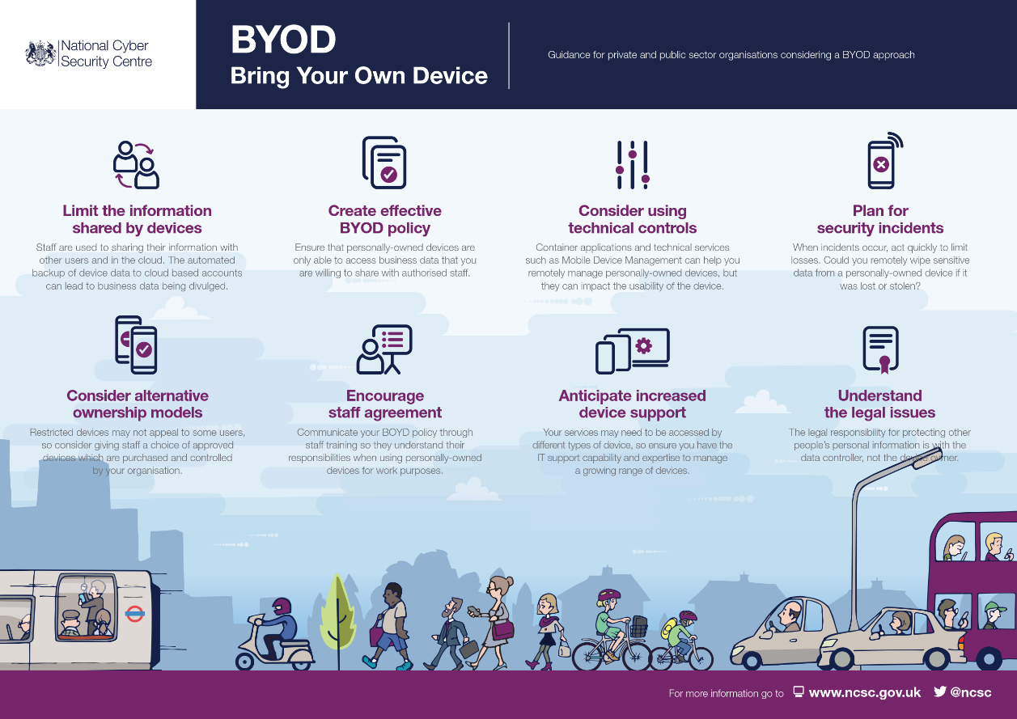
I feel that the most beneficial/useful approach would be a Virtual Desktop system, specifically using Microsoft’s Azure service. A prime reason as to why Azure was chosen was down to it’s reputation with large scale companies such as HP, Adobe and Chevron adopting the service to tackle their worldwide efforts.
Good
When talking about the benefits of implementing a Virtual Desktop system, Laurie McCabe [1] mentioned “Since everything is centrally managed, stored and secured, virtual desktops eliminate the need to install, update and patch applications, back up files, and scan for viruses on individual client devices. Desktop virtualization also helps to streamline management of software assets.”
Good
This is an aspect that could really benefit Hyperfort as, since they’re a large-scale system, a large amount of time is cut down from waiting for software to install and/or update or files to back themselves up. As a result, a lot more productive time can be spent carrying out additional tasks which will benefit Hyperfort in the long term.
Good
Since all the devices using the Virtual Desktop will be wireless, I recommend the Ruckus SmartZone 300 to manage and authenticate any incoming wireless signals from users. I decided to implement the SmartZone 300 due it’s scalability, allowing for more users to be authenticated if Hyperfort were to expand. It’s also known for it’s third-party support, allowing for potential add-ons and customization if needs be. This also includes the ability to incorporate software such as anti-malware in order to further protect any sessions that take place. Lastly, the SmartZone 300 allows for Active Directory support, which will group users together based on pre-assigned roles (such as admin, sales, support and so forth) and limit the amount of files they can access.
Good
On the importance of Network Monitoring, Paul Ferrill [2] “Network monitoring services are a critical component to keeping a company's data center healthy and functioning. These services detect, monitor, and analyze your network, examining applications and devices in real time, which can help you quickly respond to warning alerts.”
Good
I feel that the combination of Azure, Ruckus and Active Directory will allow users to easily and safely connect to Virtual Desktop service whilst only being able to view and alter files/data pertinent to their role/work.
Shown below is a Data Flow Diagram, to demonstrate how a user would connect to the Virtual Desktop System:
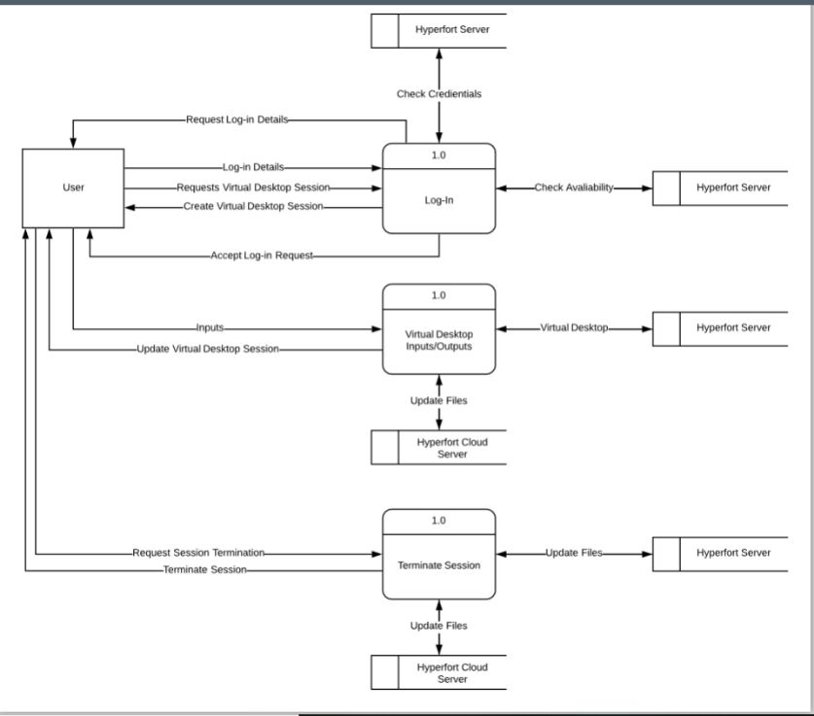
Good
Shown below is an example of how the Virtual Desktop system would be configured using the Cisco Packet Tracer software package:
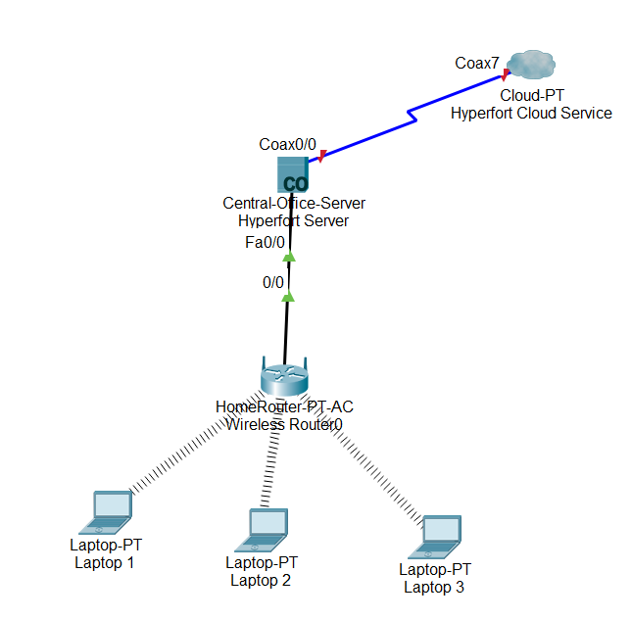
Good

Incompatibility
The most prevalent issue regarding the BYOT system that needs to be addressed is the potential compatibility issues that could arise. With an array of different potential devices each with their own models, operating systems and versions, the technology that users could bring in . For example, software needed to carry work out may only work properly on a Windows device and not an Apple or Android device due to the software not being designed with the aforementioned operating systems in mind. This leads to a plethora of potential security issues as it would prove difficult to monitor and maintain devices and information from several different devices due to them being simply incompatible.
Good
Instead of having a system that attempts to juggle multiple devices with different operating systems and versions, I feel that a BYOT system that only focuses exclusively on one operating system would be the most beneficial. In this case, I suggest a BYOT structure that focuses around the Windows operating system to ensure that it’s as secure and compatible with other devices would be the best fit.
Good

Policies
The following is an example of a series of policies that should be implemented when introducing a BYOT programme.
By opting into the BYOT programme, you are agreeing to be legally bound by the following terms:

User Policy
The BYOT programme is exclusively for work relating to the Hyperfort business. Personal aspects must NOT be incorporated into ones work at Hyperfort, an example could be using your business email to sign up for recreational websites.
You agree to not download, copy and/or distribute any Hyperfort files/content without the explicit permission of Hyperfort.
Employees are permitted to create and alter files to aid their work at Hyperfort.
Each Hyperfort employee that opts into the BYOT programme will be provided their own username and password to access their virtual desktops. Sharing the aforementioned details is strictly prohibited. Employees are requested to change their password at the start of every quarter for security upkeep.
To terminate your Hyperfort virtual desktop profile, please contact the administrative team.
We may terminate your profile and any associated data if we, Hyperfort, feel that you have breached our Terms of Service.
Devices used for the BYOT programme is strictly the responsibility of it’s user, not Hyperfort.
Good

Security Policy
Usernames will be based on a randomly generated six-digit number.
Passwords must be at least eight characters in length and contain the following: at least one lowercase letter, at least one capitalised character and at least one numerical value. New passwords cannot be duplicates of previous passwords. Passwords are to be changed on a quarterly basis.
Usernames and passwords are not to be divulged to anyone, doing so could be seen as a violation and, as such, could lead to punishment.
Security audit logs will take place on a consistent basis, the following data will recorded and potentially archived: Usernames, Log In/Out Times, Unsuccessful Log-in Attempts, Changes Made to Files/Data as well as Incoming and Outgoing Data such as Websites Visited.
Employees will be provided with an email address based on their username followed by @HyperFort.co.uk. Said email(s) are considered properties of HyperFort, as such, it’s use and contents may be monitored. Email usage must not negatively affect an employee’s productivity, the public image of Hyperfort and/or Hyperfort’s content/data.
Good

Benefits and Detriments of BYOT
The following is a series of advantages and disadvantages that the implementation of Bring Your Own Technology has:

Advantages
The implementation of the BYOT system could mitigate some of the cost used to purchase and install hardware since users will pay and bring in their own systems instead of purchasing devices for them to use.
Good
Individuals who bring their own devices are more accustomed to their design/interface leading to a higher level of productivity as they don’t have to spend time learning a new system that they’re unfamiliar with, also minimises mistakes made due to unfamiliarity with the new system.
The system encourages users to continue working whilst at home since the system they use is available to them at all time and they don’t have to be at work to exclusively carry out tasks.
Good

Disadvantages
The BYOT system has the potential to introduce and/or spread viruses across the system if an individual were to connect their infected device to the BYOT system if unprotected/handled poorly. This is extremely dangerous with potential for hardware to be damaged as well as corrupted and/or stolen data.
Good
Devices brought in might not have the necessary software/hardware needed in order to carry out certain tasks. Devices could also face compatibility issues due to being out of date, platforms that aren’t supported and so forth. However, limiting what devices can be used as well as the implementation of Virtual Desktops should mitigate this issue.
A system of this size and nature can be extremely complicated to develop and implement. As such, a lot of time and resources would have to be spent in order to properly formulate and plan the system’s creation.
Good
The initial investment to establish the BYOT system, the inclusion of servers, software and so forth, can be very high with a high degree of expertise and manpower needed in order to manage and oversee it’s development.
Good

David you need to work on your It’s and its.

Potential Issues and Solutions

Retained Data
With regards to any retained data that the virtual desktop may keep after/when a user logs in, the following data should be considered: usernames, passwords, user’s names, email addresses. The Virtual Desktop session will also record any files that are created and/or changed and upload them to a cloud service for it to be viewed at a later point in time.
Good

Data Leakage
Data Leakage is also a major issue in today’s day and age. The inclusion of a virtual desktop should minimise any potential leaks that could take place due to their security measures such as requiring a username and password in order to access a user’s virtual desktop. Furthermore, with the inclusion of Microsoft’s Active Directory, users are limited as to what data they can view and access to only what they are required to see/edit. Therefore, the amount of data that could leak by a user is also substantially limited.

Personal and Business Usage
Good
Another concern revolves around the user’s personal and business usage of their device whilst at work and at home. Since the user will use a virtual desktop in order to carry out their work, their usage is more limited than it would be at home. For example, specific websites, such as social media, will be prohibited whilst the user is on the virtual desktop. Furthermore, the blending of personal and business information/tools, such as using your business address for recreational websites is prohibited, as stated in the User Policy.
Good

Different Brands, Operating Systems and Applications
As stated previously, to prevent any issues occurring due to different devices, operating systems and applications, only Windows devices are eligible for the BYOT system. Although this could be considered a divisive measure as people may have an affinity for non-Windows devices, I feel that focusing solely on one operating system is the best way to ensure the highest level of security needed for the business.
Good

The Potential Loss, Theft and/or Fault of a Device
Due to the inclusion of the Azure virtual desktop, if a user were to lose their device, a username and password would be required in order to access any information pertinent to the business. As a result, this minimises any potential unauthorised access due to theft/an individual losing their device. Furthermore, since any changes that are made during a Virtual Desktop session are saved to The Cloud, this prevents any data from being lost due to theft or a device failing, as a copy will always be maintained and stored for future access. Lastly, as outlined in the User Policy, it is the user’s responsibility to provide their own devices in order to partake in the BYOT programme. As a result, Hyperfort will not have to worry about providing users with replacements.
Good

Conclusion
In conclusion, I feel that the BYOT system outlined would prove to be a very effective system. Although it would be a fairly expensive system to implement, I feel that it would be incredibly beneficial in the long run. Files and valuable data will be stored behind usernames, passwords and roles set by the Active Directory which will drastically limit what information users can and cannot see. Furthermore, it will be incredibly difficult to lose data as it’s consistently uploaded to the cloud, so if a physical copy of a file were to be lost due to it being stolen or corrupted, there’s always a back up. The ability to conduct work wherever the user may be so long as they have internet access and valid credentials, could be a major boost in productivity for Hyperfort, as employees are more inclined to do their work outside of the workspace. As a result, Hyperfort could see an increase in business both in terms of performance and quality due to the influx in accessibility when it comes to carrying out tasks.
Good
An area in which I feel this documentation lacks is with regards to it’s technical discussion as it’s admittedly rather limited. I feel more research and/or hands on with a virtual desktop system would go a long way to provide a more comprehensive look at a potential implementation of BYOT.
Good

References
[1] L. McCabe. (2010, November 30). What is a Virtual Desktop, and Why Should You Care? [Online]. Available: https://www.smallbusinesscomputing.com/webmaster/article.php/3914891/What-is-a-Virtual-Desktop-and-Why-Should-You-Care.htm
[2] P. Ferrill. (2017, December, 8). The Best Network Monitoring Software [Online]. Available: https://uk.pcmag.com/cloud-services/73174/the-best-network-monitoring-software

Further Reading
M. Rouse and A. Gillis (2018, June). Active Directory [Online]. Available: https://searchwindowsserver.techtarget.com/definition/Active-Directory
J. D. Tolt. (2014, October, 22). 5 network security risks your company might not be aware of [Online]. Available: https://www.irisns.com/5-network-security-risks-company-might-aware/
E. Geier. (2017, September, 18). 5 Ways to Secure Wi-Fi Networks [Online]. Available: https://www.networkworld.com/article/3224539/5-ways-to-secure-wi-fi-networks.html
User Policies [Online]. Available: https://www.independent.co.uk/service/user-policies-a6184151.html

