

Marketing Fundamentals

Assessment 1 (Task 1) Blogging to communicate

Submission Date: 25th November 2022 Name of the Lecture: Tushara Balendra​n Student ID: 2132604
Student Name: Marlon Alexander Ortiz Gavilanes

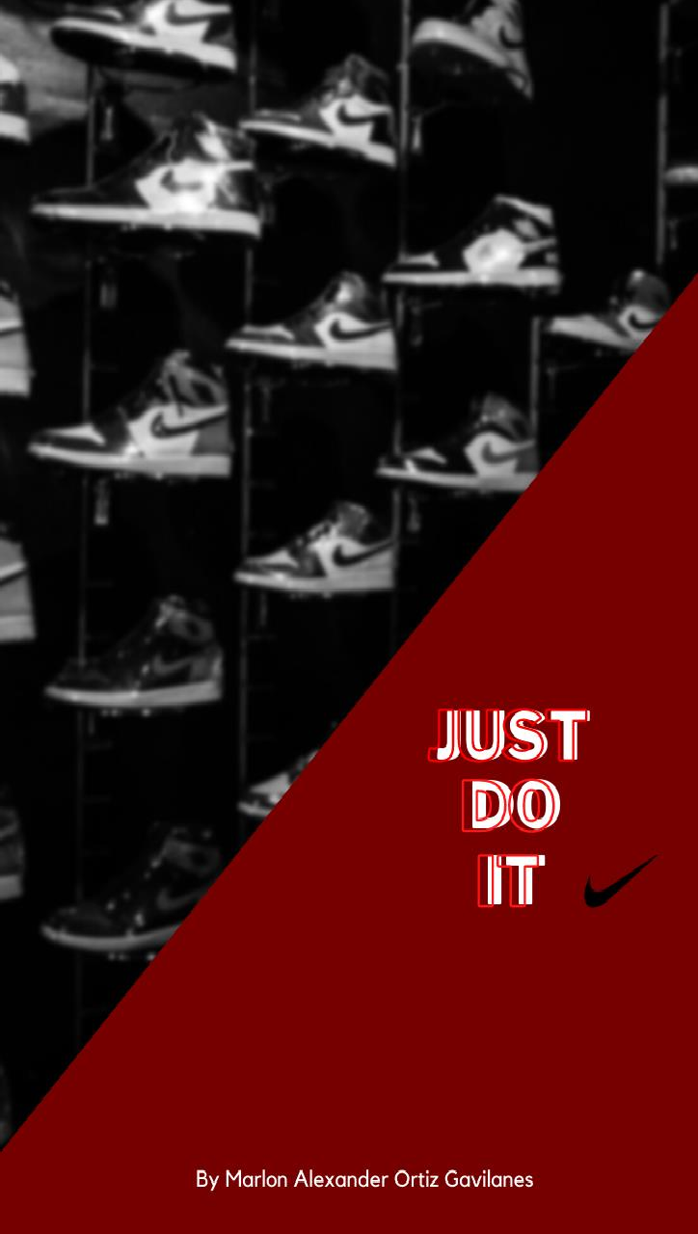

Background of Nike

The history of Nike
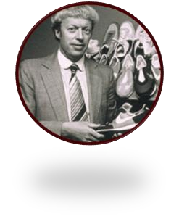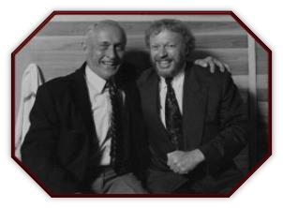

The largest clothing brand in the world began in the sixties and was founded by Phil Knight.
Phil was an American born on 24th of February 1938, was linked to the University of Oregon, had a degree in business administration and had a project in mind that was to devise a small business.
The project was to manufacture low cost running shoes in Japan and distribute them in the
United States afterward. Phill received support and inspiration for the project from Bill Bowerman, who was his coach at the
University of Oregon, and had previous
experience producing lightweight
customized running shoes.

Knight's decided travel to Japan, after the graduation of his degree, to visit one of the most significant shoe manufacturers in the country due to the creation of the great Japanese firms called Tiger. Phil Knight reached an agreement with the tiger brand and in this way the germ company of Nike was born, called Blue Ribbon Sports founded on 20th of January 1964, this company managed to sell the Japanese Tiger shoes in Oregon.

Bowerman and Knight worked hard together generating more than a million dollars in sales, but over time, Blue Ribbon Sports decided to break relations with Onitsuka and opted to introduce its own brand of shoes on 30th of May 1971, which became what is currently known as Nike (which means victory in Greek). Therefore, Blue Ribbon products officially became Nike, increasing sales from ten million to two hundred and seventy million dollars. Nike became well known and managed to gain a significant foothold in the North American market, so they began to design other sportswear, in addition to Nike shoes.

In 1985 a key moment for Nike arrives when it decides to bet on a promising basketball player, Michael Jordan. Nike realized that Jordan is a gold mine, and they begin to design a line of footwear inspired and advertised by Michael Jordan, such as the Air Jordan sneakers or the Air Flight.
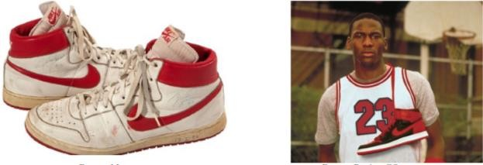
In these years Nike also launches one of the most famous slogans in the history
of advertising, which is still in force today, it is Just do it.
Today Nike uses great athletes and clubs as an advertising claim (Frisch, A. 2008).

Mission statement

Nike has a vision to bring inspiration and innovation to every athlete in the world regardless of gender, age, religion. However, Nike has adaptable sports products for all types of people.
Another of the points that we talk about in this section is the mission of the Nike brand, it is to be the largest seller of sports products for athletes around the world.
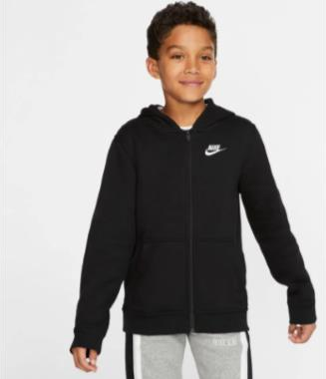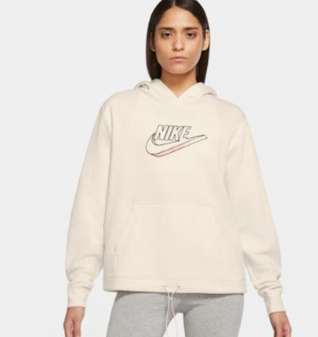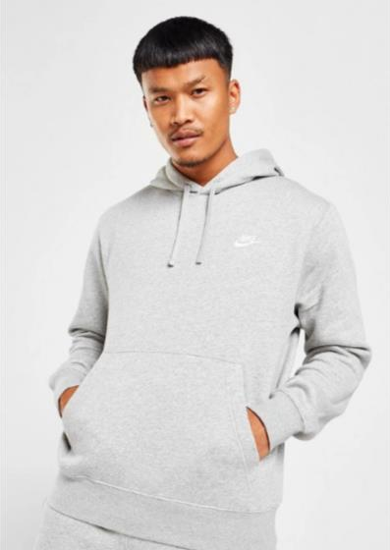The representation of Nike brand products is to attract the customer in important aspects such as product quality, service, and customer support that the brand offers to compete in all areas with other brands (Flynn,Patrick 2015).

Logo

This section talks about the Nike brand logo, which was founded by Phil Knight and
Bill Bowerman, both of whom coincided at the University of Oregon.

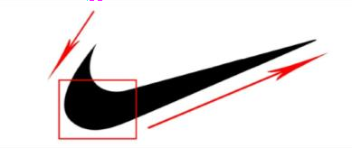In 1971 Caroline Davidson, who was an advertising student at the University of Portland, accepted a request from the founders of Nike to design a logo that could be placed on the side of her shoe. Caroline Davidson gave her the Swoosh, for which she was paid thirty- five dollars.

(Swoosh designed for Caroline Davidson 1991)
The Nike logo represents the victory wing of a Greek goddess named Nike, according
to mythology.

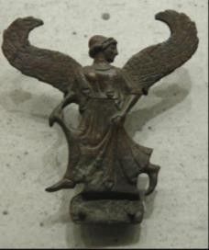(Goddess Nike bronze statue by Tentulogo 2016)

The Nike logo has been changing from 1964 to 1995. The brand have become so well known among consumers that the company does not need the name on its items for the brand to be recognizable. Therefore, in several articles, only the logo is shown. (Frisch, A. 2008)

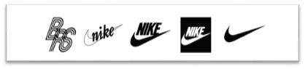
1964
1971
1978 - now
1985
1995 - now

PRODUCT

This paragraph discusses the Nike product and provides a description of all its aspects, including the advantages and characteristics of each product, as well as the package design, brand strategy, and usage of user friendly. Nike has a diverse product line that includes footwear, clothes equipment, and accessories. At the moment, all of its item are the best sellers globally; all of these things are clothes and sport equipment. Aside from that, it now sells items in athletics, baseball, ice hockey, tennis, football, lacrosse, basketball, and cricket (Shahriar, A. 2015).

Nike Mercurial Vapor 14 Elite

- Quality of the product. This model is one of the greatest quality football shoes available; it has been specially designed to provide the football player with the ideal conditions on the field, such as grip and high flexibility. It is also made of a lightweight and soft material that provides appropriate protection in all sorts of football scenarios.

- Features and Benefits. One of this Nike product is outstanding qualities is its vapour permeability, which allows moisture produced throughout the game to be released to the outside, keeping the athlete's feet dry and fresh. Nike is innovative manufacturing features contribute to the distinctive comfort and outstanding foot support. Also helping to improve player attributes on the field.

- Packaging design. There are many different sorts of packaging designs for the Nike brand, ranging from newly launched products with limitless package designs to typical Nike products that have common and standard packaging after being released to the market. (Visited on 25/11/22
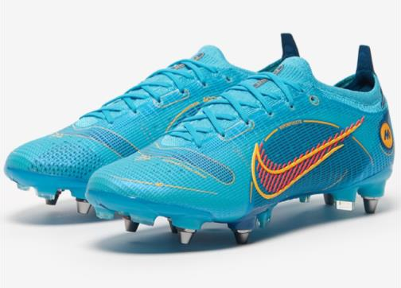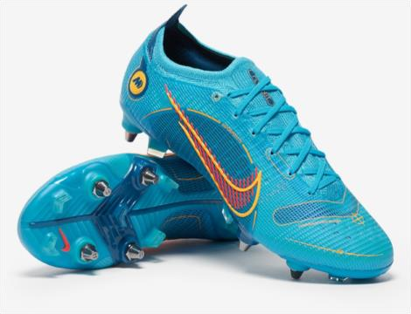at https://www.nike.com/gb/).

For more info about this Nike product, I attach the
link https://www.nike.com/us/es/t/calzado-de-f%C3%BAtbol-para-terreno-firme-
mercurial-vapor-14-elite-fg-Mq8RLH

Nike Football T-shirt F.C. Barcelona.
- Quality of the product. The highest standard in soccer sports. Due to its superior quality and design, this shirt is one of the most popular in the world. The shirt provides a variety of styles for all types of individuals including men, women, and children of all ages and features. Dri-Fit technology, which capillaries sweat from the skin to ensure breathability and comfort of the wearer.
- Features and Benefits. The creation of this shirt, which uses recycled polyester instead of virgin polyester to cut carbon emissions by up to 30%, is one of its key features. One billion plastic bottles are typically recovered by Nike each year from landfills and waterways. One of its best benefits is that the person who wears it can feel like a professional football player.
- 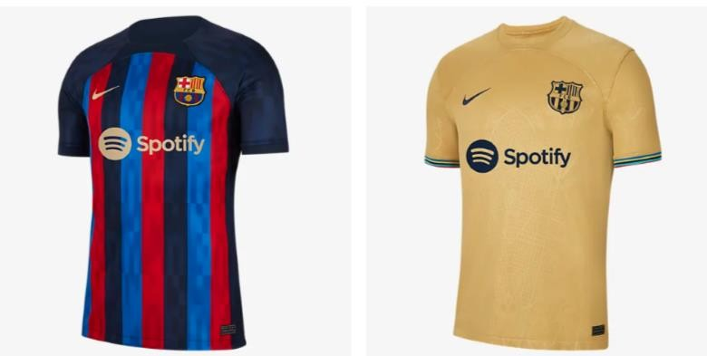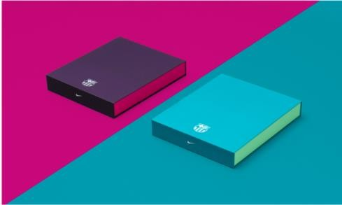Packaging design. A business called Oxygen collaborates on the packing of this team's jerseys and creates various packaging designs for it each year. Obtaining retail packaging and premium packaging is the objective for this year. The first, since it is directed at the press and VIPs, is meant to serve as a prescriptive element. This package is an additional element of the second, which is targeted at customers who purchase the shirt. (Visited on 27/11/22 at https://www.nike.com/gb/)

For more info about this Nike product, I attach the link.
https://www.nike.com/es/w/fc-barcelona-5y174

Nike Dri-Fit Strike Winter Warrior.
  - Quality of the product. Customers frequently utilize this Nike gear during cold weather. The warmth of sweat capillarization makes the product quality stand out. It maintains breathability and comfort by wicking moisture away from the skin thanks to Nike Dri-FIT technology.

  - Features and Benefits. The permeable design of this item is one of its features. Mesh above the mouth improves airflow and let is sound travel through so you can talk to your colleagues. The Adjustable Fit is one of its benefits. The design fits snugly over the ear, covers the nose, mouth, and neck, and the locking chain lets you adjust the fit to keep the neck warmer in place.

  - Packaging design. This product packaging was created from recycled materials. For a better future, the Nike firm wants to work with the environment. (Visited on 28/11/22 at https://www.nike.com/gb/)
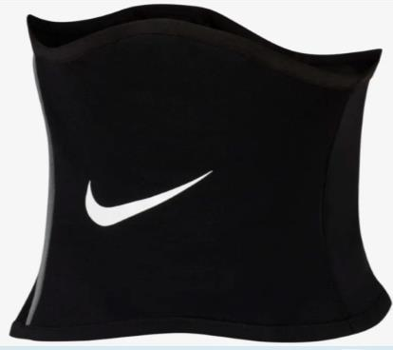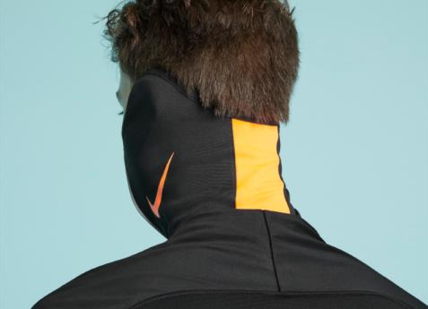

For more info about this Nike product, I attach the link.
https://www.nike.com/es/t/dri-fit-strike-winter-warrior-cuello-termico-
b62GH7/DC9165-010

Price

As part of pricing strategy, the company considers that its products are of higher quality and value than the competition, therefore establishes higher prices than rivals. However, Nike would lose clients if its prices were significantly higher than competitors like Adidas.
Nike's catalog offers a wide range of products at different prices, this can vary depending on
the size, gender, item, or lowest prices whether is on sale. Products can start from £7.69 up to
£359.95. In addition, Nike launched premium range, which includes the most expensive products for "exclusive customers" such as Kanye West's Nike Air Yeezy valued at 1.8 dollars (Soni, P. 2014)
Moreover, prices may vary depending on the country where items are sold.

Nike air force 1
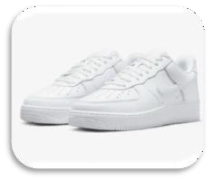
The 1982 release of the Air Force 1 revolutionized basketball footwear for both hardwood and concrete courts. Although it was the first basketball shoe to feature Nike Air, its originality has since been overshadowed by its legacy as a street legend. (Visited on 29/11/22 at https://www.nike.com/gb/)

EEUU: 150.00$ EU: 119.99E UK: 109.95£

Nike Storm-FIT ADV Utility Speed.
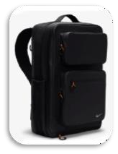
Introducing the bag that strives just as hard as you do. When it's windy or rainy outside, Nike Storm-FIT technology helps keep your gear dry so you can perform at your peak throughout the year. From dawn until dusk, padded shoulder straps that are adjustable, and a stabilizing chest strap will keep you at ease. (Visited on 29/11/22 at https://www.nike.com/gb/).

EEUU: 110.00$
EU:99.99E
UK: 89.95£

Nike Sportswear Club Fleece.
The Nike Sportswear Club Fleece Pullover Hoodie is a wardrobe essential that provides soft comfort in a street-ready design for an enhanced, daily look that you can wear every day. (Visited on 29/11/22 at https://www.nike.com/gb/)

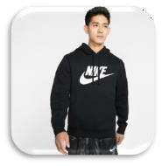
EEUU: 80.00$ EU: 69.99E UK: 54.95£

Place

The following are the principal distribution hubs for Nike's goods around the globe:
- The Nike Town Shop is positioned in key areas of big cities that are simple for customers to
access, like city centers.
- Flagship Stores: Nike has hired retail establishments with the Nike Flagship Store brand to
provide customers with high-volume Nike merchandise.
- Nike ID: This website operates as a Nike online store and offers customizing options to
clients all over the world.
- Large discount retail stores: these shops are in high demand since they allow customers to get Nike products at competitive prices.

Direct

Nike Town UK
-Service options: Buy in store, pick up in store, and home delivery.
-Address: 236 Oxford St, London W1C 1DE, United Kingdom
-Telephone: +44 20 7660 4453
-Schedule:
Monday to Friday 11:00–20:00 Saturday 10:00–20:00 Sunday11:30–18:00
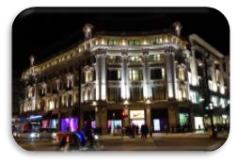
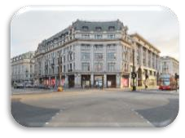
Web: https://www.nike.com/gb/retail/s/niketown- london?cp=61872410739_seo_&y_source=1_Mjc2Mjg4Mi03MTUtbG9jYXRpb24ud2Vi c2l0ZQ%3D%3D

Nike town New York
-Service options: Buy in store Pick up in store home delivery
-Located at: 650 Fifth Avenue
-Address: 650 5th Ave, New York, NY 10019, United States
-Schedule:
Monday to Sunday 11:00-20:00
-Telephone: +1 212-376-9480
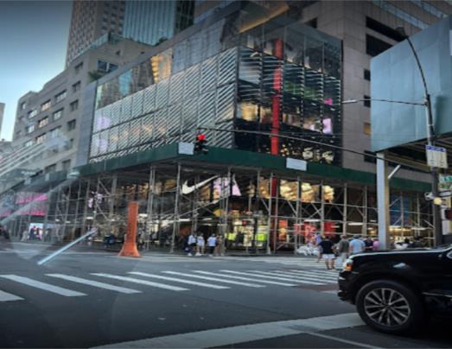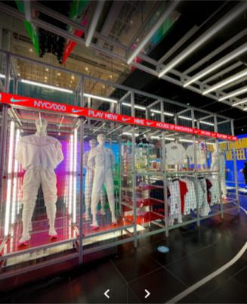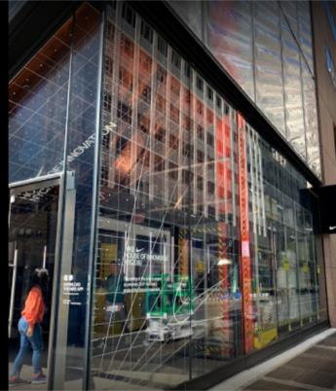Web: https://www.nike.com/retail/s/nike-nyc-house-of-innovation- 000?cp=84620811901_seo_&y_source=1_MTE4MzU1ODctNzE1LWxvY2F0aW9uLndlYnNp dGU=

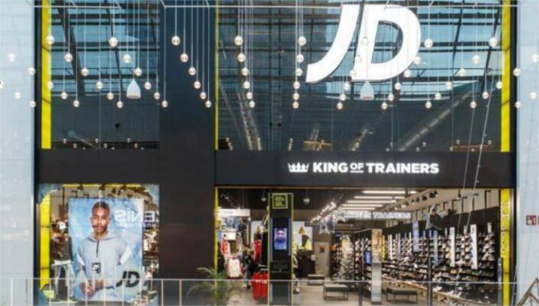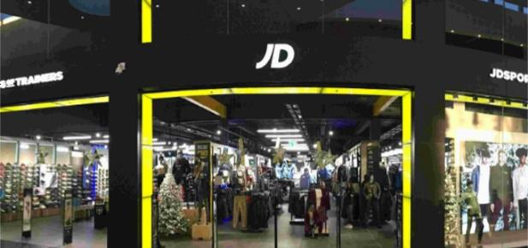Nike Town Madrid (Spain)
-Service options: Buy in store, pick up in store, and home delivery
-Address: Calle de Serrano, 19, 28001 Madrid
-Telephone: 919 03 19 78
-Hours:
Monday to Friday 10:00–21:00 Saturday 10:00–21:00
Sunday 11:00–21:00
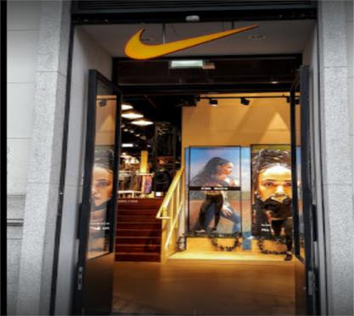Web: https://www.nike.com/es/retail/s/nike- serrano?cp=61872410739_seo_&y_source=1_Mjc2Mjc5OC03MTUtbG9jYXRpb24ud2 Vic2l0ZQ%3D%3

Indirect
Sport Direct, founded in 1982 by Mike Ashley. This business serves as a retail store for customers who purchase this kind of goods and carries a wide variety of products from various sports brands, include Nike.
Website: https://www.sportsdirect.com/
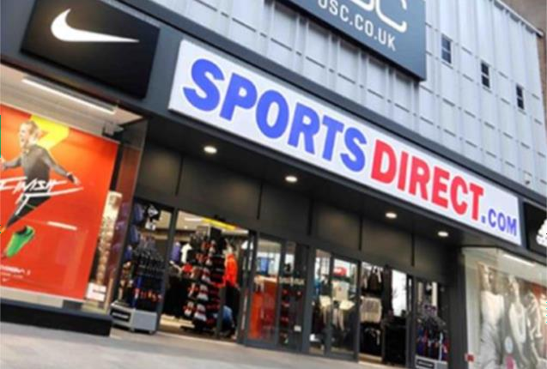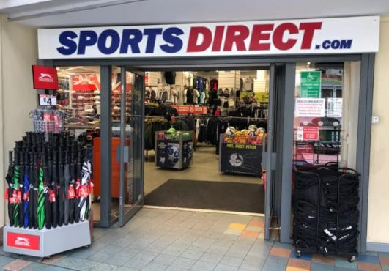Telephone: 0845 1299 200.
JD Sport, founded in 1981 is a British sports-fashion retail a British privately held
multinational corporation, Pentland Group, principally owns and invests in retail and
wholesale enterprises in the sports, outdoor, and sports fashion sectors.
Website: https://www.jdsports.co.uk/
Telephone: 0161 393 7055.

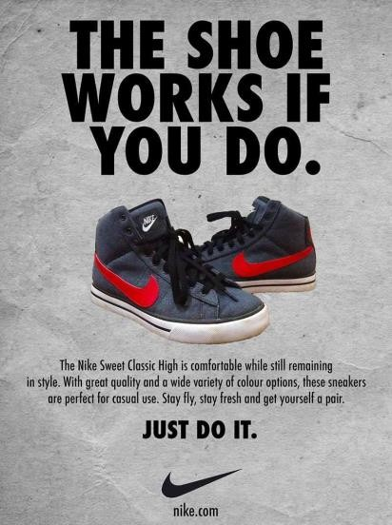
PROMOTION

Sponsorships and adverts on social networks, the internet, magazines, and television are the primary means of company promotion.
Nike does advertisements and publicity in general but always sends a strong message to the customers (Deng, T. 2009).

The company collaborates prominent celebrities and high-profile athletes from different countries like Serena Williams, Cristiano Ronaldo, and Rafael Nadal (among many others).
Nike has sponsorships in sports like cricket, the NFL, and the NBA. Direct marketing through in-person interactions with neighborhood organizations, sports teams, colleges, and schools. Additionally, the company contributes financially to non-
governmental organizations (NGOs).

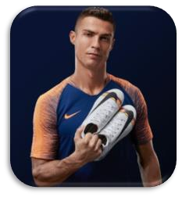
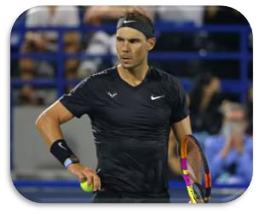

Bibliography

Flynn, Patrick. (2015) Nike Marketing Strategy: A Company to Imitate.
Frisch, A. (2008). The story of Nike. The Creative Company.
Strasser, J.N. (1991) and Becklund, Laurie. Swoosh. Orlando, Florida: HBJ.
Corporate Responsibility Report - NIKE, Inc. (n.d.). NIKE, Inc. - The official corporate website for Nike and its affiliate brands.
Goldman, R. & Papson, S. (1998). Nike Culture: The Sign of the Swoosh. Thousand Oaks,
CA: Sage.
Tapia, A (2021). The 10 Most Expensive Sneakers Ever Sold. Newsweek [online]. Available from: https://www.newsweek.com/most-expensive-pairs-sneakers-ever-sold-michael-jordan- kanye-west-nike-1644248
Ahmed, R. R., Brohi, B., Bhutto, A. H., Prithiani, J., Khubchandani, R., Kumar, S., & Abbas,
Z. (2016). Strategic Marketing Plan of Nike. ResearchGate, Indus Institute of Higher Education.
Shahriar, A. (2015). Assignment on Marketing Plan of Nike shoes. Retrieved from http://www.slideshare.net/AlShahriar/assignment-on-marketing-plan-of-nike-shoes.
Soni, P. (2014). NIKE’s Target Market Today and Tomorrow. Retrieved from
http://marketrealist.com/2014/12/nikes-target- market-today-and-tomorrow/.
About Nike. (n.d.). Retrieved from Nike Official: http://about.nike.com/pages/executives
Ugur, L. (n.d.). Nike shoes Marketing Research project. Retrieved from
https://ladinladin.wordpress.com/consumer-behavior-psychological-factors/.
Deng, T. (2009). “Just Done It” --- Nike’s New Advertising Plan, Facing Global Economic Crisis. International Journal of Business and Management
Nike Inc. (2016, 02 29). Retrieved from
https://www.google.com/finance?q=NYSE%3ANKE&fstype=ii&ei=6w68VomINMO nu
gTC5YW4Cg
NIKE Football Advertisement.
http://tw.knowledge.yahoo.com/question/?qid=1206050506920.
https://www.nike.com/gb/retail/s/niketown-
london?cp=61872410739_seo_&y_source=1_Mjc2Mjg4Mi03MTUtbG9jYXRpb24ud2Vic 2l0ZQ%3D%3D

https://www.nike.com/retail/s/nike-nyc-house-of-innovation- 000?cp=84620811901_seo_&y_source=1_MTE4MzU1ODctNzE1LWxvY2F0aW9uLndlYn NpdGU=

https://www.nike.com/gb/ http://www.flickr.com/photos/bombaylives/31165791/ https://www.sportsdirect.com/ https://www.jdsports.co.uk/

