Tutor: Scott James
Student: Beatrice-Elia Gherasim
Student ID: 2241871
Analyse the impacts of socio-economic force on employees’ performance management and monitoring in different work modes: Hospitality HR’s perspective
Personnel Resourcing and Development BMIH5005

Contents
Introduction and Background 2
Discussion 3
Description of the socio-economic factors faced by IHG with PESTLE analysis 3
Analysis of the industry trends while IHG is operating their business 5
Bleisure Travel 6
Sustainable Travel 6
Personalised experience 6
Mobile-friendly hotel experiences 6
Evaluation of different work modes and monitoring methods of the employees in IHG 7
Hybrid work mode 7
Office work arrangements 7
Flexible work mode 7
Identification of Potential Solutions 7
Evaluation and Conclusion 8
Recommendation 8
Deployment of room service robots 8
Powering up the Workforce 8
Prioritising the preventive maintenance 9
Implementing eco-friendly practices 9
References 10

Introduction and Background

This research is of paramount importance as it delves into the profound impact of socio-economic factors on the performance management of employees (Kumar & Puranam, 2020) and monitoring methods of their different work modes from the perspective of the Human Resource Department in InterContinental Hotels Groups (IHG). PESTLE analysis can comprehensively describe and evaluate the socio-economic factors affecting hospitality organisations' performance (Futrell et al., 2020), such as IHG. Analysing industry trends will further enhance the understanding of the turnover and retention rates (Sengupta et al., 2020) in IHG. Managing employee performance, a crucial aspect of any organisation, requires working with different organisational modes, and this research paper will vividly illustrate this in the context of IHG.
InterContinental Hotels Group, a pioneer in the global hospitality industry, stands as the first truly International Hotel brand. With a footprint in over 60 countries and a rich history of over 60 years in providing hospital services, IHG's success is unparalleled. IHG's strategic approach of an asset-light model to develop the most attractive business, industry segments, and high-growth markets (IHG, 2023) sets it apart. With 345.000 colleagues working worldwide and delivering their hospitality services in more than 100 countries, IHG's diverse portfolio is a testament to its global recognition. IHG has positioned itself as the preferred hotel brand for guests, with owners committed to providing services tailored to consumer preferences and needs.
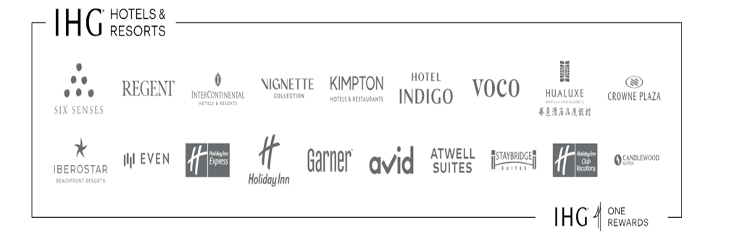
(Source: IHG, 2023)

The adjective to describe IHG is 'InterContinental ', which refers to more than one continent, reflecting the brand's global reach. The widespread core values of IHG are respecting people, doing the right thing, being responsible, staying innovative, and delivering the best performance to the consumers (IHG, 2023). These values are not just words but are deeply ingrained in the employees' interaction, and the approaches focus on excellence. IHG's vision statement aims to establish itself as a leading hospitality company by ensuring guests understand that "Good is not good enough"(IHG, 2023). Implementation of this research will help analyse the business, identify the problems, and make informed decisions. The hospitality industry can understand customers by staying ahead of the competition and following research ethics and time and budget constraints (IHG, 2022). IHG hotels are committed to reaching various communities worldwide with the participation of talented-passionate colleagues and delivering genuine hospitality every day. Researching employee performance is a necessary factor that highlights exceptional guest experiences by IHG, and the significant impacts for anticipating the needs and issues solutions can be identified.

Discussion

Description of the socio-economic factors faced by IHG with PESTLE analysis
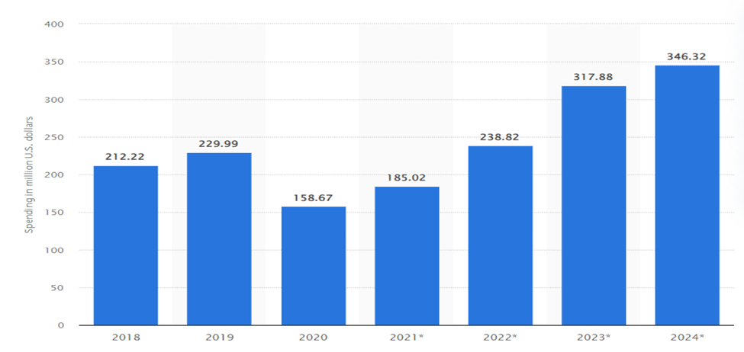
Software spending in the hospitality industry, a crucial aspect of technological advancement in the sector, significantly impacts hotel operations and performance management, such as IHG.
(Source: Vailshery, 2022)
Factors | Description | Impact
Political | The UK political environment severely affects IHG, and it guides the whole company while expanding worldwide, whether they are accepted in other locations or not. Political factors include political stabilities and instabilities, democracy and geopolitical rules, and Brexit (Team, 2022). IHG increased its properties to 159 in 2008. Political stability provides the organisation with an excellent environment for developing tourism, and with free movements, the organisation reduces some of the obstacles. | High
Economical | Some economic factors affect the business environment of IHG, including GDP, inflation rate, per capita income, interest rate, real economic growth, employment rate, economic index, and relative dominance. The world economy projects a particular impact on IHG and its tourism business (Gong, 2020). In the industry, GDP per capita remains $9230, which is the highest per annum, and this helps the business get a sound financial position in the tourism business of the UK. | High
Social | The social environment, a significant factor affecting IHG, impacts the organisation through shared beliefs, cultural environment, and religious beliefs. The level of shared beliefs affects the relationship with the people and encourages them to travel throughout the country (Team, 2022). Social situations like the coronavirus outbreak influence the hospitality sector's business, tremendously impacting the number of tourist visits to the hotel industry. | Low
Technological | Information Technology usage impacts the profit rate of the business. Currently, the UK's hotel sector uses high-tech applications and devices, the highest of which was 346.32 in 2024 (Vailshery, 2022). IHG Hotels and Resorts is reducing such technical challenges by implementing technology that is equipped with communication and easy payments. Compatible applications in iOS and Android helped the organisation reach a large number of customers. | Moderate
Legal | The significant laws and regulations of the UK affect IHG and the company's operational condition. According to the laws of the UK, IHG has to provide proper protection for consumers and follow all privacy policies, such as visitor information. | Low
Environmental | The successful functioning of IHG is intricately linked to its impact on the well-being and development of the community, its significant economic contributions, its commitment to providing equal opportunities for all, and the ethical behaviour and conduct upheld by its employees, which serves as the cornerstone of its operations. The occupancy rate of IHG has fallen from 37% to 33% (Statista, 2023). The organisation's long-term growth needs to maintain its environmental protection and safety and make consumers aware that they must not pollute the environment by throwing plastics here and there. | High

Table 1: PESTLE factors and their impact on IHG operations

Analysis of the industry trends while IHG is operating their business
According to Chaturvedi (2024), the revenues of this organisation per hotel room is 30%, and the occupancy rate has improved by more than 12% since 2019. As per the result of February 2023, IHG faced record results in their profit level and revenue.

Bleisure Travel
Bleisure travel refers to a trend in which people combine their business trips with leisure activities. This trend is relevant to 89% of individuals who take this approach. It can be classified into two categories: extending business trips to include leisure time and engaging in leisure activities after work. This type of travel is popular because it allows individuals to combine experiences with friends, family, and colleagues (Walia et al., 2021). Additionally, people can receive remote support while engaging in bleisure travel.

Sustainable Travel
Maintaining a better position within the environment by following three segments: Reuse, Reduce, and Recycle is the popular sustainability idea in 2024. Sustainability is the critical hostility trained while operating the business, and 90% of customers seek sustainability features. The hospitality sector includes electric vehicle charging stations, robust diversion and recycling programs, energy-efficient devices and green transportation services to introduce carbon-offsetting programs. These sustainability programs make the tourist feel safe, and their interest level increases as the trip leaves less carbon footprint.

Personalised experience
Applying property management automation, such as communication through SMS, email, and promotional offers, ensures the trip goes seamlessly. More than 40% of people have the advantage of going cashless while travelling and can get accommodations (Volchek et al., 2020). This can be considered the most significant hospitality trend of 2024, where the guests can stay satisfied with the accommodations.

Mobile-friendly hotel experiences
70% of travel people prefer hotels compatible with mobile devices. This is because many tasks, such as ordering room service and finding information about hotel services, can be quickly done through mobile phones. The initial booking process can also be done through mobile devices, making the hotel experience more convenient. Furthermore, mobile-friendly hotels also offer informative initiatives that enhance the guest experience.

Evaluation of different work modes and monitoring methods of the employees in IHG

Hybrid work mode
The hybrid work model helps identify the work change procedure by analysing consumer preferences and technological advancement. The hybrid hotel work design represents the cutting edge of the hotel industry, and it develops integration of core working spaces and facilitates activities (Rockfon, 2024). In 5 years, the hotel industry got advantages from hybrid work modes such as enhanced well-being and the development of eco-friendly materials. Time tracking tools, GPS tracking, and attendance management can monitor employees quickly based on their workload.

Office work arrangements
In the Hospitality industry, office work arrangements increase productivity and reduce the presence of diversity in the team. These arrangements give hospitality units several advantages in attracting talent and influencing employees to engage better. Cooperation in office work increases creativity; hence, misunderstandings can be avoided, and the employees can be monitored through calls and computers.

Flexible work mode
This work mode helps employees become versatile and resilient. With flexible schedules, employees adapt to unexpected workplace demands (Rani & Furrer, 2020). Flexible work arrangements also introduce higher retention and productivity rates among employees. Employees can be monitored by logging keystrokes, the number of emails sent, application usage, and web camera records.

Identification of Potential Solutions
In "The Future is Flexible'', about 90% of people work from home with the same effort and more than 40% claim that working from home has numerous benefits. Applying continuous improvement through the workplace will help the organisation recognise the errors and, in this way, make the future secure. Open and clear communication will help gather feedback and appreciate changes in the work schedule (Perry, 2022). The challenges regarding different work modes can be avoided so that the organisation will obtain sufficient information about any individual's knowledge, attitude, and skills in solving business challenges. The business will get a certain level of authority and responsibility by maintaining proper decision-making processes.

Evaluation and Conclusion
This research proposal addressed the political factors that impact the hospitality service and the business performance of IHG. The presence of political instability and geopolitical issues impacts the overall business performance of the organisation. There are analyses of economic factors such as interest rates, inflation rates, and economic indexes that affect the organisation's overall values. It has been illustrated that while operating in society, the factors related to the cultural environment and religious perspectives regulate the whole scenario of a hospitality organisation. The impact of technologies while serving customers in the hospitality sector has also been discussed, and the technical activities have been identified. The influence of industry trends in revenue generation is high, and this proposal has addressed the impact of Bleisure Travel, sustainable travel, mobile-based solutions, and personalised experiences. Successful hospitality management needs different kinds of work modes and monitoring methods to analyse the performance of their employees (Kretschmer et al., 2020); hence, the working principles and advantages of hybrid work modes, office work arrangements, and flexible work modes have been analysed. After analysing the trends and work modes associated with the hospitality industry, the potential solutions for the further growth of LHG have been identified and analysed.

Recommendation

Deployment of room service robots
LHG should focus on labour employment so that the workforce strength will disappear from the base and the organisation will never face issues like labour shortages. Room service robots will benefit the hotel department by delivering meals, towels, and other items. The efficient operation of a robot can solve various issues, such as operating the elevators, communicating through touch screens, and changing floors (Garcia et al., 2020).

Powering up the workforce
It is the most critical element that IHG can follow, and applying this strategy mainly boosts a business's overall workforce management. Powering up the workforce is an individual contributor that empowers the employees and becomes the reason for the desired outcome (Lam & Law, 2020).

Prioritising the preventive maintenance
IHG can follow the hotel's preventive maintenance to keep the hotel facilities functional. It will help manage the prevention of the costs from the total budget within a hotel operation. Preventive maintenance helps prolong the life of the hotel assets by anticipating certain things and improving budgeting (Van Hoof, 2020). Preventive maintenance can be done by regularly inspecting the electrical appliances, HVAC systems, and lighting fixtures.

Implementing eco-friendly practices
Switching to more sustainable suppliers is an excellent way to remove single-use plastic from the hotel (Jung & Yoon, 2020). LHG can also switch to LED lights and implement a recycling program to attract Eco-minded customers.

References
Chaturvedi, A. (2024). ‘We see ourselves opening hundreds and hundreds of hotels over time in India: Elie Maalouf, CEO, IHG Hotels & Resorts’, The Economic Times, 25 April. Available at: https://m.economictimes.com/industry/services/hotels-/-restaurants/we-see-ourselves-opening-hundreds-and-hundreds-of-hotels-over-time-in-india-elie-maalouf-ceo-ihg-hotels-resorts/articleshow/109563713.cms#:~:text=The%20chain%20said%20its%20revenue (Accessed: 1 May 2024).
Futrell, C. M., Paraskevas, A., & Davidson, R. (2020). Contemporary Hospitality Marketing: A Service Management Approach. Routledge.
Garcia, J. R., Goitia, B., & Catara-Mahaluff, G. (2020). Labour shortages and Crowding in Hotel Room Service with Food Delivery Robots: An Agent-Based Simulation. Tourism Management, p. 76.
Gong, J. (2020). ‘The Enterprise in the Emerging Market Influenced by Coronavirus: Experience From IHG’, Proceedings of the 2020 2nd International Conference on Economic Management and Cultural Industry (ICEMCl, 2020). Available at: https://doi.org/10.2991/aebmr.k.201128.032 (Accessed on 25/05/2024).
IHG (2022) What we stand for, InterContinental Hotels Group PLC. Available at: https://www.ihgplc.com/en/about-us/what-we-stand-for (Accessed on 25/05/024).
IHG (2023) About us, InterContinental Hotels Group PLC. Available at: https://www.ihgplc.com/en/about-us (Accessed on 25/05/2024).
Jung, K. J., & Yoon, Y. (2020). The effect of hotel environmental management on customer satisfaction and loyalty: Focused on eco-friendly practices and CSR activities. Journal of Sustainable Tourism, 28(6).
Kretschmer, T., Kunc, M., Nakamura, L., & Sailer, K. (2020). The Impact of COVID-19 on Hospitality: A Comparative Analysis of Global Chain, Independent and Non-profit Hotels. Journal of Hospitality and Tourism Management, 45, 67-71.
Kumar, S., & Puranam, P. (2020). Performance management strategies in a changing world of work. Journal of Management, 46(6), pp. 922-943.
Lam, T., & Law, R. (2020). Powering up the workforce: Understanding employee behaviours in hotel firms and their effects on customer satisfaction. Journal of Business Research, p. 116.
Perry, E. (2022) 13 Ways To Improve Your Work Performance, www.betterup.com. Available at: https://www.betterup.com/blog/way-to-improve-work-performance (Accessed on 27/05/2024).
Rani, U. and Furrer, M. (2020). ‘Digital labour platforms and new forms of flexible work in developing countries: Algorithmic management of work and workers’, Competition & Change, 25(2), p. 102452942090518. Available at: https://doi.org/10.1177/1024529420905187 (Accessed on 26/05/2024).
Rockfon (2024) The Trend Towards Hybrid Hotels and How to Design for It, www.rockfon.co.uk. Available at: https://www.rockfon.co.uk/about-us/blog/2023/hybrid-hotel-design-trend/#:~:text=Hybrid%20hotel%20design%20represents%20the (Accessed on 26/05/2024).
Sengupta, S., Jassawalla, A. R., & Singh, A. (2020). Hospitality and Tourism: Synergizing creativity and innovation in research. International Journal of Hospitality Management, p. 80, 1–3.
Statista (2023) Hotels - Worldwide | Statista Market Forecast, Statista. Available at: https://www.statista.com/outlook/mmo/travel-tourism/hotels/worldwide (Accessed: 26/05/2024).
Team, G.E. (2022) External Environmental Analysis Of InterContinental (IHG) Hotels And Resorts, George Business Review. Available at: https://www.george-business-review.com/external-environmental-analysis-of-intercontinenal-ihg-hotels-and-resorts/#:~:text=in%20the%20UK.- (Accessed on 25/05/2024).
Vailshery, L.S. (2022). UK: Software spending in hotel, restaurant & nightlife sector 2021, Statista. www.statista.com. Available at: https://www.statista.com/statistics/1275146/uk-software-spending-industry-accommodation-restaurants-nightlife/ (Accessed on 25/05/2024).
Van Hoof, J. (2020). Sustainable Building and Management in the Hotel Industry. Routledge.
Volchek, K. et al. (2020). ‘Exploring Ways to Improve Personalisation: The Influence of Tourist Context on Service Perception’, e-Review of Tourism Research, 17(5). Available at: https://ertr-ojs-tamu.tdl.org/ertr/article/view/557 (Accessed: 27/05/2024).
Walia, S. et al. (2021). ‘COVID-19 and the bleisure travellers: an investigation on the aftermaths and future implications’, Tourism Recreation Research, pp. 1–11. Available at: https://doi.org/10.1080/02508281.2021.1946653 (Accessed on 26/05/2024).

