

Lucius Galloway

Advanced Physics Module

OME

Table of Contents
Introduction 2
Limitations 2
History of Shaped Charges 3
2D Simulations 5
Way it was made 5
Challenges 6
Comparison (2D) 7
3D simulation: 9
Way it was made 9
Challenges 9
Comparison (3D) 9
Conclusion 10
Literature review 12
Tables 13
Figures 14
References: 20
References for data: 20
References for analysis: 20
References for History 21

Introduction
In this project Abaqus software was used to model the detonation of shaped charges.
A shaped charge is an explosive device consisting of a case, explosive fill and liner. This design exists to shape the explosion, and focus the damage, the use of the liner also produces a jet of metal deforming like a fluid under the great force, these jets can magnify the penetration and damage of an explosive charge massively, especially by concentrating the force into a smaller area.
In this case three different shaped charges were modeled, firstly two different 2D models with the same materials but different shapes then a more complex 3D simulation derived from one of the 2D simulations. This is to allow for the comparison and contrast of the 2D models to demonstrate the differences caused by the change in shape, and to show how a more advanced simulation more accurately models the detonation of a shaped charge.

Limitations
Abaqus 2D
When working with Abaqus there are several key limitations, of the system, the processing ability and the limitations for what data is provided and what changes are permitted.
For these 2D simulations the relevant limitations were that to complete the simulation in a reasonable time the mesh could not be too fine, this reduces the number of elements the component is split into, reducing the accuracy of the simulation. Additionally to use a 2D simulation and extrapolate it into a 3D equivalent a boundary condition must be used, this acts as a impenetrable barrier along the centre of this 2D shaped charge, this changes the interaction between elements along the centre of the charge and reduces accuracy of the simulation, this also interacts negatively with another limitation of the simulation, that overly distorted elements that are not destroyed by a given material property and condition applied, will crash the simulation. The final notable limitation of this simulation was that due to how Abaqus models the destruction of an element by deleting the element and thus the material it represents, the liner of the shaped charge could not have applied conditions for destruction, as the material of the liner is exposed to incredible amounts of force that change the properties and shape of the material so much that it is considered destruction of the elements involved, this would make simulation of the penetrating jet that is so important to shaped charges impossible and as such cannot be done, because of this the simulation of the liner has problems with distortion of elements crashing the simulation, inability to separate out into multiple parts or to allow the jet to fully separate from the remaining material on the sides, thus limiting its ability to project out and making it harder to form a definitively identifiable jet without crashing. With the successful simulations were a jet could be identified these problems were the ultimate cause of the crash and thus limited how far the simulations could go.

Abaqus 3D
3D simulations made using Abaqus have similar issues and limitations; The notable differences are that the simulations are more computationally intensive, due to simulating more elements, and must have coarser meshes. Additionally these meshes are more complex and difficult to align, creating more problems with elements clipping through each other or glitching and distorting. 3D simulations do not have the same boundary condition and the distortion problems are focused either on the stretching of the liner or the meshing problems. The limitations of components not being able to break were problematic for the 3D simulation as it made it much more difficult to demonstrate the formation of a jet.

History of Shaped Charges

Whilst there were earlier experiments in the use of cavities within explosive charges to better direct explosive charges, the first experiments to this effect using high explosives, capable of forming a shock wave, that can be considered as the precursor of modern shaped charges are commonly acknowledged to be done by Max Von Foerster in 1883 whilst testing compressed nitrocellulose against an iron plate. [1]
During and in the immediate years prior to WW1 research was Carried out on the practical use of shaped charges. In 1910 Westfalische Anhaltische Sprengstoff A. G. made a patent for a shaped explosive charge in Germany; they suggested the filling of the cavity with metal, specifically mentioning the use of a liner of zinc and suggesting the use of stronger metals like steel for torpedoes and thicker steel for other projectiles: This suggestion appears to have been made without foreknowledge of the extent of the contribution of the liner. [1] [2]
Multiple separate researchers observed the initial jetting effect of the lining in the years leading up to WW2 and research on what materials produced the greatest penetration began quickly, rapidly finding that ductile metals like some steels and copper had better performance. This research also led to the discovery that giving the charges a standoff distance increased penetration. [1] [2]
The Jetting Effect is the way the liner would form a jet of molten metal that project out from a shaped charge, the thin metal jet would move at immense explosive driven speeds, and there small surface area of collision made them act similarly to a much smaller, much quicker bullet, often with as much or more mass, this effect gives the shaped charge incredible penetration. The effect relies on the metal moulding to form the jet as the force of the explosion causes the metal to act more like a liquid and forces it inward. The key property for the formation of an effective jet is the ductility of the material; it is for this reason that materials like copper or light steel have been historically used for shaped charge liners. [2] [3]
Stand Off distances is the effect where the shaped charge performs better when given a distance between itself and its target, typically around twenty times the diameter of the charge used. This is both interesting and often difficult to take advantage of, it occurs because the formation of a jet from the liner takes time to occur, and as the jet is forming it is also firing out from the shaped charge, the jet forming into a thinner and longer mass across the distance increases penetration, whilst an earlier impact can break up the formation of the jet; this can be difficult to use as the proper implementation of a stand off distance in a military context with an independent shaped charge requires carful use and time to set up, when shaped charges are used as part of a launched device instead then to get the most penetration from the charge it must be detonated and directed some distance from the target, which can be quite difficult to manage. These problems are much less concerning for the use of shaped charges in mining, where there is are no urgent time constraints and charges can be set up carefully and detonated from a distance. [2] [4]
Multiple countries began producing weapons using shaped charges, notably shaped charges were first used in German military action in 1940 and would be used by both sides in infantry anti-tank weapons and some torpedoes. [1]
In the early Cold War continuing American research experimented on the impact of environment, materials and standoff distance on shaped charge performance. [1]
Both sides expended significant time and resources on researching, developing and implementing shaped charges in weapons, especially in further improving anti-tank weapons to counteract increasingly capable armour. [1]
This period also saw the widespread implementation of shaped charges in mining. [5]

2D Simulations

Way it was made
The Abaqus 2D simulations consisted of 5 significant components. Firstly producing the shape of the charge, in this case two separate shapes, then assembling the parts to form the two shaped charges, then selecting materials for the case, liner and explosive fill then finding the data, meshing the components to be able to interact as a series of elements, then defining environmental conditions, in this case a boundary condition at x=0 z=0.
Materials used
For this simulation 1045-carbon-steel was used for the case: See Table 1 for the material properties used for 1045-carbon-steel. This was chosen for being a common but relatively high quality steel used in building
Platinum was used for the liner; See Table 2 for the material properties used for the platinum liner. This was chosen for its extremely high ductility, which is an important property for the generation of a jet of material, and its higher density, allowing a smaller jet to have increased velocity and a longer, thinner jet, resulting in greater penetration in theory.
And RDX with 5% paraffin wax for the explosive fill; See Table 3 for the material properties used for the RDX explosive fill. This was chosen for being a common and relatively simple explosive with widely available data.

Shapes Used
For this simulation two shapes were used for comparison, to ensure the comparison was as fair as possible the shapes were made to contain the same amount of explosive fill, whilst having the same size and shape of liner.
Figure 1 and Figure 2
On Figure 1 you can see the first shaped charge, which has an equal distribution of explosive fill, a conical shape, whilst on Figure 2 you can see the second shaped charge, which has an unequal distribution of the explosive fill, with more of it along the sides and less directly behind the centre of the liner.

Challenges
Boundary conditions
The boundary condition that follows the y axis created challenges; The initial shape when simulating the 2D shaped charges seen in Figure 2 had a flat base along the liner toward the boundary condition, this was to help the formation of a defined slug for the main body of the jet, however the point at which the flat part moved into the angled part of the liner, upon detonation, would produce its own miniature shaped charge, angled towards the centre of the charge, for an actual shaped charge this would help form the jet as they still had significant forward momentum, however as it hit the boundary the elements distorted extremely rapidly, crashing the simulation.
Several attempts were made to resolve this, firstly by remeshing the components; A slightly less fine mesh was used, better aligned between them, which made the simulation run quicker and reduced other elements expanding through each other. It did not have a noticeable effect on the problems at the boundary condition that were causing the crash.
The amount of explosive fill behind both charges was increased, which made the simulations last longer, but still not last long enough to observe a defined jet from the liner.
Next the case of the shaped charge was made thicker, to force the expanding gas to further push the liner by constraining expansion outwards; this didn’t increase the duration of the simulation but did result in a slight increase in velocity of the liner before the simulation crashed and the change was maintained. These are the shaped charges seen in Figures 3-6
Finally, the flat base was removed, allowing the liner to form a perfect cone with a lisp around the case instead of being truncated as before, This did not fix the issue but allowed the simulation to run long enough to observe a well-defined jet seen in the following Figure 6
Finding data for platinum
When attempting to find data for all the materials it became apparent that information about the mechanical properties of the platinum liner was scarce, whilst less complex data like density was available, the specifics of Johnson-Cook damage characteristics for Platinum were not found in an initial search, when a follow up search was attempted by using two separate AI to try find data, the first, ChatGPT spat out values, but its sources were all nonsense, either not relevant or not findable, because of this this data was ignored, next an attempt was made to use Elicit, which searched through the hundred most relevant seeming before sifting through and picking out the handful that still could be relevant, after a quick read, these did not have the needed data. Because of this the original Johnson-Cook model for dynamic damage modelling could not be used, and instead data for a more simple extrapolation model was used, using the rate of strain and stress between the yield strength and one given point and extrapolating from there. This produces a much less accurate simulation compared to the curve of variant rate equations of state but allowed the simulation of platinum.

Comparison (2D)

Firstly in Figure 3 you can see that the casing distorts differently to the casing of the other charge in Figure 4 this difference is driven partially by the shape of the shell, as the can only push out against an available surface, this led to the conical charge expanding roughly equally, smoothing out more as the shell curves around the linear portions straightens out to help cover the increased outer surface area and decreasing thickness creating a smooth area under similar stresses with minimal distortion. On the other hand the flat based charges shell distorted irregularly, producing areas placed under much greater stress, in this simulation the stretching of key elements around the corner constrained the expansion of the case and helped direct the blast reducing the area the gas can expand to, however this benefit is in major part due to the simulation done not modelling for the destruction of the case, the vulnerabilities created by the irregular expansion and distortion would break slightly earlier than the conical shaped charges shell, resulting in the opposite effect as the gas escapes the confined space earlier and reduces the pressure on the liner and thus the final expected penetration. [6]
In both Figure 3 and Figure 4 the liner can be seen violating the boundary condition, these are what ultimately crashed the simulation and in both cases had the unfortunate effect of disrupting the movement of liner elements inward towards the core and base of the je; In Figure 3 this created a cavity as elements jutting in blocked passage from elements at the centre of the charge, this results in the jet relying more on projection solely from outlying elements that would normally be pushed forward further by those central elements. In Figure 4 the same elements instead of distorting inwards mostly project outwards, this makes up the bulk of the main body of the jet, whilst the outside elements projecting in are pushed forward, helping to lengthen the jet.
In Figure 6 on the left is the conical shaped charge liner, rotated around the boundary condition, to try extrapolating to a 3D environment. Despite the disruption of the jet, the liner had a max speed of 2.663 km/s at the tip of the jet as well as the jet forming with a length roughly five times the diameter of the charge. In Figure 6 on the right the flat based shaped charge liner, also rotated around the boundary condition. This liner had a lower max speed, around 2.441 km/s and the jet had only formed up to a length of 3 times the diameter of the charge. The lower speed is clearly worse performance as there is not a notably greater mass at the tip, but for the charge length it is uncertain if it means that it would form a shorter or less effective jet or if it requires a greater standoff distance to perform comparably, either way the jet resultant from the conical shaped charge was performed better. [6] [3] [4]
Surrounding both jets in Figure 6 is a ring of other parts of the liner jutting out, this is as a result of the shock wave partially reflecting off of the shell of the charge during the detonation, producing constructive interference similar to the effect of undersea explosives, this initial impact pushes the outer are of the liner out in a small area, creating a more vulnerable region of thinner material which the expanding gas finds easier to push against, creating a region of greater distortion. Notably for the flat based shape charge the region has a greater speed, suggesting that it resulted in a stronger shock front in that area, this reduces the amount of energy going towards the intended destination in the main body of the jet and could be a key reason for the reduced performance of the flat based shaped charge. Notably whilst the way this can be seen as a result of the limitations of the simulation, with the liner not having the ability to break and release the gas around the main body of the jet, it still aptly demonstrates the inefficient use of energy from the difference in design. [4] [3] [6]
Based on these results the conical shaped charge performed moderately better than the flat based shaped charge, based on this the conical shaped charge is then used to simulate a more accurate 3D model.

3D simulation:

Way it was made
The Abaqus 3D simulations consisted of 4 significant components. Firstly producing the shape of the charge, then assembling the line, fill and shell, then selecting materials for the case, liner and explosive fill, finding the relevant data for them, and finally meshing the components to be able to interact in a series of elements.
This simulation was based on the more successful 2D simulation, the charge with a conical shape, in order to get a well performing platinum jet.

Challenges
Expanding through the case
During initial 3D simulation attempts the explosive fill would clip through the casing and crash the simulation as seen in Figure 11

Several attempts were made to resolve this; Firstly by remeshing, with a finer mesh, which made the problem worse. Then a coarser mesh was used, this improved the simulation but some clipping through still occurred, then the case was made thicker, and when it did not fully clip through the elements would be pushed out of the way quicker and wouldn’t crash.
Element distortion around liner lip
During 3D simulation attempts the explosive fill would clip through the boundary between the casing and the liner and crash the simulation as seen in Figure 8

Initially the liner was re-meshed several times, but the only time notable improvements occurred was when it was significantly coarser; This was undesirable as it negatively affected simulation accuracy. Instead the liner shape was changed, firstly to wrap into the case, but this produced extreme distortion on the liner at the area; This was reverted and instead the liner lip was made longer to try reduce the gap produced in Figure 12 which was not seen in the 2D model. This made the simulation crash earlier, and so it was also reverted. Finally the liner was re-meshed to be coarser and re-attempted with both prior models, it was found that the longer lip and a slightly coarser mesh fixed the problem.

Comparison (3D)
In Figure 11 you can see the irregular distortion of the casing, whilst the rest of the casing expanded and stretched roughly equally, the rear conical region of the casing expanded irregularly and differently to as shown by the 2D simulation of the shaped charge, instead of smoothing out by expanding roughly equally, the expansion created a more bulbus belt of greater expansion around the base of the shaped charge, with the slopped and rear faces of the shell stretched more than the central region of the shell.
Within the 3D shaped charge in Figure 10 there is a similar distortion as seen in Figure 5 on the 2D shaped charge, around the rear of the liner, as some elements distort to form spikes back towards the explosive fill, but whilst it is a far less notable effect it still caused problems with the simulation and constricted the movement of other liner elements forwards and pushed back against the gas thus reducing the velocity of the jet produced by the shaped charge.
The Jet formed in the 3D simulation is significantly shorter than the jets formed by the 2D simulation, the key reason for this is that the 3D simulation crashed earlier and thus the jet didn’t have time to further develop, however it is still clearly a jet, with a much higher speed despite the early crash, the jet peaked at about 7 km/s. however this speed appears to occur in exceptionally distorted elements, whilst prior to this the jet is projecting at a more consistent speed of 2.3 km/s, which is very similar to the speed seen in the 2D simulation, however the main body of the liner has an interestingly different shape, being more oval, with a cleaner transfer between the main body and the projecting jet when compared to the 2D simulation were there is a much more visible divide from jet to the rest of the mass. This is interesting as it suggests that the simulation if continued would result in the stretching and better projection of mainly the frontmost elements of the main body into the jet, producing a similar main body shape as the 2D simulation but also lengthening the jet disproportionally, whilst keeping the main body at a similar size, this would be different to the 2D simulations, where the jet formed into a wide conical shape. [5] [6] [7]
The other parts of the liner have behaved very interestingly here, as they have achieved similar speeds at some parts to the jet of the shaped charge, this is different to what was expected based on the results form the 2D simulation where the conical shaped charge mitigated part of this effect, this appears to be related to the difference in shell distortion, with the shock wave possibly having had a greater constructive effect upon reflection, resulting in greater expansion around the area where the shock wave reflects off of the conical region of the shaped charge, resulting in a stronger localised wave impacting a second reflection point at the start of the main body of the shell, this region is where the main distortion occurred and would explain it, whilst the stronger resulting shock wave at the edges of the liner would explain the even greater initial distortion and acceleration in the surrounding liner, and would be worth re-examining in any follow up simulation. As with the 2D simulation this can be seen as a result of the limitations of the simulation, though given the difference in how the 3D model projected unevenly it also demonstrates the possibility of localised breaks producing smaller jets of platinum fragmentation heading in other forward directions to a greater extent, which if a property of a platinum shaped charge would be a significant hinderance to any use of it, as one of the main benefits of shaped charges is how controllable and directable they are. [4] [5] [7]

Conclusion
Whist the simulation had some problems and limitations it did ultimately display both the difference in performance between the two shapes of the charges, showing the better performance of a conical design, and gave an initial demonstration of the viability of platinum as the liner for shaped charges.
To develop from this a greater amount of research should be done, at least with simulations to further determine the usefulness or lack thereof of platinum as a liner material and whilst much research has been done on the optimal shape for shaped charges in different purposes, further research into the impact they have on standoff distances for denser liners could be of some use.

Literature review
References for the history of shaped charges are relatively available and three were chosen to develop a holistic view, these are all British in origin and thus may be biased or missing sources from other countries, notably the USSR.
The primary source of information for material properties was from sellers’ data for steel, with the steel chosen AISI 1045 carbon-steel, being chosen for the availability of the data and the commonality of use making it a relatively simple material to simulate.
The primary source of information for RDX was research papers, as historical and ongoing research on the material is both common and consists of all needed data, this does however make the data reliant on the validity of the study in question and some sources originally considered had to be discounted due to using variants with less available or incomplete data.
The primary source of information for platinum was the limited available information provided on mechanical data from research papers, the issues with poor data availability led to the use of a linear rate equation of state, significantly reducing the accuracy of the simulation
References for the analysis of the simulated shaped charges are widely available and several were used to look at different key parts of the simulation, these sources are mostly from research papers that focus on one or a few specific changes and so information from multiple sources had to be collated, this makes the analysis more likely to have holes, missing out on some potential subjects.
The choices made about the simulation were mostly focus on highlighting two things, firstly the use of two different shapes of explosive fill and shell to examine the differences in performance characteristics when compared to weight, size and the use of other materials. The liner was chosen to be made from platinum despite this due to the high ductility and density of the material, to try demonstrate improved performance and is interesting both in the use of a rarer and more expensive material that holds many of the beneficial properties of other shaped charge liner materials, but also in that so little research is available on the subject that it becomes a novel addition to existing work, though the limited variety of simulations, the use of a less accurate equation of state and the immense costs involved in ever actually using platinum has substantially reduced the benefits of this simulation.
Analysis of the results of the simulation used supporting information from research papers focusing on the material qualities of RDX, the mechanical properties of Platinum, research on the way the shape of the back of the charge effects shaped charges and also information on the process by which the jetting effect occurs and the influence of stand off distances on results. The main limitation with the methodology used was the focus on a small number of sources for each topic and the reliance on papers that do not focus directly on the explosive and shell shapes and materials used in this simulation.

Tables

Table 1

Table 2

Table 3

Figures
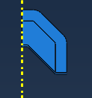
Figure 1

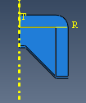
Figure 2

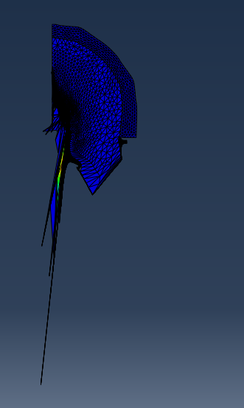
Figure 3

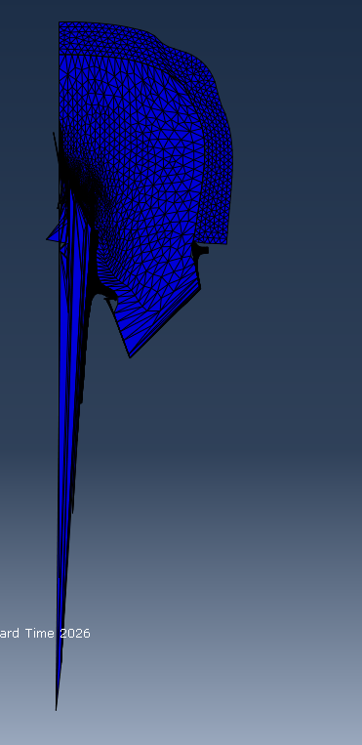
Figure 4

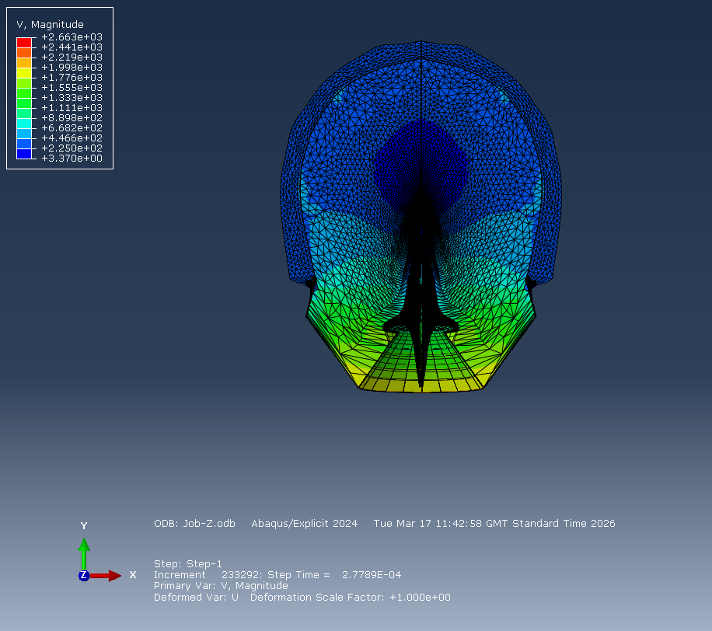
Figure 5

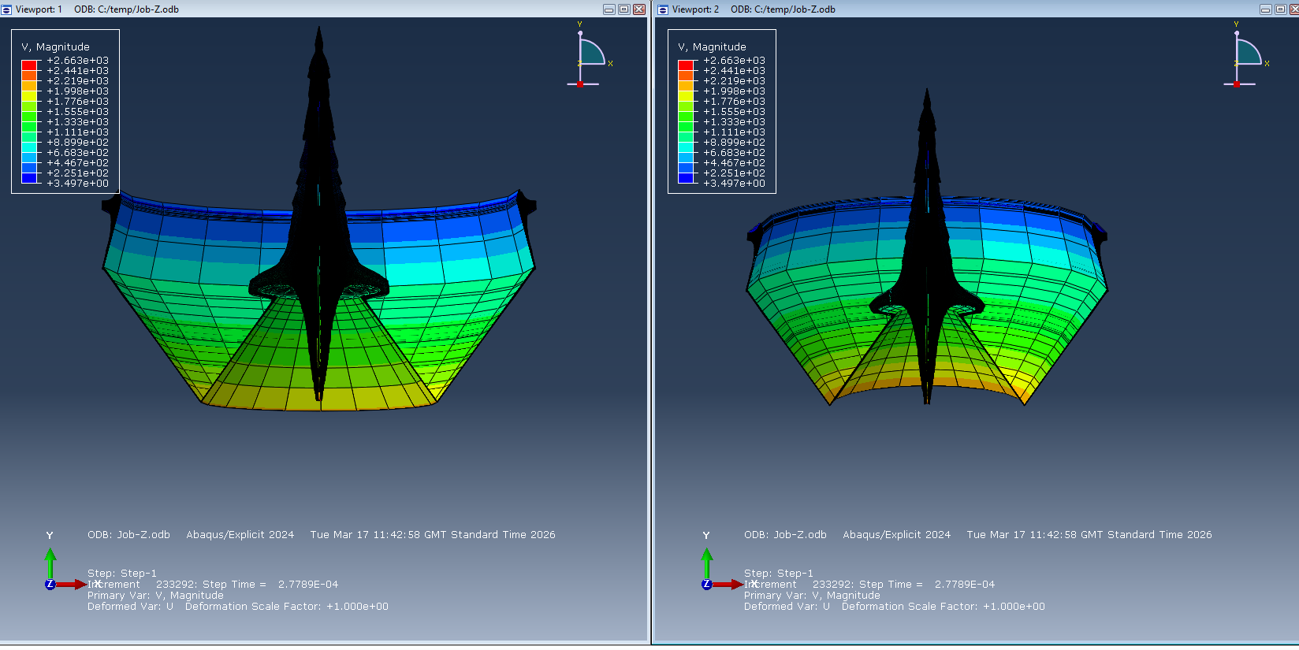
Figure 6

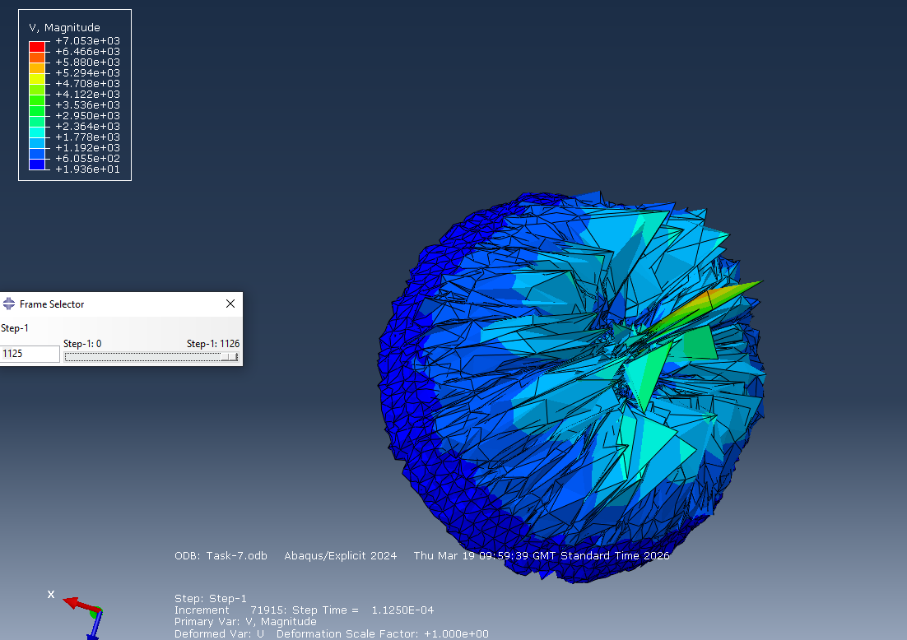

Figure 7

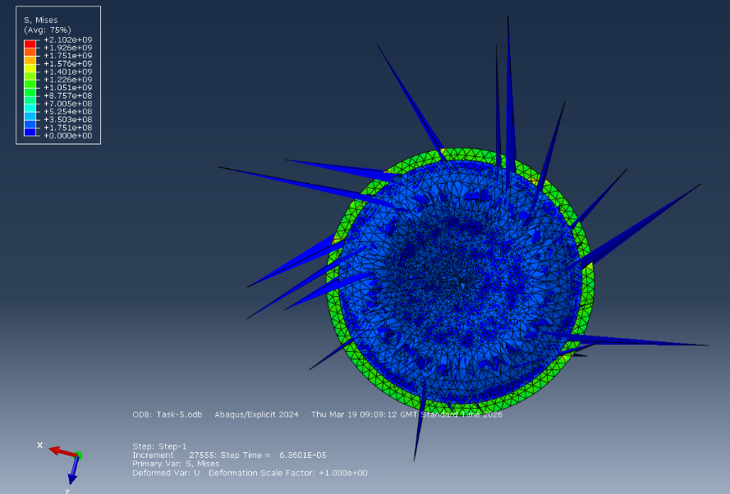

Figure 8

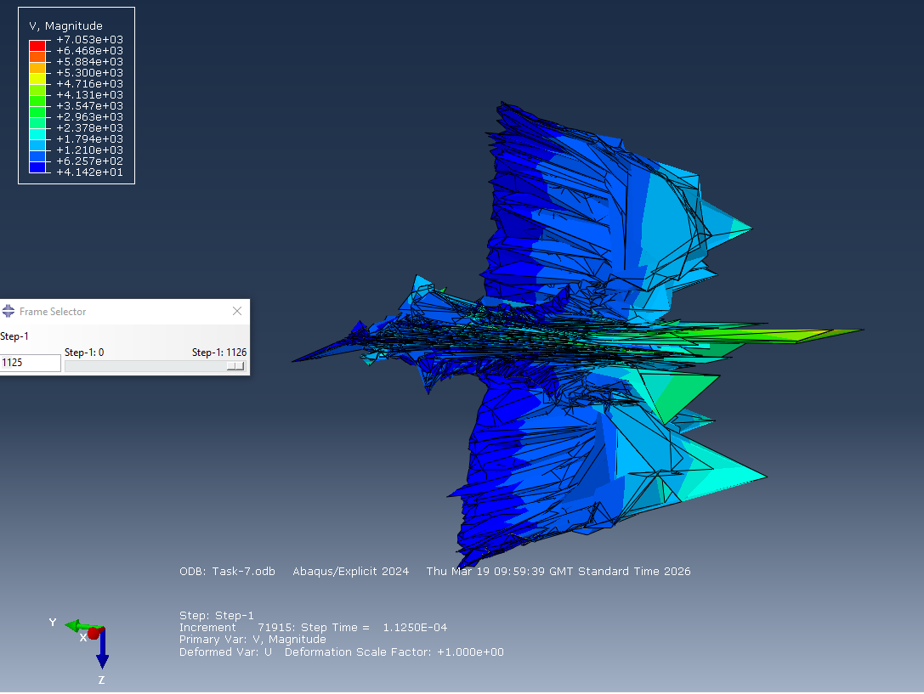
Figure 9

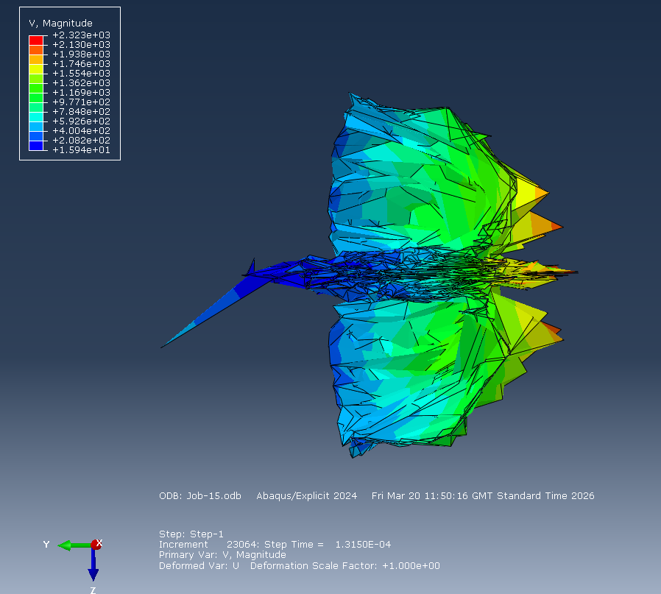
Figure 10

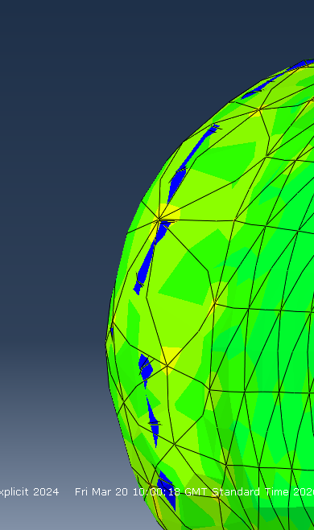

Figure 11

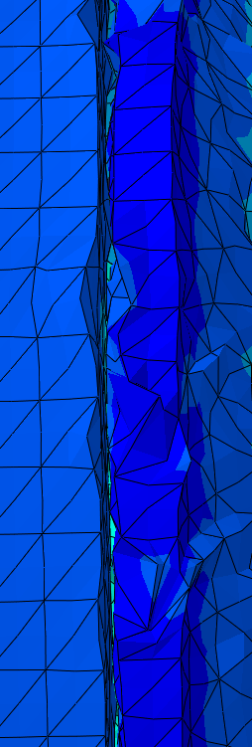

Figure 12

References:

References for data:
https://www.mdpi.com/1996-1944/18/12/2742
https://kdmfab.com/1045-carbon-steel/
https://www.theworldmaterial.com/astm-sae-aisi-1045-carbon-steel-material/
https://chinametalsupply.com/1045-carbon-steel/
Properties of selected high explosives PacSci EMC
A new insight into the mechanical behavior of high-quality RDX in pressed polymer bonded explosives - ScienceDirect
Molecular Dynamics Simulations of the Thermal Decomposition of RDX/HTPB Explosives
https://matmake.com/materials-data/platinum-properties.html
Elastic, thermal and structural properties of platinum – science direct
Platinum equation&nbsp;of state to greater than two terapascals: Experimental data and analytical models
http://www.mdpi.com/1996-1944/12/4/609

References for analysis:
A new insight into the mechanical behavior of high-quality RDX in pressed polymer bonded explosives - ScienceDirect
Molecular Dynamics Simulations of the Thermal Decomposition of RDX/HTPB Explosives
Elastic, thermal and structural properties of platinum – science direct
Platinum equation&nbsp;of state to greater than two terapascals: Experimental data and analytical models
http://www.mdpi.com/1996-1944/12/4/609
m9e5bcf923736b523b7e742ae5931df04
The influence of asymmetries in shaped charge performance
A Brief History of Shaped Charges
Simulation and Experimental Investigation of Jetting Penetrator Charge at Large Stand-off Distance
Jet formation and penetration mechanism of W typed shaped charge | Acta Mechanica Sinica | Springer Nature Link
(PDF) Study on the Pressure Characteristics of Shock Wave Propagating across Multilayer Structures during Underwater Explosion

References for History
Some Historical Aspects of the Development of Shaped Charges
Shaped Charges Market Research Report 2033
History of the Shaped Charge Effect: The First 100 Years

Lucius Galloway

Advanced Physics Module

OME

