
Communication skills in the workplace
RUNA BEGUM 1710220

July 13, 2018
University of Wales Trinity Saint David

Executive Summary
The purpose of the report is to recognises the Communication issue’s the organisation has and what are the impacts due to theses Communication issue’s. In introduction the report will explain how organisation’s communication and teamwork, can be effective through verbal and written communication. Also, explain why managers need to have effective communication. In the findings the report will show by applying model’s, theories to the organisation will help to have effective communication and teamwork. The report will look in to different types of communication and team working models, such as Communication Cycle, Tuckman and Belbin’s model, Shannon and Weaver and Berlos.

Table of Contents
Executive Summary 1
Introduction 3
Findings 4
Conclusion 8
Recommendations 9
References/Bibliography 10
Appendices 12
UPDATE TABLE FREQUENTLY – CHECK IT HAS BEEN UPDATED PRIOR TO SUBMISSION
.

Introduction

In the local council Andrea Jones is the new head of social services. She oversees 96 social workers which has been divided in to 8 teams of 12. There is a team manager, deputy team manager, a consultant and 9 social workers. They cover the whole country between them, plus an adoption, fostering team, early invention team and auditing team which covers all the areas. The case study shows there are lots of issues and impacts due to issues, because of no proper communication within the organisation. The report will show why communication is important in all aspect of life as well as in the workplace. Several types of communication models and theories has been applied to show how to improve communication and have effective communication.

Importance of communication
Communication is important because it is the most important skill in life. Communication promotes motivation.
According to CIPD (2017), communication between employees within organisation is essential. Having effective internal communication provides the opportunity to develop trust and has significant impact on employee engagement, organisational culture and productivity. However, some research shows many employees feel they receive limited or very little information. To be successful with effective communication, it needs management support and a clear strategy procedure.
According to Papa. J, (2017), verbal communication is important when giving instruction, correction and direction to teams. Without verbal communication there can be misunderstandings, frustration and lack of productivity. It also set help guidelines and boundaries in teams, which helps the teams to achieve the goals that has been set to accomplish.
According to University of Kent. (2017), written communication is important in organisational or personal communication because it allows to communicate the message with clarity. Where other communication is lacking, such as tone of voice, body language and posture. The purpose of written communication for the receiver to understand it and respond to it accordingly.
According to MSG (2018), it is important for managers to have leadership and implement their ideas and strategies. Managers are in charge to communicate theses ideas and strategies to co-workers effectively for better productivity. Communication helps managers to do their jobs and responsibilities properly, while promoting motivation.

Findings
Within the organisation there are lots of communication issues for example –
Communication issues-
- Barriers of communication.
- High absence and turnover.
- Managers not dealing with poor performances.
- No two-way communication.
- No induction or training.
- Lack of trust.
- No means of communication.
- Location of teams not in the same building.
- Poor standards.

Impact
- There was conflict.
- Workers not happy/stressed out.
- Quality issues.
- No proper report kept
- No purpose, goal, or identity.
- No permanent managers
- Shortage of staff

According to Skills You Need (2018), communication is a means of transforming information from one place to another. It can be done verbally, non-verbally, written, or through technology. It is important to communicate clearly and accurately and should not be overlooked. Developing communication skills can help all aspects of life such as professional to social gathering and everything in between.
Barnett (2017), explains communication is important because when communicating clearly and accurately it can take an individual to a new place of understanding, feeling and emotion. It does not come naturally to everyone because it requires concentrated effort but regardless of the situation communication is a must.
.
Morgan. P, (2017) suggest that communication plays a very important role in everyday life, whether it is at home, work or out in public. Miscommunication can cause issue’s in personal life or in business. It could be with a client be between co-workers. Improving communication skills in the workplace can help staffs to become a team.

The case study shows managers were not addressing the poor performance, directions were often given informally and verbally, no proper induction or training, they felt unsupported and had limited time-scale, which lead to mistakes and misunderstanding. Applying the communication cycle, can send messages through reliable channels, such as e-mail, letters so the employee can feedback to let the manager know that they received the correct information. Study.com (2017), suggests communication cycle is way to convey message and to understand each other through verbal or written methods by sending, receiving and having feedback on messages.

According to Burch (2018), communication cycle is a theory developed by Michael Argyle which focusses on the receiver as well as the sender of the message. The cycle requires feed-back to complete the communication. The general steps are sending, receiving, and feedback. The communication begins when the sender comes up with an idea for a message, which needs to be clear and use appropriate channel to deliver the message. Such as face-to-face, letter, email, text, media, online, telephone and the timing are also important. Then the receiver reviews the message to interpret it by giving appropriate level attention and importance. Next the receiver expresses and returns the message to the sender by return feedback about the understanding of the message. Giving and receiving feedback is the final stage of communication. In the final phase of the cycle the sender and the receiver must express clear feedback, proper timing and appropriate format of delivery to have effective communication within an organisation between co-worker and managers.

The case study shows there are communication barriers between managers and employees because staff was scattered throughout the building, interfering noise was causing miscommunication and the massage was not getting across properly. In this case applying Shannon and Weaver model which is verbal communication can help.
According to Communication Theory (2018), in 1948 an American mathematician, electric engineer called Shannon and American scientist called Weaver, they both designed this model to develop effective communication between sender and receiver. Firstly, this model was developed to improve technical communication in telephonic communication, but later it was applied in communication.
According to Voon (2017), the Shannon and Weaver model can help take communication in a two-way process and be applicable in general communication. This model was developed specially to maximise telephone capacity with minimum noise. By removing the noise or the problem causing the noise will help to develop effective communication. It works best when interpersonal communication is applied rather than group communication. Effective communication accours when the receiver has received the massage and understood the massage which was sent by the sender the way it was intended. For example – Sender (the information source) could be the brain. Encoder- (transmitter) would be the mouth. Channel- (is the noise) which interferes and effects the message sent by the encoder which could reduce the quality of the message sent to Decoder. Decoder- (reception) is the ear. Receiver- (destination) is the brain. Than the feedback is responded from the recipient to acknowledged that the message has been received back to sender.
The Shannon and Weaver model diagram is in appendices.

The case study also shows there are conflict between managers and employees, employee turnover and absence are high, teams were always forming and underperforming, also there are no permanent manager, plus there were trust issues and no purpose or goal. Applying Tuckman and Belbin model will help the team to reach the performing stages and develop themselves as a team and gain trust.
Mindtools (2018), explains that the Tuckman theory of Forming, Storming, Norming and performing was developed by Bruce Tuckman in 1965 for team development which focuses on the way a team takes a task from the beginning to the end of the project. Than later Tuckman added a fifth stage which Is Adjourning in the 1970s.
According to Mindtools (2018), in the 1970s management psychologist Dr Meredith Belbin discovered a way to predict the success of teams. He hoped to find the perfect team but realised that no one team is perfect for every task, because there was different pattern of behaviour in individuals according to specific projects. Eventually Belbin identified eight roles, then later added the ninth role. The roles are, The Implementer, The Co-ordinator, The Shaper, The Plant, The Resource Investigator, The Monitor Evaluator, The Team Worker, The Complete Finisher and Specialist.
According to Keller (2018), to overcome the issues within the organisation it is important to apply Tuckman and Belbin models to help the team to come out of forming stage and reach the performing stage as soon as possible. The team is stuck in the forming and storming stage. At the Forming stage the members are independent and there is no mutual trust. In Belbin’s terms at this stage teams needs to recognise each other’s strengths and weakness. Also, be able to give feedback on each other’s behaviours. The Complete Finisher and Specialist might bring the discussion level down quickly. The team is at Storming stage where there are conflict and competing, disagreements and personality clashes are happening. This must be resolved otherwise it can lower motivation. In Belbin’s term the team needs Plants to come up with innovative ideas and Monitor Evaluator needs to analyse them calmly. Team worker can build relationship internally. At this stage Shapers can be very valuable because they are straight forward, which will help the Co-ordinator, from getting to involve in team politics and move forward from ideas to outcomes. Then comes the Norming stage where there are agreements in decision making, and roles and responsibilities are clear, therefore, the team moves forward in friendly working practice. In Belbin’s term the team needs to have a clear understanding of who should do what. Also, finding the strength and weakness in team members will help the team leader and other members to identify who is suited to what kind of work. Co-ordinators are capable in making group decision. On the other hand, Implementers are good at making plans for well balanced processes, because they are reliable. However, Resource Investigators needs to gout of the way to gain insight in the competition. At the Performing stage teams are motivated and knowledgeable and understand the purpose and goals. They also can make decision without the leader present. In Belbin’s terms the team needs to use the understanding of Belbin’s language to continue the route of becoming a high performing team. At the Adjourning stage the team members have known each other for a while and is the right time to give feedback. However, Belbin uses Observer Assessments.
The diagram for the Tuckman and Belbin’s models are in the appendices.

The case study shows the organisation is using one-way communication.
According to Communication Theory (2018), David Berlos model of communication to be effective the source and the receiver needs to be in equal level. If the source and the receiver are on the same level, then only communication can be effective in an organisation. For example, if the source has excellent communication skills then the receiver should have excellent listening skills.
According to MSG (2018), David Berlo’s model of communication look at the emotional side of the message. Also, understands interpersonal communication and applies to behavioural theories. David Berlo’s follows SMCR model of communication, which is not applicable to any communication. The model has six factors with different elements.
The Berlo’s SMCR model of communication diagram is in the appendices.

Conclusion
To conclude the report, it shows that effective internal communication is important because it provides the opportunity to develop trust and has significant impact on employee engagement and productivity (CIPD, 2018). It also shows verbal communication is important when giving instruction because it sets boundaries and guidelines to achieve goals (Papa, 2017). The report shows by applying different communication models and theories, helps with communication in organisations. Such as Tuckman and Belbin model of theory helps with effective team building, to overcome conflict, build trust, reach goals and help make decision without a leader (Keller, 2017). The Shannon and Weaver model shows it is important to have two-way communication because when the sender sends the message to the receiver, then the receiver needs to send feedback, to acknowledge that the message has been received to complete the communication. This part of verbal communication in telephonic communication (Voon, 2017). The communication cycle model explains that messages can be sent through different methods such as letters, text, emails, telephone, online, media, other than just telephone. Using the correct timing and method helps in effective communications (Burch, 2018). Berlo model of communication is a one-way communication method which focuses on the emotional side of communication (Communication Theory, 2018). For the communication to be effective the source and the receiver needs to be in the same level (MSG, 2018).

Recommendations

To improve communication in the workplace it is important listening, having clarity when communicating, being friendly, be open minded, show respect, having empathy and feedback (Doyle, 2018).
According to Founders Grid (2014), suggest improving in effective teamwork, it is important to-
- Build trust and respect.
- Have open communication with team members.
- Lead by example.
- Clearly outline roles and responsibilities.
- Organize team processes.
- Setting defined goals.
- Recognize good work with rewards and intensives.
- Solve conflict quickly and efficiently.
- Sometime allow team members to make decision.

References/Bibliography

Barnett, E. (2018), ‘Why is Communication Important? You asked Google – here’s the answer | Emma Barnett | opinion | The Guardian’. [online]. Available: https://theguardian.com/.../why.is..., Accessed: [7th July 2018].

Burch. J, (2018), ‘Theories of Communication and the Communication Cycle | Your Busniess’, [online]. Available: https://yourbusiness.azcentral.com/theorie..., Accessed: [8th July 2018].

CIPD. (2017), ‘Employee Communication | Factsheet | CIPD’, [online]. Available: https://www.cipd.co.uk/.../communication..., Accessed: [7th July 2018].

Communication Theory. (2018), ‘Berlo’s SMCR model of communication- Communication Theory’, [online], Available: https://www.communicationtheory.org/..., Accessed: [10th July 2018].

Communication Theory. (2018), ‘Shannon And Weaver Model of Communication – Communication Theory’, [online]. Available: https://www.communicationtheory.org/..., Accessed: [10th July 2018].

Doyle, A. (2018), ‘communication Skills for Workplace Success – The Balance Careers’, [online]. Available: https://www.thebalancecareers.com>...>jobserching>SkillsandKeywords, Accessed: [13th June 2018].

Founders Grid. (2014), ’20 Strategies Startups Can Use to Improve Teamwork – Founders Grid’, [online]. Available: https://foundersgrid.com/teamwork/, Accessed: [10th July 2018].

Keeler. J, (2017), ‘Belbin and Tuckman: supporting your team at every stage | Jo Keeler | Pulse | LinkedIn’, [online]. Available: https://www.linkedin.com/...belbin/..., Accessed [7th July 2018].

Mindtools. (2018), ‘Belbin’s Team Roles – Leadership training from MindTools.com’, [online]. Available: https://www.mindtools.com/.../newLDR..., Accessed: [9th July 2018].

Mindtools. (2018), ‘Forming, Storming, Norming and Performing – from MingTools.com’, [online]. Available: https://www.mindtools.com/.../newLRD..., Accessed: [9th July 2018].
Morgan. P, (2017), The Business Student’s Guide to Study and Employability, London:SAGE.

MSG. (2018), ‘Berlo’s model of communication- management study guide’, [online]. Available: https://www.managementstudyguide.com..., Accessed: [10th July 2018].

MSG. (2018), ‘Importance of Communication in an Organisation - Management Study Guide’, [online]. Available: https://managementstudyguide.com/... Accessed: [10th July 2018].

Papa. J, (2017), ‘Importance of Verbal Communication in Group Interaction | Bizfluent’, [online]. Available: https://bizfluent.com/about-5398073-..., Accessed: [7th July 2018].

Skills You Need. (2018), ‘Communication Skills | Skills You Need’, [online]. Available: https://www.skillsyouneed.com/.../..., Accessed: [7th July 2018].

Study.com. (2017), ‘Communication Cycle: Definition & Stages - Video & Lesson Transcript | Study.Com’, [online]. Available: https://study.com/.../communication-cycl..., Accessed: [8th July 2018].

University of Kent. (2018), ‘Written communication Skills – University of Kent’, [online]. Available: https://www.kent.ac.uk/.../written..., Accessed: [10th July 2018].

Voon. E, (2017), ‘Shannon and Weaver’s Model of Communication (1954) – Eugene Voon’, [online]. Available: https://thevoont.com/shannon-weavers-..., Accessed: [7th July 2018].

Appendices

Tuckman model

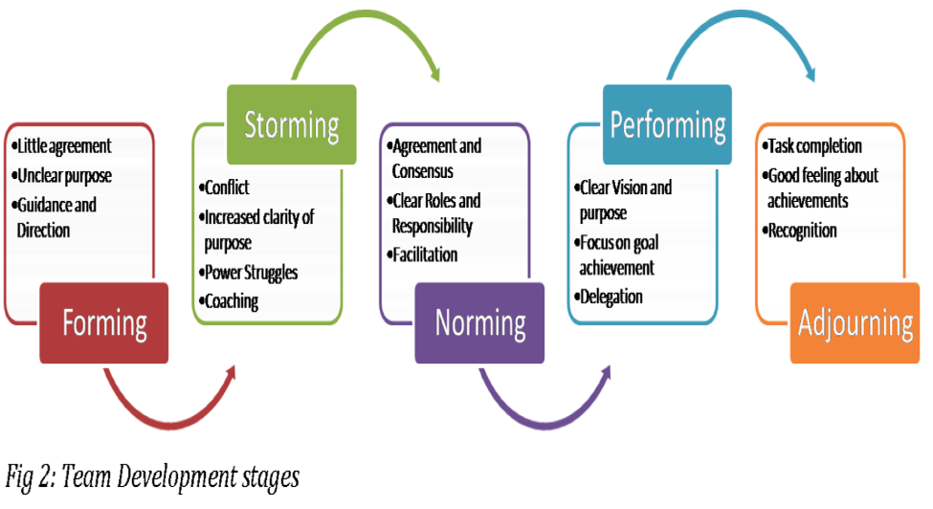

The Belbin models
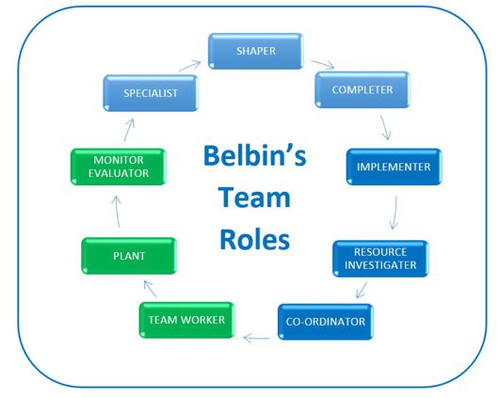

The Shannon and Weave model



The Berol’s model of communication



