The Rights of the Child: Inclusion and Diversity- Dyslexia.
All children should be given equal opportunities and inclusion should be at the forefront of all practitioners’ planning and implementation of learning. Inclusion should provide opportunities for children to be able to access the same resources and learning as their peers but in ways that are suitable for their individual needs. This allows them to be integrated into the school community effectively. One of the key principles of inclusion is that “all children and young people should have access to an appropriate education that affords them the opportunity to achieve their personal potential” (WAG,2006). Inclusive practice must be adopted throughout all of the curriculum and inclusion of any Specific Learning Difficulties (SpLD’s). SpLDs are an umbrella group of difficulties that represent a number of frequently occur and affect processing of information. SpLDs include disabilities such as: Dyslexia, Dyspraxsia, Dyscalculia and ADHD. There are varying definitions of Dyslexia, one of which is : “A processing difference experienced by people of all ages, often characterised by difficulties in literacy, it can affect other cognitive areas such as memory, speed of processing, time management, co-ordination and directional aspects”, (Reid, 2004 cited in Hall, 2009, p.7). According to the British Dyslexia Association (BDA), Dyslexia is believed to affect 10% of the population in the UK, 4% of this severely. Dyslexia is the most common SpLD. Dyslexia is defined in the Equality Act 2010 as being identifiable as a disability. Attributes of Dyslexia differ in every individual and it is important to note that not every child with dyslexia will show the same symptom’s as another. Dyslexia affects spelling and reading skills and occurs in various intellectual abilities, it is not constrained to a certain age, gender or cultural background. Frequent tendencies of Dyslexia are struggles with verbal memory, processing speed and phonological awareness. It is appropriate that dyslexia should be thought of as a continuum rather than something that can be confined to certain symptoms. Additional difficulties that often go hand in hand with the main symptoms of dyslexia are, concentration and organisation difficulties, co-ordination and the lack of ability to mentally calculate, (Rose, 2009).
The research that has been collected and analysed for the purpose of this assignment was carried out by four BA (hons) Primary Education with QTS students. All research and data gathered has complied with the University of Wales Trinity Saint David’s data guidelines and adheres to the requirements of the GDPR 2018. In order to rationalise a methodology for which Additional learning need (ALN), the group wished to research, Secondary research needed to take place to justify the need for Primary research to occur. The primary research was justified by the evidence presented by the group members in the form of annotated research, which highlighted the growing need for inclusion of children with Dyslexia, (see group file). This prompted the primary research to commence, which was done via a questionnaire. Quantitative Research forms research that can be quantified to solve a paint as it generates numerical data that can be used as statistics. Quantitative Research forms measurable data that presents factual information and makes formation of patterns possible. Methods for collating quantitative data include Questionnaires, electronic and paper form and personal interviews. In addition to completing quantitative research in the form of the electronic questionnaire, Qualitative research also took place. Qualitative Research involves less structured methods and usually takes price prior to quantitative where points can then be proven. Qualitative research includes discussions, observations and looks at opinions and background reasons for data, (Hammersley, 2007). The aim of this questionnaire was to investigate inclusive practice in Primary Schools in the local areas of: Carmarthenshire, Swansea and Neath Port Talbot.

When constructing the questionnaire, the group felt that it was appropriate to include elements that have been highlighted in secondary research as factors to look at. This will allow the writer to compare the findings of the questionnaire results alongside existing Dyslexia research. At the forefront of the groups rationale was the main question “What makes an inclusive educational setting? An aspect that we wished to look at was to investigate whether there is a barrier to inclusive learning in relation to the lack of diagnosis for dyslexia and what no diagnosis means for a child with dyslexia. Figure 1 and 2 below shows a comparison of pupils showing signs of signs of dyslexia and pupils with an actual diagnosis of dyslexia. As the graph shows, there is a clear gap between the number of pupils displaying symptoms and with a diagnosis. To ensure an inclusive curriculum, diagnosis of dyslexia is essential. Appropriate measures can be put in place to aid learning and will be tailored to the specific aspects of dyslexia that the child is struggling with most. Hall (2009) highlights the importance of screening at classroom level but hones on the importance that once an aspect of dyslexia has been noted frequently, this must be passed to the appropriate individual who can assess and diagnose correctly. This is usually the School SENCO who will put these measures in place.
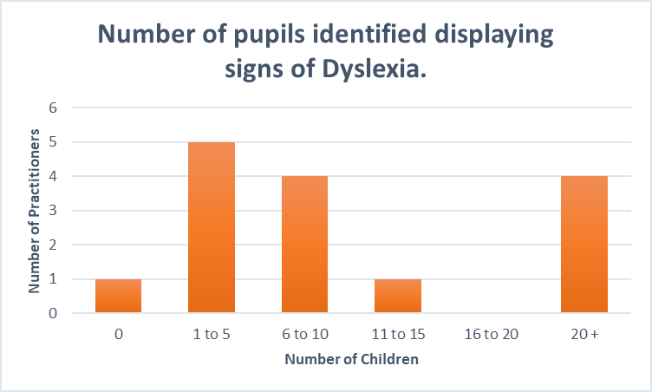

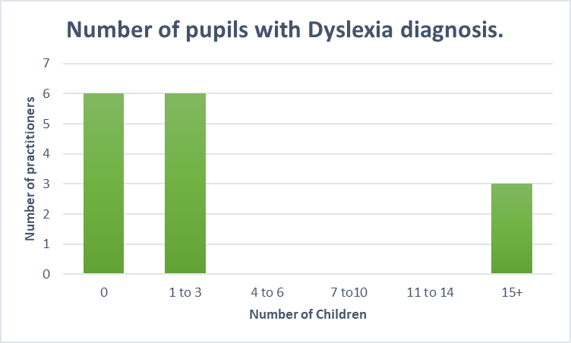
The SENCO’s role within a school is to establish effective methods of overcoming hindrances to learning and their aim should be to continue with positive teaching through assessment and inquiry of the pupils needs alongside monitoring teaching and implementing targets for improvement. The SENCO should work in line with other educational practitioners to ensure that all children’s learning is given equal priority and resources are maximised effectively, (Sen Code of Practice, 2004). The SpLD framework (2015) indicates the need for practitioners to” focus on early identification of learners by using appropriate screening tools”. The gap shown from the data produced from question 7a/b of the questionnaire highlights the need for this screening as despite respondents stating they can and have previously identified children with signs of dyslexia, it is evident from this data that there is a need for an inclusive approach to addressing symptoms of dyslexia and implementing the appropriate modes of assessment.
On respondent of the research stated that dyslexia hadn’t been ‘diagnosed but as a school they have identified “traits” of dyslexia’. Despite this being a forward-thinking route to take with identifying aspects of dyslexia, it is also important to consider the implications of not referring a child for at least dyslexic screening. It is in the interest of the child for this to be done to ensure equality amongst all.
Screening tests need to be completed quickly to help the educators with inclusion within the curriculum, and although this is effective in being able to put measures in place for the child, it also hinders the reliability of the test as time hasn’t been taken to carefully analyse the strengths and weaknesses of the child displaying elements of dyslexia. In addition to this, on average screening tests are 75% accurate and alongside the screening test, despite the outcome, it is advised that teachers should proceed with caution and monitor their progress, particularly their highlighted weaknesses (WAG, 2012). Screening takes place primarily to distinguish whether there are identifiable dyslexia difficulties. Following these identifications, there is reason for a full diagnostic assessment to take place. Screening can be done by a teacher and are implemented in different ways whereas the diagnostic assessment takes place by a specially trained practitioner. It is appropriate to note here that the data collected also highlighted that only 64% of the respondents of the questionnaire had training in dyslexia despite stating that they have previously identified signs of dyslexia. WAG (2006) advises that schools should give consideration whether the children with dyslexia are learning at a slower pace than others due to the curriculum not being inclusive. This can include the incorrect level of learning being taught due to a lack of diagnosis, as well as this it could include miss diagnosis of certain elements of dyslexia.
The ‘No To Failure project’ (2008) studied the educational importance of screening for dyslexia and was proposed to aim to interpret how, if dyslexia is ignored or miss-diagnosed, could eventually result in educational failure. This study found that 55 % of pupils who did not reach the expected level for national Standard Assessment Tests (SATs) were actually further identified to be at showing attributes of dyslexia or another SpLD. This data supports the argument for the need for diagnosis as the unidentified SpLD’s could be seen as a cause for educational failure. Further support for the need for a diagnosis is given by BDA (2012) who report that best practice schools who are Dyslexia inclusive, regularly ensure on going developments are made to achieve Dyslexia friendly status within the school and an important factor to this is regularly implementing Whole school Dyslexia awareness training.
However, on the other hand, Elliot (2014) disagrees with the need for a diagnosis and states that the belief for that it will aid teachers in identifying intervention methods is a myth. This belief is widely contradicted by the evidence to support diagnosis alongside support of training for dyslexia identification.
Another aspect of inclusive practice that was looked at within the questionnaire was how resources to support children with dyslexia are presented and used within the classroom. During prior background research, there was several aids that were frequently associated with inclusive practice of dyslexia. These aids were resources such as, Pen grips, tilted desks, coloured fonts and reading rulers. The British Dyslexia Association reviews schools to assess how dyslexia friendly their environment is and part of the criteria for success is the requirement for “desk top aids to be available and their use encouraged regularly”, another requirement to promote inclusivity is that “effective use is made of colour as visual aids and colour is used within presented information to highlight key points”,(BDA,2012). As shown by Figure 3 below more than half of the respondents favoured using reading rulers as an aid specifically for individuals with dyslexia, as well as using pen grips and tilted desks for these individuals. These resources promote inclusive practice as the children with dyslexia can remain within the mainstream classroom with the help of these aids, which will ensure their self esteem is not affected and they and equal to their peers. Excellent practice is promoted by the BDA as they advocate certain criteria for inclusive practice with children with dyslexia. To support these criteria’s, the association credits establishments with their own ‘BDA Dyslexia Friendly Quality Mark award’ to solidify their competence in dyslexia inclusion.
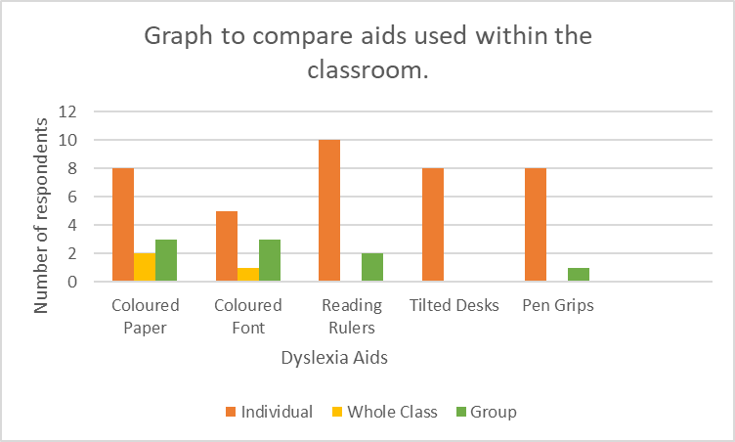
One respondent stated that in addition to using the aids listed, that they thought it was beneficial that Dyslexia friendly reading books should also be used which feature a cream page and have larger gaps between the lines. This is evidence of inclusive practice in relation to dyslexia. Although several respondents used the aids for just certain individuals, others found it beneficial to use the resources amongst groups and whole class. Coloured paper/overlays and font was used for whole class learning as an inclusive approach. Children with dyslexia often have difficulty with visual processes, Wilkins (1995) previously highlighted that coloured overlays may be beneficial in aiding these difficulties. In further support for the use of overlays, Kriss and Evans (2005) established evidence which saw 45% of dyslexic children read 5 % faster with a coloured overlay in comparison with a subject group of non-dyslexic children. The writer has previously observed these overlays in practice during a Professional Teaching experience (PTE). The teacher used these overlays with the whole class, and the writer notes that it was very inclusive particularly for the child with dyslexia as they did not feel singled out amongst their peers. In addition to this observation, the writer also conferenced with the SEN unit class teacher. During this discussion, the trained SEN professional spoke highly of the use of coloured pens particularly when giving instructions. She believed they were beneficial as the various colours distinguished a sequence to the children, for example they knew they had to write the red first, yellow next, then move to green etc. Also, during the writers PTE, the writer spent 4 afternoons in a specific SEN classroom, in KS2. Even though not all children within the class had dyslexia, the specially trained SEN teacher, used coloured pens to writer each instructions on the board to aid with sequencing. Bold (2004) gives support to this and states that the different colours are useful for the children to able to view texts from a distance within the classroom but locate their place in the reading again by referring to the colours of the texts.
A significant factor to inclusion of children with dyslexia is being able to feel confident within the mainstream classroom and not experience disadvantage to their peers. Respondents of the questionnaire provided further evidence that implementing aids from children with dyslexia had a positive effect within the classroom. 93% of respondents stated that the impact of the resources was positive, (see figure 4 below) One respondent remarked that fellow pupils have been observed being understanding of these aids and no issue has been made of it. They also added that in their experience, having a teacher’s assistant (TA) helping, it builds up a good rapport between other pupils and the assistance and aids become “the norm” within the class. Although these have a positive impact across the classroom, the writer feels that it is important to take into consideration that sometimes it is just not appropriate to use certain teaching approaches. Being inclusive also means that the specific needs of the child with dyslexia need to be explicitly considered, and this does at times mean that they are taught in a different manner to their peers, despite this they are still experiencing inclusive learning as it is tailored to their needs.
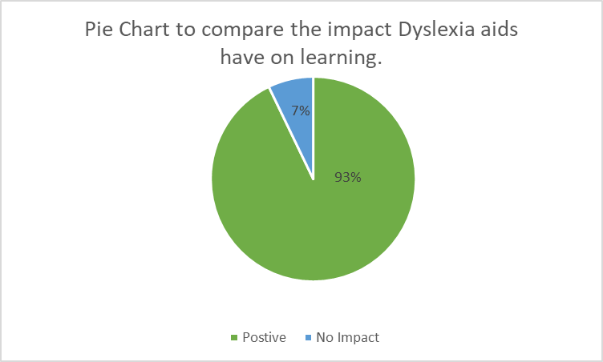

Reid (2011) supports this and notes that identification of the difficulties and strengths that the learner experiences is of utmost importance as it provides a starting point for the teacher to tailor their approach to the needs of the child. Furthermore, there has been support for intervention approaches which focus on phonological skills for reading and writing which will benefit children with dyslexia. This type of approach is favoured to include structured sessions, short bursts of information as opposed to long winded sessions and time should be given to allow reflection, (Rose,2009).
When considering the more prominent aspects of dyslexia, it was important to consider whether they have an effect on how inclusive learning is for children with dyslexia. Question 10 of the questionnaire was aimed to help consider if these aspects affect inclusive practice. Figure 5 highlights that difficulty with spelling is a frequent aspect identified by respondents as ‘always’ being displayed. 67% of respondents stated that spelling was the most prominent aspect. This data is supported by Montgomery (2006) who noted that some children with dyslexia are often gifted in reading but frequent with poor spelling. Furthermore, Waller (2001) argued that this is due to the onus placed on reading in early education, meaning spelling problems continue to develop even when reading problems in a child with dyslexia improves. Dyslexia affects the ability process currently and in terms of literacy it affects writing, reading and spelling. In addition to these difficulties it is also known to impact time management, processing speeds, memory and co-ordination, (Reid,2009). WAG (2012) highlighted spelling difficulties in a child with dyslexia could have “implications for exam provision for the young person”. This strengthens the need for inclusive practice for children with dyslexia as difficulties such as this can have profound impact of a child’s self-esteem. Qualitative research by the group found that lack of self esteem was a huge factor that affects children with dyslexia.

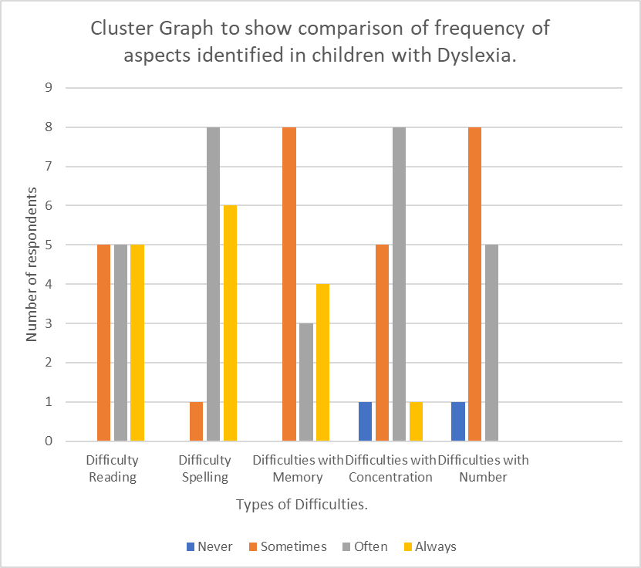
Much evidence highlights self-esteem and confidence issues in children with dyslexia and it had been found thank children with dyslexia experience lower self esteem in mainstream schools compared to learners without dyslexia, (Humphrey, 2002). Reid (2009) highlighted how important it is for educational practitioners to develop effective relationships with children with dyslexia as it provides links for children to always have someone to talk to. In addition to this, Hall (2009) states how important it is to tackle the emotional issues that children with dyslexia experience, sooner rather than later. In inclusion criterion, the BDA (2012) states that to demonstrate working partnerships with dyslexia children, they must explicitly aid the children with their emotional and behavioural issues. This means that interventions must be in place to aid with this. In the interest of inclusive practice, it is essential that teachers consider differentiation within the classroom. In inclusion guidance, WAG (2016) highlighted that it is more damaging for children to not be presented with differentiated work, it effects their self-esteem more if they are given work that is out of their level of ability.
Now to consider if age of children diagnosed with dyslexia effects inclusion. Question 7 of the questionnaire was included to investigate whether age of diagnosis plays a factor in any arising issues involving dyslexia. 43% of respondents stated that in their experience, the average of children diagnosed is 9-11 years. This data is interesting as it is at the top end of key stage two. This means that children often go through primary education without a diagnosis meaning that they have been at a disadvantage in their learning. Hall (2009) identifies that at different stages of primary education, children typically display different signs of dyslexia at different ages. Behaviour is a prominent factor that is shown in key stage 2, particularly in boys. Boys with undiagnosed dyslexia in KS2 often focus on becoming disruptive within class and have higher levels of aggression. The lack of and late diagnosis means they have felt ‘out of place’ amongst their peers, and lack identification of the root of their issues. Estyn (2012) found that a best practice key stage 3 institution displaced excellent inclusion practice by fore fronting the strengths of each individual student to ensure their progression. One respondent from a Secondary background, responded that upper key stage 2 was the most likely age of diagnosis and the reliability of this respondent could be seen as good as they have been in contact with over 20 children with dyslexia. Late diagnosis means that children lack a sense of identity, and the ability to cope with this means that their attention may be turned to less appropriate means. Thomson and Gilchrist (1997) said that it is not unusual for children to deviate form the ‘straight and narrow’ when struggling to come to terms with being diagnosed with dyslexia.
Another interesting link to consider is the correlation between dyslexia and diagnosis/symptoms of dyscalculia. Dyslexia is considered to effect literacy abilities, but evidence shows that children with dyslexia also display symptoms of dyscalculia. Dyscalculia affects the ability to mathematically process. A question shows that 60% of respondents said that children diagnosed with dyslexia also displayed symptoms of dyscalculia. In addition to this, 33% of respondents stated that they had encountered children who had a diagnosis of dyscalculia. To further support this 42% said that some or few children had a dyscalculia diagnosis as well as a dyslexia diagnosis. Despite there being ‘few’ children with both, it is evident that several respondents have experienced this. Dyscalculia affects two children in every class, (SpLD Framework, 2015). Even the slight link between the two may indicate that measures need to be implemented to ensure that if there is symptoms of both, then these need to be screened appropriately. Farrell (2006) highlighted that pupils who have been identified as dyslexic, are generally screened for mathematical difficulties.
One aspect that was touched upon during the questionnaire was the link between dyslexia and creativity. The reason this was looked at was to assess whether there was a link which could be an aid in enhancing inclusive learning by addressing that perhaps some children thrive by focusing on their creativity skills. The data collected showed that 66% of respondents stated that ‘sometimes and occasionally’ displayed more creativity than in other aspects. Although this is a high percentage, it does not indicate solid first-hand evidence from the respondents as it too vague, as it only occasional links between dyslexia and creativity. The writer has observed during PTE, a child with dyslexia who excelled at art. The child was gifted in drawing yet struggled prominently with spelling.

On reflection, it would have been effective to further data by including enquiry about self esteem and dyslexia. This would have further supported the importance of inclusion in supporting emotional issues related to dyslexia. The writer feels that the questionnaire as a whole, generated an effective response and the data has been analysed appropriately. The questionnaire was distributed electronically and in hindsight it may have been beneficial to send copies in paper form to gather a better response rate, as some may prefer writing their responses. However, Electronic forms are far more time efficient and do not burden respondents and make the completion as user friendly as possible (Smyth and Pearson,2011). One strength of the data was that the respondents were able to select a range of criteria to answer questions and often if a pre-selected option wasn’t appropriate, they were able to complete their own additional statement. However, on reflection a limitation was that mathematical figures within the questionnaire was not always consistent. For example, the age ranges differed in questions; these should have been kept the same to ensure consistency. The writer feels that after analysing the data, there is a ‘gap’. This gap has been created by the lack of further data into aids within the classroom and their effect. The data produced from this question was very effective but if there had been a slight extension to the question then the would have been a considerable amount of more evidence to support these aids. The writer feels that the use of dyslexia friendly resources is one of the key aspects to inclusive practice as they normalise dyslexia in the mainstream classroom. Another limitation is that more quantitative research wasn’t carried out in the form of personal interviews. It would have been useful for the perspective of a dyslexia trained individual to give their input into how frequent diagnosis of dyslexia is. In addition to this the writer feels that it would have also been beneficial to have considered the effects of dyslexia more in-depth whilst on PTE, as the methods adopted whole class by respondents may have been beneficial to the writers own teaching. Overall, the data was appropriate and useful in evidencing areas to work on for inclusive practice.
Reference List:

Bennett, J. (2012) Dyslexia Pocketbook. Hampshire: Teachers’ Pocketbooks.

British Dyslexia Association (2012) Dyslexia Friendly Schools Good Practice Guide. British Dyslexia Association.

Department for Education and Skills (2014) Re-writing the Future. Cardiff: Welsh Government.

Donaldson, G. (2015) Successful Futures. Crown copyright. Available at: http://gov.wales/docs/dcells/publications/150317-successful-futures-en.pdf

Elliott, J.G. and Grigorenko, E.L., 2014. The dyslexia debate (No. 14). Cambridge University Press.

Estyn. (2005) Equal Opportunities and Diversity in Schools in Wales, Cardiff: Estyn.

Estyn. (2012) Review of Disability Equality Schemes and Practice in Schools and Pupil Referral Units – June 2011, Cardiff: Estyn. Available at: http://www.estyn.gov.uk/english/docViewer/202101.9/review-of-disability-equalityschemes-and-practice-in-schools-and-pupil-referral-units-june-2011/?navmap=30,163,

Farrell, M., 2006. The Effective Teacher's Guide to Dyslexia and Other Learning Difficulties (learning Disabilities): Practical Strategies. Routledge.

Gilchrist, P., 1997. Dyslexia: a multidisciplinary approach. Nelson Thornes.

Grigg, R. (2010) Becoming an Outstanding Primary School Teacher, Harlow: Pearson, 2010.

Hall, W. (2009) Dyslexia in the Primary Classroom, Exeter: Learning Matters Ltd.

Humphrey, N., 2002. Teacher and pupil ratings of self‐esteem in developmental dyslexia. British Journal of special education, pp.29-36.

Kriss, I. and Evans, B. J. W. (2005) The relationship between dyslexia and Meares–Irlen syndrome. Journal of Research in Reading, 28, 350–364.

Montgomery, D., 2006. Spelling, handwriting and dyslexia: overcoming barriers to learning. Routledge.

No to failure project: www.notofailure.com/ The screening phase of the study (reported on in 2008): www.notofailure.com/ article/2/interim-evaluation-reports-groundbreaking-research Learning Works, UK: www.learning- works.org.uk

Reid, G., 2009. Dyslexia: A practitioner's handbook. John Wiley & Sons.

Reid, G., 2012. Dyslexia and inclusion: classroom approaches for assessment, teaching and learning. Routledge.

Rose, S.J., 2009. Identifying and teaching children and young people with dyslexia and literacy difficulties: An independent report from Sir Jim Rose to the Secretary of State for Children, Schools and Families. London.

Smyth, J.D. and Pearson, J.E., 2011. Internet survey methods: A review of strengths, weaknesses, and innovations. Social and behavioral research and the internet. Advances in applied methods and research strategies, pp.11-44.

Welsh Assembly Government (2004) Special Educational Needs Code of Practice For Wales .Cardiff: Welsh Government.

Welsh Assembly Government (2006) Inclusion and pupil Support. Cardiff: Welsh Government.

Welsh Assembly Government (2015) Specific Learning Difficulties Framework .Cardiff: Welsh Government.

Wilkins, A. J. (1995) Visual Stress. Oxford, Oxford University Press.

