UWTSD

Essay-

Marketing Fundamentals Analysis and Evaluation

Module Title: Marketing Fundamentals
Module Code: LCBB4004
Module Course Teacher: Tushara Balendran
Student Name: Mecheres Sergiu Constantin
Student ID: 1814709

Submission Date: 11.05.2020

Introduction
Marketing refers to the understanding of how an organization attracts potential customers and retain existing customers by offering superior value than competitors (Clark, 2019). It is the process by which an organization makes the final goods available for consumers that involve activities like advertising, packaging, selling, delivering, or distributing the products or services. Throughout this essay, various stages of marketing, the role of the marketing mix along with identifying the relevant stakeholders, and how they impact the marketing of an organization has been illustrated.

Marketing Process
Various ways required to create value for customers is called marketing process which identifies opportunities and formulate strategies for the customer value proposition. The marketing process can be broken up into two major parts: one is made up of companies generating value for consumers and this is the largest and most critical aspect of the process which can be redeveloped into four stages (Diller and Ivens, 2019). In return, the organization can gain customer value as the second component of the marketing process. The first step in the marketing process is to decide who the consumer is and what he wants and requires. The business will obtain a clear knowledge of the demand before all further campaign strategies make sense. To achieve so, it will study the environment and the desires and expectations of its consumers. Around the same period, marketplace knowledge and consumer data knowledge have to be handled. The second phase of the process is the creation of a marketing plan driven to consumers. First of all, it includes consumer segmentation and concentration and it has to classify the industry and then concentrate on one or more of the established segments. Specifying the segment allows the organization to focus on a certain customer group or targeting the best customer segment which will ensure them higher profitability (Sanchez, 2018). Who will be served is determined by segmentation and targeting, and the best way to serve customers is also determined in this stage by differentiation and positioning. Making customers aware of the value provided by the organization is part of the value proposition and why it is better than similar products provided by other organizations. The third step will be tackled as the marketing approach is formulated, and is directed at the creation of an integrated marketing campaign, which is called marketing mix which will be elaborated later. The marketing aims that is to make the marketing campaign a real benefit for customers and it should, therefore, have superior customer value. The fourth move in generating value for the consumer is to build successful and profitable relationships with target consumers and the reasons that relate to success go beyond consumer loyalty. The design then needs to build consumer satisfaction, ensuring that the products of the business surpass the expectations of the consumers (Diller and Ivens, 2019). Then buyers continue the purchasing activity and stay faithful and productive to the business and therefore, in the marketing process, this phase is probably the most significant. CRM contributes to the establishment and preservation of consumer ties. But it is not all alone that the business can do. Good partnerships and cooperation with marketing partners are often required to create consumer loyalty and to establish positive consumer ties, and this contributes to the PRM. Following the four actions taken, an innovative and integrated marketing plan contributing to good consumer relationships has created value for the right customers (Sanchez, 2018). The fifth phase concentrates on gaining value in exchange. Capturing trust and value from customers ensures that the business will produce income and consumer money. This is focused on pleased, delighted, and committed buyers completing the buying process and ensures repurchase. This allows the Business to maximize the Consumer lifetime Value (CLV) in the long run. If all operations are well organized and conducted, the organization will grow its market share and attract additional consumers to optimize the profit from its products.

Stages of Marketing
Marketing is the engine behind each phase in the marketing development stage from design to production and delivery (Razinkova, 2020). The function of marketing is restricted to less strategic organizations only when a company is ready for marketing – but innovation in marketing needs from the beginning. Marketing is done in various stages including development, introduction, growth, maturity, and finally, decline. In the development stage, the marketing department works closely with early product development analysts to support the marketing process, to assess what the consumer wants and changes can produce the most outcomes. Well before the manufacturing process, marketing teams play a significant role in the development of a new product, deciding if a customer wants can be met and whether the current demand needs are addressed. After the product has been developed, a life cycle begins by introducing it. The market may be limited and initially low sales are reported but marketing plays a key role in achieving success during this introductory period (Ernst, Hoyer and Rübsaamen, 2019). The cost may be higher in this stage due to formulating policy, market research, and branding. In this stage, there can be occasional impacts of reaching a high revenue point at once, but much of the time and continuous marketing is required to satisfy the demand expected to keep it competitive. Growth is the second stage in marketing and it is based on the demands known in the introduction phase. This is a period of quick growth in revenue and a major shift in the essence of the marketing strategy increases sales. At this point, the rivalry would possibly have increased, meaning that the marketing function needs to rely on strategic research and more offensive advertising. Marketing strategies must underline the maximization of market share throughout the growth period (Ernst, Hoyer and Rübsaamen, 2019). Besides, the prices would possibly escalate early in the product life cycle, and marketing should respond to early adopters at this point. In the maturity level, the volume of revenue and sales reaches its peak. The emphasis on marketing will move from the acquisition of new consumers to retaining current ones and maintaining regular returns by innovative goods and services designed to improve the demand. Brand reputation already became developed during this period, with the ability to reduce advertisement budgets. The marketing strategy solely focuses on differentiation in this stage while adding new channels of distribution and new features are added to the products along with determining a competitive price. The business has become more dynamic as the commodity development cycle is approaching to decline. When more competitors come to the market with identical goods and costs decline, the unique essence of the company will be lost (Razinkova, 2020). New marketing strategies can be undertaken to increase the falling sales of the business. However, though moving to a research and development process, marketing needs to move towards a premium-priced strategy to launch new goods in the market.

Marketing Mix
The marketing mix is an effective marketing tool to influence customers and strengthen brand value so that they buy the company’s products and it also helps an organization have the right marketing strategy which includes the product, price, place, and promotion (Boulding and Lee, 2018). Without focusing all of these, no organization will be able to strengthen its brand value and long-term customer relationship and they have an equal share of importance in creating customer value. As a brand's marketing starts with its product, the other three components are equally important and are essential for the marketing campaign to succeed. Good quality products outperform other similar products in the market and it also requires a good price to be set along with effective promotion. One of the four elements sometimes makes it possible in the other areas for any weakness and with good quality, customers intend to pay a higher price (Pulido Polo, 2018). When quality is ensured, an organization can easily demand a higher price for the products and the quality of the products will be discussed by people in the market, and promotion becomes easier. So deep understanding of the components is required to ensure strong brand value and the role of every component of the marketing mix is illustrated here. Everything offered by an organization to fulfill customer needs is called a product. Products must be unique in features, quality and design, and most importantly different than competitors. It must meet the specifications of customers to satisfy them otherwise the business will experience a negative trend of business growth. Then identifies a place where an organization markets a product and how those products are distributed through the right channels. The goal of the managers is to take their goods to customers who are willing to purchase them (Goi, 2019). Organizations need to remember that positioning includes drawing a beautiful picture of how a company wishes its customers to interpret their goods. They need a quick, funny, easy-to-remember catchphrase and it will please the customer, but should not allow them to investigate the company too closely. The amount customers willing to give in exchange for products is called price and several factors need to be considered while setting prices and the organization must ensure that price is competitive and other factors include discounts, credit collection, and cash collection. It must be ensured that customers are getting the exact value they are paying for. Pricing too low and high may not be helpful and hence, a competitive and standard price must be set to attract customers (Tapp and Spotswood, 2018). Promotion includes everything about explaining to your customers the values and advantages of your goods. This includes the usage of different approaches such as direct marketing, advertising, promotions, and personal sales, etc. The organization needs to see the market through the customer’s eye because promotion, PR, and public relation will surely put their business upfront.
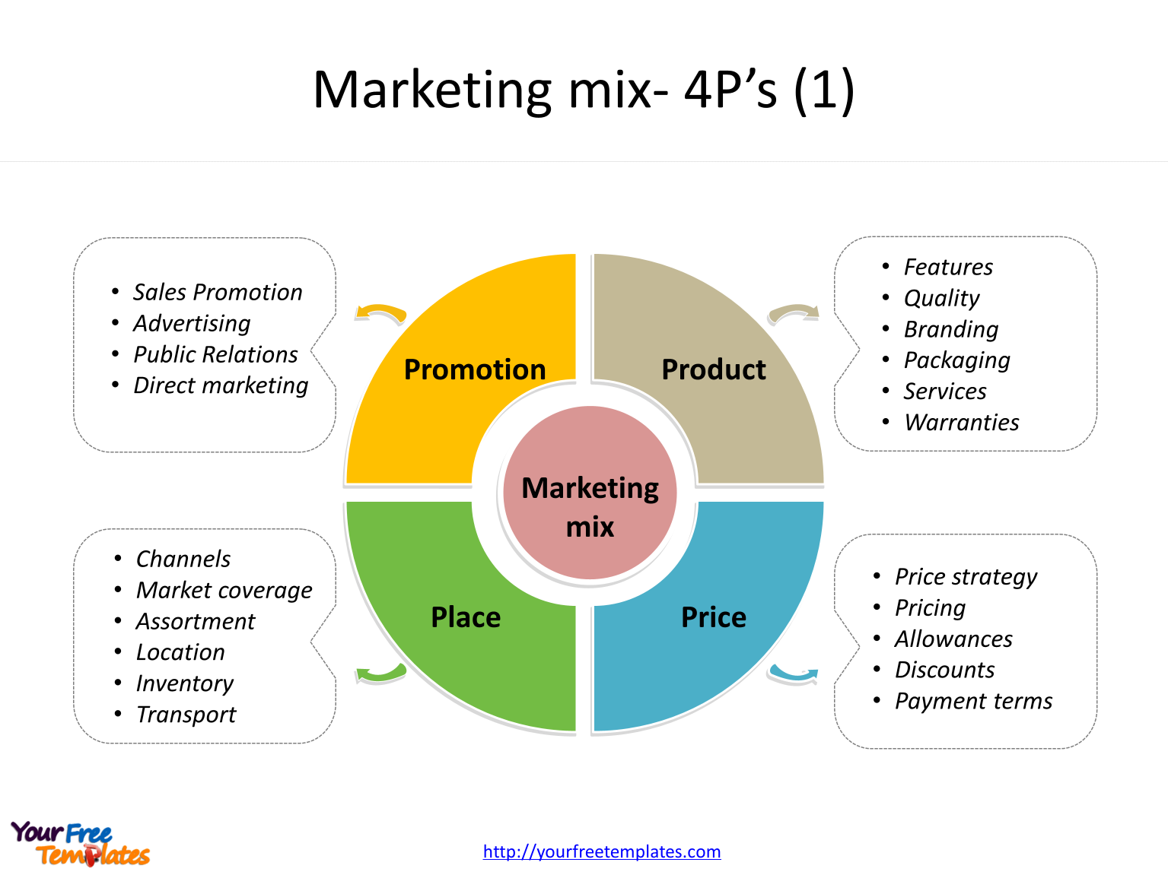

The Roles of Marketing in Creating Value for Customer
Marketing strategies are not successful as long as they are creating necessary value for the customers. Value refers to benefits received by customers in the trade of monetary exchange to the organization. Before marketing a product, an organization needs to address the features wanted by its target customers otherwise it will not make the customers satisfied (Reynolds and Lancaste, 2018). As it is discussed earlier that marketing is all about identifying new customers, satisfying and retaining them through building strong customer relationships. To serve customers, it is necessary to specify the market niche so that organizations can provide products that fit their demands. To match customer valuation, the organization requires to know what customers want and expect and whether they are willing to pay for it. If an organization fails to read the customers’ minds, the right value cannot be provided and the growth of the organization will be slowed down. Providing what customers want gives the organization an advantage over its rivals. If the organization claims higher prices than what their products offer, customers will turn to their competitors (McDonald, 2020). So, to create value, the right price must be set and the right channel must be chosen because customers want convenience in buying products or services. Putting the products at the right place ensures that customers are getting it at ease. When every demand of customers is committed to meet, they tend to buy further and become loyal to the organization which eventually leads to a strong customer relationship that is profitable and sustainable for the organization. The benefits of products must exceed the value of identical products provided by competitors to ensure that customers buy them again and again. So, when it becomes possible to meet customer demands through effective marketing, the higher customer value can be ensured which helps an organization increase its sale and productivity through a long-term relationship with customers.
ANSOFF MATRIX
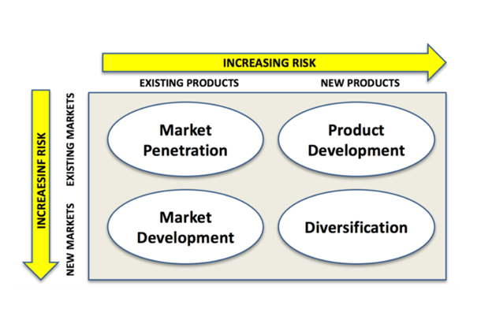
Source: (Google, 2020)
Ansoff Matrix was created to effectively develop growth strategies through a variation of product growth and market growth. Market penetration is possible for the still growing markets. Development of new products for the existing customers (market) - this approach recommended by the Ansoff Matrix, the company is expected to have the promotion and product elements of the marketing mix change.

Stakeholders Engagement
Stakeholders are generally those people who have an interest in the business and any decision taken by the organization must consider their influence (Hughes and Dann, 2019). Owners and shareholders are considered the primary stakeholders traditionally but in the modern business world, it widens the boundary ranging from employee to customers, suppliers, distributors, communities, partners, etc. Effective marketing needs involvement and engagement from all the stakeholders involved. Owners have a significant influence as they make the crucial marketing decision and financial side of marketing by providing necessary funds. Employers share their vies on marketing decisions taken by owners to evaluate them and employees may not have authority in decision making but they are responsible to implement them. The information they exchange with the customers on the market trend pass to the employees who can use them later to formulate a better marketing strategy (Hughes and Dann, 2019). Engagement of customers is also important to devise marketing strategy as they can provide reviews and feedback on products that helps the organization in making better marketing decisions in the future and they also recommend the products to others. The local community can expand their helping hands to the organization by buying products and spread good words about the organization which ensures effective and successful marketing campaigns. Without the engagement of stakeholders, the tactful and effective marketing campaign is almost impossible (Reynolds and Lancaste, 2018). Ensuring engagement of all stakeholders makes the formulation and implementation of marketing strategy easier and consistent with the market and it ensures long-term business sustainability and growth along with providing the best value for customers.
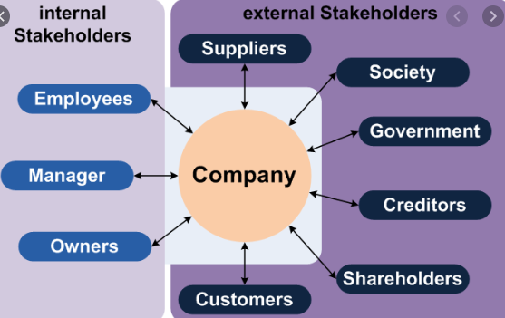
Source: (Google, 2020)
Reflection: TASK B
Tools Used to Generate Awareness and Interest

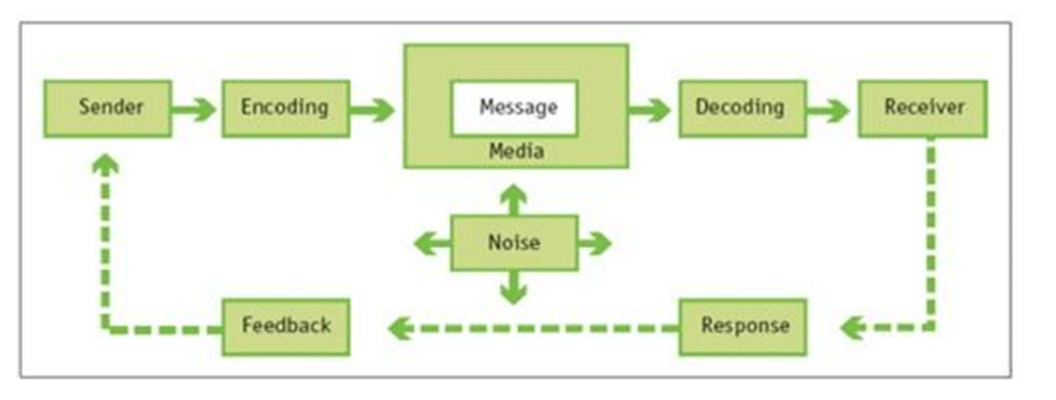
Source: (Google, 2020)
The best established and influential formal communication model, developed by
Claude Shannon and Warren Weaver in 1949. ). It is a transmission model consisting of five elements: an information source, which produces a message; a transmitter, which encodes the message into signals; a channel, to which signals are adapted for transmission; a receiver, which decodes (reconstructs) the message from the signal; a destination, where the message arrives. A sixth element, noise, is a dysfunctional factor: any interference with the message travelling along the channel (such as static on the telephone or radio) which may lead to the signal received being different from that sent.
Integrated marketing communication chart: Source: (Google: 2020)
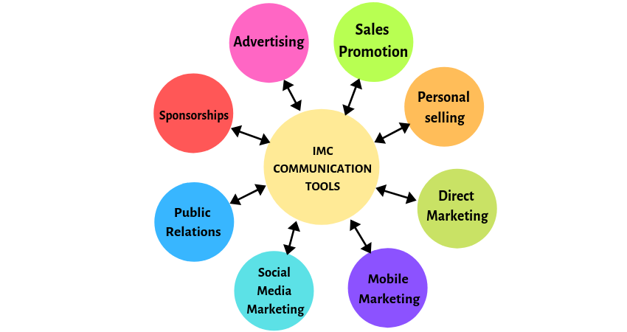
Integrated Marketing Communications ensures that all forms of communication and messages are carefully linked together.
Several tools were used to generate interest and awareness in this project. The brief 1 with the blog expounded on the stages and processes of marketing and the role of the marketing mix helped very much. The blog explained the all marketing plan and aided considerably in improving the interest and generate awareness in the project. Social media and advertorials have also been of good importance in creating awareness in the project.

Reflective Conclusion
Tactical communication is comprised of parts such as strategies, marketing channels, customer segmentation, and performance measurement and all of these are associated with digital marketing (Chaffey and Ellis, 2019). Email marketing, Search Engine Optimization, blogging, social media marketing, etc. are some of the recognized tools used for tactical communication in digital marketing. Every one of these tools has its own preferable use, pros, and cons. For example, email marketing is free, and but it needs regular attention and quite a hassle. On the other hand, search engine optimization is a bit expensive compared to free email service but it does the trick as it generates more traffic on the desired site (Chaffey et al., 2013). However, blogging is known as an effective digital marketing tool that generates a lot of traffic by making the customers come in a single platform which not only educates the customers about the stuff and features of the product but it also creates a sense of desire in those customers about the products.
To create awareness among the audience so that they feel interested in my project, I have used a few tactical communication tools that suit my need for digital marketing of my product and they are blogging, search engine optimization, and email marketing. As mentioned before, each of these communication tools has its own strategies, marketing channels, customer segmentation and performance measurement. For instance, in the case of email marketing, the strategy was to send customers an email about my project with a link to my blog where they can learn more about it so that I get their constant attention. Search engine optimization was used with a view to bringing my blogging site up in the customer’s search list. And lastly, the blogging was used to give the customer a better view of the project with a call to action feature in case they feel further interested. The customer segmentation for each of the marketing channel was the audience who might feel interested in my project or has a similar type of interest. The performance measurement for each of the marketing channels of their own. For example, for the email, the performance measurement was how many people joined the blog by clicking the link on the email. In case of the search engine optimization, it was how many visits the blog got by bringing it up in the search result through SEO activities (Stokes, 2011). And lastly, in the case of the blogging, the blog traffic was the proof for itself.

References
Boulding, W. and Lee, E., 2018. Differentiation via the marketing mix. Marketing Letters, 3(4), pp.343-356.
Chaffey, D. and Ellis-Chadwick, F., 2019. Digital marketing. Pearson UK.
Chaffey, D., Smith, P.R. and Smith, P.R., 2013. eMarketing eXcellence: Planning and optimizing your digital marketing. Routledge.
Clark, L., 2019. Marketing Courses and Marketing Research. Journal of Marketing, 12(4), p.488.
Diller, H. and Ivens, B., 2019. Process Oriented Marketing. Marketing ZFP, 28(JRM 1), pp.14-29.
Ernst, H., Hoyer, W. and Rübsaamen, C., 2019. Sales, Marketing, and Research-and-Development Cooperation Across New Product Development Stages: Implications for Success. Journal of Marketing, 74(5), pp.80-92.
Goi, C., 2019. A Review of Marketing Mix: 4Ps or More?. International Journal of Marketing Studies, 1(1).
Hughes, A. and Dann, S., 2019. Political marketing and stakeholder engagement. Marketing Theory, 9(2), pp.243-256.
McDonald, M., 2020. The role of marketing in creating customer value. Engineering Science & Education Journal, 6(4), pp.177-181.
Pulido Polo, M., 2018. Acts or events? A perspective from the marketing mix. IROCAMM-International Review Of Communication And Marketing Mix, (1), pp.56-66.
Razinkova, M., 2020. STAGES OF MARKETING PLANNING IN RESTAURANT BUSINESS. Ekonomika ta derzhava, (2), p.62.
Reynolds, P. and Lancaste, G., 2018. Marketing.
Sanchez, R., 2018. Modular Architectures in the Marketing Process. Journal of Marketing, 63, p.92.
Stokes, R., 2011. eMarketing: The essential guide to digital marketing. Quirk eMarketing.
Tapp, A. and Spotswood, F., 2018. From the 4Ps to COM-SM: reconfiguring the social marketing mix. Journal of Social Marketing, 3(3), pp.206-222.

