10/21/2025
University of Wales Trinity Saint David
London campus
E-Portfolio Link: https://pakistanmuridke70.wixsite.com/e-portfolio

Module Name: Learning In the Digital Era
Module Code: ACCA 4025

Student Name: Masood Rana
Student ID: 2512874
Group: 4

Lecturer’s Name: Dr Dipo Dunsin,

LDE Assignment 1
E-Portfolio
Table of Contents
Task 1: Essential Academic and Employment Skills for the future career Path 2
Task 1 (a): Report on Essential Academic and Employment Skills 2
Introduction 2
Main Body 2
Essential Academic and Employment Skills 2
Task 1 (b): Evaluation of Task 1 (a) based on Similarity report’ 3
Task 2: Collaborative Mind Map and Individual Poster 4
Mind Map (Collaborative) 4
Poster (Individual) 5
Task 3: Virtual Collaboration and RefWorks 6
Report on Virtual Collaboration 6
Step-by-step process of using RefWorks with visuals 7
Task 4: E-Portfolio Creation and Evaluation 9
Task 4 (a): E-Portfolio Creation 9
Task 4 (b): Illustrative Review of E-Portfolio tool Selection 13
Conclusion 13
References 13
Task 1: 13
References: 13
Task 3 References: 13

Task 1: Essential Academic and Employment Skills for the future career Path

Task 1 (a): Report on Essential Academic and Employment Skills

Introduction
When it comes to studying or working, I’ve realised that it’s not only about what you know — it’s more about how you use what you know. In college and later in a job, you need a few solid study habits and the right attitude. I’ve noticed that being able to manage time properly, think clearly, and write in your own words makes a big difference [1]. These small habits help you stay organised and feel more confident when you’re explaining ideas or trying to solve a problem [2].

Main Body

Essential Academic and Employment Skills
On top of that, there are soft skills — things like teamwork, patience, and staying calm when things get stressful. I’ve seen that every job needs people who can talk properly, listen to others, and adjust when something unexpected happens [3]. For social care jobs, empathy and communication matter even more because you deal with people directly and need to build trust [4].
Since I want to work as a social worker, I’ve been trying to improve these skills early. Knowing how to research, manage time, and talk with people in a respectful way will help me handle work pressure later. These are the skills that will not only help me do my job well but also help me connect with people in a genuine way.
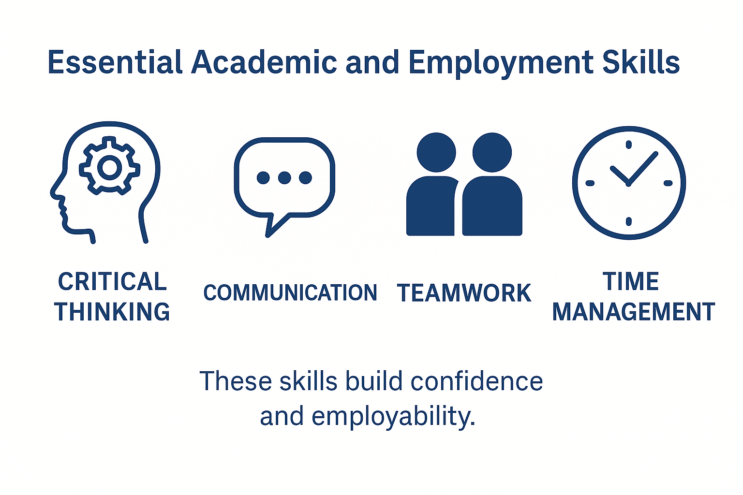
Essential academic and employment skills that support study and career success.

Task 1 (b): Evaluation of Task 1 (a) based on Similarity report’

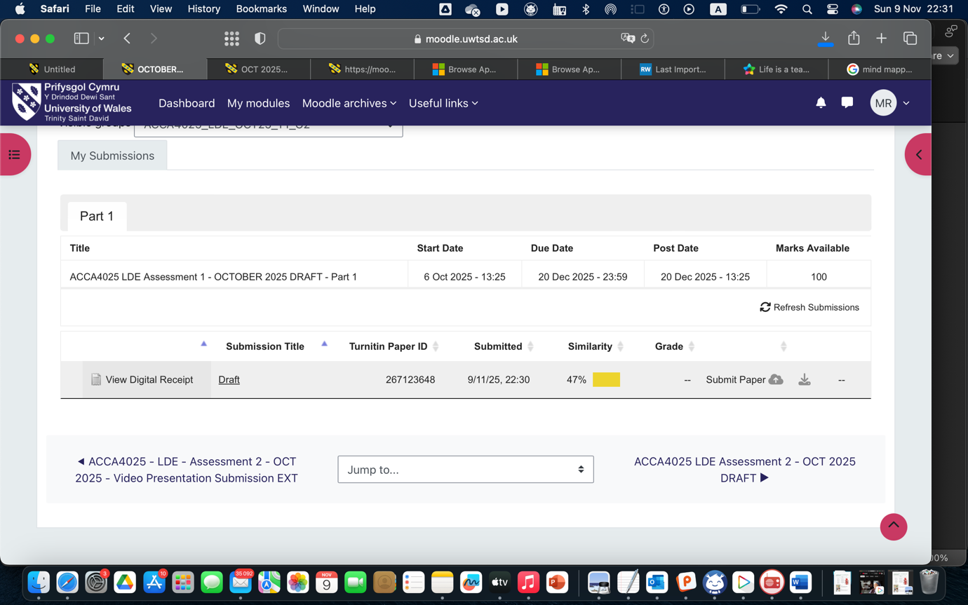

After submitting my work to Turnitin, my similarity score was low, which shows that most of the writing was my own. I made sure to paraphrase information and cite all the sources I used correctly. Next time, I can improve by using more of my own interpretation instead of relying on similar wording from articles. According to the Generic Assessment Criteria, I would give myself 80%, as my work is well organised and supported with good references, but I can still improve my vocabulary and critical thinking in the main body.

Task 2: Collaborative Mind Map and Individual Poster

Mind Map (Collaborative)
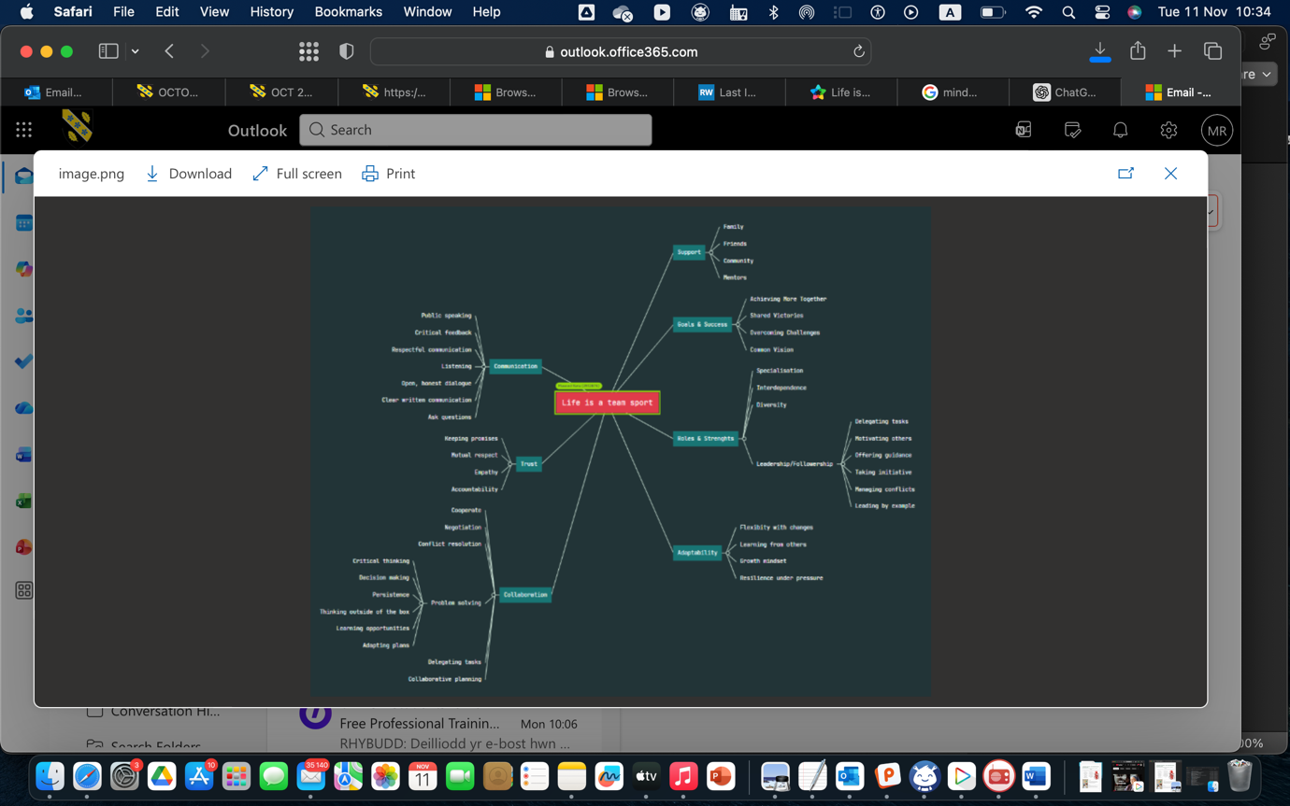

Poster (Individual)
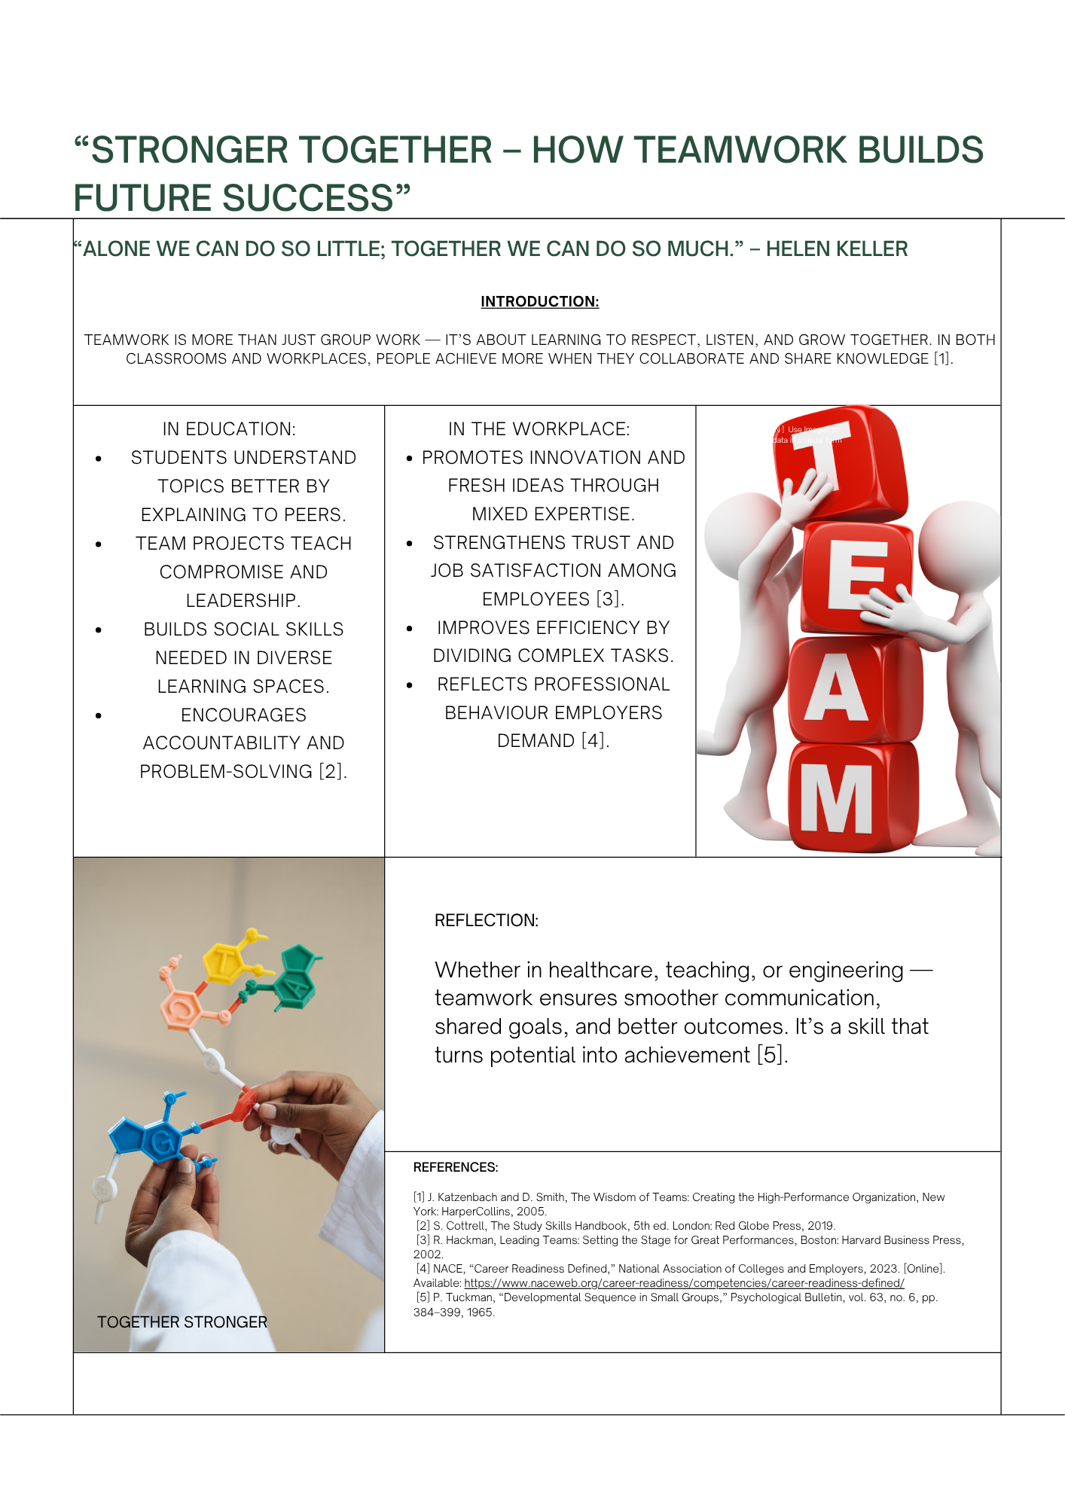

https://www.canva.com/design/DAG5VaH5EAs/TLXivnrdvD0rpqcJzUHhlg/edit?utm_content=DAG5VaH5EAs&utm_campaign=designshare&utm_medium=link2&utm_source=sharebutton

Task 3: Virtual Collaboration and RefWorks

Report on Virtual Collaboration
When a new team starts working together, things usually feel a bit awkward in the beginning. Everyone is still trying to understand what the task really involves and who is going to take on which part. I’ve noticed that if people talk openly right from the start, it helps the whole team relax and get a clearer idea of what they’re aiming for. It also makes it easier for everyone to settle into their role instead of guessing what to do.
Working in a virtual team is even more different because you don’t meet face-to-face. Sometimes people are in different places, different schedules, and the only way to talk is through a screen. You have to depend on apps like Teams or Zoom, and honestly, sometimes messages get misunderstood because you can’t see someone’s expressions properly. So writing clearly and checking your tone becomes important.
I’ve realised that setting a few simple rules early on helps a lot — things like when the team will meet, who will update the group, and how the work will be divided. When this isn’t done, people either repeat the same work or wait for someone else to start. Clear roles remove that confusion.
Another thing I’ve learned is that small bits of interaction actually build trust. Even quick updates or short check-ins make the group feel more connected, especially when everyone is online and can’t meet in person. It sounds small, but it matters later when the workload increases.
In the end, I feel that virtual teamwork only works well when there’s a mix of technology and people actually trying to understand each other. The tools help to organise things, but teamwork really depends on communication, patience, and supporting each other toward the same target.

Step-by-step process of using RefWorks with visuals
I managed my citations with RefWorks inside Microsoft Word. I first signed in to RefWorks via the library link, then added sources two ways: by clicking Add → Create new reference for books, and by using Google Scholar → “Export to RefWorks.” In Word, I opened RefWorks Citation Manager (RCM), set the style to IEEE, and placed the cursor where I needed a citation. Hitting Cite this dropped in the numbered reference (e.g., [1], [2]). When I finished writing, I clicked Insert Bibliography and Word built the full IEEE reference list automatically. This kept everything accurate and saved me a lot of time.
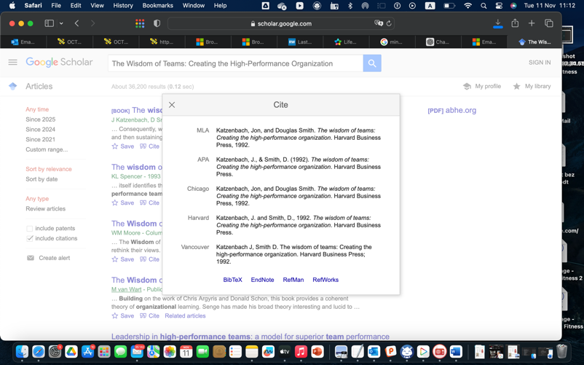
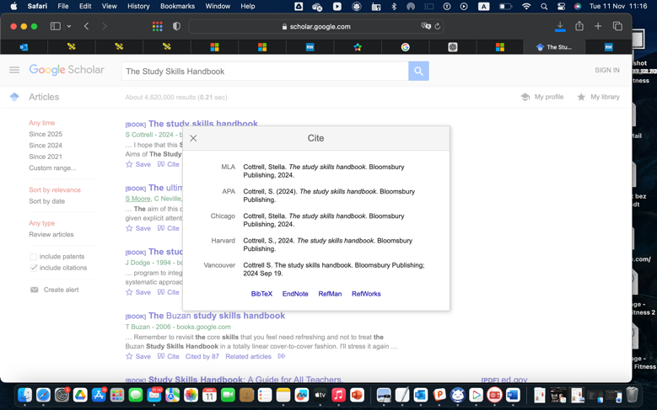
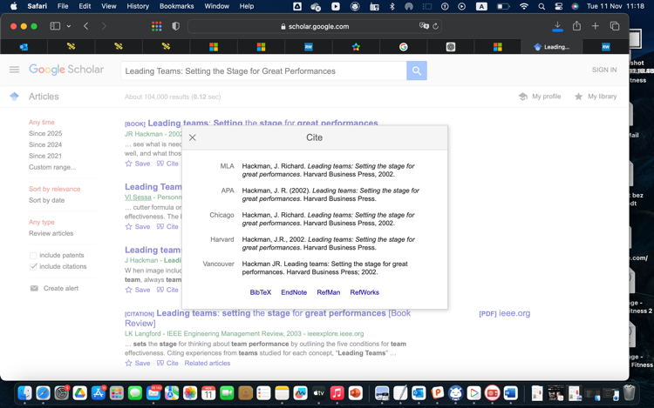
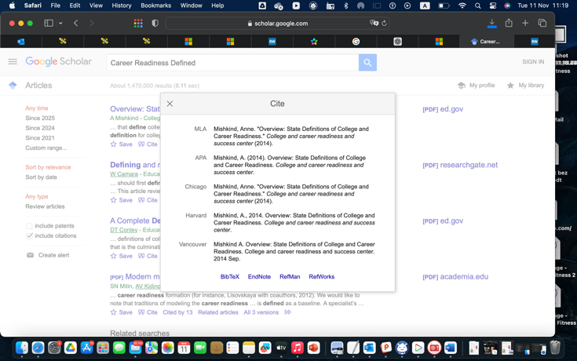
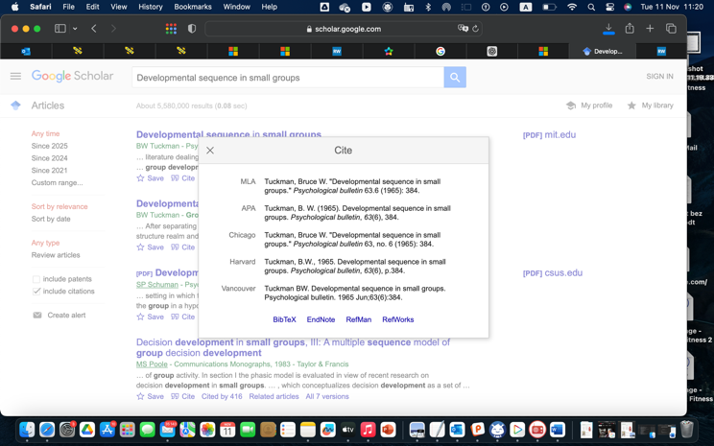

Tuckman (1965)Mishkind (2014)Hackman (2002)Cottrell (2024)Katzenbach & Smith (1992)

Task 4: E-Portfolio Creation and Evaluation

Task 4 (a): E-Portfolio Creation

Wix was the best choice for making my e-portfolio because it is easy to use and has a basic UI. I started by going to the Wix homepage and choosing a simple design so I could make things look the way I wanted them to. Then I added the pages I needed for this position, like Home, Skills Audit, SWOT Analysis, Tasks, and Reflection. I kept the design simple because it looks more professional and makes it easier for the reader to move from one part to the next. I also added short descriptions, titles, and photographs to each page to make it obvious and easy to follow. This setup lets me show all of my evidence in one location without making it hard for the visitor to grasp.

Task 4 (b): Illustrative Review of E-Portfolio tool Selection

- Go to Wix.com
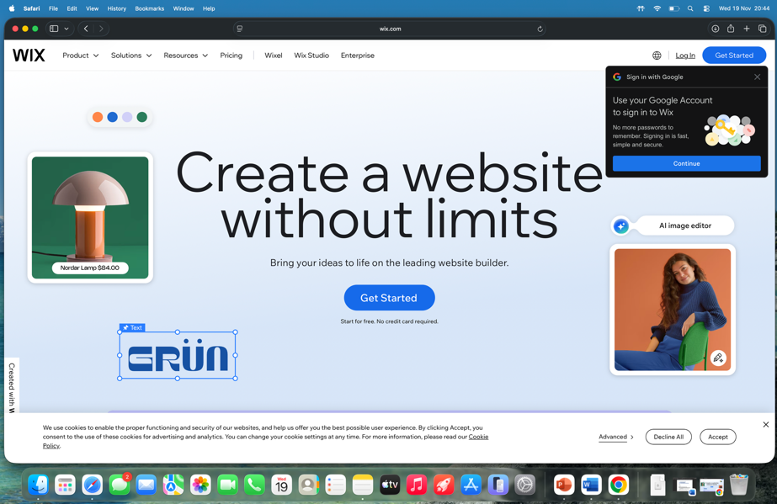

- Sign up to create account
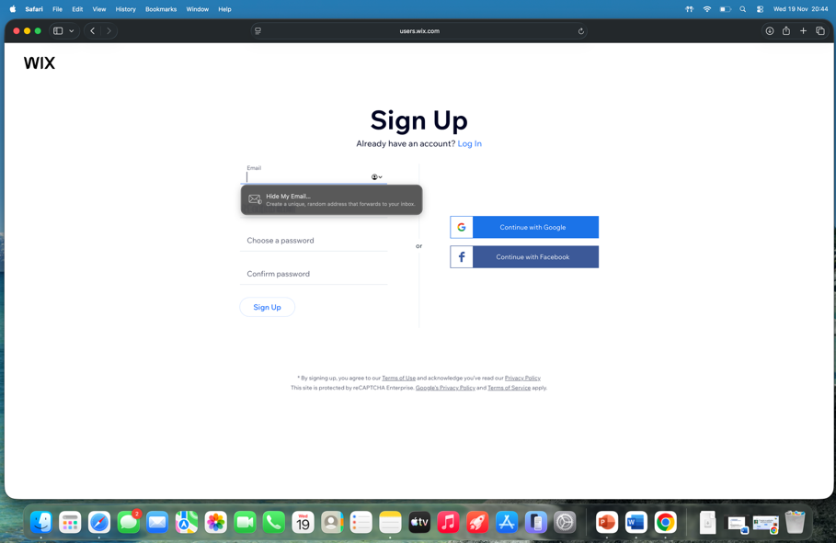

- Topic of website
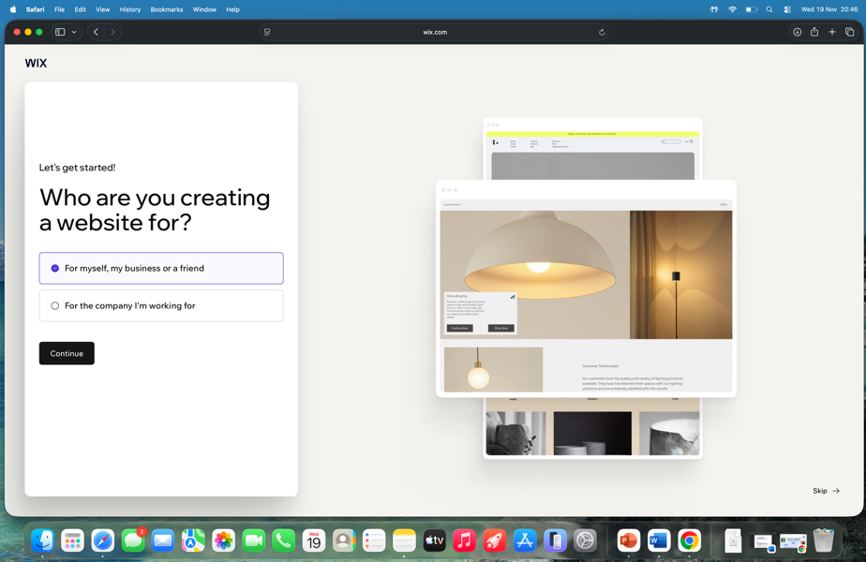

- What is the site all about
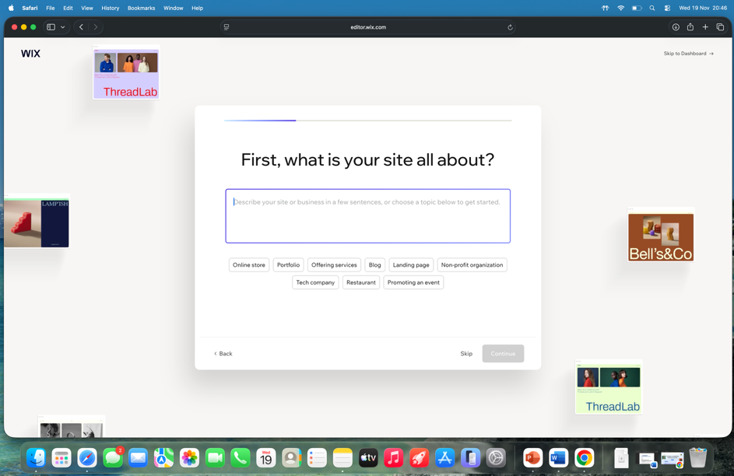

- Name the site: Portfolio

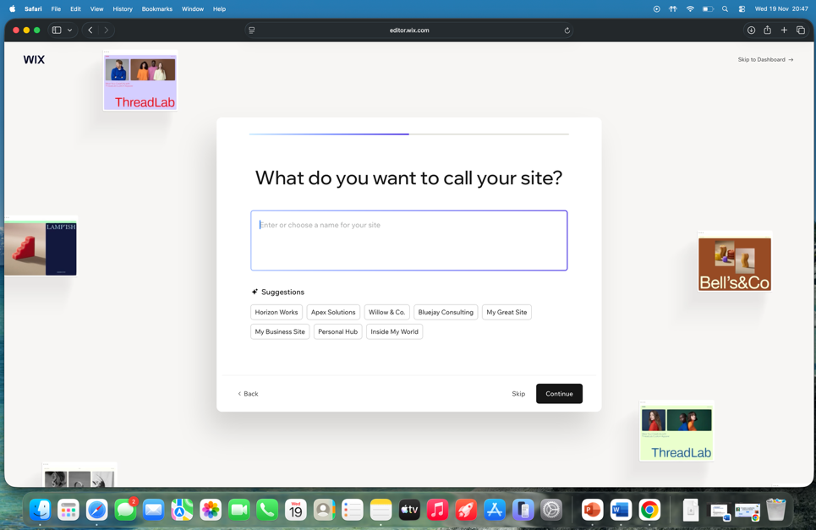

- Wx Welcome Page

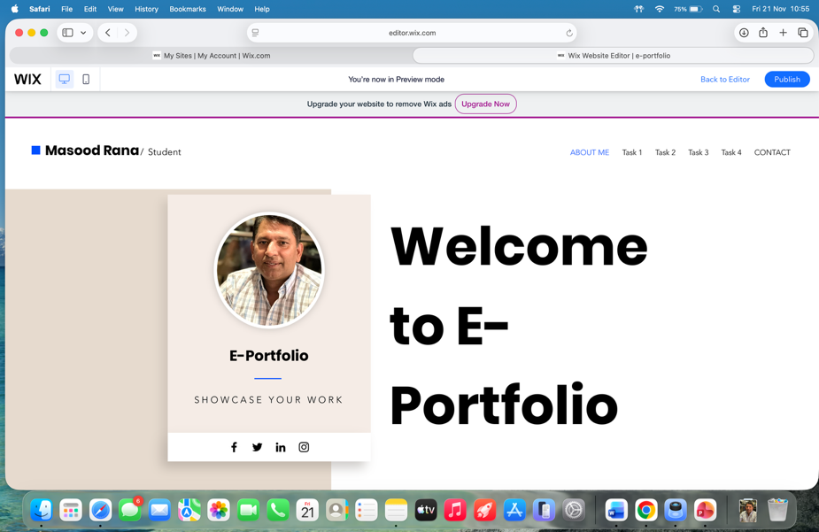

- Task 1
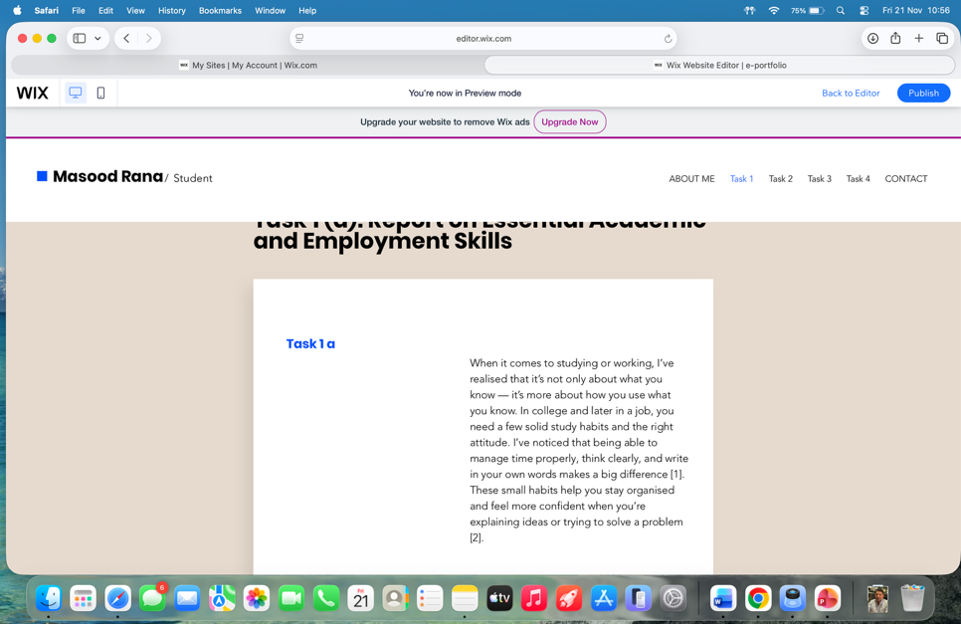

- Task 2
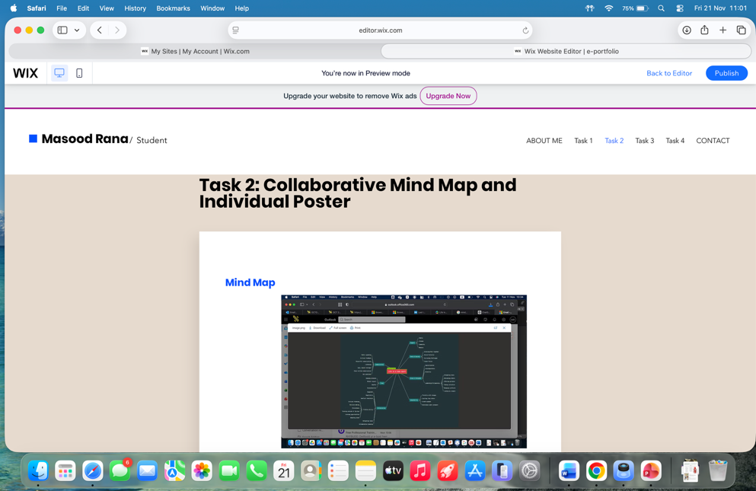

- Task 2 Poster
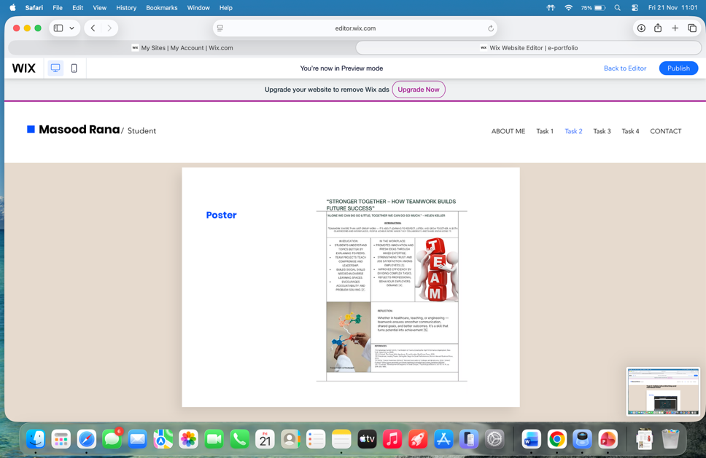

- Task 3
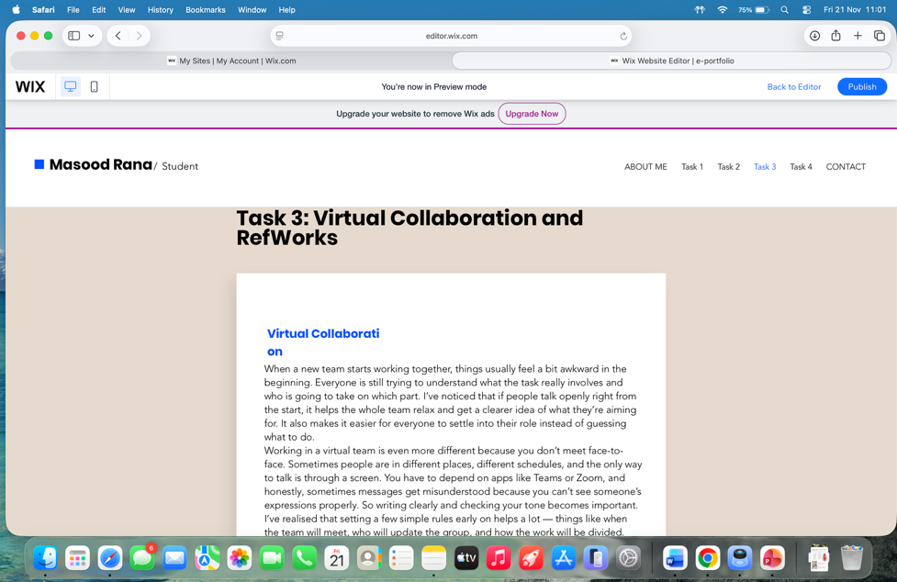
- Task 3
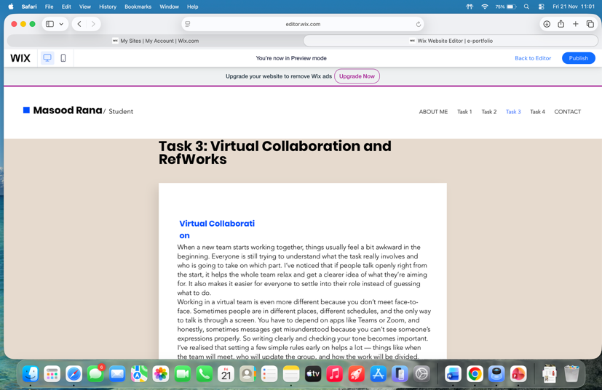

- Task 4
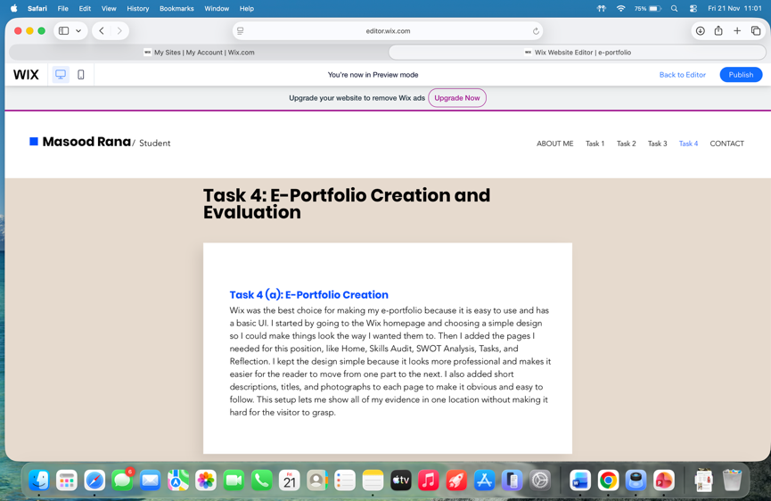

Conclusion
In the end, what I really understand from this whole task is that virtual teamwork isn’t something you figure out in one go. It takes a bit of time to get used to everyone’s way of working, and the first stage is honestly the most confusing one. But once the team starts talking properly and everyone knows what they’re supposed to do, things become easier. Even small check-ins help a lot. Using online tools is helpful, but they don’t fix everything — people still need to make an effort to listen and stay patient. So for me, good virtual teamwork just comes down to clear communication and people trying their best to work together.

References:
[1]. (2019). The Study Skills Handbook. London: S. Cottrel.
[2]. (2023, 5 11). Key Attributes Employers Seek on Students' Resumes. Retrieved from The National Association of Colleges and Employers (NACE): http://www.naceweb.org
[3]. (2006). Emotional Intelligence: Why It Can Matter Than IQ. New York: Bantam Books.
[4]. (2016). The Social Work Companion. London: Routledge.

