Cloud Computing Architecture (ACCA5025_LON)

Student: Eduard Stefan (2114821) Lecturer: Fernando Suneth

Contents
Virtual machines 3
Virtual Networks(vNETs) 8
Additional exercise 11
Bibliography 16

Figure 1- VM creation 3
Figure 2- Admin role for VM 4
Figure 3 - VM configuration 5
Figure 4 - Image creator diagram 7
Figure 5 - Image creation - Image deployment 8
Figure 6 - Vnet fiagram 1 10
Figure 7 - NGS diagram 11

Virtual machines
Most people are undoubtedly familiar with Azure Virtual Machines. It belongs to the IaaS (infrastructure as a service) class.
Customers may install and operate virtual machines (VMs) quickly and easily using Azure Virtual Machines as an IaaS.
Customers using Azure VMs are in charge of administering the guest OS and any software that has been installed on the VMs, including patching and security measures. The underlying hardware, hypervisor, and datacenter infrastructure, including power, cooling, physical access security, redundancy, and disaster recovery, are all handled by Azure.
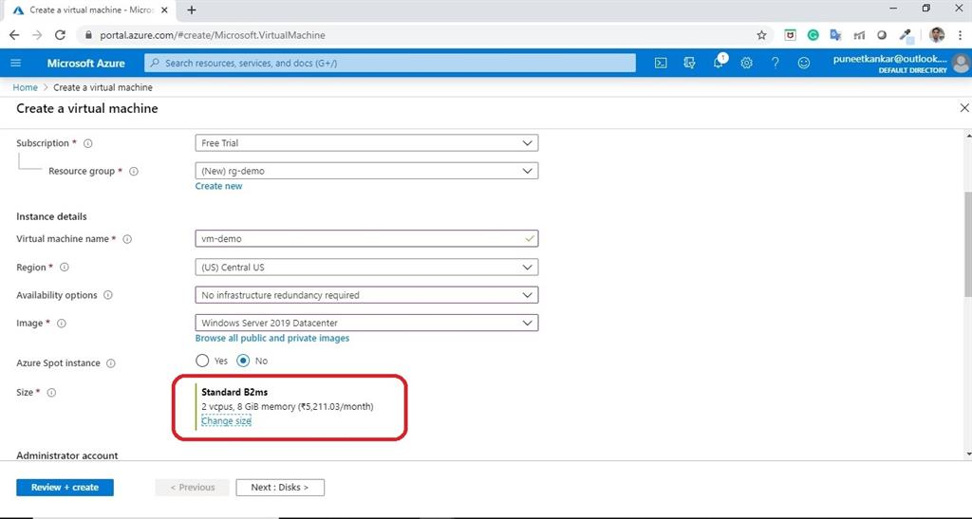

Figure 1- VM creation
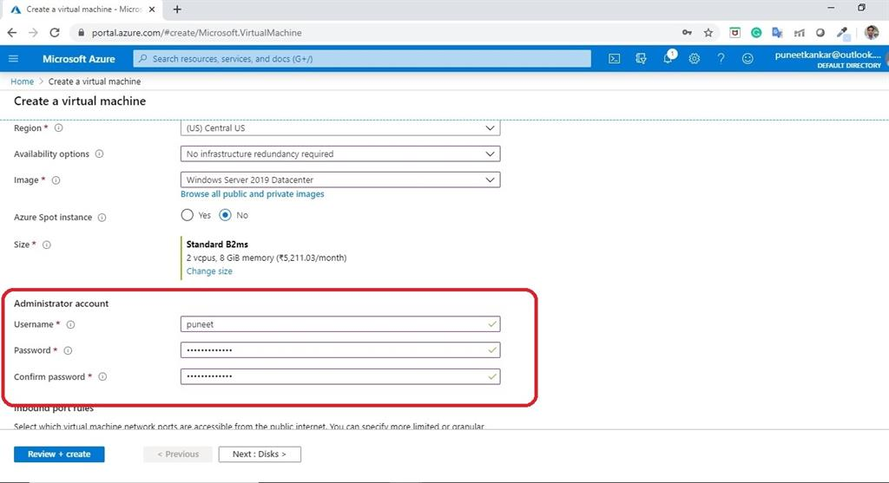
Figure 2- Admin role for VM
Because virtual machines (VMs) are the most straightforward cloud service to deploy, VMs typically mark the beginning of an organization's cloud experience. There is a considerable level of experience with provisioning, operations, and administration ideas at this time because the majority of organisations have been using virtualization on servers for more than ten years.
Since the customer controls everything from the operating system up the stack, virtual machines are a supported environment. It has been confirmed that tens of thousands of programmes operate identically on VMs. Tools to move workloads from VMware, Citrix, Microsoft, and AWS virtualization systems to Azure have been available from Microsoft and third-party suppliers for a long time.
The third category includes Azure datacenters, each of which has extra capacity and quick scaling capabilities. Azure datacenters may be hundreds of miles distant in terms of geo-redundancy. By default, VMs in a datacenter are set up on three physically distinct infrastructures that are dispersed around the building. It's referred to as local redundancy. You can decide if the VMs are replicated to geographically distinct datacenter facilities that are spread apart from one another as an Azure client. Geo-redundancy occurs alongside local redundancy; it does not serve as a replacement.
Therefore, Azure's built-in local and geo-redundancy capabilities are the biggest advantage for many organisations when hosting VMs there. This is particularly more crucial if a company's datacenter infrastructure fits the first legacy category of overcrowded buildings. Organisations can fulfil their requirements for high availability (HA) and disaster recovery (DR) by leveraging local and geo-redundancy.
A 99.95% service-level agreement (SLA) for Azure VMs with two or more instances deployed in the same availability set is backed by money.
Customers of Azure VMs are no longer required to update and replace hardware. They never longer encounter server racking issues or processing delays for hardware shipments. Customers of Azure VMs have access to the most recent hardware, and all they need to know is how many CPU cores, how much memory, and what kind of storage is available.
There are numerous options for VMs, including D-series with solid state drives (SSDs) and A-series with high performance, business drives. The G-series of virtual machines, described by Microsoft as the "largest VM in the cloud," was introduced in January 2015. The G-series virtual machines offer the most memory, computing power, and local SSD storage of any VM currently on the market. The most recent Intel Xeon processor E5 v3 family is used in the G-series virtual machines. 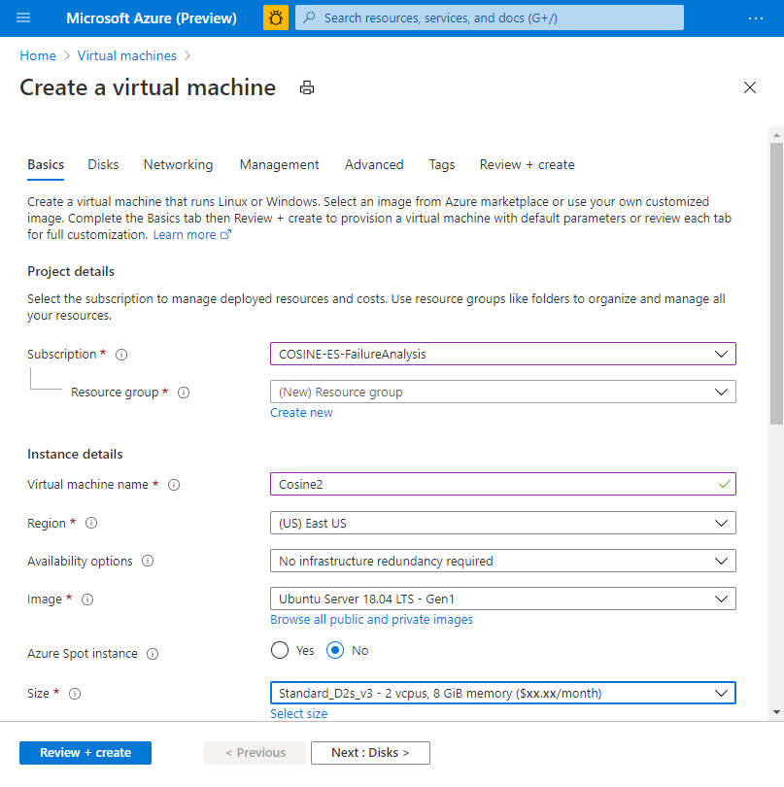
Figure 3 - VM configuration

Because requirements are subject to change, the infrastructure that supports an application frequently expands or contracts. Applications were built on physical infrastructure and remained locked in with older virtualization technology. As a result, it was challenging to scale up or down in response to an organization's needs. Applications' VM types can be changed, giving them the flexibility to use the best architecture available at the time and to make the most of IT operational expenditures. The ability to manually or automatically schedule VM shutdowns increases the efficiency of operations budgets because IT teams can only spend money on VMs that are actually used.

Azure provides a variety of hardware configurations for virtual machines (VMs) to meet different workload requirements. Here are some of the hardware options available in Azure VMs:
- CPU: Azure VMs support a wide range of CPU options, including Intel and AMD processors, with various numbers of cores and clock speeds. The number of vCPUs available depends on the selected VM size.
- Memory: Azure VMs provide varying amounts of RAM, ranging from 768 MB to 12 TB, depending on the selected VM size.
- Storage: Azure VMs can be configured with different types of storage, including local temporary storage, Azure Managed Disks, Azure Blob Storage, Azure Files, and more.
- GPUs: Azure VMs support various types of GPUs for workloads that require graphics processing or parallel computing, such as machine learning, gaming, and video rendering.
- Networking: Azure VMs support different types of network adapters, including standard and accelerated networking interfaces.
- Instance types: Azure offers different instance types, such as general-purpose, memory-optimized, compute-optimized, and storage-optimized, to cater to different workload requirements.
- Custom VM sizes: Azure allows you to create custom VM sizes by choosing the number of vCPUs, amount of RAM, and type of storage.
These are some of the hardware options available for Azure VMs. You can choose the appropriate VM configuration based on your workload requirements, performance needs, and budget constraints.
Disc type: Your data and operating system are saved on the disc type. It includes the following categories:
HDD: A hard disc drive that offers 500 IOPS/1TB and is supported by a magnetic disc. According to the demands of the customer, it is employed for any task.
SSD: It is also known as a premium disc, and it offers 7500 IOPS/1TB and is supported by a solid-state drive. Workload for production is where it is mostly employed.
Standard SSD: This SSD and HDD disc combo offers quicker performance and offers 500 IOPS/1TB. It may be applied to UAT and development environments.
Azure provides the ability to use custom images to deploy virtual machines (VMs) with pre-configured settings, applications, and data. Using an image to deploy VMs can save time and effort as you do not have to manually configure each VM.
Azure VMs size is a collection of the capabilities (memory, disc, IOPS, etc.) and features that are enabled by your Azure VMs instance, such as 2 GB RAM and 120 GB of disc space as your on-premises hardware. Based on the needs, you may make decisions. Large instance sizes are supported, making them suitable for SAP or GPU-based applications.
Azure network components are mostly used to connect your virtual machines and services to your network. For instance, you must choose the virtual network and subnet that determine the network border of your VMs when you create them.
If you wish to access and connect apps openly or connect your virtual machines to the internet, you must utilise a public IP address.
NSG (inbound and outgoing port): Based on the specifications, you can allow the ports. The network security group establishes the rules for ports that need to be permitted or refused. Ports come in two varieties:
Inbound port: The traffic that you wish to let into your virtual machines (VMs) from the internet.
Outbound port: The traffic that your VMs should be able to send to the internet.
Boot diagnostics: In the event of an issue, it helps you present the figures of the VM operating on a host by capturing the console output.
OS diagnostics for guests: The metrics of your virtual machine should be gathered. As a result, you may use alerts that you build to inform your staff.

Accounts for diagnostics: The account you wish to use to keep the diagnostics logs for additional troubleshooting is just your storage account.
Auto shutdown configuration: It aids in automatically shutting down the VMs after your business hours. It is advised against using this option in production situations.
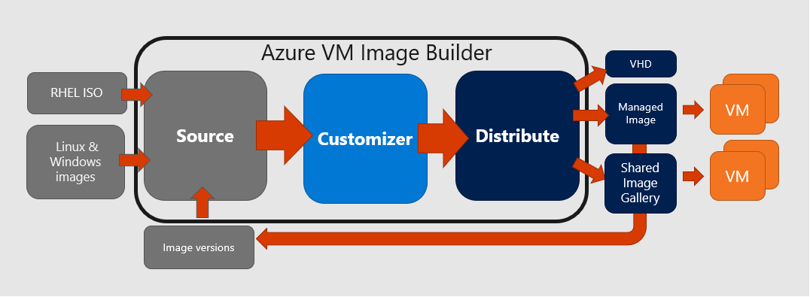
Figure 4 - Image creator diagram
Here are the basic steps to deploy a VM using an image in Azure:
Create a VM image: Create a VM with the desired settings, applications, and data. Then, generalize the VM by running the Sysprep tool (for Windows VMs) or the waagent tool (for Linux VMs) to remove system-specific data and prepare the VM for imaging. Once the VM is generalized, create an image of the VM using the Azure portal, PowerShell, or Azure CLI.
Create a VM from the image: In the Azure portal, navigate to the "Virtual machines" section and click on "Add". In the "Basics" tab of the "Create a virtual machine" wizard, choose the subscription, resource group, and name for the new VM. Then, select "Image" as the source type and choose the custom image that you created in step 1.
Configure the VM: In the "Size" tab of the wizard, select the VM size that meets your performance and budget requirements. In the "Settings" tab, configure the networking, storage, and other settings for the VM. You can also add extensions to the VM to enable additional functionality.
Review and create the VM: Review the configuration settings of the VM and click "Create" to deploy the VM from the image.
By using a custom image to deploy VMs in Azure, you can streamline the VM deployment process and ensure consistency across VMs.
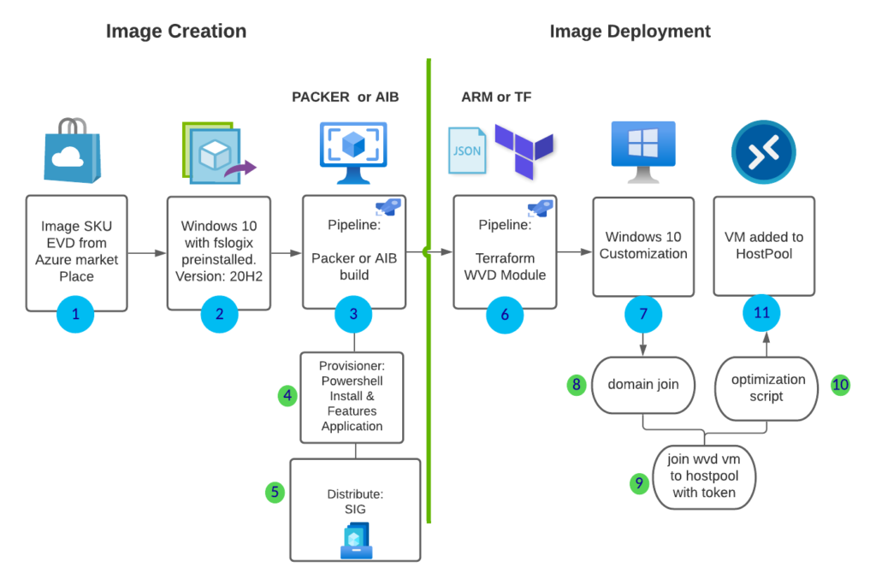
Figure 5 - Image creation - Image deployment

Virtual Networks(vNETs)
Azure administrators may extend their on-premises datacenter into the cloud using a variety of connections to their on-premises infrastructure. It may be necessary to combine a few different types of connections depending on the various use cases' differing workloads, security concerns, and routing needs.
In Azure hybrid networking, there are
Virtual network in Azure
Load Balancer for Azure
Cloud DNS
ExpressRoute for Azure
Traffic Manager Azure
Azure VPN entry point
Private ExpressRoute circuits, VPN connections, and direct Internet connections are all possibilities; each has certain advantages and disadvantages.

The easiest way to connect to Microsoft Azure is over the internet. Since all Azure PaaS services use public IP addresses, anyone with Internet access can access the workload's DNS and connect to it. Additionally, this implies that all Azure PaaS services can be accessed online. The workload's private IP address in the Azure virtual network must be NAT'd (network address translation) to a public IP address on Microsoft Azure's "Edge," or external network, which is connected to the Internet.
Many use cases for Azure's internet-based workloads are successful. Making the workload Internet-facing can have several benefits, including security, when you don't require it to go across a private or internal network, if the workload's intended user population is coming from the Internet, or if the user population is from a separate organisation. Not coupling the Azure environment to your on-premises environment provides a security boundary if you are making a workload externally facing to "untrusted" systems and users, which means they are not managed by your organisation. Your workload would be the only thing a malicious actor or piece of malware could access if they were to 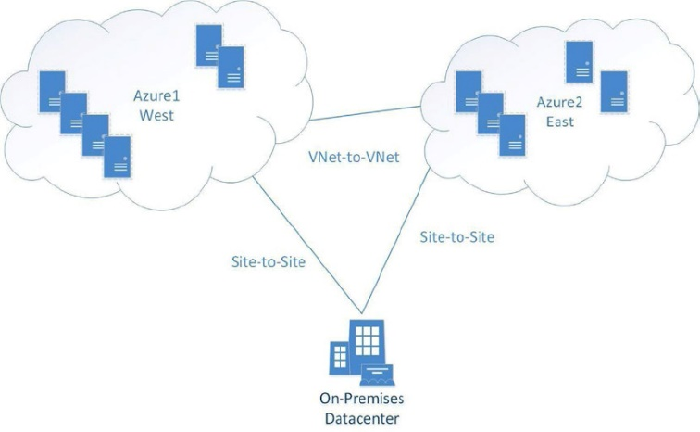

Every Azure cloud service by default permits communication between VMs. However, you use a VNet to communicate with other VMs in a different cloud service. When you extend your network from an on-premises datacenter to Azure cloud services, VNets are also necessary.
The following are the networking steps:
Connect a single site or multiple sites.
Create an IP network plan.
Manage and deploy your networks.
Azure offers two different VNet configuration types:
Cloud-only VNet: You can build an IP address space that enables communication between virtual machines and PaaS entities and other IP addresses within the same Azure subscription or with another VNet located within a different Azure subscription. This offers subnet functionality to assist in coordinating and managing various business solutions in Azure separately, just as they are maintained in a datacenter that is located on-premises.
Cross-premises In order to fulfil a requirement to expand your datacenter from a single building with constrained resources to an Azure public cloud with infinite resources, you can use VNet, which extends IP networks for many different configurations. Offering a secure VPN access into a top-notch, cutting-edge datacenter is an incredible alternative for any network engineer.
With these two types of VNets, you can build many different types of IP subnet and networking configurations. Let's walk you through the steps to complete a few Azure VNet tasks, including the following:
VNet in Azure (cloud only)
VNet from Azure to a client computer (one or many)
VNets from Azure to a local datacenter (hybrid)
VNets into multiple Azure regions

There are more options than these four, but all Azure network configurations use one or more of these standard network connections to build larger networks.
Single-Cloud Virtual Network
Cloud-only VNets establish direct connections between virtual machines (VMs) and cloud services. Cloud-only VNets don't need a complex network architecture and don't link from one cloud service to another using a VNet gateway. Also keep in mind the requirement that the IP addresses used must not conflict with those of other IP subnets.
You can add new VMs and instances from a PaaS after the VNet has been built. Because communication between two endpoints is conducted over an Azure VNet, the entire VNet is secure. 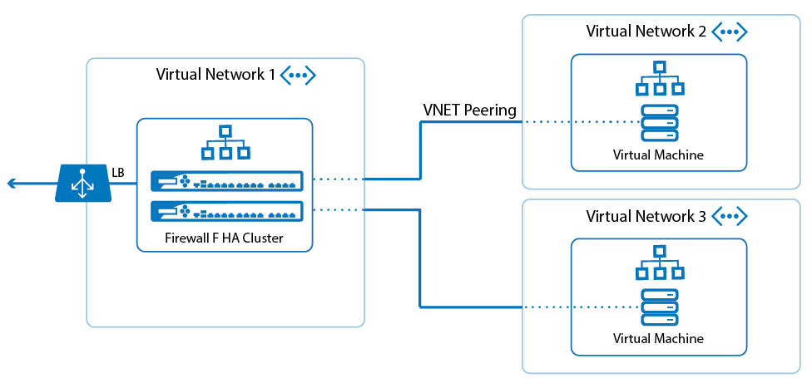
Figure 6 - Vnet fiagram 1
To further secure traffic flow within a VNet, you can use Network Security Groups (NSGs) to filter network traffic based on rules that you define.
Here are some key features and benefits of NSGs in Azure VNets:
- Filter network traffic: NSGs allow you to filter inbound and outbound network traffic based on source and destination IP address, port, and protocol. You can define rules that permit or deny traffic, and you can prioritize the rules to ensure that the most specific rules are evaluated first.
- Apply to subnets and VMs: NSGs can be associated with subnets or individual VMs in a VNet. When an NSG is associated with a subnet or VM, all inbound and outbound traffic to and from that subnet or VM is subject to the NSG rules.
- Secure network communication: By using NSGs, you can enforce network security policies to restrict traffic to and from specific resources in your VNet, reducing the risk of unauthorized access or data exfiltration.
- Monitor network traffic: NSGs can be used to monitor network traffic and detect potential security threats. Azure provides NSG flow logs that capture information about allowed and denied network traffic, which can be used for troubleshooting and analysis.
- Flexible management: NSGs can be managed through the Azure portal, PowerShell, Azure CLI, or REST API. You can also use Azure Policy to enforce NSG rules across your Azure environment.
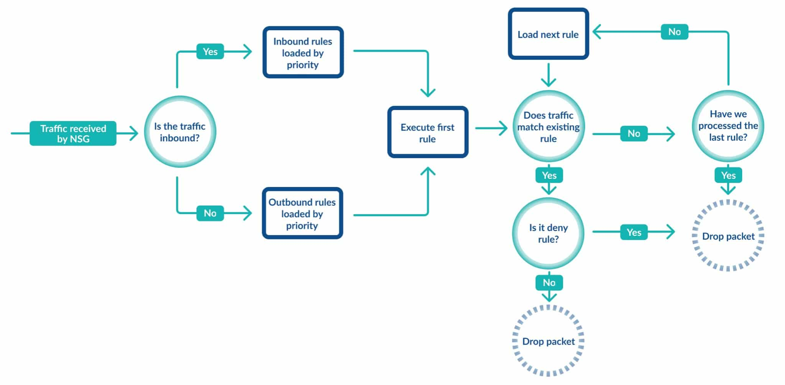
Figure 7 - NGS diagram

Additional exercise

Virtual Network with 2 subnets available
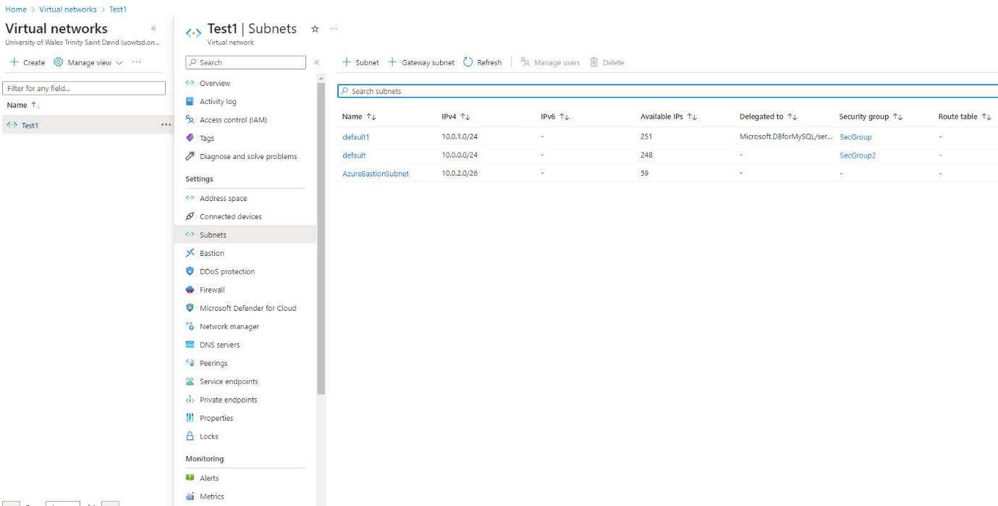

First subnet
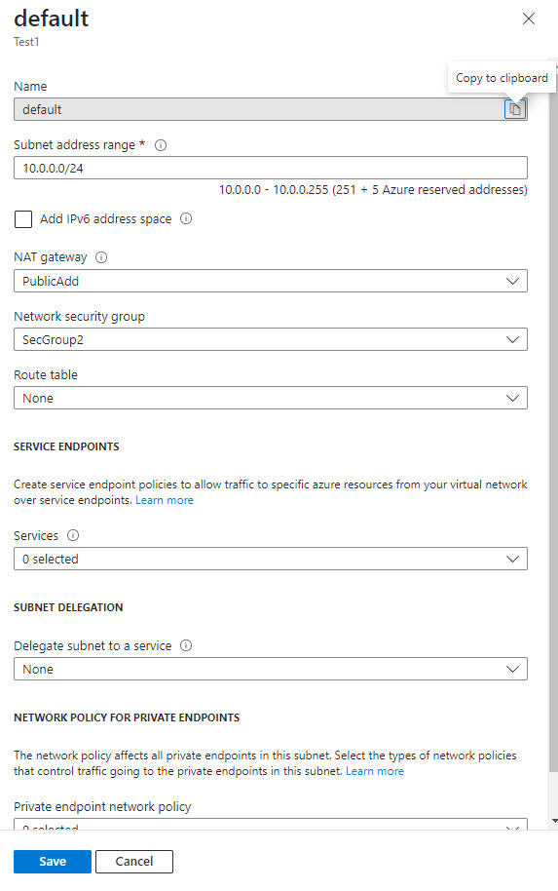
Virtual machines created showing 1 windows SQL server with no public IP address and 1 ubuntu web server with public IP address
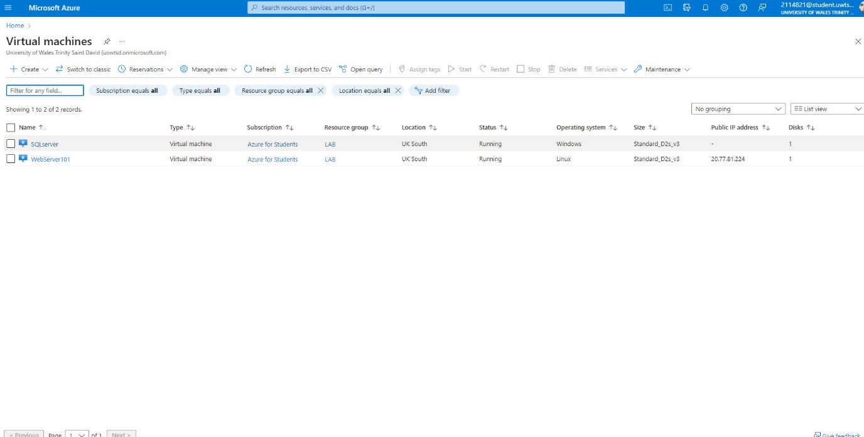
Second subnet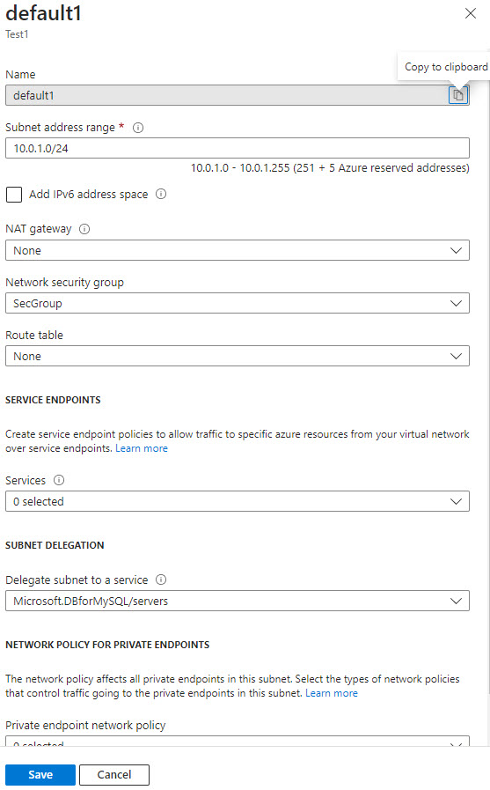
Network Security group for the SQL server having inbound rule blocking internet access.
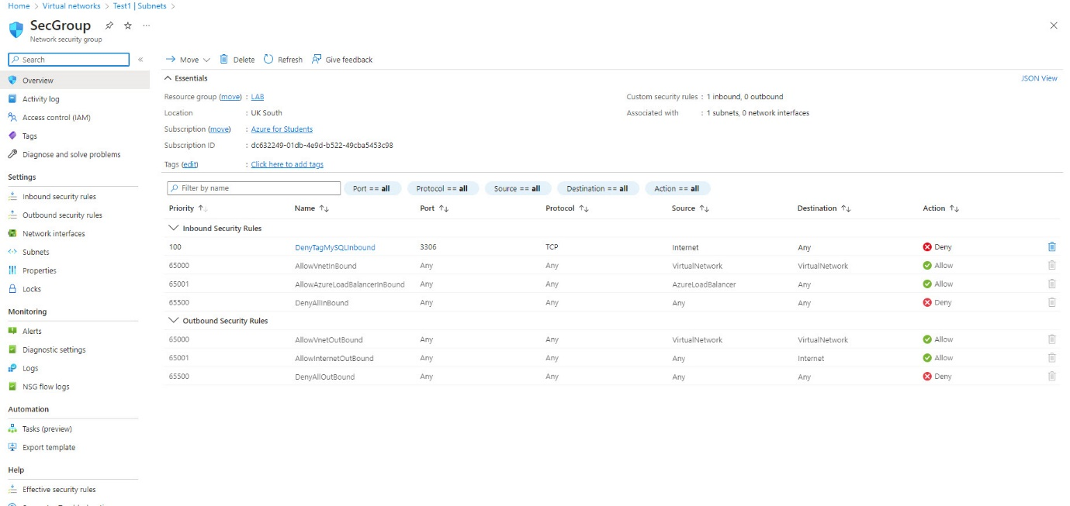
Network security Group for the web server with inbound rule allowing access for TCP port 22 traffic and TCP 3389 RDP traffic for remote management.
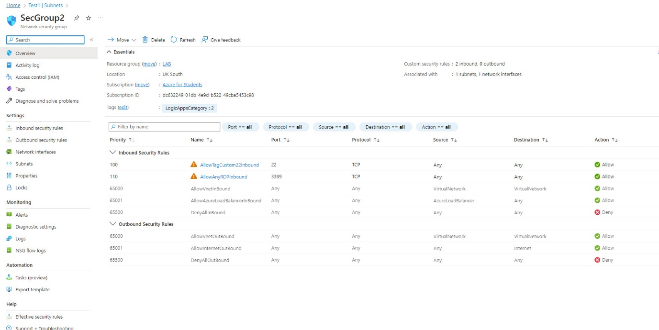

SQL server overview configurations

Web server VM overview configurations
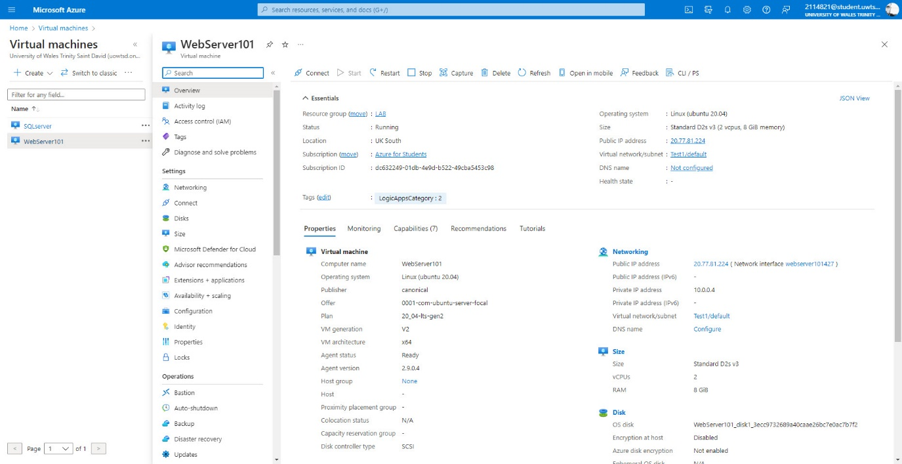

Bibliography

[1] | M. Athaulla, Microsoft Azure AI: A Beginner’s Guide: Explore Azure Applied AI Services, Azure Cognitive Services and Azure Machine Learning with Practical Illustrations, BPB Publications, 2022.
[2] | A. Lisdorf, Cloud Computing Basics: A Non-Technical Introduction, Apress, 2021.
[3] | S. L. A. S. Abhishek Mishra, Hands-On Azure Data Platform: Building Scalable Enterprise-Grade Relational and Non-Relational database Systems with Azure Data Services, First Edition, BPB Publications, 2022.
[4] | R. Skaria, MCA Microsoft Certified Associate Azure Administrator Study Guide: Exam AZ-104, Sybex, 2022.
[5] | J. Switzer, MC Microsoft Certified Azure Data Fundamentals Study Guide: Exam DP-900, Sybex, 2022.
[6] | Microsoft, “.azure.microsoft.com/,” Microsoft, May 2023. [Online]. Available: https://azure.microsoft.com/en-gb/?ef_id=_k_CjwKCAjwjMiiBhA4EiwAZe6jQ--iP2sRociVu04EGPgFbzOdVrKu2FoUxD-03132dbpqU0gBMw1CFRoCfL8QAvD_BwE_k_&OCID=AIDcmm3bvqzxp1_SEM__k_CjwKCAjwjMiiBhA4EiwAZe6jQ--iP2sRociVu04EGPgFbzOdVrKu2FoUxD-03132dbpqU0gBMw1CFRoCfL8QAvD_B. [Accessed 2023].
[7] | I. Foulds, Learn Azure in a Month of Lunches, Second Edition, Manning Publications, 2020.

