Dylan Evans
1701153@student.uwtsd.ac.uk
Advanced Web Development Assignment 1
BSc Software Engineering

Contents
Introduction 2
1.0 User Stories 3
1.1 What are user stories? 3
1.2 Tuck shop user stories 3
2.0 Version Control 4
2.1 What is Version Control? 4
2.2 Why a Git artefact passes through three phases and the process by which it transitions between them 4
2.3 Why is Version Control Important? 5
2.4 Why is version control important to software teams? 6
2.5 Why is version control important to individuals 6
2.6 Git Commands 6
2.7 Evidence of Using Version Control 8
3.0 Conclusion 8
4.0 References 8
4.0 Appendix (Code Listings) 9

Introduction
This report will cover Version Control and how it allows developers to make creating projects more efficient. The report will cover the version control system git along with the commands used in the system. The report will also include a technique known as user stories to show the requirements of the website that the author is creating (tuck shop).

User Stories

What are user stories?
User stories are descriptions from the perspective of a user of an application, to show how they want the program to work/ what functionalities they want to be included. User stories are apart of the agile development methodology.

1.2 Tuck shop user stories
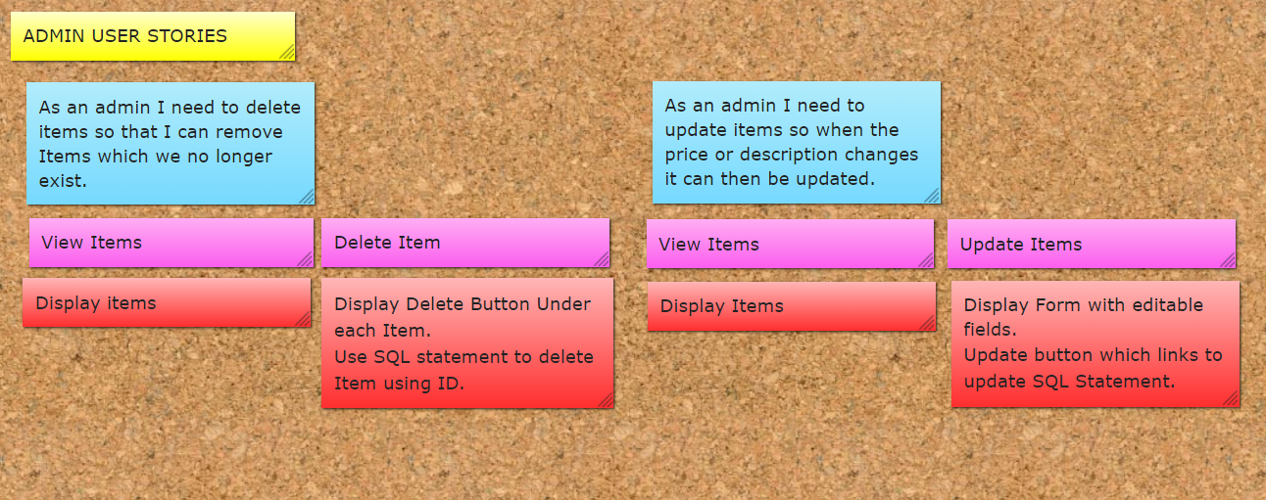
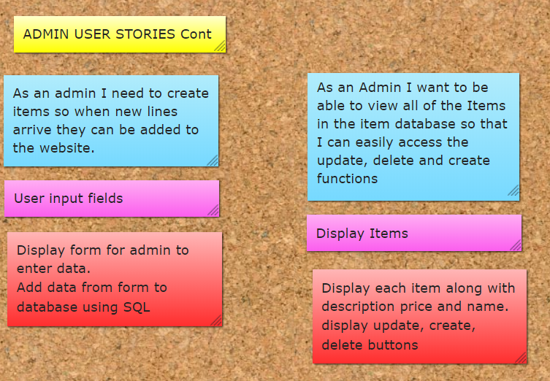
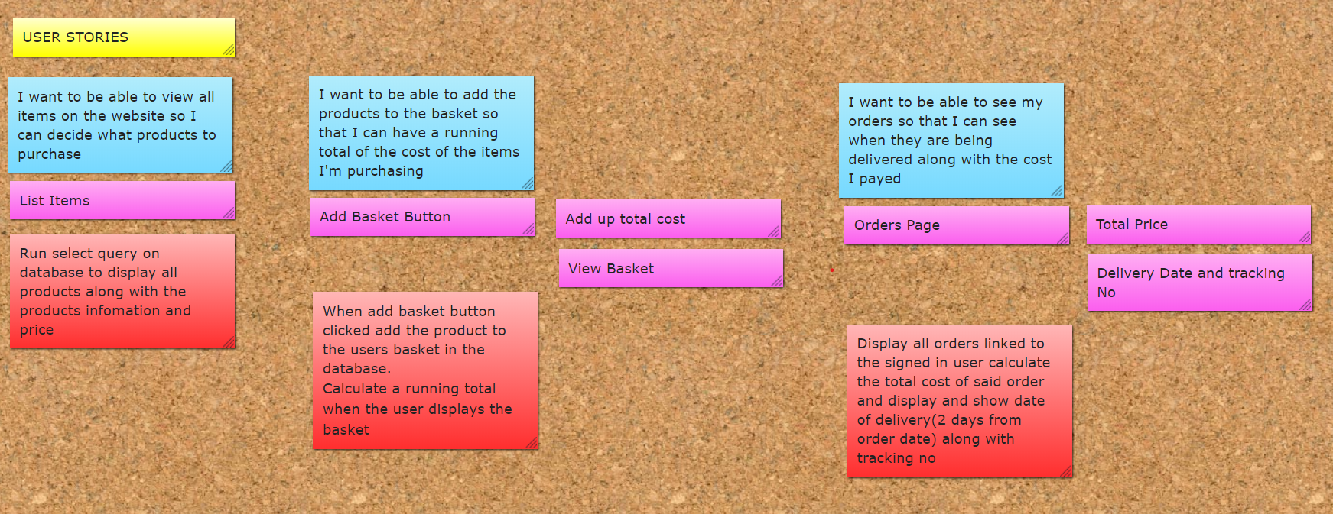

Version Control

What is Version Control?
Version control is widely used throughout the software development industry. To keep track of all changes made to the software throughout its development stages. It’s also useful to track on teams of developers each change made is tracked on a developer basis so that each change can be traced back to the person who did it. Version control is also useful for development as branches can be used, these branches can be split into development and release branches this makes tracking of versions easier [1].

Why a Git artefact passes through three phases and the process by which it transitions between them
There are three stages within git:
Untracked: The file exists but git does not include this file as part of its version control system.
Within this stage, git knows what the files are but does not track any changes in order to add them to the staging area a command “git add foo.txt” this command will then add the file mentioned to the staging area.
Staged: Within this stage, Git knows about the files but has not yet added the changes to the system.
Once the file is in the staging area you can check to see whether the files added to the staging area by running a command “git status” this will then show all the files within the working directly and display whether they are untracked, new file(staged), modified(previously committed code changes made and added to the staging area) and deleted (this file has been removed and will be removed in the next version once committed).
To commit the files which have been staged a command can be run “git commit”.
Committed: Within this stage, Git pushes the changes to the version control system.
Git passes through these three stages to give the developer as much flexibility in tracking file changes as possible.
Within this final stage when the files are being committed a text editor will appear for the developer to enter a commit message this is where all changes to the files can be documented in order to make it easier to see changes down the line. Once this message has been saved the files will then be committed and running the “git status command” will return “the working directory is clean” unless there are untracked or modified files.

Why is Version Control Important?
Version control is important within software development as there will always be a rollback to a previous version if some code changes break a program.
Version control also gives developers the ability to work independently as a part of a team, the workload can be split within a team of developers then committed to the version control system. Keeping track of all changes within programs is important as one line of code could break an entire program, if said program was over 10,000 lines long this line could be quite difficult to place, but with version control, the developer can look back at the changes made within each file in order to see what caused the failure.
An addon available for a popular version control system (git) is called git blame this addon is particularly useful in checking who made a change to a file which can be useful when working with large teams to see who possibly made a potential programming breaking change.
If a version control system was not in place when developing some software, a solution could be to host the files for the program in a shared directory. This solution is not ideal as the team cannot work on the same file at the same time.
Version control is also useful for storing files within a project. The developer has a choice of storing the entire project on their hard drive which will take up a lot of space or just storing the parts they are working on which makes it difficult to view the complete project. With version control systems the entire project can be stored on an online system like GitHub or AWS Code Commit. Version control is also useful for differentiating between project versions by using commit messages which is a distinct way of checking versions compared to naming files by their version numbers.
Another advantage of a version control system is using the online systems as backup members of a software development team could store their projects on their local disks but then also the project can be stored on the version control system as a backup.

Why is version control important to software teams?
Version control is very useful on software development teams as a collaboration tool, workloads can be shared, and files can be pushed to the main branch on a developer basis. The version control system can be used as a fallback if anything goes wrong during development stages, each change can be tracked via the commit messages (if the messages are effective and not written poorly) otherwise changes can be tracked by comparing code in previous versions by using commands similar to git diff. Version control within teams is also good at preventing conflicts as all developers can see what the other members of the team have pushed to the version control system. Also, if multiple teams are working on different projects if these are stored in branches they can be later merged down the line if need be. This would not be possible if for example one team was working on a SharePoint site and the other was working on a shared directory on a network.

Why is version control important to individuals
Version control for individuals is very important as it can be good for the security of storing their projects. If the developer loses the files for their project, they would be backed up to the version control system. Version control for individual developers is useful when it comes to progress they can assess how far they have got through the program and understand how much more they have to do, the version control system can also be linked in with systems such as Jira to manage time more efficiently.

Git Commands
git config: this command is used to set the username and password within the configuration file in order to push files to a version control system. Example uses of git config are:
git config –get (gets a value)
git config –add (add a new variable ie username and password)
get config –list (lists all variables within the config)
git init: this command is used to initialise a directory to be used with git. Initialized empty Git repository should be outputted once this command has been run to show that git has successfully be initialised within the said directory.
git checkout: this command is used to switch between branches. Example syntax
git checkout <branch>
git commit: this command is used when changes have been made and files have been added to the staging area.
git remote: this command can be used to add a remote repository in order to push changes to the repository.
Example uses:
Git remote –add (adds a remote repository)
Git remote –set-url (sets url of the remote repository)
git push: this command adds commits to the remote repository along with any commit message added as part of the commit command.
Example outputs include:
Total 0 (delta 0), reused 0 (delta 0)
To https://github.com/urlhere
* [new branch] br-1 -> br-1
* [new branch] br-2 -> br-2
* [new branch] br-3 -> br-3
git log: this command displays all the commits made along with the date time and commit message made.
Example outputs include:
commit d9a1de50295a61ef21a08ac0ccf0aad8294be83c
Author: Dylan Evans <dylan@Dylan-Laptop.shinecymru.co.uk>
Date: Wed Feb 12 14:21:59 2020 +0000
General Bug fixes and improvements
git diff: this command shows differences between previous and current working directories showing recently added files and files which have been recently updated.
Example outputs include:
--- a/index.php
+++ b/index.php
git status: this command shows the current status of a working directory. Example outputs include:
nothing added to commit but untracked files present.
no changes added to commit
modified: <filename>
deleted <filename>
untracked <filename>
there are many more git commands, but the author believed that these are the most used commands and that any others are less commonly used within the software development industry.

Evidence of Using Version Control
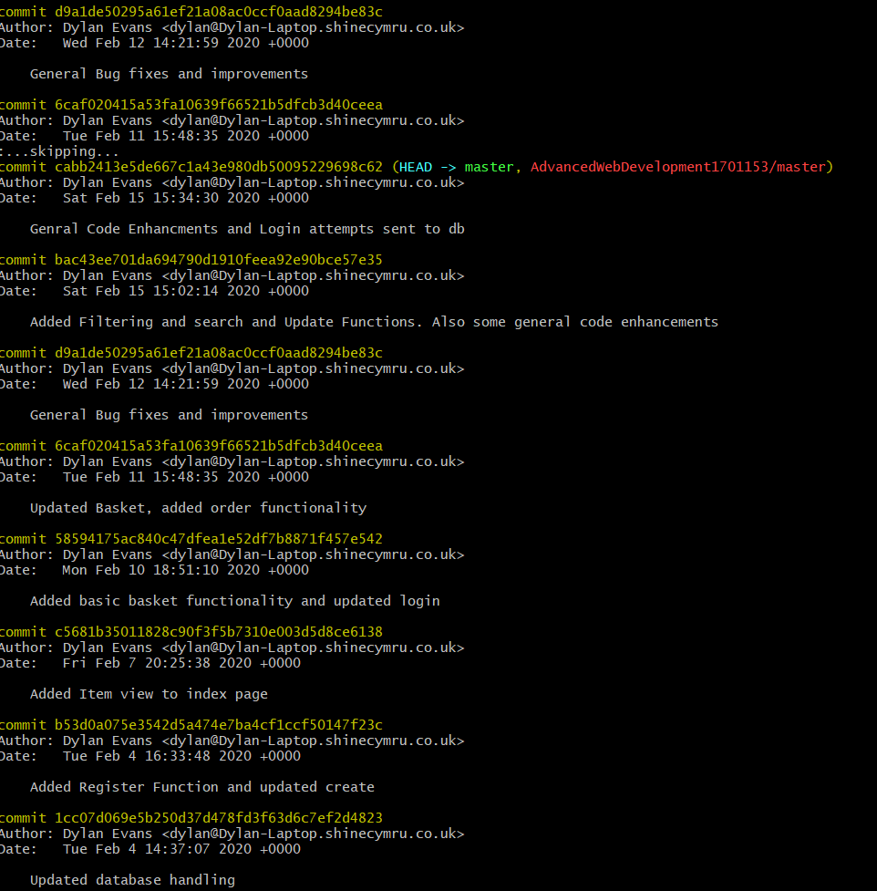
Above is evidence of the author using git via the git command “git log” the log shows all the commits that the author has made to the version control system GitHub.

Conclusion
To conclude version control is very important within the software development process and is used in order to keep track of any changes made and is very useful in finding what recent additions to code have caused errors and potentially stopped a project from working. The author believes that his system meets the user stories.

4.0 References
[1] F. F. Blauw, “The Use of Git as Version Control in the South African Software Engineering Classroom,” in 2018 IST-Africa Week Conference (IST-Africa), 2018, p. Page 1 of 8-Page 8 of 8.

Appendix (Code Listings)
Code listings are also available at https://github.com/dylanevs/AdvancedWebDevelopment1701153

4.1 BasketAdd.php
<?php
// Includes
require_once("DatabaseHandling.php");
require_once("BasketItem.php");
use Shop\DatabaseHandling\DatabaseHandling;
use Shop\BasketItem\BasketItem;

session_start(); // Opens the session for use
$dbhandle = new DatabaseHandling();
$Item = $_GET["itemID"];
$basketItem[] = new BasketItem($Item,$_SESSION["userID"]); // Creates a new basket item for the currently signed in user
$basketItem[0]->AddToBasket($dbhandle); // Adds item to basket table in database.
echo("added to basket returning to index in 5 seconds.... </br> <a href='index.php'>Redirect Now</a>");
header( "Refresh:5; url=index.php", true, 303); // Waits 5 seconds and redirects to index

?>

4.2 BasketItem.php
<?php

namespace Shop\BasketItem;

class BasketItem
{
// Atributes
private $_ID;
private $_Item;
private $_TotalCost;
private $_UserID;

// Constructor
public function __construct($Item,$UserID)
{
$this->_Item = $Item;
$this->_UserID = $UserID;
}

// Methods for properties
public function GetUserID()
{
return $this->_UserID;
}
public function SetUserID($val)
{
$this->_UserID = $val;
}

public function GetItem()
{
return $this->_Item;
}
public function SetItem($val)
{
$this->_Item = $val;
}

// Methods
public function AddToBasket($dbhandle)
{
$dbhandle->AddToBasket($this->_Item, $this->_UserID);
}
public function CalculateTax($totalCost)
{
// Calculates the VAT based upon vat being 0.15
$VAT = 0.15;
return $VAT * $totalCost;
}
}

?>

4.3 ClearBasket.php
<?php
require_once("DatabaseHandling.php");
use Shop\DatabaseHandling\DatabaseHandling;
$dbhandle = new DatabaseHandling();
session_start(); // Opens the session for use
$dbhandle->ClearBasket($_SESSION["userID"]); // Clears the currently signed in users basket
header("Location: index.php"); // Redirects to index

4.4 Create.php
<?php
require_once("DatabaseHandling.php");
use \Shop\DatabaseHandling\DatabaseHandling;

if( isset($_POST['submit']) )
{
// Once submit is pressed post variables will be set to variables
$itemName = htmlentities($_POST['itemName']);
$category = htmlentities($_POST['category']);
$price = htmlentities($_POST['price']);
$description = htmlentities($_POST['description']);
$dbhandle = new DatabaseHandling();
$dbhandle->create($itemName,$category,$price,$description); // item from user entered form added to database
header("location:index.php");
}
?>
<html>
<head>
<script src="https://code.jquery.com/jquery-3.3.1.slim.min.js" integrity="sha384-q8i/X+965DzO0rT7abK41JStQIAqVgRVzpbzo5smXKp4YfRvH+8abtTE1Pi6jizo" crossorigin="anonymous"></script>
<script src="https://cdnjs.cloudflare.com/ajax/libs/popper.js/1.14.7/umd/popper.min.js" integrity="sha384-UO2eT0CpHqdSJQ6hJty5KVphtPhzWj9WO1clHTMGa3JDZwrnQq4sF86dIHNDz0W1" crossorigin="anonymous"></script>
<link rel="stylesheet" href="styles.css">
<link rel="stylesheet" href="https://stackpath.bootstrapcdn.com/bootstrap/4.3.1/css/bootstrap.min.css" integrity="sha384-ggOyR0iXCbMQv3Xipma34MD+dH/1fQ784/j6cY/iJTQUOhcWr7x9JvoRxT2MZw1T" crossorigin="anonymous">
<script src="https://stackpath.bootstrapcdn.com/bootstrap/4.3.1/js/bootstrap.min.js" integrity="sha384-JjSmVgyd0p3pXB1rRibZUAYoIIy6OrQ6VrjIEaFf/nJGzIxFDsf4x0xIM+B07jRM" crossorigin="anonymous"></script>
<?php include("nav.php");?>
</head>
<body>
</br>
<form action="" method="POST">
Item Name:
<input type="text" name="itemName" id="itemName"></input>

<br></br>
Category:
<select id="category" name="category">
<option value="Grocery">Grocery</option>
<option value="Frozen">Frozen</option>
<option value="Bakery">Bakery</option>
<option value="Drinks">Drinks</option>
<option value="Ambient">Ambient</option>
</select>

<br></br>
Price:
<input type="text" name="price" id="price"></input>
<br></br>
Description:
<input type="text" name="description" id="description"></input>
<br></br>

<br></br>

<input type="submit" name="submit" value="submit"></input>
</form>
</body>
</html>

4.5 DatabaseHandling.php
<?php
namespace Shop\DatabaseHandling;
require_once "IDatabaseHandling.php";
use \PDO;
class DatabaseHandling implements IDatabaseHandling
{
// Attributes
private $_DSN="mysql:host=localhost;dbname=shop";//server name
private $_user="root"; //server username
private $_password=""; //server password
private $_pdoLink;

// Constructor
public function __construct()
{
$this->_pdoLink = new PDO($this->_DSN,$this->_user,$this->_password); // Initialises the link to the db using PDO
}

// Methods for properties

// Methods

public function Create($itemName,$category,$price,$description)
{
$stmt = $this->_pdoLink->prepare("INSERT INTO item(itemName,category,price,description) VALUES (:itemName, :category, :price, :description)");
$stmt->bindParam(':itemName', $itemName, PDO::PARAM_STR,50);
$stmt->bindParam(':category',$category, PDO::PARAM_STR, 50);
$stmt->bindParam(':price',$price, PDO::PARAM_STR);
$stmt->bindParam(':description',$description, PDO::PARAM_STR,100); // Checks query for SQL injection then runs query
$stmt->execute();
}
public function Update($itemID,$itemName,$category,$price,$description)
{
$stmt = $this->_pdoLink->prepare("UPDATE item set itemName=:itemName, category=:category,price=:price,description=:description WHERE ID=:itemID");
$stmt->bindParam(':itemName', $itemName, PDO::PARAM_STR,50);
$stmt->bindParam(':category',$category, PDO::PARAM_STR, 50);
$stmt->bindParam(':price',$price, PDO::PARAM_STR);
$stmt->bindParam(':description',$description, PDO::PARAM_STR,100);
$stmt->bindParam(':itemID',$itemID,PDO::PARAM_INT); // Checks query for SQL injection then runs query
$stmt->execute();
}
public function ViewItem($itemID)
{
$stmt = $this->_pdoLink->prepare("SELECT * FROM item WHERE ID LIKE :itemID");
$stmt->bindParam(':itemID', $itemID, PDO::PARAM_INT);
$stmt->execute(); // Checks query for SQL injection then runs query
return $stmt;

}
public function Select($requestedTable)
{
$stmt = $this->_pdoLink->prepare("SELECT * FROM $requestedTable");
$stmt->execute();
return $stmt; // Selects all from user requested table

}
public function Search($itemName)
{
$stmt = $this->_pdoLink->prepare("SELECT * FROM item WHERE itemName LIKE :itemName");
$stmt->bindParam(':itemName', $itemName, PDO::PARAM_STR,100);
$stmt->execute(); // Checks query for SQL injection then runs query
return $stmt;
}
public function Filter($itemCategory)
{
$stmt = $this->_pdoLink->prepare("SELECT * FROM item WHERE category LIKE :itemCategory");
$stmt->bindParam(':itemCategory', $itemCategory, PDO::PARAM_STR,100);
$stmt->execute(); // Checks query for SQL injection then runs query
return $stmt;
}
public function SearchBasket($UserID)
{
$stmt = $this->_pdoLink->prepare("SELECT * FROM basket WHERE UserID LIKE :userID");
$stmt->bindParam(':userID', $UserID, PDO::PARAM_INT);
$stmt->execute(); // Checks query for SQL injection then runs query
return $stmt;
}

public function Delete($id)
{
$stmt = $this->_pdoLink->prepare("DELETE FROM item WHERE ID = :id");
$stmt->bindParam(':id', $id, PDO::PARAM_INT); // Checks query for SQL injection then runs query
$stmt->execute();
}
public function ClearBasket($UserID)
{
$stmt = $this->_pdoLink->prepare("DELETE FROM basket WHERE userID = :id");
$stmt->bindParam(':id', $UserID, PDO::PARAM_INT); // Checks query for SQL injection then runs query
$stmt->execute();
}

public function AddUser($firstName,$surname,$phoneNumber,$email,$password,$addressLine1,$town,$city,$postcode,$cardNumber,$cvc,$cardExpiry)
{

$stmt = $this->_pdoLink->prepare("INSERT INTO user
(firstName,surname,phoneNumber,email,password,addressLineOne,town,city,postcode,cardNumber,cvc,cardExpiry)
VALUES (:firstName,:surname,:phoneNumber,:email,:password,:addressLineOne,:town,:city,:postcode,:cardNumber,:cvc,:cardExpiry)");
$stmt->bindParam(':firstName', $firstName, PDO::PARAM_STR,50);
$stmt->bindParam(':surname',$surname, PDO::PARAM_STR, 50);
$stmt->bindParam(':phoneNumber',$phoneNumber, PDO::PARAM_STR,50);
$stmt->bindParam(':email',$email, PDO::PARAM_STR,50);
$stmt->bindParam(':password',$password, PDO::PARAM_STR,50);
$stmt->bindParam(':addressLineOne',$addressLine1, PDO::PARAM_STR,50);
$stmt->bindParam(':town',$town, PDO::PARAM_STR,50);
$stmt->bindParam(':city',$city, PDO::PARAM_STR,50);
$stmt->bindParam(':postcode',$postcode, PDO::PARAM_STR,50);
$stmt->bindParam(':cardNumber',$cvc, PDO::PARAM_STR,16);
$stmt->bindParam(':cvc',$cvc, PDO::PARAM_STR,50);
$stmt->bindParam(':cardExpiry',$cardExpiry, PDO::PARAM_STR,50);
$stmt->execute(); // Checks query for SQL injection then runs query
}
public function AddToBasket($item,$UserID)
{
$stmt = $this->_pdoLink->prepare("INSERT INTO basket (item,userID) VALUES (:item,:userID)");
$stmt->bindParam(':item',$item,PDO::PARAM_INT);
$stmt->bindParam(':userID',$UserID,PDO::PARAM_INT);
$stmt->execute(); // Checks query for SQL injection then runs query
}
public function CheckLogin($email,$password)
{
$stmt = $this->_pdoLink->prepare("SELECT * FROM user WHERE email LIKE :email and password like :password");
$stmt->bindParam(':email', $email, PDO::PARAM_STR,50);
$stmt->bindParam(':password', $password, PDO::PARAM_STR,50);
$stmt->execute();// Checks query for SQL injection then runs query
if ($stmt->rowCount() > 0)
{
// If user exists in table then return user details to be added to session variables
return $stmt;
}
else
{
// User does not exist or password entered incorectly
return false;
}
}
public function CreateOrder($UserID,$totalCost,$deliveryDate)
{
$CurrentBasketItems = $this->SearchBasket($UserID); // Gets basket items in users basket
$itemArray = array();
foreach ($CurrentBasketItems as $row)
{
$itemArray[] = $row["item"]; // Adds all items in users basket to an array
}
$items = implode(', ', $itemArray); // Converts item array to string
$trackingNumber = ("SW". rand() . "GB"); // Generates random tracking number
$stmt = $this->_pdoLink->prepare("INSERT INTO orders(userID,items,deliveryDate,totalCost,trackingNo) VALUES (:userID,:items,:deliveryDate,:totalCost,:trackingNo)");
$stmt->bindParam(':userID', $UserID, PDO::PARAM_INT);
$stmt->bindParam(':items',$items, PDO::PARAM_STR, 50);
$stmt->bindParam(':deliveryDate',$deliveryDate, PDO::PARAM_STR);
$stmt->bindParam(':totalCost',$totalCost, PDO::PARAM_STR,100);
$stmt->bindParam(':trackingNo',$trackingNumber, PDO::PARAM_STR,100); // Checks query for SQL injection then runs query
$stmt->execute();
}

public function ViewOrders($UserID)
{
$stmt = $this->_pdoLink->prepare("SELECT * FROM orders WHERE UserID LIKE :userID");
$stmt->bindParam(':userID', $UserID, PDO::PARAM_INT);
$stmt->execute(); // Checks query for SQL injection then runs query
return $stmt;
}
public function LogData($Search,$UserID)
{
$stmt = $this->_pdoLink->prepare("INSERT INTO loggedSearches (userID,searchTerm) VALUES (:userID,:searchTerm)");
$stmt->bindParam(':userID',$UserID,PDO::PARAM_INT);
$stmt->bindParam(':searchTerm',$Search,PDO::PARAM_STR,100); // Checks query for SQL injection then runs query
$stmt->execute();
}
public function LogLogin($username, $trueFalse)
{
$stmt = $this->_pdoLink->prepare("INSERT INTO loggedLogins (username,loginSuccesful) VALUES (:username,:trueFalse)");
$stmt->bindParam(':username',$username,PDO::PARAM_STR);
$stmt->bindParam(':trueFalse',$trueFalse,PDO::PARAM_INT);
$stmt->execute();// Checks query for SQL injection then runs query
}
}

?>

4.6 Delete.php
<?php
namespace Shop\Delete;
require_once("DatabaseHandling.php");
use Shop\DatabaseHandling\DatabaseHandling;

$dbhandle = new DatabaseHandling();

$dbhandle->Delete("1");
?>

4.7 deleteItem.php
<?php
require_once("DatabaseHandling.php");
use \Shop\DatabaseHandling\DatabaseHandling;
$dbhandle = new DatabaseHandling();
$dbhandle->Delete($_GET["itemID"]);
header("location:index.php");
?>

4.8 Filter.php
<?php
namespace Shop\Search;
require_once("DatabaseHandling.php");
use Shop\DatabaseHandling\DatabaseHandling;
$dbhandle = new DatabaseHandling();
?>
<html>
<head>
<script src="https://code.jquery.com/jquery-3.3.1.slim.min.js" integrity="sha384-q8i/X+965DzO0rT7abK41JStQIAqVgRVzpbzo5smXKp4YfRvH+8abtTE1Pi6jizo" crossorigin="anonymous"></script>
<script src="https://cdnjs.cloudflare.com/ajax/libs/popper.js/1.14.7/umd/popper.min.js" integrity="sha384-UO2eT0CpHqdSJQ6hJty5KVphtPhzWj9WO1clHTMGa3JDZwrnQq4sF86dIHNDz0W1" crossorigin="anonymous"></script>
<link rel="stylesheet" href="styles.css">
<link rel="stylesheet" href="https://stackpath.bootstrapcdn.com/bootstrap/4.3.1/css/bootstrap.min.css" integrity="sha384-ggOyR0iXCbMQv3Xipma34MD+dH/1fQ784/j6cY/iJTQUOhcWr7x9JvoRxT2MZw1T" crossorigin="anonymous">
<script src="https://stackpath.bootstrapcdn.com/bootstrap/4.3.1/js/bootstrap.min.js" integrity="sha384-JjSmVgyd0p3pXB1rRibZUAYoIIy6OrQ6VrjIEaFf/nJGzIxFDsf4x0xIM+B07jRM" crossorigin="anonymous"></script>
<?php include("nav.php");?>
</head>
<body>
<?php
$stmt = $dbhandle->Filter($_GET["itemFilter"]);
if ($stmt->rowCount() > 0)
{
foreach($stmt as $row)
{
?>
<ul class="list-unstyled">
<li class="media my-4">
<img class="mr-3" src="img/bread.jpeg" alt="Bread" width="100vw" height="100vh">
<div class="media-body">
<h5 class="mt-0 mb-1"><a href="viewItem.php?itemID=<?php echo $row["ID"];?>"><?php echo ($row["itemName"]);?></a></h5>
<?php echo ($row["price"]);?>
</div>
</li>
</ul>
<?php }}
else
{
echo("No items found using that search term <a href='index.php'>Return Home</a>");
}
?>
</body>
</html>

4.9 IDatabaseHandling.php
<?php
namespace Shop\DatabaseHandling;
interface IDatabaseHandling
{

public function Create($itemName,$category,$price,$description);

public function Update($itemID,$itemName,$category,$price,$description);

public function ViewItem($itemID);

public function Select($requestedTable);

public function Search($itemName);

public function Filter($itemCategory);

public function SearchBasket($UserID);

public function Delete($id);

public function ClearBasket($UserID);

public function AddUser($firstName,$surname,$phoneNumber,$email,$password,$addressLine1,$town,$city,$postcode,$cardNumber,$cvc,$cardExpiry);

public function AddToBasket($item,$UserID);

public function CheckLogin($email,$password);

public function CreateOrder($UserID,$totalCost,$deliveryDate);

public function ViewOrders($UserID);

public function LogData($Search,$UserID);

public function LogLogin($username, $trueFalse);
}

4.10 Index.php
<?php
require_once("DatabaseHandling.php");
use Shop\DatabaseHandling\DatabaseHandling;

$dbhandle = new DatabaseHandling();
$stmt = $dbhandle->Select("item");

?>

<html>
<head>
<script src="https://code.jquery.com/jquery-3.3.1.slim.min.js" integrity="sha384-q8i/X+965DzO0rT7abK41JStQIAqVgRVzpbzo5smXKp4YfRvH+8abtTE1Pi6jizo" crossorigin="anonymous"></script>
<script src="https://cdnjs.cloudflare.com/ajax/libs/popper.js/1.14.7/umd/popper.min.js" integrity="sha384-UO2eT0CpHqdSJQ6hJty5KVphtPhzWj9WO1clHTMGa3JDZwrnQq4sF86dIHNDz0W1" crossorigin="anonymous"></script>
<link rel="stylesheet" href="styles.css">
<link rel="stylesheet" href="https://stackpath.bootstrapcdn.com/bootstrap/4.3.1/css/bootstrap.min.css" integrity="sha384-ggOyR0iXCbMQv3Xipma34MD+dH/1fQ784/j6cY/iJTQUOhcWr7x9JvoRxT2MZw1T" crossorigin="anonymous">
<script src="https://stackpath.bootstrapcdn.com/bootstrap/4.3.1/js/bootstrap.min.js" integrity="sha384-JjSmVgyd0p3pXB1rRibZUAYoIIy6OrQ6VrjIEaFf/nJGzIxFDsf4x0xIM+B07jRM" crossorigin="anonymous"></script>
<?php include("nav.php");?>
</head>

<body>
<h1 style = "text-align:center">Welcome to the Tuckshop</h1>
<?php
if(@$_SESSION["userID"] == 1)
{?>
<a class="btn btn-primary" href="create.php" role="button">Create Item</a>

<?php
}
$itemCount = 0;
echo("<div class='row'>");
echo("<div class='card-deck-wrapper'>");
echo("<div class='card-deck'>");?>
<?php foreach ($stmt as $row) {?>
<div class="card m-3" style="width: 18rem;">
<img src="img/bread.jpeg" class="card-img-top" alt="...">
<div class="card-body">
<h5 class="card-title"><?php echo $row["itemName"]?></h5>
<p class="card-text"><?php echo $row["description"]?></p>
</div>
<ul class="list-group list-group-flush">
<li class="list-group-item"><?php echo $row["category"]?></li>
<li class="list-group-item"><?php echo $row["price"]?></li>
</ul>
<div class="card-body">
<?php if(@$_SESSION["username"]){?>
<a href="basketAdd.php?itemID=<?php echo $row["ID"];?>" class="card-link">Add to basket</a>
<?php }
else{
echo("Please login to add to basket");
}?>
<?php
// Checks to see if user has ID 1 (admin)
if(@$_SESSION["userID"] == 1){?>
<a href="updateItem.php?itemID=<?php echo $row["ID"];?>" class="card-link">Update Item</a>
</br>
<a href="deleteItem.php?itemID=<?php echo $row["ID"];?>" class="card-link">Delete Item</a>
<?php }?>
</div>
</div>
<?php $itemCount++;
if($itemCount >=5)
{
echo("</div>");
echo("</div>");
echo("<div class='card-deck-wrapper'>");
echo("<div class='card-deck'>");
$itemCount = 0;
}}?>
</div>
</div>
</div>
</body>

<footer>

</footer>
<html>

4.11 Login.php
<?php
require_once("DatabaseHandling.php");
use \Shop\DatabaseHandling\DatabaseHandling;

if( isset($_POST['submit']) )
{
$username = htmlentities($_POST['username']);
$password = htmlentities($_POST['password']);
$dbhandle = new DatabaseHandling();
$loginCheck = $dbhandle->checkLogin($username,$password);
if ($loginCheck != false)
{
session_start(); //accesses sesion
foreach ($loginCheck as $row)
{
$_SESSION["userID"]=$row["ID"];
$_SESSION["name"]=$row["firstName"] . " " . $row["surname"];
}
$_SESSION["username"]=$username; // Gets users username.
$dbhandle->LogLogin($_POST['username'],1);
header("Location: index.php");
}
else
{
$dbhandle->LogLogin($_POST['username'],0);
echo("Sorry incorrect username or password");
}
}
?>

<?php if( isset($result) ) echo $result; //print the result above the form ?>

<form action="" method="POST">
Username:
<input type="text" name="username" id="username"></input>

<br></br>
Password:
<input type="password" name="password" id="password"></input>

<br></br>

<input type="submit" name="submit" value="submit"></input>
</form>

4.12 Logout.php
<?php
session_start();
session_destroy();
header("location:index.php");
?>

4.13 nav.php
<?php
session_start();
$username = "";
if(@$_SESSION["username"])
{
$username = $_SESSION["username"];
$name = $_SESSION["name"];
}

?>
<nav class="navbar navbar-expand-lg navbar-light bg-light">
<a class="navbar-brand" href="#">The Tuckshop</a>
<button class="navbar-toggler" type="button" data-toggle="collapse" data-target="#navbarSupportedContent" aria-controls="navbarSupportedContent" aria-expanded="false" aria-label="Toggle navigation">
<span class="navbar-toggler-icon"></span>
</button>

<div class="collapse navbar-collapse" id="navbarSupportedContent">
<ul class="navbar-nav mr-auto">
<li class="nav-item">
<a class="nav-link" href="index.php">Home <span class="sr-only">(current)</span></a>
</li>
<li class="nav-item">
<a class="nav-link" href="viewBasket.php">Basket</a>
</li>
<li class="nav-item dropdown">
<a class="nav-link dropdown-toggle" href="#" id="navbarDropdown" role="button" data-toggle="dropdown" aria-haspopup="true" aria-expanded="false">
My Account
</a>
<div class="dropdown-menu" aria-labelledby="navbarDropdown">
<a class="dropdown-item" href="ViewOrders.php">Orders</a>
</div>
</li>
</ul>
<form class="form-inline my-2 my-lg-0" action="Search.php" method="POST">
<?php if ($username){?>
<p style="padding-right:10px;padding-top:10px;">Hello <?php echo(" ".$name);?></p>
<a class="nav-link" href='logout.php'>Logout</a>
<?php }else{?>
<a class="nav-link" href='Register.php'>Register</a>
<a class="nav-link" href='login.php'>Login</a>
<?php
}?>
<input class="form-control mr-sm-2" type="search" placeholder="Search" aria-label="Search" name="Search">
<div class="dropdown">
<button class="btn btn-secondary dropdown-toggle m-3" type="button" id="dropdownMenuButton" data-toggle="dropdown" aria-haspopup="true" aria-expanded="false">
Filter
</button>
<div class="dropdown-menu" aria-labelledby="dropdownMenuButton">
<a class="dropdown-item" href="Filter.php?itemFilter=Grocery">Grocery</a>
<a class="dropdown-item" href="Filter.php?itemFilter=Frozen">Frozen</a>
<a class="dropdown-item" href="Filter.php?itemFilter=Bakery">Bakery</a>
<a class="dropdown-item" href="Filter.php?itemFilter=Drinks">Drinks</a>
<a class="dropdown-item" href="Filter.php?itemFilter=Ambient">Ambient</a>
</div>
</div>
<input type="submit" class="btn btn-outline-success my-2 my-sm-0" name="submit" value="Search"></input>
</form>
</div>
</nav>

4.14 Order.php
<?php

namespace Shop\Order;

class Order
{
// Atributes
private $_ID;
private $_userID;
private $_items;
private $_deliveryDate;
private $_trackingNo;
private $_deliveryCost;
private $_totalCost;

// Constructor
public function __construct($userID,$totalCost,$deliveryDate)
{
$this->_userID = $userID;
$this->_totalCost = $totalCost;
$this->_deliveryDate = $deliveryDate;
$this->_totalCost = $this->CalculateTax($this->_totalCost) + $this->_totalCost;
}

// Methods for properties
public function GetUserID()
{
return $this->_UserID;
}
public function SetUserID($val)
{
$this->_UserID = $val;
}

public function GetItem()
{
return $this->_Item;
}
public function SetItem($val)
{
$this->_Item = $val;
}

// Methods
public function CreateOrder($dbhandle)
{
$dbhandle->CreateOrder($this->_userID,$this->_totalCost,$this->_deliveryDate);
}

public function ViewOrders($dbhandle,$userID)
{
return $dbhandle->ViewOrders($userID);
}
public function CalculateTax($totalCost)
{
$VAT = 0.15;
return $VAT * $totalCost;
}
}

?>

4.15 placeOrder.php
<?php
namespace Shop;
require_once("DatabaseHandling.php");
require_once("BasketItem.php");
require_once("Order.php");
use Shop\DatabaseHandling\DatabaseHandling;
use Shop\BasketItem\BasketItem;
use Shop\Order\Order;
?>
<html>
<head>
<script src="https://code.jquery.com/jquery-3.3.1.slim.min.js" integrity="sha384-q8i/X+965DzO0rT7abK41JStQIAqVgRVzpbzo5smXKp4YfRvH+8abtTE1Pi6jizo" crossorigin="anonymous"></script>
<script src="https://cdnjs.cloudflare.com/ajax/libs/popper.js/1.14.7/umd/popper.min.js" integrity="sha384-UO2eT0CpHqdSJQ6hJty5KVphtPhzWj9WO1clHTMGa3JDZwrnQq4sF86dIHNDz0W1" crossorigin="anonymous"></script>
<link rel="stylesheet" href="styles.css">
<link rel="stylesheet" href="https://stackpath.bootstrapcdn.com/bootstrap/4.3.1/css/bootstrap.min.css" integrity="sha384-ggOyR0iXCbMQv3Xipma34MD+dH/1fQ784/j6cY/iJTQUOhcWr7x9JvoRxT2MZw1T" crossorigin="anonymous">
<script src="https://stackpath.bootstrapcdn.com/bootstrap/4.3.1/js/bootstrap.min.js" integrity="sha384-JjSmVgyd0p3pXB1rRibZUAYoIIy6OrQ6VrjIEaFf/nJGzIxFDsf4x0xIM+B07jRM" crossorigin="anonymous"></script>
<?php
include("nav.php");
$dbhandle = new DatabaseHandling();
$stmt = $dbhandle->SearchBasket($_SESSION["userID"]);
$totalPrice = 0;
foreach ($stmt as $row)
{
$itemID = $row["item"];
$itemStmt = $dbhandle->ViewItem($itemID);
foreach($itemStmt as $row)
{
$totalPrice = $totalPrice + $row["price"];
}

}
$date = date("Y-m-d");
$deliveryDate = date('Y-m-d', strtotime($date. ' + 2 days'));
$Order = new Order($_SESSION["userID"],$totalPrice,$deliveryDate);
$vat = $Order->CalculateTax($totalPrice);
$totalCostIncludingVAT = $totalPrice + $vat;
$Order->CreateOrder($dbhandle);
$dbhandle->ClearBasket($_SESSION["userID"]);
echo("Order Placed Redirecting to Your Orders in 5 seconds.... </br> <a href='viewOrders.php'>Redirect Now</a>");
header( "Refresh:5; url=viewOrders.php", true, 303);

?>

4.16 Register.php
<?php
require_once("DatabaseHandling.php");
use \Shop\DatabaseHandling\DatabaseHandling;

if( isset($_POST['submit']) )
{
$firstName = htmlentities($_POST['firstName']);
$surname = htmlentities($_POST['surname']);
$phoneNumber = htmlentities($_POST['phoneNumber']);
$username = htmlentities($_POST['username']);
$password = htmlentities($_POST['password']);
$addressLine1 = htmlentities($_POST['addressLine1']);
$town = htmlentities($_POST['town']);
$city = htmlentities($_POST['city']);
$postcode = htmlentities($_POST['postcode']);
$cardNumber = htmlentities($_POST['cardNumber']);
$cvc = htmlentities($_POST['cvc']);
$cardExpiry = htmlentities($_POST['cardExpiry']);
$db = new DatabaseHandling();
$db->AddUser($firstName,$surname,$phoneNumber,$username,$password,$addressLine1,$town,$city,$postcode,$cardNumber,$cvc,$cardExpiry);
header("Location:Login.php");
}
?>

<?php if( isset($result) ) echo $result; //print the result above the form ?>

<form action="" method="POST">
First Name:
<input type="text" name="firstName" id="firstName"></input>

<br></br>
Surname:
<input type="text" name="surname" id="surname"></input>

<br></br>
Phone Number:
<input type="text" name="phoneNumber" id="phoneNumber"></input>

<br></br>
Username(Email):
<input type="text" name="username" id="username"></input>

<br></br>
Password:
<input type="password" name="password" id="password"></input>

<br></br>
Address Line 1:
<input type="text" name="addressLine1" id="addressLine1"></input>

<br></br>
Town:
<input type="text" name="town" id="town"></input>

<br></br>
City:
<input type="text" name="city" id="city"></input>

<br></br>
Postcode:
<input type="text" name="postcode" id="postcode"></input>

<br></br>
Payment Card Number:
<input type="text" name="cardNumber" id="cardNumber"></input>

<br></br>
Payment Card CVC:
<input type="text" name="cvc" id="cvc"></input>

<br></br>
Payment Card Expiry:
<input type="date" name="cardExpiry" id="cardExpiry"></input>

<br></br>

<input type="submit" name="submit" value="submit"></input>
</form>

4.17 Search.php
<?php
namespace Shop\Search;
require_once("DatabaseHandling.php");
use Shop\DatabaseHandling\DatabaseHandling;
$dbhandle = new DatabaseHandling();
?>
<html>
<head>
<script src="https://code.jquery.com/jquery-3.3.1.slim.min.js" integrity="sha384-q8i/X+965DzO0rT7abK41JStQIAqVgRVzpbzo5smXKp4YfRvH+8abtTE1Pi6jizo" crossorigin="anonymous"></script>
<script src="https://cdnjs.cloudflare.com/ajax/libs/popper.js/1.14.7/umd/popper.min.js" integrity="sha384-UO2eT0CpHqdSJQ6hJty5KVphtPhzWj9WO1clHTMGa3JDZwrnQq4sF86dIHNDz0W1" crossorigin="anonymous"></script>
<link rel="stylesheet" href="styles.css">
<link rel="stylesheet" href="https://stackpath.bootstrapcdn.com/bootstrap/4.3.1/css/bootstrap.min.css" integrity="sha384-ggOyR0iXCbMQv3Xipma34MD+dH/1fQ784/j6cY/iJTQUOhcWr7x9JvoRxT2MZw1T" crossorigin="anonymous">
<script src="https://stackpath.bootstrapcdn.com/bootstrap/4.3.1/js/bootstrap.min.js" integrity="sha384-JjSmVgyd0p3pXB1rRibZUAYoIIy6OrQ6VrjIEaFf/nJGzIxFDsf4x0xIM+B07jRM" crossorigin="anonymous"></script>
<?php include("nav.php");?>
</head>
<body>
<?php
$stmt = $dbhandle->Search("%".$_POST["Search"]."%");
if(@$_SESSION["userID"])
{
$dbhandle->LogData($_POST["Search"],$_SESSION["userID"]);
}
else
{
$dbhandle->LogData($_POST["Search"],0);
}
if ($stmt->rowCount() > 0)
{
foreach($stmt as $row)
{
?>
<ul class="list-unstyled">
<li class="media my-4">
<img class="mr-3" src="img/bread.jpeg" alt="Bread" width="100vw" height="100vh">
<div class="media-body">
<h5 class="mt-0 mb-1"><a href="viewItem.php?itemID=<?php echo $row["ID"];?>"><?php echo ($row["itemName"]);?></a></h5>
<?php echo ($row["price"]);?>
</div>
</li>
</ul>
<?php }}
else
{
echo("No items found using that search term <a href='index.php'>Return Home</a>");
}
?>
</body>
</html>

4.18 updateItem.php
<?php
require_once("DatabaseHandling.php");
use \Shop\DatabaseHandling\DatabaseHandling;
$dbhandle = new DatabaseHandling();
$item = $dbhandle->ViewItem($_GET["itemID"]);

if( isset($_POST['submit']) )
{
$itemName = htmlentities($_POST['itemName']);
$category = htmlentities($_POST['category']);
$price = htmlentities($_POST['price']);
$description = htmlentities($_POST['description']);
$dbhandle = new DatabaseHandling();
$dbhandle->Update($_GET["itemID"],$itemName,$category,$price,$description);
header("location:index.php");
}
?>
<html>
<head>
<script src="https://code.jquery.com/jquery-3.3.1.slim.min.js" integrity="sha384-q8i/X+965DzO0rT7abK41JStQIAqVgRVzpbzo5smXKp4YfRvH+8abtTE1Pi6jizo" crossorigin="anonymous"></script>
<script src="https://cdnjs.cloudflare.com/ajax/libs/popper.js/1.14.7/umd/popper.min.js" integrity="sha384-UO2eT0CpHqdSJQ6hJty5KVphtPhzWj9WO1clHTMGa3JDZwrnQq4sF86dIHNDz0W1" crossorigin="anonymous"></script>
<link rel="stylesheet" href="styles.css">
<link rel="stylesheet" href="https://stackpath.bootstrapcdn.com/bootstrap/4.3.1/css/bootstrap.min.css" integrity="sha384-ggOyR0iXCbMQv3Xipma34MD+dH/1fQ784/j6cY/iJTQUOhcWr7x9JvoRxT2MZw1T" crossorigin="anonymous">
<script src="https://stackpath.bootstrapcdn.com/bootstrap/4.3.1/js/bootstrap.min.js" integrity="sha384-JjSmVgyd0p3pXB1rRibZUAYoIIy6OrQ6VrjIEaFf/nJGzIxFDsf4x0xIM+B07jRM" crossorigin="anonymous"></script>
<?php include("nav.php");?>
</head>
<body>
</br>
<?php foreach($item as $row){?>
<form action="" method="POST">
Item Name:
<input type="text" name="itemName" id="itemName" value="<?php echo $row["itemName"];?>"></input>

<br></br>
Category:
<input type="text" name="category" id="category"value="<?php echo $row["category"];?>"></input>

<br></br>
Price:
<input type="text" name="price" id="price"value="<?php echo $row["price"];?>"></input>
<br></br>
Description:
<input type="textarea" name="description" id="description"value="<?php echo $row["description"];?>"></input>

<br></br>

<br></br>

<input type="submit" name="submit" value="submit"></input>
</form>
<?php }?>
</body>
</html>

4.19 ViewBasket.php
<?php
require_once("DatabaseHandling.php");
require_once("BasketItem.php");
require_once("Order.php");
use Shop\DatabaseHandling\DatabaseHandling;
use Shop\BasketItem\BasketItem;
use Shop\Order\Order;
$dbhandle = new DatabaseHandling();
?>
<html>
<head>
<script src="https://code.jquery.com/jquery-3.3.1.slim.min.js" integrity="sha384-q8i/X+965DzO0rT7abK41JStQIAqVgRVzpbzo5smXKp4YfRvH+8abtTE1Pi6jizo" crossorigin="anonymous"></script>
<script src="https://cdnjs.cloudflare.com/ajax/libs/popper.js/1.14.7/umd/popper.min.js" integrity="sha384-UO2eT0CpHqdSJQ6hJty5KVphtPhzWj9WO1clHTMGa3JDZwrnQq4sF86dIHNDz0W1" crossorigin="anonymous"></script>
<link rel="stylesheet" href="styles.css">
<link rel="stylesheet" href="https://stackpath.bootstrapcdn.com/bootstrap/4.3.1/css/bootstrap.min.css" integrity="sha384-ggOyR0iXCbMQv3Xipma34MD+dH/1fQ784/j6cY/iJTQUOhcWr7x9JvoRxT2MZw1T" crossorigin="anonymous">
<script src="https://stackpath.bootstrapcdn.com/bootstrap/4.3.1/js/bootstrap.min.js" integrity="sha384-JjSmVgyd0p3pXB1rRibZUAYoIIy6OrQ6VrjIEaFf/nJGzIxFDsf4x0xIM+B07jRM" crossorigin="anonymous"></script>
<?php include("nav.php");?>
</head>
<?php
if(@$_SESSION["userID"])
{
$stmt = $dbhandle->SearchBasket($_SESSION["userID"]);
$totalPrice = 0;
if ($stmt->rowCount() > 0)
{

foreach ($stmt as $row)
{
$itemID = $row["item"];
$itemStmt = $dbhandle->ViewItem($itemID);
foreach($itemStmt as $row)
{
$totalPrice = $totalPrice + $row["price"];
?>
<ul class="list-unstyled">
<li class="media my-4">
<img class="mr-3" src="img/bread.jpeg" alt="Bread" width="100vw" height="100vh">
<div class="media-body">
<h5 class="mt-0 mb-1"><a href="viewItem.php?itemID=<?php echo $row["ID"];?>"><?php echo ($row["itemName"]);?></a></h5>
<?php echo ($row["price"]);
?>
</div>
</li>
</ul>
<?php }

}
$basket = new BasketItem(null,null);
$vat = $basket->CalculateTax($totalPrice);
echo ("VAT: " .sprintf('%0.2f',$vat));
echo ("</br>");
echo ("Total item Cost: ".sprintf('%0.2f',$totalPrice));
echo ("</br>");
$totalCostIncludingVAT = $totalPrice + $vat;
echo ("Total item Cost including VAT: ".sprintf('%0.2f',$totalCostIncludingVAT));
echo("</br");
?>
<body>
<a class="btn btn-primary" href="placeOrder.php" role="button">Place Order</a>
<a class="btn btn-danger" href="ClearBasket.php" role="button">Clear Basket</a>
<?php
}
else
{
echo("Your basket is empty <a href='index.php'>Return Home</a>");
}
}
else
{
echo ("Please login before trying to view your basket <a href='login.php'>Login here</a>");
}
?>
</body>
</html>

4.20 ViewItem.php
<?php
require_once("DatabaseHandling.php");
use Shop\DatabaseHandling\DatabaseHandling;
$dbhandle = new DatabaseHandling();
$itemID = $_GET["itemID"];
$item = $dbhandle->ViewItem($itemID);?>
<html>
<head>
<script src="https://code.jquery.com/jquery-3.3.1.slim.min.js" integrity="sha384-q8i/X+965DzO0rT7abK41JStQIAqVgRVzpbzo5smXKp4YfRvH+8abtTE1Pi6jizo" crossorigin="anonymous"></script>
<script src="https://cdnjs.cloudflare.com/ajax/libs/popper.js/1.14.7/umd/popper.min.js" integrity="sha384-UO2eT0CpHqdSJQ6hJty5KVphtPhzWj9WO1clHTMGa3JDZwrnQq4sF86dIHNDz0W1" crossorigin="anonymous"></script>
<link rel="stylesheet" href="styles.css">
<link rel="stylesheet" href="https://stackpath.bootstrapcdn.com/bootstrap/4.3.1/css/bootstrap.min.css" integrity="sha384-ggOyR0iXCbMQv3Xipma34MD+dH/1fQ784/j6cY/iJTQUOhcWr7x9JvoRxT2MZw1T" crossorigin="anonymous">
<script src="https://stackpath.bootstrapcdn.com/bootstrap/4.3.1/js/bootstrap.min.js" integrity="sha384-JjSmVgyd0p3pXB1rRibZUAYoIIy6OrQ6VrjIEaFf/nJGzIxFDsf4x0xIM+B07jRM" crossorigin="anonymous"></script>
<?php include("nav.php");?>
</head>
<?php
foreach($item as $row)
{
?>
<div class="card mb-3" style="max-width: 540px;">
<div class="row no-gutters">
<div class="col-md-4">
<img src="img/bread.jpeg" class="card-img" alt="Bread">
</div>
<div class="col-md-8">
<div class="card-body">
<h5 class="card-title"><?php echo ($row["itemName"]);?></h5>
<p class="card-text"><?php echo ($row["description"]);?></p>
<p class="card-text"><small class="text-muted"></small><?php echo ($row["price"]);?></p>
</div>
</div>
</div>
</div>
<a href='index.php'>Return Home</a>

<?php }
?>

4.21 ViewOrders.php
<?php
namespace Shop;
require_once("DatabaseHandling.php");
require_once("Order.php");
use Shop\DatabaseHandling\DatabaseHandling;
use Shop\Order\Order;
?>
<html>
<head>
<script src="https://code.jquery.com/jquery-3.3.1.slim.min.js" integrity="sha384-q8i/X+965DzO0rT7abK41JStQIAqVgRVzpbzo5smXKp4YfRvH+8abtTE1Pi6jizo" crossorigin="anonymous"></script>
<script src="https://cdnjs.cloudflare.com/ajax/libs/popper.js/1.14.7/umd/popper.min.js" integrity="sha384-UO2eT0CpHqdSJQ6hJty5KVphtPhzWj9WO1clHTMGa3JDZwrnQq4sF86dIHNDz0W1" crossorigin="anonymous"></script>
<link rel="stylesheet" href="styles.css">
<link rel="stylesheet" href="https://stackpath.bootstrapcdn.com/bootstrap/4.3.1/css/bootstrap.min.css" integrity="sha384-ggOyR0iXCbMQv3Xipma34MD+dH/1fQ784/j6cY/iJTQUOhcWr7x9JvoRxT2MZw1T" crossorigin="anonymous">
<script src="https://stackpath.bootstrapcdn.com/bootstrap/4.3.1/js/bootstrap.min.js" integrity="sha384-JjSmVgyd0p3pXB1rRibZUAYoIIy6OrQ6VrjIEaFf/nJGzIxFDsf4x0xIM+B07jRM" crossorigin="anonymous"></script>
<?php
include("nav.php");
$dbhandle = new DatabaseHandling();
if(@$_SESSION["userID"])
{

$Order = new Order(null,null,null);

$Orders = $Order->ViewOrders($dbhandle,$_SESSION["userID"]);
?>
<table class="table">
<thead class="thead-dark">
<tr>
<th scope="col">Order #</th>
<th scope="col">Items</th>
<th scope="col">Delivery Date</th>
<th scope="col">Tracking No</th>
<th scope="col">Order Date</th>
<th scope="col">Total Cost</th>
</tr>
</thead>
<tbody>
<?php
foreach ($Orders as $row)
{
$itemArray = explode(',', $row['items']);
?>
<tr>
<th scope="row"><?php echo($row['ID'])?></th>
<td>
<?php
foreach($itemArray as $item)
{
$itemStmt = $dbhandle->ViewItem($item);
foreach($itemStmt as $itemRow)
{
echo ($itemRow["itemName"] . " </br>");
}
}
?>
</td>
<td><?php echo($row['deliveryDate'])?></td>
<td><?php echo($row['trackingNo'])?></td>
<td><?php echo($row['orderDate'])?></td>
<td><?php echo($row['totalCost'])?></td>
</tr>
<tr>

<?php } ?>
</tbody>
</table>
<?php
}
else
{
echo ("Please login before trying to view your orders <a href='login.php'>Login here</a>");
}

4.22 Database export in SQL
-- phpMyAdmin SQL Dump
-- version 4.9.2
-- https://www.phpmyadmin.net/
--
-- Host: 127.0.0.1:3306
-- Generation Time: Feb 18, 2020 at 05:54 PM
-- Server version: 10.4.10-MariaDB
-- PHP Version: 7.3.12

SET SQL_MODE = "NO_AUTO_VALUE_ON_ZERO";
SET AUTOCOMMIT = 0;
START TRANSACTION;
SET time_zone = "+00:00";

/*!40101 SET @OLD_CHARACTER_SET_CLIENT=@@CHARACTER_SET_CLIENT */;
/*!40101 SET @OLD_CHARACTER_SET_RESULTS=@@CHARACTER_SET_RESULTS */;
/*!40101 SET @OLD_COLLATION_CONNECTION=@@COLLATION_CONNECTION */;
/*!40101 SET NAMES utf8mb4 */;

--
-- Database: `shop`
--

-- --------------------------------------------------------

--
-- Table structure for table `basket`
--

DROP TABLE IF EXISTS `basket`;
CREATE TABLE IF NOT EXISTS `basket` (
`ID` int(11) NOT NULL AUTO_INCREMENT,
`item` varchar(100) NOT NULL,
`userID` int(11) NOT NULL,
PRIMARY KEY (`ID`)
) ENGINE=InnoDB AUTO_INCREMENT=13 DEFAULT CHARSET=latin1;

-- --------------------------------------------------------

--
-- Table structure for table `item`
--

DROP TABLE IF EXISTS `item`;
CREATE TABLE IF NOT EXISTS `item` (
`ID` int(11) NOT NULL AUTO_INCREMENT,
`itemName` varchar(50) NOT NULL,
`category` varchar(50) NOT NULL,
`price` decimal(7,2) NOT NULL,
`description` varchar(100) NOT NULL,
PRIMARY KEY (`ID`)
) ENGINE=MyISAM AUTO_INCREMENT=8 DEFAULT CHARSET=latin1;

--
-- Dumping data for table `item`
--

INSERT INTO `item` (`ID`, `itemName`, `category`, `price`, `description`) VALUES
(1, 'Noodles', 'Grocery', '1.00', 'Fresh noodles'),
(6, 'Chips', 'Frozen', '1.00', 'Chunky Cut Chips'),
(3, 'Bread', 'Bakery', '1.50', 'Freshly made bread from our bakery department'),
(4, 'Pepsi Max Cherry', 'Drinks', '0.85', 'Pepsi Max Cherry 330ml Can'),
(5, 'Raspberry Jam', 'Ambient', '1.00', 'Long Shelf Life Raspberry Jam in a Jar');

-- --------------------------------------------------------

--
-- Table structure for table `loggedlogins`
--

DROP TABLE IF EXISTS `loggedlogins`;
CREATE TABLE IF NOT EXISTS `loggedlogins` (
`ID` int(11) NOT NULL AUTO_INCREMENT,
`username` varchar(100) NOT NULL,
`loginSuccesful` tinyint(1) NOT NULL,
`timeOfLogin` datetime NOT NULL DEFAULT current_timestamp(),
PRIMARY KEY (`ID`)
) ENGINE=MyISAM AUTO_INCREMENT=14 DEFAULT CHARSET=latin1;

--
-- Dumping data for table `loggedlogins`
--

INSERT INTO `loggedlogins` (`ID`, `username`, `loginSuccesful`, `timeOfLogin`) VALUES
(1, 'user1@tuckshop.co.uk', 1, '2020-02-15 15:54:03'),
(2, 'user1@tuckshop.co.uk', 1, '2020-02-15 15:57:27'),
(3, 'admin@tuckshop.co.uk', 1, '2020-02-15 15:57:54'),
(4, 'user1@tuckshop.co.uk', 1, '2020-02-15 15:58:50'),
(5, 'admin@tuckshop.co.uk', 1, '2020-02-15 15:59:06'),
(6, 'admin@tuckshop.co.uk', 1, '2020-02-16 13:18:03'),
(7, 'user1@tuckshop.co.uk', 1, '2020-02-16 13:19:04'),
(8, 'admin@tuckshop.co.uk', 1, '2020-02-16 14:03:24'),
(9, 'bob@bob.com', 1, '2020-02-18 17:27:30'),
(10, 'admin@tuckshop.co.uk', 0, '2020-02-18 17:28:31'),
(11, 'admin@tuckshop.co.uk', 1, '2020-02-18 17:28:37'),
(12, 'john.smith@msn.com', 0, '2020-02-18 17:53:34'),
(13, 'admin@tuckshop.co.uk', 1, '2020-02-18 17:53:53');

-- --------------------------------------------------------

--
-- Table structure for table `loggedsearches`
--

DROP TABLE IF EXISTS `loggedsearches`;
CREATE TABLE IF NOT EXISTS `loggedsearches` (
`ID` int(11) NOT NULL AUTO_INCREMENT,
`userID` int(11) NOT NULL,
`searchTerm` varchar(100) DEFAULT NULL,
PRIMARY KEY (`ID`)
) ENGINE=MyISAM AUTO_INCREMENT=5 DEFAULT CHARSET=latin1;

--
-- Dumping data for table `loggedsearches`
--

INSERT INTO `loggedsearches` (`ID`, `userID`, `searchTerm`) VALUES
(1, 1, 'pepsi'),
(2, 2, 'pepsi'),
(3, 2, ''),
(4, 3, 'cherry');

-- --------------------------------------------------------

--
-- Table structure for table `orders`
--

DROP TABLE IF EXISTS `orders`;
CREATE TABLE IF NOT EXISTS `orders` (
`ID` int(11) NOT NULL AUTO_INCREMENT,
`userID` int(11) NOT NULL,
`items` varchar(100) NOT NULL,
`deliveryDate` date DEFAULT NULL,
`trackingNo` varchar(100) DEFAULT NULL,
`totalCost` decimal(7,2) NOT NULL,
`orderDate` date NOT NULL DEFAULT current_timestamp(),
PRIMARY KEY (`ID`)
) ENGINE=InnoDB AUTO_INCREMENT=10 DEFAULT CHARSET=latin1;

--
-- Dumping data for table `orders`
--

INSERT INTO `orders` (`ID`, `userID`, `items`, `deliveryDate`, `trackingNo`, `totalCost`, `orderDate`) VALUES
(1, 1, '1, 2', '2020-02-17', 'SW1363481879GB', '2.30', '2020-02-15'),
(2, 1, '5', '2020-02-17', 'SW648650052GB', '1.15', '2020-02-15'),
(3, 1, '1', '2020-02-17', 'SW1648237842GB', '1.15', '2020-02-15'),
(5, 1, '1', '2020-02-17', 'SW198261680GB', '1.15', '2020-02-15'),
(6, 1, '5', '2020-02-17', 'SW336834195GB', '1.15', '2020-02-15'),
(7, 1, '1', '2020-02-17', 'SW307175459GB', '1.15', '2020-02-15'),
(8, 1, '1', '2020-02-18', 'SW445691108GB', '1.15', '2020-02-16'),
(9, 3, '1', '2020-02-20', 'SW1993486060GB', '1.15', '2020-02-18');

-- --------------------------------------------------------

--
-- Table structure for table `user`
--

DROP TABLE IF EXISTS `user`;
CREATE TABLE IF NOT EXISTS `user` (
`ID` int(11) NOT NULL AUTO_INCREMENT,
`firstName` varchar(50) NOT NULL,
`surname` varchar(50) NOT NULL,
`phoneNumber` varchar(50) NOT NULL,
`email` varchar(50) NOT NULL,
`password` varchar(50) NOT NULL,
`addressLineOne` varchar(50) NOT NULL,
`town` varchar(50) NOT NULL,
`city` varchar(50) NOT NULL,
`postcode` varchar(50) NOT NULL,
`cardNumber` varchar(16) NOT NULL,
`cvc` int(5) NOT NULL,
`cardExpiry` date NOT NULL,
PRIMARY KEY (`ID`),
UNIQUE KEY `email` (`email`)
) ENGINE=InnoDB AUTO_INCREMENT=4 DEFAULT CHARSET=latin1;

--
-- Dumping data for table `user`
--

INSERT INTO `user` (`ID`, `firstName`, `surname`, `phoneNumber`, `email`, `password`, `addressLineOne`, `town`, `city`, `postcode`, `cardNumber`, `cvc`, `cardExpiry`) VALUES
(1, 'Dylan', 'Evans', '07578383235', 'admin@tuckshop.co.uk', 'password', '1 Fake Street', 'Fake Town', 'Fake City', 'SA18EW', '123', 123, '2022-05-30'),
(2, 'John', 'Smith', '0757375742', 'user1@tuckshop.co.uk', 'password', '1 Fake Street', 'Fake Town', 'Fake City', 'SA18EW', '123', 123, '2023-01-31'),
(3, 'Bob', 'Roberts', '123456789', 'bob@bob.com', 'password', '1 Fake Street', 'Fake Town', 'Fake City', 'SA79BS', '123', 123, '2022-01-21');
COMMIT;

/*!40101 SET CHARACTER_SET_CLIENT=@OLD_CHARACTER_SET_CLIENT */;
/*!40101 SET CHARACTER_SET_RESULTS=@OLD_CHARACTER_SET_RESULTS */;
/*!40101 SET COLLATION_CONNECTION=@OLD_COLLATION_CONNECTION */;

