Academic and Employability skills (BMSW4001)
Lecturer-Gregory Cowan
Student: Anisoara Sevescu (1921539)
London (2021)
Heart palpitations


Anisoara, (2009). Italy, Personal source. [image].

Introduction
Heart palpitations in patient infected with Covid-19

People with heart disease are prone to infections and health complications because, immunity plays an especially key role, thus following into the high-risk category of this vital organ, also called cardiovascular system, being much more vulnerable to disease and in special in contamination with Covid-19.
Viral infection aften causes myocarditis and is the cause of a general inflammatory condition or oven a reaction to a drug.
You should therefore consult a cardiologist.

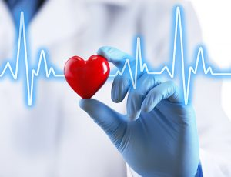
2021.Cardiologist. [image].

Body
In the case of patients with heart disease, the likelihood of being symptomatic can have much more severe complications compared to people who do not suffer from these conditions to bacterial pneumonia, which affects the cardiovascular system It is difficult to say and establish for the time being the development of long-term symptoms, these being researched and monitored based on different diseases and differing from one person to another in degree of intensity and development based on antibodies produced by the body. These antibodies are components of the immune system that circulates through the blood of each person having the responsibility and duty to recognize bacteria and viruses as foreign bodies entering the body to find and destroy them providing protection to the next foreign body entering the body unrecognized by it. Would characterize it as a detector and protector that stores the foreign intruder in the database. As well, part of the defines of the entire system against the enemy alerts the body which destroys the reproduced clones. Here we are talking about myocarditis which is nothing but inflammation of the heart muscle that can triggered by a viral infection or from various side complications with various pathologies. Once in the body, the virus causes major damage to the lungs and triggers an inflammation that causes stress in the cardiovascular system causing lower blood pressure. Under these conditions, the heart begins to beat much faster with a much higher intensity, aiming to oxygenate and supply oxygen to vital organs in the body. The diagnosis based on the data obtained and verified by the physical examination of each patient following the medical investigations performed provides a complete analysis of the data provided to make a correct diagnosis. The equipment used to identify abnormalities in the heart's functionality to normal standards, or to detect it, can validating a diagnosis such as: radiography, ultrasound, computed tomography. Considering different pathologies differing from patient to patient, these techniques help to detect and classify the respective disease in the respective categories, helping to restrict the causes and lesions found in a small circle of research and providing a correct diagnosis to the patient. Thus, the prescription of a treatment based on the medical investigations made and the communication both verbal and written in the prescription of the respective treatment. The method of diagnosis granted to be effective in cardio diseases, through medical techniques and imaging and the process of its internal investigations, body in performing medical tests incorporating visualization of the functions of certain organs and tissues visualized during medical examination. Including prevention and treatment in addition to medication, measures to reduce the risk of developing cardiovascular disease, such as smoking cessation, if the patient smokes, be careful of body weight, helping you maintain your health in normal parameters. Try to eat healthy if you still cannot keep a diet. Exercise and walking in nature help you both physically and mentally. Eat a healthy lifestyle to help keep your health from deteriorating.
The equipment, techniques, and medical imaging in the process of conducting investigations in performing analyses are multiple starting with the electrocardiogram, magnetic resonance helps to find a diagnosis and restrict the causes of a patient's injury or a disease that provides the correct assessment. Technology is an excellent category in the development of all branches of health, helping to develop the work done in improving the invention offered, facilitating and rehabilitating patients. The forms of development are different, but they all belong to the functions of the human body starting from the psyche contemplating intellectually, emotions, raising our morale and reporting from society. The technology helps medical staff, especially when working as medical staff meeting compromised areas and infected patients (Covid-19), comes into operation special overalls and personal protective equipment not allowing the virus and infection rate transmitted but its protection be at the same time protecting each other. During all this difficult period pandemic, technology has made an impact in the real world by changing habits and offering adaptation to new emergencies using new technological techniques. Thus comes the invention of the so-called 'doctor' tablet. instructions for individual use for this category in the field of doctors and tablets for nurses, to monitor and supervise the remote assistance allowed by law in making visits to patients online by making direct contact visits with people at longer intervals than in previous visits This has made it possible to reduce cases of infections by providing greater safety for staff and patients. Online platforms also by inventing innovative programs have created services in the global support of multinationals in the category of companies in the global economic world, thus helping not to collapse. total economic. Demonstrating thus elaborates by their creation and diversity a wide spectrum helping from a formative point of view in training employers in adapting and accepting innovative technologies.
The directive on safety at work establishes the obligations of both employers and employees. In fact, when we talk about health, it also includes education as a means of developing knowledge and improving it in knowing the risk factors. By introducing measures to improve health and safety, the rules stipulate that employer have an obligation to ensure the safety and health of staff, according to certain company-based criteria. Internal rules and compliance with the article to provide in health. A positive e attitude in maintaining the safety of the other demonstrates and supports healthy behaviour from an ethical professional point of view.
Use of search engines, such as: text, e-mail, power point. All these activities help to create, present, and learn resources in having various knowledge and use them easily, using this source to communicate and solve problems in all branches and all fields. The growth of technology in the healthcare system has accelerated, increased technologically, and allowed patients to make medical appointments, order prescriptions and view their medical records through the recently launched NHS Digital Library, far more efficient healthcare, quickly accessible and time saving.
Thus, with the change in technology and its progress, new training and refresher courses on digital literacy have been allocated to staff, taking the new step in global technology and, at the same time, in the health system.

In case of patients with cardiac pathologies the probability of being symptomatic can have much more severe complications compared to people who do not suffer from these conditions. Once in the body, the virus causes major damage to the lungs and triggers an inflammation that causes stress to the cardiovascular system causing blood pressure to drop. Under these conditions the heart begins to beat much faster with higher intensity, aiming to oxygenate and supply oxygen to vital organs in the body.

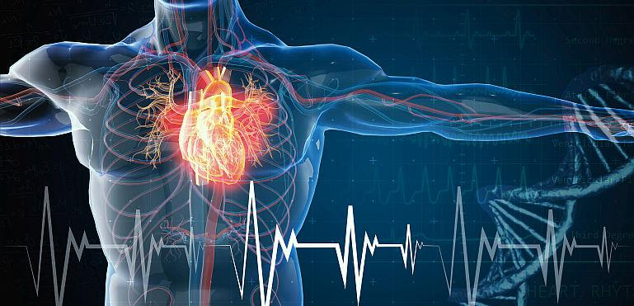
2021.Palpitations. [image].

The diagnosis based on the data obtained and verified by the physical examination of each patient following the medical investigations made gives a complete analysis of data provided in making a correct diagnosis .Including the prevention and treatment apart the medicate , measures to reduce the risk of developing cardiovascular disease like quit smoking if the patient is smoke ,take care of your body weight by helping you maintain your health in normal parameters .Exercise and walking in nature help both physically and mentally .Adopt a healthy life to help you not worsen your health .
The equipment, techniques, and medical imaging in the process of conducting investigations in performing the analyses are multiple starting whit electrocardiogram, magnetic resonance. It helps to find a diagnosis and restrict the causes of a patient’s injury or a disease offering the correct evaluation. Technology is an excellent category in the development of all branches of health, helping to develop the work done in perfecting the invention offered, facility and to rehabilitation for patients.
The work place safety directive sets out the obligations of both employers and employees .By introducing measures to improve health and safety ,the rules stipulate that employers have the obligation to ensure the safety and health of the staff ,according to certain criteria based on the company’s internal rules and respecting the article of the low provided in health .A positive attitude in maintaining the safety of the other demonstrates and supports a healthy behaviour from an professional ethical point of view .
The use of search engines such as :text ,e-mail, power point etc .All this activities help to create ,present and learn resources in having various knowledge and using them easily ,using this source to communicate and solve problems in all branches and all fields .The growth of technology in the healthcare system has accelerated ,growing technologically and allowing patients to make doctor’s appointments, order prescriptions and view their medical records through the recently launched NHS Digital Library application for healthcare , much more efficient ,fast accessible and saving time .
Thus, with the change of technology and its progress, new training and refresher courses have assigned to the staff in terms of digital literacy, adopting to the new steps in global technology and at the same time in the healthcare system.

Conclusion

To date, records of the factors that cause the risk scale in this new form of Covid-19 disease are under continuous research experiences over the years, researched and discovered, improve the use and practical, theoretical, and technological combination, to a complementary extent, ensure the efficiency of people together in research and performance of procedures used in the practice of medicine for the benefit of mankind. The collaboration leads to success and success to development. From this point of view, I consider that the free training in large numbers offered by certain branches of industry and made available to staff does nothing but bring efficiency to these economic colossal by preparing employees to European technological standard.
The collaboration leads to success and success to development. From this point of view, i consider that the free training in large numbers offered by certain branches of industry and made available to staff does nothing but bring efficiency to these economic colossal by preparing employees to European technological standard. offering the opportunity for personal and career growth as well as for the economic level of the respective branch, heading towards progress.

Technical competences applied based on technical knowledge. The skills required in this area provide successful results in the role obtained in terms of professional competence, responsibility, and knowledge. Combining practice with theory and using logic is the magic recipe for success.

The most important thing is not to always forget to smile
.
Anisoara. S, (2009).Personal source. [image].
Happiness is the recipe of every human being.

Reference: Thomson Reuters. (2015). "International Journal of Cardiology". (2014) Journal Citation Reports. Web of Science (Sed.).

