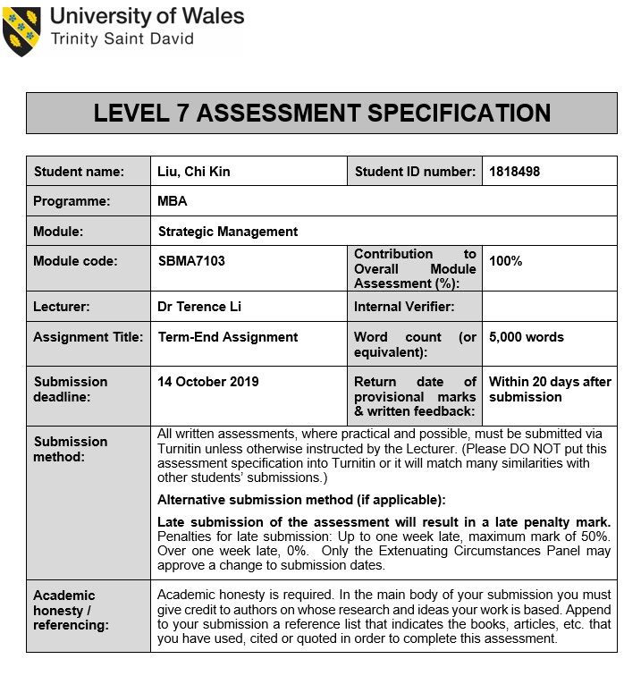

Executive Summary
Esprit is an apparel retailer established in 1968 and has a footprint all over the world. The company was under steady growth from listed from 2003 to 2008. In facing the global financial crisis and the top management changes, Esprit share price was dropped significantly in 2009 and lost the momentum since.
The extradition bill crisis in Hong Kong exposed the fundamental issues about the city, in a combination of the political and economic instability of regional and international. Apparel industry facing significant challenges in the near future. Forever 21 filed for bankruptcy in September 2019, and this is a good demonstration of how unforgiving this industry.
For the last two years, Esprit is using a combination of strategies trying to revive their situation. Downsizing the organization, cost control, and exiting Australia and New Zealand market were some initial actions taken on their restructuring plan. Using differentiation approaches and better understand their customer needs are some changes mentioned in their latest report. They are trying to reposition itself the company mission and vision, focusing on the new corporate and business strategy.
Battering within the apparel industry is not an easy task; it is recommended that Esprit have an unrelated diversification strategy by developing Esprit Pet Food. Overview of consumer products, Pet food industry is a booming market with the demand focused in China and the United States. Sharing similarity with the existing business, and partner with online distribution, and with the right talent in place, this plan along with the proposed plan by the management, if it is closely monitored, it is expected to see a positive outcome.
Launching Esprit Pet Food creates an opportunity, along with the power of the Esprit brand, Esprit Pet Food is very positive to create a new dynamic for the group.

Table of Contents
Executive Summary i
Table of Contents ii
List of Tables iii
List of Figures iv
1. Introduction 1
2. Macro and micro environmental assessment for Hong Kong casual wear industry 3
2.1. Political 3
2.2. Economical 4
2.3. Social 6
2.4. Technology 6
2.5. Porter’s five force 7
2.6. Profit potential 8
2.7. The External Factor Evaluation Matrix 9
3. Corporate strategy and business strategy of Esprit 10
3.1. Balanced Scorecard 10
3.1.1. Financial measure 11
3.1.2. Customer 12
3.1.3. Learning and growth 12
3.1.4. Internal business process 12
4. Recommendation 13
4.1. Segmentation, Target, and Positioning for Esprit Pet Food 14
4.2. Product 14
4.3. Price 15
4.4. Place 15
4.5. Promotion 15
4.6. HR, IT, & Finance 16
5. Implementation 17
5.1. Internal Communication 17
5.2. General Administration 17
5.3. Hiring 17
5.4. Service provider negotiation 18
5.5. Supplier Setup 18
5.6. Product development 19
5.7. Logistic Arrangement 19
5.8. Production and Quality Assessment 20
5.9. Go live 20
6. Contingency 21
Bibliography 22

List of Tables
Table 1.1 | Esprit 5 Years Financial Summary……………………………………………............................. | 2
Table 2.1 | Overview of the World Economic Outlook Projection ………………………………………….. | 4
Table 2.2 | Esprit External Factor Evaluation Matrix ……………………………………………………….. | 9
Table 3.1 | Employee Cost Comparison ………………………………………………….............................. | 11
Table 3.2 | Return on Equity and Return on Assets Comparison ……………………………………………. | 11
Table 4.1 | Worldwide Pet Populations 2019 ……………………………………………………………….. | 13
Table 4.2 | Cat and Dog Annual Spending Breakdown …………………………………………………….. | 14

List of Figures
Figure 1.1 | Share Price of Esprit……………………………………………..………………………………. | 1
Figure 2.1 | Porter’s Five Force of Esprit ………….………………………………………………………… | 8
Figure 5.1 | Esprit pet food implementation timeline ……………………………………………………….. | 17

Introduction
Esprit Holdings Limited is a manufacturer and distributor of apparel established in 1968 and listed in Hong Kong Stock Exchange (Stock Code: 00330). Global business headquarters is located in Ratingen, Germany; and the Global Financial Headquarters is located in Hong Kong. This worldwide fashion retailer carries a wide range of products under its owned brand, including casual wear, footwear, fashion accessories, jewelry, and cosmetics. As of 2018, Esprit has 586 direct managed stores and employed over six thousand staff around the world (Esprit, 2018).
At the beginning of listing in 2003, the stock price enjoyed steady growth, from around $10 per share reaches $100 per share in 2007. Management restructuring occurred in 2008, one of the co-founders, Mr. Michael Ying, resigned all his position from the Esprit Group (Esprit, 2008), and the share price started to drop, although the share price had a slight rebound between 2009 and 2010; however, the momentum was lost, and the share prices have been dropped since then.
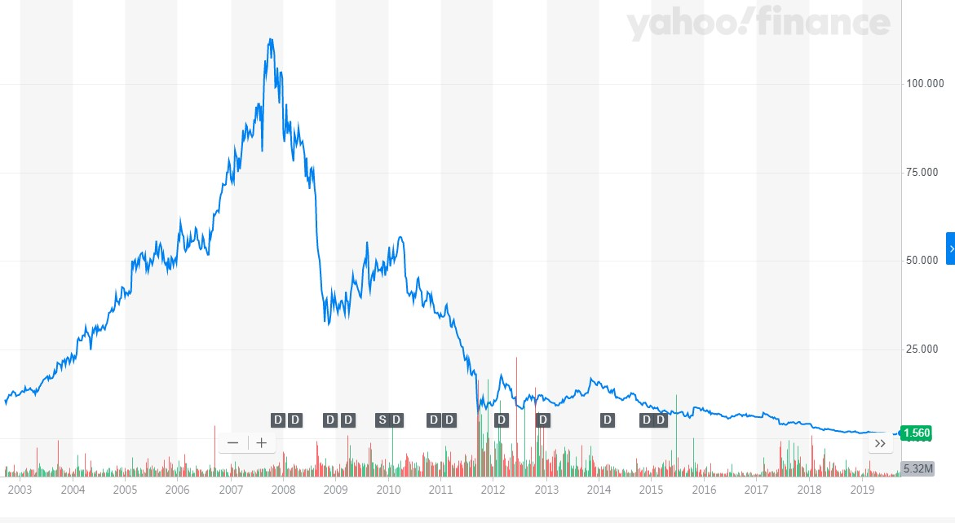
Figure 1.1 Share price of Esprit
Source: Yahoo Finance (2019)
In review of the financial statement (Esprit, 2019), the overall performance is dreadful, and revenue has been shrink along with the operating margin. Meanwhile, the total equity has been dropped from around HK$19 billion in 2010 to 6.7 billion in 2019, and the group has been selling the asset to sustain the business.

Macro and micro environmental assessment for Hong Kong casual wear industry
Retail is remained as an important industry in Hong Kong, according to the latest publication by the Hong Kong Government, this sector alone contributed 4% of Hong Kong GDP (Census and Statistics Department, 2019a). In particular, clothing retails employed around 50,000 people who make up around 1.2% of the labor force in Hong Kong (Census and Statistics Department, 2019b).
Because of today’s environment, political matters affecting the economic performance, and vice versa. Illustrated considerable uncertainties in Hong Kong, and expected to be impacted by this phenomenal just unclear is the magnitude. These significant challenges and instability are the key influencing factor for the casual wear industry in Hong Kong.

Political
Textile quota was a historical issue in the apparel industry, after a ten years’ transitional program, the quota had ended within the WTO members in 2005 (WTO, 1995), it created a better trade environment and at the same time, higher competition in the world.
The trade war between the US and China has just recently escalated, and no one can predict the end of the trade war at this moment (BBC, 2019). Brexit is still an unstable core factor in Europe. Although the Queen has signed a law preventing the United Kingdom exiting European Union without a deal, but any proposition in regards to Brexit has to be agreed by not only the UK Parliament but also the European Union Parliament, as the deadline, 31st October 2019, is approaching, this complicated situation affect the stability of the whole continent and the world.

In Hong Kong, the summer of 2019 marks the toughest political challenge in this post-handover to China era. It began with the debate on The Fugitive Offenders and Mutual Legal Assistance in Criminal Matters Legislation (Amendment) Ordinance (2019) as known as the extradition bill. The bill has raised a grave concern not only for the people of Hong Kong, but also the foreign diplomats (SCMP, 2019b), believing the autonomy of Hong Kong under one country two systems, and the Rules of Law will be jeopardized. Many countries speak out their concerns, large scale of demonstration and protest continuous thought out the summer and there is no sign of stopping, although the government of Hong Kong had yet made another proposal on withdrawing the bill, the people in Hong Kong is not accepting the government proposition, as the society is polarized and it is extremely difficult to restore the peace in the near future.

Economical
The latest projection from International Monetary Fund has revised, and the GDP from global economic projection is 3.2% in 2019, advanced economic growth only managed a 1.9% growth and dropped to 1.7% in 2020 (International Monetary Fund, 2019).

Domestically, the 2018 Hong Kong GDP is increased by 3.2% (Financial Secretary’s Office, 2018), and the unemployment rate managed at 3.6% (Census and Statistics Department, 2018). The first quarter of 2019, GDP only slightly up by 0.6%, it has been dropped by 4.0% compared to the same period in 2018 (Census and Statistics Department, 2019c).

Looking back in recent history, the Chinese government launched the Individual Visit Scheme in July 2003 wanted to help the economy of Hong Kong. The scheme was a success in terms of attracting a large number of tourists coming to Hong Kong. Since then, this scheme becomes an essential driving force of the Hong Kong economy, especially in tourism-related industries including retail sectors. In today’s political unstable environment, wearing apparel retail dropped 13% in July 2019 (Census and Statistics Department, 2019d). As the visitor number has been dropped significantly, mainland China fell 5.5% in July and 42.3% in August, compared to same period last year (Hong Kong Tourism Board, 2019). It is foreseeable that the tourism-related sector is not able to survive in this prolonged unstable environment.
Fitch Ratings Inc and Moody’s had recently revised the rating of Hong Kong, Fitch downgraded Hong Kong credit rating from AA+ to AA (Fitch Ratings, 2019), and Moody’s downgraded the outlook of Hong Kong to negative, stated the current situation of Hong Kong is very likely to damage the medium-term economic prospects (Moody’s Investor Service, 2019). Both rating companies shared the same view in regards to the recent instability, in spite of some concessions to Hongkongers' demand, it is believed the public discontent will linger. This ongoing conflict and it has not yet been resolved, which the further outlook of Hong Kong is negative.
It is also worth mentioning Hong Kong has a Linked exchange rate policy with the US dollar since 1983 (Hong Kong Monetary Authority, 2019). This historical policy helped Hong Kong went through many financial crises in the past. A key factor to maintain the stability of the currency, the interest rate in Hong Kong should follow the United States federal reserve system and revise in parallel. However, in recent years, the United States federal reserve system increased the Federal fund rate four times in 2018, from 1.5% to 2.5% (Trading Economics, 2019), but the Hong Kong Monetary Authority did not follow. The interest rate gap between creating a favorable trend towards the US dollar, which creates an instability factor to the linked exchange rate system. To stabilize the system, the interest rate should get as close as the US fund rate, which indicates that the interest rate in Hong Kong will increase in the future, and this will increase the finance cost for business if a loan is needed from banks.
This risk of downward economy leads businesses to shut down, and the unemployment rate will increase, this phenomenon, on the other hand, creates an opportunity for expansion, as the rental cost is going to be lower, and at the same time, the unemployment rate increases, the employee cost should much lower.

Social
One of the deep conflicts in Hong Kong is the excessive-high rental cost. This phenomenon is not only affecting businesses but also creates social discontent. Gini coefficient from 0.518 in 1996 (Hong Kong Economy, 2006) reaches a record high of 0.536 in 2016 (Census and Statistics Department, 2017). The young consumer is the vital driving force for the fast fashion industry (Bruce and Daly, 2006, pp.335). Today in Hong Kong, however, with the 34% of income spent on rental, surplus flows into clothing dropped 5% compared to 5 years ago (Census and Statistics Department, 2016), which causes a significant reduction in internal demand. Moreover, according to Maslow’s hierarchy of needs, fast fashion purchases supposed to boost self-esteem (Muthu, 2018). Young teenagers who are relatively active on protesting, they instead spending on their protective gear, downscale to the safety and basic physiological needs, which impacts the whole retail market in Hong Kong.

Technology
Hong Kong is a very first city popularized the use of Radio Frequency Identification (RFID). The octopus card company is a massive success, with over 99% of Hongkonger people between 15 to 64 years old hold at least one Octopus card (Octopus, 2019). However, virtual banking is prevalent in nearby cities. In China, the dominant payment methods are WeChat Pay and Alipay (Pavia, 2018). Consumer behavior creates diversity on receiving payment, which creates a significant challenge to Hong Kong which is more acceptance towards the traditional payment methods such as VISA, Master Card, and even cash payment.

Porter’s five force
Threats of potential new entrants (High) – It is due to the barriers enter and exit the market is relatively low, especially for brands or distributors. The quota on textile has been eliminated since 2005, this historical legal requirement was enforced for market protection, but has been removed by WTO. Also, apparel product differentiation is low and does not require an exceptional storage condition which makes the logistic and storage cost is more moderate and more comfortable to handle.
Threats of substitute products (High) – In apparel retailing, both customer loyalty and brand preferences are not high, the customer is always seeking the best value item in the market. Sportswear is widely available for replacing casual wear.
Bargaining power of consumer (Moderate) – Esprit customers relatively price-sensitive and they expect quality. With the technological advancement, price and style are highly transparent over the world, switching cost for the consumer is low which evaluate the power of the customer.
Bargaining power of suppliers (Low) – Apparel suppliers are vastly available in China, and exponentially growing in Southeast Asia countries such as Cambodia, Indonesia, Vietnam, and South Asia countries such as Bangladesh, India, and Pakistan. The switching cost from one supplier to another is also low, and consumer is more concern on the quality instead of getting from which supplier. Therefore, the overall bargaining power of supplier is low.
The threat of competitive rivalry (High) – A vast number of competitors is available in the industry, and the growth rate is projected slightly over 5% (Statistia, 2019), along with the product differentiation is low, which lead to the threat of competitive rivalry is high.
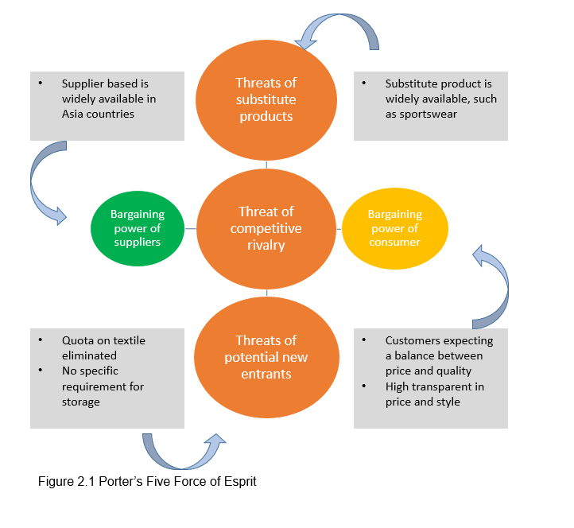

Profit potential
The recent filing for bankruptcy of Forever 21 is a good illustration of how unforgiving of this industry, the only shop in Hong Kong has been shut down after the filing (SCMP, 2019a). It is clear that the profit potential is low due to a combination of factors; selling price is not going to be high as both substitute of products and bargaining power of the consumer is significant. Hong Kong market is minimal and many international brands available in this small city; competition rivalry is high which affecting the sales and profit. Although the supplier base is widely available it is not beneficial enough to counteract with other forces. Therefore, the profit potential is low in this industry.

The External Factor Evaluation Matrix
In summarizing the industry environment, key external factors that have been listed are generated in Table 2.2
Esprit has scored a 1.6 in the total weighted score, which is below the industry average and has much room for improvement.

Corporate strategy and business strategy of Esprit
According to the 2018 annual report and 2019 announcement, Esprit is using a combination of growth, stability, and retrenchment as their corporate strategies.
Retrenchment is a key corporate strategy for Esprit, unprofitable retail stores have been closed, and they exited the Australia and New Zealand market in 2018. Another action taken was reducing the staff number. The group has emphasized trimmed headcounts and reduce employee cost.
For growth strategy, Esprit is using the differentiation approaches and revisiting the customer needs and the identity of the brand. In 2019, according to Group CEO, Esprit is not fast fashion nor a discounter. New Esprit brand defines as “Radical Positivity – Loving Our Customer – Quality Always.” In addition, Esprit is relaunching the loyalty program, increase social media, and working with other organizations promoting gender equality, and all these actions are aimed to improve customer engagement and enhance the customer experience.
Product Development is being used as Esprit’s business strategy. In 2019, they are aimed to improve the product offer by launching new labels, new product categories, and also incorporated science and technology into the new collection. Besides, quality improvement is also mentioned to create a value driver in the differentiate strategy.
Stability corporate strategy is referring to Esprit wholesale business, providing better service to the existing customer by adjusting the delivery schedule to better accompany the customer need.

Balanced Scorecard
To evaluate Esprit’s strategy, a balanced scorecard approach is used to give a more comprehensive perspective of these strategy implementations.

Financial measure
Executive Chairman of Esprit, Dr. Raymond Or, stated the group loss before interest and taxation (LBIT) has improved from HK$ 909 million to HK$ 587 million, seems to be a positive trend of improvement, however, in more in-depth view on their retrenchment strategy in terms of reducing headcount, the number of staff has been reduced from 7304 in 2017 to over 4900 in 2019, but Esprit employee cost is significantly higher in the industry. In 2019, their employee cost related to sales is 21.7%. It is understandable on the retrenchment strategy, reducing the cost by limited the store and staff number. However, the result and the execution are highly questionable. If the intention of reducing the store and staff number is to reduce the cost, from the data shown, it is failed to achieve the goal. Therefore, the management should be revisiting the strategy and investigating the failure to drop the cost after the redundant.
Both Return on Equity and Return on assets were showing negative numbers, compared to the industry, all of them were showing the positive numbers, which Esprit is not performing as they should in correlate to the industry.

Customer
It is delighted to see Esprit is taking a proactive approach for customer engagement by better use of the social media, although it has been widely used by the competitors already, it is never too late to implement such plan. The loyalty program is also a key factor to increase the loyalty and retention of the customer, and the result is needed; however, to closely monitor shortly in conjunction with customer satisfaction.

Learning and growth
Esprit realized the shortfall within their organization. There is no new label or product line being introduced for a long time. Within the corporate strategy, which is needed to spend more effort into the research and development department and yet to see any results.

Internal business process
Wholesales business is identified as a core business in Esprit, the action has been taken to provide a better service to the partner, by better scheduling the delivery to meet the needs of the customer, there is no question on such approach but need to monitor of the results carefully.

For the last two years, Esprit has layout both corporate strategy and business strategy, these strategies seem sensible, however, take the reducing headcount as example, although it is successfully reduced the headcount, but the employee cost has not been reflected but also increased, the management should reason with their execution plan and evaluation the intended results.

Recommendation
There is a particular area that Esprit is failed to address in their recent announcement; it is what to introduce into their brand and product line. The strength of Esprit is having an international brand recognition and operational experience, with the threats is high competition in apparel retailing. Therefore, the recommendation is focusing on an unrelated diversification approach to incorporate with their existing strategy.
In reviewing different categories of consumer products, Pet care is a strong category with steady growth. Table 4.1 showed the cat and dog population around the world.
From a pet owner's perspective, the cost of owning a pet can be categorized into five areas; Veterinary care, Food, Toys & Accessories, Kennel boarding, and Grooming. The annual spending of a dog and a cat is estimated at US$ 1,381 and US$908, respectively (APPA, 2019). Based on the estimate in conjunction with the top two countries of Cats and Dogs population, the pet food market reaches US$ 250 billion annual in China and the United States alone. Pet food has no seasonality fluctuation, which is one of the distinct advantages over apparel products. In turn the sales volume of pet food is relatively stable and much easier to forecast.

Segmentation, Target, and Positioning for Esprit Pet Food
With the above information, it is clear that the strategy segmentation is focusing on domestic Pets, the targeting market for Esprit Pet Food is going to be Cat or Dog owners who are living in the US or China. As the distribution has shown that these two countries have the largest number of Cats and Dogs, it is reasonable and almost expected to target these markets. As a newcomer of the market, the position is aimed to benchmark with the market leader in terms of quality and pricing.

Product
There are many OEM pet food manufactories around the world, and it is very concentrated in Asia countries (British Retail Consortium, 2019). It is very convenient to partner with a manufacturer as Esprit office is located in Hong Kong. In addition, Pet food is a long shelf-life product, and the storage is in ambient condition, which gives logistic a flexibility and much easier to handle, the infrastructure required for supply chain will be very similar with the existing distribution.

Price
The profit margin for retail pet food is around 50% (Entrepreneur, 2015), which is a much higher margin compared to apparel retail. As no major fast-fashion brand has stepped into this market, Esprit can enjoy flexibility in price setting. Benefiting and capitalizing from brand name recognition, Esprit Pet Food not only able to but should position its product benchmark the price and quality with the pet food market leader.

Place
Esprit eshop is the only segment that can generate profit, which gives a reliable indicator that online should be the place for launching the new product line. The behavior of the online shoppers has been studied by the Consumer Council in Hong Kong, for those customers who have an experience with online shopping, they are not only a high repeating rate but also increase the likelihood to extend the shopping into another category (Consumer Council, 2016), this behavioral phenomenal benefit Esprit in creating synergy between apparel and pet food category.
There is a significant similarity in selling pet food and apparel online. Esprit already has the capability of performing the sales and controlling the supply chain, which in turn can execute the plan without many modifications with the existing platform.

Promotion
In collaboration with the online store, the promotion platform should capitalize the use of social media, which has already been identified in Esprit's strategy. The advantage of social media promotion is the data point is well collected by different platforms, in turn, the target audience is more precise compared with traditional advert with interactive advertising the efficient, and effectiveness is much higher (Kumar, 2017, pp. 13). The online promotion also served as an essential tool for educating consumers, transform the product knowledge into an engagement. (Harris and Rae, 2010).
Facebook, as an example, as of August 2019, there are 186 million Facebook users in the US (Napoleon, 2018). Each profile contains at least 98 data points (DailyMail, 2016). Equivalent to Facebook in China, Weibo currently has 465 million active users (DMR, 2019). These data points are able to let the advertisement reaches to selected target audience, in this case would be pet owners who live in China and the United States. Using social media is compared with the traditional advert; it can deliver the message to a much focus audience and much active promotion channel nowadays.
Also, study has shown that feedback left on social media is essential for customer satisfaction. This electronic Word-to-Mouth (e-WOM) not only crucial to the company's reputation (Sharma et al. 2019, p.285) but also able to predict the sales and product movement using various models (Lee, Xu, and Lin, 2019, p.68). Therefore, utilizing social media coverage is an essential promotion tool.

HR, IT, & Finance
Although the strategy is an unrelated diversification approach, the resource required for implementing the strategy in terms of HR, IT, and Finance is relatively low, as there functional department can be shared within the existing organization. However, specific talents are required, such as the Sourcing team and Technical team, and they will become the major player to implement the plan, and needed specific product knowledge and deep understanding of the market.

Implementation
When implementing the Esprit Pet Food, Michael Porter’s model of the value chain is being used as a framework of implementation and divided into three stages.

Internal Communication
Before investigating the primary activities and costs, the mission and vision of Esprit Pet should be well communicated within the organization. This new product line is going to create in the group and going to match with the existing mission and vision, providing exceptional product and joy to Esprit customers.
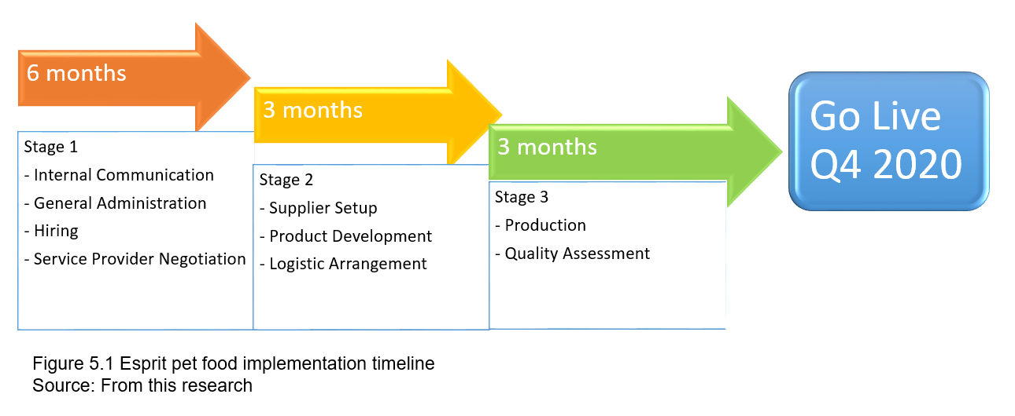

General Administration
As Esprit is a well-established company, there should be no concern regarding General Administration, and this new team can be formed in the existing office in Hong Kong.

Hiring
Moving into a new product area, pet food products required an exceptional talent for carrying out such task, which additional human resource is needed. In referencing with many sourcing offices in Hong Kong, a competent team, including sourcing personnel and technologist should able to carry out the task.
The primary duty of the sourcing team is to carry out the market study and look for a supplier who is able to deliver the own-brand product. The sourcing team is going to perform the market study, understanding what type of pet food is available in the market, and focus on those that are for cats and dogs. Once the team is assembled, the sourcing team can move into the second stage.

Service provider negotiation
Although Esprit has an excellent fundamental online operating platform in Germany, it is lack of success in penetrating the US and China in terms of online sales, therefore, partnering with the national no. 1 platform is going to be a cost-effective way to launching the product into the market. While putting the right team into place, the senior management should start the discussion with the operation team. To capitalize on which is already available in the market, Esprit should join the conversation with Amazon in the U.S., and Weibo, in particular, TMall in China, as the distribution channel of the new product line.

Supplier Setup
The second stage begins with research and looking for factories that are in this pet food business. Many platforms provide such information, and the team should able to get access from the database, such as British Retail Consortium, International Featured Standards, or Marine Stewardship Council. These are the regulatory platform that has a specific pet food category.
Once the potential supplier has been identified, the sourcing team should plan for a vetting visit. The main objective of such visit is to share the mission and vision with the future partner, understand what Esprit aims to achieve, the timeline of the project, and also explaining the commercial terms of working with Esprit.
The technical team is also needed to take up the responsibility of understanding the supplier capability. The ideal supplier would already have the footprint in both China and the U.S. market, which they have the understanding in regards to the local laws and regulation of the exporting countries.

Product development
It is expected that the supplier can own the product formulation. At the beginning of the launch, benchmarking with the market leader and sell exactly the same types of products should be sufficient. The technical team will work closely with the supplier to ensure the right quality of the product can be delivered.

Logistic Arrangement
The logistics team is also playing an important role in the implementation plan. As the shipment handling is very similar to apparel, the primary focus should not be international shipping schedule, but instead from the port of landing to the fulfillment center. As a general practice, Esprit should setup a sizeable warehouse near the seaport, such as Long Beach, California, and Newark, New York, as these two seaports in West and East coast are very commonly used from Asia ocean freight liner.
On top of arranging the ocean flight, the logistic team is also responsible for the inventory of the stock, and the logistic team should hold a set of information such as ordering lead time and the stock level movement in each fulfillment center, they are the ultimate responsible party for order tracking and delivery. Standard shipment and clearance from any Asian countries to the U.S. should take about a month, and the inland logistic from the port to the 175 fulfillment centers of Amazon may varies (Amazon, 2019).

Production and Quality Assessment
Moving into stage 3, the supplier should focus on the production schedule with the initial order quantity, and at the same time, quality assessment should be carried out in a scheduled matter.
It is also vital that the logistics team is working alongside the technical team to ensure the product exit the factory is complying and meet the requirement agreed upon. A prevalent practice is conducted a pre-shipment inspection on the goods.

Go live
As the team follows with the production schedule and the quality of the product, with the execution of the logistic team, the product should be ready at the depot and either send to or collected by the partnering distributor, which will than entering to their fulfillment centers and the sales of ready to go live. As mentioned before, logistic team will work alongside with the sourcing and technical team.
In summary, the success of implementing is relied on close communication with all the stakeholders. Management should provide enough autonomy and resource for the operation team, and the operation team should follow the plan that agreed upon, using the professional knowledge to execute the plan.

Contingency
Implementing a strategy in this magnitude, management should prepare for any possible outcome. This section will be focusing on the contingency plan of the implementation.
There should be no question about finding the right person in the right place. Perhaps if the Human Resources team is not able to find a suitable candidate for the opening in Hong Kong, it is recommended the company should expand the radius and recruit from the neighboring cities such as Shanghai, Shenzhen, Guangzhou, or in other Asia cities such as Singapore, Malaysia, Bangkok, which are major talent and many sourcing offices located in these cities
With logistics, if the newly created team is not competent to handle the complication challenges facing at the beginning, it is also an option to outsource such operation to a third party, also known as 3PL. These companies are widely available around the world.
In case of the negotiation with partnering the largest online platform did not go well. For the US market, partnering in a more pet food-specific platform is going to be an alternative solution such as Petsmart Inc or Petco. In China, the second-largest online platform is JD.com, which can serve as an alternative if the negotiation with TMall did not go well.
- Conclusion
Under today’s business atmosphere, both macro and micro environment is not favorable to the apparel industry. Esprit strategy has been listed and the problem is not about the strategy itself, but is the implementation of the strategy. Employee cost remains high is already addressed which Esprit needs to put additional effort into securing the strategy.
Besides, recommended an unrelated diversification approach creates an opportunity to seek elsewhere; having a high growth rate and also able to enjoy a high-profit margin is very rare in consumer products. Using the power of the brand, closely related operation system, and taking advantage of e-commerce, Esprit Pet Food should bring a new dynamic for the group.

Bibliography


