

LOCATION: Swansea | LLEOLIAD: abertawe
LEVEL 6 | LEFEL 6
EXAMINATION PERIOD | CYFNOD ARHOLIADAU
May 2025 | Mai 2024
MODULE CODE: ACCA6023
Enterprise Networking, Security and Automation

Student Name: _______________________________

STUDENT ID: _________________________________

TIME: 2 HOURS
answer all questions

This is an individual practical lab-test, held under examination conditions. You will be assigned three Routers, 0ne Switch and Two PCS. configure these devices based on the following specifications.
The routerS ARE R1,r2 and ISP. the switch s1 and the PCs are PC1, PC2.

This paper contributes 75 % to overall module ASSESSMENT.

Task 1: In class Activity (15 %)
- OSPF Challenge (7.5%) 07/03/2025
- NAT Challenge (7.5%) 21/03/2025

Task 2: Network Configuration (85 %)

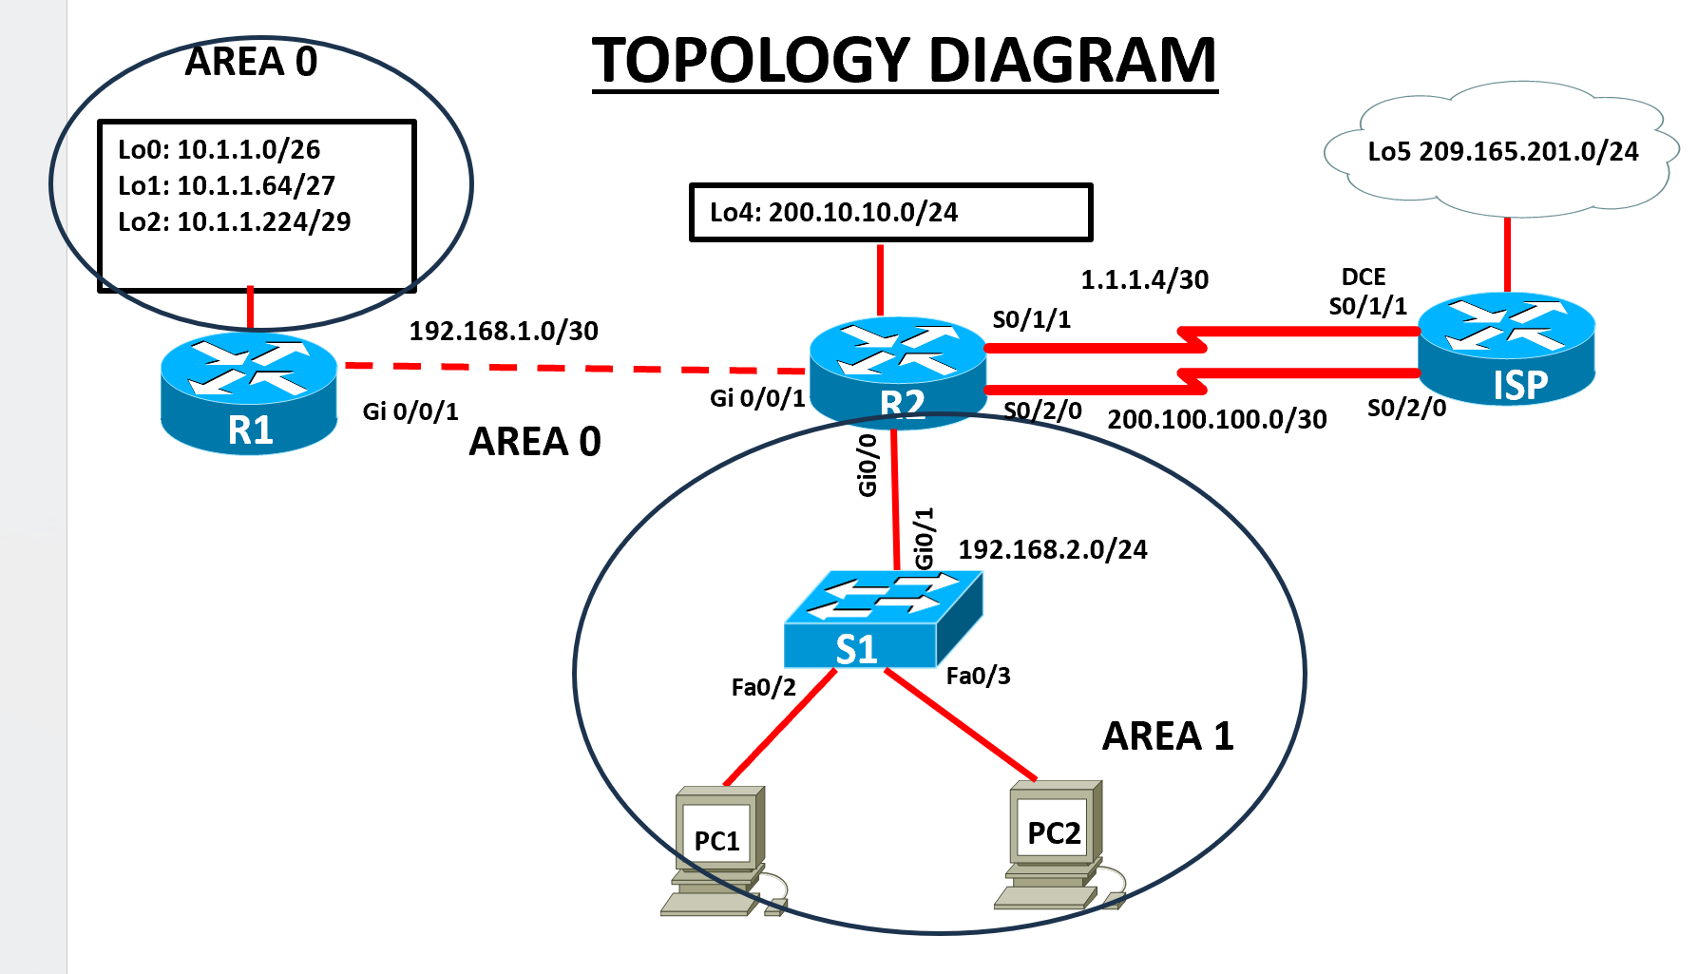

2.1

- From the topology diagram, fill in the IP Address table below. For the LAN, assign the first usable address to the router interface, the second usable address to the switch, and use the third and fourth addresses for the PCs. For the loopback interfaces, use the first usable addresses. ( 10 marks)

Addressing Table

Device | Interface | IP Address | Subnet Mask | Default Gateway
R1 | Gi0/0/1 |  |  | N/A
R1 | Lo0 |  |  | N/A
 | Lo1 |  |  | N/A
R1 | Lo2 |  |  | N/A
R2  R2  R2 | Gi0/0/1 |  |  | N/A
R2  R2  R2 | Se0/1/1 |  |  | N/A
R2  R2  R2 | Se 0/2/0 |  |  | N/A
R2  R2  R2 | Gig 0/0/0 |  |  | N/A
R2  R2  R2 | Lo4 |  |  | N/A
ISP | Se0/1/1 |  |  | N/A
ISP | Se0/2/0 |  |  | N/A
ISP | Lo5 |  |  | N/A
S1 | VLAN 1
PC1 | NIC
PC2 | NIC

(ii)Physically cable the network as shown in the topology diagram. (5 marks)

Examiner Comments and Signature:
Signature:

Configure the routers R1 ,R2 and ISP (15 marks)
Configuration tasks for R1,R2 and ISP include the following:
It is essential that you complete a 'show ip interfaces brief' on the routers before you commence. Some will have Gi0/0 & Gi0/1 interfaces, while others will have Gi0/0/0 & Gi0/0/1, depending on the model used in each Cisco Academy. Interfaces for switches might also differ depending on the model.

- Disable DNS lookup, configure all routers with hostname R1,R2,and ISP as appropriate.
- Configure IP addresses according to the Addressing Table, setting appropriate Descriptions on the Interfaces and make sure the interfaces are activated
- Configure Multi-area OSPF with Process ID 1 on R1 and R2, and Areas 0 and 1 as shown on the topology. Use Router IDs 1.1.1.1 and 2.2.2.2 on R1 and R2 respectively.
NB: On R2, include only two networks for OSPF Process ID 1: 192.168.1.0/30 and the LAN 192.168.2.0/24.
- Set LAN and Loopback interfaces to Passive
- Configure Lo0 on R1 as a point-to-point network for OSPF
- On all the Routers ,configure the hello-interval timer to 30 seconds.
- On all the Routers ,configure the dead timer-interval to 120 seconds.
- Configure a static default route with Se 0/1/1 on R2 as the exit interface, then share the default information with R1

2.3 Configure S1. (2 marks)
Configuration tasks for the switches include the following:

- Disable DNS lookup, configure the switch with hostname S1.
- Configure the IP address according to the Addressing Table, setting appropriate Description (on the Interface , make sure the interface is activated

Configure host computers and Test for Connectivity(4 marks)
Configure the host computers PC1 and PC2 with IP addresses according to the addressing table.

After configuring each host computer, perform the following tests;
Source | Target | Protocol | Expected Result
PC1 | PC2 | Ping | Success
PC1 | R2(Gi0/0/1) IP address | ping | Success
PC1 | R1( Lo0) IP address | ping | Success
PC2 | ISP(Lo5) IP address | ping | Failure

Examiner Comments and Signature:
Signature:

Configure PAT(NAT overload) ( 12 marks)
You have been advised to implement PAT on the Se0/1/1 interface, which is on the subnet 1.1.1.4/30, so that devices on the LAN 192.168.2.0/24 can access the internet on 209.165.201.0/24.
- Define the inside and outside NAT interfaces
- Create a standard access list to define which IP addresses are allowed to be translated.
- Configure PAT to allow multiple devices to share the single IP address on Se 0/1/1
- Verify the Configuration
Source | Target | Protocol | Expected Result
R2 | ISP(Lo5) IP address | Ping | Success
PC1 | ISP(Lo5) IP address | Ping | Success
PC2 | ISP(Se0/1/1) IP address | Ping | Success
- Run the Show ip nat translations on R2 command and record the following Ip addresses;
Inside global…………………… Inside local………………… Outside global ……………….

Examiner Comments and Signature:
Note: Ask the invigilator to check and sign off the 2.4 Task . If not signed off by the invigilator, marks will not be awarded for this task.
Network Connectivity Verification:

Signature:

Configure eBGP ( 10 marks)
Configure eBGP (External Border Gateway Protocol) between R2 and the ISP router using the serial link with the network 200.100.100.0/30.

- Verify whether you have configured IP addresses on the Interfaces using the 200.100.100.0/30 network
- Set up eBGP peering between R2 (AS 65001) and ISP (AS 65002) routers
- Advertise ISP(Lo5) and R2(Lo4) loopback interfaces via eBGP
- Verify the Configuration
Source | Target | Protocol | Expected Result
ISP(Lo5)IP address | R2(Lo4) IP address | Extended Ping | Success

Configure CDP,LLDP,and NTP ( 12 marks)

- Disable CDP globally on R2 and S1
- Enable LLDP globally on R2 and s1
- On R2, configure the link to S1 to only receive LLDP messages.
- On S1 switch, configure the link to R2 router to only send, not receive, LLDP messages.
- Disable LLDP completely on access port fa 0/2 that is in use.
- Display the current time on R2
- Set the time on R2 , time entered should be in UTC
- Configure R2 to be the NTP master with a stratum level of 1
- Configure S1 as NTP client. Use the appropriate NTP commands to obtain time from R2’s G0/0 interface , as well as to periodically update the calendar or hardware clock on the switch.
- Use appropriate show command to verify that S1 is synchronized with R2

Saving and Cleanup

Submission Requirement:
For each device you configured, a txt file containing the following outputs must be submitted on Moodle. The file name should be StudentID_devicename.txt
show run
show ip int brief
show ip protocols (NB:for routers only)
show ip route
show ip nat translations (R2 only)
Show ip bgp summary (R2 and ISP only)
Show ip bgp (R2 and ISP only)
Show ntp status
All documentation for your solution should be submitted electronically on Moodle within the time allocated. It is your responsibility that you copy all the files correctly. Any files submitted after the deadline will be capped at 40%

