
Master of Business Administration
Student Name: Kamal Hussain
Student Number: 2503973
Module code: LCMB7023
Assessment: Individual report
Course Name: Human Capital Management
Lecturer: Ejike Udeogu

Submission Deadline: 17th October 2025

Table of Contents
Introduction 1
Question-01: How are technological advancements (e.g., AI, automation, digital platforms) reshaping labour markets, and what implications does this have for HRM and IHRM strategies? 2
The technological change and how it is transforming labour markets. 2
Implications for HRM and IHRM strategies 3
Question-02: What are the key demographic and geopolitical factors influencing employment markets today, and how do they create challenges for HR professionals? 4
The demographic elements that affect the job markets 4
Geopolitical factors shaping employment markets 5
Challenges for HR / IHRM professionals 6
Question-03: How can organisations address persistent skills gaps and talent shortages in critical sectors through strategic HRM? 8
Question:04. Global Readiness: Self-reflection on the Capabilities I have to do the Changing Workplace 9
Strengths and Development Areas Analysis in an International and Digital Situation: 9
Conclusion 13
References 14

Introduction
This report is a critical analysis of the role of the national and global labour markets on Human Resource Management (HRM) and International HRM (IHRM) strategies. The report also assesses strategic HRM practises to cope with major shortage of personnel in the sector by skilling, labour planning and managing talent worldwide. And, lastly, it gives a reflective thought of my own competencies in technology, communication, teamwork, leadership, and self-directed learning, strengths, areas of work, and how I can succeed in a globalised workplace.

Question-01: How are technological advancements (e.g., AI, automation, digital platforms) reshaping labour markets, and what implications does this have for HRM and IHRM strategies?

The technological change and how it is transforming labour markets.
1. Task polarisation and skill polarisation.
AI and automation are likely to replace routine and monotonous unprofessional work. According to empirical studies conducted in the United States (2015-2022), AI of the automation type harms the employment and wage increases in the low-skill jobs, whereas AI of the amplification type (that raises the capabilities of the workers) promotes the growth and wages in high-skilled jobs (Marguerit, 2025). This adds to polarisation of skills: increased demand (and reward) of higher-skill, cognitive, creative, interpretative, or managerial work, and many lower-skill, manual, or repetitive jobs are eliminated. (Marguerit, 2025; Ganuthula and Balaraman, 2025).
2. Creation of new employment and changing work positions
Although certain jobs are being eliminated due to technological change, it opens up new opportunities and new positions (e.g. AI ethicists, data scientists, automation maintenance, digital platform managers). Employees are forced to be more digital, capable of operating or monitoring automated systems, and cope with an unceasing change (Mer et al., 2023; Sharma, Bhattacharya & Bhattacharya, 2025).
3. Platform / work around the world
The organisation of labour is changing through the use of digital platforms (e.g. gig work, freelancing marketplaces). There is an upsurge in flexibility, remote work, and work internationally. This not only alters the nature of the work performed, but the place working as well as the conditions of employment (Bhatt and Shah, 2023).
4. Nursing and moral issues; disparity
The change in technology brings up issues related to job security, the welfare of workers, equity, algorithmic discrimination, privacy, transparency, and the amplification of inequalities between countries (as developing countries are frequently less prepared to implement and adapt to) and inside countries (between skill groups etc.) (Sadeghi, 2024; Ganuthula and Balaraman, 2025).

Implications for HRM and IHRM strategies
Given these changes, HRM and IHRM strategies need to adapt in several key ways:
1. Redesign of jobs and roles
There will be a significant amount of redesigning of many positions: the elimination of routine routine, the combination of control over AI tools, team work of humans and machines, more attention to creativity, judging, interpersonal relationships.
2. Just, moral and open systems
AI application in talent acquisition, performance assessment, appointments etc should be developed to prevent any bias, deliver transparency, uphold privacy, not to lose the trust of employees. HR / IHRM should include policies, governance, perhaps regulatory compliance across borders, in such aspects as data protection, algorithmic accountability.
3. Talent acquisition and employer branding in the digital / global sense
As employment is becoming more remote, high-end, and digital platforms are mediating various job relations, HR / IHRM has to reconsider the way of attracting, selecting, and retaining talent.
4. Adaptation to culture and change management.
Since technology does not only destroy work but also the expectations of the workers, organisational culture, psychological contracts etc., the HR needs to take a front seat in change management: communication, engagement of the workers in the change, fear of losing the job, cultivation of trust in AI-enhanced tools (e.g. human-robot teams) (Arslan et al., 2022).
5. International congruence vs national flexibility in IHRM
In the case of international companies, a balance between global approach and local difference in technology is significant. Certain countries will be more modernised in terms of infrastructure, law provisions; others might be backward.
Table 1: Impact of Technological Advancements on Labour Markets and Implications for HRM/IHRM
Technological Trend | Effect on Labour Markets | Implications for HRM Strategies | Implications for IHRM Strategies
Artificial Intelligence (AI) | Automation of routine tasks; increased demand for analytical and creative skills (WEF, 2024). | Focus on reskilling and talent analytics to support AI integration | Global coordination for AI ethics, data privacy, and talent deployment.
Automation and Robotics | Job displacement in low-skilled sectors; creation of new tech-based roles (Erigbe, 2025). | Workforce planning to balance automation and human roles. | Standardisation of HR policies for cross-border technological adaptation.
Digital Platforms and Remote Work | Growth of gig economy and global freelance markets (Braesemann et al., 2021). | Flexible HR models; digital onboarding and performance systems. | Management of virtual teams across time zones and cultures.
Data Analytics and HR Tech | Data-driven recruitment and performance assessment (Cappelli, 2021). | Adoption of predictive analytics in HR decision-making. | Cross-country integration of HR data and compliance systems.
Virtual and Augmented Reality (VR/AR) | Changing training methods and immersive learning environments. | Development of virtual learning programmes and simulation-based training. | Standardised international e-learning for global staff development.

Question-02: What are the key demographic and geopolitical factors influencing employment markets today, and how do they create challenges for HR professionals?
In both national and international scenarios, demographic and geopolitical pressures are having a dramatic impact on labour markets.

The demographic elements that affect the job markets
1. Ageing population and ageing and falling working-age populations
In Europe, the labour force is estimated to fall by 10 percent by 2050 due to which the labour shortage and wage inflation in the chosen sectors are under pressure (Stehrer et al., 2019). Stagnant growth in labour supply is also cautioned by the International Labour Organisation since several economies encounter the issue of demographic limitations (ILO, 2025).
2. Long working hours and multigenerational employees
Most of the firms and governments are encouraging the old generation of workers to work longer due to the labour shortages. This leads to more age-diverse workforce that is associated with an additional set of challenges: differences in career expectations, adoption rates of technologies, health support, flexible work requirements, and intergenerational conflict (Acemoglu, Sondergaard & Scott, 2022).
3. Movement, urbanisation and movement of talent
The internal (rural to urban) and international migration patterns transform the place of talent. The high skilled labour is also usually attracted to higher-income areas compared to the low-income area and this increases the competition and brain drain in the low-income regions. Remote and platform work also increase the spatial concentration: those cities and nations that have good digital infrastructure seize more opportunities of remote work (Braesemann et al., 2021).
4. Shifting generational values and generations expectation in workforce
Newer generations (Millennials, Gen Z) are more flexible, purposeful, are more focused on life-work balance, have high expectations regarding feedback and constant learning. HR needs to change the motivational, retention, and engagement strategies accordingly to meets such expectations (Ganguli, 2023).

Geopolitical factors shaping employment markets
1. Trade wars, protectionism and disruptions of the global value chain
The increase in geopolitical tensions trades restrictions, tariffs and sanctions disruptions in supply chains and relocation choices. The firms can re-shore, near-shore or deglobalize operations, a process that re-architectures the demand of the local labour. This leads HR to rethink location strategy, redeployment and skills requirements (IBA, 2025).
2. Political insecurity, war and displacement
Displacement and refugee movements are the result of conflicts and crises (e.g. in Ukraine, the Middle East) and result in a change in the labour supply in the country of origin and the country of destination, and strain integration, regulation and social cohesion. In hiring, compliance and integrating workforce, HR professionals should also handle legal, cultural, and social implications (IBA GEI, 2025).
3. Data governance, regulatory fragmentation and national security
Technology, AI, data and labour skills are all becoming the national security concerns of governments. This gives rise to regulatory obstacles (e.g. data localization, limiting foreign workers to numicous locations), immigration quotas, rigid labour and compliance regulations. There is a fractured legal environment and compliance risk that HR & IHRM will have to manoeuvre the legal environment through (Atlas HXM, 2025).
4. Volatility in the economy, sanctions and nationalism of resources
Other employment sectors are impacted differently by volatile commodity prices, sanction regimes, and nationalisation of industries in some sectors (Weber 2015).

Challenges for HR / IHRM professionals
1. Shortage and rivalry of talent
Receding labour forces increase the competition of skilled employees, which increases remuneration, and retention becomes more challenging. HR should build a better employer branding, talent pipeline, succession planning and global recruiting practises.
2. A global versus a local approach
Under international company, IHRM needs to settle the discrepancies between global standards and local demographic realities (e.g. ageing, migration), and geopolitics (regulations, trade). A universal HR policy can not work in every environment.
3. Complexity of regulatory and compliance
As the level of migration increases, cross-border employment, regulation of data and AI, and geopolitical demands, HR needs to learn to handle multi-jurisdictional labour legislation, immigration policies and risk control.

4. Culture, integration and inclusion
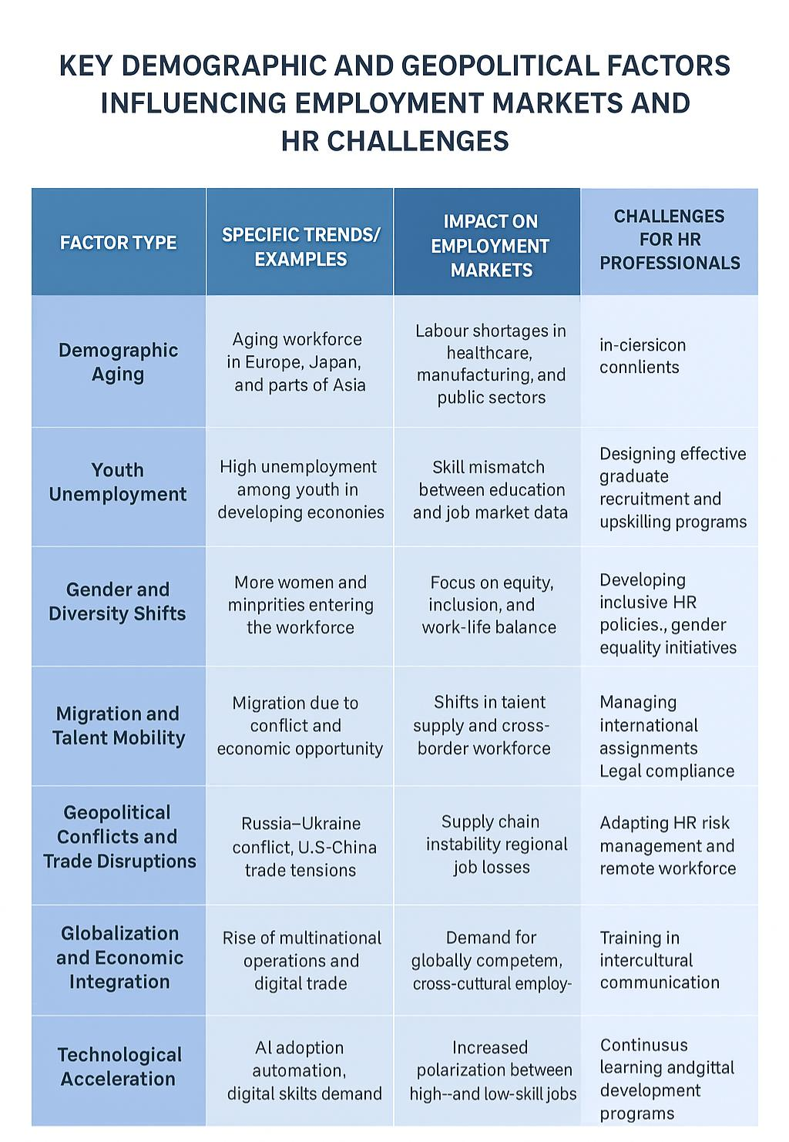
Multi-national, multi-generational and diverse workforces demand minor change management, inclusion, cross-cultural awareness and training of the workforce to accommodate tensions and assure involvement.

Question-03: How can organisations address persistent skills gaps and talent shortages in critical sectors through strategic HRM?
The issue of skills gap and shortage of talent is now a characteristic in the most significant industries like technology, healthcare, and hospitality. The traditional talent pipelines have been surpassed by the rapid technological change, population trends and alterations in worker needs and expectations. Strategic Human Resource Management (SHRM) offers a business model to solve these shortages by linking long-term business goals with workforce planning, learning and recruitment.
One of the factors that lead to skills shortages is technological disruption. Washington Post (n.d.) cites a report by the World Economic Forum (2024) which reveals that the planet will need to reskill more than 60 percent of its workers by 2027, as automation and digital transformation alter the content of work. The data analytics, cybersecurity and AI skills are in high demand in the technology industry, which is well above supply (OECD, 2023). In its reaction, SHRM lays stress on the continuous learning and development (L&D) programmes. Employers are putting money in in-house academies and university relationships so as to develop future-proof skills (Cappelli, 2021).
In the medical field, lack of personnel is primarily due to population strain and burnout. Job redesign, flexible scheduling, and well-being programmes are HR solutions that are oriented on work-life balance (Buchan et al., 2022). In addition, predictive analytics may be used to forecast shortages by place and specialty to activate strategic talent planning and recruitment and training (Kaur and Randhawa, 2022).
Emotional labour and customer experience skills, which cannot be automated and outsourced, are vital to retention and service quality in the hospitality sector. Employer branding, well developed career ladders and cross training are some of the strategies that organisations are employing to build employee loyalty and versatility in skills (Baum, 2021).
Global talent mobility and collaboration is also needed with strategic HRM. In IHRM views, companies are able to address such shortages of skills at the national level through international assignments, global sourcing, and remote workforce integration (Tarique and Schuler, 2020).

Question:04. Global Readiness: Self-reflection on the Capabilities I have to do the Changing Workplace

Strengths and Development Areas Analysis in an International and Digital Situation:
The times of globalisation and digitization have made cross-cultural competence, flexibility in the use of technology, and lifelong learning more critical to professional success. This reflective report is the critical evaluation of my current abilities in the work under the international environment-in terms of technology, communication, collaborative teams and teams, leadership and self-directed learning.
1. Technological Capability
Introduced by technology usage in international business spaces, it completely transformed the method of teamwork and the way people work (World Economic Forum, 2024). My course work and an internship allow me to possess good experience in digital collaboration tools, including Microsoft Teams, Google Workspace, and data analytics tools, specifically, Excel and Power BI.
Strengths:
- Acumen in online communication and information presentation.
- Belief in technology as a problem-solving and decision making tool.
Knowledge of cybersecurity and ethical usage of the digital environment.
Weaknesses:
- Minimal knowledge of sophisticated analytics or code-based applications (e.g. Python, SQL).
- Sometimes excessive dependence on technology in interaction decreasing the amount of interaction.
To be better, I will complete brief online certifications on data analytics and automation to enhance my expertise in the field of analysis and technical versatility. Ongoing technological learning will make me employable in data-driven working environments (Cappelli, 2021).
2. Communication Skills
All international cooperation is based on the effective communication. Effective communication with a variety of audiences and adaptation of styles of speaking to specific people has been cultivated by my MBA learning experience where I did group projects with students with a different cultural background.
Strengths:
- Tone and style adaptability and Culturally sensitive communication.
- Good written and presentation skills at school and in business.
- Being active and empathetic to different orientations in communication.
Weaknesses:
- At times, shy in expressing opposing views in multicultural groups.
- Should develop negotiations and persuasion communication techniques.
It has been found that intercultural communication competence is a fundamental predictor of success in the global working environment (Nguyen and Tran, 2022). I will be involved in different role-playing activities, negotiation games, and public speaking to improve my power and confidence. Besides, post-presentation reflection journaling will be used to see common barriers to communication (Moon, 2013).
3. Teamwork and Collaboration
Working in an international team necessitates degree of inclusiveness, flexibility and collective responsibility (Tuckman, 1965). During this term, I was also working in groups that comprised of other individuals who had different cultural and disciplinary orientations.
Strengths:
- Skills to achieve teamwork and promote cohesion.
- Dignified attitude to divergent opinions and dispute management.
- Ability to inspire teammates with compassion and elasticity.
Weaknesses:
- Propensity to commit himself or herself on tasks, sometimes resulting in stress or micromanagement.
- Still have to delegate better and rely on the competencies of others.
To counter this, I will set boundaries clearly, and rely on project management software (e.g., Trello, Asana) to delegate the work effectively.
4. Leadership and Influence
Global operational leadership entails cultural intelligence (CQ), making ethical choices, and adapting (Earley and Ang, 2003). Although the current leadership practises were confined to an academic environment, they helped to reinforce my skills as a motivator and leader in multifaceted tasks with peers.
Strengths:
- The democratic style of leadership that attaches importance to inclusivity and participation.
- Good self-awareness and desire to become a leader by example.
- Moral behaviour was in line with sustainability and justice.
Weaknesses:
- Not very much experience in conflict/performance management.
- Should be more assertive and faster in making decisions in the uncertain world.
The reflection will enable me to appraise leadership experiences and improve my strategic influence when using the Gibbs Reflective Cycle (Gibbs, 1988).
5. Self-Managed Learning and Adaptability.
In the modern dynamic global situations where knowledge is fast changing, self-directed learning is essential (Knowles, 1984).
Strengths:
- Internal focus of motivation and learning new concepts.
- Skills of critically assessing and synthesising academic data.
Weaknesses:
- Occasionally got overstretched because of various learning obligations.
- Less time spent in reflection on the outcomes in learning.
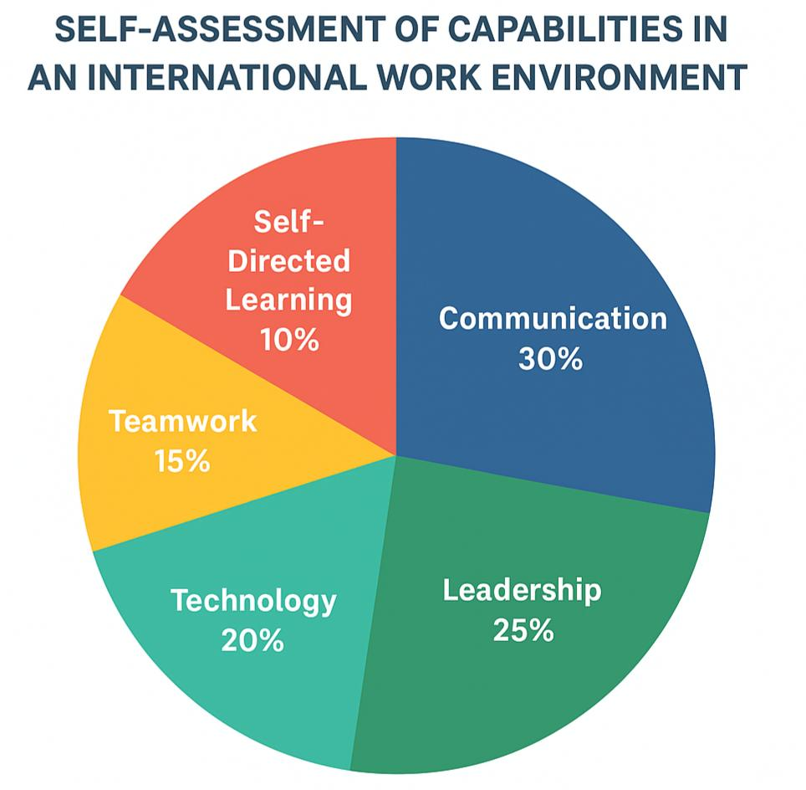
To enhance this aspect, I will ensure that I take SMART learning objectives, designate reflective learning sessions each week and incorporate discussions with peers. Learning lifelong will be increased by developing metacognitive awareness, i.e. thinking about the way I learn (Mezirow, 2009).

The pie chart is an examination of self-evaluation of major abilities needed to perform in a global workplace. The highest concentration of 30 percent is the communicating, which indicates great success in interacting with people and cross-cultural communication. The next one is leadership at 25 per cent, which refers to the capacity to lead different teams. The technological competence takes 20 per cent with an accent on adapting to digital tools.

Conclusion
The interactivity of technological/demographic/geopolitical has been pointed in this report as factors in influencing the national and international labour markets, and how these might impact both HRM and IHRM strategies. It illustrates the way organisations can deal with skills and talent shortages by using strategic workforce planning, reskilling, and global talent management. The reflective analysis highlights the need to develop continuously on technology, communication, teamwork, leadership and self-directed learning.

References
- Marguerit, D. (2025) Augmenting or Automating Labor? The Effect of AI Development on New Work, Employment, and Wages. Working Paper, arXiv: 2503.19159. Available at: https://econpapers.repec.org/paper/arxpapers/2503.19159.htm
- Arslan, A., Cooper, C., Khan, Z., Golgeci, I. & Ali, I. (2022) “Artificial intelligence and human workers interaction at team level: a conceptual assessment of the challenges and potential HRM strategies”, International Journal of Manpower, 43(1), pp. 75-88. Available at: https://www.emerald.com/insight/content/doi/10.1108/ijm-01-2021-0052/full/html
- Petrova, M., Schubert, G., Taska, B. & Yildirim, P. (2024) “Career Values for Labor Markets: Evidence from Robot Adoption”, NBER Working Paper No. 32655. Available at: https://www.nber.org/papers/w32655
- Erigbe, S. (2025) “Reshaping the Workforce: The Impact of AI, Automation, and Robotics on Labor Markets”, American Scientific Research Journal for Engineering, Technology, and Sciences, 102(1), pp. 360-370. Available at: https://asrjetsjournal.org/American_Scientific_Journal/article/view/11881
- Brasanan, K. (2025) “The role of digital platforms in transforming HRM: a scoping review across sectors”, Informatics. Economics. Management, 2(4), pp. 2028-2034. Available at: https://ouci.dntb.gov.ua/en/works/9866qQnq/
- Braesemann, F., Stephany, F., Teutloff, O., Kässi, O., Graham, M. & Lehdonvirta, V. (2021) The polarisation of remote work. SSRN. Available at: https://ssrn.com/abstract=3919655
- Stehrer, R., Bykova, A., & Stoellinger, R. (2019). Demographic challenges for labour supply and growth. The Vienna Institute for International Economic Studies (wiiw). Available at: https://wiiw.ac.at/demographic-challenges-for-labour-supply-and-growth-dlp-4868.pdf
- Stehrer, R., Bykova, A., & Stoellinger, R. (2019). Demographic challenges for labour supply and growth. The Vienna Institute for International Economic Studies (wiiw). Available at: https://wiiw.ac.at/demographic-challenges-for-labour-supply-and-growth-dlp-4868.pdf
- Acemoglu, D., Søndergaard, L. & Scott, M. (2022). Technology, aging, and the labour market: A global perspective. Working Paper, MIT/World Bank. Available at: https://arxiv.org/abs/2212.03355
- Ganguli, S. (2023). “Gen Z in the workplace: Expectations and engagement strategies in the post-pandemic era.” South Asian Journal of Human Resources Management, 10(2), pp. 203–222. Available at: https://journals.sagepub.com/doi/full/10.1177/09711023231197819
- International Bar Association (IBA) (2025). Geopolitical impact on global employment and the future of HRM. IBA Global Employment Institute. Available at: https://iclg.com/news/22917-iba-highlights-geopolitical-impact-on-global-employment
- Kliemt, H. (2025). Geopolitical disruption and the future of work: What does this mean for employers? Kliemt Blog. Available at: https://kliemt.blog/2025/08/22/geopolitical-disruption-and-the-future-of-work-what-does-this-mean-for-employers/
- Atlas HXM (2025). Global workforce challenges for HR leaders in 2025. Atlas Human Experience Management. Available at: https://www.atlashxm.com/resources/global-workforce-challenges-hr-leaders-2025
- Baum, T. (2021) Sustainable human resource management in the hospitality industry. International Journal of Contemporary Hospitality Management, 33(5), pp. 1572–1590.
- Buchan, J., Charlesworth, R. and Gershlick, B. (2022) Addressing workforce burnout and shortages in healthcare. Health Policy Journal, 126(3), pp. 345–359.
- IBA GEI (2025). Forced migration, conflict, and employment: Global HR policy challenges. International Bar Association Global Employment Institute. Available at: https://iclg.com/news/22917-iba-highlights-geopolitical-impact-on-global-employment
- Kaur, S. and Randhawa, G. (2022) Predictive analytics and strategic workforce planning in healthcare HRM. International Journal of Human Resource Studies, 12(2), pp. 88–104.
- Tarique, I. and Schuler, R. (2020) Global talent management: A strategic perspective. Journal of World Business, 55(2), pp. 1–11.
- Cappelli, P. (2021) Reskilling and the strategic management of talent. Human Resource Management Review, 31(4), pp. 100–117. Available at: https://www.sciencedirect.com/science/article/pii/S1053482221000388
- Earley, P.C. & Ang, S. (2003) Cultural Intelligence: Individual Interactions Across Cultures. Stanford, CA: Stanford University Press. Available at: https://www.sup.org/books/title/?id=3681
- Gibbs, G. (1988) Learning by Doing: A Guide to Teaching and Learning Methods. Oxford: Oxford Polytechnic.
- Goleman, D. (2018) Working with Emotional Intelligence. London: Bloomsbury. Available at: https://www.bloomsbury.com/uk/working-with-emotional-intelligence-9780749958930/
- Knowles, M. (1984) The Adult Learner: A Neglected Species. Houston, TX: Gulf Publishing. Available at: https://www.guilford.com/books/The-Adult-Learner/Malcolm-Knowles/9780874250014
- Mezirow, J. (2009) Transformative Learning in Practice: Insights from Community, Workplace, and Higher Education. San Francisco: Jossey-Bass. Available at: https://onlinelibrary.wiley.com/doi/book/10.1002/9780470479216
- Moon, J.A. (2013) Reflection and Employability: Learning through Experience. London: Routledge. Available at: https://www.routledge.com/Reflection-and-Employability-Learning-through-Experience/Moon/p/book/9780415531096

